Testing Promotion REST APIs

# PowerShell Scripts

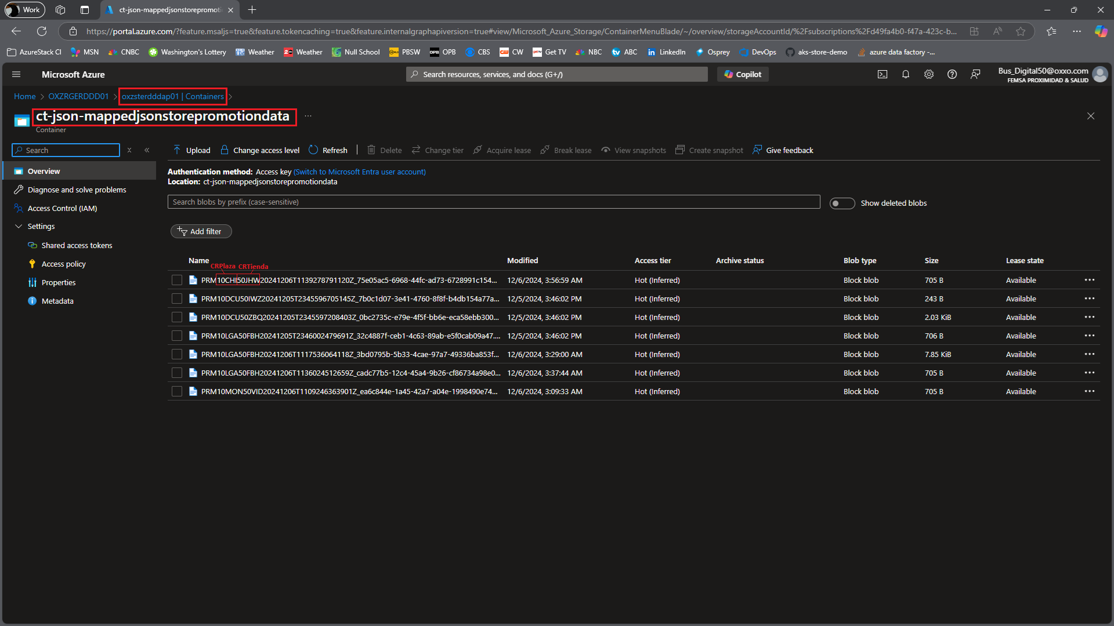

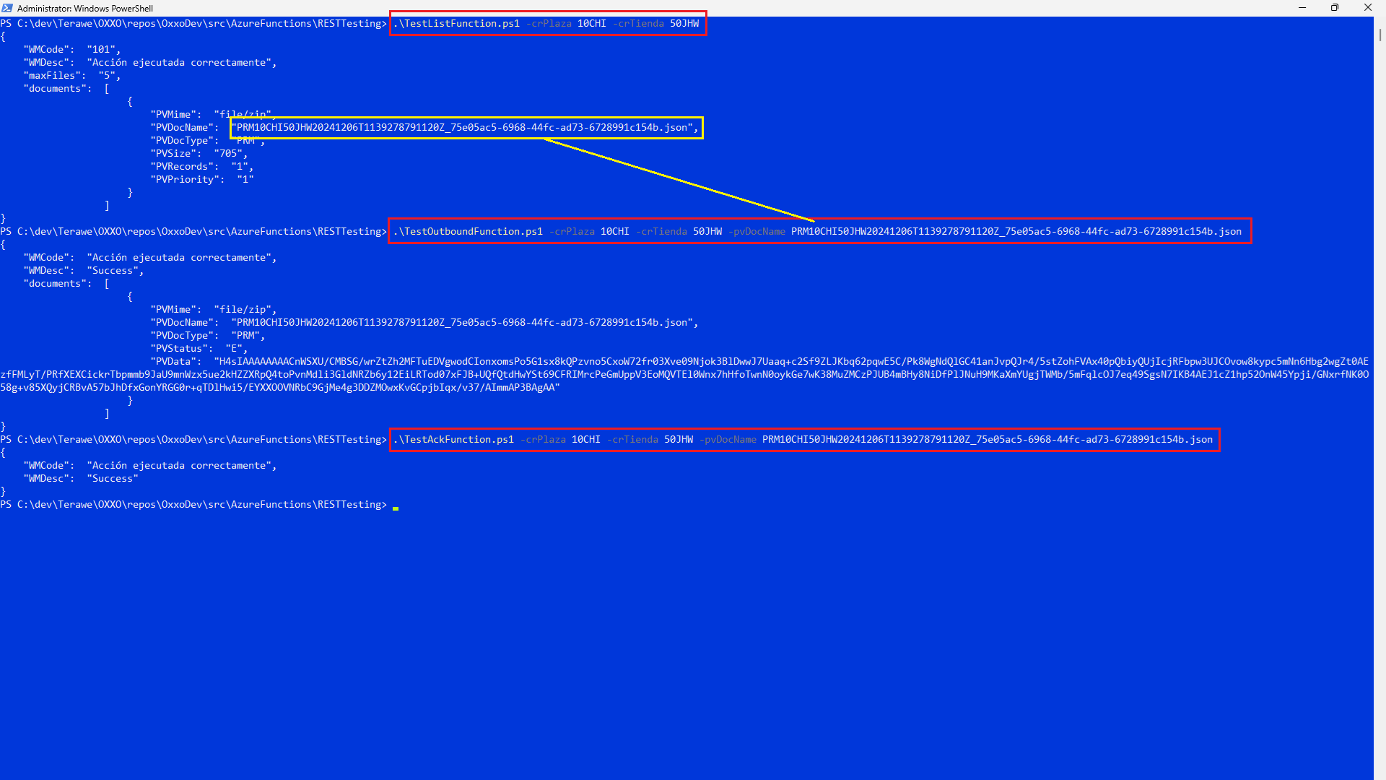

# Azure Portal

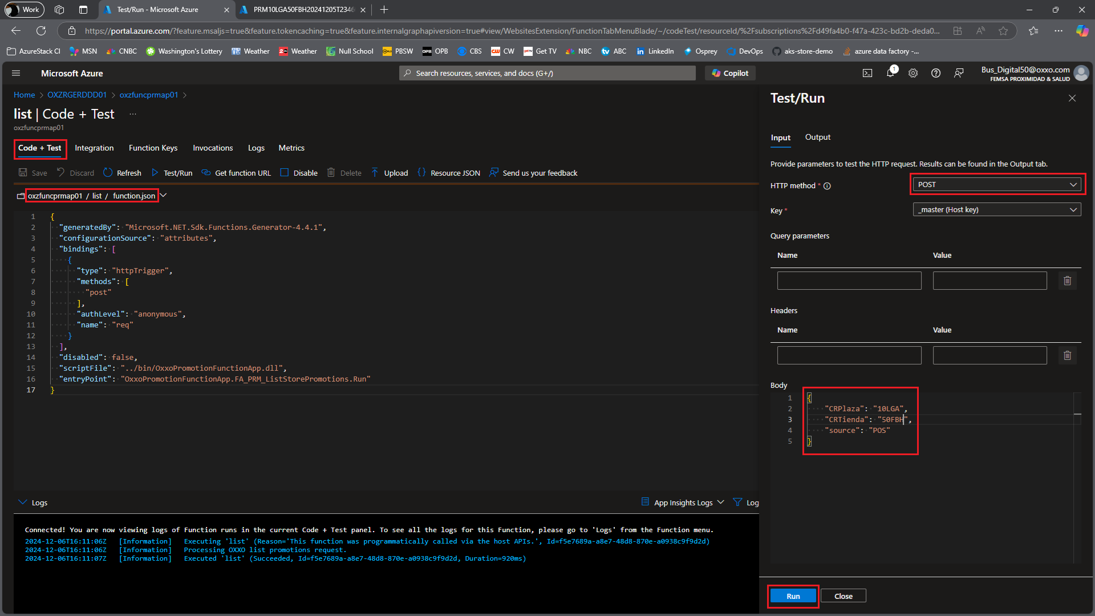

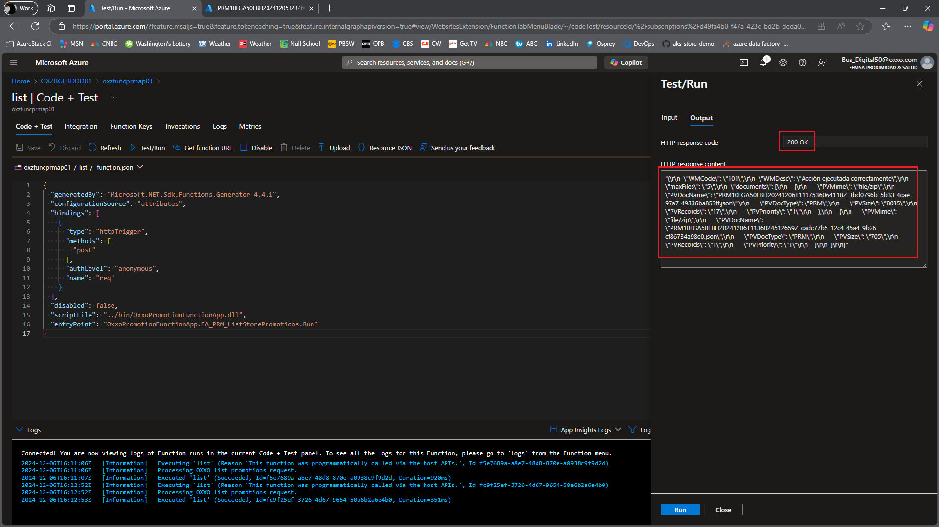

# Decode and Decompress Promotion Document

