**GROUP 10**

**Members**

**Basaya, Edmark**

**Base, John Christian**

**Ramos, Zherge**

**Anadilla, Nino Oliver**

APP OPEN (**ONCREATE , ONSTART , ONRESUME**) APP IS HIDDEN (**ONPAUSE,ONSTOP**)

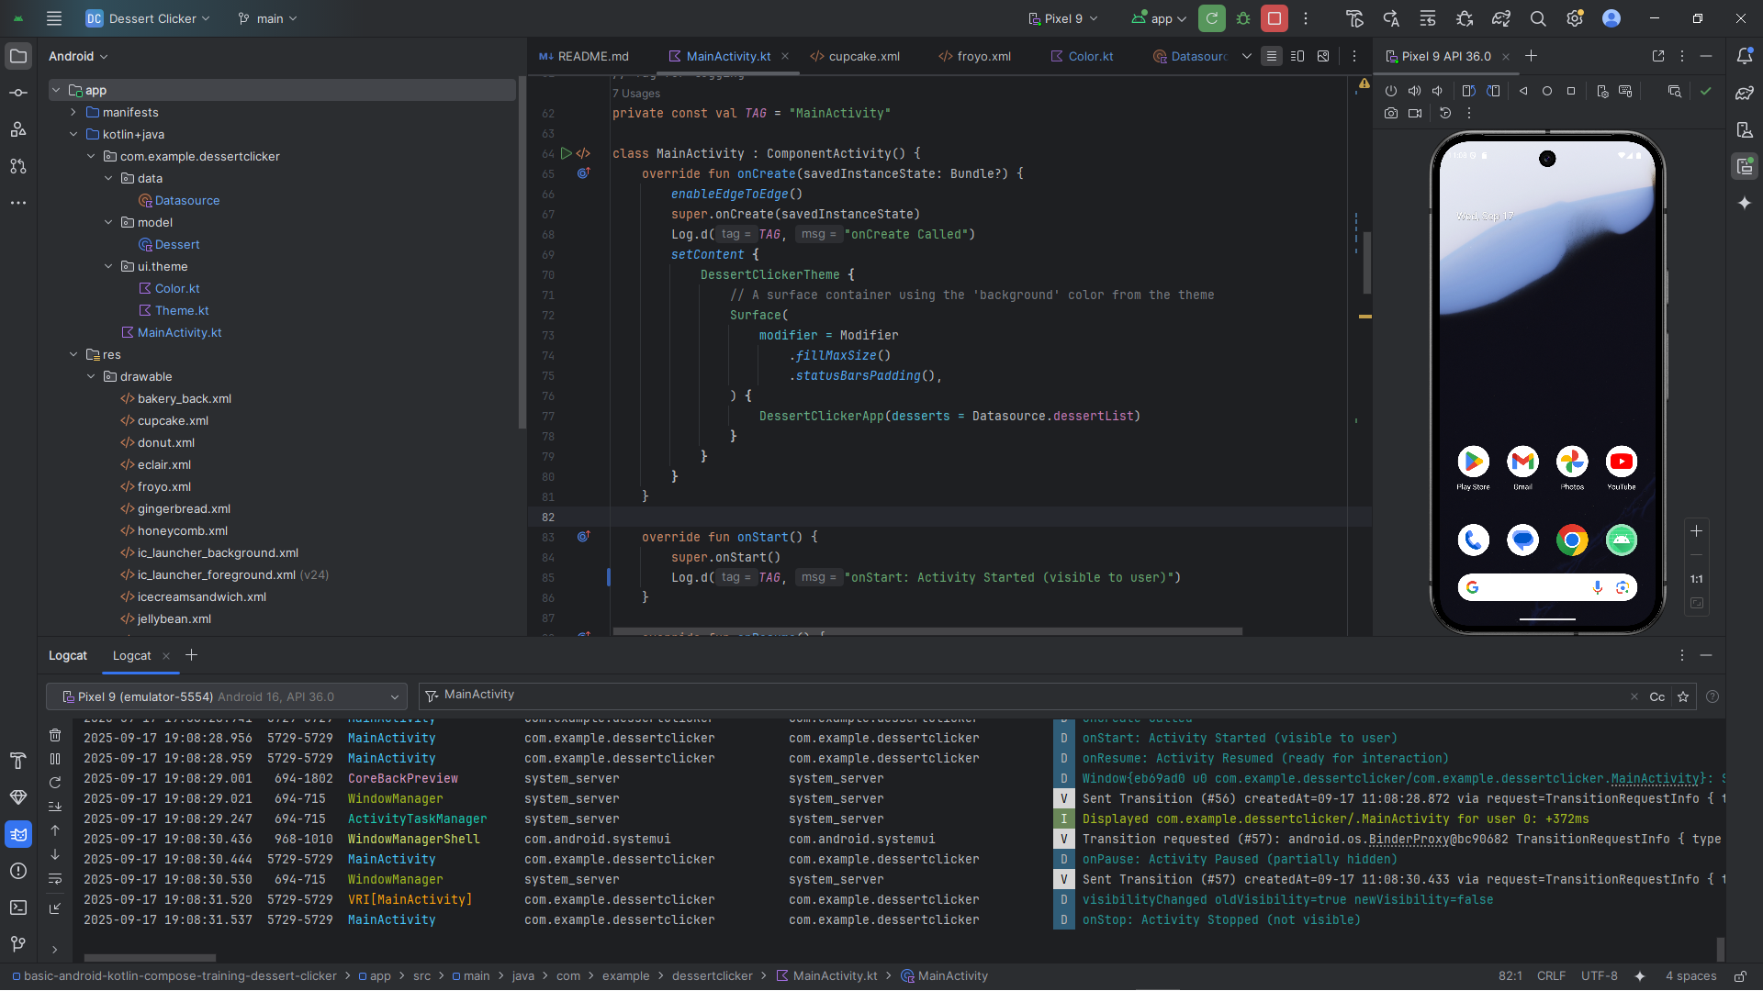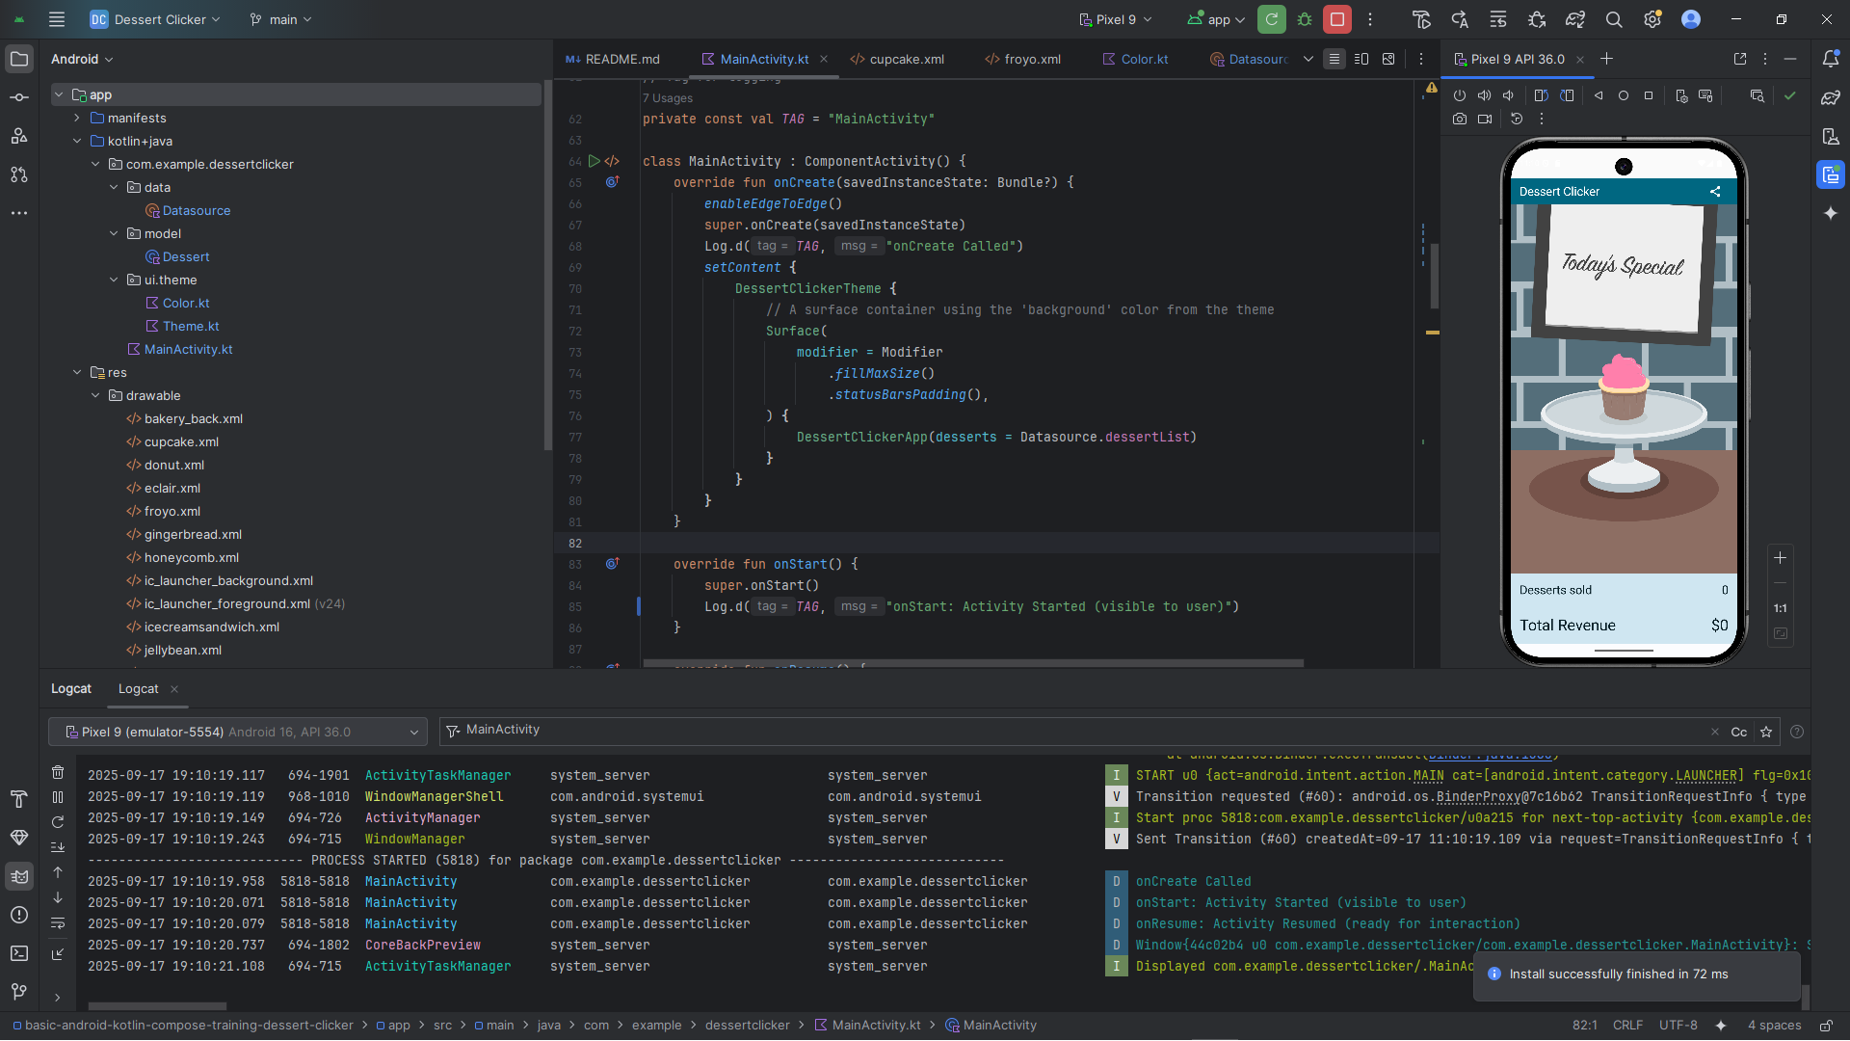

RETURN APP(**ONRESTART , ONSTART , ONRESUME )** CLOSED APP( **ONPAUSE , ONSTOP, ONDESTROY**)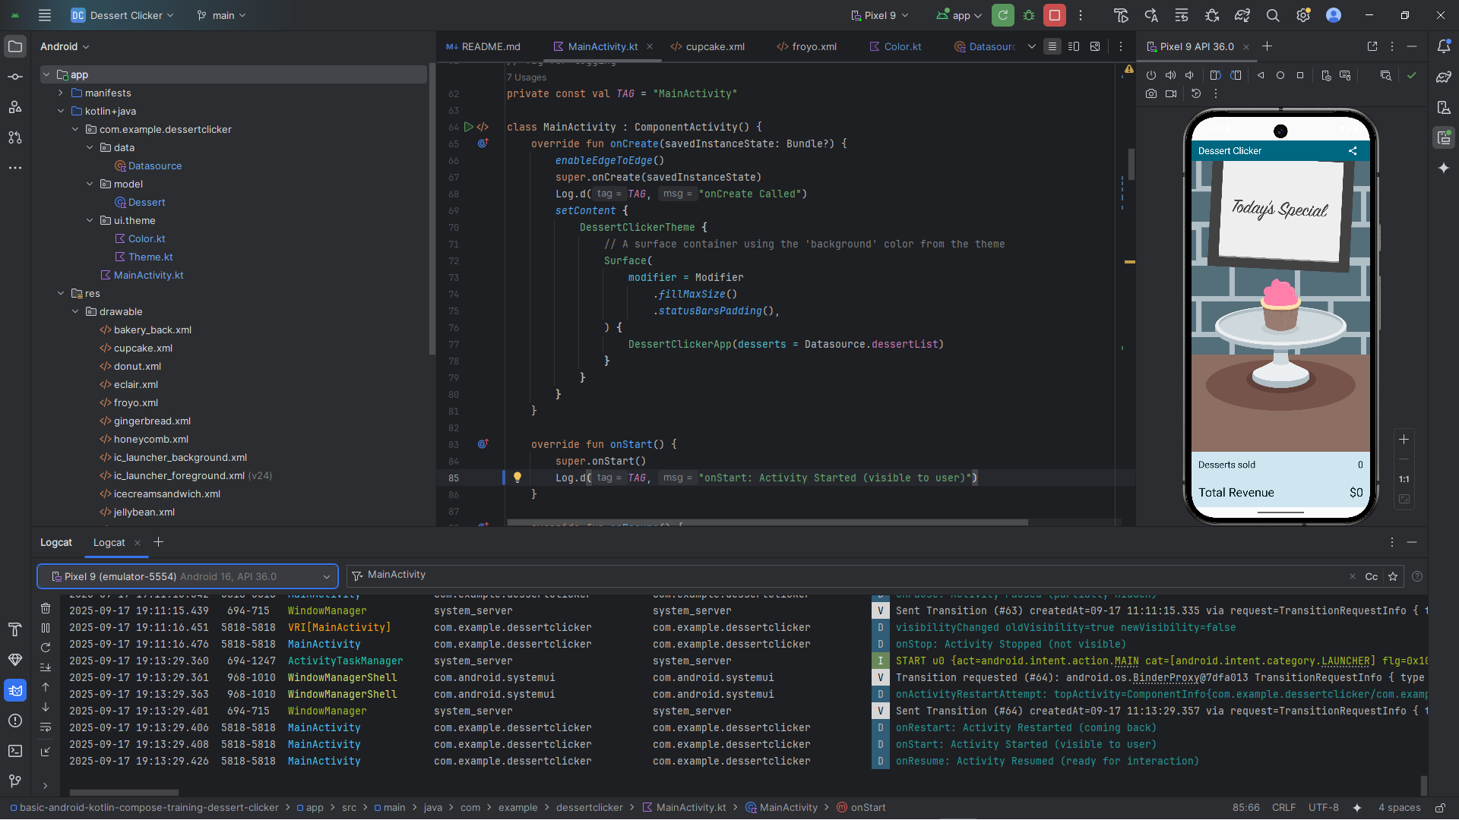

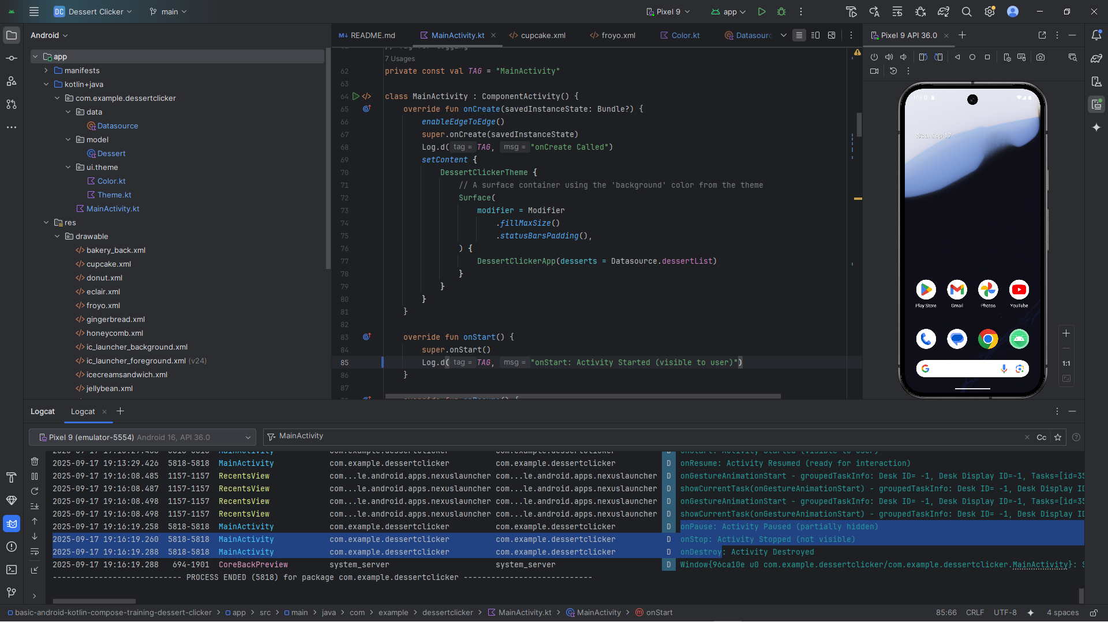

If you rotate the screen, the Dessert Sold and Total Revenue do not change.

Log d(**ONCREATE , ONSTART, ONRESUME**)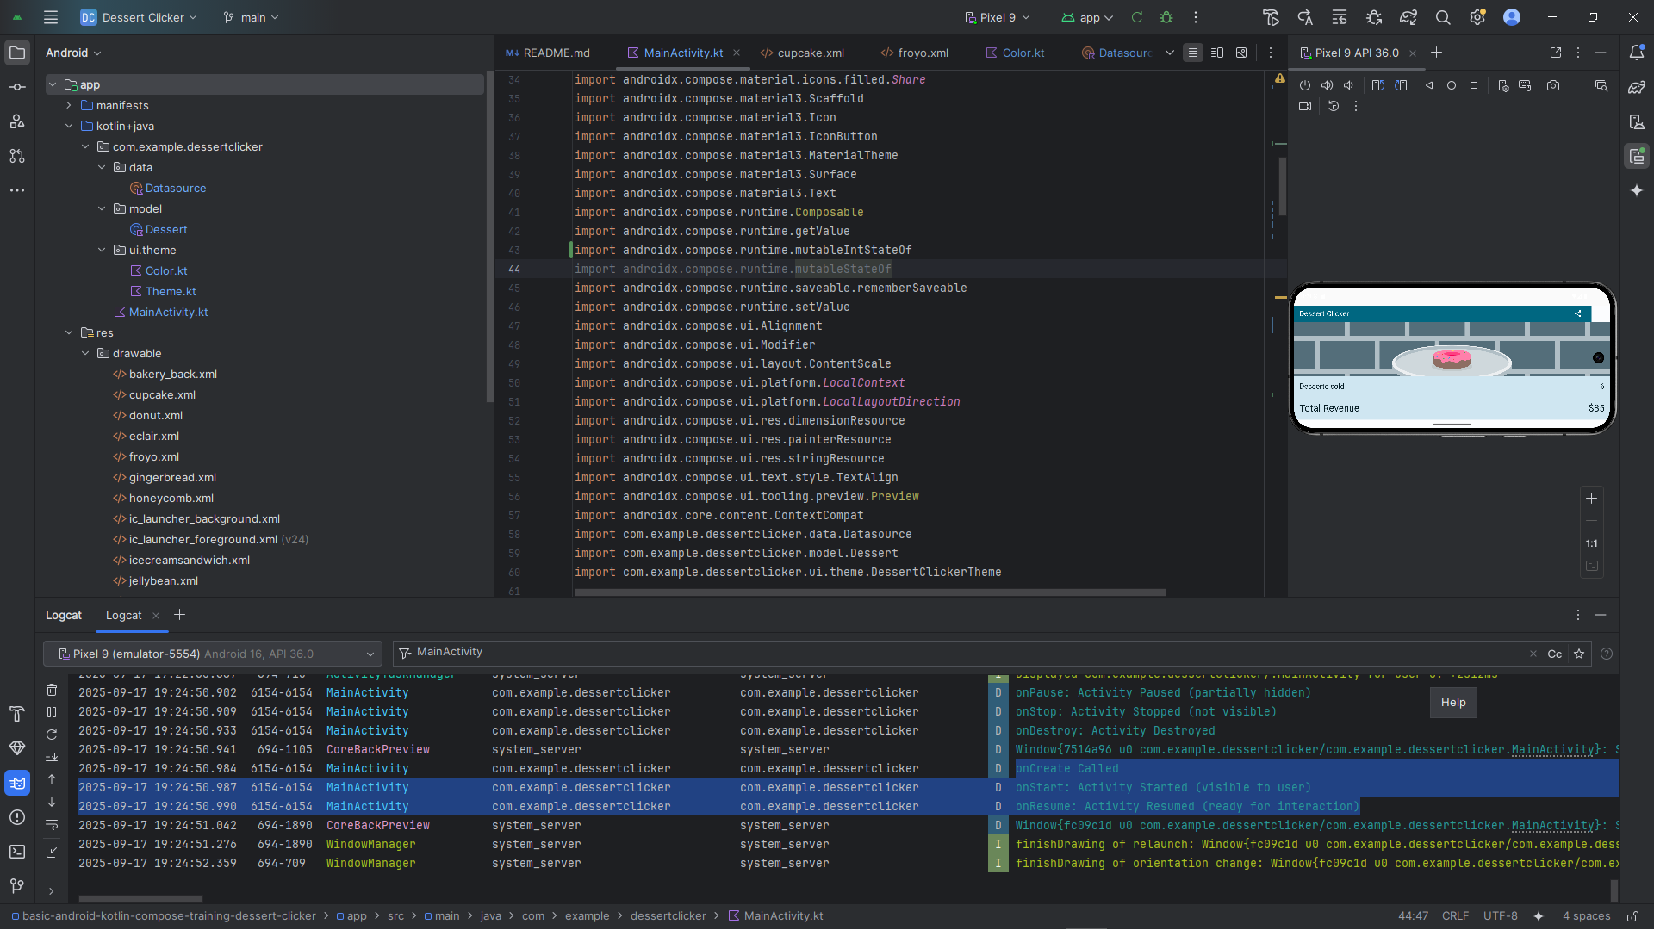

IF U HIDDEN THE APP THE DESSERT VALUE AND TOTAL REVENUE WILL NOT CHANGE