NATURAL LANGUAGE PROCESSING
Financial institutions face increasing challenges in detecting fraud due to the vast amount of unstructured text data generated.

Emails, transaction notes, customer support chats, and regulatory documents. Traditional fraud detection methods often rely on structured numerical data, leaving text-based signals underutilized.

Natural Language Processing (NLP) bridges this gap by enabling machines to understand, classify, and extract meaning from text, thereby uncovering fraud-related patterns that would otherwise remain hidden.

NLP for Text Data in Financial Systems
- Textual Sources: Customer complaints, transaction descriptions, loan applications, contracts, and communication logs.
- Role of NLP: Converts raw text into structured insights, allowing fraud detection systems to:
  - Identify suspicious language (e.g., urgency in phishing emails).
  - Detect inconsistencies in financial documents.
  - Monitor communication channels for fraudulent intent.

Basic NLP Techniques in Fraud Detection
- Text Classification
  - Categorizes documents or messages into fraud-related vs. legitimate classes.
  - Example: Classifying emails as phishing attempts or safe communications.
- Keyword Extraction
  - Identifies critical terms or phrases linked to fraud (e.g., “urgent transfer,” “guaranteed returns”).
  - Helps flag suspicious transactions or contracts.
- Sentiment Analysis
  - Detects emotional manipulation in text, such as fear or urgency.
Detecting Fraud-Related Patterns
NLP enhances fraud detection by uncovering hidden patterns in text data:
- Behavioral Anomalies: Detecting unusual communication styles or repeated suspicious requests.
- Entity Recognition: Identifying people, organizations, or accounts mentioned in fraudulent contexts.
- Document Consistency Checks: Spotting mismatched details in contracts or loan applications.
- Real-Time Monitoring: Automated alerts when suspicious language or anomalies are detected in customer interactions.
CONCLUSION:

NLP provides financial institutions with a powerful toolkit to analyze unstructured text data, complementing traditional fraud detection methods.

By applying techniques like text classification, keyword extraction, and sentiment analysis, NLP systems can detect fraud-related patterns early, reduce manual review workloads, and improve compliance monitoring.

As fraudsters evolve their tactics, NLP ensures that financial systems remain adaptive, scalable, and proactive in safeguarding assets.
WORKFLOW OF HOW TEXT DATA PROCESSED BY USING NLP

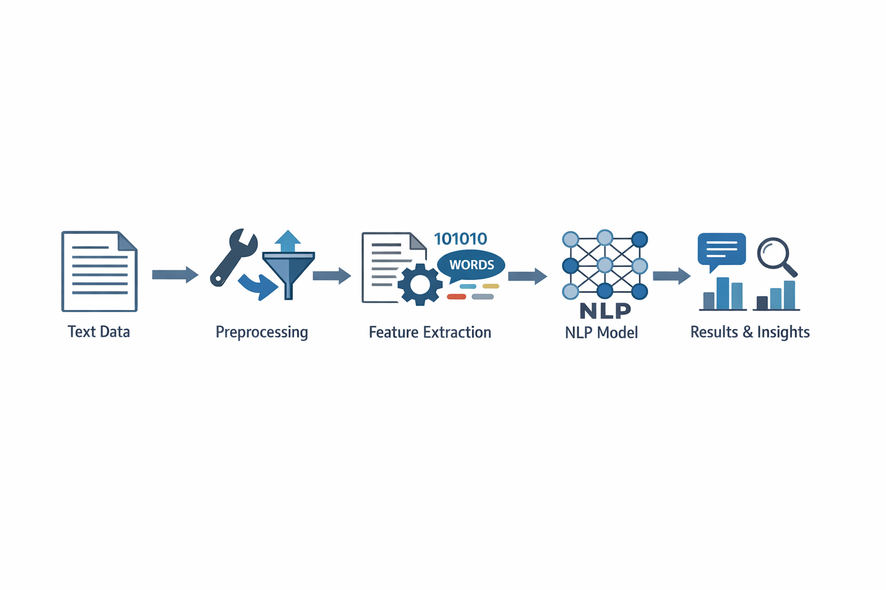

Text Input:
Raw data such as documents, tweets, or emails

Preprocessing:
Cleaning, tokenization, stop word removal, stemming.

Feature Extraction:
Converting text into numerical formats (e.g., TF-IDF, embeddings).

Model:
Applying NLP models for classification, translation, etc.

Output:
Insights like sentiment, named entities, or summaries.

OBSERVATIONS:

Unstructured Data Analysis

- Over 80% of financial data is unstructured, including emails, chat logs, and contracts.
- NLP enables systems to extract meaning from this data, identifying suspicious language, unusual requests, or hidden entities that structured databases overlook.

Named Entity Recognition (NER) and Sentiment Analysis

- NLP techniques like NER help identify people, organizations, and locations involved in transactions.
- Sentiment analysis detects emotional manipulation, such as urgency or fear in phishing emails or scam messages.

Behavioural Pattern Detection

- NLP models can track user behaviour across communication channels, flagging deviations from normal patterns.
- Sequence model helps detect fraudulent activity chains, such as repeated login attempts followed by unusual fund transfers.

Real-Time Alerts and Automation

- NLP enables automated fraud detection systems that generate real-time alerts based on suspicious language or document anomalies.
- This reduces manual review time and enhances scalability for financial institutions.

