experiment-01 4
Aim: 4
Source code : 4
Output: 6
Introduction to DBMS (Database Management System) 6
advantages of a DBMS: 6
experiment-02 8
Aim: 8
ER DIAGRAM: 8
Why Use ER Diagrams In DBMS? 8
Symbols Used in ER Model 9
Observation 9
experiment-03 10
Aim: 10
EER DIAGRAM(TABLE) 10
The entities and there attributes in the ER diagram are: 10
Relationships in the Diagram: 11
experiment-04 12
Aim: 12
EER DIAGRAM(TABLE) 12
Forward engineer: 14
Observation: 18
experiment-05 19
Aim: 19
5.1.1 : CREATE USER 19
5.1.2 : CREATE DATABASE 19
5.1.3 : CREATE TABLE 20
Observation: 21
5.2.1 : DROP DATABASE 22
5.2.2 : DROP TABLE 22
5.2.3 : DROP USER 22
Observation: 23
5.3 ALTER 24
5.3.1 : Add 24
5.3.2 : DROP 24
5.3.3: RENAME 24
5.3.4: MODIFY 25
Observation: 25
5.4.1 : TRUNCATE 26
Observation: 26
experiment-06 27
Aim: 27
6.1 INSERT 27
Observation: 28
6.2 : UPDATE 28
Observation: 28
6.3 DELETE 29
Observation: 29
experiment-07 30
Aim: 30
SELECT Statement 30
WHERE Clause 31
LIKE Clause 32
BETWEEN Clause 33
AND Clause 33
Combining WHERE, LIKE, AND 34
Using LIKE with Wildcards 34
WHERE with Multiple Conditions (AND, OR) 35
BETWEEN Combining Multiple Clauses￼ 36
Combining Multiple Clauses 37
Observation: 38
experiment-08 39
Aim: 39
String Functions 39
Observation: 41
Aim: 42
Number Functions 42
Observation: 43
Aim: 44
Date Functions 44
Observation: 45
experiment-09 46
Aim 46
Independent Queries: 46
Observation: 48
Aim 49
Correlated Queries : 49
Observation: 51
experiment-10 52
Aim 52
Sub Query : Using Select 52
Sub Query : Using Joins 53
Sub Query : Using GROUP BY and HAVING 55
Sub Query : Using IN, EXISTS 56
Sub Query : Using UPDATE and DELETE 57
Observation: 58
experiment-11 59
Aim 59
Unnormalized Form (UNF): 59
First Normal Form (1NF) 59
2NF Rules: 60
3NF Rules: 62
SQL SCRIPT for creating tables : 63
SQL SCRIPT for creating tables 64
Tables: 64
Observation: 65

Week-01 | experiment-01 | Date: 5 Dec 2024

Aim:
To understand the differences between a Database Management System (DBMS) and a traditional File System by analyzing their functionalities, advantages, and limitations. This study will highlight how data storage, retrieval, security, integrity, and performance differ between the two approaches.

- I have Write a program to store the data in the file system
- while choosing 1 for entering student details (Name,Course_name, Marks),2 for showing the details of student 3 for Delete the data from the file and 4 update data5. for exit.
- Data of student stored in excel file using python

Source code :
import pandas as p
from IPython.display import FileLink
student = p.DataFrame(columns=['id', 'name', 'eng', 'tel', 'hindi'])
student = student.set_index('id')

def read(student, id, row):
student.loc[id] = row
return student

def add_student():
id = int(input('Enter id of student: '))
n = input('Enter name of student: ')
s1 = int(input('Enter english mark of student: '))
s2 = int(input('Enter telugu mark of student: '))
s3 = int(input('Enter hindi mark of student: : '))
row = { 'id': id, 'name': n, 'eng': s1, 'tel': s2, 'hindi': s3 }
read(student, id, row)
def display(student):
print(student)
def remove(student):
a = int(input('Enter id of student: '))
if a in student.index:
student = student.drop(index=a,inplace = True)
return student
def update(student):
a=int(input("enter the id"))
b=input("enter the column ")
c=int(input("enter:"))
student.loc[a,b]=c
return student
while True:
print('1. Add student in data')
print('2. Display student data')
print('3. Remove student data')
print('4. Update student data')
print('5. Exit')
choice = int(input('Enter your choice: '))
if choice == 1:
add_student()
elif choice == 2:
display(student)
elif choice == 3:
remove(student)
elif choice == 4:
update(student)
elif choice == 5:
break
else:
print('Invalid choice')
student.to_csv('data.csv')
FileLink('data.csv')

Output:
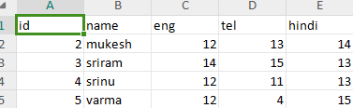

while creating a database in a programming language like Python is possible, it comes with significant challenges in terms of data integrity, security, performance,scalability, and maintenance, making it less efficient than using a dedicated DBMS.

Introduction to DBMS (Database Management System)
- DBMS stores large amounts of data in a structured way, ensuring that it is easy to access and manipulate.
- It allows users and applications to query the database and retrieve data quickly.
- Provides mechanisms to control access to the database, ensuring that only authorized users can perform specific operations.
- DBMS separates the data from the applications, allowing changes in data structure without affecting the application programs.

advantages of a DBMS:
- Data Redundancy Control: Eliminates duplicate data and saves storage space by centralizing data.
- Data Integrity: Ensures accurate and consistent data through rules and constraints.
- Data Security: Protects data by controlling access and ensuring only authorized users can access sensitive information.
- Efficient Data Retrieval: Speeds up data retrieval using optimized query processing.
- Concurrency Control: Allows multiple users to access the database simultaneously without conflicts.
- Backup and Recovery: Protects data by offering regular backups and mechanisms for data recovery in case of failure.

Week-02 | experiment-02 | Date: 14 Dec 2024

Aim:
To design an ER diagram for a Bank Management System to visually represent entities, attributes, and relationships for efficient database management.

ER DIAGRAM:
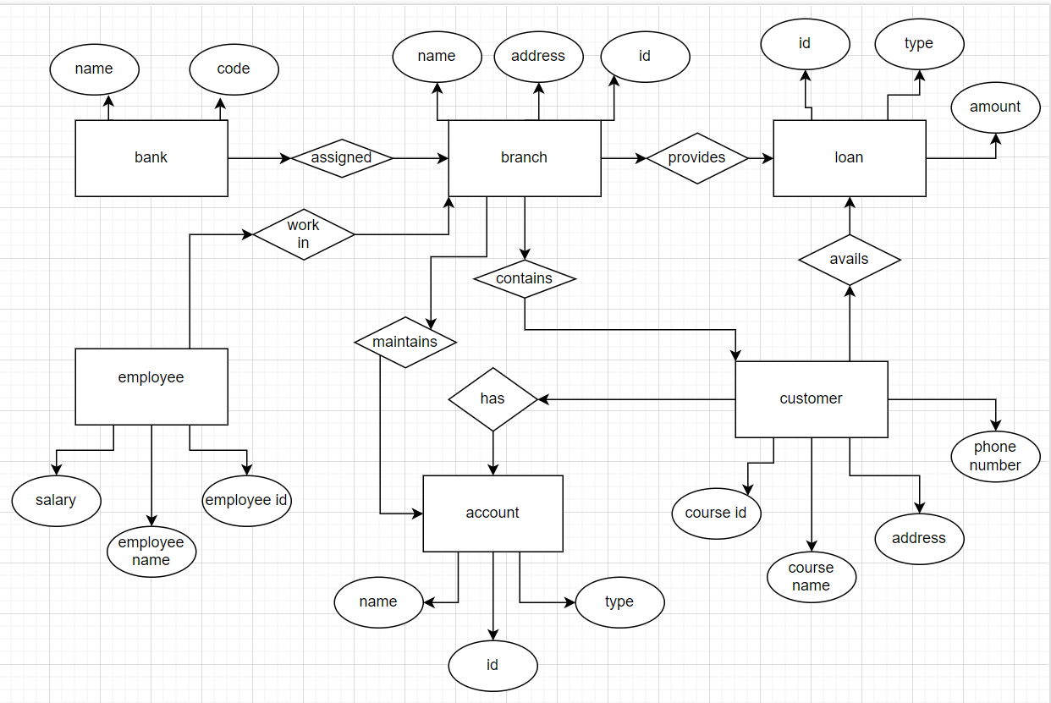

Why Use ER Diagrams In DBMS?

- ER diagrams represent the E-R model in a database, making them easy to convert into relations (tables).
- ER diagrams provide the purpose of real-world modeling of objects which makes them intently useful.
- ER diagrams require no technical knowledge of the underlying DBMS used.
- It gives a standard solution for visualizing the data logically.

Symbols Used in ER Model
ER Model is used to model the logical view of the system from a data perspective which consists of these symbols:
- Rectangles: Rectangles represent Entities in the ER Model.
- Ellipses: Ellipses represent Attributes in the ER Model.
- Diamond: Diamonds represent Relationships among Entities.
- Lines: Lines represent attributes to entities and entity sets with other relationship types.
- Double Ellipse: Double Ellipses represent Multi-Valued Attributes.
- Double Rectangle: Double Rectangle represents a Weak Entity.

Observation
- The above er diagram shows the entity relationship for the bank management system.
- I have draw er diagram using draw io online site. Draw.io is a free and simple tool for making ER diagrams. Here’s why it’s useful:
- 1. Easy to Use: Drag and drop shapes to quickly create diagrams.
- 2. Collaboration: Work with others in real time and share easily.
- 3. Export Options: Save diagrams as images or PDFs for presentations

Week-03 | experiment-03 | Date: 21 Dec 2024

Aim:
Creating an EER(Enhanced entity relationship ) Table for the Bank management System.

EER DIAGRAM(TABLE)

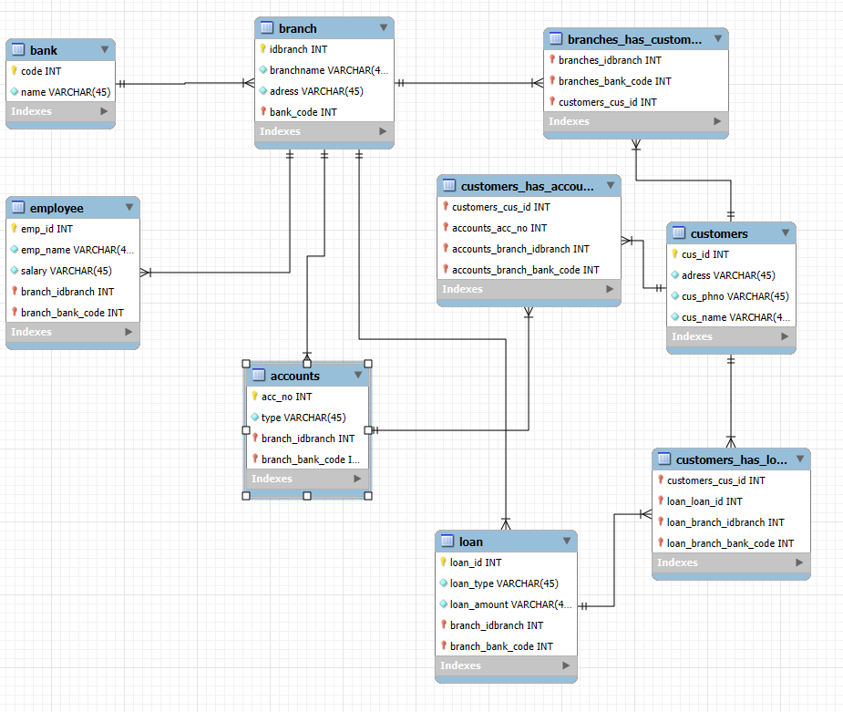

The entities and there attributes in the ER diagram are:

- Bank
- Attributes: name: Name of the bank , code: Unique identifier for the bank.

- Branch
- Attributes: name: Name of the branch , address: Address of the branch , branch_id: Unique identifier for the branch.
- Employee
- Attributes:Employee ID: A unique identifier for the employee , Employee Name: The name of the employee , Salary: The employee's salary.

- Account.
- Attributes: Account ID: A unique identifier for the account , Account Type: The type of account , Balance: The current balance in the account
- Loan
- Attributes:
- loan_id: Unique identifier for the loan , amount: Loan amount , loan_type: Type of loan (e.g., personal, home).
- Customer
- Attributes: customer_id: Unique identifier for the customer , name: Name of the customer , address: Address of the customer , phone_number: Customer's contact number.

Relationships in the Diagram:

- Bank has Branches(Type : One-to-Many.).
- Employee works in a Branch(Type : Many-to-one.).
- Branch contains customer(Type : Many-to-Many.).
- Branch proBranch contains customer(Type : Many-to-Many.).
- Customer avails Loans(Type : Many-to-Many.).
- Customer has Accounts(Type : Many-to-Many.).
- branch maintains Accounts(Type : One-to-Many.)

Week-04 | experiment-04 | Date: 25 Dec 2024

Aim:
Basic scheme creation: create ot an EER diagram for Libary management System that includes entities Books Author, member, and BorrowedBooks. Define for relationships primary and foreign lay

- A primary key is a column (or a set of columns) in a table that uniquely identifies each row in that table.
- A foreign key is a column (or a set of columns) in one table that refers to the primary key in another table.

EER DIAGRAM(TABLE)
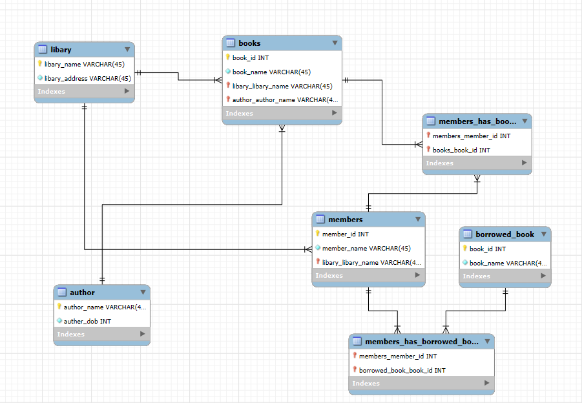
- Library
- Primary Key: library_name(Unique identifier for each library).
- No Foreign Keys.

- Books
- Primary Key: book_id(Unique identifier for each book).
- Foreign Keys: library_library_name → References library_name in Library ( A book belongs to a specific library).
- author_author_name → References author_name in Author(Each book is written by a specific author).

- Author
- Primary Key: author_name(Unique identifier for each author).
- No Foreign Keys.

- Members
- Primary Key: member_id(Unique identifier for each library member).
- Foreign Key: library_library_name → References library_name in Library(Each member belongs to a specific library).

- Members_Has_Books
- Primary Key: Composite Key (members_member_id, books_book_id)(A combination of member and book IDs uniquely identifies a record).
- Foreign Keys:members_member_id → References member_id in Members (Relates a specific member to books).
- books_book_id → References book_id in Books(Relates a specific book to members).

- Borrowed_Book
- Primary Key: book_id(Unique identifier for a borrowed book).
- No Foreign Keys.

- Members_Has_Borrowed_Book
- Primary Key: Composite Key (members_member_id, borrowed_book_book_id) (A combination of member and borrowed book IDs uniquely identifies a record).
- Foreign Keys: members_member_id → References member_id in Members(Relates a specific member to borrowed books).
- borrowed_book_book_id → References book_id in Borrowed_Book(Relates a specific borrowed book to members).

Forward engineer:

-- MySQL Workbench Forward Engineering

SET @OLD_UNIQUE_CHECKS=@@UNIQUE_CHECKS, UNIQUE_CHECKS=0;
SET @OLD_FOREIGN_KEY_CHECKS=@@FOREIGN_KEY_CHECKS, FOREIGN_KEY_CHECKS=0;
SET @OLD_SQL_MODE=@@SQL_MODE, SQL_MODE='ONLY_FULL_GROUP_BY,STRICT_TRANS_TABLES,NO_ZERO_IN_DATE,NO_ZERO_DATE,ERROR_FOR_DIVISION_BY_ZERO,NO_ENGINE_SUBSTITUTION';

-- -----------------------------------------------------
-- Schema mydb
-- -----------------------------------------------------

-- -----------------------------------------------------
-- Schema mydb
-- -----------------------------------------------------
CREATE SCHEMA IF NOT EXISTS `mydb` DEFAULT CHARACTER SET utf8 ;
USE `mydb` ;

-- -----------------------------------------------------
-- Table `mydb`.`libary`
-- -----------------------------------------------------
CREATE TABLE IF NOT EXISTS `mydb`.`libary` (
`libary_name` VARCHAR(45) NOT NULL,
`libary_address` VARCHAR(45) NOT NULL,
PRIMARY KEY (`libary_name`),
UNIQUE INDEX `libary_name_UNIQUE` (`libary_name` ASC) VISIBLE)
ENGINE = InnoDB;

-- -----------------------------------------------------
-- Table `mydb`.`author`
-- -----------------------------------------------------
CREATE TABLE IF NOT EXISTS `mydb`.`author` (
`author_name` VARCHAR(45) NOT NULL,
`auther_dob` INT NOT NULL,
PRIMARY KEY (`author_name`),
UNIQUE INDEX `author_name_UNIQUE` (`author_name` ASC) VISIBLE)
ENGINE = InnoDB;

-- -----------------------------------------------------
-- Table `mydb`.`books`
-- -----------------------------------------------------
CREATE TABLE IF NOT EXISTS `mydb`.`books` (
`book_id` INT NOT NULL,
`book_name` VARCHAR(45) NOT NULL,
`libary_libary_name` VARCHAR(45) NOT NULL,
`author_author_name` VARCHAR(45) NOT NULL,
PRIMARY KEY (`book_id`, `libary_libary_name`, `author_author_name`),
UNIQUE INDEX `book_id_UNIQUE` (`book_id` ASC) VISIBLE,
INDEX `fk_books_libary1_idx` (`libary_libary_name` ASC) VISIBLE,
INDEX `fk_books_author1_idx` (`author_author_name` ASC) VISIBLE,
CONSTRAINT `fk_books_libary1`
FOREIGN KEY (`libary_libary_name`)
REFERENCES `mydb`.`libary` (`libary_name`)
ON DELETE NO ACTION
ON UPDATE NO ACTION,
CONSTRAINT `fk_books_author1`
FOREIGN KEY (`author_author_name`)
REFERENCES `mydb`.`author` (`author_name`)
ON DELETE NO ACTION
ON UPDATE NO ACTION)
ENGINE = InnoDB;

-- -----------------------------------------------------
-- Table `mydb`.`members`
-- -----------------------------------------------------
CREATE TABLE IF NOT EXISTS `mydb`.`members` (
`member_id` INT NOT NULL,
`member_name` VARCHAR(45) NOT NULL,
`libary_libary_name` VARCHAR(45) NOT NULL,
PRIMARY KEY (`member_id`, `libary_libary_name`),
UNIQUE INDEX `members_id_UNIQUE` (`member_id` ASC) VISIBLE,
INDEX `fk_members_libary1_idx` (`libary_libary_name` ASC) VISIBLE,
CONSTRAINT `fk_members_libary1`
FOREIGN KEY (`libary_libary_name`)
REFERENCES `mydb`.`libary` (`libary_name`)
ON DELETE NO ACTION
ON UPDATE NO ACTION)
ENGINE = InnoDB;

-- -----------------------------------------------------
-- Table `mydb`.`borrowed_book`
-- -----------------------------------------------------
CREATE TABLE IF NOT EXISTS `mydb`.`borrowed_book` (
`book_id` INT NOT NULL,
`book_name` VARCHAR(45) NOT NULL,
PRIMARY KEY (`book_id`),
UNIQUE INDEX `book_id_UNIQUE` (`book_id` ASC) VISIBLE)
ENGINE = InnoDB;

-- -----------------------------------------------------
-- Table `mydb`.`members_has_borrowed_book`
-- -----------------------------------------------------
CREATE TABLE IF NOT EXISTS `mydb`.`members_has_borrowed_book` (
`members_member_id` INT NOT NULL,
`borrowed_book_book_id` INT NOT NULL,
PRIMARY KEY (`members_member_id`, `borrowed_book_book_id`),
INDEX `fk_members_has_borrowed_book_borrowed_book1_idx` (`borrowed_book_book_id` ASC) VISIBLE,
INDEX `fk_members_has_borrowed_book_members_idx` (`members_member_id` ASC) VISIBLE,
CONSTRAINT `fk_members_has_borrowed_book_members`
FOREIGN KEY (`members_member_id`)
REFERENCES `mydb`.`members` (`member_id`)
ON DELETE NO ACTION
ON UPDATE NO ACTION,
CONSTRAINT `fk_members_has_borrowed_book_borrowed_book1`
FOREIGN KEY (`borrowed_book_book_id`)
REFERENCES `mydb`.`borrowed_book` (`book_id`)
ON DELETE NO ACTION
ON UPDATE NO ACTION)
ENGINE = InnoDB;

-- -----------------------------------------------------
-- Table `mydb`.`members_has_books`
-- -----------------------------------------------------
CREATE TABLE IF NOT EXISTS `mydb`.`members_has_books` (
`members_member_id` INT NOT NULL,
`books_book_id` INT NOT NULL,
PRIMARY KEY (`members_member_id`, `books_book_id`),
INDEX `fk_members_has_books_books1_idx` (`books_book_id` ASC) VISIBLE,
INDEX `fk_members_has_books_members1_idx` (`members_member_id` ASC) VISIBLE,
CONSTRAINT `fk_members_has_books_members1`
FOREIGN KEY (`members_member_id`)
REFERENCES `mydb`.`members` (`member_id`)
ON DELETE NO ACTION
ON UPDATE NO ACTION, ON DELETE NO ACTION

ON UPDATE NO ACTION,

CONSTRAINT `fk_members_has_books_books1`

FOREIGN KEY (`books_book_id`)

REFERENCES `mydb`.`books` (`book_id`)

ON DELETE NO ACTION

ON UPDATE NO ACTION)

ENGINE = InnoDB;

SET SQL_MODE=@OLD_SQL_MODE;

SET FOREIGN_KEY_CHECKS=@OLD_FOREIGN_KEY_CHECKS;

SET UNIQUE_CHECKS=@OLD_UNIQUE_CHECKS;

CONSTRAINT `fk_members_has_books_books1`
FOREIGN KEY (`books_book_id`)
REFERENCES `mydb`.`books` (`book_id`)
ON DELETE NO ACTION

ON UPDATE NO ACTION)

ENGINE = InnoDB;

SET SQL_MODE=@OLD_SQL_MODE;

SET FOREIGN_KEY_CHECKS=@OLD_FOREIGN_KEY_CHECKS;

SET UNIQUE_CHECKS=@OLD_UNIQUE_CHECKS;
ENGINE = InnoDB;

SET SQL_MODE=@OLD_SQL_MODE;
SET FOREIGN_KEY_CHECKS=@OLD_FOREIGN_KEY_CHECKS;
SET UNIQUE_CHECKS=@OLD_UNIQUE_CHECKS;

Observation:
The Enhanced Entity-Relationship (EER) Diagram for the Library Management System effectively represents entities, relationships, primary keys, and foreign keys for efficient database structuring. The forward engineering SQL script ensures accurate implementation of relationships, enforcing data integrity and consistency within the database.

Week-05 | experiment-05 | Date: 5 jan 2024

Aim:
created a User in “MySQL Workbench” .Created a database with our respective regno in the following user account. After we performed some Data Definition Language (DDL) commands on the database.

5.1.1 : CREATE USER

query: | 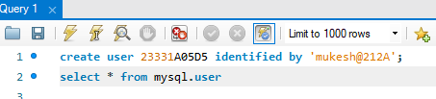
output: | 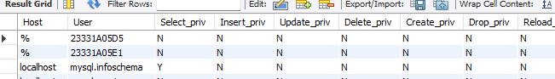

5.1.2 : CREATE DATABASE
O/P :

query: | 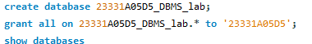
output: | 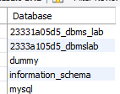

5.1.3 : CREATE TABLE
O/P :

query: | 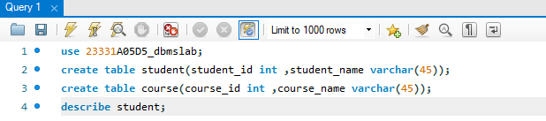
output: | 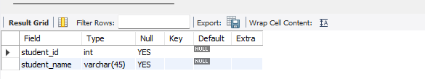
query: | 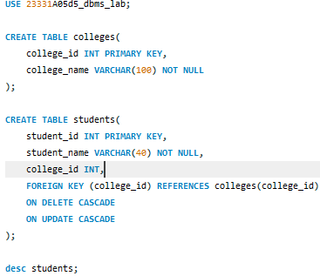
output: | 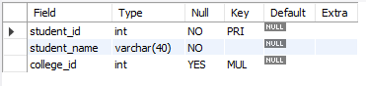

Observation:
- MySQL error code 1007 :Database with the same name already exists.
- MySQL error code 1146 : occurs when MySQL is unable to find a table that it is supposed to exist
- The experiment successfully demonstrates user creation, database setup, and table creation in MySQL Workbench using DDL (Data Definition Language) commands.

5.2.1 : DROP DATABASE
To ‘DROP’ , first we have to create a Database ‘23331A05D6’ . After we ‘Drop’ it.
O/P :

query: | 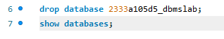
output: | 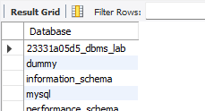

5.2.2 : DROP TABLE
To drop a table we have to create a table ‘ dept ’. After we have to DROP it.

O/P :

query: | 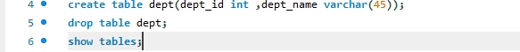
output: | 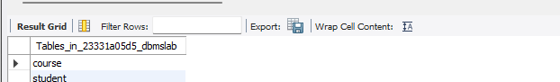

5.2.3 : DROP USER
To drop a USER we have to create a user ‘ mukesh’. After we have to DROP it.

query: | 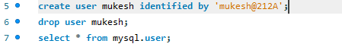
output: | 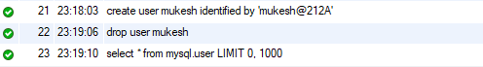

Observation:
- SQL Error code 1064: the SQL query you've written isn't valid because it contains a mistake in the syntax
- SQL Error code 1008:occurs when a user attempts to drop a database that does not exists
- The experiment demonstrates dropping a database and a table in MySQL Workbench using the DROP command. It first creates a database and a table before executing
- the DROP command to remove them. The results confirm successful deletion

5.3 ALTER

5.3.1 : Add

Whenever we created a table ,we forgot to add another column. So at that time thecommand ‘ALTER’ is used..

O/P :-

query: | 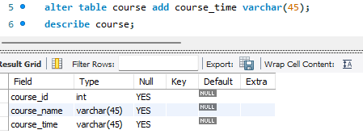
output:

5.3.2 : DROP
In the above task we added an extra column to the table ‘couser’ i.e.. couser_time. Now we have to drop it.

O/P :
query: | 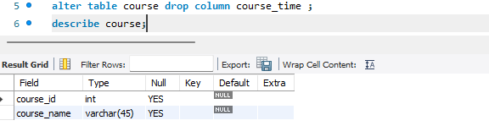
output:

5.3.3: RENAME
The ‘RENAME’ command is used to rename a table or a column.

O/P :
query: | 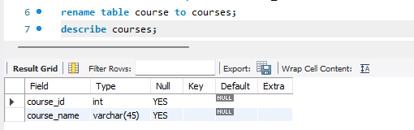
output:
query: | 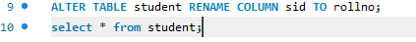
output: | 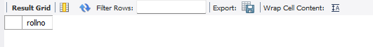

5.3.4: MODIFY
to modify the table structure, such as changing the data type of sid

query: | 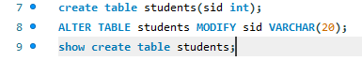
output: | 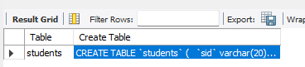

Observation:
- SQL Error code 1091: when trying to drop a column that is not in the table.
- SQL Error code 1060: when trying to add a column that already exists.
- SQL Error code 1054: when trying to modify a non-existing column.

5.4.1 : TRUNCATE
The ‘TRUNCATE’ statement is used to remove all rows from a table, but it does so in a more efficient way compared to the ‘DELETE’ statement.

O/P :

query: | 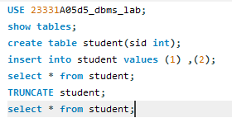
output:

before | 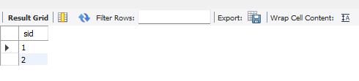
after | 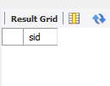

Observation:
SQL Error code1146 : When Trying to truncate a table that does not exist.

Week-06 | experiment-06 | Date: 19 jan 2024

Aim:
perform Data Manipulation Language (DML) commands on the database.

6.1 INSERT
6.1.1:Insert the Values in the Table with column name :
query:
output: | 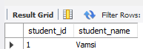
query:
output: | 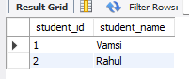

6.1.2:Insert the Values in the Table without column name :
query: | 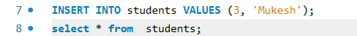
output: | 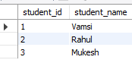
query:
output:

Observation:
- SQL Error code 1136 :when the number of values in INSERT does not match the table's column count.

6.2 : UPDATE
6.2 :Update the Values in the Table
query: | 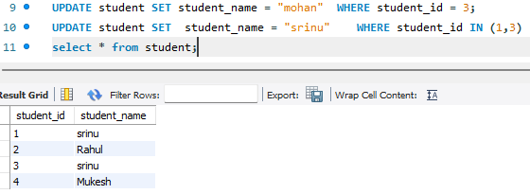
output:

Observation:
The UPDATE command was successfully executed to modify student names based on their student_id. The SELECT query verified the changes, displaying the updated values in the table

6.3 DELETE
6.3 : Delete the Values in the Table :
query: | 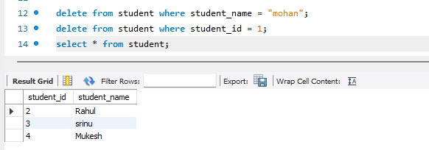
output:

Observation:
The DELETE command was executed to remove specific rows from the student table based on student_name and student_id conditions. The SELECT query confirmed the successful deletion of the specified records.

Week-07 | experiment-07 | Date: 25 jan 2024

Aim:
To perform various SQL queries using SELECT, WHERE, LIKE, BETWEEN, AND, OR, and wildcard operators to retrieve specific data from the Student table.

SELECT Statement
- Retrieve all columns from the Student table.
query:
output: | 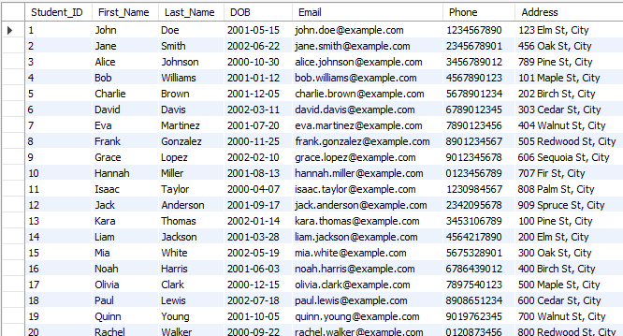

- Write a query to retrieve only the First_Name, Last_Name, and Email of all students from the Student table.
query:
output: | 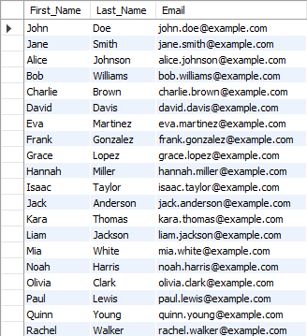

WHERE Clause
- Write a query to retrieve all students whose DOB is after January 1, 2001.
query:
output:

- Retrieve the details of students whose First_Name is "John".

query:
output:

LIKE Clause
- Write a query to retrieve all students whose Email contains the domain "example.com".

query:
output:

- Retrieve the First_Name and Last_Name of students whose Last_Name starts with "S".
query:
output:

BETWEEN Clause
- Write a query to find students whose Student_ID is between 10 and 20.

query:
output: | 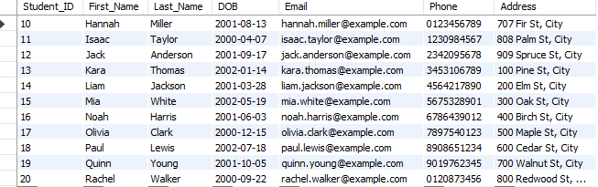

- Retrieve students whose DOB is between 2000-01-01 and 2001-12-31.

query:
output:

AND Clause
- Write a query to find students whose Department is "CSE" and whose DOB is before 2001-01-01.
query:
output: | 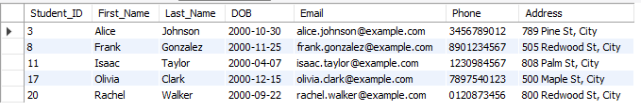

- Retrieve the students whose First_Name is "Alice" and Last_Name is "Johnson".
query:
output:

Combining WHERE, LIKE, AND
- Retrieve students whose First_Name starts with "A" and whose Email contains "edu".
query:
output:
- Write a query to find students who belong to the "CSE" department and whose Phone starts with "9" using the AND condition.
query:
output:

Using LIKE with Wildcards
- Write a query to find students whose Email ends with "gmail.com"
query:
output: | 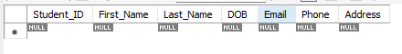

- Retrieve all students whose First_Name contains the letter "a"

query:
output: | 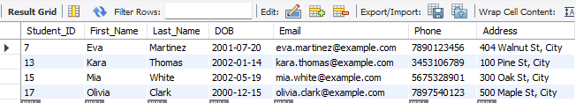

WHERE with Multiple Conditions (AND, OR)
- Retrieve students whose Department is either "CSE" or "IT", and who are born before 2001-01-01.

query:
output: | 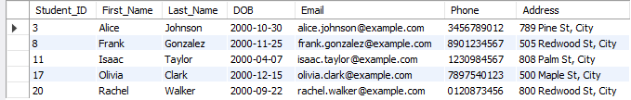

- Find students who are enrolled in either "Data Structures" or "Algorithms" courses and have marks greater than 80.
query:
output: | 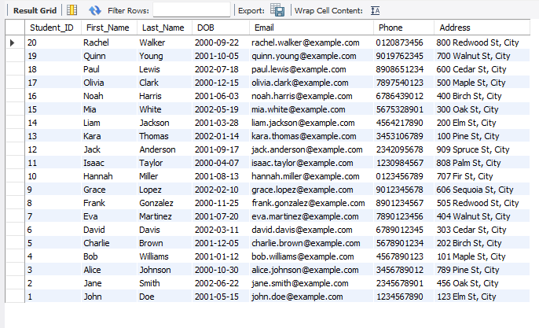

BETWEEN Combining Multiple Clauses￼
- Write a query to find all students whose DOB is between 2001-01-01 and 2002-12-31.
query:
output: | 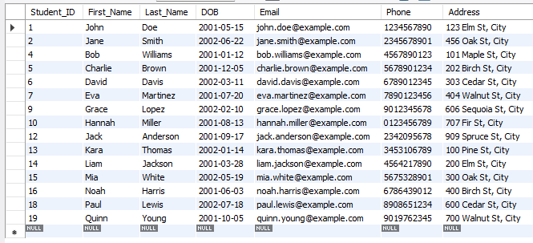

- Retrieve students who joined after 2002-06-01 and before 2003-01-01.
query:
output: | 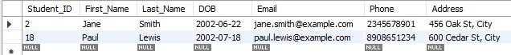

Combining Multiple Clauses
- Write a query to find students whose First_Name starts with "J", Last_Name starts with "D", and who are enrolled in a course with Course_ID between 1 and 5.

query: | 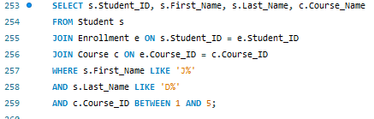
output: | 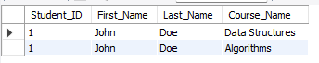

- Retrieve the First_Name, Last_Name, and Email of students whose DOB is between 2000-01-01 and 2001-12-31, and whose Phone starts with "9".
query:
output: | 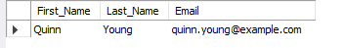

Observation:
By executing the SQL queries, we successfully retrieved and filtered data from the Student table based on different conditions. The use of SELECT, WHERE, LIKE, BETWEEN, AND, OR, and wildcard operators helped in fetching specific records efficiently.
These queries demonstrated:
- Basic retrieval of all student records.
- Conditional filtering using WHERE for attributes like DOB, First_Name, and Department.
- Pattern matching with LIKE to find specific email domains and name patterns.
- Range filtering using BETWEEN for Student_IDs and date ranges.
- Combining conditions using AND and OR for precise data extraction.

Week-08 | experiment-08 | Date: 15 feb 2025

Aim:
manipulate student and city names by converting them to uppercase, extracting portions, filtering based on characters, formatting for compatibility, and counting name lengths. Using string function

String Functions
- Retrieve all student names in uppercase.
query: | 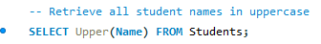
output: | 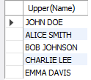

- Extract the first three characters of each city name.
query: | 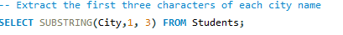
output: | 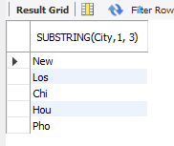
- Find students whose names contain the letter "a".
query:
output: | 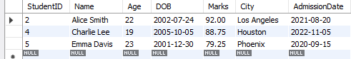

- Replace spaces in student names with underscores.
query:
output: | 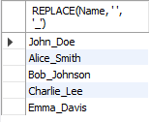

- Count the number of characters in each student's name.
query:
output: | 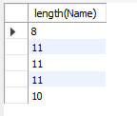

Observation:
- If a city name has fewer than three characters, attempting to extract three characters will result in just the available characters, which might not be as expected..
- If any name is not a string (e.g., a number or null value), applying this function could result in a type error or unexpected behavior.
- If the column containing student names includes non-string data types (such as integers or NULL values), trying to use the REPLACE() function will result in an error.

Aim:

to apply various number functions to student marks, including rounding to the nearest integer, finding the highest and lowest marks, calculating the absolute difference from 100, determining the average marks, and generating random numbers to simulate data.

Number Functions
- Round off student marks to the nearest integer.
query: | 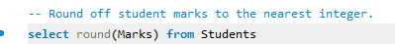
output: | 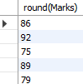
- Find the highest and lowest marks.
query:
output: | 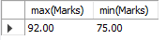

- Get the absolute difference between marks and 100.
query:
output: | 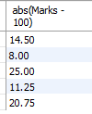

- Calculate the average marks of students.
query:
output: | 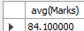

- Generate a random number between 1 and 100 for each student.
query:
output: | 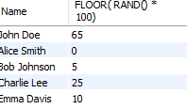

Observation:
Errors may arise due to non-numeric data, such as text or null values, when performing operations like rounding, finding the highest or lowest marks, and calculating differences. Issues like empty data sets or dividing by zero can occur when calculating averages or generating random numbers.

Aim:
to apply date functions to work with student-related dates, including retrieving the current date, calculating ages based on DOB, extracting the admission year, identifying students admitted before 2022, and calculating the number of days since admission.

Date Functions
- Retrieve the current date.
query:
output: | 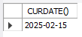
- Extract the year from the admission date.
query:
output: | 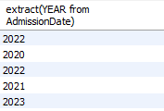
- Calculate the age of each student using their DOB.
query:
output: | 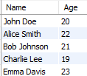

- Find students who were admitted before 2022.
query:
output: | 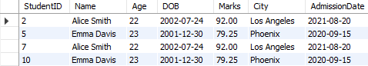
- Calculate the number of days since admission for each student.
query:
output: | 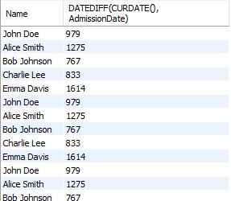

Observation:
date functions involve potential errors such as TypeError when the date is in an incorrect format or missing, and ValueError when the date format is invalid. Common error codes include TypeError: 'datetime' object is required and ValueError: invalid date. These errors arise when trying to manipulate non-date values or performing operations on improperly formatted dates. Ensuring correct date formats and handling exceptions can resolve these issues.

Week-09 | experiment-09 | Date: 21 feb 2024

Aim
- List the names and types of all boats that have a rental price greater than $200.
- Find the total revenue generated from boat rentals for each type of boat.
- Identify the boat with the highest capacity and find out how many reservations were made for it.
- List all boats that have never been reserved and their corresponding boat type.
- Calculate the total sales revenue generated from each service (e.g., boat tours, fishing, etc.) for the last quarter.

Independent Queries:
- List the names and types of all boats that have a rental price greater than $200.
query: | 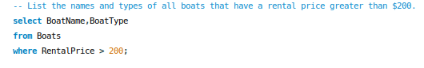
output: | 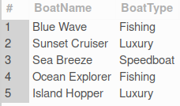

- Find the total revenue generated from boat rentals for each type of boat.
query: | 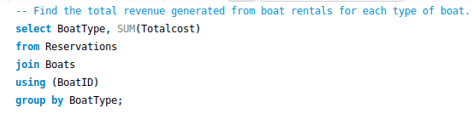
output: | 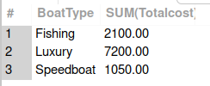
- Identify the boat with the highest capacity and find out how many reservations were made for it.
query: | 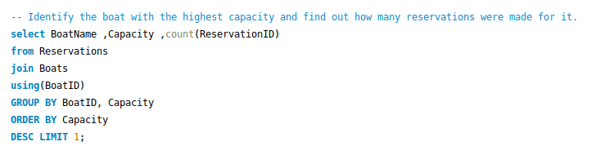
output: | 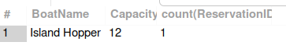

- List all boats that have never been reserved and their corresponding boat type.

query: | 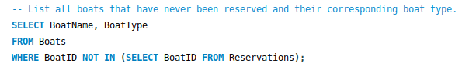
output: | 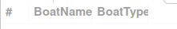

- Calculate the total sales revenue generated from each service (e.g., boat tours, fishing, etc.) for the last quarter.
query: | 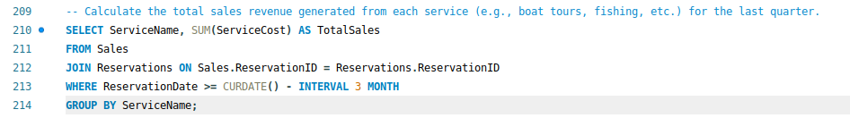
output: | 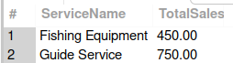

Observation:
- Proper Joins: They correctly link tables to completed the querys.
- Date Filtering: The last query smartly filters data for the last quarter to get recent sales revenue.
- Correct Data Filtering: Queries properly use conditions like > 200 and MAX(Capacity) to get specific results.
- Grouping for Summarization: The use of GROUP BY helps in summarizing total revenue by boat type and service.

Aim
- List all customers who have made more than 3 reservations and include their contact information.
- Find the total sales (boat rental + services) for each customer.
- Find the customers who have reserved boats for a total of more than 10 hours in the past month.
- Find the reservation details (Customer Name, Boat Name, Date) for the reservations that included fishing services.
- Identify the top 3 most popular boat types based on the number of reservations made, and display their rental price and capacity.

Correlated Queries :
- List all customers who have made more than 3 reservations and include their contact information.

query:
output: | 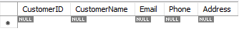

- Find the total sales (boat rental + services) for each customer.

query: | 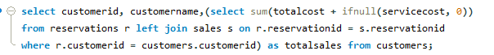
output: | 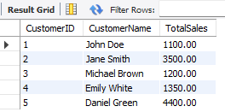
- Find the customers who have reserved boats for a total of more than 10 hours in the past month.

query: | 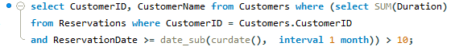
output: | 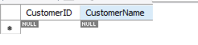

- Find the reservation details (Customer Name, Boat Name, Date) for the reservations that included fishing services.

query: | 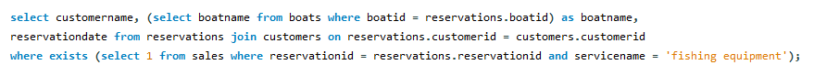
output: | 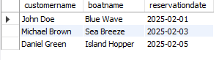

- Identify the top 3 most popular boat types based on the number of reservations made, and display their rental price and capacity.

query: | 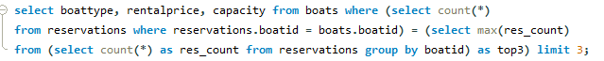
output: | 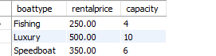

Observation:
- Correlated queries effectively track frequent customers and total sales but may impact performance.
- Identifying long-hour reservations and fishing service usage is simpler but less efficient.
- Using correlated queries for popular boat types works but is slower than JOIN methods; indexing can help.

Week-10 | experiment-10 | Date: 17 feb 2024

Aim
- To learn how to use SQL subqueries to retrieve and manage data effectively.

Sub Query : Using Select
- Retrieve all student records from the students table.
query: | 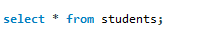
output: | 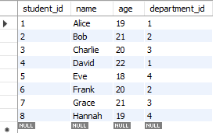

- Find the names of all students who are older than 20.
query:
output: | 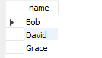

- List all courses offered by the IT department.
query:
output: | 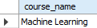

- Show all details of students who belong to the CSE department.
query:
output: | 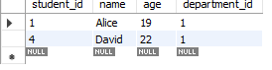

Sub Query : Using Joins
- Display students along with their department names.
query:
output: | 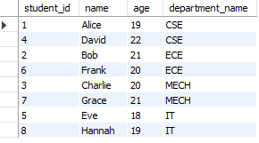

- List students and the courses they are enrolled in.

query: | 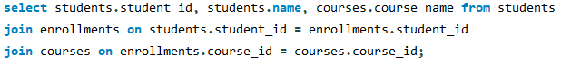
output: | 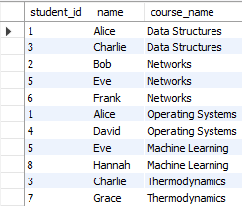

- Find students and their enrolled courses, including students who have not enrolled in any course.

query: | 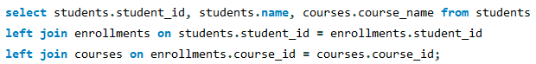
output: | 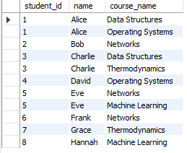

- Show department-wise student count.
query:
output: | 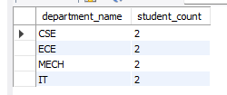

Sub Query : Using GROUP BY and HAVING
- Find the total number of students in each department
query: | 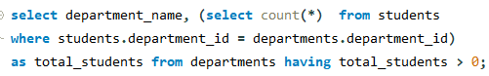
output: | 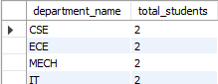

- Find departments that have more than equal 2 students enrolled.
query:
output: | 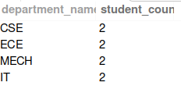

- Find the average marks in each course.
query: | 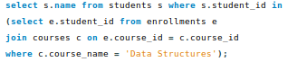
output: | 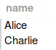

Sub Query : Using IN, EXISTS
- Find students who are enrolled in the "Data Structures" course.
query:
output: | 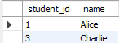

- List students who have enrolled in at least one course.
query:
output: | 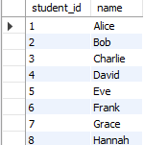

- Find students who are NOT enrolled in any course.

query:
output: | 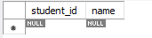

- Find students who scored above the average marks in "Data Structures".
query: | 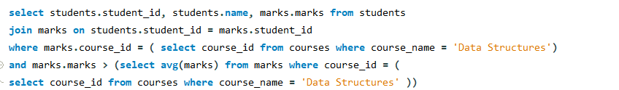
output: | 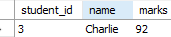

Sub Query : Using UPDATE and DELETE
- Increase the age of all students in the "CSE" department by 1 year.
query: | 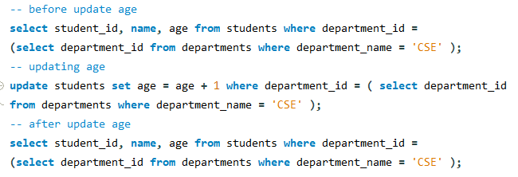
Before update output: | 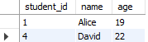
After update output: | 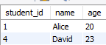

Observation:
- SQL Error code 1140 (Grouping Error) : This error occurs when you mix non - aggregated columns with aggregate functions without properly grouping them.
- SQL Error code1242(Subquery Error):This error occurs when a subquery returns multiple rows where only one value is expected (e.g., when using = instead of IN).

Week-11 | experiment-11 | Date: 17 feb 2024

Aim
- normalization is to organize data efficiently by eliminating redundancy and ensuring data integrity.

Unnormalized Form (UNF):
- Data is stored without any defined structure.
- Contains repeating groups and multi-valued attributes.
- Prone to data redundancy and inconsistency.
- Difficult to manage, update, and query efficiently.
- Used as a starting point before applying normalization rules
Example : student-hostel details

Student ID | Name | Room No | Block | Guardian Name | Guardian Contact | Services
1 | varma | A01 | A | Krishna | 9445566778 | Gym, Ground
2 | sriram | B01 | B | Mahesh | 9988776655 | Laundry, Ground
3 | rahul | C01 | C | Suresh | 8765432109 | Laundry, Gym
4 | mukesh | D01 | D | Ramesh | 9123456789 | Laundry, Gym, Ground

First Normal Form (1NF)
- 1NF Rule: Eliminate repeating groups by ensuring all columns contain atomic (indivisible) values.
1NF Conversion for the Unnormalized Form Table
Student ID | Name | Room No | Block | Guardian Name | Guardian Contact | Services
1 | varma | A01 | A | Krishna | 9445566778 | Gym
1 | varma | A01 | A | Krishna | 9445566778 | Ground
2 | sriram | B01 | B | Mahesh | 9988776655 | Laundry
2 | sriram | B01 | B | Mahesh | 9988776655 | Ground
3 | rahul | C01 | C | Suresh | 8765432109 | Laundry
3 | rahul | C01 | C | Suresh | 8765432109 | Gym
4 | mukesh | D01 | D | Ramesh | 9123456789 | Laundry
4 | mukesh | D01 | D | Ramesh | 9123456789 | Gym
4 | mukesh | D01 | D | Ramesh | 9123456789 | Ground

2NF Rules:

- Be in 1NF.
- Remove partial dependencies (i.e., a non-key attribute should depend on the whole primary key, not just a part of it).
2NF Conversion for the 1NF Table
Student Details Table
Student ID | Name | Room No | Block | Guardian Name | Guardian Contact
1 | varma | A01 | A | Krishna | 9445566778
2 | sriram | B01 | B | Mahesh | 9988776655
3 | rahul | C01 | C | Suresh | 8765432109
4 | mukesh | D01 | D | Ramesh | 9123456789
Student Services Table
Student ID | Services
1 | Gym
1 | Ground
2 | Laundry
2 | Ground
3 | Laundry
3 | Gym
4 | Laundry
4 | Gym
4 | Ground

3NF Rules:
- Be in 2NF.
- Remove transitive dependencies (i.e., non-key attributes must not depend on another non-key attribute).
3NF Conversion for the 2NF Tables
Student Table

Student ID | Name
1 | varma
2 | sriram
3 | rahul
4 | mukesh

Guardian Table

Student ID | Guardian Name | Guardian Contact
1 | Krishna | 9445566778
2 | Mahesh | 9988776655
3 | Suresh | 8765432109
4 | Ramesh | 9123456789

room Table

Student Id | Room No | Block
1 | A01 | A
2 | B01 | B
3 | C01 | C
4 | D01 | D

Student Services Table

Student ID | Services
1 | Gym
1 | Ground
2 | Laundry
2 | Ground
3 | Laundry
3 | Gym
4 | Laundry
4 | Gym
4 | Ground

SQL SCRIPT for creating tables and inserting data :
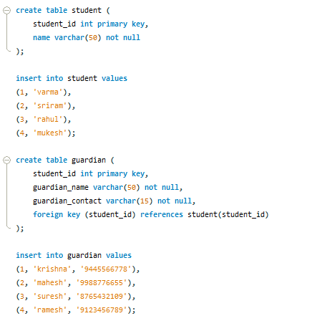
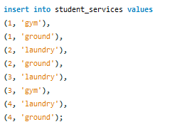
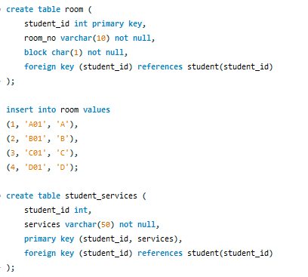

Tables:
query: | 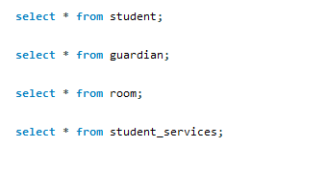
output: | 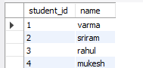
query:
output: | 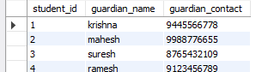
query:
output: | 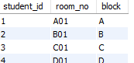
query:
output: | 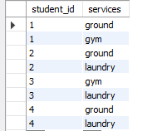

Observation:
- Normalization Achieved:The database follows 3NF, ensuring no transitive dependencies and improved data organization.
- Data Integrity:Separate tables for guardians, rooms, and services reduce redundancy and enhance consistency.
- Efficiency:The structure allows flexible updates, making it easy to add new data without modifying existing tables.
- Enhanced Design:The database satisfies BCNF and 4NF by ensuring every determinant is a candidate key and handling multi-valued dependencies efficiently.

Week-12 | experiment-12 | Date: 17 feb 2024

Aim
- normalization is to organize data efficiently by eliminating redundancy and ensuring data integrity.

Boyce-codd normal form(BCNF):
- It is already in 3NF.
- For every functional dependency (X → Y), X must be a superkey.

Student Details Table
Student ID | Name | Room No | Guardian Name
1 | varma | A01 | Krishna
2 | sriram | B01 | Mahesh
3 | rahul | C01 | Suresh
4 | mukesh | D01 | Ramesh

Guardian table:

Student ID | Guardian Name | Guardian Contact
1 | Krishna | 9445566778
2 | Mahesh | 9988776655
3 | Suresh | 8765432109
4 | Ramesh | 9123456789
Student Services Table
Student ID | Services
1 | Gym
1 | Ground
2 | Laundry
2 | Ground
3 | Laundry
3 | Gym
4 | Laundry
4 | Gym
4 | Ground

Fourth Normal Form (1NF)
- It is already in BCNF.
- It has no non-trivial multi-valued dependencies.
Student Details Table
Student ID | Name
1 | varma
2 | sriram
3 | rahul
4 | mukesh

Guardian Table

Student ID | Guardian Name | Guardian Contact
1 | Krishna | 944556677
2 | Mahesh | 9988776655
3 | Suresh | 8765432109
4 | Ramesh | 9123456789

Student Services Table

Student ID | Services
1 | Gym
1 | Ground
2 | Laundry
2 | Ground
3 | Laundry
3 | Gym
4 | Laundry
4 | Gym
4 | Ground

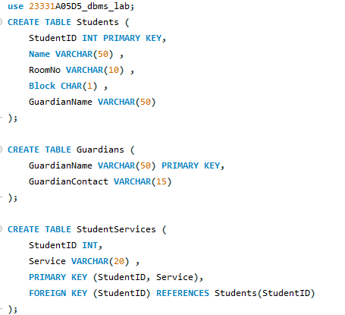
SQL SCRIPT for creating tables :

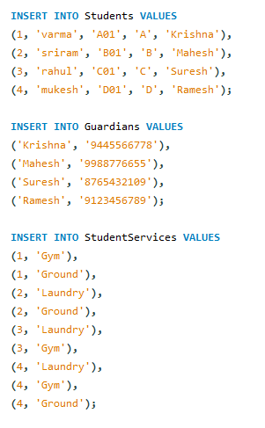
SQL SCRIPT for creating tables

Tables:
query:
output: | 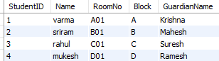
query:
output: | 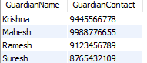
query:
output: | 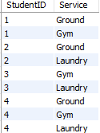

Observation:
- UNF: Data had repeating groups, causing redundancy and inconsistency.
- 1NF: Data was split into atomic values by separating multiple services into individual rows.
- 2NF: Services were moved to a separate table, reducing partial dependencies.
- 3NF: Guardian contact details were placed in a new table, eliminating transitive dependencies.

