**Botanical Garden in Ex-Situ Conservation**

Name – Pragyan Khati

Roll no-26(A)

Subject-Biology

**Background**

Botanical garden is often referred to as multitude of living plants, which is orientated precisely to demonstrate the interrelationship within different plant groups. [1] It may subdue specialized plant species like medicinal herbs, cacti, succulents etc. In modern times, botanical garden is more or less associated with group of ornamental plants. In the past times, they were often linked with physic or medicinal garden of single specimen of zoological peculiarity [2].

Conservation culminates protection, preservation, management of wild life and natural resources. Conservation of rare, endangered species is a global challenge. For the proper conservation of wildlife and to promote the concept of biodiversity, two types of conservation system were introduced:

* Ex-Situ Conservation
* In-Situ Conservation

In-situ conservation deals with conservation of genetic resource in its natural habitat whereas ex-situ conservation focuses on conservation of genetic resources outside of its natural habitat. Examples of ex-situ conservation include zoological park, seed banks, tissue culture banks and botanical gardens. [3]

Botanical gardens are either established by government or with the help of private administration. Key Royal Botanical Garden is the oldest and largest botanical garden which was established in 1840 AD [4]. There are many benefits of botanical garden. It acts as a center for conducting scientific research, especially for taxonomists. Plants habituated to different climates can co-exist. Moreover, it plays a significant role in displaying the diversity of plants; especially cultivated ones. Accordingly, we can administer the fact that botanical gardens play a major role in ex-situ conservation of plant biodiversity.

The cultivation of plants and garden has been present for thousands of years. The first example dated around 3000 years ago in Ancient Egypt and Mesopotamia. Later, the herbalists invigorated the concept of botanical garden. With the end of the 16th century, there were overall fiver gardens in Europe. Pisa (1543) and Padua (1545) were the first established gardens in Europe. In the beginning, botanical gardens were majorly associated with medical schools of universities. [5]

Nepal is no guest to the customs of botanical garden. One of the most recognized botanical garden in Nepal is ‘ National Botanical Garden ‘ which is located in Godawari, Lalitpur. Different wild tree species, herbs, shrubs, orchids, cacti, succulents and fern ornamentals are grown; also counting green house, herbarium and tissue culture laboratory. The garden’s original layout was planned by two British advisors. The main focus of the garden revolves around enriching the garden with indigenous plants to accumulate its collection for carrying out scientific researches, conservation of plants, demonstration of bio-diversity and for educational purposes as well. [6]

We can clearly evaluate its importance in the field of conservation of diversity. However, there are some drawbacks to the system of botanical garden. Number of species that can be conserved in a botanical garden will always be limited due to unavailability of space. Majority of the gardens are established near urban areas in temperate countries. Nonetheless, the majority of botanical and animal diversity is discovered on tropical climate, but since majority of the gardens are in temperate countries, the collection must be expanded which limits the availability of space. Very few individuals of each species can be held which severely restricts the range of genetic diversity found in protected wildlife. [7]In Nepal, the popularity of botanical gardens is a long way from reaching its peak as there is only one dominant botanical garden all over Nepal. Hence, government must put forward sincere efforts in introducing botanical gardens to our nation.

Botanical gardens play a significant role in ex-situ conservation of plant biodiversity. They hold the key to safeguard the threatened species. They are able to create awareness in public, so as to promote sustainable use of natural resources possible in all levels of society. However, there is still a lot to be done in the field of management of ex-situ conservation in botanical gardens, although efforts are being carried on. [8]

**Objective**

Plant diversity is currently being strayed at an unparalleled rate, resulting in associated fall of ecosystem services. About a third of the world’s vascular plant species face the threat of extinction due to climate change, exotic invasive species and many more. Therefore, we need to increase our efforts to develop accumulative conservation methods.

This project especially focuses on ex-situ conservation method; botanical garden is one of the few examples of this method. Botanical gardens contribute their resources to the study and conservation of plants, as well as awaking the globe about the richness of floral diversity.

Hence, the objective of this project writing revolves around conducting case studies of botanical gardens around the globe and its contribution to conservation of floral biodiversity.

**Methodology**

For case study of importance of botanical garden in ex-situ conservation of Plant biodiversity, I conducted studies in three countries namely: Nepal, China and The Netherlands along with distribution of botanical gardens throughout the globe.

I conducted my research and data collection with the aid of available papers as it was more reliable than haphazardly searching on the internet. In addition to that, available papers (which are mentioned in the ‘References’) are legal and trustworthy and since the papers have gone through the process of self-verification, it naturally becomes more admissible.

For Nepal

**National Botanical Garden** is located in the base of Mount Phulchoki (2751m.) at Godawari (1515m.) at the south east corner of Kathmandu valley. The temperature here ranges from 20 degree Celsius to 30 degree Celsius in summer and -5 degree Celsius to 20 degree in winter. The area of the garden is 82 hectares. The garden was inaugurated by Late Mahendra Bir Bikam Shah Dev on 20th of October, 1962. [9]

It is surrounded by evergreen natural forests. It is also a very famous tourist spot. Ever since its establishment, much of the activities have been prioritized around enriching the garden with indigenous plants. Ex-situ conservation program is existent.

Types of garden present in National Botanical Garden: [10]

* Lily Garden
* Terrace Garden
* Fern Garden
* Japanese Style Garden
* Conservation and Educational Garden
* Rose Garden

It’s set in natural landscape, surrounded by scattered evergreen and ornamental plants. It holds many species of indigenous medicinal plants. It is also a home to some endangered or rare species.

Data regarding floral diversity in the garden: [10]

|  |  |
| --- | --- |
| Flora | Quantity |
| Orchids | 115 |
| Cacti and succulents | 77 |
| Trees and shrubs | Approx. 200 |

Fig: National Botanical Garden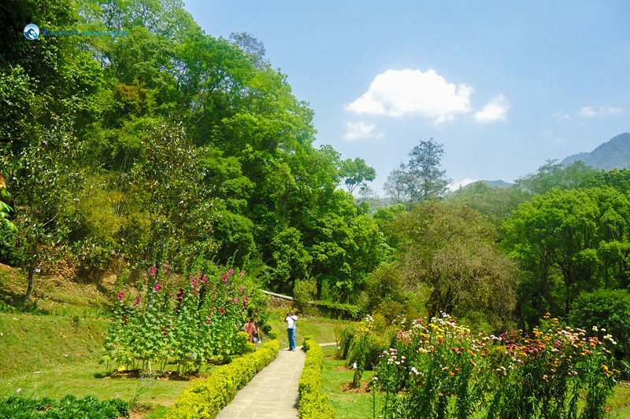

For China

**Kunming Botanical Garden (KBG)** was founded in 1938 and incorporated with the Kunming Institute of Botany, Chinese Academy of Services. It has an average annual rainfall of 1006.5 mm, an annual average temperature of about 14.7 degree Celsius with an annual relative humidity of 73%. KBG heavily focuses on ex-situ conservation. The garden aims to compose a suitable environment for conduction of scientific researches, species conservation and the development of sustainable application of plant resources.

Well-known gardens of KBG include Camellia Garden (633 species and varieties), the Rhododendron Garden (about 200 species), the Medicinal Plant Garden (more than 100 species), the Ornamental Fruit Plants (more than 400 species), the Magnolia Family Garden (11 genera and about 110 species), the Monocotyledon Garden (near 200 species), the Gymnosperm Garden (more than 200 species) and many more. [11]

Volunteers of KBG have investigated the diversity of ants which was found to be more than 42 species and birds (more than 107 species). KBG also holds re-introduction and restoration program as they are of equal importance for integrative conservation.



Fig: Kunming Botanical Garden

**Beijing Botanical Garden** was founded in 1956 with the goal of collecting, preserving and displaying researches on plant diversity. It holds a vast number of plant species. It holds about 10,000 taxa. Some of the genera are tabulated below: [12]

|  |  |
| --- | --- |
| S.N. | Genera |
| 1 | *Bashania* |
| 2 | *Berberis* |
| 3 | *Duchesnea* |
| 4 | *Forsythia* |
| 5 | *Hosta* |
| 6 | *Indocalamus* |
| 7 | *Lagerstroemia* |
| 8 | *Salix* |
| 9 | *Sasa* |

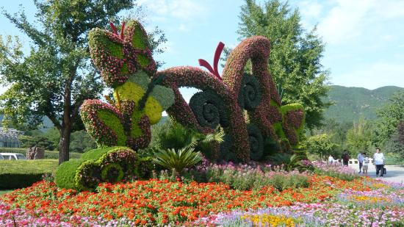 Fig: Beijing Botanical Garden

For The Netherlands

On 18th of February 1998, the Dutch Association of Botanic Gardens was created as a team of botanical engineers working to gather in a project regarding ex-situ conservation. As of now, the Dutch Botanic Garden Foundation which is in charge of only the management of National Plant Collection and the specimen impounded under the CITES Convention.

**Hortus Botanicus Amsterdam**

With about 334 years of prevalence, the botanical garden of Amsterdam is one of the oldest botanical gardens in the world. It is devoted to protect the local flora from over exploitation, illegal trade and extinction.

Despite having a surface area of 1.2 hectare only, and most of the researches concerning plant sciences no longer takes place in it, it is still considered one of the most salient source of knowledge. In its small space, it hosts about 4000 taxa which generally include genera such as *Agapanthus*, *Banksia, Callistemon, Caryota, Elaeis, Enchephalarotos, Haemanthus, Haworthia, Leucospermum, Macadamia, Macrozamia, Melaleuca, Phoenix and Protea* etc. [13]

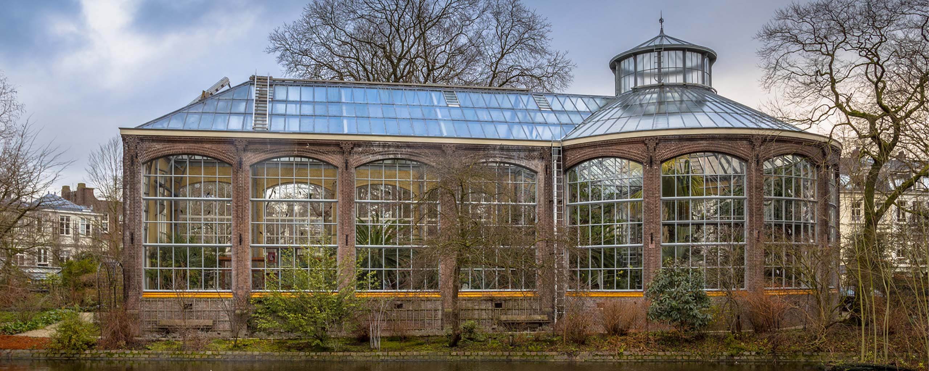

Fig: Hortus Botanicus Amsterdam

**Findings**

From the data gathered above, we can illustrate the role of botanical gardens.

In Nepal, National Botanical Garden helps in conservation of 550 species of plants and 66 different species of fern while also holding many species of indigenous medicinal plants. This illustrates how the garden has established conservation of different species; also there are different types which provide the factor of ease for growth of different varieties of plants establishing floral diversity. Conservation of endangered species is also prevalent.

From China, Kunming and Beijing Botanical Garden were taken as case studies. Programs such as ‘Re-introduction’ and ‘Restoration’ have been vitalized by Kunming Botanical Garden; they have over 700 plant species and cultivars. The garden also receives 800,000 visitors per year which signifies the importance of garden for educational and entertainment purposes. They have also used artificial techniques to conduct artificial pollination in unsubtle topographical or climatic conditions. They promote the idea of ex-situ conservation, endangered plant species are carefully looked into by the botanical gardens for proper conservation. Similarly, Beijing Botanical Garden has about 10,000 taxa and promotes conservation of endangered species. Netherland’s Hortus Botanicus Amsterdam has about 4000 taxa and they have popularized the concept of conservation.

All of the above observations compel us to put forward an opinion that botanical gardens have a positive role in ex-situ conservation of floral biodiversity.

Fig: Botanical Garden Distribution around the globe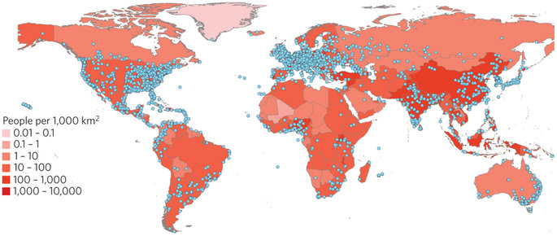

**Conclusion**

I have applied different methods of data observation and extraction, while taking references from various pages for proper construction of role of botanical gardens in ex-situ conservation. Furthermore, the aspects of the data collected were explained so as to grasp the concept of reasons behind its importance.

Ex-situ conservation plays a key role for conservation of floral species. Botanical gardens help in fulfilling the role of ex-situ conservation by conserving different endangered species, encouraging the concept of diversity. Hence it is of a huge importance that botanical gardens start becoming more prioritized. To strengthen conservation of floral diversity, specialized gardens should be established and research programmes should be conducted, by improvising and developing facilities for research that relies on accustoming variety of plants in a particular area. Awareness regarding the importance of botanical gardens should be spread.

**REFERENCES**

1)

https://www.britannica.com/science/botanical-garden-study-and-exhibition-garden

2)

Sodestrom M. "Botanical Gardens", 2010, 1-2

3)

Shakya S.R., Aryal M.R., Chitrakar P., Adhikari D.C., Manandhar I.M., "Secondary Level (+2) BIOLOGY" 2077, 5,322-323

4)

"Royal Botanic Gardens, Kew". World Heritage, UNESCO, 2009

5)

https://www.bgci.org/about/about-botanic-garden/

6)

Milligan K. “Nepal’s National Botanical Gardens" 2019

7)

Maxted N. "In Situ, Ex Situ Conservation" Encyclopedia of Biodiversity (Second Edition), 2013, 313-323

8)

Palomares H.R.P., Ocharan C.E.S., "The role of botanical gardens in conservation: three examples around the World" 2016

9)

https://tools.bgci.org/garden.php?id=534?id=534

10)

https://nepalindata.com/insight/national-botanical-garden-godawari/

11)

Chen G. and Sun W. "The role of botanical gardens in scientific research, conservation, and citizen science", 2018, 40, 184-185

12)

Palomares H.R.P., Ocharan C.E.S., "The role of botanical gardens in conservation: three examples around the World" 2016, 3-4

13)

Palomares H.R.P., Ocharan C.E.S., "The role of botanical gardens in conservation: three examples around the World" 2016, 5-6

14)

Chen G. and Sun W. "The role of botanical gardens in scientific research, conservation, and citizen science", 2018, 40, 187-188

**~THE END ~**