**Energy Consumption Pattern In Nepal**

Name – Pragyan Khati

Roll no – 26

Subject – Physics

**Background**

Energy is a prime requirement for the economic prosperity of a nation; it also holds a significant role in upgrading quality of life and boosts the human development in a nation. Energy resources play a very important role in facilitating energy. Consumption pattern of energy is closely linked with rural and household areas. Resources like oil, gas, electricity etc are quintessential in determining the quality life of households. The composition of energy use in rural and urban areas has an enormous impact on the household income and the welfare of the people living there. [1]

There are lots of factors that affect energy consumption in general. The traits of the households such as family size, educational level, their lifestyle in general affect energy consumption. Also, the price and availability of energy resources are important in identification of affordability factor of a particular household. [2] Electricity is used quantitatively more in urban areas as compared to rural due to which rural areas thrive on biomass, fuel wood, charcoal, kerosene. Hence, topographical variations are important in identifying consumption pattern in different places. To elaborate the imbalance between use of energy resources, around the globe; 1.06 people don’t have access to electricity and more than 3 billion people are accustomed with resources like wood, charcoal and dung for cooking and heating. [3] However, developing countries are prioritizing the use of modern fossil fuels and electricity over biomass-based fuel energy. [4]

Nepal is one of the least developed nations with 81% of its household in rural areas. Facilitation of clean energy in rural areas seems to be nothing but a myth despite its genuine accessibility in urban areas. It may come off as a surprise but households in Nepal constitute nearly 87% of the total energy in Nepal. [5] In spite of the convenience of Hydro power in Nepal, biomass still remains to be the most important primary source of energy. Nepal does have high potential in terms of Hydro power due to glaciers in The Himalayas, regular monsoon rain and the general local topography. So, it becomes a big question as to why we aren’t able to surplus from hydropower. One of the prime reasons is that Himalayan Rivers consist of large quantity of sediment with hard particles, which is a hurdle for the economic exploitation of hydropower resource [6].

Nepal is poor in terms of resources such as oil, gas or coal reserves and the positioning of Himalayas makes it difficult to approach remote and extremely remote communities inflicting unavailability of energy there. On account of resources, Nepalese have historically attended their needs with the help of resources like: biomass, imported kerosene, traditional water-powered vertical axis mills. This situation has led to experts labeling the country’s energy consumption ‘Medieval’ and if this wasn’t enough; load shedding that occurs throughout Kathmandu has given rise to more problems for the nation to overcome. The electricity crisis started way back in 2006. Back then, the NEA (Nepal Electricity Authority) settled down the situation with excuse of “No water in rivers”. However, the crisis took a huge turn in 2011 where it gained a skeptical popularity among consumers. This led to people turning their heads to kerosene, charcoal and fuel wood etc. Despite of our nation’s overwhelming availability in hydro power, our government’s defective vision and improper initiation has led to corrosion of energy availability throughout the nation. [7]

For a developing country like Nepal, the demand for energy increases day by day due to the rapid growth in urbanizing rate. The electricity use and the number of consumers increase at a rate of approx. 9% each year. [8] If our government officials continue disregarding the vastness of our resources, it’ll inflict severe damages upon the nation’s energy consumption pattern and heavily affect the socio-economic growth of the nation. Hence, proper awareness regarding the utilization of resources should be spread. Government must initiate accomplished workers, engineers to tackle the hurdles arising throughout the process of energy extraction from available resources. Households should be conspicuous about the employment of energy. Sincere initiation of such ideas can replenish energy and boost consumption pattern all over the nation.

**Objective**

Understanding about energy consumption pattern is a major key to unraveling numerous sorts of relations. It helps to strengthen the knowledge of the use of natural resources. It is also significant in conservation of energy resources as it reveals how energy in some places is being deteriorated. The data gives significant update upon which government officials can look into, and provide results with respective solutions.

Nepal faces lots of problem with respect to management of energy resources. Not being able to figure out where the required energy should output is an issue. Additionally, if a nation can’t balance its energy resources as per the demanded energy, extinction of resources is inevitable which is a big blow to the nation. Hence, scrutinizing the energy consumption pattern is a serious issue to straighten out the priorities of the transformation process, which helps to lead into a sustainable consumption of energy. On that account, the main objective of this project is to compare the pattern of energy consumption and energy efficiency in Nepal between 2010 and 2018.

**Methodology**

For comparative study of energy consumption pattern, study was divided into two separate years: 2010 and 2018.

I conducted my research and data collection with the help of available papers as it was more reliable than randomly searching on the internet. In addition to that, available papers (which are mentioned in the ‘References’) are legal and verified by the government of Nepal and since papers have gone through the process of self-verification, it becomes more trustworthy and admissible.

For the year, 2010

In 2010, Nepal’s total energy consumption rounded about 428 PJ (1e+12 Joules). Renewable energy sources (excluding large hydro power) like biogas, micro-hydro and solar energy constituted about 0.7 % of the national balance altogether. It increased by 40% since 2005.

Energy consumption in economic sectors:

|  |  |
| --- | --- |
| Residential | 87% |
| Transport | 6% |
| Industry | 5% |
| Commercial (services) | 1% |
| Agriculture | 1% |

Primary energy sources: [9]

|  |  |
| --- | --- |
| Biomass | 85% |
| Petroleum Products | 9% |
| Coal | 3% |
| Hydro Electricity | 2% |
| Renewable | 1% |

Energy Consumption on Household Level:

In rural areas, 3.9% of the population used, 2.4% used biogas, 1% used kerosene, 0.1% used charcoal, 81.4% used wood, 9.1% used dung and 1.8% used crop waste.

In urban areas however, only 33% of the population used solid fuels (charcoal, coal, crop waste, dung and wood) whereas rest of them prefer kerosene, biogas, natural gas, LPG etc. [10]

Electricity:

NEA (Nepal Electricity Authority) is responsible for electricity supply through the nation. Electricity supply was limited to 43.6% of the population [11] which mainly included only urban areas. Only 8% in rural area had access to electricity.

Solar:

943 medium-sized solar PV (Photovoltaic) units provided 1.2 MWp of electricity for the communication field. 225,000 of solar home systems are used throughout the nation across 2600 villages. [12]

Hydro:

List of installed and planned hydro powers:

|  |  |
| --- | --- |
| Total Major Hydro Grid Connected | 472,994 kW |
| Total Small Hydro Isolated(NEA) | 4,536 kW |
| Total hydro IPP | 158,315 kW |
| Total Hydro-Nepal | 635,845 kW |

For the year 2018:

Electricity:

Nepal’s average annual per capita electricity consumption was about 161 kWh, which was one of the lowest consumption all over South Africa.

The sources of electricity are tabulated below [13]

|  |  |
| --- | --- |
| Hydro | 43% |
| Diesel thermal | 23% |
| Imports | 34% |

Use of electricity in different areas is graphed [14] 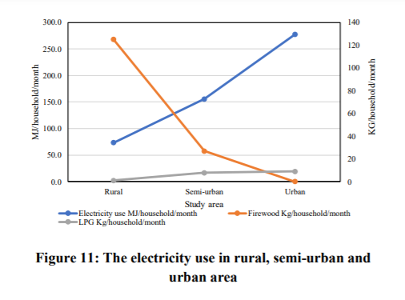

Hydro Power Plants:

Distribution of hydropower is tabulated below:

|  |  |  |
| --- | --- | --- |
| Stage | Category | Installed Capacity(MW) |
| Completed | Hydropower Plants | 489 |
| Under construction | Hydropower Plants | 1,017 |
| Planned | Hydropower Plants | 2,920 |
| Ongoing | Micro Hydropower Plants | 14 |
| Isolated | Micro Hydropower Plants | 5 |

Energy Consumption on Household Level: 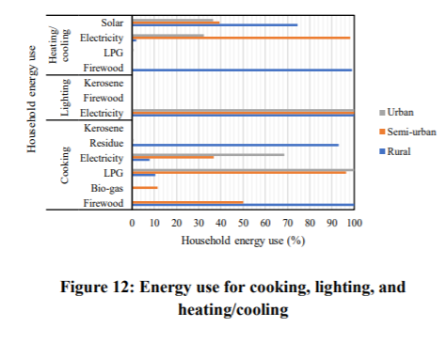

**Findings**

For the year 2010

In the field of economic sectors, residential sector dominated the consumption with 87% whereas agriculture and commercials were areas with least energy consumption each comprising 1% each.

The primary source of energy being biomass whereas hydro electricity and renewable contributed less. Hydro electricity back then wasn’t at its prime due to which electricity in overall got flat as Nepal depended on its water sources for electricity

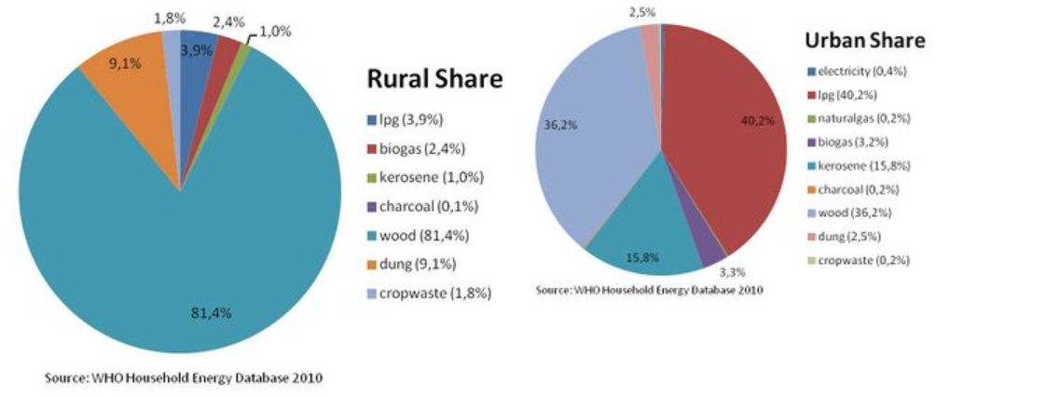

From the above pie chart, we can see the barrier between rural and urban areas. Urban areas are less dependent on solid fuels whereas rural areas are highly dependent on them (till 90%) and the above graph demonstrates how only rural areas had accessibility to electricity. However, all over Nepal only 43.6% of the population was facilitated with electricity. One of the major reasons of unavailability of electricity back then was due to load shedding. Hydrology of the country was one of the reasons that the country couldn’t thoroughly harness its hydro electric potential. The mismatch between when water was available and when it was needed year-round to generate hydroelectricity fabricated a complicated challenge for the engineers, leading to severe load shedding especially in winter (for almost 18 hours). From all of this, we can conclude how electricity was almost hypothetical back in 2010.

For the year 2018

In the field of economic sectors, unlike 2010; industrial section dominated the scene of energy consumption.

From 2010 to 2018, a drastic variation in availability of electricity can be seen.

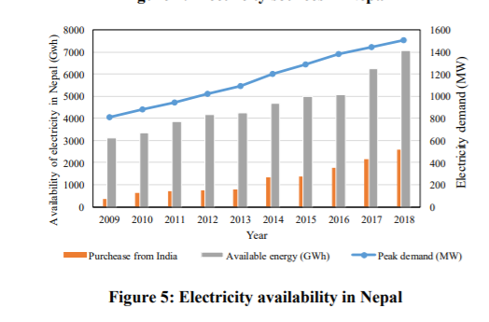

From the above graph, we can see how available electrical energy has kept on increasing with a commendable growth from 2017 to 2018. While we can cherish the fact that our country is inclining towards electrical energy, one cannot deny the fact that import of electrical energy from other country has also increased which is not good news. Having said that, we can be proud about the fact that our country has been more effective regarding utilization of hydro sources as 43% of hydro power contributed to electrical energy.



Electricity use is still superior in urban areas but throughout the years, it is gradually increasing in rural areas which is a healthy sign for the nation.



The above graph represents the use of resources for general household chores in different states of urbanization. There’s a significant amount of difference in use of resources between rural and urban areas. It can be seen that firewood is the major source of tackling household chores whereas electricity is the messiah in urban areas.

**Conclusion**

I have applied different methods of data observation and calculation, while taking references from various pages for proper construction of consumption pattern throughout the years. These calculations were further elaborated so as to grasp the proper concept of how the scene of energy consumption has immensely changed from 2010 to 2018.

A developing country like ours needs to choose the right path in terms of energy consumption. Only when we understand how our energy sources are being handled, are providing the output will we know how to put it into proper use. The concept of conservation of energy resources is given by the data provided by conducting such surveys.

Hence, it is of great importance that we conduct more surveys with regard to consumption of energy resources for flourishing the socio-economic aspect of our nation.

**References**

1.

R. Wang and Z. Jiang, “Energy consumption in China’s rural areas a study based on village energy survey”, Journal of Cleaner Production, 2017, 143, 452-461

2.

R. Heltberg, “Factors determining household fuel choice in Guatemala”, Environment and Development Economics, 2005, 10, 337-361

3.

World Bank, “Understanding poverty”, 2013.

4. L. Chen, N. Heerink and M. Berg, “Energy consumption in rural china: A household model for three village in Jiangxi province”, Ecological Economics, 2006, 58, 407-420

5.

WECS, Nepal, “Energy consumption situation in Nepal year 2011/2012”, 2014

6.

Thapa B., "Problems of Nepalese hydropower projects due to suspended sediments" Research Gate, 2005, 8(3),1-2

7.

Shrestha R. "Electricity Crisis (Load Shedding) in Nepal, Its Manifestations and Ramifications" Research Gate, 2011, 6, 1-2

8.

NEA, "A Year in Review", 2017/2018

9.

Renewable Energy and Energy Efficiency Partnership (REEEP) Clean Energy Information Portal, Energy Profile Nepal (Vienna: REEEP Secretariat, 2012)

10.

” WHO Household Energy Database” , (2010)

11/12.

https://energypedia.info/wiki/Nepal_Energy_Situation#cite_note-UNDP_Asia_Pacific-2

13.

Shahi D. "Study on Household Energy Usage Patterns in Urban and Rural Areas of Nepal" 2019, 15(3), 4-5

14.

Shahi D. "Study on Household Energy Usage Patterns in Urban and Rural Areas of Nepal" 2019, 15(3), 7-8

**~THE END~**