**What This Project Does –**

**It’s a Role Base Web App**

1. First user have to login , If user is not register can register by navigating register page . Need to Select Role [Admin/User]
2. After succesfull Regster user can login from Login window
3. If User Successful Login a Access Token will be generated from backend which will be valid for 3 minutes as time defined in Backend

Token will be save In the localstorage

1. Anduser will be redirected to the dashboard and if the role is user then only he get option to upload a file . The file be saved in Cloudinary cloud platfrom and we store the details in backend including the role ,user id , file url , Record created time .

**Project Structure –**

**It has 3 Components**

* Login Component
* Register User Component
* Dashboard Component

**Url - Al the URLs registered in app routing module.ts file**

**Service – LoginService** Used in the Project for the code reusability in the components all the api are registered in the Service file in order to follow Code Reusability .

**Interceptor – Auth Interceptor** is used to add authorization token in Request Header

**Auth Guard** is used to protect the urls , if the urls are hitting from browser without login then auth guard wont enter the url page

**Features –**

* + **Login Logout Functionality**
  + **Role base Access Control**
  + **Token based Authorization**
  + **Document Upload Utility**

**Version of Angular Project –**

**Angular CLI 14**

**Commands to Configure and run project –**

**Dependency - Node Version - v16.17.0**

**Angular CLI –**

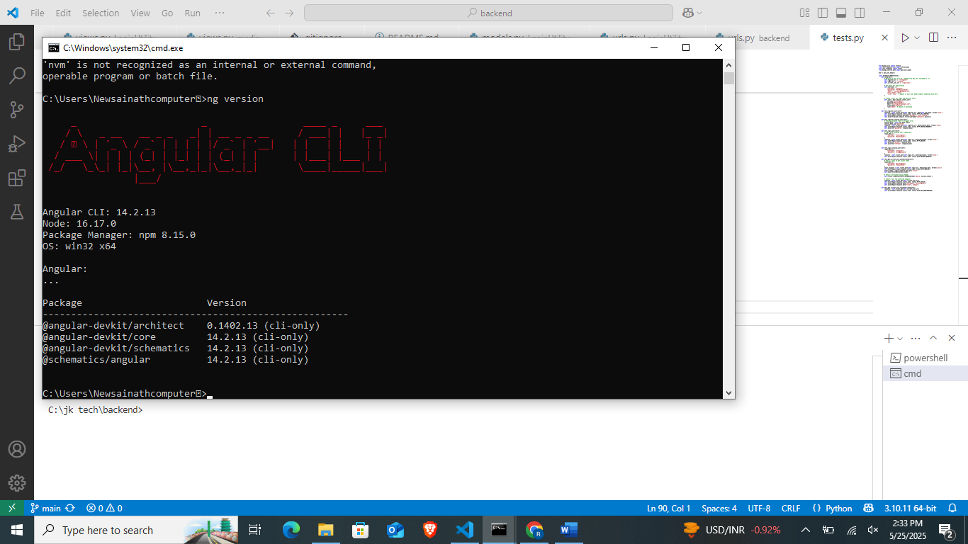

**Install node v16.17.0**

**Install angular cli - npm install -g @angular/cli@14.2.13**

**Package installing – npm install**

**To Run Project – ng serve**