Simple SEO Analyser

**Pre-Requisite**:

Visual Studio 2013

NuGET – HtmlAgilityPack

NuGET - System.Linq.Dynamic

The above two NuGET can be installed in Package Manager (Tools > NuGet Package Manager > Package Manager Console).

PM> Install-Package HtmlAgilityPack -Version 1.8.10

PM> Install-Package System.Linq.Dynamic -Version 1.0.7

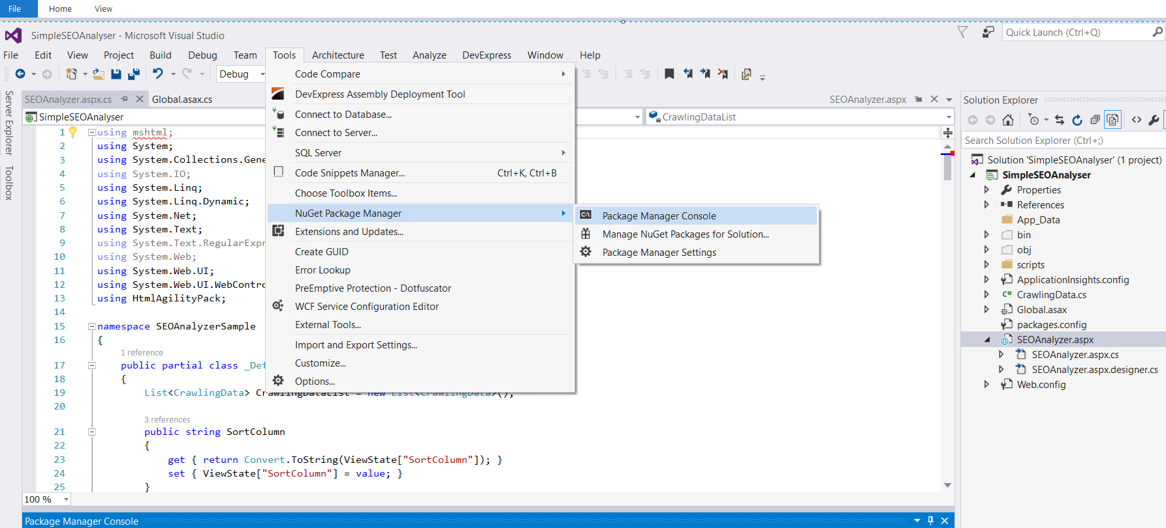

**Installation**.

Download from GitHub

Open the Source SimpleSEOAnalyzer in VS2013

Right click SEOAnalyzer.aspx and set as start page.

Press Ctrl+F5 or click on the menu as shown in the Image below,

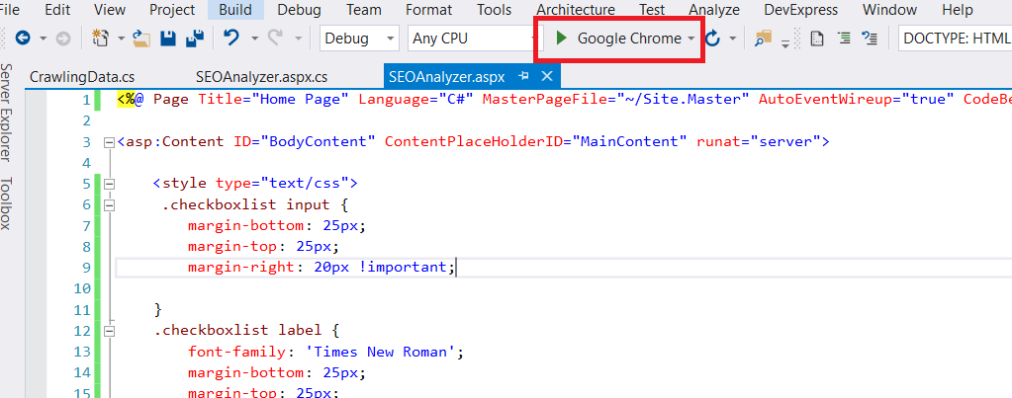

**User Manual**

When the application successfully executes, it will open the page in the default browser set and I have used Chrome.

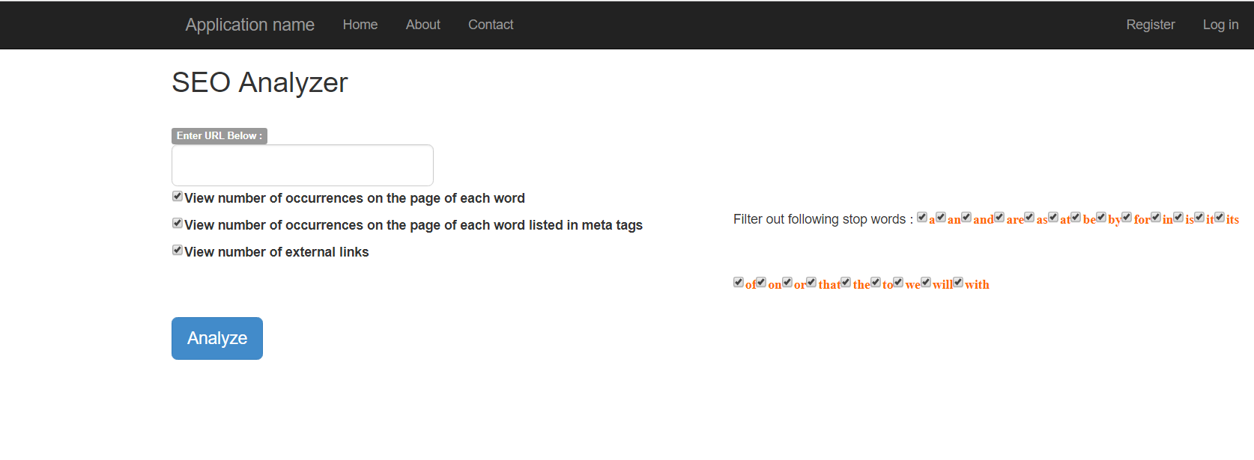

**Analysis Options** - The analyzing options are provided in check box, and by default all the options were ticked.

On the left, Option to View the word & its number of occurrences of word in page, in meta tags and view the external links in the url.

On the right, is the filter out options provided. More options can be added by giving additional ListItem for the Checkbox list **StopWordCheckBoxList** inSEOAnalyzer.aspx

Once desired options are set, click on Analyze button, to view the results.

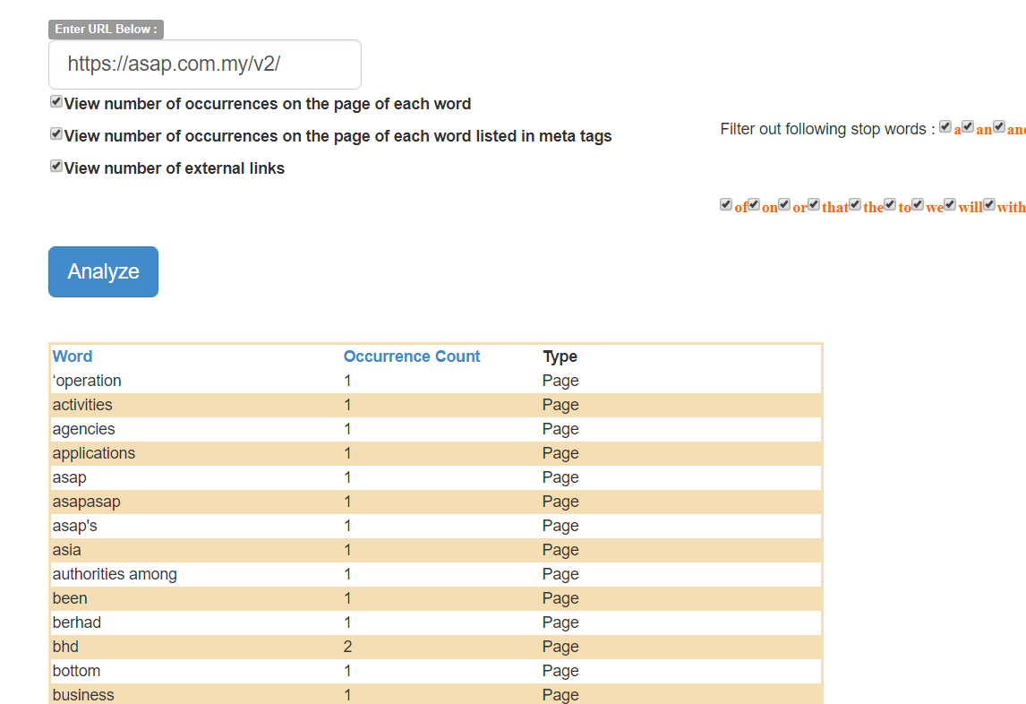

Columns Word & Count can be sortable. word – Displays the Word; with Occurrence count of the word in the Page. Type can be either Page or Meta tags.

When we scroll below, we can see External links count and list of links.

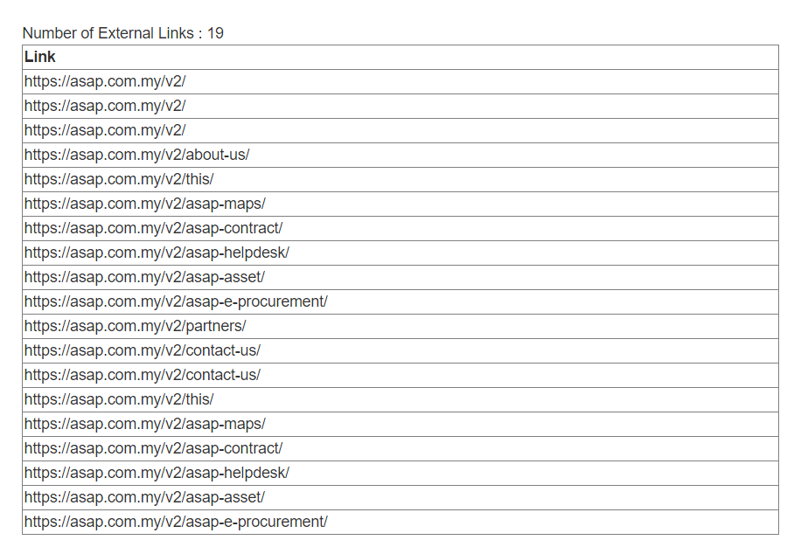

On giving wrong url, page displays simple message at the top left corner as shown below.

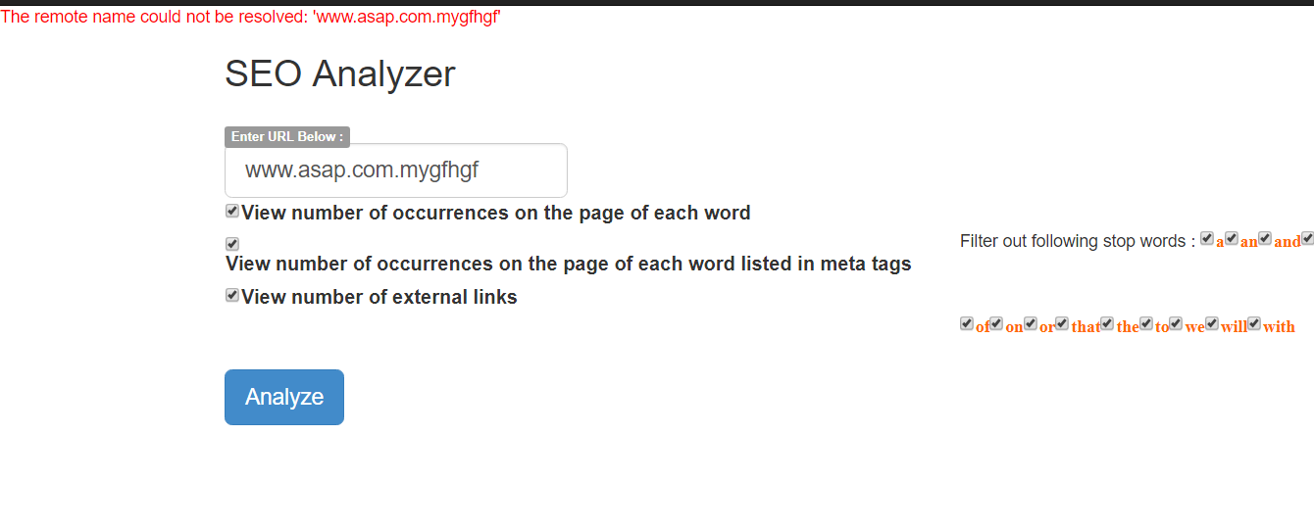

**Assumptions**:

1. The input expected is English text or URL, but since the rest of the functionality is based on url, I have implemented for URL. If for English text, word count functionality can be reused.
2. I have not used Dictionary, which offers better performance as I was using List to show another column in the grid / table.
3. Input validation is not done.

**Logic / Algorithm**:

1. Read the URL
2. Check URL status, if not valid show message
3. If Valid, Read the content of the url based on the analysis option provided in checkbox.
4. Read h1-h6, <p> tags for page content, Calculate word count & store in list
5. Read meta tag content, if option is ticked. Calculate word count & store in list.
6. Read the external links, store in list.
7. Bind the list to gridview for display.