How to Build Up a Local WordPress Site?

A local site can be created in your personal computer using WordPress which can then be published online. Please find below the step-by-step guide to practice creating a local WordPress site.

# The Installation and the Set-up Process

1. Go to [www.localwp.com](http://www.localwp.com) and click the Download button.
2. Download and install the Local WordPress software.
3. In the home page of the Local site dialog box, click the Create a new site button.
4. In the Create a site page, select Create a new site pane, and then click Continue.
5. Fill the site name of your choice in the What’s your site’s name page.
6. Select Preferred under Choose your environment and then click Continue.
7. In the Set Up WordPress page, enter the WordPress username, password, and e-mail.

A dashboard in the name of the username opens.

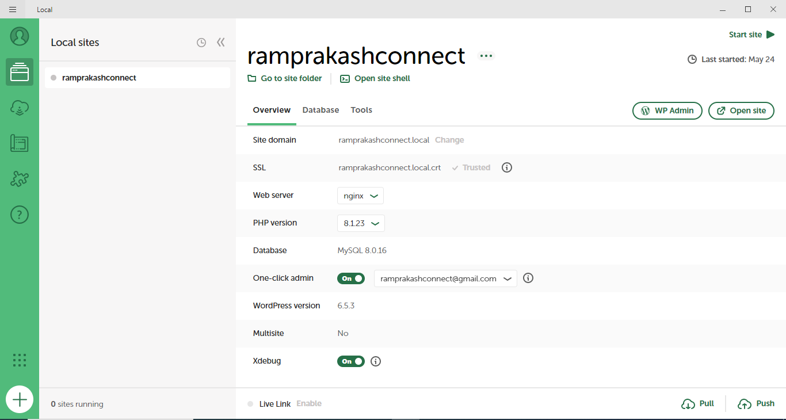

# Setting Up the Dashboard

1. Click on the Open Site button.
2. Address will be .local in the new browser.

***Note***: In case if the page does not open in the browser, turn off your antivirus to allow the page to open in the browser.

1. Click WP Admin button near the Open Site button.

WordPress backend dashboard opens.

Five tabs, i.e., Post, Pages, Appearance, Plugins, and Settings are listed on the left pane with various other tabs.

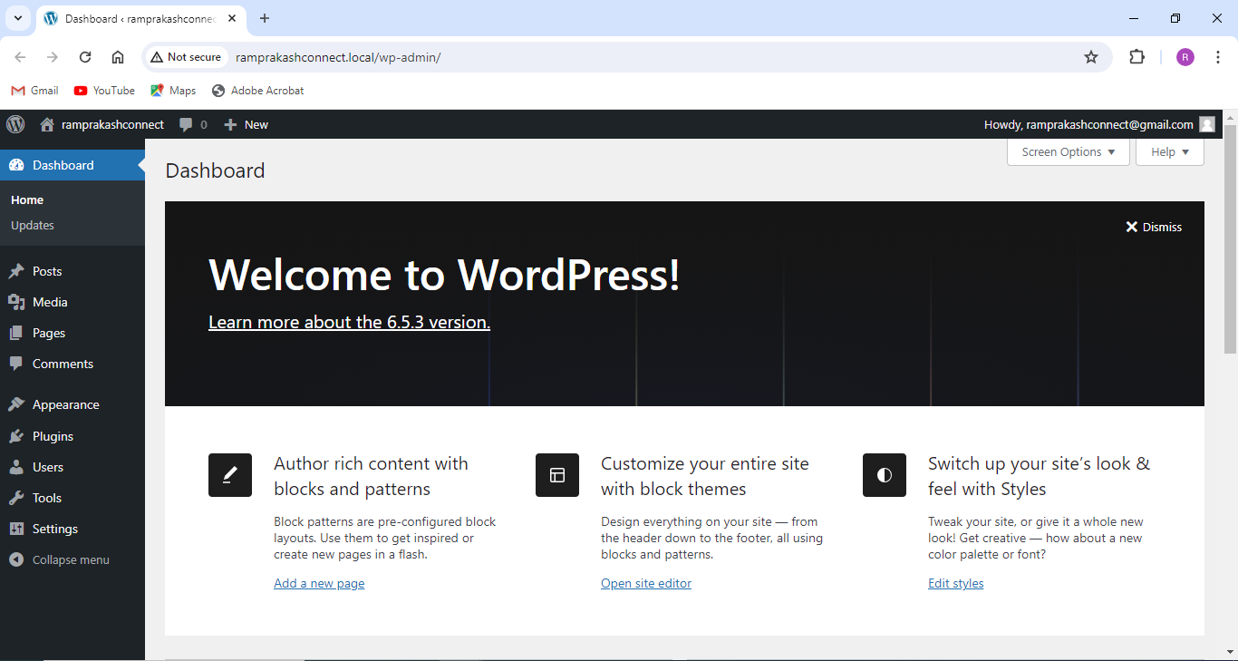

# Settings Tab

1. Select Settings > General.
2. Make changes in the Site Title, Tagline, WordPress Address, Site Address, and Administration Email Address textboxes as required.
3. Uncheck “Anyone can register” against Membership.
4. Set Site Language as English (United States).
5. Set Timezone, Date Format, Time Format, and Week Starts On options as desired.
6. Click Save Changes button.
7. Let the default settings remain the same in the Writing, Reading, Discussion, Media, Permalinks, and Privacy options.

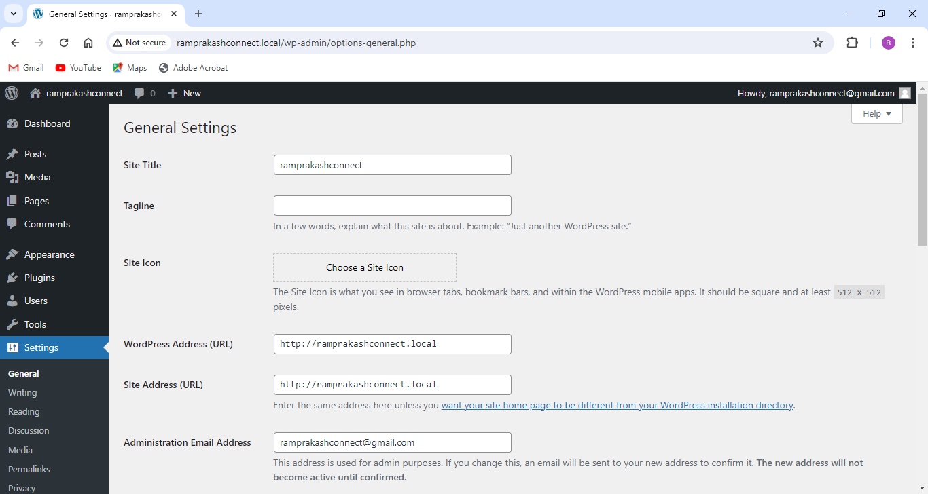

# Plugins Tab

Plugins are extended apps to enhance the site functionality of WordPress.

1. Click Installed Plugins to view all the plugins installed.
2. Click Add New Plugin to view all available plugins to install.
3. Browse various other plugins using the popular tags listed at the bottom.
4. Install required plugins using the Install Now button against each of the widgets.

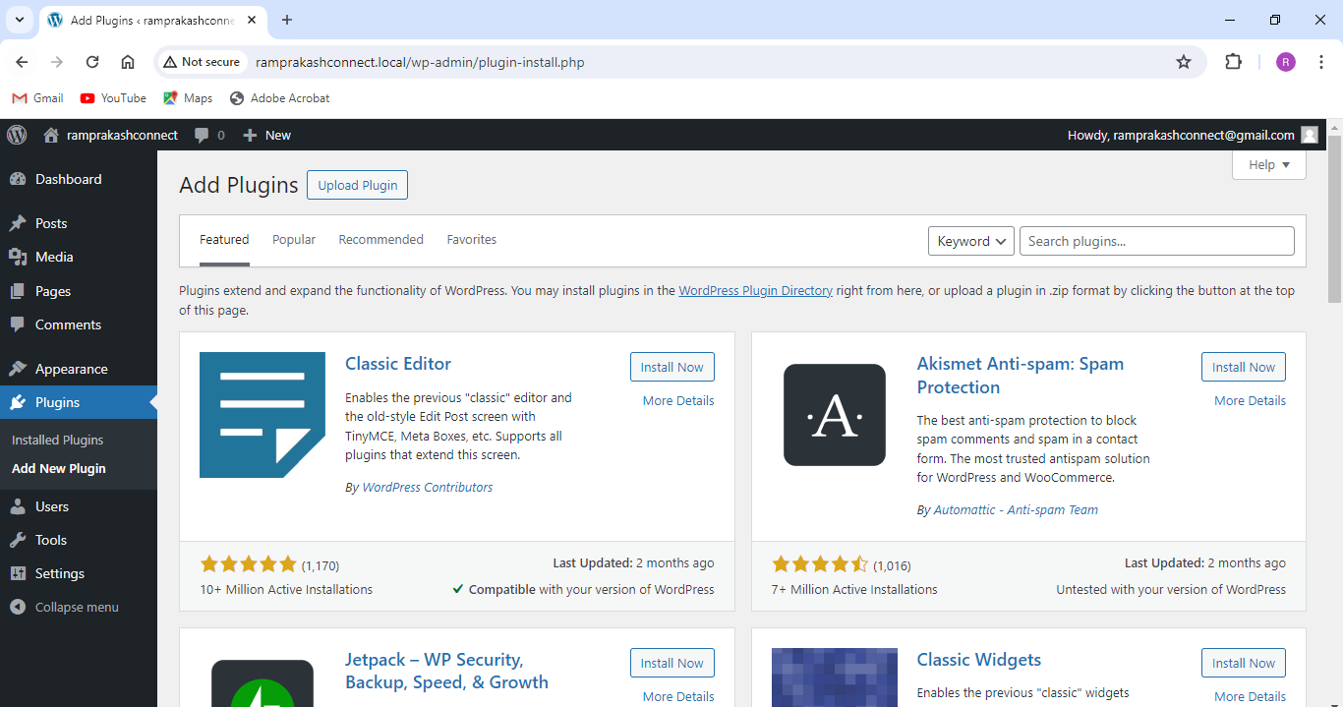

# Posts Tab

1. Select Add New Post in the Posts tab.
2. Add a new title and insert the content below the title.
3. Fill the category name in the Add New Category textbox placed in the Categories dropdown on the right.
4. Click the Publish button.
5. The title and the content are displayed on the site page.
6. Edit the content again and then click the Update button.

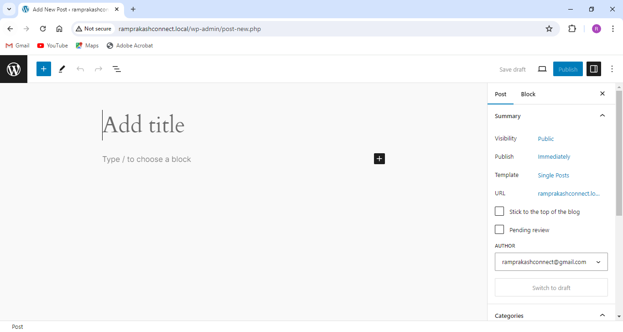

# Pages Tab

1. Select All Pages under Pages in the left pane.
2. Select and delete the default pages that are not required.
3. Click the Add New Page button.
4. Give a title to the new page and add content below the title.
5. Click the Publish button on the top right.
6. Add any number of pages as required using the Add New Page button.
7. Give title and content for each of the pages created and publish them.

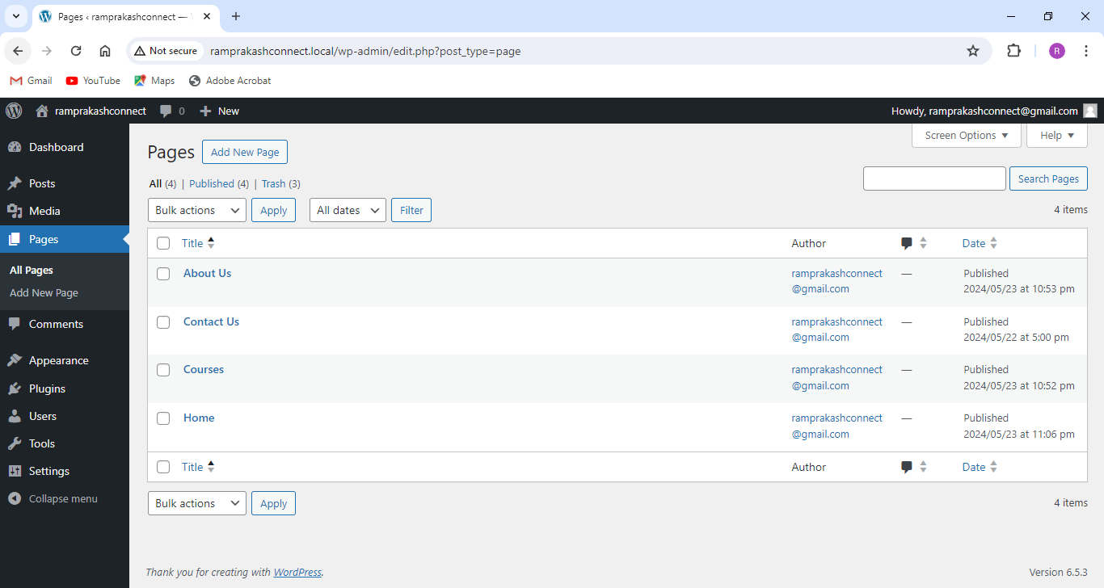

# Appearance Tab

1. Click Themes under Appearance in the left pane.
2. Customize the activated theme or install and activate new themes using the Add New Theme button.
3. Click Customize in the activated theme.
4. Navigation, Styles, Pages, Templates, and Patterns are the tabs under Design.
5. Select each of them and make the changes as required.
6. Save the changes made.

The new appearance gets reflected in the website.

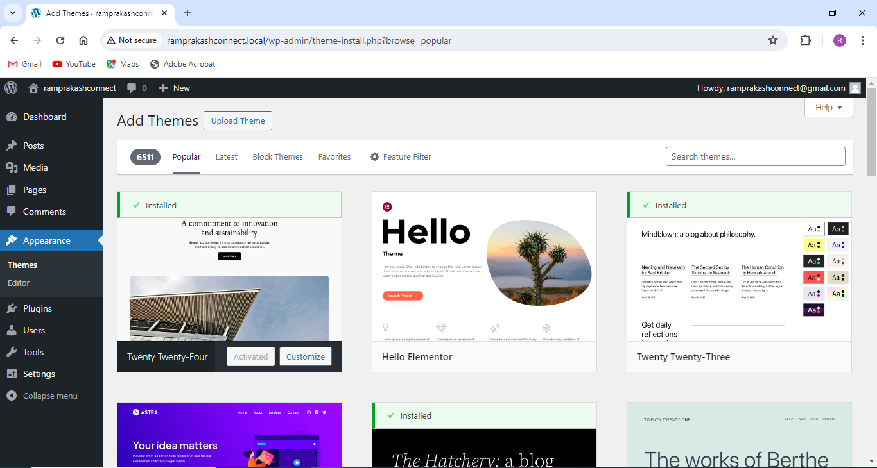

Your new local site is now created.

