Ex-6 : Implement Wi-Fi security (WPA2, IP based, MAC Based)

Procedure:

1. Power on your D-Link Router.
2. Connect your PC to the router using an Ethernet Cable or WiFi.
3. Once your PC is connected, open a web browser and go to [***http://192.168.0.1***](https://19216801.one/)
4. A login page will appear. The default username is admin and the password field is to be left blank. Click on **Log In.**

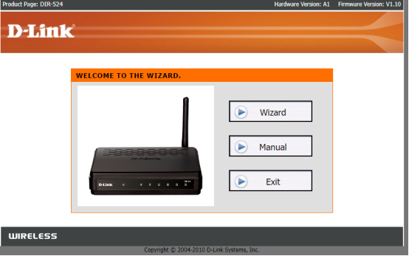

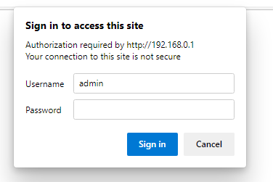

5. Now, configure and set up your router using the **Internet Connection Setup Wizard.**

**6. Under Wireless Setup enter SSID (WiFi Name) and Key (Password).**

**7. Under WAN Setup choose Connect type: DHCP/Static/PPPoE**

**DHCP: ( Dynamic Host Configuration Protocol)**

**DHCP dynamically and automatically assigns IP addresses to network devices on a physical network. It provides an automated way to distribute and update IP addresses and other configuration information over a network.**

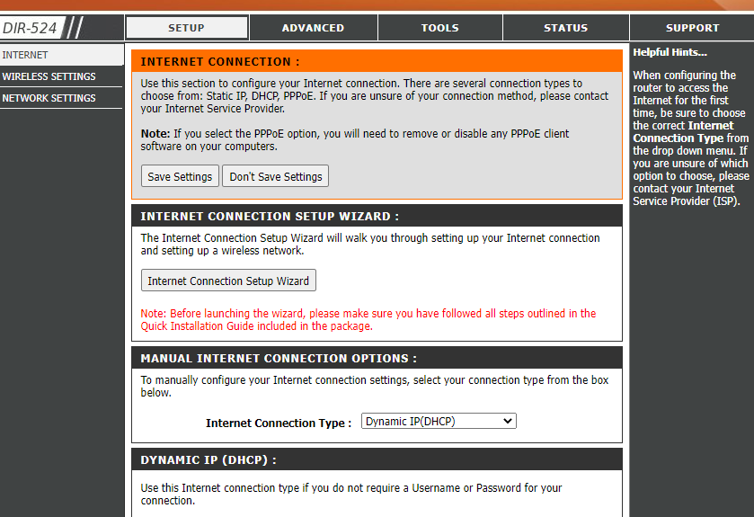

**8.After configuring internet connection, click on Save and Connect and the router will now connect to the Internet.**

**Static IP: A fixed IP address to each computer on a network. The address does not change over time unless it is changed manually.**

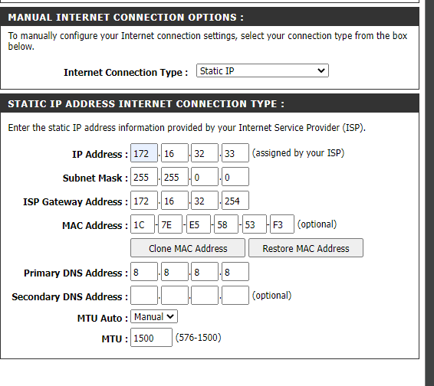

**9.Visit the Wireless Settings and set up your Wi-Fi Network including its SSID and password.**

