**Experiment 10: Test security of UPI applications on Desktop sharing applications.**

***Step 1:***

Download and install UPI application on your phone

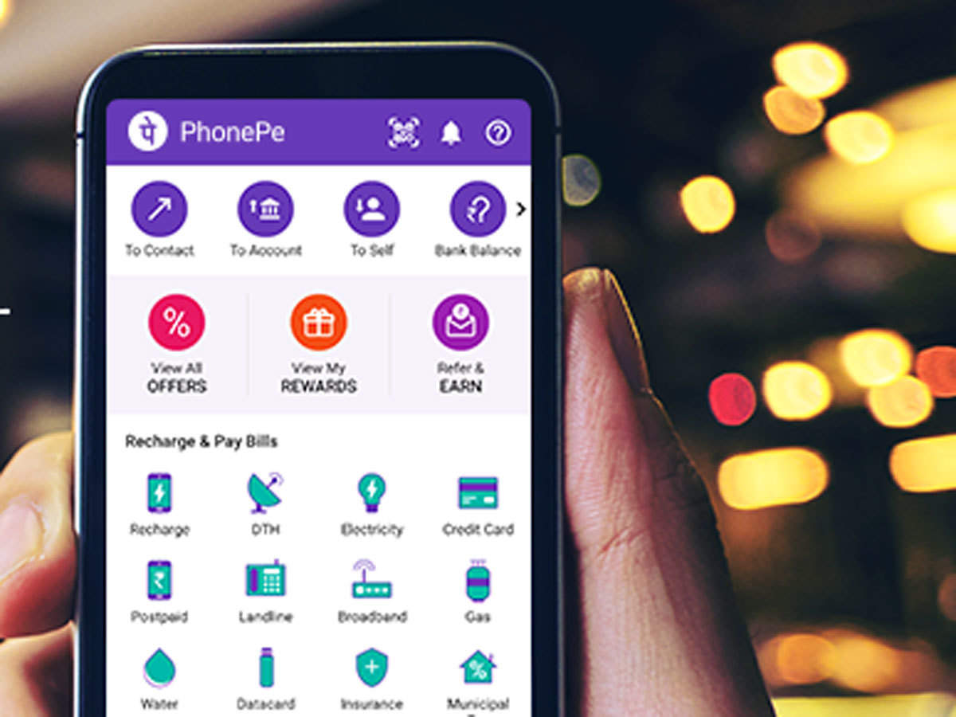

Download and install Team Viewer on your phone and computer

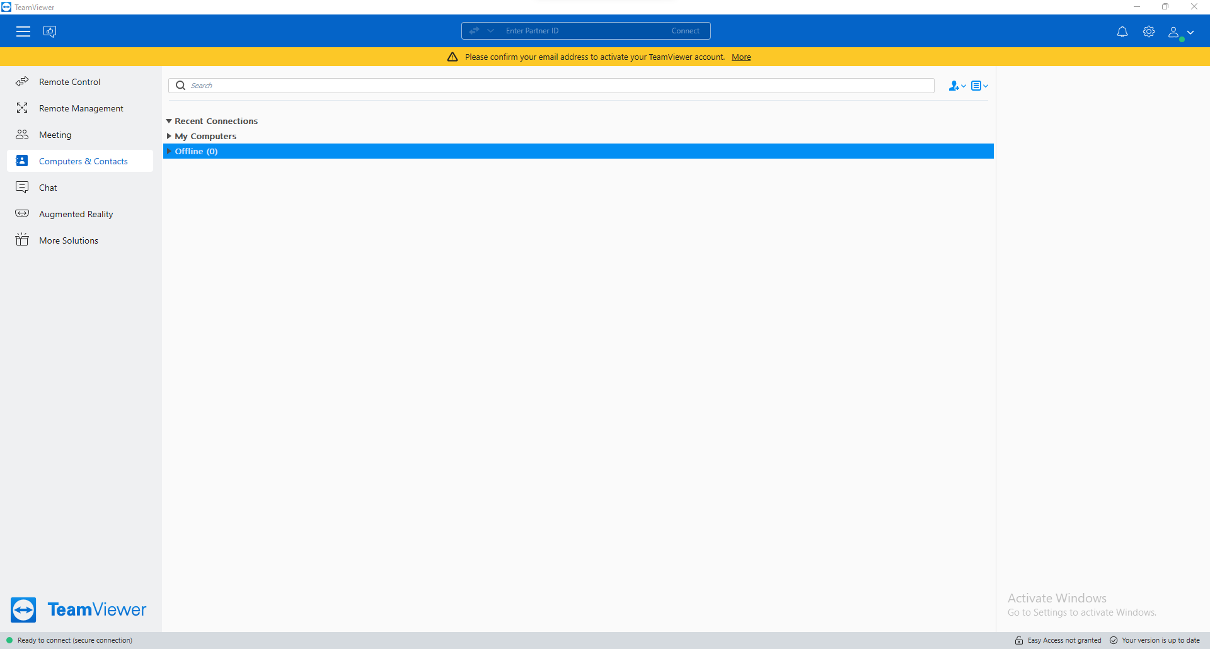

Download and install Anydesk on your phone and computer

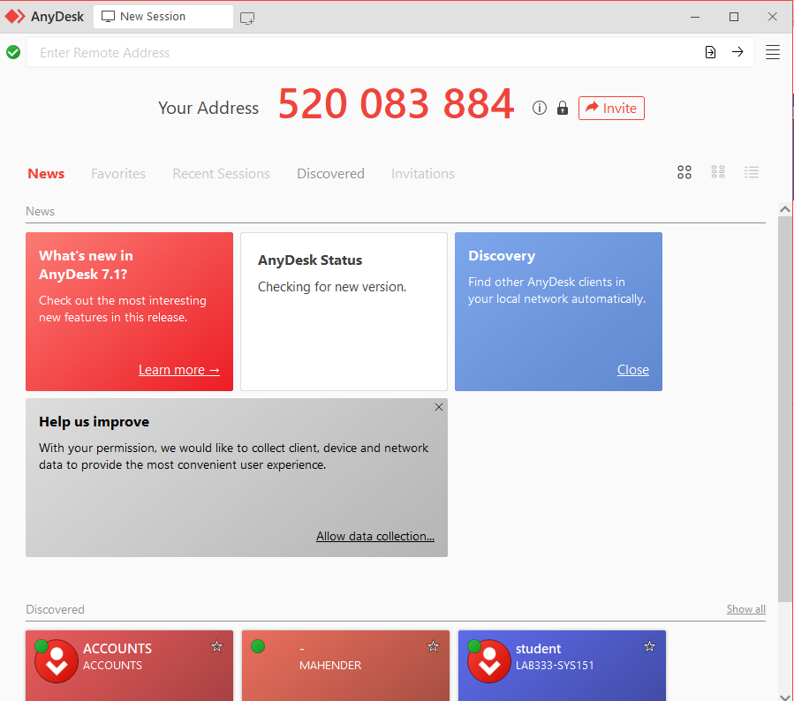

***Step 2:***

Test the security of the application and fill the table (keep adding more applications as you test)

Connecting mobile and computer.

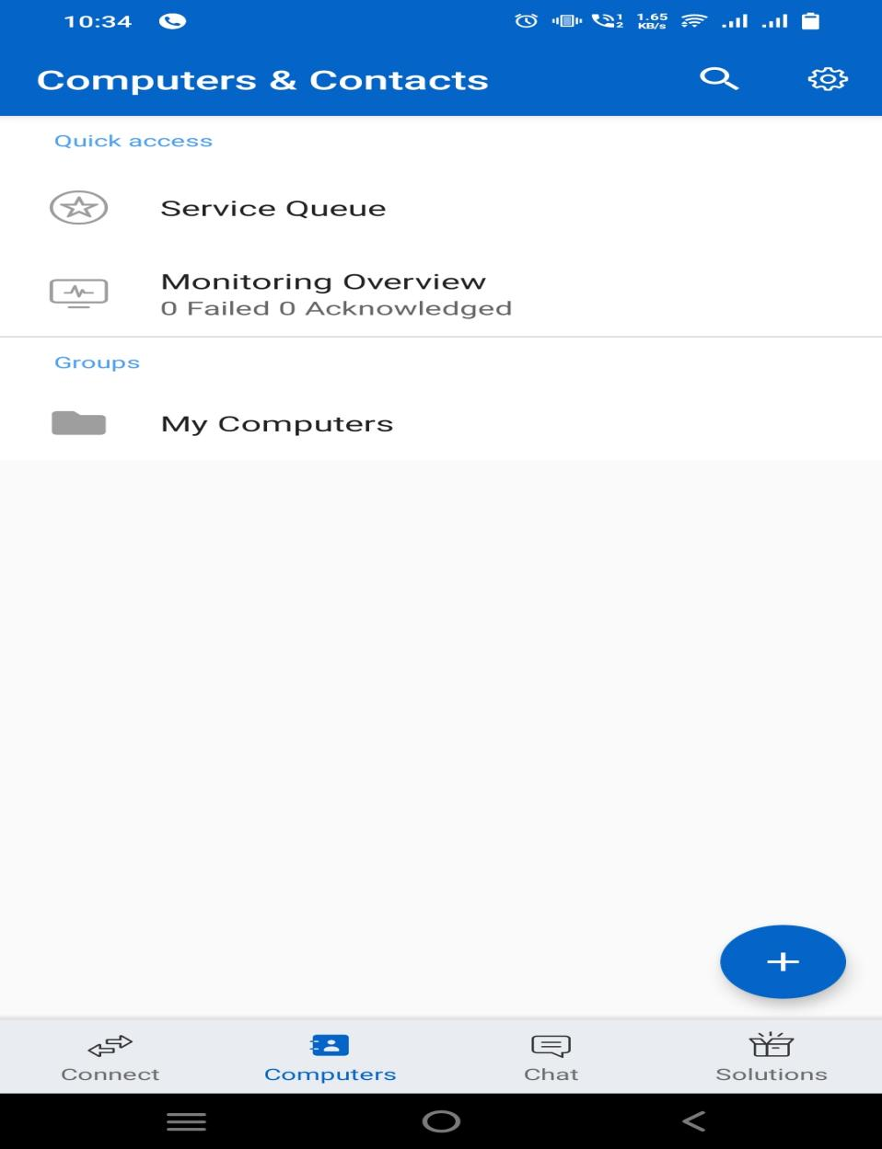

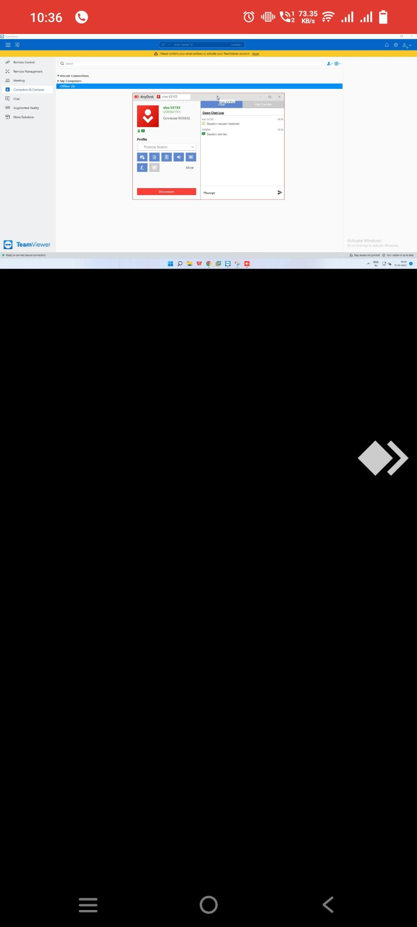

|  |  |  |
| --- | --- | --- |
| **UPI Apps** | **Team Viewer** | **Any Desk** |
| BHIM |  |  |
| Google Pay |  |  |
| Phonepe |  |  |

If we try to perform any transactions using any UPI applications it won’t allow to perform transactions.