Step 1: Connect PC to your Router using a cable

Step2: Run IP address of router in any of the browser

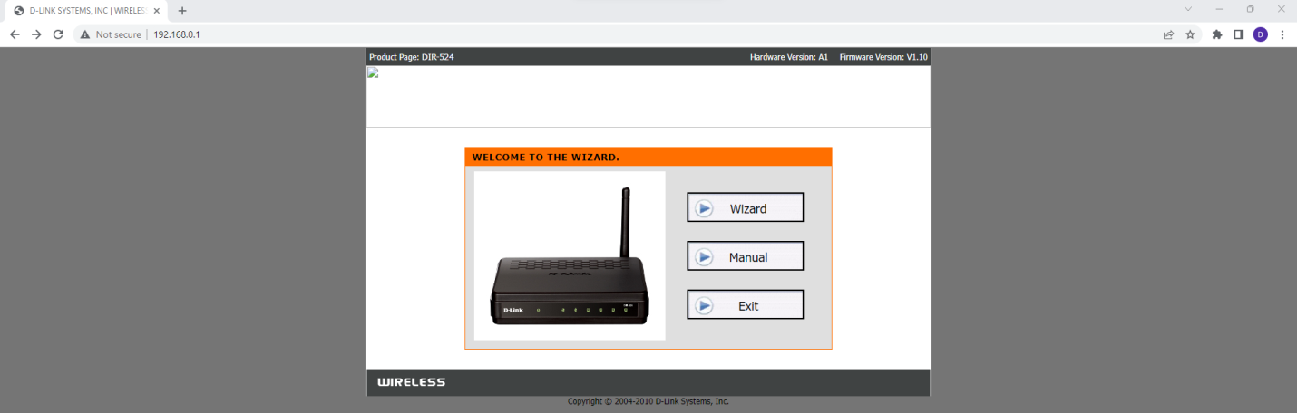

Step3: click Wizard

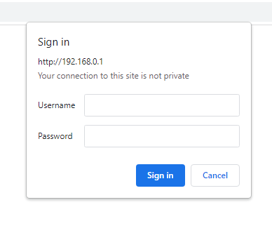

Step4: Login with the credentials which are available on the router

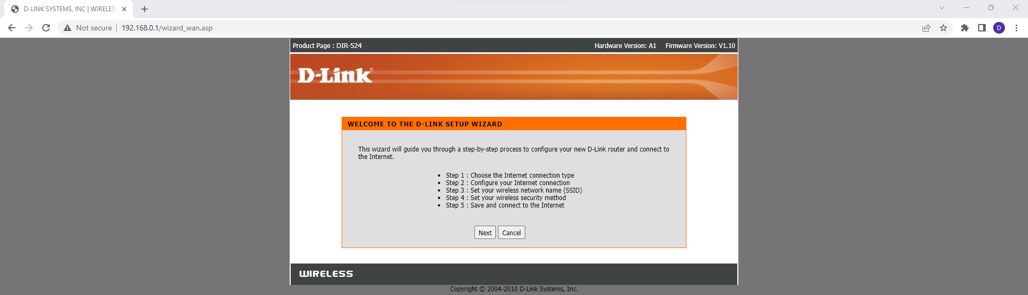

Step 5: click Next

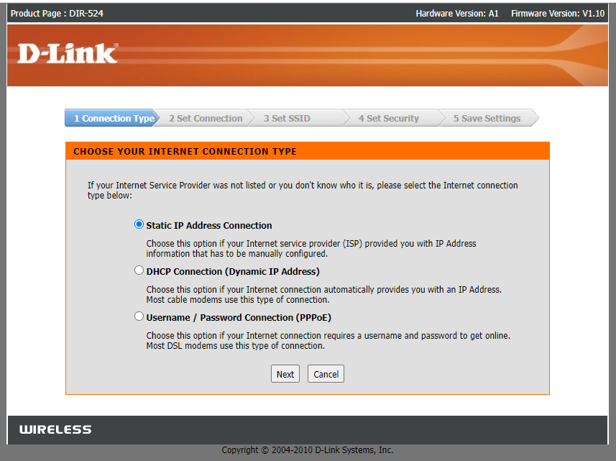

Click Next and Enter IP address provided by service provider

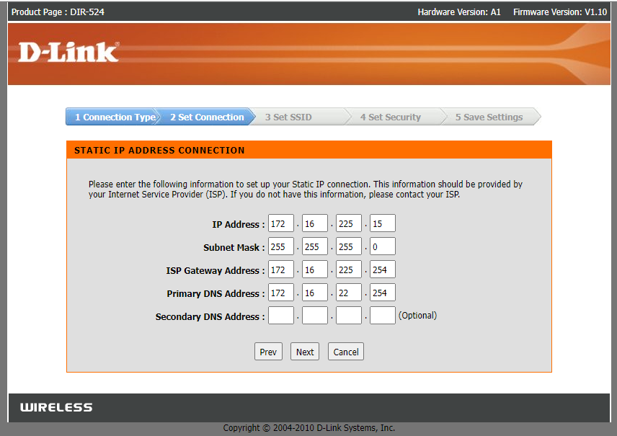

Click Next and enter the name of the wireless network

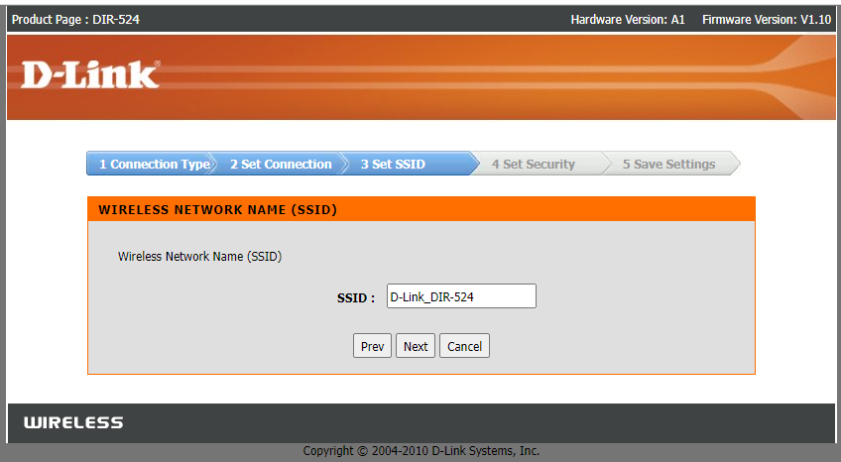

Click Next and set the security mode

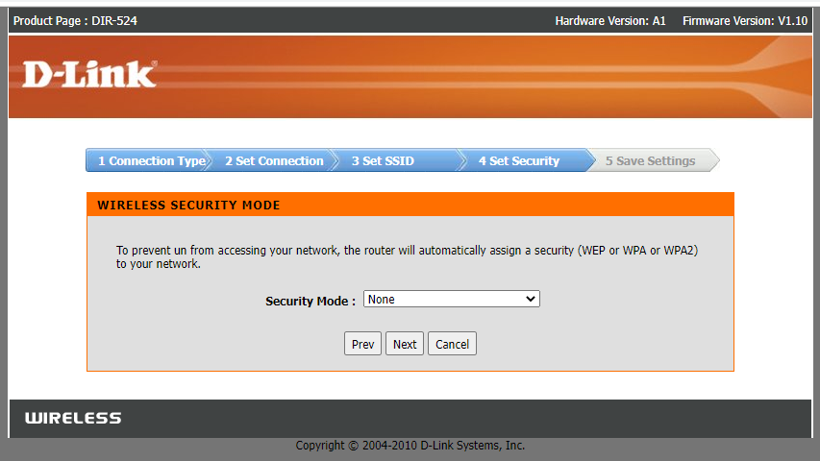

click Next 🡪 save 🡪 continue

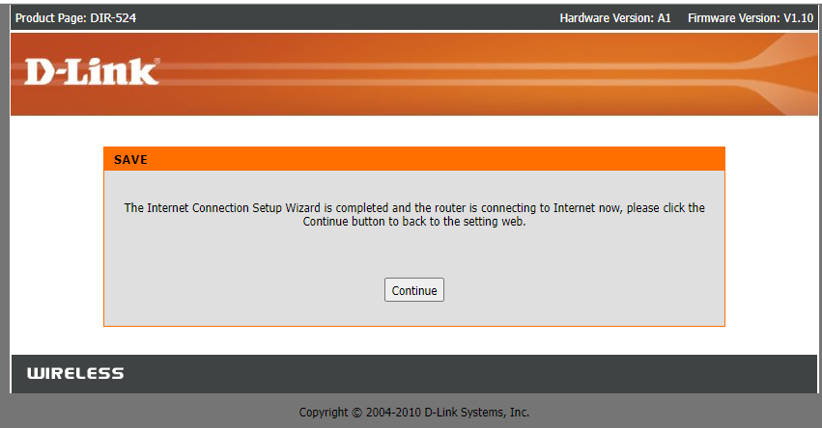

click continue

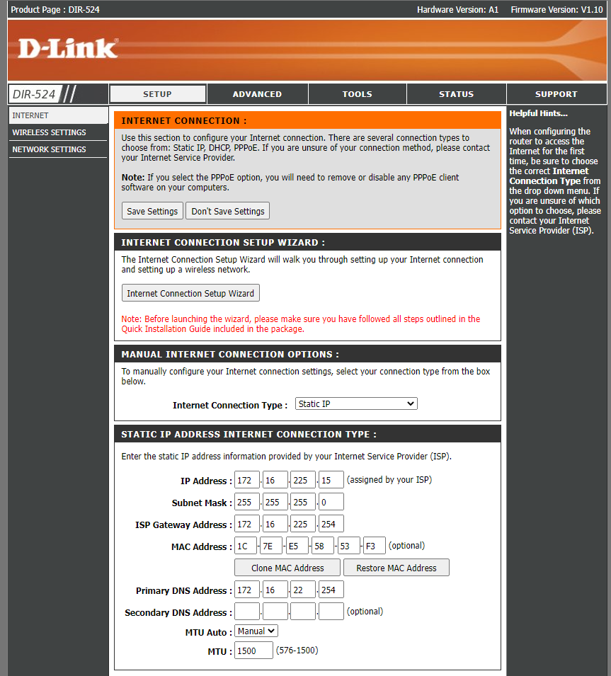

Step 6: In manual internet connection setup wizard

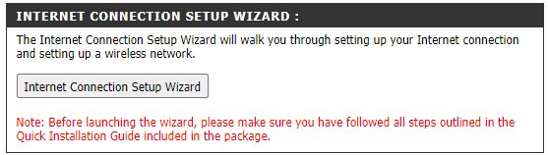

Step 7: Click Next

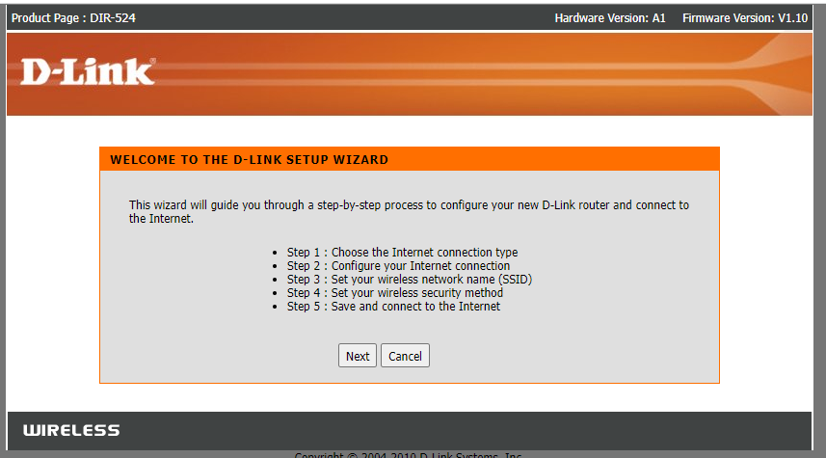

Click next

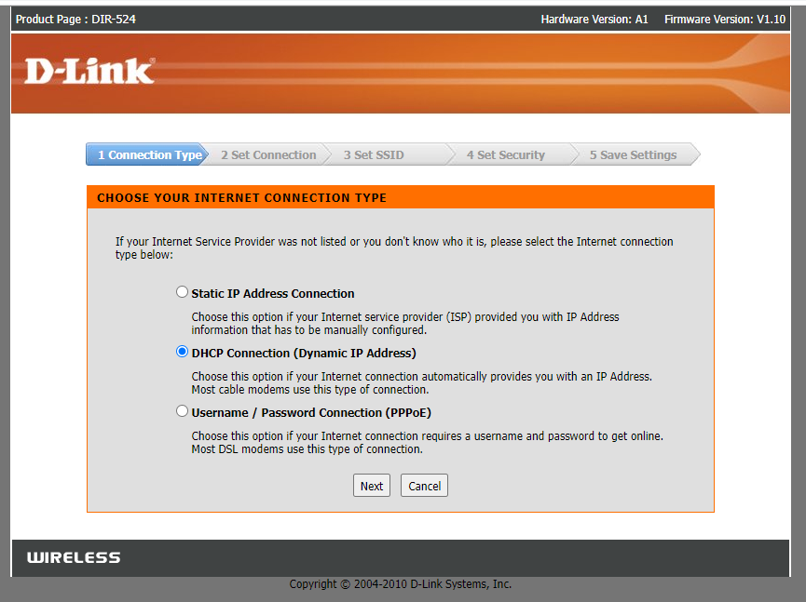

Click Next

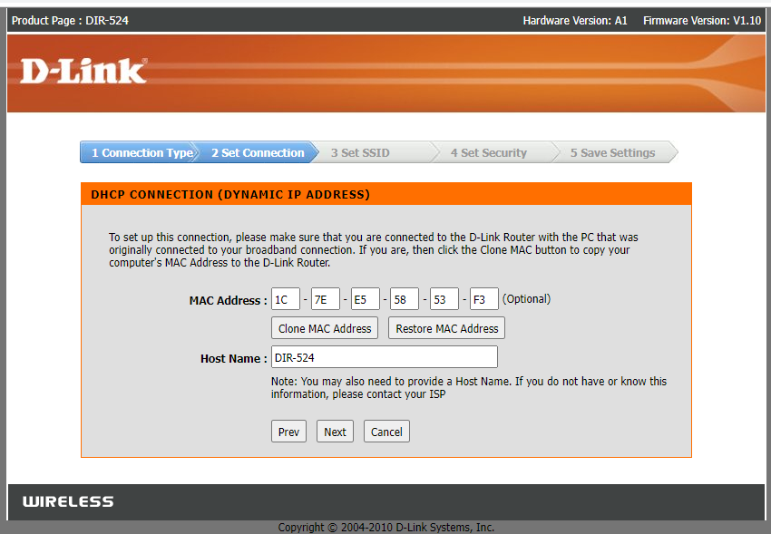

Click Next

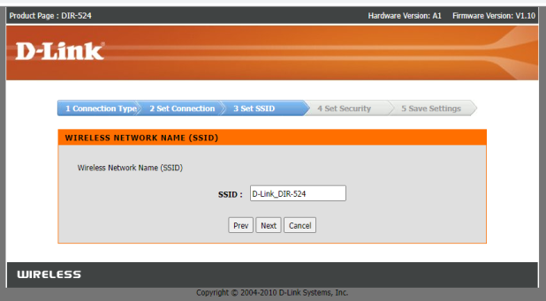

Click Next

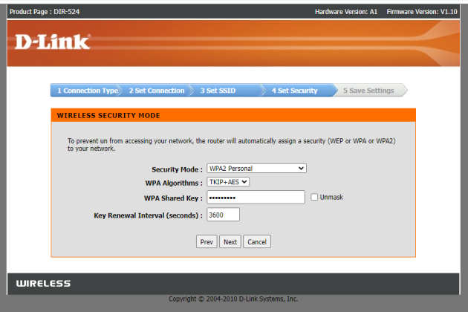

Click Next

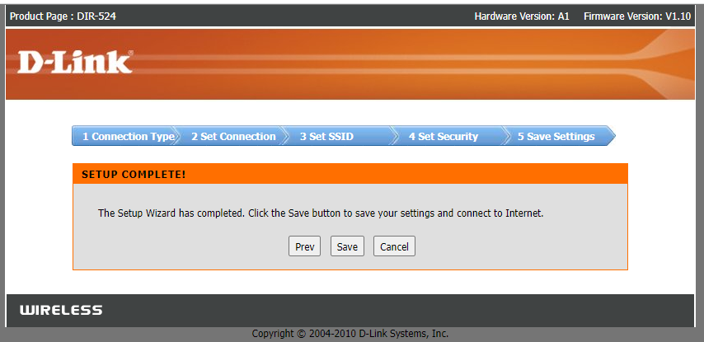

Click Continue

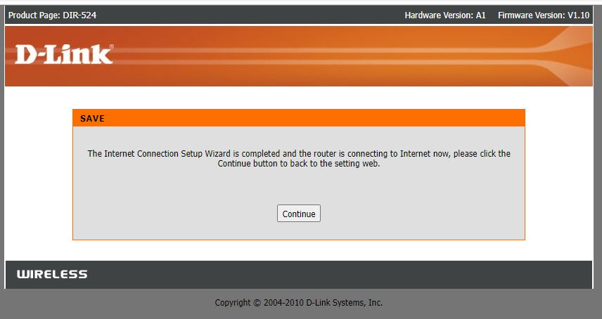

Step: 8 Click wireless Settings

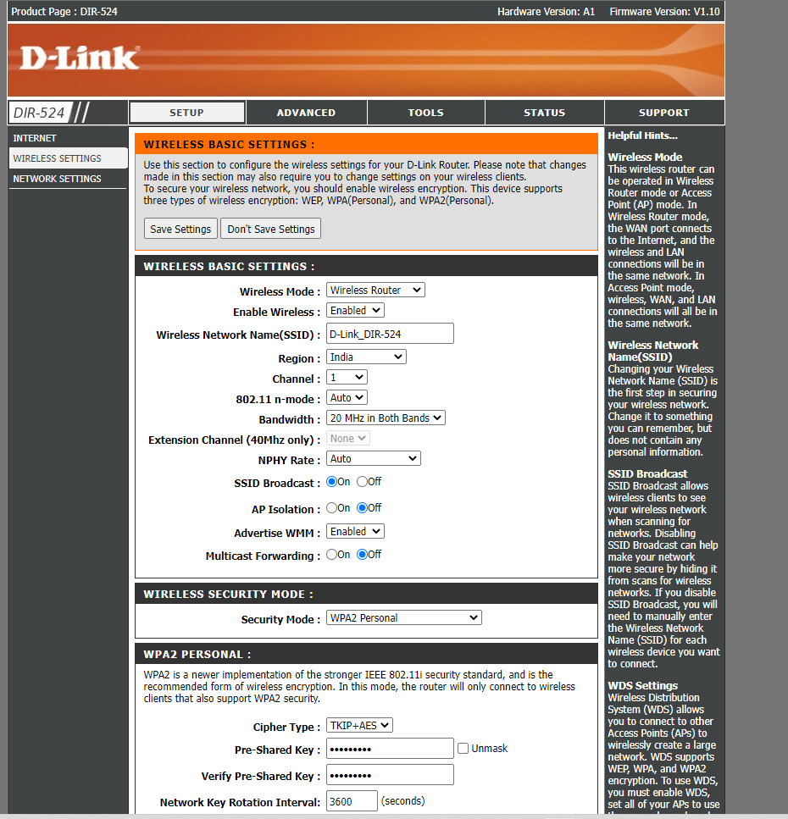

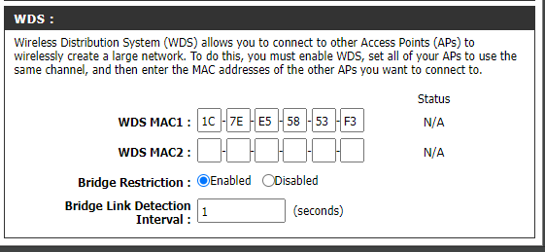

Step 9: Click Save.

Step 10: Goto Network and Internet and connect to the wifi-DLink_DIR-524

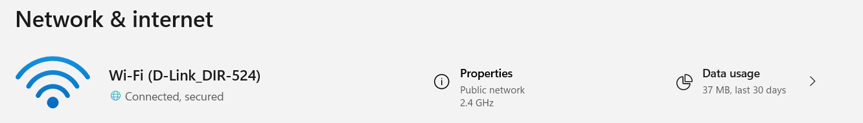

Step 11: run google.com in the browser to check the availability of Wifi

