Final Assignment

SQL 330 Final

**Welcome to the final assignment! This is the largest assignment, so you will have until the end of the quarter to complete it. Remember you have other learning material to read and watch in Assignment 07, 08, 09, and 10, just no additional assignment tasks.** This assignment will take about 9-16 hours to complete, so plan accordingly!

# ****Required Software****

* SQL Developer Edition (or equivalent)
* Visual Studio 2019 Community edition with the SSIS Extension
* Visual Studio 2019 Community edition with the SSRS Extension

# Final Assignment Tasks

In the assignment's tasks, you create a data processing and management solution using SQL Server and its associated software.

## Step 1. Create OLTP and OLAP relational databases

This step organizes files in a blank Visual Studio Solution, and creates the starting databases.

1. **Create** a Blank Visual Studio Solution called **DWIndependentBookSellers_YourNameHere**.
2. **Add** physical and logical folders to the Solution called **Documents, Reports, and Scripts**.
3. **Place** this assignment document and all the provided SQL scripts in their respective folders.
4. **Save** the configuration using the Save All button.

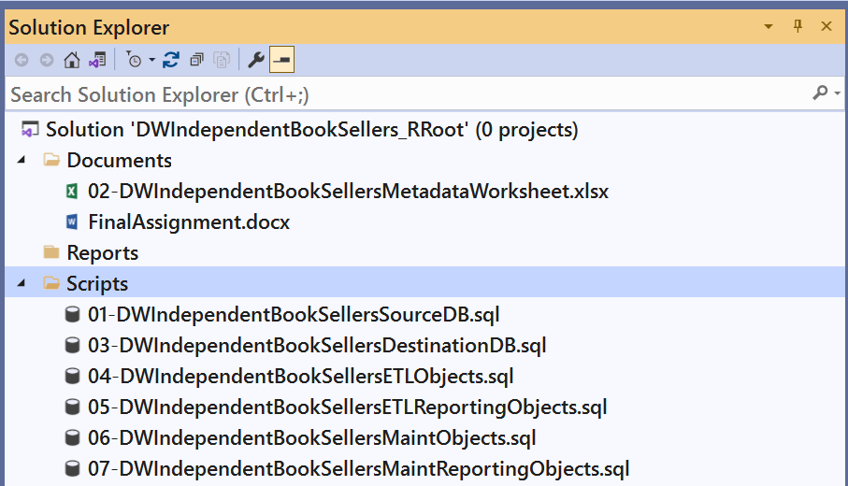

Figure 1

1. **Open, review, and execute** the script**, 01-DWIndependentBookSellersSourceDB.sql** to create the source database. Then, **add** it to the Visual Studio Solution.

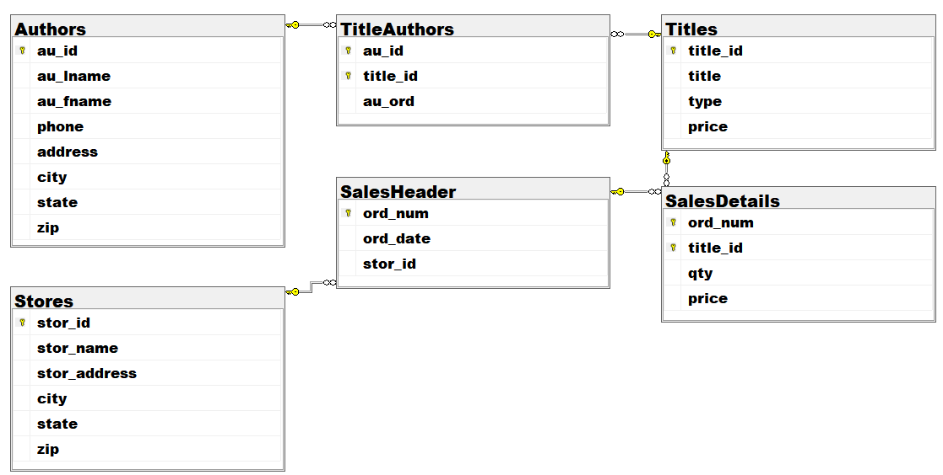

Figure 2

1. **Review** the metadata worksheet, **02-DWIndependentBookSellersMetadataWorksheet.xlsx**. Then, **add** it to the Visual Studio Solution.

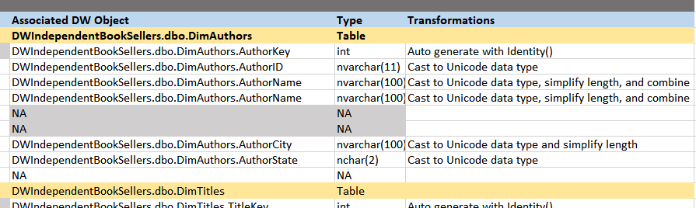

Figure 3

1. **Open, review, and execute** the script **03-DWIndependentBookSellersDestinationDB.sql** to create the destination database. Then, **add** it to the Visual Studio Solution.

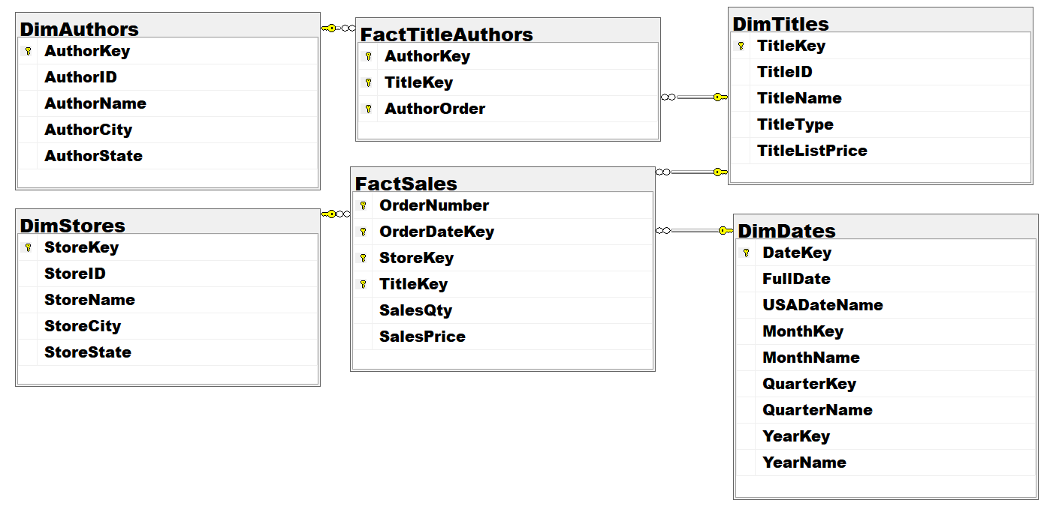

Figure 4

## Step 2. Program the ETL Process with SQL

In this step, you create a new ETL process using SQL programming.

1. **Open, review, and complete** the script **04-DWIndependentBookSellersETLObjects.sql** to create an ETL process.
2. **Execute and test** all the objects until they work without errors.

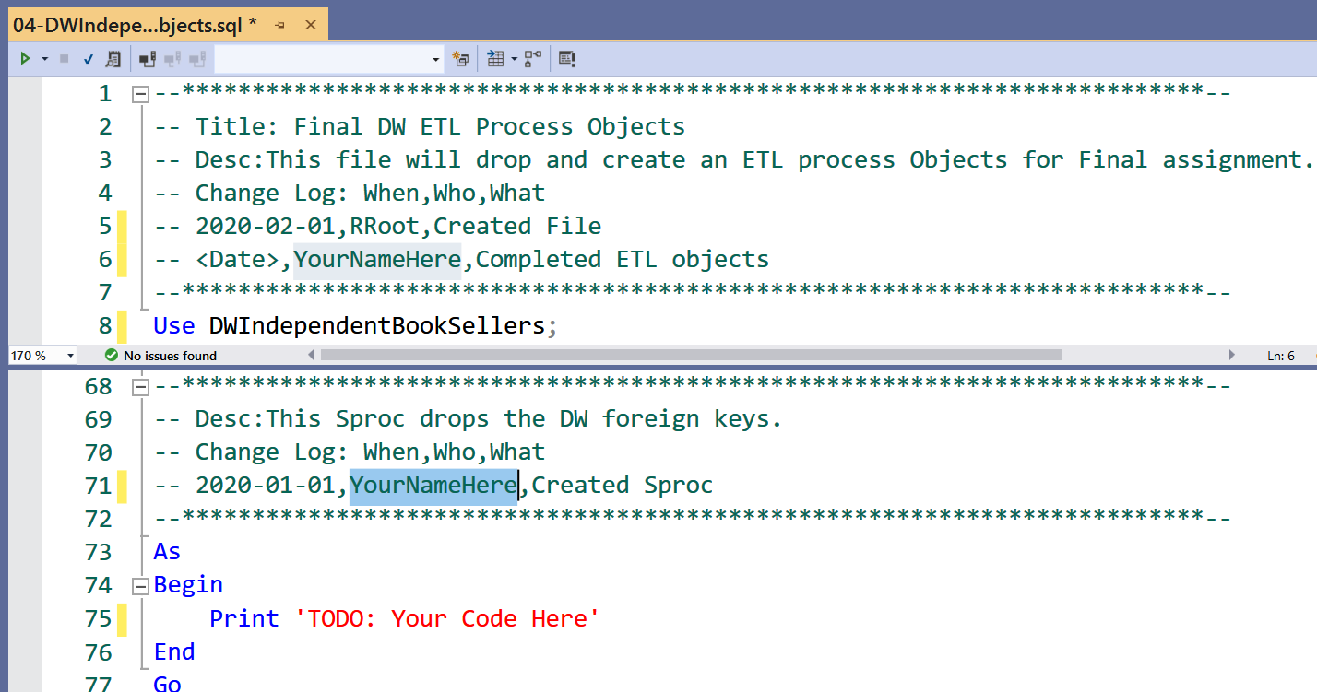

Figure 5

## Step 3. Visualize the ETL Process with SSIS

In this step, you create a new SSIS project with an ETL package.

1. **Add** an SSIS project called **IndependentBookSellersETL** to your Visual Studio solution.
2. **Rename** the package file to **IndependentBookSellersETLpackage.dtsx**.
3. **Add** Pre-Load, Load Dimension Tables, Load Fact Tables, and Post-Load **Sequence Containers** to the packaged
4. **Configure** the package file to execute the ETL stored procedures in the proper Sequence Containers.

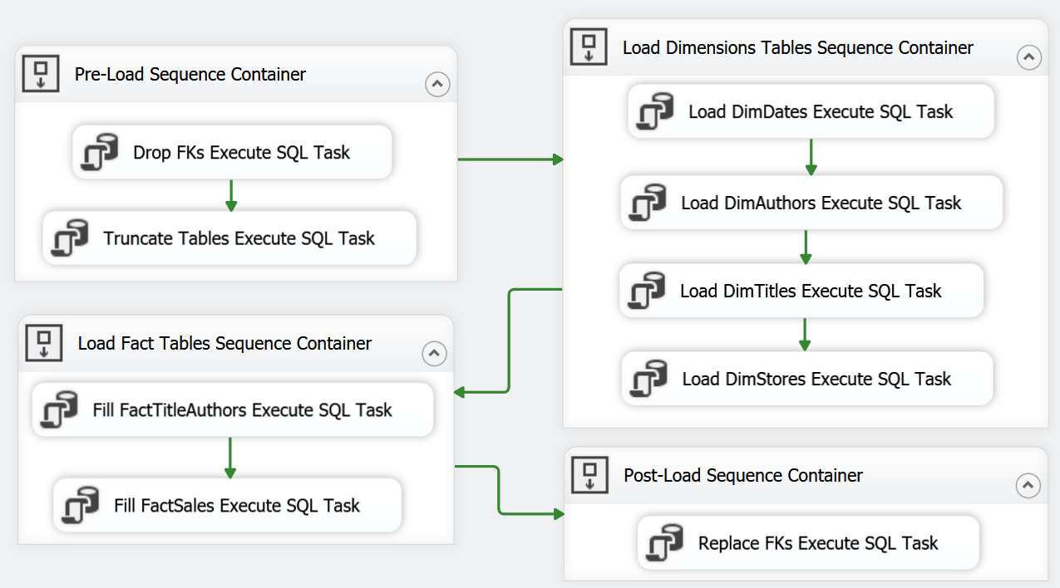­­

Figure 6

## Step 4. Program DB Maintenance with SQL

In this step, you create database maintenance stored procedures.

1. **Open, review, and complete** the script **05-DWIndependentBookSellersMaintObjects.sql** to create an ETL process.
2. **Execute and test** all the objects until they work without errors.

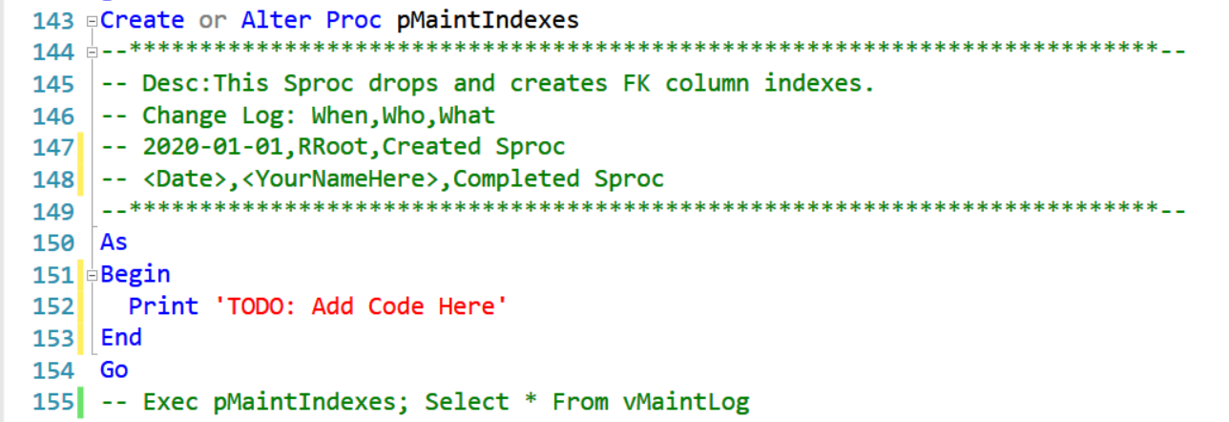

Figure 5

## Step 5. Automate the ETL Process

In this step, you create a new SQL Agent Job to automate your ETL process.

1. **Copy** your SSIS package to folder **C:\_SQL330** (make this folder if you do not have it already!)
2. **Create** a SQL Agent Job called **DWIndependentBookSellersETL** to **run** your SSIS package.
3. **Set** the Job Owner as **SA** and **configure** it to run each night at **1 AM.**
4. **Generate** a SQL Script for the Job and **add** structured error handling to the script.
5. **Save** it as **DWIndependentBookSellersETLJob.sql.**
6. **Add** the script file to the Visual Studio Solution.

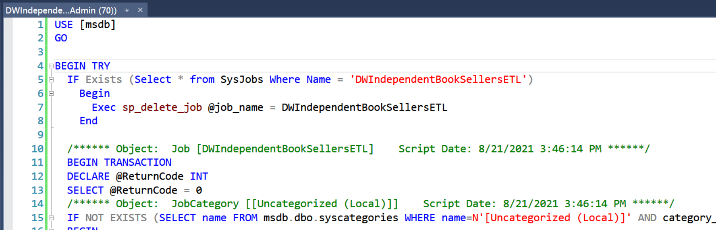

Figure 6

## Step 6. Automate the Maintenance Process

In this step, you create a new SQL Agent Job to automate your Maintenance process.

1. **Create** a SQL Agent Job called **DWIndependentBookSellersMaint** to run your maintenance sprocs .
2. **Set** the Job Owner as **SA** and **configure a** **step for each** maintenance stored **procedure** **to run 2 AM.**
3. **Generate** a SQL Script for the Job and **add** structured error handling to the script
4. **Save** it as **DWIndependentBookSellersMaintJob.sql.**
5. **Add** the script file to the Visual Studio Solution.

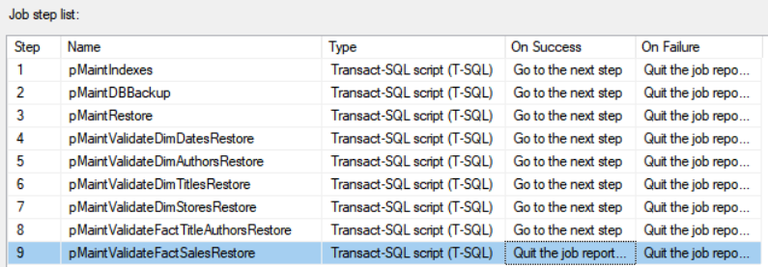

Figure 7

## Step 7. Create Reporting Objects

1. **Open, review, and execute** the script **06-DWIndependentBookSellersETLReportingObjects.sql** to create the ETL report views.
2. **Open, review, and execute** the script **07-DWIndependentBookSellersMaintReportingObjects.sql** to create the ETL report views.

**Note: The ETL and Maint reporting objects script will only work after creating the ETL and Maintenance objects.**

## Step 8. Create ETL Reports with SSRS (2hrs)

In this step, you create a new SSRS project with reports that show the ETL status using reporting views.

1. **Add** an SSRS project called **DWIndependentBookSellersAdminReports** to your Visual Studio solution.
2. **Create** ETL reports for each dimension and fact table views (except for DimDates).
3. Create ETL reports for the ETL lot table views.
4. Create Maint reports for the ETL lot table views.
5. Make your reports **similar to those created in assignment 06**

**Note:** Be sure to n**ame** your SSRS DataSources and DataSets to identify what database or objects they are using.

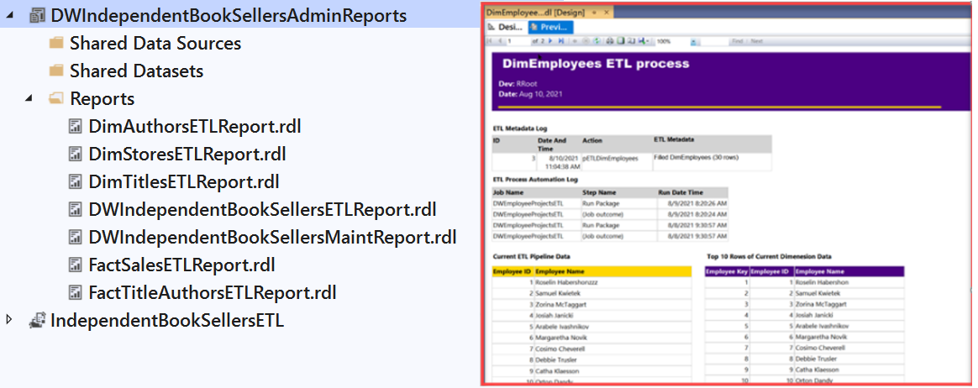

Figure 8

## Step 9. Document the Solution

After creating your ETL and DB Maintenance Solution, **create a manual describing how your Solution works.** **Included enough detail** that a co-worker could troubleshoot the process if you were on vacation! **Save** the file **as DWIndependentBookSellersAdminManual.pdf** and **add** it to your Visual Studio Solution.

**Important:** Make sure to **click** the Save-All button in Visual Studio when you are done!

# Submit your work to the Canvas site

After you complete your work, **compress** the Solution folder into a single zip file, then submit the zip file on the Canvas website in the appropriate module Assignment.

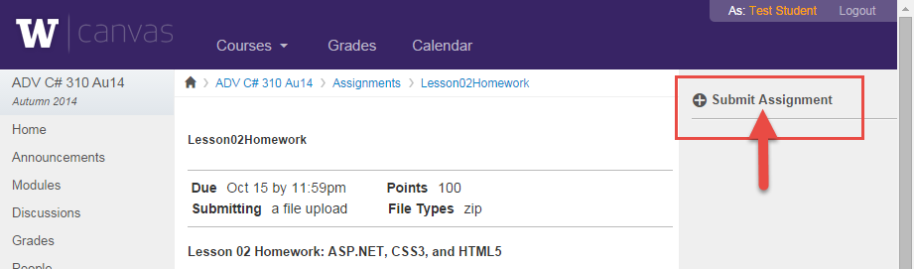

Figure 5. The submit assignment button in Canvas.

***You are done!***