Assignment 01

Getting Setup for the Course

In this “hands on” assignment you will install SQL Server's Relational, Cube, and Tabular Servers, plus two sample databases needed for this class. This assignment may take you about 10 to 15 hours, so plan accordingly!

The assignment consists of the follow steps:

1. Obtain the Software
2. Install the course software.
3. Post an introduction for yourself on the Canvas website
4. Review some websites.
5. Watch the module videos.
6. Read the module documents.
7. Install the class databases
8. Capture a Screenshot that proves your installation was successful.
9. Submit your work to the Canvas site.

# Obtain the Software

We have a lot of different software to install in this course! Some of it install very quickly and we will install those in our class session. Others, Like SQL Server, take too long to do in class so you need to do them outside of our class sessions.

# Install the Software

Install SQL Server 2022 DEVELOPER EDITION on your personal computer. (We will install SSIS later)

<https://www.microsoft.com/en-us/sql-server/sql-server-downloads> (external site)

Install SQL Server Management Studio (SSMS) on your personal computer. Even if you have been using Azure data studio, you need this one as well. Both can be installed on used on the same computer, but each has some different features.

<https://docs.microsoft.com/en-us/sql/ssms/download-sql-server-management-studio-ssms?view=sql-server-ver15> (external site)

Next, Install Visual Studio (VS) 2019 Community Edition. VS is an Integrated Development Environment (IDE) that hosts multiple plugins (extensions). The Extension you need for this course is the SQL Server Development Tools (SSDT). Here is a webpage that describes the current process.

[**https://red9.com/blog/installing-ssdt-2019/**](https://red9.com/blog/installing-ssdt-2019/)(external site)

**Notes**:

1. Please watch the video I created about installing SQL Server 2019 before you try installing the software.

2. The book files and web pages may reference different versions of SQL, but we use SQL 2019 in class. However, SQL 2005, 2008, or 2008 r2, 2013, 2014, 2016, or 2017 are all similar enough that it will not matter much.

3. The install process can take from 2 hours to 2 weeks depending on what issues you encounter. I know it's not fair, but some people will have problems installing the software and others will not. So please, read all the web pages and watch the videos I have posted before you begin. These will help you be one of the people who get it installed with as little issues as possible.

4. The most common issue is not being logged in or running as the Administrator when you are installing the software! You have been warned! [Using the Run As Administrator Option](https://youtu.be/hzVHKqPeRss) (external site)

5. Don't use a Work Laptop if you can help it. If you do use a Work laptop, please contact your organizations Tech Support for installations assistance.

6. You can also use a Windows **Virtual Machine** on Mac, Linux. The VM will need at least 80 GB drive space and 4 GB of memory (this means you need 8GB on your computer!)

7. If you continue to have problems installing the software, consider getting a $350. A new laptop will have less software that can interfere with our installations! Make sure it uses at least Windows 10 Home, has at least 4GB of RAM, and has at least a 128GB drive, and an Intel processor (not Mac or Chromebook). [Search Amazon for $350 laptop](https://www.amazon.com/s?k=windows+10+home+laptops+under+350+dollars+128ssd) (external site).

8. You can also use a Virtual Machine on a Cloud service Azure or AWS. On the Cloud you only pay for the VM without any additional charges for SQL Server since the software we use in this course is all free. This can be the most complex setup, so only choose this if you must or want a greater challenge. (<https://docs.microsoft.com/en-us/azure/azure-sql/virtual-machines/windows/sql-server-on-azure-vm-iaas-what-is-overview>) (<https://azure.microsoft.com/en-us/pricing/calculator/>)(external site).

# Post an introduction for yourself on the Canvas website

Please submit a brief introduction about yourself using the Discussions page on the Canvas website.

# Review some websites (Review means quickly scan!)

Please table some time to familiarize yourself with some the following topics.

3) How to: Connect to SQL Server from Windows

<http://msdn.microsoft.com/en-us/library/bb326612.aspx> (external site)

4) Creating Screenshots in windows

<http://www.wikihow.com/Take-a-Screenshot-in-Microsoft-Windows> (external site)

5) Creating Zip files in windows

<http://www.wikihow.com/Zip-Files-Together> (external site)

# Watch the module Videos

Please watch the following assignment videos. Most of them cover review topics to make sure everyone has the information fresh in their mind before we move forward.

<https://youtube.com/playlist?list=PLfycUyp06LG_ahgKrAyyZI5OFTGLy28_k> (external site)

# Perform Assignment Tasks

The assignment's tasks include installing the Northwind and Pubs Sample Databases by running the scripts found in this modules Assignment01\Databases folder. The script names are InstNwnd.sql and InstPubs.sql, but you may not see the extension, depending on your computer's settings. Make sure to turn on the extension if you cannot. Afterward, you will create a Word document proving your installation, create a blank Visual Studio solution, and add files to the blank solution. Here is an outline of the steps you need to perform:

1. **Execute** the InstNwnd.sql and InstPubs.sql SQL Scripts
2. **Execute** the following SQL Query in SQL Management Studio:

**Select Name From SysDatabases;**

1. **Execute then Save** your Script as A01Code.sql.
2. **Prove** that the databases are installed on your SQL Server by **taking a screen shot** of the results and **pasting it into a Word** document.
3. **Save** the document as "ListOfDatabases.docx".
4. **Create** a Blank Visual Studio Solution**.**
5. **Add** your SQL script and your Word document to the Solution.

# Add your files to the Visual Studio Solution

Now that the SQL script and Word document is complete, add all files to your Blank solution. Make sure your Solution, folders, and files look like the Figure 1 image.

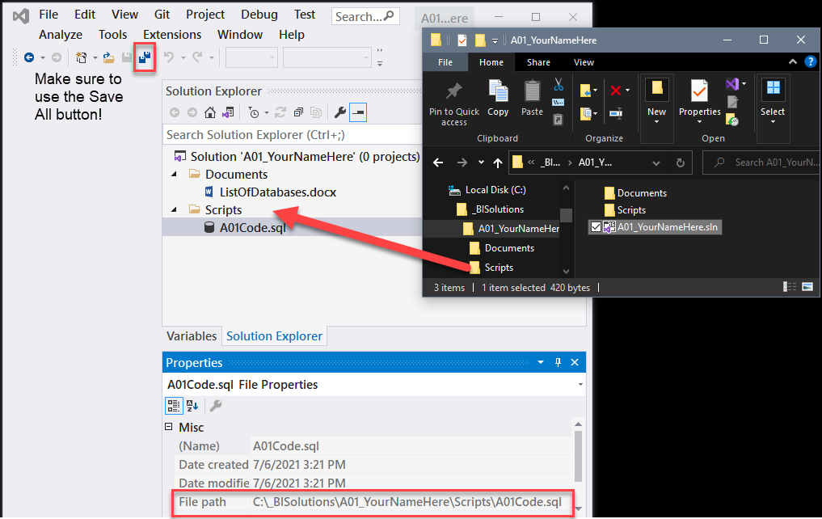

Figure 1. Adding the files and folders to your Visual Studio Solution

# Submit your work to the Canvas

After you complete your work, compress the solution folder (the one with the .sln file inside of it) folder into a single zip file then submit the zip file on the Canvas website in the appropriate module Assignment.

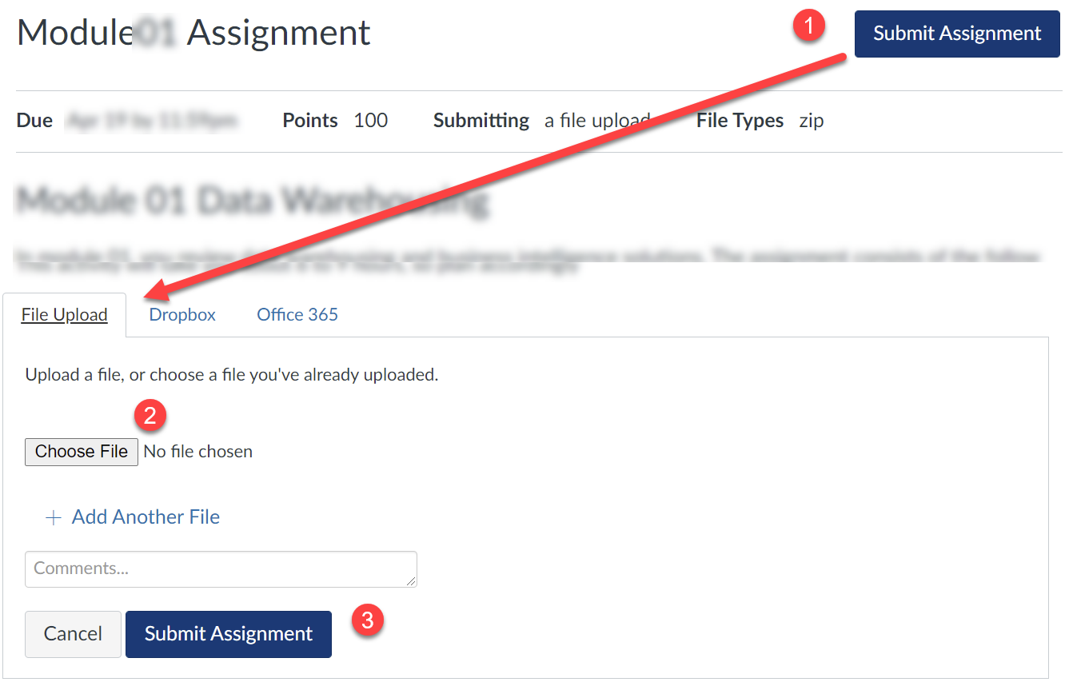

Figure 2. Submitting your work to Canvas.