Assignment 02

Relational vs Non-Relational Data

In this “hands on” assignment you will install SQL Server, Analysis Cube and Tabular Servers, and two sample databases needed for this class. This assignment will take you about 10 to 15 hours, so plan accordingly!

The assignment consists of the follow steps:

1. Obtain the Software
2. Install the course software.
3. Post an introduction for yourself on the Canvas website
4. Review some websites.
5. Watch the module videos.
6. Read the module documents.
7. Install the class databases
8. Capture a Screenshot that proves your installation was successful.
9. Submit your work to the Canvas site.

# **Required Software**

Please install the Visual Studio with the **SSAS extension and Excel.**

# Assignment Videos

Please watch the following assignment videos.

<https://youtube.com/playlist?list=PLfycUyp06LG-Ubj4jmBhPDz1IxAv6377o>

# Assignment Articles

Please read the following documents:

<https://www.sqlshack.com/working-with-xml-data-in-sql-server/>

<https://www.c-sharpcorner.com/article/working-with-json-in-sql-server-2016/>

<https://www.mssqltips.com/sqlservertip/4154/tabular-vs-multidimensional-models-for-sql-server-analysis-services/>

<https://docs.microsoft.com/en-us/analysis-services/analysis-services-tutorials-ssas?view=asallproducts-allversions>

# Assignment Tasks

The assignment's tasks include creating an SSAS **Tabular** data model and optionally a SSAS Cube. Afterward, you write a Word document about what you have learned.

Here are the tasks you need to perform:

## Task 1: Create a Visual Studio to organize you work

1. **Open, review, and execute** the files "0_CreateAndLoadPubs.sql"
2. **Open, review, and execute** the files "1_CreateAndLoadDWPubsLite.sql"
3. **Review** the data inside the data warehouse DWPubsLite database.
4. **Create** a Blank Visual Studio Solution **called** **A02YourNameHere in** your course folder. Make sure to run Visual Studio as an administrator!

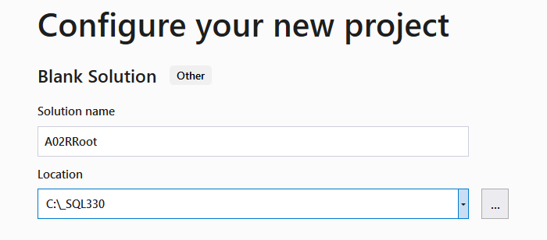

Figure 1. Creating a Blank Solution in Visual Studio

1. **Add** physical and logical folder to the Solution **called** Documents and Scripts.
2. **Place** the assignment documents and scripts in their respective folders.
3. **Save** the configuration using the Save All button.

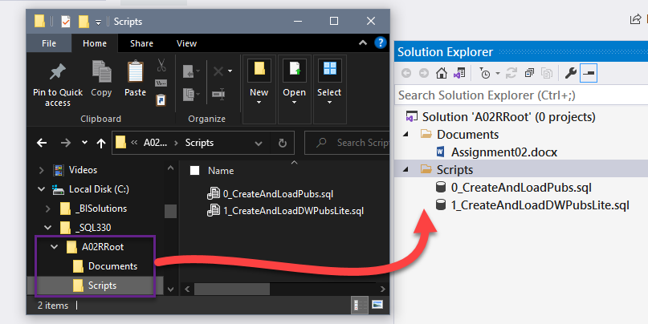

Figure 2. Adding the files and folders to your Visual Studio Solution

**Note:** Please create your solution using the location and name show in Figure 2 (**C:/_SQL330/A02YourNameHere**).

## Task 2: Create an SSAS Tabular data model

1. **Add an SSAS Tabular project to the Solution.**

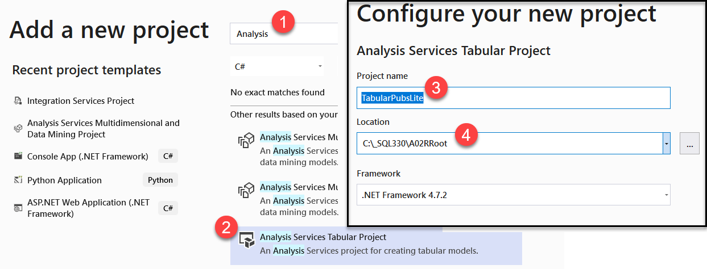

Figure 3. Adding SSAS Tabular Project to your Visual Studio Solution

**Important:** To connect to from SSAS Tabular DB to your relational DB you need to run Visual Studio as an Administrator.

1. When prompted choose an Integrated Workspace and a compatibility level of SQL 2019

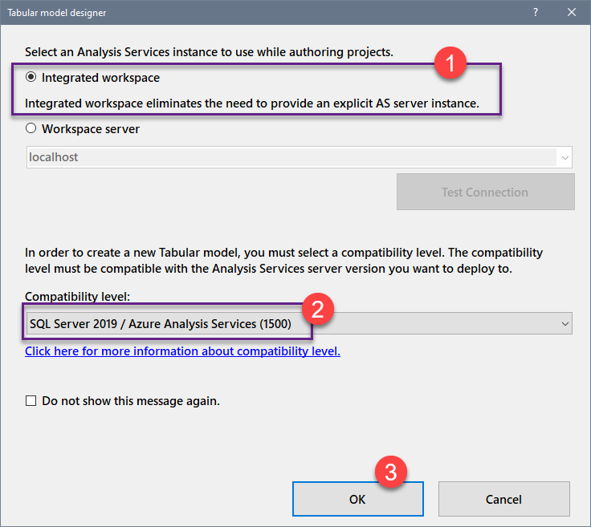

Figure 4. Configuring your SSAS Tabular Project on creation

1. **Use** the DWPubsLite database to **create** an SSAS Tabular Model.

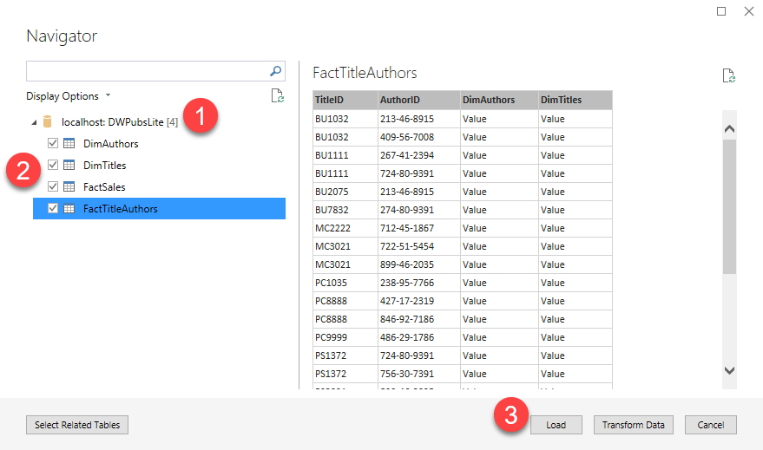

Figure 5. Using the DWPubsLite for Tabular data

1. **Test** your Tabular module using the Excel button.
   1. Make sure that the many-to-many dimension are correctly configured.
   2. Make sure to add a measure for the sales quantity.

## Task 3: Document your knowledge

After you have created and tested your tabular model, write a paper **describing the difference and between Relational and Tabular databases.**

Please **save your document as** a **PDF** **file**. Then, place it in the Document folder of your Visual Studio Solution (Make sure to Save All).

You only need a few differences, but you may have to search the internet, review the readings, or videos. You only need about a page in length. You can do more if you want, but an introduction, summary, and one or more topic paragraphs are all that is required.

**Note:** Make sure you put it in the proper, professional-level formatting! It does not have to be perfect, but you won't get credit for turning in a simple blob of text! Use this link to understand what I am looking for: [Creating Professional Documents](https://youtu.be/9ojhSW9ljjo) (External Site)

## Task 4: Create an SSAS Cube (Optional for 20 bonus points)

Create an SSAS cube as seen if the playlist. This is optional, and I recommend doing it **only** if your company is using SSAS cubes. If you decide to go for it these videos will help you: <https://youtube.com/playlist?list=PLfycUyp06LG9e8CJzSqpQQBDwf5Lo6vrL>

# Submit your work to the Canvas

After you complete your work, **compress the Solution folder** (the one with the **.sln** file inside of it) folder into a single zip file then submit the zip file on the Canvas website in the appropriate module Assignment.

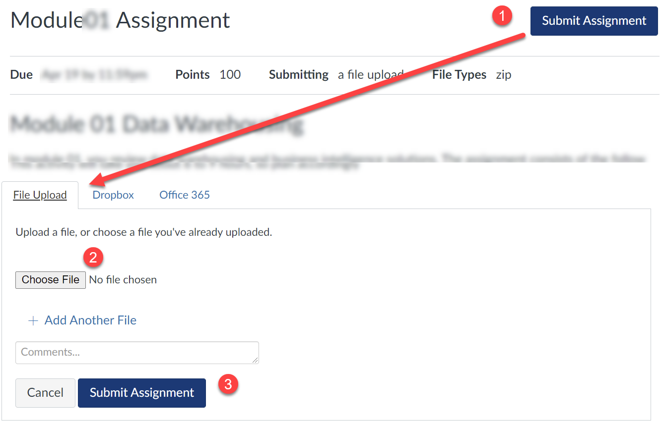

Figure 2. Submitting your work to Canvas.