Assignment 03

Overview of Advanced SQL & Business Intelligence

# ****Module Overview****

In this module, you learn about the basics data warehouse design and implementation. However, you will mainly learn how to use SQL programming to move data between databases by creating an ETL process. This assignment will take you about 10 to 15 hours, so plan accordingly!

# ****Required Software****

Install SQL Developer Edition (or equivalent), Visual Studio 2019 Community edition, and Report Builder.

# Assignment Videos

Please watch the following assignment videos. You can watch them all at once, but I recommend watching a few, changing to a different task, like reading, and them watching a few more.

<https://youtube.com/playlist?list=PLfycUyp06LG8G05Y3MgFQHho7w2CfGOMI>

# Assignment Articles

Please read the following documents. There are included in the module's assignment folder.

* 1_ELT Processing with SQL_Ch06.pdf

**Note:** I have included the chapters, 04 and 05 pdf files in case someone would like to read that too, but it is optional, since it covers topics you likely already know.

# Assignment Tasks

In this assignment you fill a data warehouse using SQL programming, create a simple SSRS report, and a document describing how you ETL process works.

Perform the following tasks:

## Task 1: Create a simple Data Warehouse with ETL views and sprocs.

1. **Open, review, and execute** the script, **2_Assignment03SourceDatabase.sql** to create the source database.
2. **Review** the metadata worksheet, **3_Assignment03MetadataWorksheet.xlsx.**
3. **Open, review, and execute** the script **4_Assignment03DWDatabase.sql**. to create the destination.
4. **Open, review, and modify** the script **5_Assignment03ETL.sql** to create an ETL process.

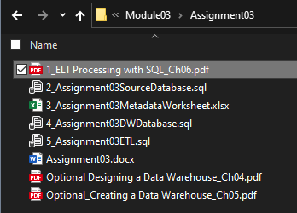

Figure 1. The files in the assignment folder

## Task 2: Create a ETL Administration Report

**Create** a metadata administration report using Report Builder that shows the ETL logging data.

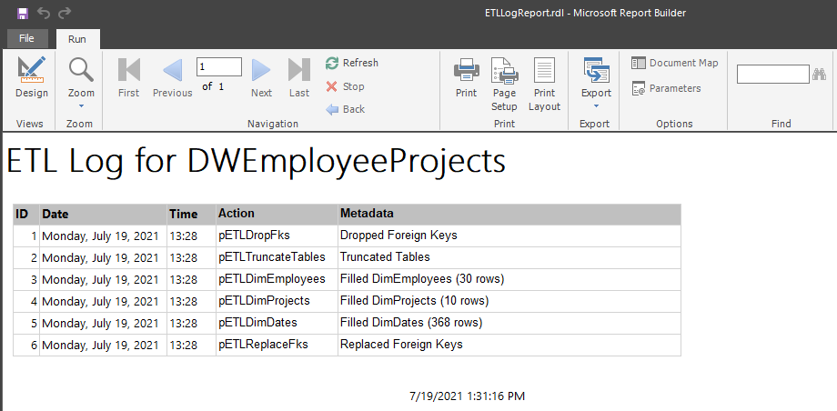

Figure 2. A simple administrative report using Report Builder

## Task 3: Document your knowledge

After you have created your **ETL process and report**, write a paper **describing how they work as if you were explaining it to a coworker.**

Please use **save document as a PDF file**. Then, place it in the Document folder of your Visual Studio Solution (Make sure to Save All).

You only need about a few paragraphs, though you can do more if you want. Make sure there are an introduction, a summary, and one or more topic paragraphs.

**Note:** Make sure you put it in the proper, professional-level formatting! It does not have to be perfect, but you won't get credit for turning in a simple blob of text! Use this link to understand what I am looking for: [Creating Professional Documents](https://youtu.be/9ojhSW9ljjo) (External Site)

**Important:** Make sure to **add** your completed document to Visual Studio solution with your other files.

## Task 4: Add your files to the Visual Studio Solution

Now add all the SQL scripts and documents to a Blank solution. Make sure your Solution, folders, and files look like the Figure 2.

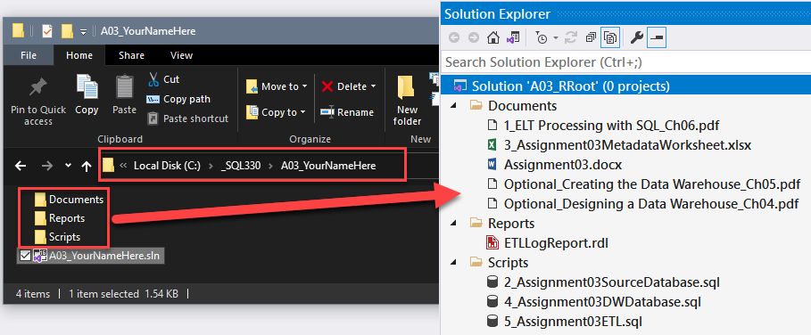

Figure 3. The physical and logical folder and their files in a Visual Studio solution

**Note:** Please create your solution using the location and name show in Figure 2 (**C:/_SQL330/A03_YourNameHere**).

**Important:** Make sure to **click** the Save-All button in Visual Studio when you are done!

# Submit you work to the Canvas site

After you complete you your work, **compress** **the Solution folder** into a single zip file, then submit the zip file on the Canvas website, in the appropriate module Assignment.

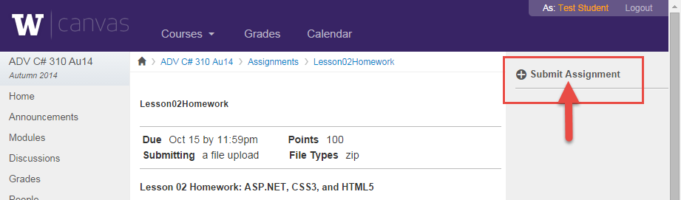

Figure 4. The submit assignment button in Canvas.

***You’re done!***