Assignment 04

Data Movement – Part 2 (Visual ETL Processing)

# ****Module Overview****

In this module, you learn about moving data between databases by creating a Visual ETL process. This assignment will take you about 10 to 15 hours, so plan accordingly!

# ****Required Software****

Install SQL Developer Edition (or equivalent), Visual Studio 2019 Community edition with the SSIS Extension.

# Assignment Videos

Please watch the following assignment videos. You can watch them all at once, but I recommend watching a few, changing to a different task, like reading, and then watching a few more.

<https://youtube.com/playlist?list=PLfycUyp06LG9W6DDsZ53Yu_EXie4EgqZB>

# Assignment Articles

Please read the following documents:

* **1_Visual ELT with SSIS_Ch07.pdf** (included in the module's assignment folder)
* <https://www.mssqltips.com/sqlservertip/1643/using-openrowset-to-read-large-files-into-sql-server/>
* <https://codingsight.com/sql-server-bulk-insert-part-1/>
* <https://www.sqlshack.com/introduction-bcp-utility-bulk-copy-program-sql-server/>

**Notes:**

* You do **not** need to perform any of the demos are labs in these articles
* I have included the chapter 08 file in case you would like to read that too, but it is **optional**.

# Assignment Tasks

In this assignment's tasks, you will create two SSIS projects. The first project will simply execute a set of provided ETL stored procedures using SSIS Execute SQL tasks. The second project will import file data into a SQL server database using more advanced features of SSIS.

## Task 1: Create a DW with ETL Objects

In this step, you review and execute my pre-made ETL code.

1. **Open, review, and execute** the script, **2_Assignment03SourceDatabase.sql** to create the source database.
2. **Review** the metadata worksheet, **3_Assignment03MetadataWorksheet.xlsx.**
3. **Open, review, and execute** the script **4_Assignment03DWDatabase.sql**. to create the destination.
4. **Open, review, and execute** the script **5_Assignment03ETL.sql** to create an ETL process.

## Task 2: Create Solution

In this step, you organize the assignment files using SSIS.

1. **Create** a Blank Solution called **A04_YourNameHere**.
2. **Create** physical and logical folders in the Solution called **Documents, Reports, and Scripts**.
3. **Add** the assignment files to the physical solution folders and then include them in Visual Studio Solution.

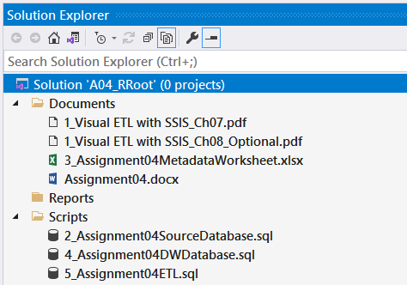

Figure 1. The files in the assignment folder

**Important:** Make sure to **click** the Save-All button in Visual Studio when you are done!

## Task 3: Create an SSIS Project

In this step, you create an SSIS project that executes the ETL objects created in Step 1.

1. **Add** an SSIS project to your VS Solution called "**A04ETLProcess**"
2. **Rename** to package file to "**ETLProcess**"
3. **Add and Rename** SSIS Sequence Container to the package called:

* **"Pre-Load Sequence Container"**
* **"Load Dim Tables Sequence Container "**
* **"Load Fact Tables Sequence Container "**
* **"Post-Load Sequence Container"**

1. **Add** **and** **Rename** SSIS Execute SQL Tasks to the Sequence Containers called:

* **"Drop Fks"**
* **"Truncate Tables"**
* **"Fill DimEmployees"**
* **"Fill DimProjects"**
* **"Fill DimDates"**
* **"Fill FactEmployeeProjectHours"**
* **"Replace Fks"**

1. **Configure** each Execute SQL Task to execute the stored procedures you created by running the **5_Assignment03ETL.sql** file.

* Exec pETLDropFks;
* Exec pETLTruncateTables;
* Exec pETLDimEmployees;
* Exec pETLDimProjects;
* Exec pETLDimDates;
* Exec pETLFactEmployeeProjectHours;
* Exec pETLReplaceFks;

1. Test your SSIS package and verify that the ETL process is working as expected.

* Select * From [ETLMetadata];
* Select * From [dbo].[DimEmployees];
* Select * From [dbo].[DimProjects];
* Select * From [DimDates];
* Select * From [FactEmployeeProjectHours];

**Important:** Make sure to **click** the **Save All** button in Visual Studio when you are done!

## Task 4: Create an ETL Administration Report

In this step, you create a simple administrative report.

1. **Create** a metadata administration report using Report Builder that shows the ETL logging data.
2. **Add** the resulting RDL file to your physical solution folder called Reports and then include it in Visual Studio.

## Step 5. Create another SSIS Project

In this step, you perform a part of Microsoft's tutorial for SSIS. This tutorial can be difficult for beginners, but you have already seen how I've done the tutorial in this assignment's video playlist. Please use those videos as a reference if you get stuck.

1. **Read and perform** the tasks in lessons 1 through 4 of Microsoft's tutorial for SSIS.

*"Lessons in This Tutorial*

[*Lesson 1: Create a Project and Basic Package with SSIS*](https://docs.microsoft.com/en-us/sql/integration-services/lesson-1-create-a-project-and-basic-package-with-ssis?view=sql-server-ver15) *In this lesson, you create a simple ETL package that extracts data from a single flat file, transforms the data using lookup transformations and finally loads the result into a fact table destination.*

[*Lesson 2: Adding Looping with SSIS*](https://docs.microsoft.com/en-us/sql/integration-services/lesson-2-adding-looping-with-ssis?view=sql-server-ver15) *In this lesson, you expand the package you created in Lesson 1 to take advantage of new looping features to extract multiple flat files into a single data flow process.*

[*Lesson 3: Add Logging with SSIS*](https://docs.microsoft.com/en-us/sql/integration-services/lesson-3-add-logging-with-ssis?view=sql-server-ver15) *In this lesson, you expand the package you created in Lesson 2 to take advantage of new logging features.*

[*Lesson 4: Add Error Flow Redirection with SSIS*](https://docs.microsoft.com/en-us/sql/integration-services/lesson-4-add-error-flow-redirection-with-ssis?view=sql-server-ver15) *In this lesson, you expand the package you created in lesson 3 to take advantage of new error output configurations."* ( <https://docs.microsoft.com/en-us/sql/integration-services/ssis-how-to-create-an-etl-package>, 2018)

**Important:** When instructed to create a new SSIS project in Lesson 1-1, add the project to your current Solution instead!

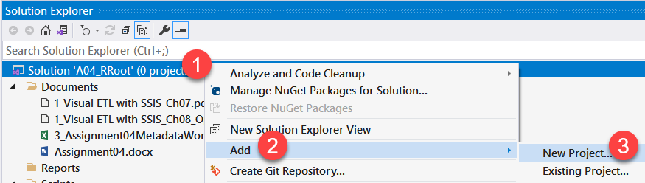

Figure 2. Adding a new Project to your VS Solution.

## Task 5: Document Your Knowledge

After you have created your ETL Solution, **write** a paper as if **describing to a coworker what SSIS is and why it is important to SQL professionals.**

Please **save your document as** **a PDF file**. Then, place it in the Document folder of your Visual Studio Solution (Make sure to Save All).

You only need about a few paragraphs, though you can do more if you want. Make sure there are an introduction, a summary, and one or more topic paragraphs.

**Note:** Make sure you put it in the proper, professional-level formatting! It does not have to be perfect, but you won't get credit for turning in a simple blob of text! Use this link to understand what I am looking for: [Creating Professional Documents](https://youtu.be/9ojhSW9ljjo) (External Site)

**Important:** Make sure to **add** your completed document to your Visual Studio solution with your other files.

# Submit your work to the Canvas site

After you complete your work, **compress** the **Solution folder** into a single zip file, then submit the zip file on the Canvas website, in the appropriate module Assignment.

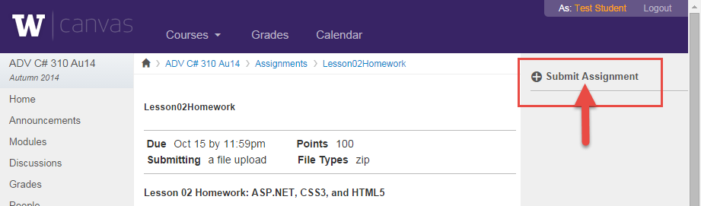

Figure 4. The submit assignment button in Canvas.

***You’re done!***