Assignment 05

Automation

# ****Module Overview****

In this module, you learn about automating tasks to run on a predefined schedule using SQL Server Agent and Windows Scheduler.

# ****Required Software****

* SQL Developer Edition (or equivalent)
* Visual Studio 2019 Community edition with the SSIS Extension
* Report Builder

# Assignment Videos

Please watch the following assignment videos. You can watch them all at once, but I recommend watching a few, changing to a different task, like reading, and then watching a few more.

<https://youtube.com/playlist?list=PLfycUyp06LG8bKCdWgJEkP9xdlTlARvZ6>

# Assignment Articles

Please read the following documents:

<https://www.sqlshack.com/introduction-to-the-sql-server-agent/>

<https://www.sqlshack.com/multiple-methods-for-scheduling-a-sql-server-backup-automatically/>

<https://www.sqlshack.com/automate-sql-database-backups-using-maintenance-plans/>

<https://www.mssqltips.com/sqlservertip/5019/sql-server-agent-job-schedule-reporting/>

**Note:** You do **not** need to perform any of the demos are labs in these articles

# Assignment Tasks

In this assignment's tasks, you will create two SSIS projects. The first project will simply execute a set of provided ETL stored procedures using SSIS Execute SQL tasks. The second project will import file data into a SQL server database using more advanced features of SSIS.

## Task 1: Create a DW with ETL Objects

In this step, you review and execute my pre-made ETL code.

1. **Open, review, and execute** the script, **1_Assignment03SourceDatabase.sql** to create the source database.
2. **Review** the metadata worksheet, **2_Assignment03MetadataWorksheet.xlsx.**
3. **Open, review, and execute** the script **3_Assignment03DWDatabase.sql**. to create the destination.
4. **Open, review, and execute** the script **4_Assignment03ETL.sql** to create an ETL process.

## Task 2: Review a Solution

In this step, you review and Visual Studio Solution. The solution is already created, but you must make sure that the package can run on your machine. If not, verify that the databases and all the ETL objects have been created.

1. **Open, review, and execute** the SSIS package DWEmployeeProjectsETLProcess.

2. **Change** the name of the Solution to use your name.

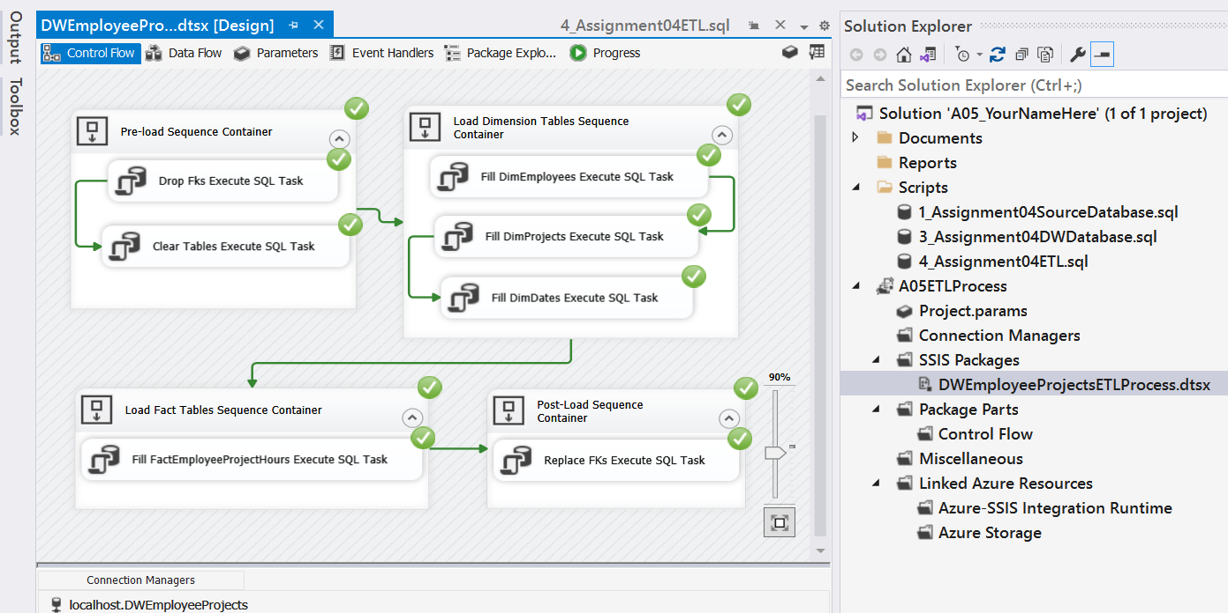

Figure 1. Testing the SSIS package

**Tips:** Remember to check the SQL Server Connection if you are using a named instance

## Task 3: Automate the SSIS Package using SQL Agent

You are now going to create an SQL Agent automation job. Then you will create a script so that your instructor can run this script to verify that your job was configured correctly.

1. **Copy** the SIS SSIS package in two a folder called C:\_SQL330.

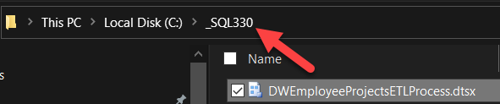

Figure 2. Copying the SSIS package

2. **Create** a SQL Server agent automation job to execute the package each day at 1:00 AM.

3. **Create** a SQL script so that the job can be created on another computer.

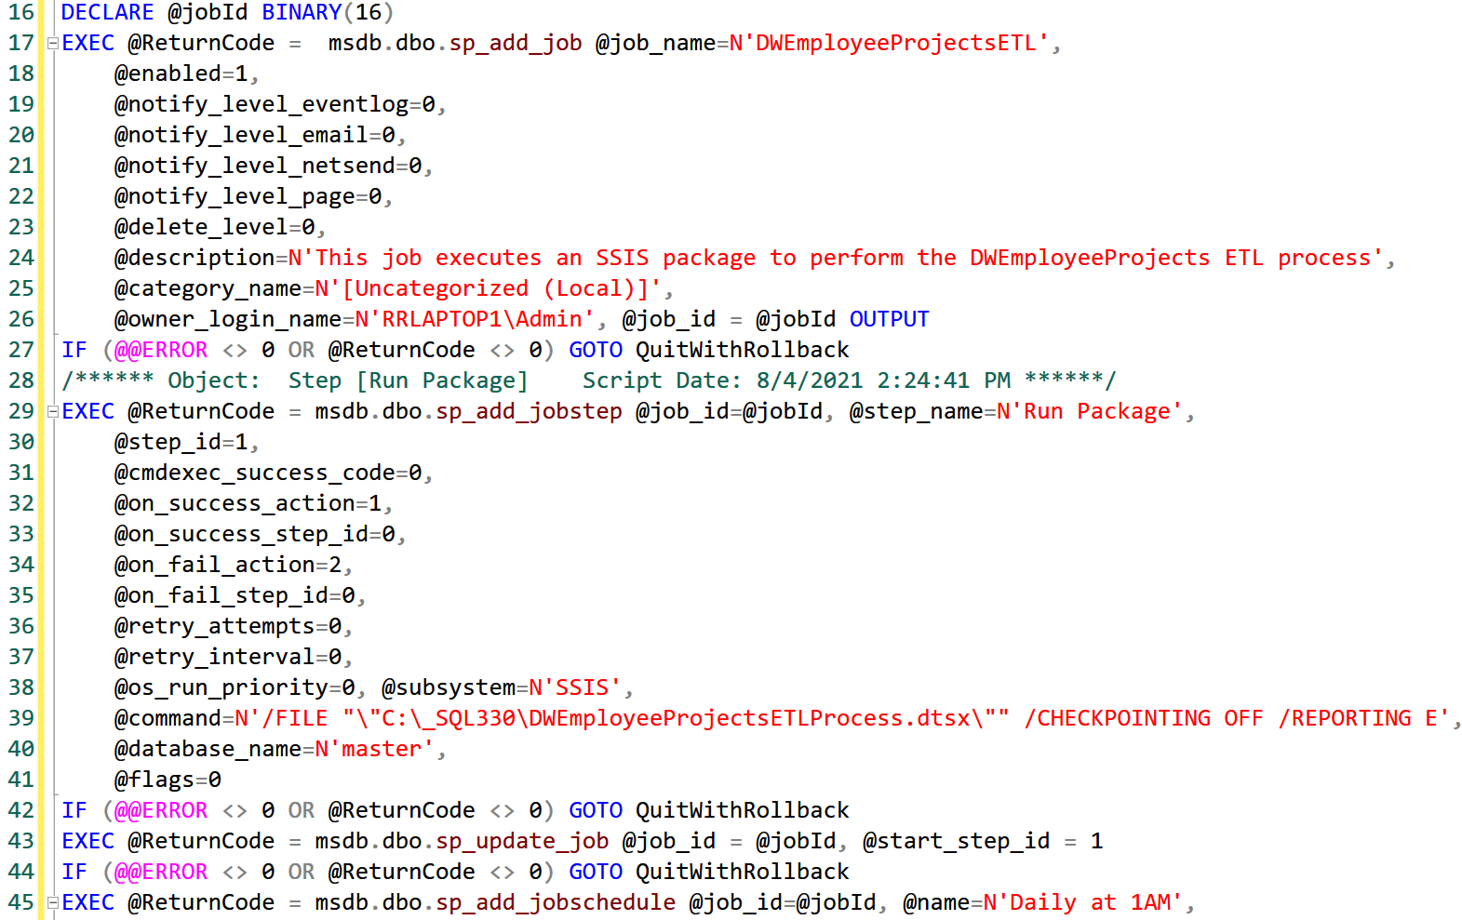

Figure 3. The Job as a script file.

4. **Add** the SQL Agent Job Script to your VS Solution and **click** Save All.

## Task 4: Create an Automation Report

Use SSRS Report Builder to report on both the ETL log and the SQL Agent job history.

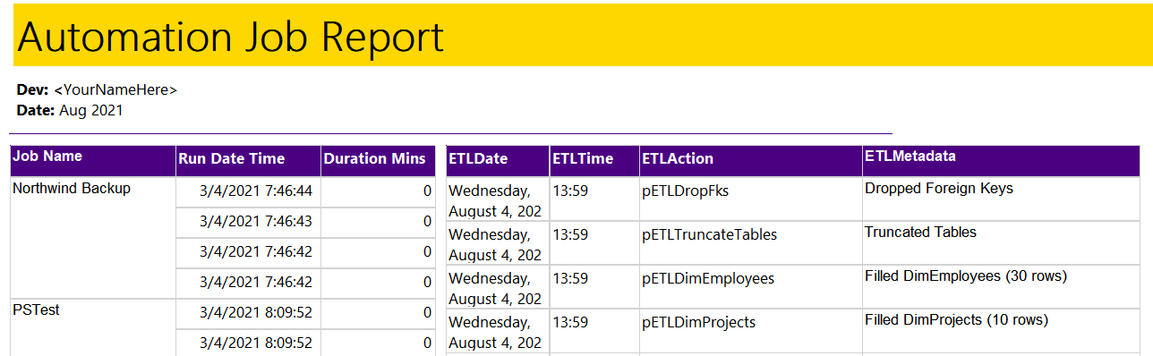

Figure 4. The Report Builder report

**Tips:** If elements overlap they will hide one of them.

## Task 5: Document Your Knowledge

After you have created your ETL Solution, **write** a paper as if **describing to a coworker how your ELT Automation process works.** **Included enough detail** that they could troubleshoot the processes if you were on vacation!

Please **save your document as a PDF file**. Then, place it in the Document folder of your Visual Studio Solution (Make sure to Save All).

You only need about a few paragraphs, though you can do more if you want. Make sure there are an introduction, a summary, and one or more topic paragraphs.

**Note:** Make sure you put it in the proper, professional-level formatting! It does not have to be perfect, but you won't get credit for turning in a simple blob of text! Use this link to understand what I am looking for: [Creating Professional Documents](https://youtu.be/9ojhSW9ljjo) (External Site)

## Task 6: Add your files to the Visual Studio Solution

Now that the SQL **script** and Word **document** are complete, **add** all files **to** the assignment's VS **Solution**.

**Important:** Make sure to **click** the Save-All button in Visual Studio when you are done!

# Submit your work to the Canvas site

After you complete your work, **compress** the Solution folder into a single zip file, then submit the zip file on the Canvas website, in the appropriate module Assignment.

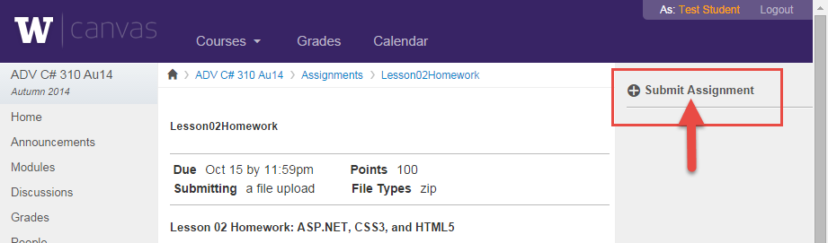

Figure 5. The submit assignment button in Canvas.

***You’re done!***