Assignment 06

Reporting

# ****Module Overview****

In this module, you learn about creating and managing reports using PowerBI Reporting Server.

# ****Required Software****

* SQL Developer Edition (or equivalent)
* Report Builder
* Visual Studio 2019 Community edition with the SSRS Extension
  + <https://marketplace.visualstudio.com/items?itemName=ProBITools.MicrosoftReportProjectsforVisualStudio>
* **Optional** SSRS Server (See the article on installation **)
  + <https://www.microsoft.com/en-us/download/details.aspx?id=100122>

# Assignment Videos

Please watch the following assignment videos. You can watch them all at once, but I recommend watching a few, changing to a different task, like reading, and then watching a few more.

<https://youtube.com/playlist?list=PLfycUyp06LG-5ST4OowGWXfK0r5Sw9LY9>

**NOTE: If you have time**, and are interested in learning more about this subject, watch the included **Optional Videos**

23:03 Tableau in Two Minutes - Tableau Basics for Beginners Penguin Analytics

20:29 Creating a simple application with the Entity Framework Randal Root

34:20 Ethics in Data Management Gregory Thomas Hay

27:53 How to use Microsoft Power BI - Tutorial for Beginners

# Assignment Articles

Please read the following documents:

* **\*\*** <https://docs.microsoft.com/en-us/sql/reporting-services/install-windows/install-reporting-services?view=sql-server-ver15>
* <https://www.mssqltips.com/sqlservertip/6816/getting-started-with-ssrs/>
* <https://docs.microsoft.com/en-us/power-bi/report-server/get-started>
* <https://docs.microsoft.com/en-us/power-bi/fundamentals/desktop-getting-started>
* <https://www.stratascratch.com/blog/types-of-window-functions-in-sql-and-questions-asked-by-airbnb-netflix-twitter-and-uber/>

**Notes:**

* You do **not** need to perform any of the demos are labs in these articles

# Assignment Tasks

In this assignment's tasks, you will create two SSIS projects. The first project will execute a set of provided ETL stored procedures using SSIS Execute SQL tasks. The second project will allow you to create a collection of SSRS ETL reports.

Step 1. Create a DW with ETL and Reporting Objects

In this step, you review and execute my pre-made ETL code.

1. **Open, review, and execute** the script, **1_Assignment06SourceDatabase.sql** to create the source database.
2. **Review** the metadata worksheet, **2_Assignment06MetadataWorksheet.xlsx.**
3. **Open, review, and execute** the script **3_Assignment06DWDatabase.sql** to create the destination database.
4. **Open, review, and execute** the script **4_Assignment06ETL.sql** to create an ETL process.
5. **Open, review, and execute** the script **5_Assignment06ETLReportingObjects.sql** to create the ETL report views.

## Step 2. Review a Solution

In this step, you review a Visual Studio Solution that I've created and ensure that the SSIS package runs on your machine. If not, check the connection manager and verify that the databases and ETL objects are created.

1. **Open, review, and execute** the SSIS package DWEmployeeProjectsETLProcess.

2. **Change** the name of the Solution to use your name.

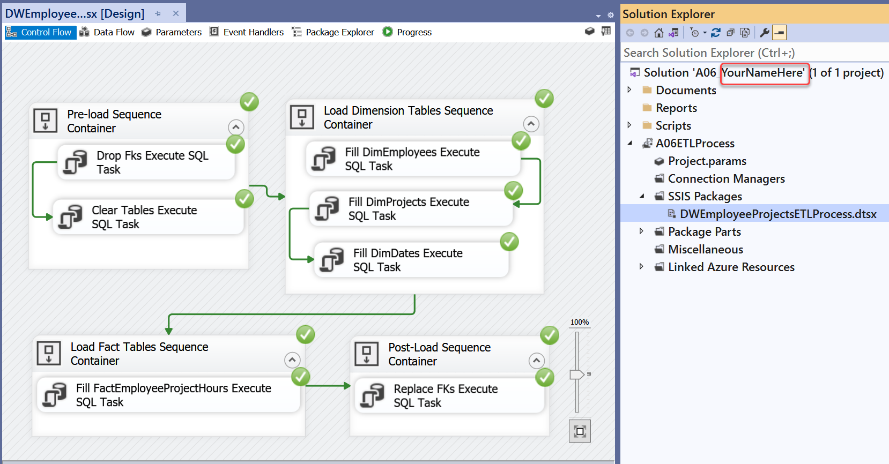

Figure 1. Testing the SSIS package

**Tips:** Remember to check the SQL Server Connection if you are using a named instance

## Step 3. Create a Reporting Server (SSRS) Project

In this step, you will create a new SSRS project with several reports.

a. **Verify or install** the SSRS Extension in Visual Studio.

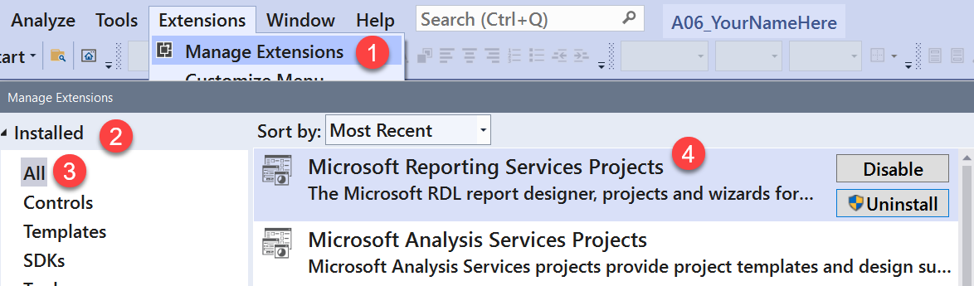

Figure 1. Checking that the installation of the SSRS extension

b. **Add** an SSRS project named **DWEmployeeProjectsReports** to the Solution.

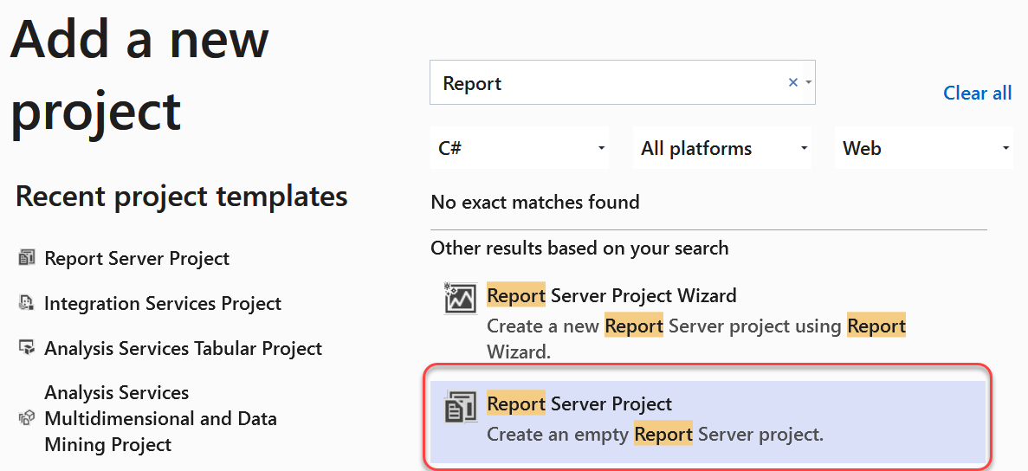

Figure 2. Adding a new SSRS project to the Solution.

## Step 4. Create ETL Reports

Create SSRS reports for each of the DWEmployeeProjects data warehouse tables.

**TIP:** If you get stuck, you can use the Microsoft tutorial as a guide.

<https://docs.microsoft.com/en-us/sql/reporting-services/lesson-1-creating-a-report-server-project-reporting-services?view=sql-server-ver15>

a. **Create** a new report named **DimEmployeesETLReport**, then **click** the Save-All button.

b. **Add** a Data Source and four Data Sets for the DimEmployees report.

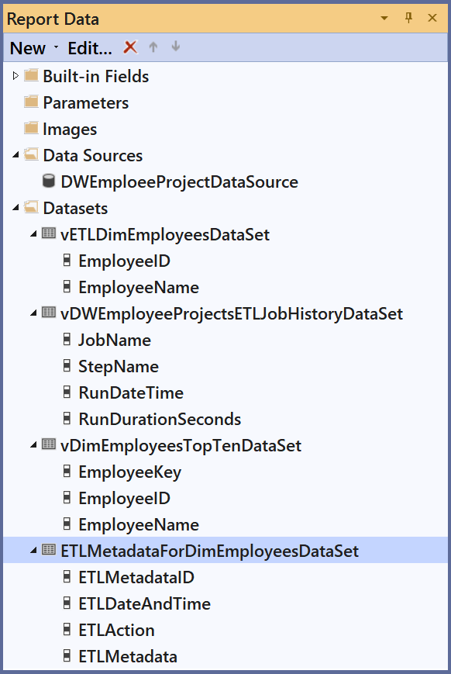

Figure 3. The DimEmployeesETLReport's Data Source and Data Sets

c. Add a Header and a Footer to the report by right-clicking the body and choosing Insert>Page Header and Insert>Page Footer from the context menu.

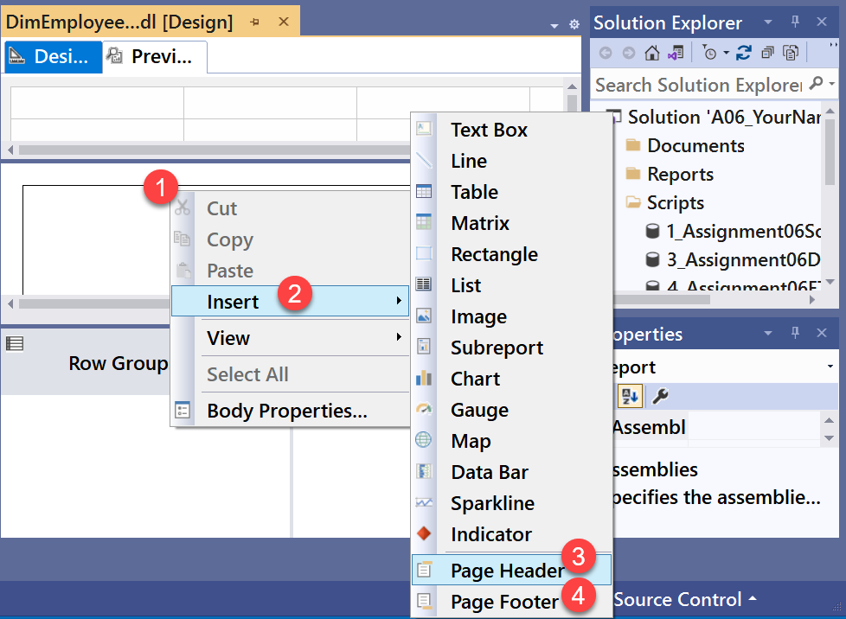

Figure 4. Adding a header and footer to the report

d. Configure the header to include the report's name, developer name, and the date the report was created. Next, configure the footer to include the report's run date.

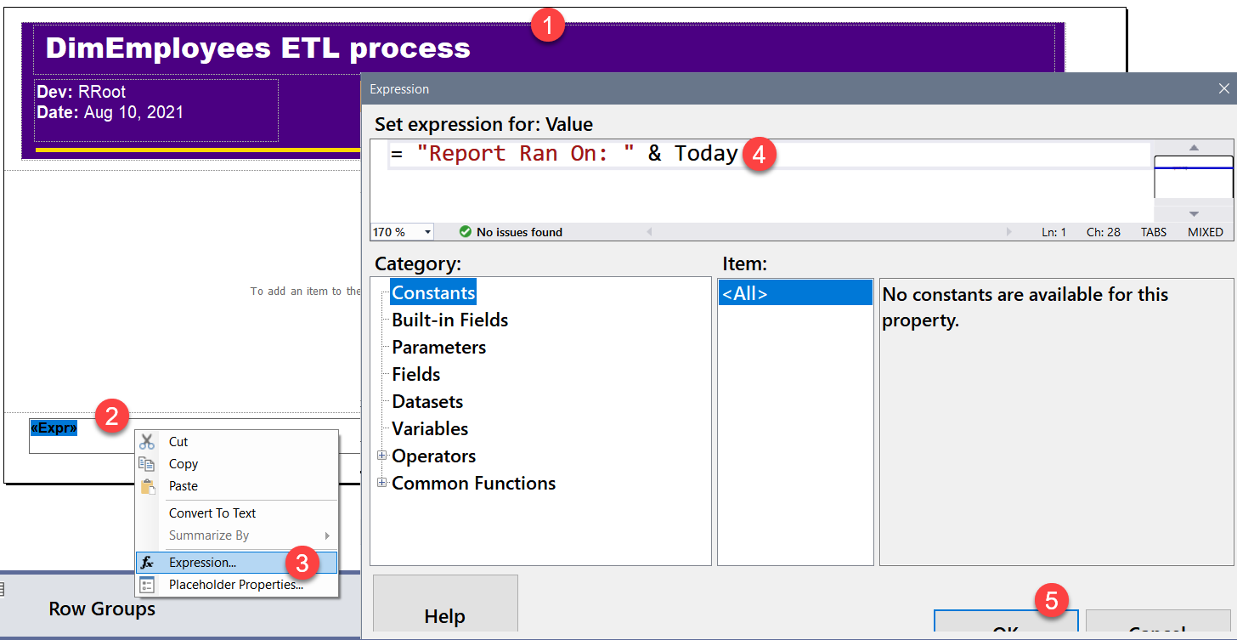

Figure 5. Configuring the header and footer.

e. Configure the body of the report to show the data in the four data sets. Try to match the following image.

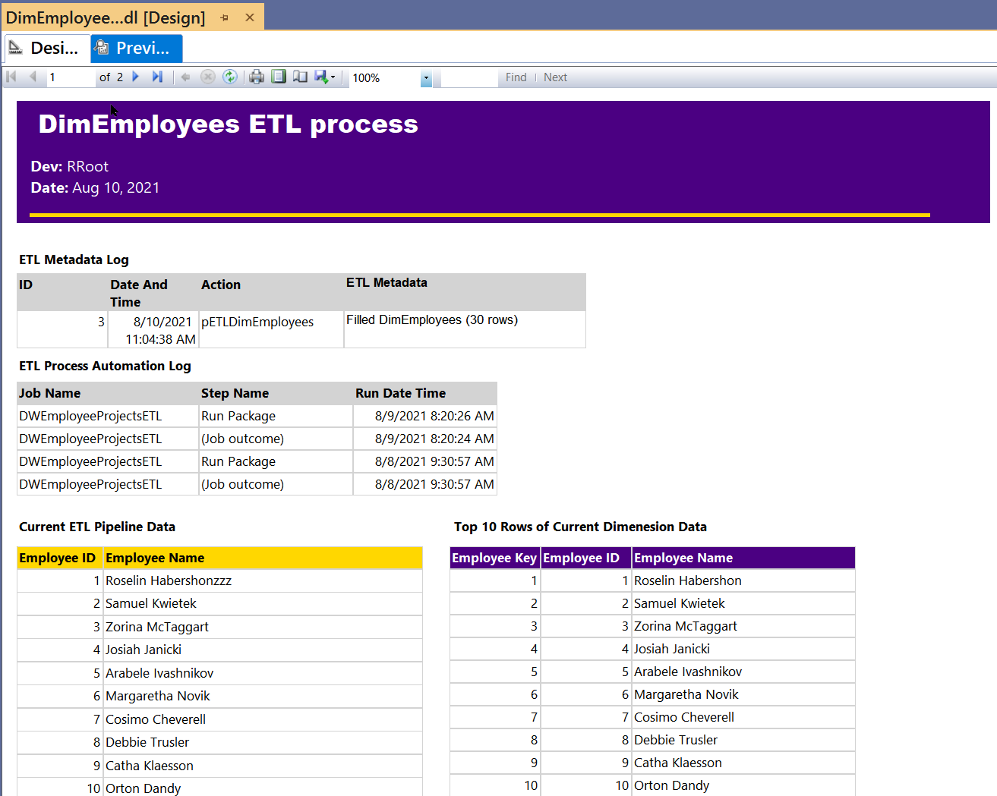

Figure 6. The configured body of the report when Previewed.

f. **Note** that the data for Employee 1 is not in sync between the data source and its destination.

g. **Execute** the SSIS Package and **verify** that the destination database is updated.

h. **Copy and Paste** your report to your _SQL330 folder.

i. **Add** your report as a Custom report in SSMS.

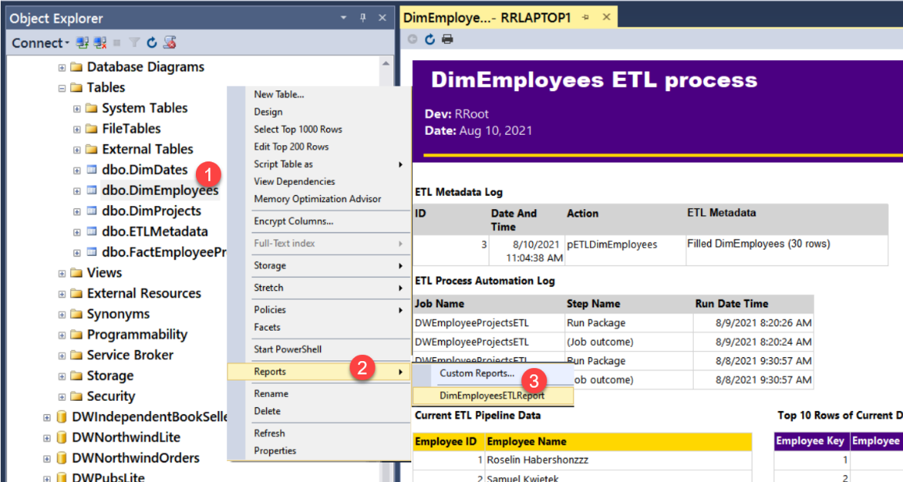

Figure 7. Viewing the report from SSMS

j. **Optionally**, **add** reports for the Projects dimension and FactEmployeeProjectHours tables. (20 Bonus Points)

# Assignment Knowledge Document

After you have created your ETL Solution, **write** a paper as if **describing to a coworker how your ELT Reporting process works.** **Included enough detail** that they could troubleshoot the process if you were on vacation!

Please use an MS Word compatible editor and **save your files as** **either a doc or docx file**. Then, place it in the Document folder of your Visual Studio Solution (Make sure to Save All).

You only need about a few paragraphs, though you can do more if you want. Make sure there are an introduction, a summary, and one or more topic paragraphs.

**Note:** Make sure you put it in the proper, professional-level formatting! It does not have to be perfect, but you won't get credit for turning in a simple blob of text! Use this link to understand what I am looking for: [Creating Professional Documents](https://youtu.be/9ojhSW9ljjo) (External Site)

# Add your files to the Visual Studio Solution

Now that the Word **document** is complete, **add** it **to** the assignment's VS **Solution**.

**Important:** Make sure to **click** the Save-All button in Visual Studio when you are done!

# Submit your work to the Canvas site

After you complete your work, **compress** the Solution folder into a single zip file, then submit the zip file on the Canvas website, in the appropriate module Assignment.

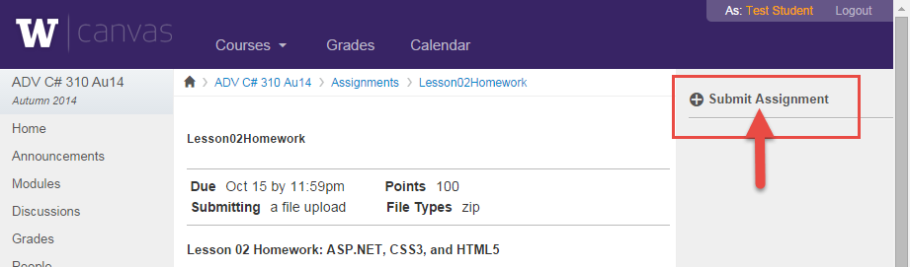

Figure 5. The submit assignment button in Canvas.

***You are done!***