<https://kubernetes.io/docs/concepts/overview/>

automating deployment, scaling, and management of containerized applications.

**Cluster**

* Multiple computing nodes or hosts that work together to support an application or middleware such as a database.
* A cluster is a group of inter-connected computers or hosts (Nodes) that work together to support applications and middleware (e.g. databases). In a cluster, each computer is referred to as a “node”.
* Nodes in a cluster are usually connected to each other through high-speed LAN. Each node runs its own instance of an operating system.
* A computer cluster may range from a simple two-node system connecting two personal computers to a supercomputer with a cluster architecture.
* Computer clusters are often used for cost-effective high-performance computing (**HPC**) and high availability (**HA**). If a single component fails in a computer cluster, the other nodes continue to provide uninterrupted processing.
* A computer cluster can provide faster processing speed, larger storage capacity, better data integrity, greater reliability, and wider availability of resources.
* Computer clusters are usually dedicated to specific functions, such as load balancing, high availability, high performance, or large-scale processing.

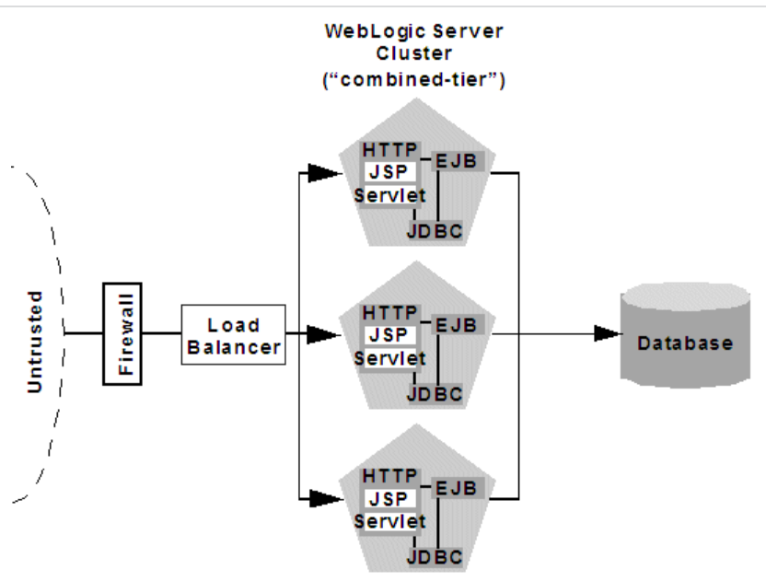

Container

Node

POD

Load Balancing

Objects In Kubernetes

Object spec and status

**NGINX Ingress Controller for Kubernetes Release 1.7.0**

**Ingress load balancing on Kubernetes platforms,**

<https://www.nginx.com/blog/announcing-nginx-ingress-controller-for-kubernetes-release-1-7-0/>

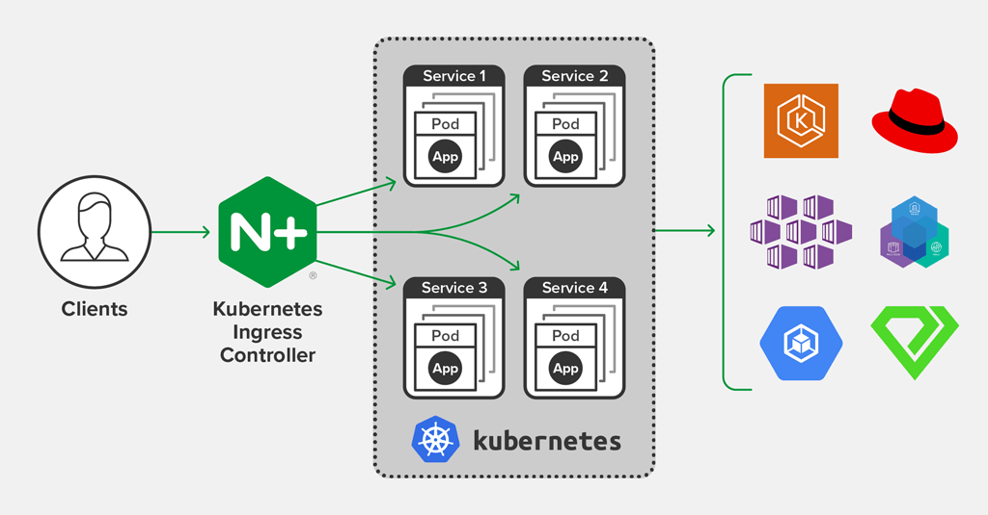

Kubernetes Objects Management

Object Names and IDs

Labels and Selectors