Prototype Pattern

In this lab, you will create objects using the Prototype pattern.

# Objectives

In this lab, you will

* Define a method, duplicate(), in the Interface
* Implement the duplicate() method in the Big class
* Create a duplicate in the Tester

# Exercise

1. The Prototype design patterns makes it easier and faster to create objects using an existing object for a template. Java supports this with the Object.clone() method which makes a shallow copy of an object, but returns the type Object. This exercise creates a prototype returning the correct type.
2. In Eclipse, in the exercises workspace, open the package com.paypal.patterns.Prototype to view the project files.
3. Open Tester.java as shown below;

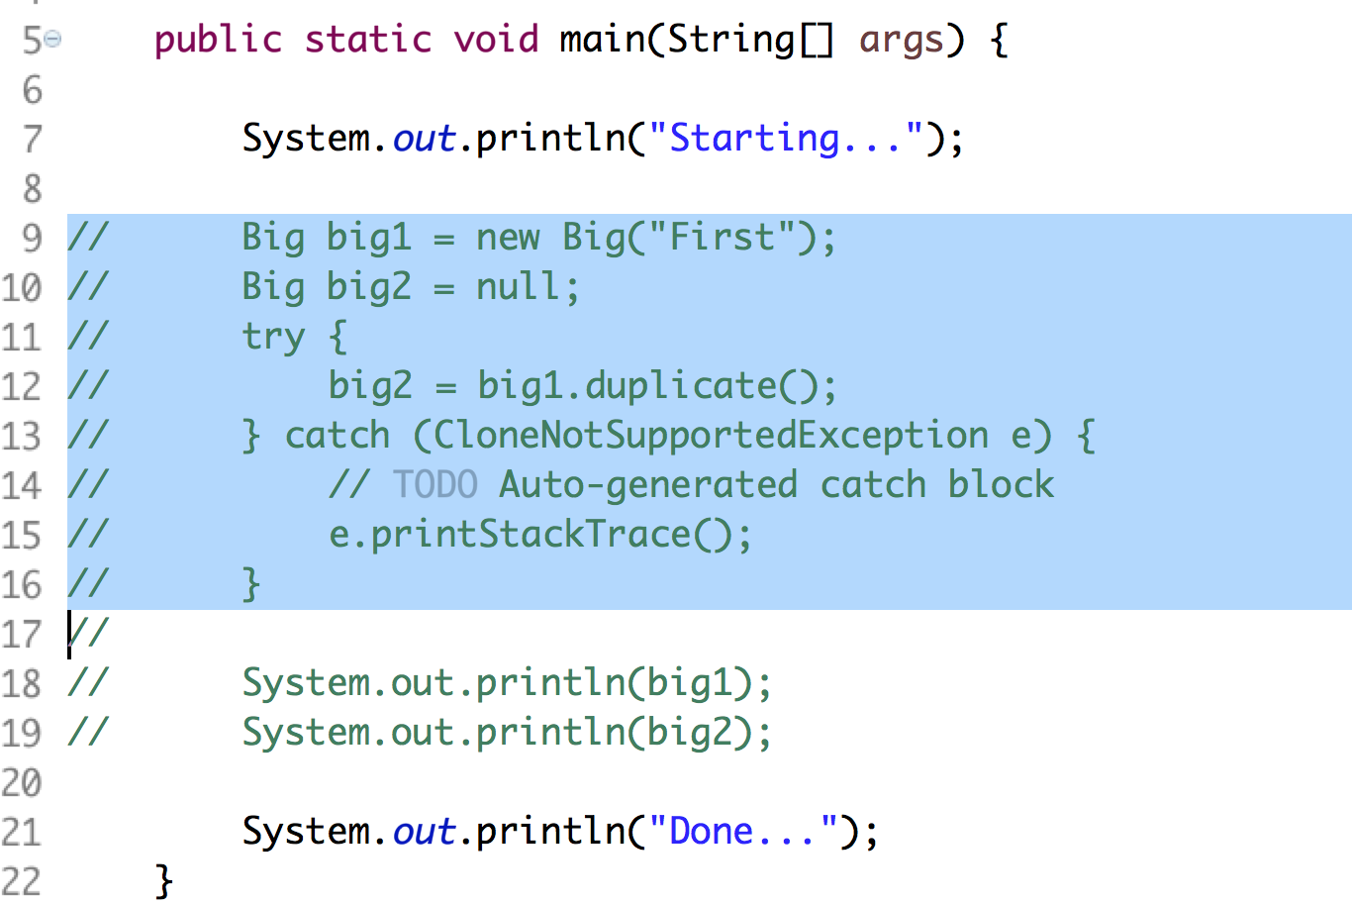

1. On line 9, it creates a Big object to serve as the template (or prototype). On line 12, it duplicates the object, creating a new Big object with the same properties. Examine the results from lines 18 and 19 when it executes and you will see the same property values, but different hashcode() values indicating unique objects.
2. Open BigPrototype.java as shown below;

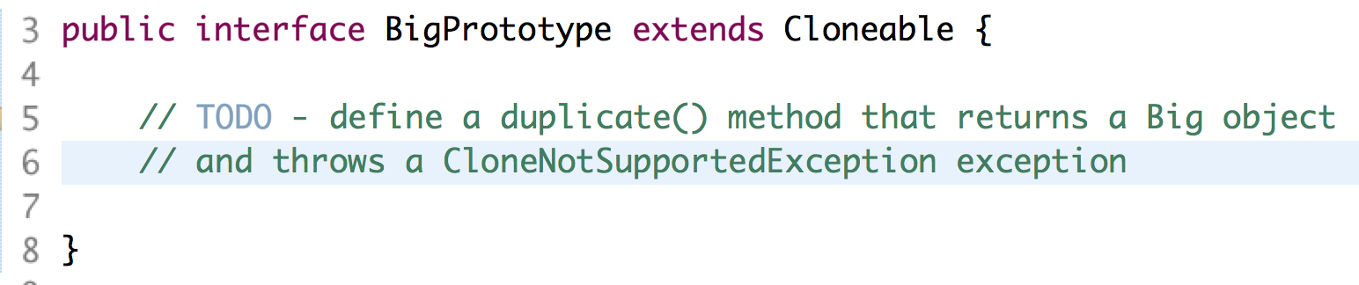

1. From lines 5 - 6, define the duplicate() method. It returns a Big object and might throw a CloneNotSupportedException.
2. Open Big.java as shown below;

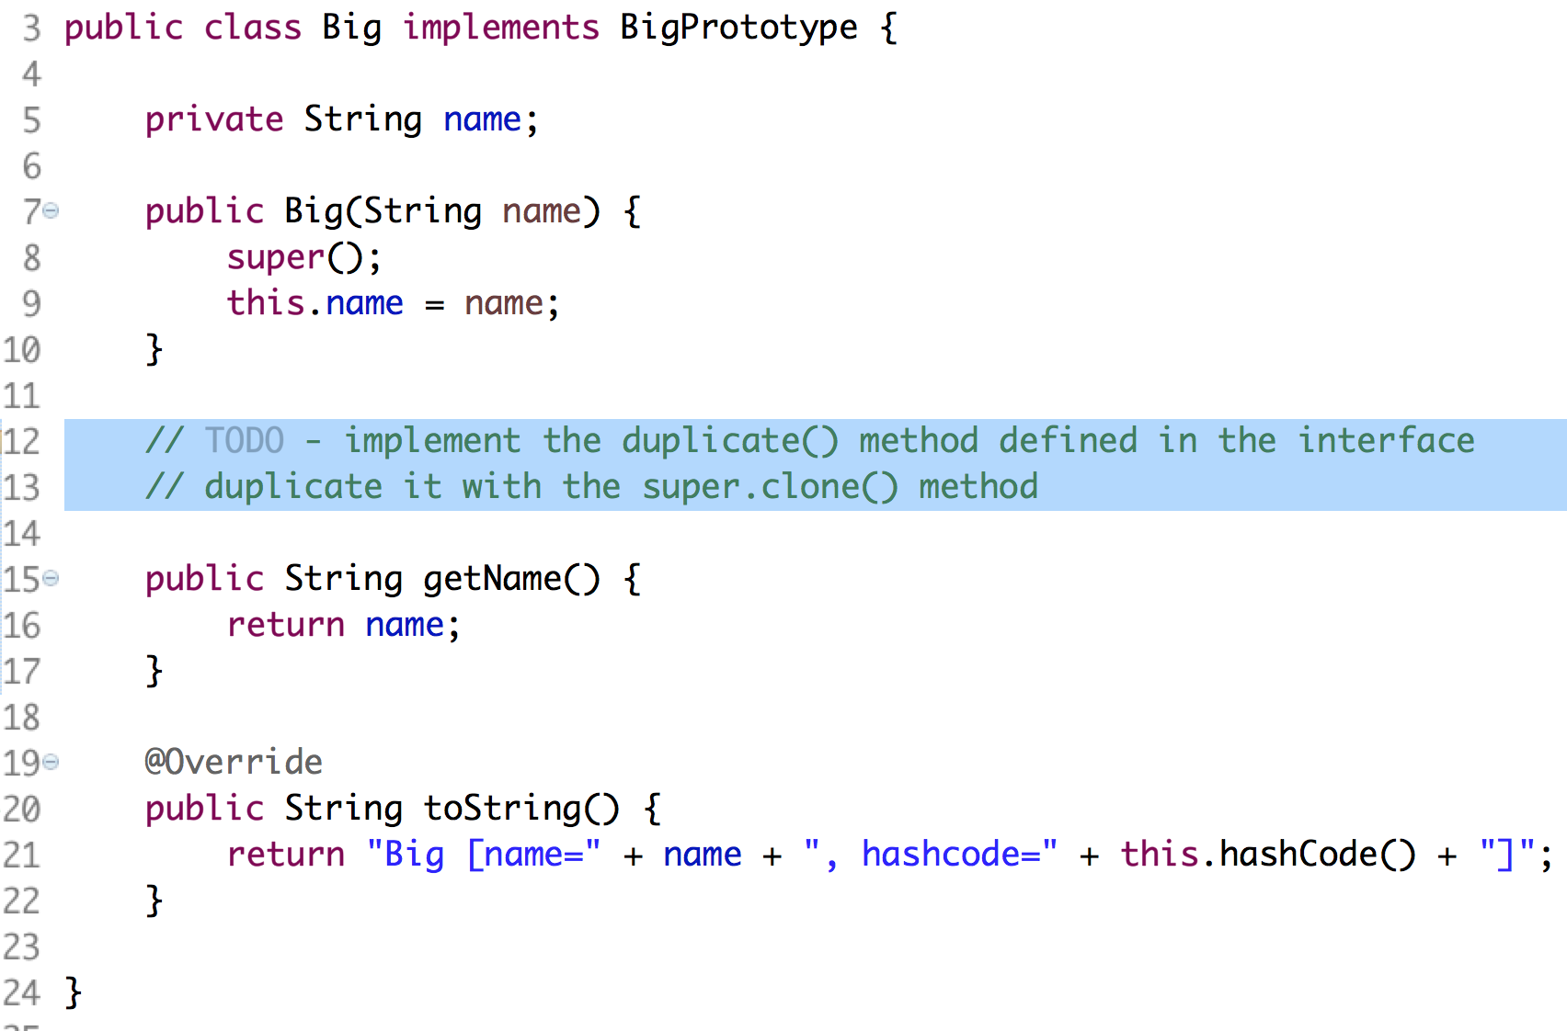

1. From lines 12 - 13, implement the duplicate() method. Use the super.clone() method to get the shallow copy, cast it to the Big type, and return the object created.
2. Uncomment the lines in Tester.java and execute it as a Java application.
3. Notice the two name values are the same, but the two hash code values are different. The properties were duplicated into the new instance.

Congratulations. You have completed this lab.