Singleton

In this lab, you will create a singleton application.

# Objectives

In this lab, you will

* Create a Singleton class
* Create a Class variable
* Access the class variable via an instance method

# Exercise

1. This program generates UUIDs. The purpose of a singleton is to protect the unique nature of the ID. If multiple instances of the class existed, each instance would have its own version of the unique number and they would no longer be unique!!!
2. In Eclipse, in the exercises workspace, open the package com.paypal.patterns.Singleton to view the project files.
3. Open the file, Singleton.java as shown below.

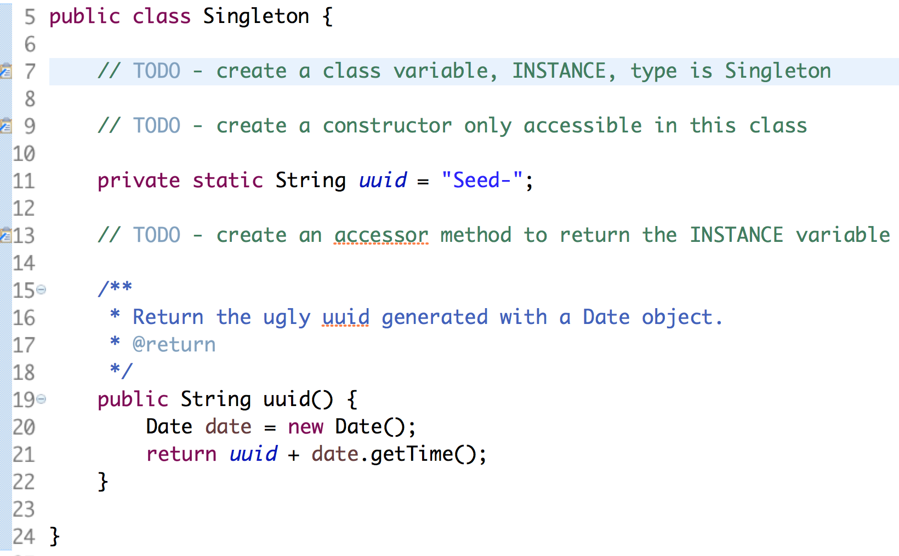

1. On line 7, create a class variable, INSTANCE. In Java, class variables use the keyword: static. Also, mark the variable, private, to prevent other classes from accessing it.
2. On line 9, create a constructor only accessible inside the class.
3. On line 13, create an accessor method, getInstance(), which returns the INSTANCE variable of our singleton.
4. Now we want to call the uuid() method from our singleton.
5. Open the Tester.java file:

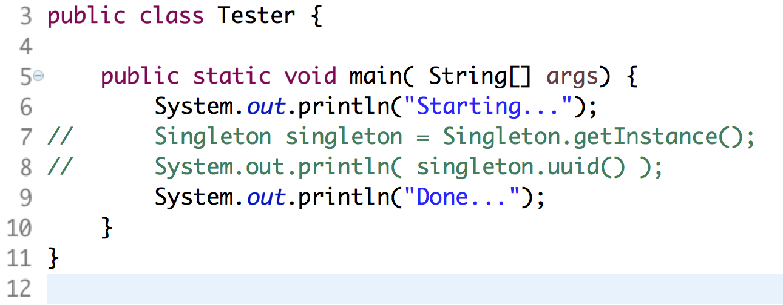

1. Uncomment lines 7 and 8.
2. Run the Tester program as a Java application and view the results.

Congratulations. You have completed this lab.