Command Pattern

In this lab, you will create a set of commands to be executed, then undone.

# Objectives

In this lab, you will

* Examine the commands, Add, Subtract, Multiply, and Divide
* Create a command list of these commands
* Execute the commands
* Undo all the executions

# Exercise

1. The Command pattern represents a set of things to do without naming the context. Usually, the set of commands executes in a separate environment (context), often on the other side of a network.
2. In this example, we create four commands: Add, Subtract, Multiply, and Divide. These commands modify a Counter object which maintains a value changed by the commands. Each command has an execute() and an undo() method.
3. In Eclipse, in the exercises project, open the package com.paypal.patterns.Strategy to view the project files.
4. Examine the client, Tester.java, as shown below:

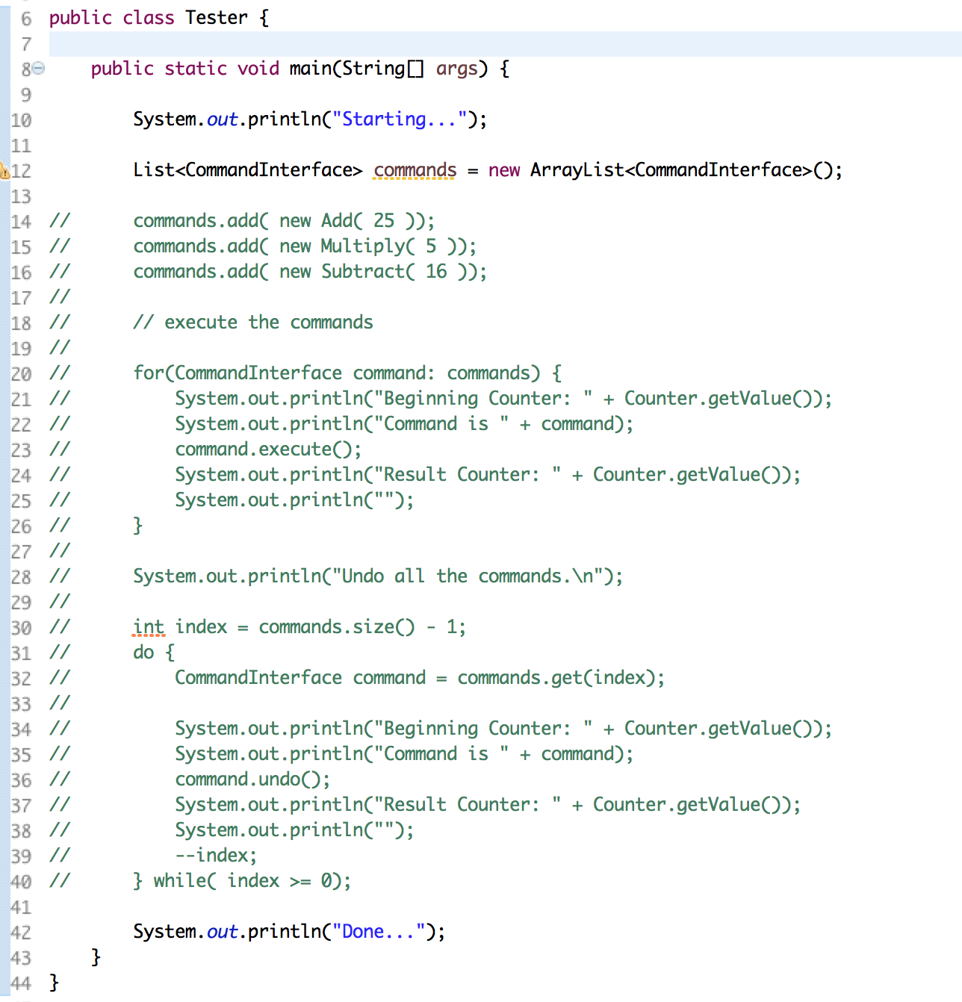

1. In the above, lines 14-16 add the commands to the list of commands. Note: the context for the commands is the Counter singleton described later.
2. Lines 20-26 execute the commands.
3. Lines 30-40 undoes the commands.
4. The Counter singleton provides the context for these commands.
5. Examine the Counter singleton below:

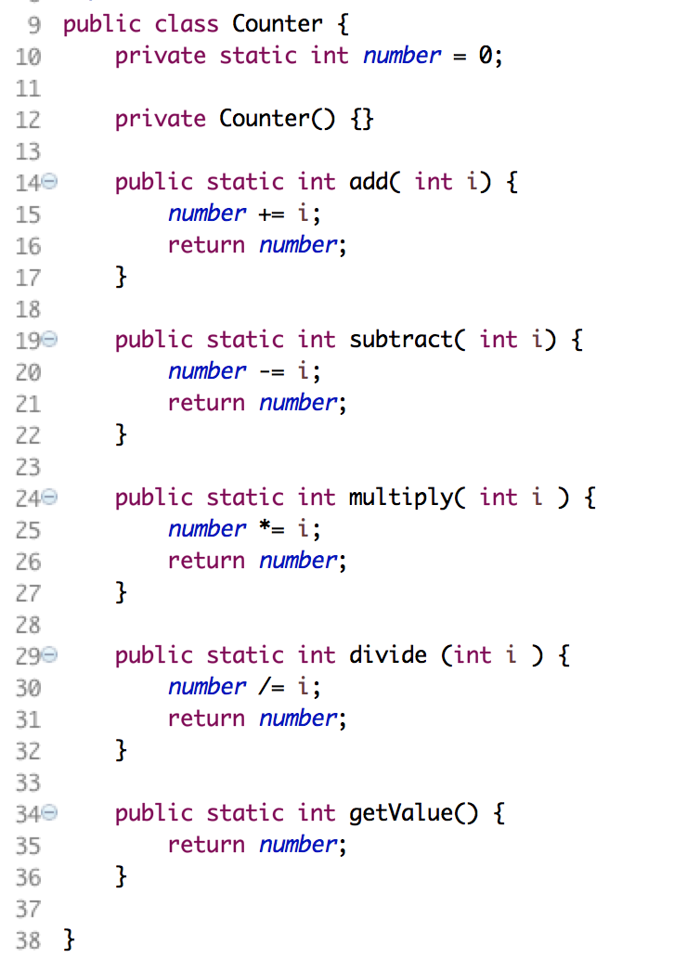

1. The above wraps a number and performs the normal operations on it.
2. NOTE: this context is separate from the commands. Commands usually operate on a context separate from the set of commands.
3. Examine the CommandInterface.java below:

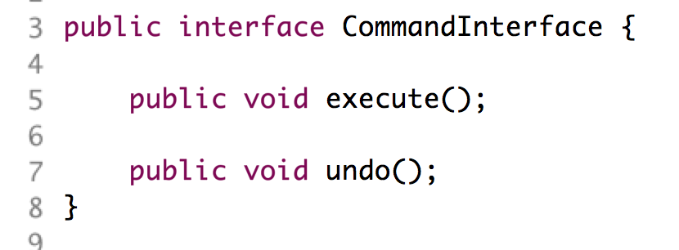

1. This defines the two methods, execute() and undo(). Each of our commands must implement these two methods.
2. Examine one command, Add.java, below:

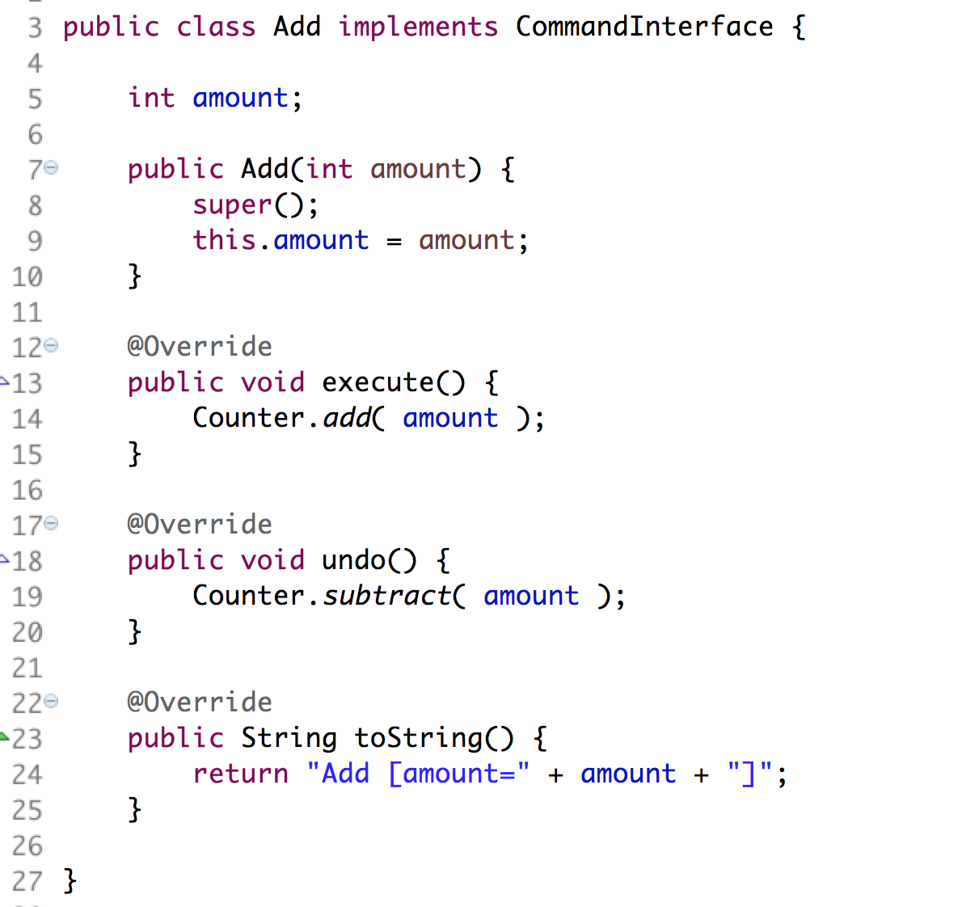

1. Notice how it implements the interface on lines 12-20.
2. Notice how it maintains its state in the constructor. The commands must be able to be run, then undone, then redone, then…
3. Our task is to fix the Subtract and Multiply commands.
4. Edit Subtract.java shown below:

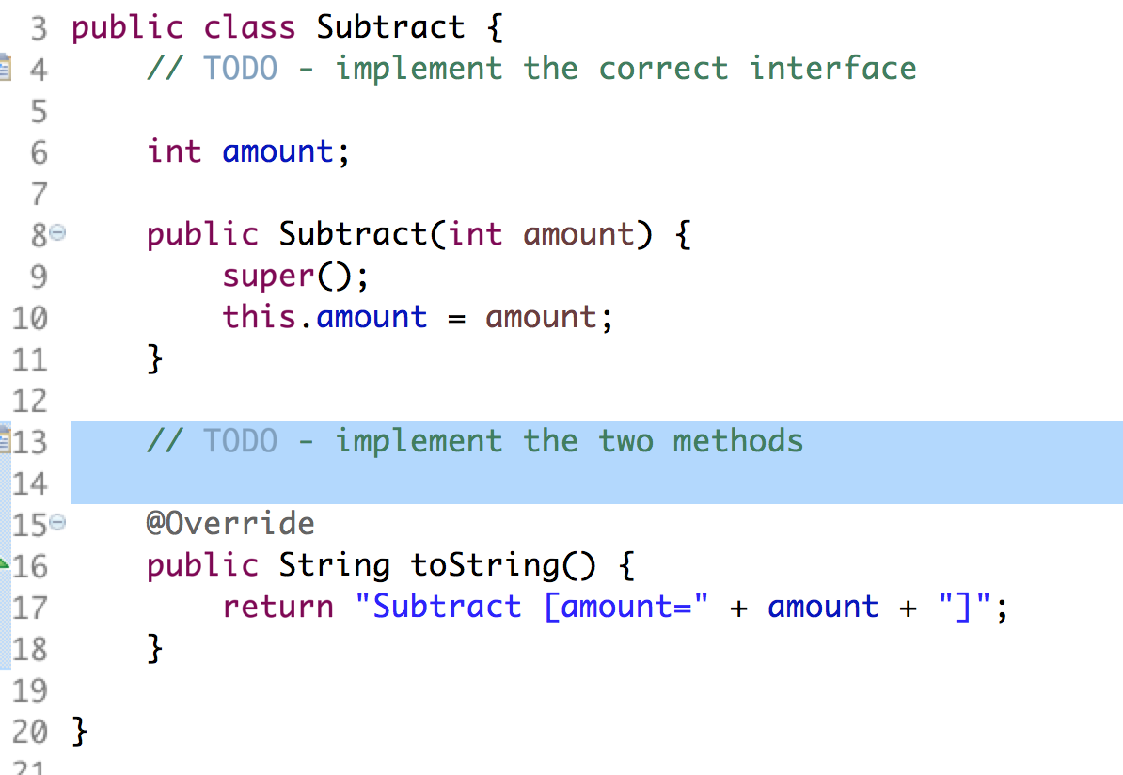

1. Add a reference to the interface on the class definition in line 3.
2. Implement the two methods, execute() and undo().
3. Do the same work for the Multiply.java file.
4. Uncomment the lines in Tester.java and execute the file as a Java application. You should see:

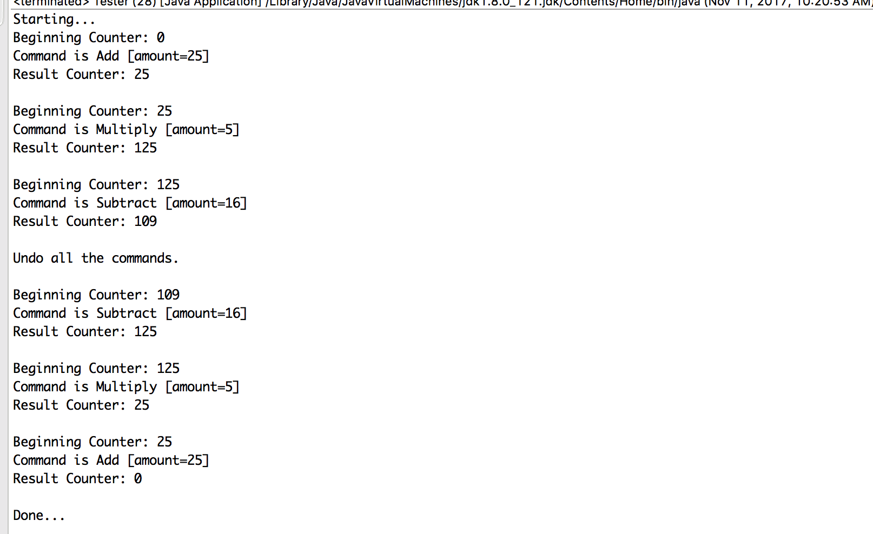

Congratulations. You have completed this lab.