TemplateMethod Pattern

In this lab, you will use the TemplateMethod pattern to replace one step with another.

# Objectives

In this lab, you will

* Examine the original Template class
* Override one step (method) in the Template
* Run the new app

# Exercise

1. The TemplateMethod pattern represents a method that calls other methods to implement a standard sequence of steps. Sometimes, we want to replace one of the steps with another but allow most steps to continue.
2. In this example, the Template class calls the three steps when the client invokes the templateMethod(). We will extend this class with MyTemplate which overrides the second step.
3. In Eclipse, in the exercises project, open the package com.paypal.patterns.TemplateMethod to view the project files.
4. Examine the client, Tester.java, shown below:

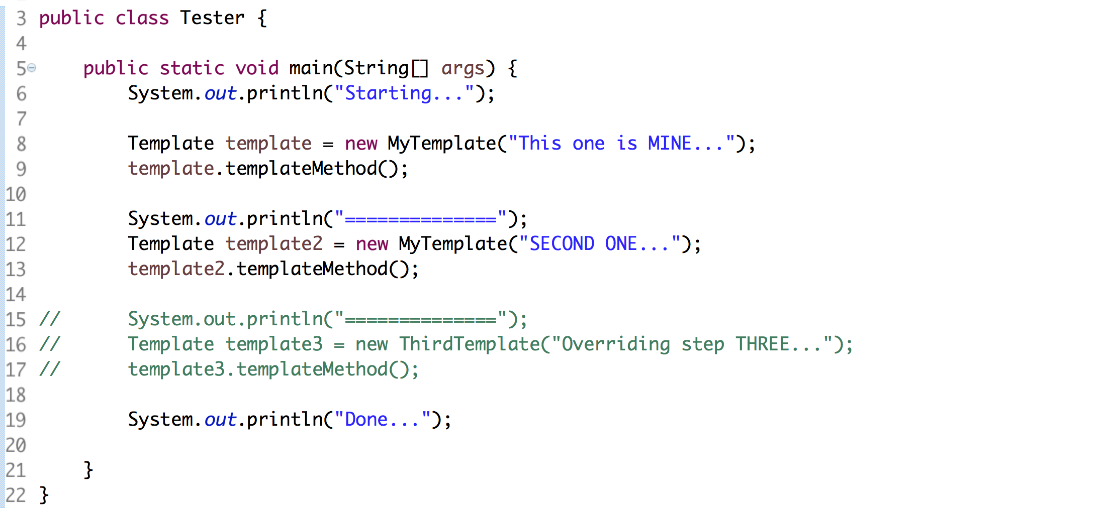

1. It creates several templates, instances of MyTemplate, and invokes the templateMethod() on each one.
2. Examine the base class, Template.java, shown below:

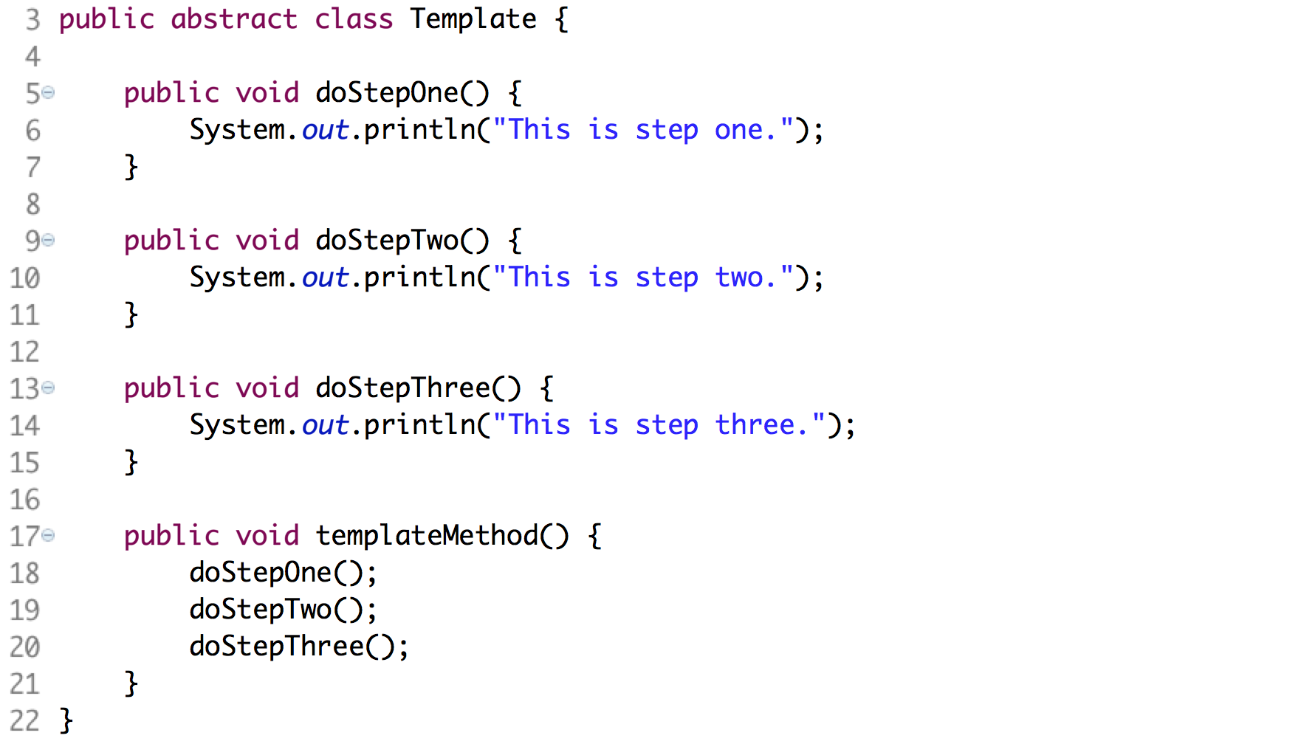

1. From line 3, the class is abstract so we cannot create an instance of it.
2. Lines 17-21define the templateMethod() which calls the three steps.
3. Examine MyTemplate.java below:

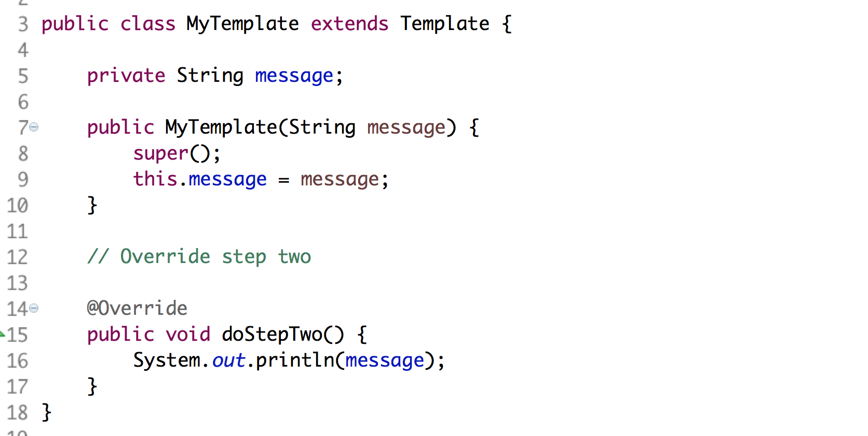

1. This extends Template defining all four methods in it. Then it overrides step two with its own implementation.
2. Create a new class, ThirdTemplate, which extends Template and overrides step three instead of step two.
3. Uncomment the lines in Tester.java and execute the file as a Java application. You should see:

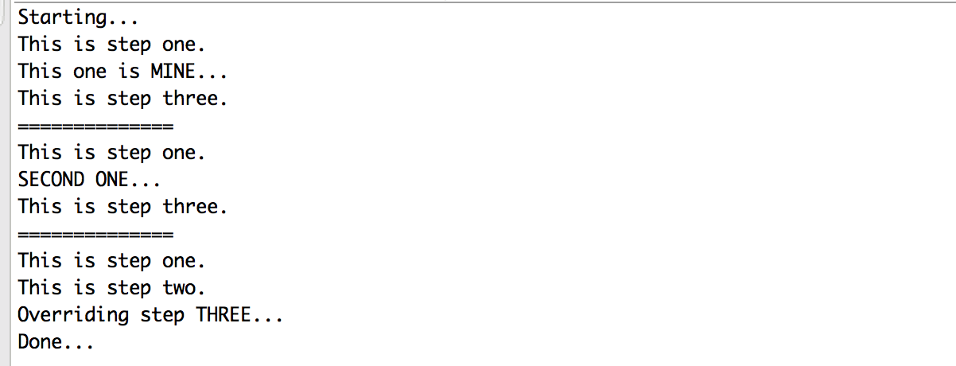

Congratulations. You have completed this lab.