Let’s solve the following problem stepwise to consolidate your learning on how to make a decision about any hypothesis using the p-value method.

You are working as a data analyst at an auditing firm. A manufacturer claims that the average life of its product is 36 months. An auditor selects a sample of 49 units of the product, and calculates the average life to be 34.5 months. The population standard deviation is 4 months. Test the manufacturer’s claim at 3% significance level using the p-value method.

First, formulate the hypotheses for this two-tailed test, which would be:

H₀: μ = 36 months and H₁: μ ≠ 36 months

Now, you need to follow the three steps to find the p-value and make a decision.

Try out the three-step process by answering the following questions.

Question 1/3 p-value Method
Step 1: Calculate the value of z-score for the sample mean point on the distribution. Calculate z-score for sample mean (¯x) = 34.5 months.
0.86
-0.86
2.62
-2.62
✓ Correct
Feedback:
You can calculate the z-score for sample mean 34.5 months using the formula: (​​¯x​ - μ) / (σ/​√n) . This gives you (34.5 - 36) / (4/√49) = (-1.5) * 7/4 = -2.62. Notice that, since the sample mean lies on the left side of the hypothesised mean of 36 months, the z-score comes out to be negative.

Question 2/3 p-value Method
Step 2: Calculate the p-value from the cumulative probability for the given z-score using the z-table. Find out the p-value for the z-score of -2.62 (corresponding to the sample mean of 34.5 months).
Hint: The sample mean is on the left side of the distribution and it is a two-tailed test.
0.0044
0.9956
0.0088
✓ Correct
Feedback:
The value in the z-table corresponding to -2.6 on the vertical axis and 0.02 on the horizontal axis is 0.0044. Since the sample mean is on the left side of the distribution and this is a two-tailed test, the p-value would be 2 * 0.0044 = 0.0088.

Question 3/3 p-value Method
Step 3: Make the decision on the basis of the p-value with respect to the given value of α (significance value). What would be the result of this hypothesis test?
Fail to reject the null hypothesis
Reject the null hypothesis
✓ Correct
Feedback:
Here, the p-value comes out to be 2 * 0.0044 = 0.0088. Since the p-value is less than the significance level (0.0088 < 0.03), you reject the null hypothesis that the average lifespan of the manufacturer's product is 36 months.
Comprehension
Let’s revisit an example we looked at earlier.
Let’s say you work at a pharmaceutical company that manufactures an antipyretic drug in tablet form, with paracetamol as the active ingredient. An antipyretic drug reduces fever. The amount of paracetamol deemed safe by the drug regulatory authorities is 500 mg. If the value of paracetamol is too low, it will make the drug ineffective and become a quality issue for your company. On the other hand, a value that is too high would become a serious regulatory issue.

There are 10 identical manufacturing lines in the pharma plant, each of which produces approximately 10,000 tablets per hour.
Your task is to take a few samples, measure the amount of paracetamol in them, and test the hypothesis that the manufacturing process is running successfully, i.e. the paracetamol content is within regulation. You have the time and resources to take about 900 sample tablets and measure the paracetamol content in each.
Upon sampling 900 tablets, you get an average content of 510 mg with a standard deviation of 110. What does the test suggest, if you set the significance level at 5%? Should you be happy with the manufacturing process or should you ask the production team to alter the process? Is it a regulatory alarm or a quality issue?
Solve the following questions in order to find out the answers to the questions stated above.
One thing you can notice here is that the standard deviation of the sample of 900 is given as 110, instead of the population’s standard deviation. In such a case, you can use the sample standard deviation (110 in this case) to calculate an approximate population standard deviation.
Question 1/3 p-value Method
Calculate the z-score for sample mean (¯x) = 510 mg.
36.67
-36.67
-2.73
2.73
✓ Correct
Feedback:
You can calculate the z-score for the sample mean 510 mg using the formula: (​¯x​ - μ) / (σ /​√N​). This gives you (510 - 500) / (110 /√900) = (10) / (110 / 30) = 2.73. Notice that, since the sample mean lies on the right side of the hypothesised mean of 500 mg, the z-score comes out to be positive.
Question 2/3 p-value Method
Find out the p-value for the z-score of 2.73 (corresponding to the sample mean of 510 mg).
0.0032
0.0064
✓ Correct
Feedback:
The value in the z-table corresponding to 2.7 on the vertical axis and 0.03 on the horizontal axis is 0.9968. Since the sample mean is on the right side of the distribution and this is a two-tailed test (because we want to test if the value of the paracetamol is too low or too high), the p-value would be 2 * (1 - 0.9968) = 2 * 0.0032 = 0.0064.
Question 3/3 p-value Method
What decision would you make about the manufacturing process from this hypothesis test?
The manufacturing process is completely fine and need not be changed
✕ Incorrect
Feedback:
The p-value is equivalent to the probability of the null hypothesis being accepted (or more aptly, not being rejected). If the p-value is greater than the significance level, you fail to reject the null hypothesis; otherwise, you reject the null hypothesis.
The manufacturing process is not fine and changes need to be made
✓ Correct
Feedback:
Here, the p-value comes out to be 0.0064. Since the p-value is less than the significance level (0.0064 < 0.05) and smaller p-value gives you greater evidence against the null hypothesis. So you reject the null hypothesis that the average amount of paracetamol in medicines is 500 mg. So, this is a regulatory alarm for the company and the manufacturing process needs to change.

Types of Errors
While doing hypothesis testing, there is always the possibility of making the wrong decision about your hypothesis. These instances of a wrong decision being made are referred to as errors. Let’s learn about the different types of errors during hypothesis testing.
There are two types of errors that can result during the hypothesis testing process — type-I error and type-II error.
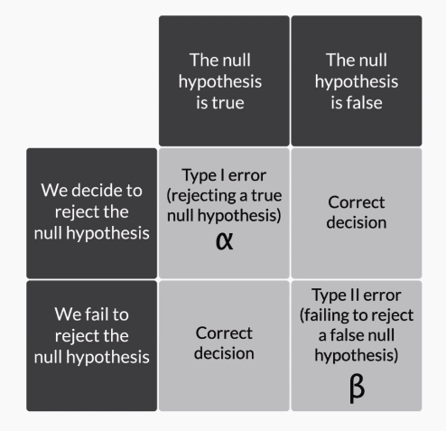
Figure 1 - Types of errors
A type I-error represented by α occurs when you reject a true null hypothesis.
A type-II error represented by β occurs when you fail to reject a false null hypothesis.
The power of any hypothesis test is defined by 1 - β. Power of the test or calculation of β is beyond the scope of this course. You can study more about power of a test from this link.
If go back to the analogy of the criminal trial example, you would find that the probability of making a type-I error would be more if the jury convicts the accused even on less substantial evidence. The probability of a type-I error can be reduced if the jury adopts more stringent criteria to convict an accused party.
However, reducing the probability of a type-I error may increase the probability of making a type-II error. If the jury becomes very liberal in acquitting the people on trial, there would be a higher probability that an actual criminal is able to walk free.
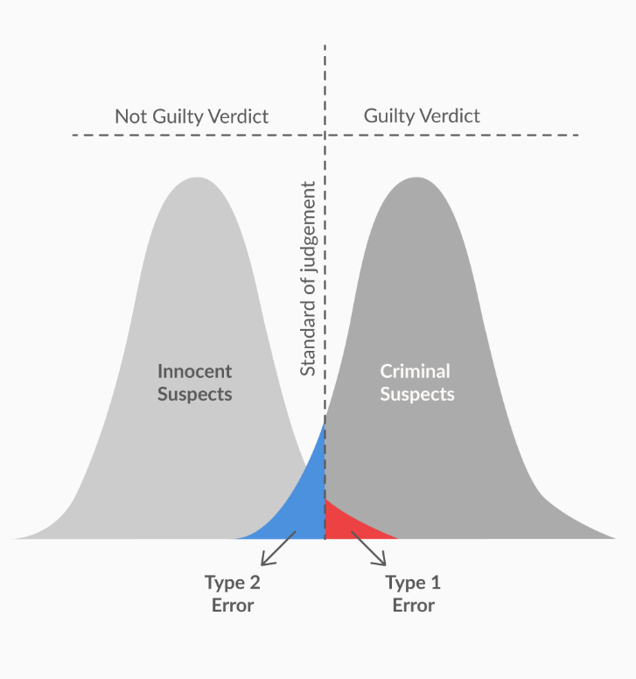
Figure 2 -Two types of errors in criminal trial example
Question 1/2 Errors in Hypothesis Testing
Mark all the correct options.
Type-I error occurs when the null hypothesis is rejected when it is in fact correct
✓ Correct
Feedback:
Type-I error occurs when the null hypothesis is true (i.e. the sample mean lies in the acceptance region) but you incorrectly reject it.
Type-I error occurs when the null hypothesis is not rejected when it is in fact incorrect
Type-II error occurs when the null hypothesis is rejected when it is in fact correct
Type II error occurs when the null hypothesis is not rejected when it is in fact incorrect
✓ Correct
Feedback:
Type-II error occurs when the null hypothesis is not true (i.e. the sample mean lies in the critical region) but you incorrectly fail to reject the null hypothesis.
Your answer is Correct.
Question 2/2 Types of errors
Suppose the null hypothesis is that a particular new process is as good as or better than the old one. A type-I error is to conclude that:
The old process is as good as or better than the new one, when it is not
The old process is better than the new one, when it is
The old process is better than the new one, when it is not
✓ Correct
Feedback:
Type-I error means incorrectly rejecting a true null hypothesis. So, type-1 error means that the null hypothesis is true, i.e. the new process is as good as or better than the old one, but you reject it, i.e. you conclude that the old process is better.
The new process is as good as or better than the new one, when it is

Summary
So what did you learn in this session?

- Making a decision - p-value method:
- Calculate the value of Z-score for the sample mean point on the distribution
- Calculate the p-value from the cumulative probability for the given z-score using the z-table
- Make the decision on the basis of the p-value with respect to the given value of α (signIficance level)

- Types of errors:
- Type-I error - Occurs when you reject a null hypothesis even when it is true
- Its probability is represented by α
- Type-II error - Occurs when you fail to reject the null hypotheses even though it is false
- Its probability is represented by β

Let’s look at the crisp summary of the first two sessions in this video.

Question 1/1 p-value Method
Suppose you conduct a hypothesis test and observe that the values of the sample mean and sample standard deviation when n = 25 do not lead to the rejection of the null hypothesis. You calculate the p-value as 0.0667. What would happen to the p-value if you observe the same sample mean and sample standard deviation for a larger sample size, say greater than 50?
Increase
Decrease
✓ Correct
Feedback:
With an increase in the sample size, the denominator of the z-score decreases, and thus the absolute value of Z-score increases, which means that the sample mean would move away from the central tendency towards the tails. This means that the p-value would actually decrease. Conceptually, Increasing the sample size will make the distribution of sample means narrower, and chance of sample mean falling in the critical region decreases. So p-value will decrease.
Question 1/2 Types of errors
Consider the null hypothesis that a process produces no more than the maximum permissible rate of defective items. In this situation, a type-II error would be:
To conclude that the process does not produce more than the maximum permissible rate of defective items, when it actually does not
To conclude that the process produces more than the maximum permissible rate of defective items, when it actually does
To conclude that the process produces more than the maximum permissible rate of defective items, when it actually does not
To conclude that the process does not produce more than the maximum permissible rate of defective items, when it actually does
✓ Correct
Feedback:
Type-II error means not rejecting the incorrect null hypothesis. So, a type-II error would signify that the null hypothesis is actually incorrect, i.e. the process actually produces more than the maximum permissible rate of defective items, but you fail to reject it, i.e. you think it does not produce more than the maximum permissible rate of defective items.

Question 2/2 Types of errors
A test to screen for a serious but curable disease is similar to hypothesis testing. In this instance, the null hypothesis would be that the person does not have the disease, and the alternate hypothesis would be that the person has the disease. If the null hypothesis is rejected, it means that the disease is detected and treatment will be provided to the particular patient. Otherwise, it will not. Assuming the treatment does not have serious side effects, in this scenario, it is better to increase the probability of:
Making a type-I error, i.e. not providing treatment when it is needed
Making a type-I error, i.e. providing treatment when it is not needed
✓ Correct
Feedback:
Here, type-I error would be providing treatment upon detecting the disease, when the person does not actually have the disease. And type-II error would be not providing treatment upon failing to detect the disease, when the person actually has the disease. Since the treatment has no serious side effects, type-I error poses a lower health risk than type-II error, as not providing treatment to a person who actually has the disease would increase his/her health risk.
Making a type-II error, i.e. not providing treatment when it is needed
Making a type-II error, i.e. providing treatment when it is not needed

Industry demonstration of hypothesis testing

Introduction
In the previous sessions, you learnt about the basic concepts of hypothesis testing and learnt how to statistically test the inferences made from inferential statistics or the insights generated during EDA. You learnt how to formulate the hypotheses and then make a decision through either the critical value method or the p-value method.

In this session
You will learn how hypothesis testing is used in the industry and how the basic concepts learnt in the previous session form an important foundation of useful industry concepts such as A/B testing.

We will cover the following topics in this session:
- T distribution
- Two-sample mean test
- Two-sample proportion test
- A/B testing
- Industry relevance

Guidelines for in-module questions
The in-video and in-content questions for this module are not graded.

People you will hear from in this session
Subject Matter Expert
Tricha Anjali
Associate Professor, IIIT- B
The International Institute of Information Technology, Bangalore, also known as IIIT-B, is one of India's foremost graduate schools. Through its Integrated M.Tech., M.Tech., M.S. (Research) and PhD programs in the IT space, it focuses equally on innovation and education.

Industry Expert
Deepak Singh
Product & Growth, UpGrad
At UpGrad, Deepak Singh specialises in analytics (product, sales and marketing) and engagement. He was previously associated with Housing, where he headed the product analytics team. His interests include user research and psychology, behavioural economics, demand-supply dynamics of business, and marketing.

Ankit Jain
Data Scientist at Uber
Ex-Head of Data Science & Analytics, Roadrunnr

S. Anand
Chief Data Scientist, Gramener
Gramener is a data visualisation and analytics company. Founded in 2010 by Ex-IBM and BCG leaders, it addresses the essential need of making the "consumption" of data simple, rapid and coherent across organisations.

Madhukar Kumar
Principal Data Scientist & Delivery Head, SG Analytics
SG Analytics (SGA) is a leading research and analytics company providing end-to-end customised research and analytics to clients across Europe, US, APAC and the Middle East.

Presenter
Rohit Sharma

T Distribution
As an analyst in the industry, when you would use hypothesis testing, the standard deviation of the population would be unknown most of the times. So how would you proceed in such a scenario?

A t-distribution is also referred to as Student’s T distribution. A t-distribution is similar to the normal distribution in many cases; for example, it is symmetrical about its central tendency. However, it is shorter than the normal distribution and has a flatter tail, which would eventually mean that it has a larger standard deviation.
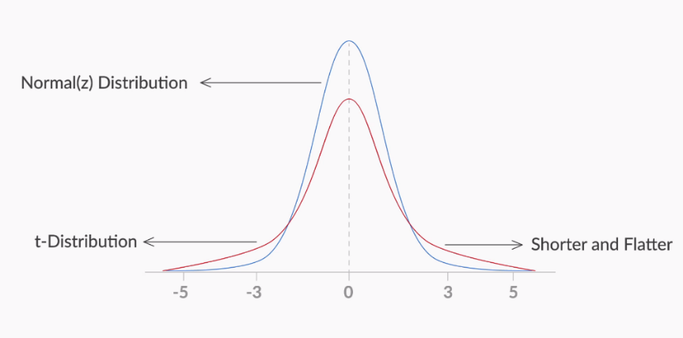
Figure 1 - t-distribution vs standard normal distribution
At a sample size beyond 30, the t-distribution becomes approximately equal to the normal distribution.

The most important use of the t-distribution is that you can approximate the value of the standard deviation of the population (σ) from the sample standard deviation (s). However, as the sample size increases more than 30, the t-value tends to be equal to the z-value. Thus, if you want to summarise the decision-making in a flowchart, this is what you would get.
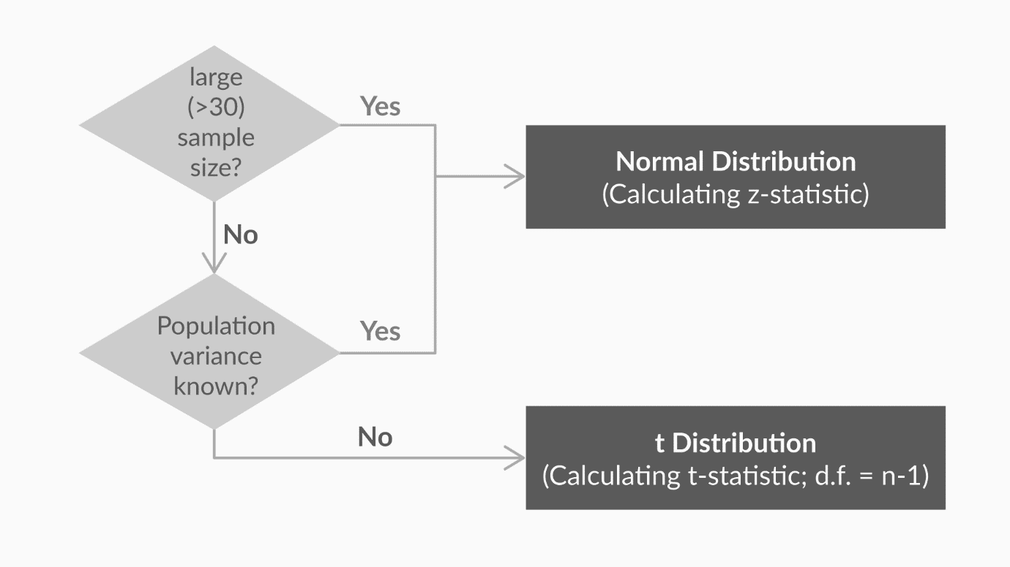
Figure 2 - Flowchart for deciding the test
Look at the flowchart above and answer the following questions.
Question 1/2 Type of tests
If the sample size is 10 and the standard deviation of the population is known, which distribution should be used to calculate the critical values and make the decision during hypothesis testing?
Standard normal distribution (z-distribution)
✓ Correct
Feedback:
Whenever the standard deviation of the population is known, you have to use z-distribution, irrespective of the value of the sample size (N).
T distribution
Question 2/2 Type of tests
If the sample size is 10 and the standard deviation of the population is unknown, which distribution should be used to calculate the critical values and make the decision during hypothesis testing?
Standard normal distribution (z-distribution)
T distribution
✓ Correct
Feedback:
T distribution is used whenever the standard deviation of the population is unknown and the sample size is less than 30.
Your answer is Correct.
Let’s look at how the method of making a decision changes if you are using the sample’s standard deviation instead of the population’s. If you recall the critical value method, the first step is as follows:
Calculate the value of Zc from the given value of α (significance level). Take it as 5% if not specified in the problem.
So, to find Zc, you would use the t-table instead of the z-table. The t-table contains values of Zc for a given degree of freedom and value of α (significance level). Zc, in this case, can also be called as t-statistic (critical).
Download the t-table given below and attempt the following questions to understand how to use the t-table to find Zc.
Question 1 of 2 Mandatory t-test
You are given the standard deviation of a sample of size 25 for a two-tailed hypothesis test of a significance level of 5%. Use the t-table given above to find the value of Zc.
1.711
2.064
✓ Correct
Feedback:
For sample size = 25, your degrees of freedom would become 25 - 1 = 24. So, if you look for the value in the t-table corresponding to d.f. = 24 and α = 0.05 for a two-tailed test, you would get the t-value as 2.064.
2.060
1.708
Question 2 of 2 Mandatory t-test
You are given the standard deviation of a sample of size 32 for a two-tailed hypothesis test of a significance level of 5%.Use the t-table given above to find the value of Zc.
1.711
2.064
1.645
1.96
✓ Correct
Feedback:
For sample size = 32, your degrees of freedom would become 32 - 1 = 31. So, if you look for the value in the t-table corresponding to d.f. > 29 and α = 0.05 for a two-tailed test, you would get a value of 1.96.
Your answer is Correct.
In the second question, you used the t-table to find the value of Zc for sample size = 32 and a significance level of 5%. If you use the z-table for the same, you would get the same value of Zc, since, for sample size ≥ 30, the t-distribution is the same as the z-distribution.
Practically you would not need to refer to the z-table or t-table when doing hypothesis testing in the industry. Going forward when you need to do hypothesis testing in demonstrations of Excel or R, you would use the term t-test since that is mostly performed in the industry. All calculations and results of a t-test are same as the z-test whenever the sample size ≥ 30.

Two-Sample Mean Test
Now, let’s see how the different concepts that you learnt in the previous session are applied in real-world industry scenarios.
Deepak will walk you through a demonstration of hypothesis testing on Excel, so download the Excel file given below and perform all the steps along with Deepak for a deeper understanding. You will also be introduced to a new concept called two-sample mean test.
Two-sample mean test - paired is used when your sample observations are from the same individual or object. During this test, you are testing the same subject twice. For example, if you are testing a new drug, you would need to compare the sample before and after the drug is taken to see if the results are different.

Two-Sample Mean Test - Paired
There is a hypothesis that Virat Kohli performs better or as good in the second innings of a test match as the first innings. This would be a two-sample mean test, where sample 1 would contain his score from the first innings and sample 2 would contain his score from the second innings. This would be a paired test since each row in the data would correspond to the same match.
What would be the null hypothesis in this case?
H₀: μ₂ - μ₁ = 0
H₀: μ₂ - μ₁ ≥ 0
✓ Correct
Feedback:
Here, the assumption is that Virat Kohli performs better or as good as in the second innings, which means his average in the second innings is assumed to be greater than or equal to his average in the first innings. So, the null hypothesis would be: μ₂ ≥ μ₁ or μ₂ - μ₁ ≥ 0
H₀: μ₂ - μ₁ ≤ 0
H₀: μ₁ - μ₂ ≠ 0
Your answer is Correct.
Two-sample mean test - unpaired is used when your sample observations are independent. During this test, you are not testing the same subject twice. For example, if you are testing a new drug, you would compare its effectiveness to that of the standard available drug. So, you would take a sample of patients who consumed the new drug and compare it with another sample who consumed the standard drug.

In the Excel file, go to the third tab ‘2-sample mean test - Unpaired’ and perform the required test. Answer the questions below after performing this test, taking a significance level of 5%.
Question 1 of Two-Sample Mean Test - Unpaired
What would be the p-value for this test if you consider it as a two-tailed test?
0.0055
0.011
0.022
✓ Correct
Feedback:
If you perform the steps shown in the demonstration above and look at the second-last row of the output table, you would see that the p-value of a two-tailed test is 0.022.
0.044
Your answer is Correct.
Question 2/2 Two-Sample Mean Test - Unpaired
What can you conclude from this test about the two unpaired samples if you take a significance level of 5%?
There is no significant difference between the means of the two samples
There is some significant difference between the means of the two samples
✓ Correct
Feedback:
The null hypothesis in this test is that the means of the two samples are the same, and there is no significant difference between them. As the p-value (0.022) is less than 0.05 (value of α), you can reject the null hypothesis and conclude that there is some significant difference between the means of the two samples.
Your answer is Correct.
So, you now know how to compare the mean of a sample to a particular value using the one-sample mean test, and the means of two different samples using the two-sample mean test.

One thing you should observe in these tests is that the data from the sample is always numeric in nature. But what would you do if the data is categorical in nature, i.e. 1 or 0; Yes or No, etc.? Let’s take a look.

Two-sample proportion test is used when your sample observations are categorical, with two categories. It could be True/False, 1/0, Yes/No, Male/Female, Success/Failure etc.

For example, if you are comparing the effectiveness of two drugs, you would define the desired outcome of the drug as the success. So, you would take a sample of patients who consumed the new drug and record the number of successes and compare it with successes in another sample who consumed the standard drug.

You can download the Excel file given below and play around with the two-sample proportion-test after installing the trial version of the XLSTAT add-in from this link.

A/B Testing Demonstration
Let’s now learn from Ankit Jain about a process that is widely used in digital and online companies — A/B testing. A/B testing is a direct industry application of the two-sample proportion test sample you have just studied. me 0:00
While developing an e-commerce website, there could be different opinions about the choices of various elements, such as the shape of buttons, the text on the call-to-action buttons, the colour of various UI elements, the copy on the website, or numerous other such things.

Often, the choice of these elements is very subjective and is difficult to predict which option would perform better. To resolve such conflicts, you can use A/B testing. A/B testing provides a way for you to test two different versions of the same element and see which one performs better. You can read more about A/B testing from this link.

You can see a few more case studies and applications of A/B testing in the real world here.

The two-sample proportion test is used when you want to compare the proportions of two different samples. Let’s now see how A/B testing is entirely based on the two-sample proportion test, and go through an Excel demonstration of A/B testing with Deepak.Quality Levels
You can use various other tools also to conduct A/B testing, like R, Optimizely etc.

Hypothesis testing in Python
You can easily do hypothesis testing in Python by using stats from Scipy library.

1-sample t-test: testing the value of a population mean

To test, if the population mean of data is likely to be equal to a given value
scipy.stats.ttest_1samp()
stats.ttest_1samp(data['column'], x)
#where x is the mean value you want to test

2-sample t-test: testing for difference across populations
scipy.stats.ttest_ind()

stats.ttest_ind(column_1,column_2)

Paired tests: repeated measurements on the same individuals
stats.ttest_rel()

stats.ttest_rel(column_1,column_2)

Question 1/1
Mandatory

Industry Relevance
For this example of Domino’s campaign for Peppy Paneer Pizza, test population is considered as it is purchasing that particular pizza because of the campaign and control population is the one which buys that pizza normally.
What would be the null hypothesis in this case?
The difference in response rate of control and test population is statistically significant
✕ Incorrect
Feedback:
This is a 2-sample proportion test. The null hypothesis would contain the equality parameter.
The difference in response rate of control and test population is statistically insignificant
✓ Correct
Feedback:
This is a 2-sample proportion test. The null hypothesis would contain the equality parameter. So you would assume that difference between response rates of both groups is equal to zero, or you can say that the difference is statistically insignificant.

Industry Relevance
Different industry experts have different views on the applications and usability of hypothesis testing because of different reasons.

Let us first hear from Madhukar about the applications of hypothesis testing in the real world and get some insights into how this will be relevant in the next courses of Machine Learning when you reach the model building stage of the Crisp-DM framework.
nowadays, all the data is available digitally for most industries. This makes the usability of hypothesis testing a little limited in lot of scenarios.
To summarise, hypothesis testing still holds importance in the following two types of industries, even if all the data is available digitally:
- Manufacturing processes in the food, pharmaceuticals, chemicals industries, where it is not practically possible to gather information on the entire population.
- E-commerce, advertising and digital marketing companies, where the amount of data collected from various samples is so huge that analysing all data becomes very difficult without having big data systems in place.

Summary
So what did you learn in this session?

- T-distribution:
  - A T-distribution is used whenever the standard deviation of the population is unknown
  - The degrees of freedom of a T-distribution is equal to sample size n - 1
  - For sample size ≥ 30, the T-distribution becomes the same as the normal distribution
  - The output values and results of both t-test and z-test are same for sample size ≥ 30
- Two-sample mean test - paired:
  - It is used when your sample observations are from the same individual or object
  - During this test, you are testing the same subject twice
- Two-sample mean test - unpaired:
  - During this test, you are not testing the same subject twice
  - It is used when your sample observations are independent

- Two-sample proportion test:
  - It is used when your sample observations are categorical, with two categories
  - It could be True/False, 1/0, Yes/No, Male/Female, Success/Failure, etc.
- A/B Testing:
  - A/B testing is a direct industry application of the two-sample proportion test
  - It is a widely used process in digital companies in the ecommerce, manufacturing and advertising domains
  - It provides a way to test two different versions of the same element and see which one performs better

You can download the lecture notes for the module from below. The lecture notes include a summary of the entire module.

Note : The number of stores (page number 6 or page which contains Figure 5) should be 36 instead of 25.

