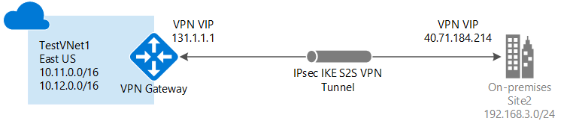

VPN connection :

To create a VPN connection from On-premises site to Azure
Reason for VPN connection , cloud is public if u need to have some intranet application to be hosted in public and every time an instance is restarted azure cloud provides new public IP to access , so to access from private IP you need to include the azure network in your internal network, and also if an VPN connection is created it opens a tunnel , so you are basically provided with very secured layer to communicate to instances and azure resources.

Create a Virtual network
Go to Portal(portal.azure.com) and select Virtual networks

Click Add button to create network inside the network creation pane , you have to provide
Name
Cidr
Resource Group

After you created network you can create subnets in the same nework
Select your Virtual network created in the portal.azure.com and inside the pane you have the network configuration and properties details.
Go to Subnets pane and Click add again
follow the same procedure as network creation just give the cidr as subset of your network cidr and location should be same as network.

Create as many as subnets as per your requirement
For planning network , see below diagram and example .

Create a address space use a resource group and create subnet from the sub – cidr you had given in the network address space..
ex . 10.0.0.0/16 ( gives more hosts ip address in network)
subnet cidr – 10.0.1.0/24 ( less address space )
Always use part of cidr in subnet address ...

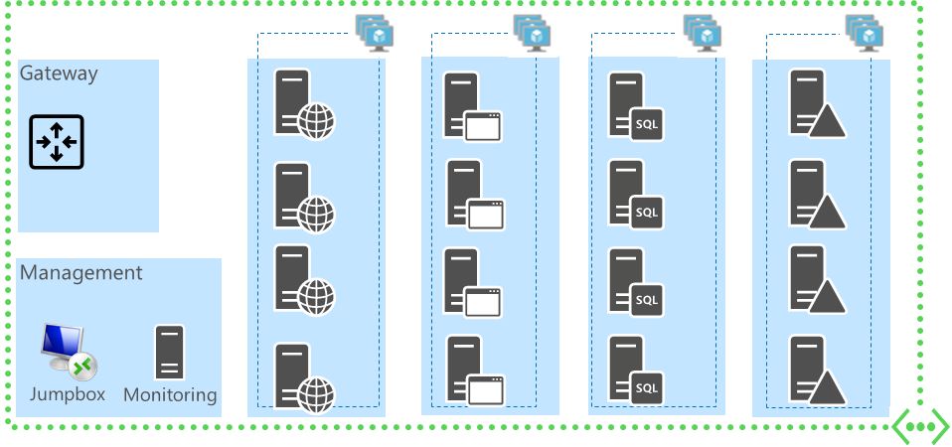
The above diagram shows the network subnets planning...

First tier is always a Frontend servers , which should be exposed in public ....

And application servers forms second tier with backend servers in 3rd tier ..

Where each subnets have different traffic filtering and different inbound and outbound which can be done by network secirity groups

To go to network security groups from portal.azure.com type nsg in search box.

