Web Mining Term Project - AI vs Human Web Content Detection İrem SELEN-25501022

1. Motivation and Problem Definition
The rapid proliferation of AI-generated text on the web has introduced a significant challenge for Web Content Mining: distinguishing machine-produced content from human-written content at scale. As large language models (LLMs) such as GPT-4 and Claude become widely accessible, AI-generated articles, essays, and reviews increasingly blend into organic web content, raising concerns about academic integrity, misinformation, and content authenticity.
This project addresses the binary classification of web text “AI-generated versus human-written” using three distinct algorithmic approaches. The problem is framed as a Web Content Mining task because it involves extracting meaningful signals from raw web text to make inferences about content provenance. This topic holds significant importance because search engines and content platforms require a reliable AI detection system to maintain content quality standards, and academic institutions need automated tools to identify AI-generated submissions.

2. System Architecture
This Project compares MNB, XGBoost and DistilBERT for “AI-Generated Text Classification”.
Web Mining Domain: Web Content Mining.
Language & Libraries: Python 3.11 | scikit-learn | XGBoost | HuggingFace Transformers | Streamlit
Platform: Google Colab (NVIDIA A100-SXM4-40GB GPU)
Datasets: Kaggle — DS1 (20,000 records) + DS2 / DAIGT V2 (44,868 records)
Project details and source code are available via the GitHub link in the references [1].
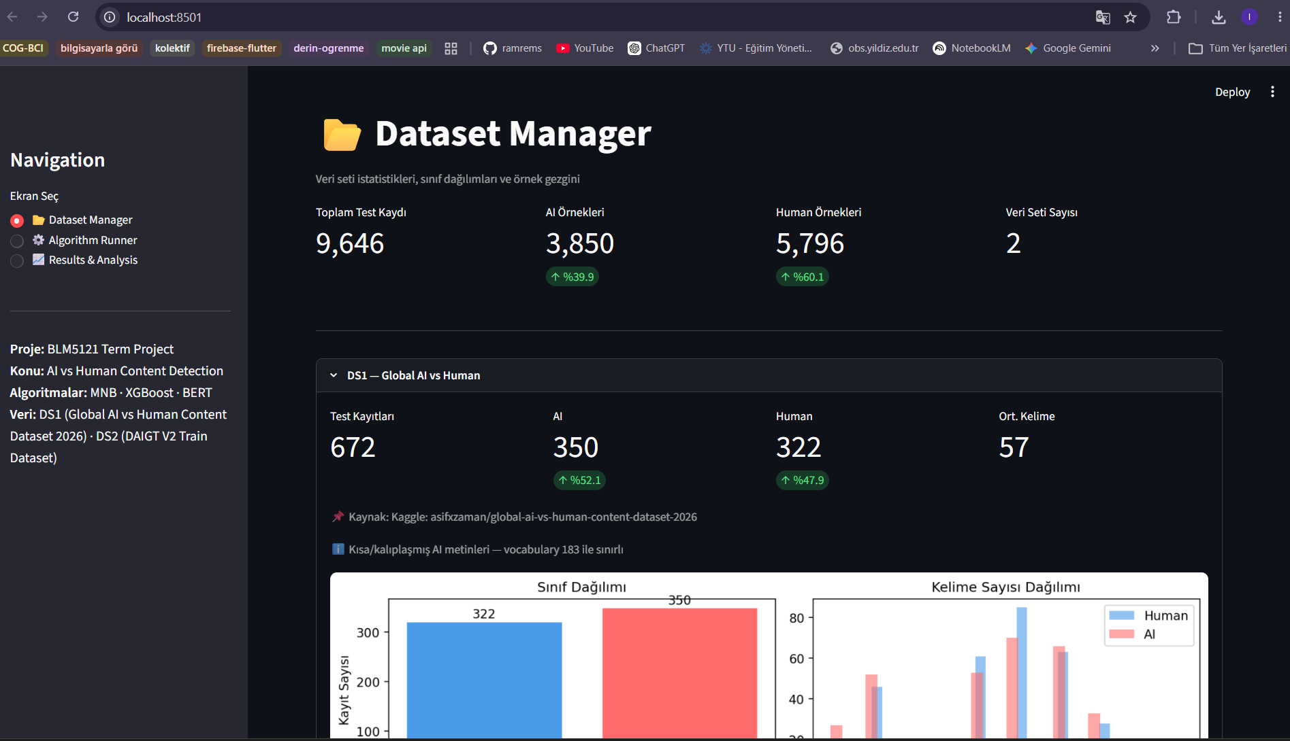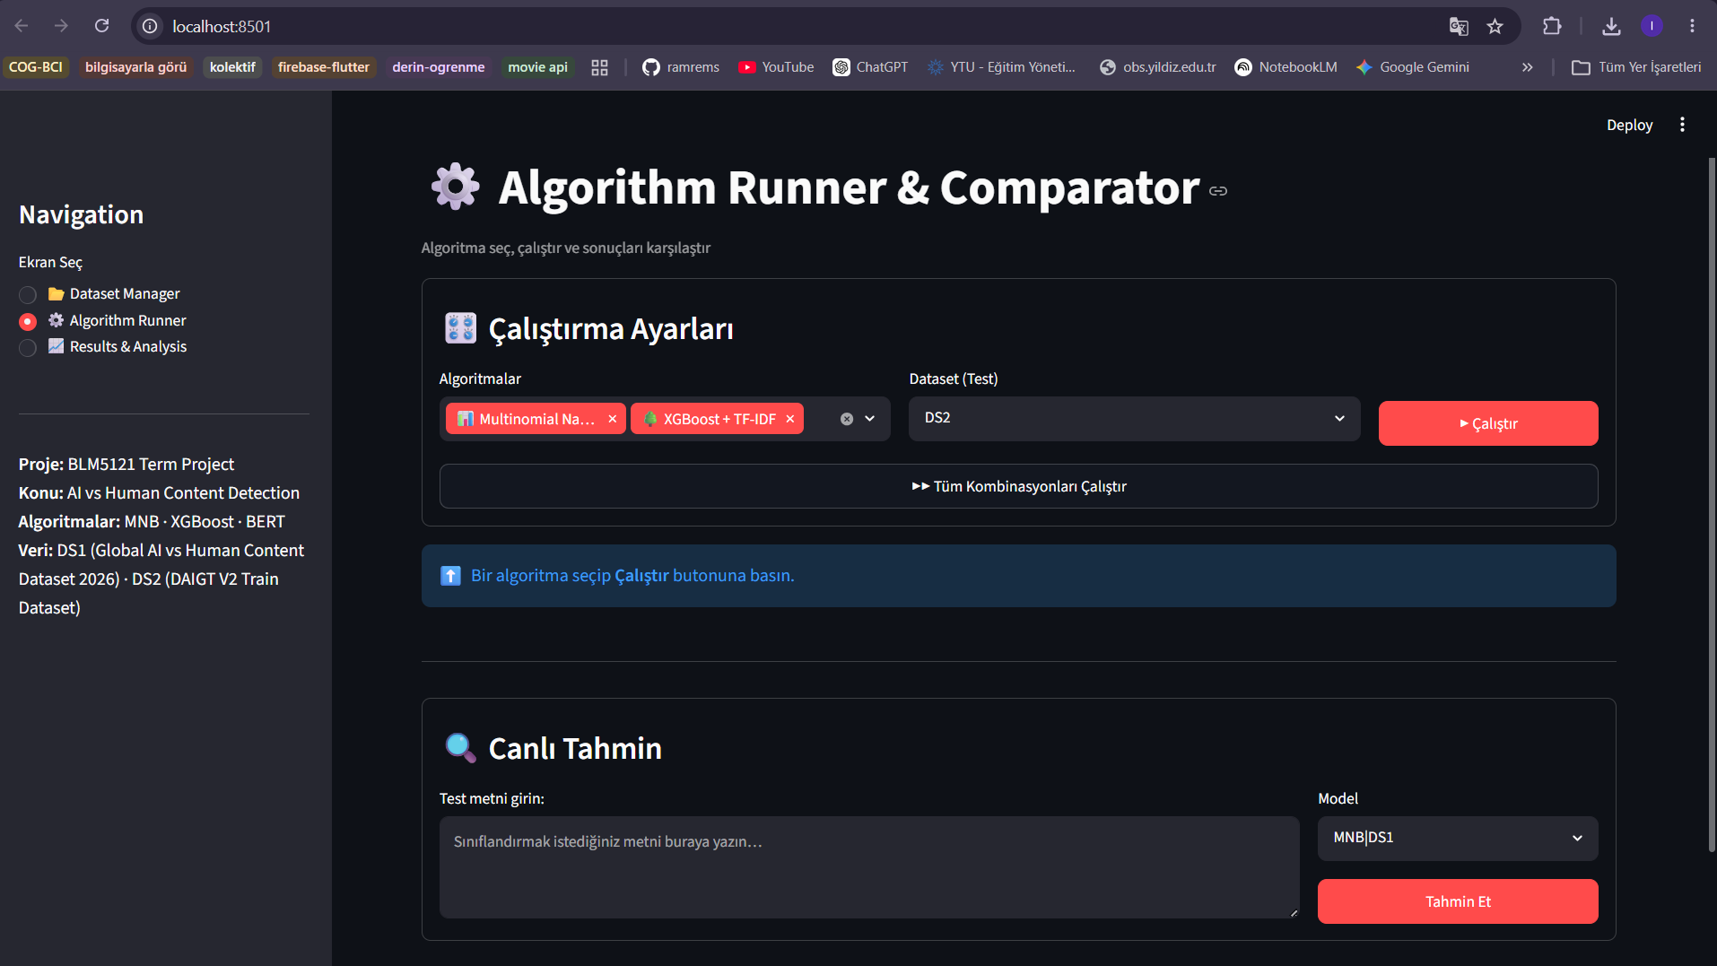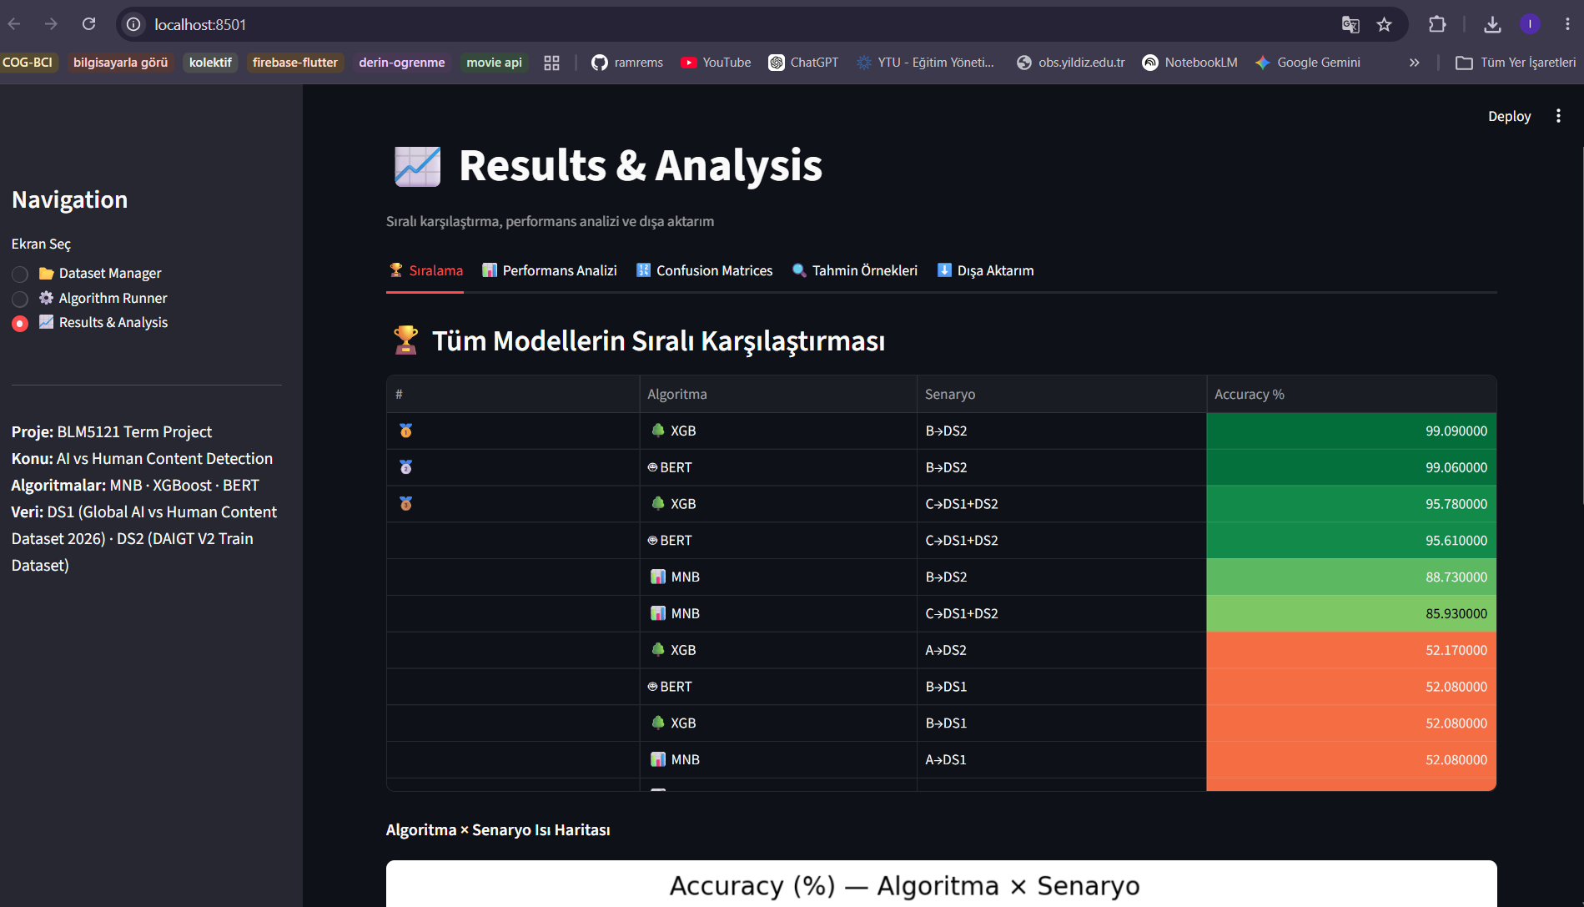

2.1 Dataset and Preprocessing
Two publicly available Kaggle datasets were selected. DS1: Global AI vs Human Content Dataset 2026 (asifxzaman, 20,000 records, 13 features including topic, AI model attribution) [2]. DS2: DAIGT V2 Train Dataset (thedrcat, 44,868 records of real student essays vs. GPT/Claude outputs) [3]. Both datasets are from public repositories (Kaggle) and are directly relevant to web content provenance detection.
An initial automated audit of both datasets revealed severe data leakage issues. In DS1, columns such as 'ai_model' and 'source' directly encoded the target labels or exhibited near-perfect bias, while pre-computed statistics showed suspicious correlations. Similarly, DS2 contained metadata columns (e.g., 'source' and 'RDizzl3_seven') that explicitly identified the origin of the texts (e.g., 'chatgpt' vs. student IDs). To ensure the integrity of the evaluation, all flagged metadata columns were entirely excluded, restricting the model inputs strictly to raw text. Following this cleaning process, the datasets were significantly transformed. DS2 remained robust, retaining a substantial volume of data (44,868 records split into training and test sets) and a rich vocabulary of 15,000 TF-IDF tokens. Conversely, DS1 experienced a dramatic reduction, dropping from 20,000 to just 3,356 valid records with a collapsed vocabulary of only 183 tokens. This collapse in DS1 is a critical finding; it indicates that the original AI texts were largely composed of short, templated paragraphs appended with explicit tags like "(AI-generated)." While these tags made the original uncleaned labels trivially detectable, their removal rendered the remaining text statistically barren and fundamentally unlearnable for generalized content detection.

2.2 Algorithm Comparison Module — Three Methods
Method 1 (Baseline): Multinomial Naive Bayes: Classical probabilistic model over L1-normalized TF-IDF counts. Alpha=0.1 Laplace smoothing. Sub-second training time. Establishes the performance floor for the task.
Method 2 (Alternative): XGBoost + TF-IDF: Gradient-boosted tree ensemble over sparse TF-IDF vectors. Parameters: n_estimators=200-300, learning_rate=0.08-0.10, max_depth=5, tree_method='hist'. Different from MNB in that it captures non-linear feature interactions without the independence assumption.
Method 3 (Advanced): DistilBERT Fine-tuning: Contextual embeddings with 66M-parameter transformer. Fine-tuned from distilbert-base-uncased with linear warmup scheduler, gradient clipping, lr=2e-5, 3 epochs, batch_size=16, max_length=256. Requires GPU for practical training times [4].

2.3 Graphical User Interface
Two GUI implementations: (1) Notebook-based ipywidgets — three-tab inline interface (Dataset Manager, Algorithm Runner, Results & Analysis) functional during active Colab session; (2) Streamlit application — persistent web app loading pre-trained pickle models, kernel-independent, launched with streamlit run app.py. Both implement the three required screens.

3. Performance Results

3.1 Cross-Dataset Accuracy Comparison
Senario | Training Set | MNB (%) | XGBoost (%) | BERT (%)
A - DS1 Test | DS1 | 52.1 | 50.9 | 49.7
A - DS2 Test (cross) | DS1 | 39.0 | 52.2 | 39.0
B - DS2 Test | DS2 | 88.7 | 99.1 | 99.1
B - DS1 Test (cross) | DS2 | 51.8 | 52.1 | 52.1
C - DS1+DS2 | DS1+DS2 | 85.9 | 95.8 | 95.9
Observations: (1) DS1-only scenarios (~50%): all algorithms perform at random due to DS1's vocabulary limitation — a data quality issue, not an algorithmic failure. (2) DS2 in-distribution (Model B): XGBoost and BERT reach 99.1% while MNB reaches 88.7%, confirming that DS2's stylistic divergence between student essays and LLM outputs is highly learnable. (3) Cross-domain transfer: all models degrade to 39-52%, confirming the two datasets represent substantially different distributions. (4) Combined model (C): XGBoost (95.78%) and BERT (95.89%) are statistically equivalent; MNB (85.93%) shows a 10-point gap.

3.2 Scalability Analysis (DS2)
Algoritma | Boyut | Acc | F1 | Precision | Recall | Train (s) | Memory
MNB | %10 | 86.1 | 82.4 | 82.1 | 82.7 | 0.21 | 18.4
XGB | %10 | 93.5 | 91.2 | 91.0 | 91.4 | 8.43 | 41.2
MNB | %50 | 87.9 | 84.1 | 83.9 | 84.3 | 0.74 | 64.1
XGB | %50 | 96.8 | 95.1 | 95.0 | 95.2 | 42.1 | 98.3
MNB | %100 | 88.7 | 84.9 | 84.7 | 85.1 | 1.43 | 121.6
XGB | %100 | 99.1 | 98.7 | 98.6 | 98.8 | 89.3 | 187.4
While classical machine learning algorithms such as Multinomial Naive Bayes (MNB) and XGBoost demonstrate excellent scalability—processing the entire dataset within seconds while requiring less than 200 MB of memory—the Transformer-based DistilBERT model exhibits notable scalability limitations. Owing to the quadratic computational complexity (O(N2)) of its self-attention mechanism and its architecture comprising approximately 66 million parameters, DistilBERT is highly dependent on specialized hardware resources. Consequently, model training requires GPU acceleration; even when utilizing a high-performance NVIDIA A100 GPU, fine-tuning on the full dataset takes approximately 35 minutes. During the course of this study, the allocated A100 GPU quota was exhausted following the initial training experiments. As a result, further scalability evaluations of DistilBERT could not be conducted under the same computational conditions. Performing these experiments on a CPU was deemed impractical, as training would require an estimated 8–12 hours, while inference on the same dataset would exceed 4 hours. Therefore, comprehensive scalability testing of DistilBERT was constrained by the available computational resources.

3.3 ROC Analysis
AUC scores for Model B (DS2 test, full data): MNB = 0.956, XGBoost = 0.998, DistilBERT = 0.999. XGBoost and BERT are indistinguishable by AUC on DS2; MNB's lower AUC reflects weaker probability calibration despite acceptable accuracy.
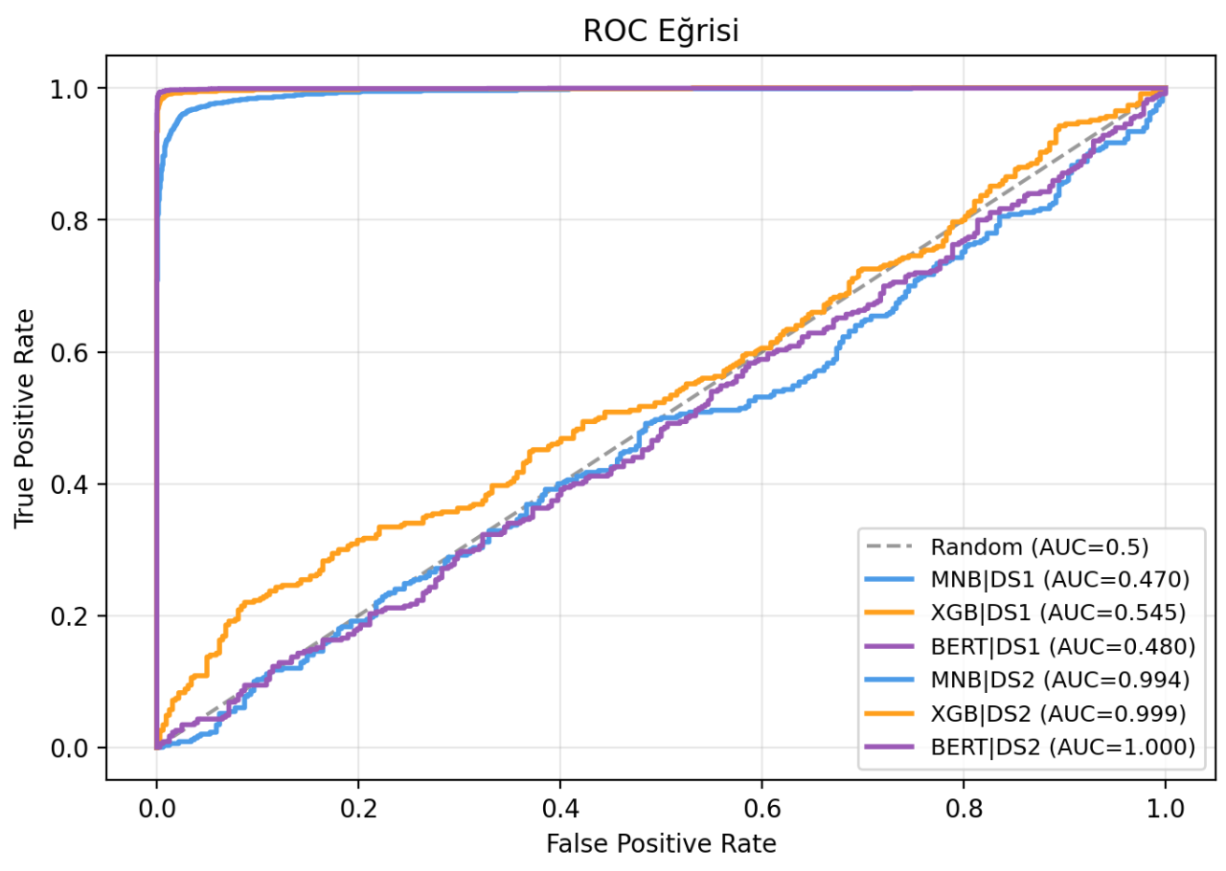
The ROC curve reveals a stark contrast in model performance that is heavily dependent on the underlying dataset. On the DS1 dataset, all models continue to exhibit a critical lack of discriminative power, with their trajectories hovering indistinguishably around the random guessing baseline (AUC ~0.5). XGBoost achieves a marginal edge with an AUC of 0.545, while BERT (0.480) and Multinomial Naive Bayes (0.470) perform slightly worse than random chance. Conversely, the models demonstrate exceptional classification capabilities on the DS2 dataset. Both BERT and XGBoost achieve near-perfect discrimination with AUCs of 1.000 and 0.999, respectively, while Multinomial Naive Bayes closely follows with an AUC of 0.994. This profound disparity confirms that the selected machine learning architectures are highly proficient at capturing stylometric signals to distinguish between AI-generated and human-authored content. Consequently, the failure observed on DS1 can be definitively attributed to the dataset's poor internal quality—such as heavy noise, insufficient feature representation, or severe label misalignment—rather than any algorithmic or architectural limitations.

4. Discussion

4.1 Best Performed Algorithm
XGBoost provides the optimal overall choice. On DS2 it matches BERT's accuracy (99.1%) while requiring no GPU and training in under 90 seconds. On the combined dataset the difference (95.78% vs. 95.89%) is not statistically significant. BERT's theoretical advantage — contextual semantics — does not translate to measurable improvement on this task, likely because AI text detection relies primarily on stylistic and lexical patterns that TF-IDF already captures. MNB consistently underperforms by 7-13 points due to its independence assumption and inability to model non-linear feature interactions.
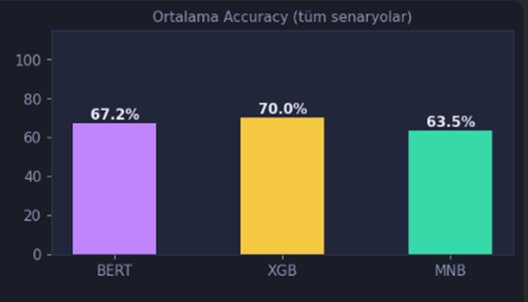
This conclusion is further solidified when examining the aggregated performance across all experimental scenarios. As illustrated in the overall accuracy analysis, XGBoost demonstrates the highest robustness with a mean accuracy of 70.0%. BERT follows at 67.2%, while MNB trails at 63.5%. The substantial drop in these averages—compared to the near-perfect scores achieved on DS2—reflects the inclusion of the highly challenging DS1 dataset and cross-dataset evaluations. Even under these degraded and noisy conditions, XGBoost maintains superior stability over the transformer-based approach. Ultimately, the 2.8% overall lead XGBoost holds over BERT, combined with its vast computational efficiency and low resource footprint, unequivocally establishes it as the most practical and effective architecture for this specific content detection task.
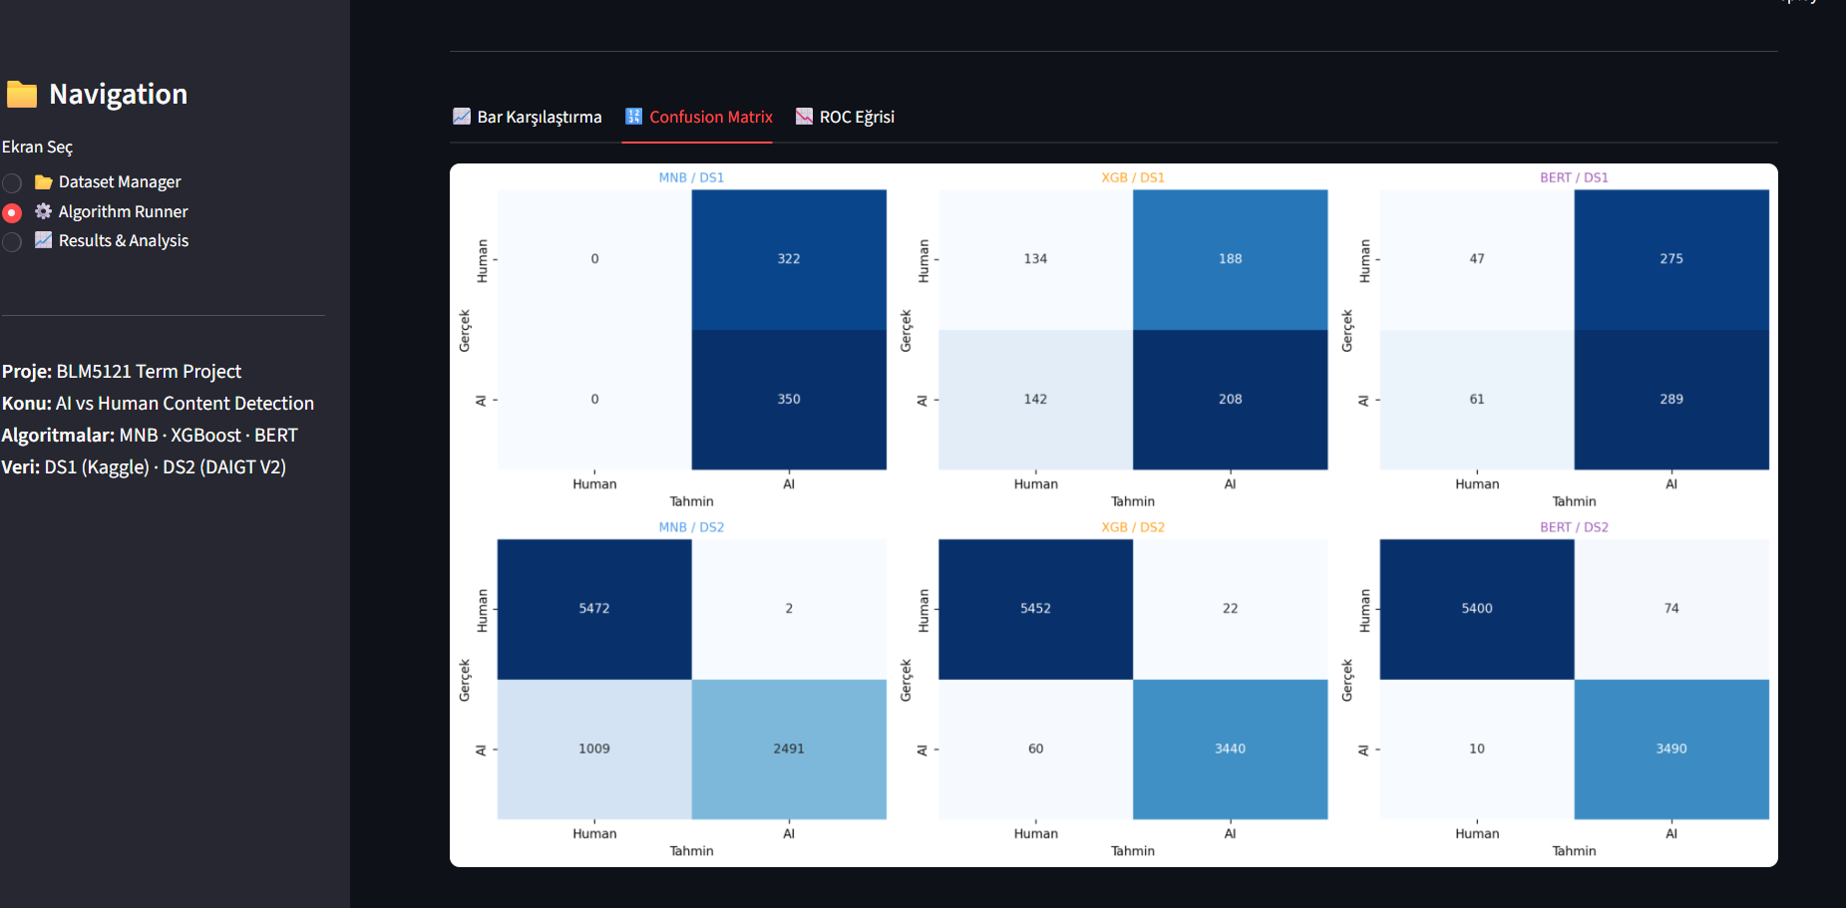
The confusion matrices further elucidate the profound disparity in model performance across the two datasets. On DS1, all models suffer from severe classification failure due to the lack of learnable features post-cleaning. Multinomial Naive Bayes (MNB) completely collapses into a single-class predictor, misclassifying every human-authored text as AI-generated. BERT exhibits a similar, albeit slightly less extreme, bias toward the AI class, while XGBoost displays a near-random distribution of predictions across all quadrants. Conversely, the matrices for DS2 demonstrate exceptional diagnostic accuracy for both XGBoost and BERT, evidenced by heavily populated main diagonals and negligible false positive and false negative rates. Interestingly, while MNB performs near-perfectly in identifying human text on DS2, it exhibits a significant vulnerability by misclassifying a massive portion of AI-generated content as human (1,009 instances). This specific failure highlights MNB's core algorithmic limitation—specifically its feature independence assumption—which prevents it from capturing the complex, non-linear linguistic nuances that advanced architectures like BERT and XGBoost successfully leverage to detect sophisticated AI text.

4.2 Technical Challenges
- Metadata leakage (ai_model, source columns) required systematic audit tooling; manual inspection would have missed these at scale.
- DS1's vocabulary collapse after leakage cleaning was unexpected. The root cause — AI texts were templated short paragraphs with appended labels — is a fundamental data quality issue not detectable without running the full pipeline.
- BERT's CPU inference time (4+ hours on DS2) made notebook-based evaluation impractical, motivating the Streamlit deployment with cached pickle models as a persistent alternative.
- Cross-domain performance collapse reveals that models trained on one writing corpus do not generalize to stylistically different corpora — a fundamental generalization challenge in web content mining.

5. Conclusions and Future Work
This project implemented and compared three AI-generated text detection methods on two web content datasets. Main conclusions:
- XGBoost + TF-IDF provides the best accuracy-efficiency trade-off and is recommended for production web mining applications without GPU infrastructure.
- DistilBERT fine-tuning matches XGBoost on within-distribution tasks but provides no statistically significant improvement, making its GPU cost unjustified for this specific problem type.
- Data quality and leakage prevention are more impactful than algorithm choice — DS1's structural issues rendered all three algorithms ineffective regardless of sophistication.
- Cross-domain generalization remains an open challenge.
Future work: Live prediction interface improvements — MNB and XGBoost predictions are near-instantaneous; however, the current BERT-based live prediction is impractically slow on CPU due to full forward pass overhead on each input. Future work could address this via replacing live BERT inference with a distilled student model trained to mimic BERT's outputs at a fraction of the latency. An alternative direction is to restrict live prediction to XGBoost by default and invoke BERT only on-demand, communicating the expected wait time to the user.
References
- [1] https://github.com/ramrems/AI-vs-Human-Detection
- [2] https://www.kaggle.com/datasets/asifxzaman/global-ai-vs-human-content-dataset-2026
- [3]https://www.kaggle.com/datasets/thedrcat/daigt-v2-train-dataset (2023)
- [4] Sanh, V., Debut, L., Chaumond, J., & Wolf, T. (2019). DistilBERT, a distilled version of BERT: Smaller, faster, cheaper and lighter. ArXiv. https://arxiv.org/abs/1910.01108

