WEEK 5 PROJECT REPORT
Deep Learning Application in Data Science
Fashion-MNIST Clothing Image Classification with a Regularized CNN
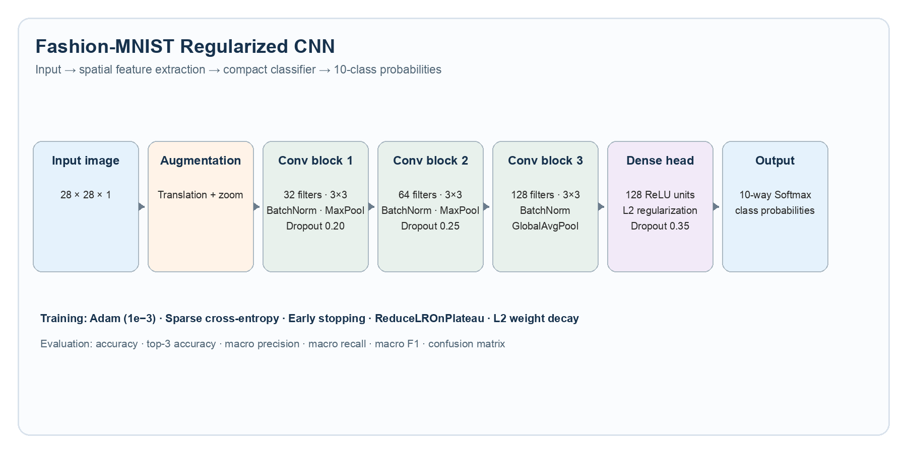
Objective 1: Build, train, and evaluate a reproducible convolutional neural network that classifies ten categories of clothing images, then explain the architecture, training behavior, evaluation results, limitations, and improvement opportunities.

Prepared as a professional internship project starter package

Executive summary
This project applies deep learning to a practical image-classification problem: recognizing the category of an item of clothing from a small grayscale image. Fashion-MNIST was selected because it is public, balanced, compact, and sufficiently challenging to demonstrate the complete deep-learning workflow without requiring specialized hardware.
The proposed solution is a compact convolutional neural network (CNN) built with TensorFlow/Keras. It combines convolutional feature extraction with batch normalization, dropout, L2 regularization, light geometric augmentation, global average pooling, and an Adam optimizer. The design is intentionally more rigorous than a basic dense network while remaining practical to run in VS Code on a CPU.
- Primary deliverable: a reproducible end-to-end training script that downloads the dataset, trains the model, evaluates it, and saves evidence artifacts.
- Core evaluation: test accuracy, top-3 accuracy, macro precision, macro recall, macro F1, class-level report, learning curves, and a confusion matrix.
- Critical focus: diagnosing overfitting, interpreting visually similar classes, and balancing model capacity with local compute limits.
Submission note: Run train.py before final submission and replace any indicative results with the exact values in outputs/metrics.json and outputs/classification_report.csv.

1. Problem statement and project objective
Given a 28×28 grayscale image of a fashion product, predict one of ten clothing categories. This is a supervised, multi-class classification task with a single categorical label per image.

Objective 1
Design and implement a reproducible deep-learning pipeline that classifies Fashion-MNIST clothing images, evaluates performance rigorously, and communicates the model’s behavior through metrics and visual diagnostics.

Why this is a data-science problem
- It requires data preparation: scaling pixel intensities and creating a validation split without changing class proportions.
- It requires model selection: comparing a spatially aware CNN design with the limitations of a fully connected baseline.
- It requires measurement: using multiple metrics rather than accuracy alone, especially when some classes are visually similar.
- It requires interpretation: using a confusion matrix and representative predictions to understand the model’s errors.

2. Dataset analysis and selection
Three public datasets were considered. The choice was made using four criteria: suitability for CNNs, clear licensing and documentation, local compute requirements, and enough complexity to demonstrate meaningful error analysis.

Candidate | Strengths | Limitations | Decision
MNIST | Very small; easy baseline; 10 balanced digit classes. | Too easy for a strong deep-learning case study; errors are less informative. | Rejected for final project.
Fashion-MNIST | 60,000 training and 10,000 test examples; 28×28 grayscale; 10 balanced clothing classes; CPU-friendly. | Visually similar classes such as Shirt, T-shirt/top, Pullover, and Coat. | Selected.
CIFAR-10 | Color images; more realistic object-recognition challenge. | Higher compute and memory requirements; harder to explain in a short internship report. | Good extension.

Selected dataset: Fashion-MNIST
Fashion-MNIST contains 70,000 grayscale images of Zalando clothing articles. Each image is 28×28 pixels and belongs to one of ten classes. The official TensorFlow documentation describes 60,000 training examples and 10,000 test examples. The labels are mutually exclusive integers from 0 to 9.
Label | Class | Expected modeling implication
0 | T-shirt/top | Often confused with Shirt and Pullover.
1 | Trouser | Distinct silhouette; often a strong class.
2 | Pullover | Can overlap with Coat and Shirt.
3 | Dress | Shape and length provide useful spatial cues.
4 | Coat | May overlap with Pullover and Shirt.
5 | Sandal | Distinct footwear pattern.
6 | Shirt | Known hard class because of visual similarity.
7 | Sneaker | Distinct footwear pattern.
8 | Bag | Strong outline and texture cues.
9 | Ankle boot | Distinct footwear pattern.

Dataset rationale: Fashion-MNIST is difficult enough to show the value of convolutions and regularization, but small enough that an intern can reproduce the full experiment on a normal laptop.

3. Methodology

3.1 Data preparation
- Pixel values are converted from uint8 [0, 255] to float32 [0, 1] by dividing by 255.
- A channel dimension is added so the input shape becomes (28, 28, 1), which is the standard CNN image format.
- The original training set is split into 54,000 fitting examples and 6,000 validation examples using a fixed random seed and stratification.
- The official 10,000-example test set remains untouched until final evaluation.

3.2 Architecture design
Figure 1. Proposed regularized CNN architecture.
Component | Configuration | Reason for inclusion
Input | 28×28×1 | Matches dataset shape and preserves spatial structure.
Augmentation | Random translation 8%; random zoom 10% | Improves robustness to small position and scale changes.
Conv block 1 | 32 filters, 3×3; BatchNorm; MaxPool; Dropout 0.20 | Learns low-level edges and textures while controlling noise.
Conv block 2 | 64 filters, 3×3; BatchNorm; MaxPool; Dropout 0.25 | Builds mid-level shapes with more feature channels.
Conv block 3 | 128 filters, 3×3; BatchNorm; GlobalAveragePooling | Captures higher-level patterns without a large flattening layer.
Dense head | 128 ReLU; L2=1e−4; Dropout 0.35 | Combines learned features while limiting co-adaptation.
Output | 10-way softmax | Returns a probability distribution over the ten classes.

3.3 Design justification
A CNN is preferred over a fully connected network because nearby pixels form meaningful local patterns such as edges, collars, soles, and garment outlines. Weight sharing allows the same detector to be reused across image locations, which reduces parameter waste and improves translation tolerance.
Global average pooling is used instead of flattening the final feature maps. This reduces the number of parameters in the classification head and makes the model less likely to memorize individual training images. Batch normalization stabilizes intermediate activations, while dropout, L2 weight decay, augmentation, early stopping, and learning-rate reduction address different forms of overfitting or unstable optimization.

4. Training process

4.1 Hyperparameters
Setting | Value | Reason
Optimizer | Adam | Reliable default for image classification and easy to tune.
Initial learning rate | 0.001 | A common starting point for Adam on normalized images.
Loss | Sparse categorical cross-entropy | Correct for integer-encoded, mutually exclusive classes.
Batch size | 128 | Balances gradient stability, speed, and laptop memory.
Maximum epochs | 20 | Enough room to converge; early stopping can end sooner.
Early stopping | Patience 4 on validation accuracy | Restores the best validation checkpoint and limits over-training.
Learning-rate schedule | Reduce by 0.5 after 2 stagnant validation-loss epochs | Allows finer updates near a plateau.
Seed | 42 | Enables a stable comparison across reruns.

4.2 Key training code
(x_train, y_train), (x_test, y_test) = tf.keras.datasets.fashion_mnist.load_data()
x_train = x_train.astype("float32") / 255.0
x_test = x_test.astype("float32") / 255.0
x_train = np.expand_dims(x_train, axis=-1)
x_test = np.expand_dims(x_test, axis=-1)
x_fit, x_val, y_fit, y_val = train_test_split(
x_train, y_train, test_size=0.10,
random_state=42, stratify=y_train
)
history = model.fit(
x_fit, y_fit,
validation_data=(x_val, y_val),
epochs=20,
batch_size=128,
callbacks=callbacks,
verbose=2,
)
The full runnable implementation is in train.py inside the accompanying ZIP package. It creates all plots and tabular outputs automatically, which makes the final report evidence-based rather than dependent on manually copied values.

5. Evaluation plan and metrics
The test set is used once after training and after restoring the best validation checkpoint. This separation prevents the test set from influencing model selection.

Metric | Definition | Why it matters
Accuracy | Correct predictions ÷ all test examples. | Simple overall performance measure.
Top-3 accuracy | True class appears among the three highest predicted probabilities. | Useful when a decision-support system can show a shortlist.
Precision | Of examples predicted as a class, the fraction that truly belong to it. | Measures false-positive control per class.
Recall | Of true examples in a class, the fraction recovered. | Measures missed examples per class.
Macro F1 | Unweighted mean of class-level F1 scores. | Prevents large or easy classes from hiding weak classes.
Confusion matrix | Counts of true class versus predicted class. | Shows the error structure and visually similar categories.

5.1 Expected result interpretation
A well-tuned compact CNN on Fashion-MNIST commonly achieves high-80s to low-90s test accuracy, depending on TensorFlow version, hardware, augmentation, and stopping point. The exact result must be taken from outputs/metrics.json after running the supplied code; no measured accuracy is claimed in this report before execution.
Important: Do not report an expected range as if it were an observed result. Use the saved JSON and CSV files from your own run in the final submission.

5.2 Evidence artifacts generated by the script
- training_curves.png: compares training and validation loss/accuracy and exposes divergence.
- confusion_matrix.png: identifies systematic class-level errors.
- classification_report.csv: records precision, recall, F1, and support for each class.
- sample_predictions.png: provides qualitative evidence, including correct and incorrect predictions with confidence.

6. Critical analysis: challenges and mitigation
Challenge | Risk to the project | Mitigation implemented | How to verify
Overfitting | Training accuracy rises while validation accuracy stalls or falls. | Dropout, L2 regularization, augmentation, early stopping, and checkpointing. | Inspect the gap in training_curves.png.
Visually similar classes | Shirt, T-shirt/top, Pullover, and Coat share silhouettes. | Three convolutional stages and class-level metrics instead of accuracy alone. | Inspect the corresponding confusion-matrix cells.
Resource constraints | Long training time or memory pressure on CPU laptops. | Small 28×28 inputs, compact channel sizes, batch size 128, and an optional 2-epoch smoke test. | Compare runtime and system memory on the local machine.
Validation leakage | Using test data during tuning inflates the final score. | Fixed stratified validation split and one final test evaluation. | Confirm test set appears only in evaluate().
Reproducibility | Random splits or initialization change conclusions. | Fixed seed, saved metadata, saved history, and explicit requirements. | Compare run_metadata.json and history.csv across reruns.

6.1 Likely error pattern
The model is expected to be strongest on visually distinct footwear and bag categories. The hardest errors are likely to occur among upper-body garments because the 28×28 resolution removes fine-grained details. A high overall accuracy can therefore coexist with lower recall for Shirt or T-shirt/top; macro F1 and the confusion matrix are included to reveal this issue.

6.2 Limitations
- Fashion-MNIST images are centered and low resolution, so results do not directly represent deployment performance on photographs.
- The test set is a fixed benchmark rather than a live stream; distribution shift is not measured.
- Class labels describe broad categories and do not include color, brand, material, gender, or style attributes.
- A single model seed and one architecture do not establish statistical significance. A stronger study would repeat runs and report mean ± standard deviation.

7. Reproduction guide for VS Code
Open the extracted project folder in VS Code and run the following commands in the integrated terminal:
python -m venv .venv
# Windows PowerShell
.venv\Scripts\Activate.ps1
# macOS/Linux
source .venv/bin/activate
python -m pip install --upgrade pip
pip install -r requirements.txt
python train.py --epochs 20 --batch-size 128 --output-dir outputs
The first run downloads the public dataset automatically. If the machine is resource-constrained, use --epochs 2 as a smoke test, then increase to 15–20 epochs for the report run. When execution finishes, open outputs/metrics.json, outputs/classification_report.csv, and the three PNG files before writing the final result paragraph.

Suggested final-results paragraph
After training, the best checkpoint achieved a test accuracy of [XX.XX%],
top-3 accuracy of [XX.XX%], and macro F1 of [XX.XX%]. The confusion
matrix showed the greatest overlap between [CLASS A] and [CLASS B],
which is consistent with the low-resolution appearance of upper-body
garments. The learning curves indicated [stable convergence / mild
overfitting], so [the regularization strategy / further tuning] was
[effective / still necessary].

8. Conclusion and future work
This project demonstrates a complete deep-learning application in data science: selecting a public dataset, defining a supervised problem, designing a CNN, training with validation controls, evaluating with multiple metrics, and critically analyzing failure modes. The architecture is deliberately compact and defensible for an internship project because it improves on a naive dense network without requiring a large GPU or a complex pretrained model.
Future work could compare the CNN against a dense baseline, repeat the experiment across multiple seeds, tune augmentation strength, evaluate calibration of predicted probabilities, or transfer the workflow to CIFAR-10. For a production setting, the next steps would include monitoring distribution shift, adding model explainability, and testing on real-world product photographs.

References
- TensorFlow Datasets — Fashion-MNIST — https://www.tensorflow.org/datasets/catalog/fashion_mnist
- TensorFlow API — tf.keras.datasets.fashion_mnist.load_data — https://www.tensorflow.org/api_docs/python/tf/keras/datasets/fashion_mnist/load_data
- TensorFlow tutorial — Basic classification: Classify images of clothing — https://www.tensorflow.org/tutorials/keras/classification
- TensorFlow tutorial — Convolutional Neural Network (CNN) — https://www.tensorflow.org/tutorials/images/cnn
- Original Fashion-MNIST repository — https://github.com/zalandoresearch/fashion-mnist

Appendix A. Package contents
File | Purpose
train.py | Complete training, evaluation, and artifact-generation script.
requirements.txt | Pinned dependency ranges for a reproducible environment.
README.md | Quick-start instructions, labels, and output guide.
docs/architecture_diagram.png | Architecture diagram used in this report.
outputs/ | Destination for saved model, metrics, curves, and confusion matrix.

Academic integrity: This package is a reproducible starter project. Run the script yourself, inspect the artifacts, and write the final numerical result from your own run.

