1

D:06/05/2017

Angular2 12 Apps

1.HomePageApp

package.json:

This file is main for app. It has configuration and dependencies and version information. Also extensions of js files.

Npm init (run this cmd in your terminal then enter till end. Then its created package.json file in your folder)

Botstrap is the take care of loading the applicaton.

1) a2web/package.json

2) a2web/tsconfig.json for typescript

3) a2web/typings.json

4) a2web/systemjs.config.js

5) npm install (in ur app)

6) app/app.module.ts

7) app/app.component.ts (every ag2 project has app.component.ts file )

8) app/main.ts

9) index.html

10) npm start (run the server)

11) app/component/navabar/navbar.component.ts

If we create any component in app then import that component app.component.ts file

12) app/component/navabar/navbar.component.html

D: 08/05/2017

app/component/jumbotron/jumbotron.component.html

in app.component.html( when we create the component then we need to mention app.component.html )

Constructor:

The constructor method is not actually an Angular 2method. It is a predefined method in a TypeScript class which is called when the class is instantiated. The constructor's purpose is to help prepare the creation of a new instance of the class. In the context of Angular 2 it can be used to properly initialize fields.

App/app.routing.ts

2.GitHubApp

1) Register this your app in this url https://github.com/settings/applications

2) clone this project to your local machine git clone https://github.com/angular/quickstart githubs

3) cd githubs

4) npm install

5) npm start

6) app/components/

app/components/profile.component.ts

app/components/profile.component.html

app/services/github.service.ts

**D: 09/05/2017**

3.Need Music

1) app/compoenents

2) app/compoenents/about/

3) app/compoenents/search/

4) app/compoenents/navbar/

5) app.component.ts (copy this and paste it)

6) add this components in **app.module.ts**

7) add this link in **index.html**  <http://bootswatch.com/cyborg/bootstrap.min.css>

8) app/app.routing.ts (**routes**)

path: ‘’; (Represents the home page) after that import this file in **app.module.ts**

D:10/05/2017

4.Todo

**D:11/05/2017**

5.Firebase

1). npm install [angular-cli@1.0.0-beta.15](mailto:angular-cli@1.0.0-beta.15) install in your project folder.

Or

sudo npm install -g -f angular-cli

2). ng new businesscontacts

3). <https://github.com/angular/angularfire2>

**D:12/05/2017**

6.Myworkouts

1) <http://ionic.io/2>

2) <http://ionicframework.com/docs/intro/installation/>

3) <https://developer.android.com/studio/index.html>

4) npm install -g [ionic@beta](mailto:ionic@beta) (installation)

5) sudo $ npm install -g ionic cordova

6) ionic start myworkouts –v2

7) cd myworkouts

8) ionic serve

9) <http://localhost:8100/>

10) npm install -g cordova

11) ionic cordova platform add android

12) cordova platform add android

13) cordova emulate

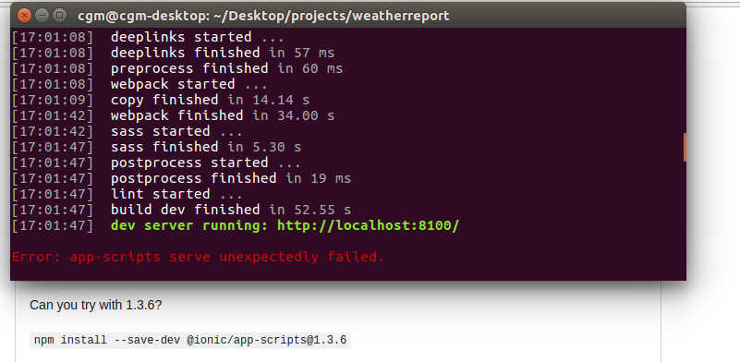14)

D:15/05/2017

9.Auth Apllication

1) [www.manage.auth0.com](http://www.manage.auth0.com/) login here

2) git clone https://github.com/angular/quickstart authapp

3) npm install

4) npm start

5) npm install angular2-jwt –save

6) npm install auth0-lock –save

7) npm start

8) app/components

9) components/home

10) components/profile

11) app/routing.ts

import {ModuleWithProviders} from '@angular/core';

import {Routes, RouterModule} from '@angular/router';

import {HomeComponent} from './components/home/home.component';

import {ProfileComponent} from './components/profile/profile.component';

const appRoutes: Routes = [

{

path:'',

component: HomeComponent

},

{

path:'profile',

component: ProfileComponent

}

];

export const appRoutingProviders: any[] = [];

export const routing: ModuleWithProviders = RouterModule.forRoot(appRoutes);

12) then go to **app.module.ts** file

Import the components which we have create in routes.

13) **<base href="/">** Add this line in **index.html**

14) <router-outlet></router-outlet> in  **app.component.html**

15) components/services (its must be app name)

**D:16/05/2017**

10.Google Maps

1) npm install -g @angular/cli

2) ng new mapit

3) ng serve

4) npm install angular2-google-maps –save

5) ng serve

11. Movie Finder

1) git clone https://github.com/angular/quickstart movie

2) npm install

3) npm start

4) Completed on 17/05/2017

**D: 18/05/2017**

**12.Devlogger**

**npm run tsc:w**

1) sudo npm install feathers-cli -g (in project folder) https://feathersjs.com/

2) mkdir devlogger

3) cd devlogger

4) feathers generate app

5) feathers generate service

6) npm search yeoman-generator (its different from videos)

**13.SocketChat**

1) <https://socket.io/>

2) git clone https://github.com/angular/quickstart socketchat

3) npm install

4) npm start

5) server( create server folder)

6) cd server

7) npm init

8) npm install

9) server/server.js

10) server> node server

11) app/chat

12) chat/chat.component.ts

chat/chat.component.html

13) app/services

14) services/chat.service.ts

15) socketchat> npm install socket.io-client –save

16) typings install dt~socket.io-client --save –global

**liflecycle methods:**

OnInit, OnDestroy

17) bower install bootstrap --save

ng new proname

sudo npm install

ng serve

**INSTALLATION OF am**

sudo npm install angular-material

sudo npm install angular-material –save

npm init

sudo npm install jspm -g

jspm install angular-material

sudo npm install bower -g

bower install angular-material

bower install angular-material –save

bower init

npm install -g tsd

tsd query angular

tsd query angular-material

tsd install angular angular-material –save

git clone https://github.com/angular/material2.git am2

npm install

npm run build

ng new material

npm start

npm install --save @angular2-material/{core,button,card,checkbox,icon,input,list,toolbar}@2.0.0-alpha.5