**1. Check your system**

Please ensure that you have met the prerequisites below (e.g., numpy), depending on your package manager. Anaconda is our recommended package manager since it installs all dependencies. Refer to <https://pytorch.org/get-started/locally/>

Example) Windows

|  |
| --- |
| PyTorch is supported on the following Windows distributions:   * Windows 7 and greater; Windows 10 or greater recommended. * Windows Server 2008 r2 and greater   Currently, PyTorch on Windows only supports Python 3.x; Python 2.x is not supported. |

If you use Anaconda to install PyTorch, it will install a sandboxed version of Python that will be used for running PyTorch applications.

**2. Go to pytorch website**, <https://pytorch.org/get-started/locally/>

**3. Select my computer configuration and copy command in the “Run this Command”**

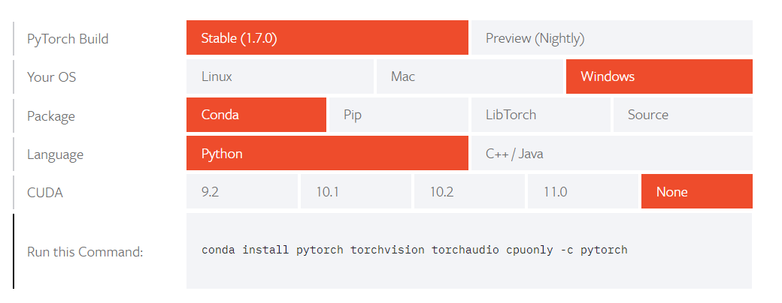

**4. Run Anaconda command prompt and paste this command and hit enter button**

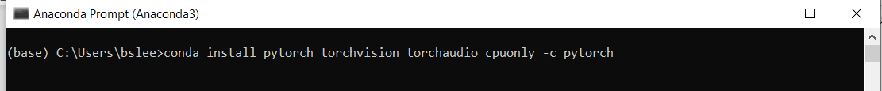

Follow instruction and type ‘y’ if it asks.

**5. Check the installed list**

**Coda list**

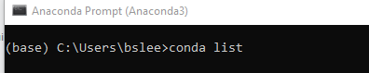

Check the pytorch version

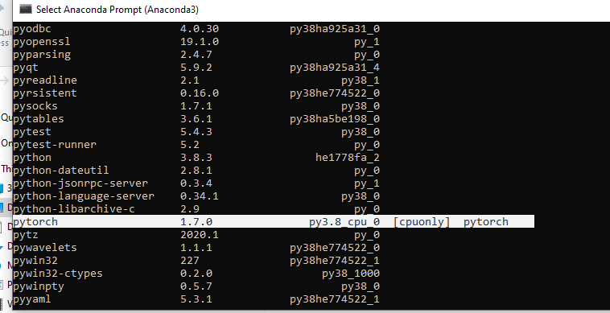

**6. Verify pytorch in the Jupyter notebook. Run following statements.**

Import torch

x = torch.rand(5,3)

print(x)

**7. If you see the followint error message, download vc_redist.x64.exe**

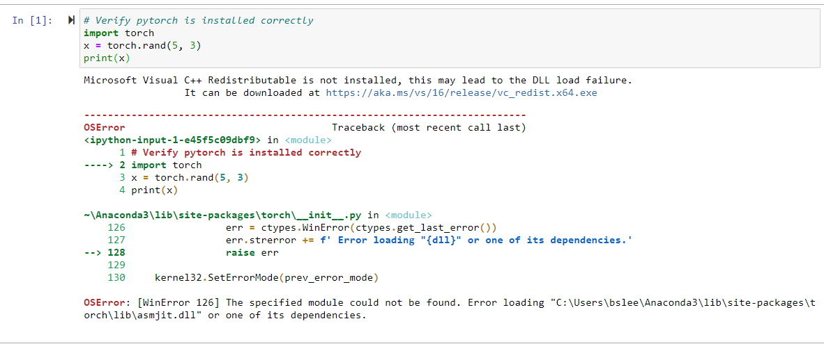

Microsoft Visual C++ Redistributable is not installed, this may lead to the DLL load failure. It can be downloaded at <https://aka.ms/vs/16/release/vc_redist.x64.exe>

**7. After install the vc_redist.x64.exe, there is no issue**

