**1. Linear Regression**

In statistics, **linear regression** is a **linear** approach to modelling the relationship between a scalar response and one or more explanatory variables (also known as dependent and independent variables).

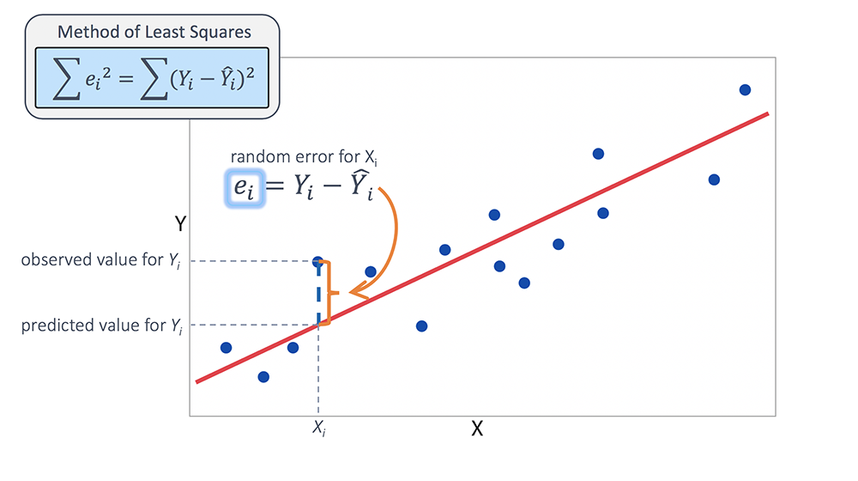

**2. Neural Network**

<https://medium.com/yottabytes/everything-you-need-to-know-about-gradient-descent-applied-to-neural-networks-d70f85e0cc14>

As you probably already know (don’t run away if so) a neural network is composed of *neurons*organized in layers:



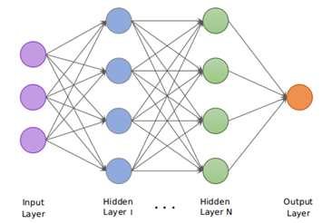

Each network neuron (except those in the input layer) is actually a sum of all its inputs, which are in fact the outputs from the previous layer multiplied by some **weights.**An additional term called **bias** is added to this sum. And a nonlinear function known as activation function is applied to the result.

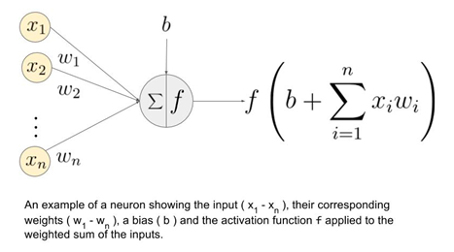

These **parameters** (weights, bias) are exactly the numerical values ​​that we’ll try to adjust by **training** the network with an already labeled dataset, as in any other supervised Machine Learning problem. The final result will be a model built from that data, able to make predictions over future samples.