

**YOUR HEALTH IS OUR PRIORITY**

**Pain Management**

Pain is the single most reason why people seek medical services. With our highly skilled PTs, we can help you feel pain-free in no time!

**Possible Techniques:**

Dry Needling

Cupping Therapy

Corrective Exercises

Fascial Manipulation

Instrument Assisted Soft Tissue Mobilization

Joint Mobilization

Spinal Correction





**CONTACT US**

Call us to schedule an appointment and we’ll get back to you as soon as possible!

**Facebook:** @privatehomePT

**Instagram:** homecareptph

**Email:** homecarephysicaltherapy00

@gmail.com

**Contact Numbers:**

**Globe** 0917-332-9584

**Smart** 0929-801-1751

**AREAS COVERED**

Manila

Quezon

Caloocan

Malabon

Navotas

Valenzuela

Cainta

Antipolo

Taytay

Marikina

Pasig

San Juan

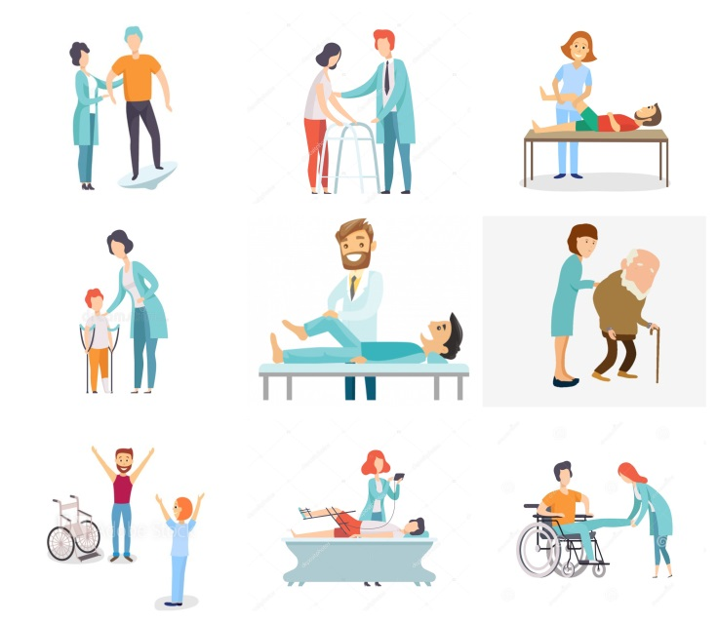



Are you concern about your health?

We are highly-trained professionals who provide the highest quality of care to help you get back to your normal activities as quickly as possible. Reach out today to learn more about our approach and therapeutic services.



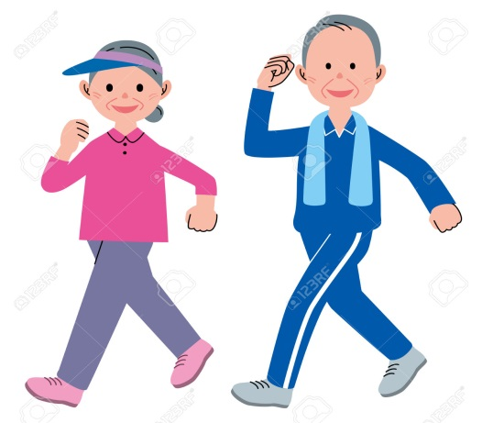

**Geriatric Rehabilitation**

As we age, our bodies tend to feel the effects of our actions when we are still young so it is common to experience pain, brittleness of bones, slowness of movement, and high risk for falls. Let us help you reverse the effects of aging and start moving today!

**Treatments:**

Balance Training

Cardiovascular Training

Deconditioning Management

Fall Prevention Techniques

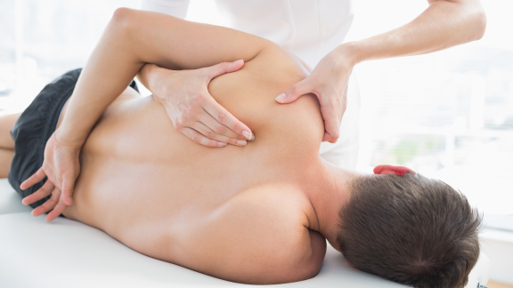

**Musculoskeletal Condition**

Injuries happen to all of us and in some cases, doctors recommends that you undergo surgery. Why don’t you consult with us first? Because there are times that a simple consultation and treatment with a physical therapist can help you ease your condition which will result with you not needing a surgery. Contact us now!

**We are well equipped to handle cases like:**

Ligamentous sprain

Muscular strain

Fracture

Sports injury

Pre/Post surgery rehabilitation

And many more!

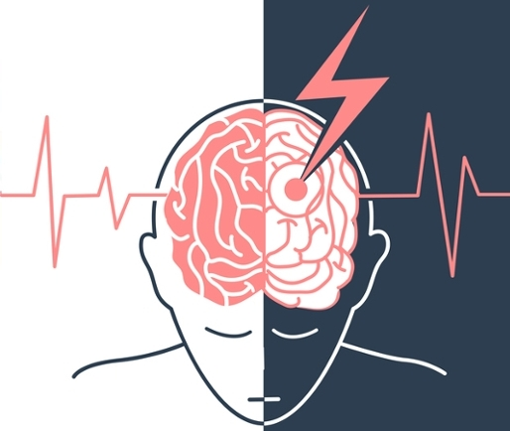

**Stroke and Other Neurological Condition**

Have you or know someone who suffered a stroke or other neurological conditions like ones listed below? Do you like to undergo physical therapy without the hassle of the traffic and do it at the comfort of your home? Contact us now!

**We are well equipped to handle cases like:**

Bell’s Palsy

Stroke (CVA)

Spinal cord Injury

Traumatic brain Injury

Pediatric Condition

And Many More!