Exploratory Data Analysis

Nik Bear Brown

In the this lesson, we look graphical techniques summarize their main characteristics of one, two variable, and multi-variable data sets. To find relationships amongst variables and to find the variables which are most interesting for a particular analysis task.

Rationale: Exploratory data analysis helps one understand the data, to form and change new theories, and decide which techniques are appropriate for analysis. After a model is finished, exploratory data analysis can look for patterns in these data that may have been missed by the original hypothesis tests. Successful exploratory analyses help the researcher modify theories and refine the analysis.

## Additional packages needed

To run the code in M01_Lesson_03.Rmd you may need additional packages.

* If necessary install ggplot2 package.

`install.packages("ggplot2");

require(ggplot2)

## Loading required package: ggplot2

## Topics

* Exploratory Data Analysis
* Types of Variables
* Descriptive Statistics
* Measures of Central Tendency
* Measures of spread
* Summary Statistics
* Univariate Data Analysis
* Box-Plots
* Bar charts
* Histograms
* Line plots
* Multivariate Data Analysis
* Aesthetic mappings
* Faceting
* Position Adjustments
* Scatter plots
  + Scatter Plot with No apparent relationship
  + Scatter Plot with Linear relationship
  + Scatter Plot with Regression Lines
  + Scatter Plot with Quadratic relationship
  + Scatter plot with Homoscedastic relationship
  + Scatter plot with Jittering
* QQplot
* Assingment

## Exploratory Data Analysis

In statistics,exploratory data analysis (EDA) is an approach to analyzing data sets to summarize their main characteristics, often with visual methods concepts apply to statistics and to graphical methods. EDA is for seeing what the data can tell us before the formal modeling or hypothesis testing task.

* from [Exploratory Data Analysis - Wikipedia)](https://en.wikipedia.org/wiki/Exploratory_data_analysis)

Early forms of Exploratory Data Analysis such as the box plot are often attributed to John Tukey (1970s)

*John Tukey*

John Wilder Tukey (June 16, 1915 - July 26, 2000) was an American mathematician best known for development of the FFT algorithm and box plot.The Tukey range test, the Tukey lambda distribution, the Tukey test all bear his name.

* from [John Tukey - Wikipedia)](https://en.wikipedia.org/wiki/Exploratory_data_analysis)

*Goals of Exploratory Data Analysis*

* get a general sense of the data
* data-driven (model-free)
* visual (Humans are great pattern recognizers)
* test assumptions (e.g. normal distributions or skewed?)
* identify useful raw data & transforms (e.g. log(x))
* distributions (symmetric, normal, skewed)
* data quality problems
* outliers
* correlations and inter-relationships
* subsets of interest
* suggest functional relationships

## Data

We will be using the diamonds,economics, and mpg datasets (from ggplot2) as well as some simulated [Twitter](https://twitter.com/). Feel free to tweet questions to [@NikBearBrown](<https://twitter.com/NikBearBrown>)

# Load our data  
data(mpg)  
data(economics)  
data(diamonds)  
data_url <- 'http://54.88.34.236/YouTube/MachineLearning/M01/M01_quasi_twitter.csv'  
twitter <- read.csv(url(data_url))

## R Functions for Understanding Data

* We can use class(), dim(), nrow(), ncol(), names() to understand datasets
  + object.size(data.frame) = returns how much space the dataset is using in memory
* head(data.frame, n), tail(data.frame, n) = returns first/last rows of data; default = 6
* summary() = provides summary statistics for each variable, depending on type of variable (numeric,factor).
  + for numerical variables, displays min max, mean median, etx.
  + for categorical (factor) variables, displays number of times each value occurs
* table(data.frame$variable) = table of all values of the variable, and how many observations there are for each
* str(data.frame) = structure of data, provides data class, num of observations vs variables, and name of class of each variable and preview of its contents
* view(data.frame) = opens and view the content of the data frame

## ggplot2 diamonds data?

What is in the diamonds data? ?diamonds typed in the R prompt opens up a full description.

str(diamonds)

## 'data.frame': 53940 obs. of 10 variables:  
## $ carat : num 0.23 0.21 0.23 0.29 0.31 0.24 0.24 0.26 0.22 0.23 ...  
## $ cut : Ord.factor w/ 5 levels "Fair"<"Good"<..: 5 4 2 4 2 3 3 3 1 3 ...  
## $ color : Ord.factor w/ 7 levels "D"<"E"<"F"<"G"<..: 2 2 2 6 7 7 6 5 2 5 ...  
## $ clarity: Ord.factor w/ 8 levels "I1"<"SI2"<"SI1"<..: 2 3 5 4 2 6 7 3 4 5 ...  
## $ depth : num 61.5 59.8 56.9 62.4 63.3 62.8 62.3 61.9 65.1 59.4 ...  
## $ table : num 55 61 65 58 58 57 57 55 61 61 ...  
## $ price : int 326 326 327 334 335 336 336 337 337 338 ...  
## $ x : num 3.95 3.89 4.05 4.2 4.34 3.94 3.95 4.07 3.87 4 ...  
## $ y : num 3.98 3.84 4.07 4.23 4.35 3.96 3.98 4.11 3.78 4.05 ...  
## $ z : num 2.43 2.31 2.31 2.63 2.75 2.48 2.47 2.53 2.49 2.39 ...

names(diamonds)

## [1] "carat" "cut" "color" "clarity" "depth" "table" "price"   
## [8] "x" "y" "z"

## Quasi-Twitter data?

What is in the Quasi-Twitter data? This is a simulated Twitter data set based on real Twitter data.

str(twitter)

## 'data.frame': 21916 obs. of 25 variables:  
## $ screen_name : Factor w/ 21916 levels "+5400E1.","000D0se7",..: 4341 15303 21127 13570 14085 3607 14942 8653 15547 19146 ...  
## $ created_at_month : int 2 11 4 3 4 2 7 5 1 1 ...  
## $ created_at_day : int 9 21 1 24 23 9 15 23 23 13 ...  
## $ created_at_year : int 2007 2009 2007 2007 2009 2009 2006 2008 2009 2009 ...  
## $ country : Factor w/ 44 levels " Germany","Argentina",..: 44 19 19 44 44 12 44 5 44 44 ...  
## $ location : Factor w/ 378 levels "Akron Ohio","Alabama",..: 188 202 25 233 211 79 365 41 242 83 ...  
## $ friends_count : int 1087 5210 1015 338 641 917 1574 16300 8316 640 ...  
## $ followers_count : int 22187643 6692814 6257020 3433218 2929559 2540842 1960373 1934803 1855827 1697620 ...  
## $ statuses_count : int 60246 93910 118465 78082 93892 59397 41023 62178 56057 82912 ...  
## $ favourites_count : int 1122 3825 1143 0 226 2122 20160 15 540 3 ...  
## $ favourited_count : int 105005 40487 87968 25943 32589 19760 13558 25084 8732 24515 ...  
## $ dob_day : int 29 24 4 22 9 1 2 6 15 26 ...  
## $ dob_year : int 1999 1991 1997 1998 1963 1995 1999 1986 1991 1986 ...  
## $ dob_month : int 4 10 3 8 11 1 11 10 2 9 ...  
## $ gender : Factor w/ 2 levels "female","male": 1 1 2 2 1 1 1 2 1 2 ...  
## $ mobile_favourites_count: int 0 0 0 0 0 0 0 0 0 0 ...  
## $ mobile_favourited_count: int 0 5032191 0 0 0 0 0 1934803 0 0 ...  
## $ education : int 8 15 9 9 13 15 14 10 11 12 ...  
## $ experience : int 0 0 0 44 24 21 31 0 27 20 ...  
## $ age : int 29 0 32 40 45 14 27 31 34 40 ...  
## $ race : Factor w/ 10 levels "arab","asian",..: 10 10 10 10 10 10 10 10 2 1 ...  
## $ wage : num 16.3 17.9 15.7 7 17.9 ...  
## $ retweeted_count : int 1 1 2 0 1 2 1 2 0 0 ...  
## $ retweet_count : int 30 6 65 8 7 64 13 14 15 10 ...  
## $ height : int 156 162 168 180 162 158 160 178 156 173 ...

names(twitter)

## [1] "screen_name" "created_at_month"   
## [3] "created_at_day" "created_at_year"   
## [5] "country" "location"   
## [7] "friends_count" "followers_count"   
## [9] "statuses_count" "favourites_count"   
## [11] "favourited_count" "dob_day"   
## [13] "dob_year" "dob_month"   
## [15] "gender" "mobile_favourites_count"  
## [17] "mobile_favourited_count" "education"   
## [19] "experience" "age"   
## [21] "race" "wage"   
## [23] "retweeted_count" "retweet_count"   
## [25] "height"

## Types of Variables

*Continuous variables*

Always numeric Integers - a whole number; a number that is not a fraction. e.g. -1,0,1,2,3,4, ...

Floating point numbers (a rational number or a 'float') - a rational number is any number that can be expressed as the quotient or fraction p/q of two integers, p and q, with the denominator q not equal to zero. Since q may be equal to 1, every integer is a rational number. e.g. -1.3, 0.0, 3.14159265359, 2.71828, ...

Continuous variables can be any number, positive or negative

Examples: age in years, weight, website 'hits' and other measurements

*Categorical variables* A categorical variable is a variable that can take on one of a limited, and usually fixed, number of possible values.

Types of categorical variables are ordinal, nominal and dichotomous (binary)

### Nominal Variables

Nominal variable is a categorical variable without an intrinsic order

Examples of nominal variables: Where a person lives in the U.S. (Northeast, South, Midwest, etc.) Sex (male, female) Nationality (American, Mexican, French) Race/ethnicity (African American, Hispanic, White, Asian American)

|  |  |
| --- | --- |
| Enum | *Nationality* nominal |
| 1 | American |
| 2 | Mexican |
| 3 | French |
| 4 | Brasilian |

Ordinal Variables

Ordinal variables are categorical variable with some intrinsic order or numeric value

Examples of ordinal variables: Education (no high school degree, HS degree, some college, college degree) Agreement (strongly disagree, disagree, neutral, agree, strongly agree) Rating (excellent, good, fair, poor) Any other scale (e.g. On a scale of 1 to 5)

|  |  |
| --- | --- |
| Rank | *Degree* ordinal |
| 1 | PhD |
| 2 | Master's |
| 3 | Bachelors |
| 4 | Associate's |
| 5 | High School |

*Dichotomous Variables*

Dichotomous (or binary) (or boolean) variables – a categorical variable with only 2 levels of categories * yes or no * true or false * accept or reject * pass or fail

## Factors

Factors represent *categorical data* in R

There are two types: **unordered** vs **ordered** just like **ordinal** vs **nominal** categorical variables.

* `table(factor_Variable)` = how many of each are in the factor

Factor is a data type that is unique to R (although similar to an [Enumerated type](https://en.wikipedia.org/wiki/Enumerated_type) in other languages.)

* The *levels* are the external presentation of the factors
* Internally it's stored as integers (what is known as an "enum" in many other languages)

## Descriptive Statistics

Descriptive statistics is the discipline of quantitatively describing the main features of a collection of data. Common descriptive measures used are measures of central tendency and measures of variability or dispersion or spread.

*Measures of central tendency*

Measures of central tendency are used to describe the most typical measure.

Mode: the value in a string of numbers that occurs most often Median: the value whose occurrence lies in the middle of a set of ordered values

Mean: sometimes referred to as the arithmetic mean. It is the average value characterizing a set of numbers

### Mode

* the value that occurs most frequently
* used w/ nominal data
* there can be "ties"

### Median

* score at the center of the distribution
* sort and take the middle value (or average or two middle values)
* determine w/ :
* equal to 50th percentile

### Mean (or arithmetic mean)

* can be misleading when there are large outliers

### Properties of the Measures of Center

1. adding or subtracting a constant does the same to the measure of center
2. multiplying or dividing by a constant does the same to the measure of center

*Measures of Spread*

Measures of variability aare used to reveal the typical difference between the values in a set of values

Measures of Spread  
* Range, Quartile 2nd Quartile is the median * Quartiles: sort and divide in 4 parts. * Frequency distribution reveals the number (percent) of occurrences of each number or set of numbers * Range identifies the maximum and minimum values in a set of numbers * Standard deviation (or variance) indicates the degree of variation

## Summary statistics

In descriptive statistics, summary statistics are used to summarize a set of observations, in order to communicate the largest amount of information as simply as possible. Statisticians commonly try to describe the observations in:

* a measure of location, or central tendency, such as the arithmetic mean
* a measure of statistical dispersion like the standard deviation
* a measure of the shape of the distribution like skewness or kurtosis
* if more than one variable is measured, a measure of statistical dependence such as a correlation coefficient

from [Summary statistics - Wikipedia](https://en.wikipedia.org/wiki/Summary_statistics)

mean(twitter$followers_count)

## [1] 5859.258

range(twitter$followers_count)

## [1] 0 22187643

diff(range(twitter$followers_count))

## [1] 22187643

head(twitter[,"followers_count"])

## [1] 22187643 6692814 6257020 3433218 2929559 2540842

median(twitter$followers_count)

## [1] 336

mean(twitter$followers_count)-median(twitter$followers_count)

## [1] 5523.258

var(twitter$followers_count)

## [1] 29142362169

sd(twitter$followers_count)

## [1] 170711.3

sqrt(var(twitter$followers_count))

## [1] 170711.3

summary(twitter$followers_count)

## Min. 1st Qu. Median Mean 3rd Qu. Max.   
## 0 105 336 5859 1075 22190000

summary(twitter)

## screen_name created_at_month created_at_day created_at_year  
## +5400E1. : 1 Min. : 1.000 Min. : 1.00 Min. :2006   
## 000D0se7 : 1 1st Qu.: 3.000 1st Qu.: 8.00 1st Qu.:2009   
## 001apdov : 1 Median : 6.000 Median :16.00 Median :2011   
## 001RBTePh: 1 Mean : 6.069 Mean :15.78 Mean :2011   
## 003B0K2 : 1 3rd Qu.: 9.000 3rd Qu.:23.00 3rd Qu.:2013   
## 007unfasa: 1 Max. :12.000 Max. :31.00 Max. :2015   
## (Other) :21910   
## country location friends_count   
## USA :14905 Mexico : 122 Min. : -84   
## Canada : 943 Boston : 108 1st Qu.: 123   
## India : 890 Montreal : 107 Median : 324   
## Earth : 516 Nevada : 80 Mean : 1058   
## England : 467 Bangalore : 79 3rd Qu.: 849   
## Australia: 291 Indianapolis Indiana: 76 Max. :660549   
## (Other) : 3904 (Other) :21344   
## followers_count statuses_count favourites_count   
## Min. : 0 Min. : 1 Min. : 0   
## 1st Qu.: 105 1st Qu.: 558 1st Qu.: 16   
## Median : 336 Median : 2341 Median : 164   
## Mean : 5859 Mean : 12486 Mean : 2217   
## 3rd Qu.: 1075 3rd Qu.: 9348 3rd Qu.: 950   
## Max. :22187643 Max. :1136198 Max. :1140139   
##   
## favourited_count dob_day dob_year dob_month   
## Min. : 0.00 Min. : 1.00 Min. :1900 Min. : 1.000   
## 1st Qu.: 2.00 1st Qu.: 5.00 1st Qu.:1965 1st Qu.: 3.000   
## Median : 9.00 Median :13.00 Median :1982 Median : 6.000   
## Mean : 92.24 Mean :13.49 Mean :1976 Mean : 6.398   
## 3rd Qu.: 36.00 3rd Qu.:21.00 3rd Qu.:1990 3rd Qu.: 9.000   
## Max. :105005.00 Max. :35.00 Max. :2000 Max. :1992.000   
##   
## gender mobile_favourites_count mobile_favourited_count  
## female: 7319 Min. : 0.0 Min. : 0   
## male :14569 1st Qu.: 0.0 1st Qu.: 0   
## NA's : 28 Median : 0.0 Median : 0   
## Mean : 152.9 Mean : 649   
## 3rd Qu.: 0.0 3rd Qu.: 0   
## Max. :377123.0 Max. :5032191   
##   
## education experience age race   
## Min. : 3.0 Min. :-32.00 Min. :-6.00 white :18032   
## 1st Qu.:11.0 1st Qu.: 0.00 1st Qu.:28.00 latino : 1115   
## Median :13.0 Median : 7.00 Median :36.00 asian : 960   
## Mean :12.5 Mean : 10.88 Mean :35.54 persian : 376   
## 3rd Qu.:14.0 3rd Qu.: 20.00 3rd Qu.:44.00 hispanic : 353   
## Max. :24.0 Max. : 74.00 Max. :91.00 pacific islander: 276   
## (Other) : 804   
## wage retweeted_count retweet_count height   
## Min. : 5.00 Min. : 0.0000 Min. : 0.00 Min. : 1.0   
## 1st Qu.: 13.52 1st Qu.: 0.0000 1st Qu.: 0.00 1st Qu.:165.0   
## Median : 20.36 Median : 1.0000 Median : 3.00 Median :172.0   
## Mean : 22.97 Mean : 0.9715 Mean : 52.73 Mean :171.5   
## 3rd Qu.: 28.40 3rd Qu.: 1.0000 3rd Qu.: 19.00 3rd Qu.:178.0   
## Max. :104.97 Max. :705.0000 Max. :5506.00 Max. :203.0   
##

## Univariate Data Analysis

Univariate data analysis-explores each variable in a data set separately. This serves as a good method to check the quality of the data on a variable by variable basis. See [Wikipedia Univariate analysis](https://en.wikipedia.org/wiki/Univariate_analysis)

## Five point summary

Five point summary (min, Q1,Q2,Q3, max)

* the sample minimum (smallest observation)
* the lower quartile or first quartile
* the median (middle value)
* the upper quartile or third quartile
* the sample maximum (largest observation)

In R the function summary() = provides different output for each variable, depending on type of variable (numeric,factor)

r summary(diamonds$price)

## Min. 1st Qu. Median Mean 3rd Qu. Max. ## 326 950 2401 3933 5324 18820

Note that summary can be applied to the whole data set.

r summary(diamonds)

## carat cut color clarity ## Min. :0.2000 Fair : 1610 D: 6775 SI1 :13065 ## 1st Qu.:0.4000 Good : 4906 E: 9797 VS2 :12258 ## Median :0.7000 Very Good:12082 F: 9542 SI2 : 9194 ## Mean :0.7979 Premium :13791 G:11292 VS1 : 8171 ## 3rd Qu.:1.0400 Ideal :21551 H: 8304 VVS2 : 5066 ## Max. :5.0100 I: 5422 VVS1 : 3655 ## J: 2808 (Other): 2531 ## depth table price x ## Min. :43.00 Min. :43.00 Min. : 326 Min. : 0.000 ## 1st Qu.:61.00 1st Qu.:56.00 1st Qu.: 950 1st Qu.: 4.710 ## Median :61.80 Median :57.00 Median : 2401 Median : 5.700 ## Mean :61.75 Mean :57.46 Mean : 3933 Mean : 5.731 ## 3rd Qu.:62.50 3rd Qu.:59.00 3rd Qu.: 5324 3rd Qu.: 6.540 ## Max. :79.00 Max. :95.00 Max. :18823 Max. :10.740 ## ## y z ## Min. : 0.000 Min. : 0.000 ## 1st Qu.: 4.720 1st Qu.: 2.910 ## Median : 5.710 Median : 3.530 ## Mean : 5.735 Mean : 3.539 ## 3rd Qu.: 6.540 3rd Qu.: 4.040 ## Max. :58.900 Max. :31.800 ##

## Box-Plot

A Box-Plot is a visual representation of a five point summary, with some additional information about outliers (1.5 times the lower and upper quartiles)

Box-Plot ( < 1.5 times Q1 outliers, expected min, Q1,Q2,Q3, expected max, outliers > 1.5 times Q3)

qplot(1,price, data=diamonds, geom="boxplot")

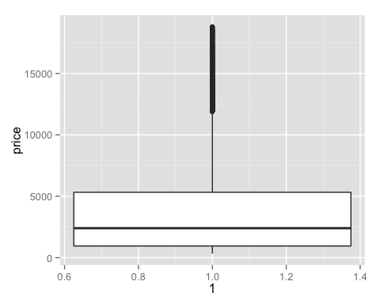

Box-Plots are useful for comparing five point summary of subsets of a data set confitioned on a factor.

qplot(cut,price, data=diamonds, geom="boxplot")

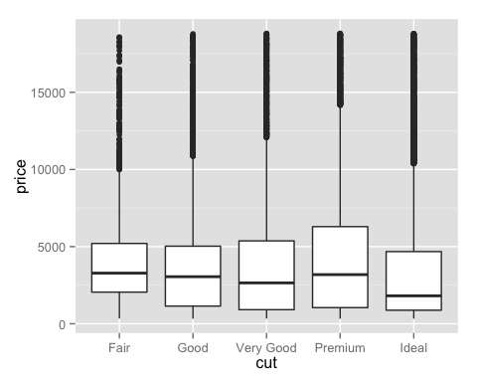

Alternatively it can be written using "layers."

qplot(cut,carat, data=diamonds)+geom_boxplot()

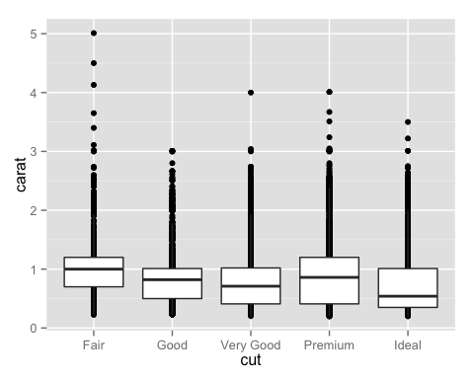

Reordering a boc-plot.

qplot(reorder(cut,carat),carat, data=diamonds)+geom_boxplot()

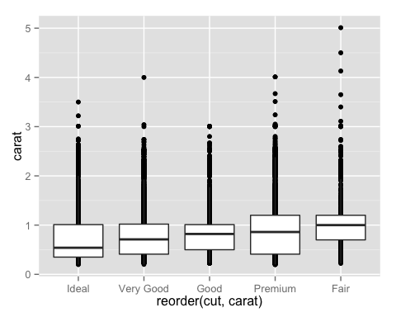

Filling by the color of the diamond.

qplot(cut,carat, data=diamonds,fill=color)+geom_boxplot()

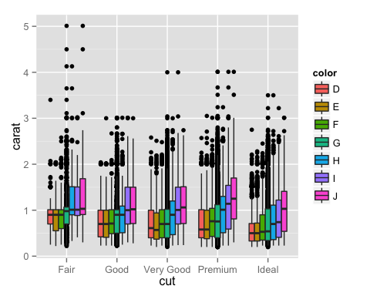

qplot(cut,carat, data=diamonds,fill=color)+geom_boxplot() + scale_y_log10()

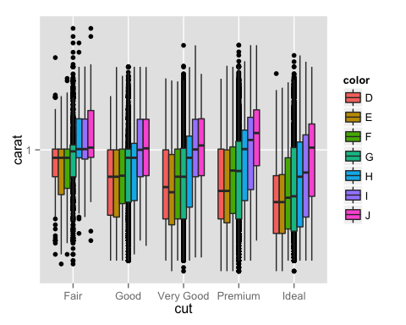

## Violin plots

A violin plot is a method of plotting numeric data. It is a box plot with a rotated kernel density plot on each side. The violin plot is similar to box plots, except that they also show the probability density of the data at different values.

qplot(cut,carat, data=diamonds)+geom_violin()

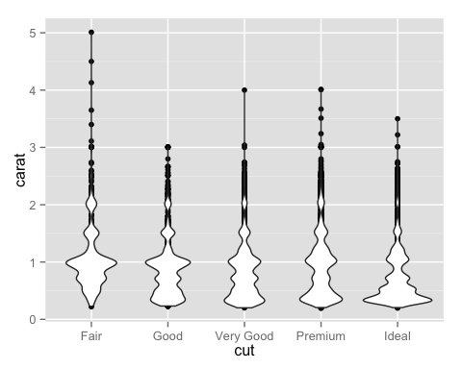

## Saving a graph to a variable

Graph can be saved to a variable to easily play with geom's.

g<-qplot(cut,carat, data=diamonds)  
g+geom_point()+geom_violin()

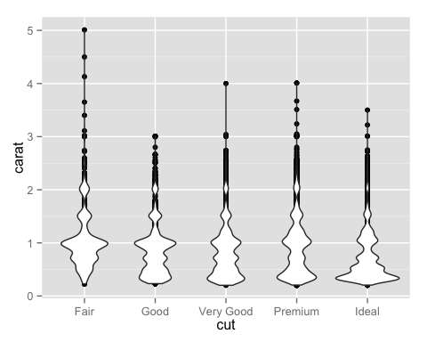

g+geom_violin()+geom_point()

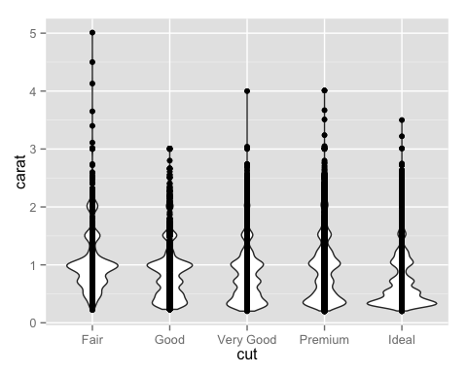

g+geom_jitter()+geom_point()+geom_violin()

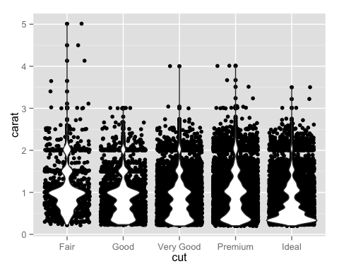

## Bar charts

A bar chart or bar graph is a chart that presents Grouped data with rectangular bars with lengths proportional to the values that they represent. [Bar chart - Wikipedia](https://en.wikipedia.org/wiki/Bar_chart)

qplot(cut, data=diamonds)

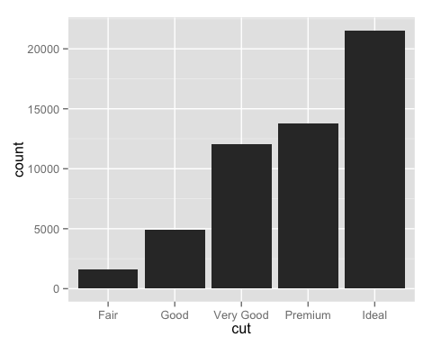

We can use an aesthetic mappings (e.g. color, size, shape) to dig deeper in the data by mapping variables to visual properties (aesthetics).

qplot(cut, data=diamonds, fill=color)

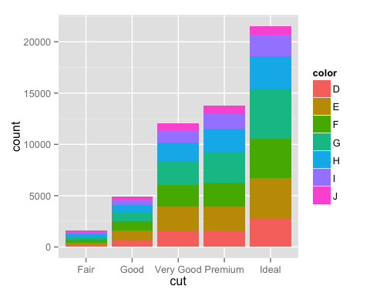

*Position Adjustments*

Position adjustments can be used to fine tune positioning of objects to achieve effects like dodging, jittering and stacking.  
* position_dodge - Adjust position by dodging overlaps to the side.  
* position_fill - Stack overlapping objects on top of one another, and standardise to have  
* position_identity - Don't adjust position  
* position_stack - Stack overlapping objects on top of one another.  
* position_jitter - Jitter points to avoid overplotting (we will discuss jitter in the scatter plots section)

qplot(cut, data=diamonds, fill=color, position="stack")

 *position stack - Stack overlapping objects on top of one another* stack is the default.

qplot(cut, data=diamonds, fill=color)



qplot(cut, data=diamonds, fill=color, position="dodge")

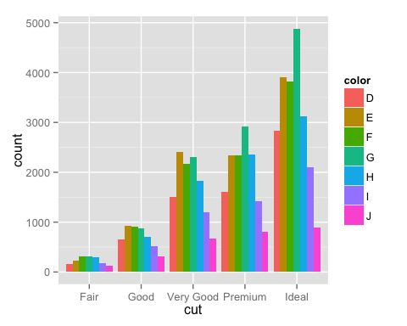 *position dodge - Adjust position by dodging overlaps to the side*

qplot(cut, data=diamonds, fill=color, position="identity")

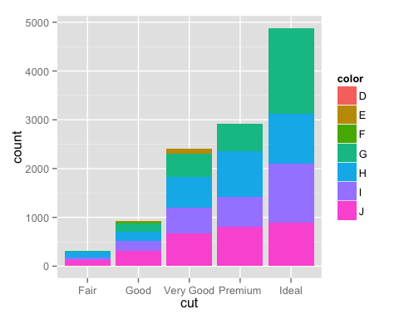

qplot(cut,data=diamonds,fill=color,position = "identity")



qplot(color,data=diamonds,fill=cut,position = "identity")

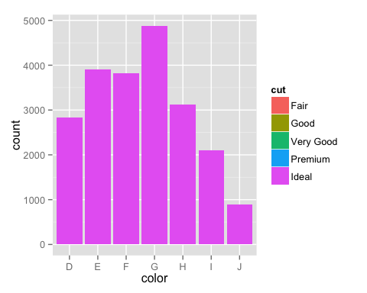

qplot(color,data=diamonds,fill=cut,position = "stack")

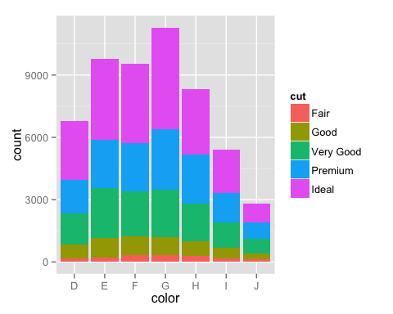

*position identity - Don't adjust position*

qplot(cut, data=diamonds, fill=color, position="fill")

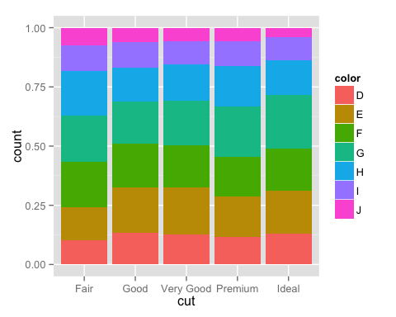 *position fill - Stack overlapping objects on top of one another, and standardise to have*

## Histograms

A histogram is like a bar chart but with continuous variables. To group with divide a continuous variable into intervals called *bins* then count the number of cases within each bin.

* use bars to reflect counts
* intervals on the horizontal axis
* counts on the vertical axis

A histogram is a form of density estimation. That is, the construction of an estimate, based on observed data, of an unobservable underlying probability density function.

Histogram and density plots show the distribution of a single variable.

qplot(carat, data = diamonds, geom = "histogram")

## stat_bin: binwidth defaulted to range/30. Use 'binwidth = x' to adjust this.

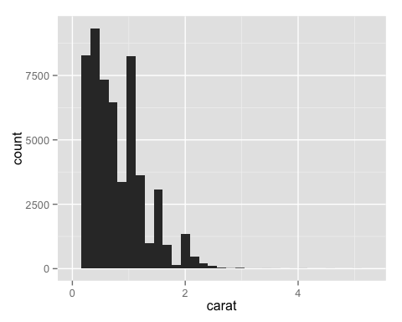

Playing with the histogram binwidth can reveal interesting aspects of the data.

qplot(carat, data = diamonds, geom = "histogram", binwidth = 0.1,  
 xlim = c(0,3))

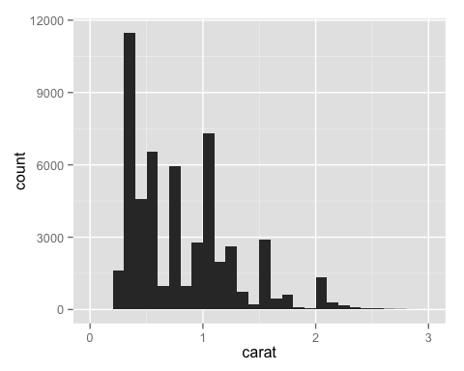

qplot(carat, data = diamonds, geom = "histogram", binwidth = 0.5,  
 xlim = c(0,3))

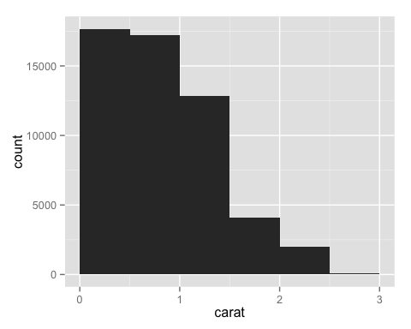

## Density plots

You can use probability densities instead of (or with) frequencies for density estimation

qplot(carat, data = diamonds, geom = "density")

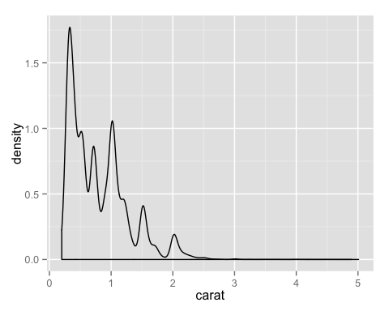

Mapping a categorical variable to an aesthetic

qplot(carat, data = diamonds, geom = "density", colour = color)

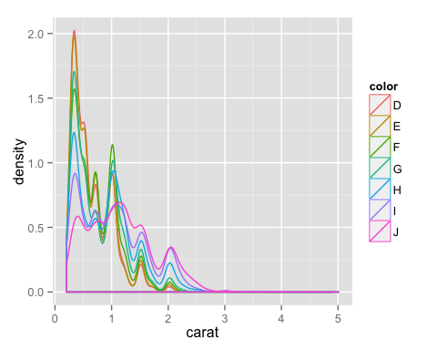

qplot(depth, data=diamonds)

## stat_bin: binwidth defaulted to range/30. Use 'binwidth = x' to adjust this.

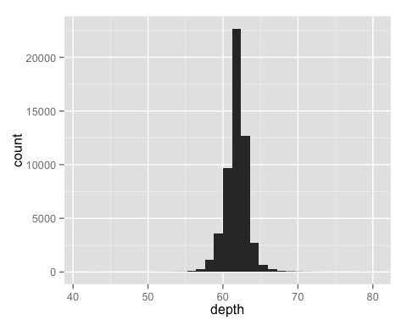

qplot(depth, data=diamonds) + xlim(55, 70)

## stat_bin: binwidth defaulted to range/30. Use 'binwidth = x' to adjust this.

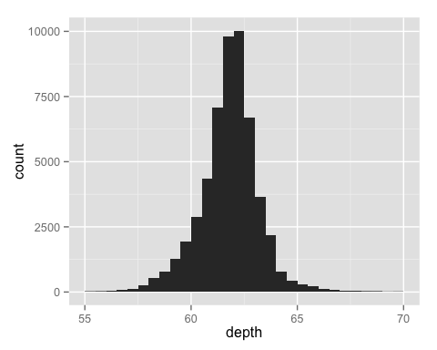

qplot(depth, data=diamonds, fill=cut) + xlim(55, 70)

## stat_bin: binwidth defaulted to range/30. Use 'binwidth = x' to adjust this.

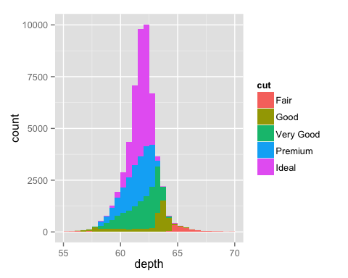

qplot(depth, data=diamonds, fill=cut, geom="density") + xlim(55, 70)

## Warning: Removed 43 rows containing non-finite values (stat_density).

## Warning: Removed 1 rows containing non-finite values (stat_density).

## Warning: Removed 1 rows containing non-finite values (stat_density).

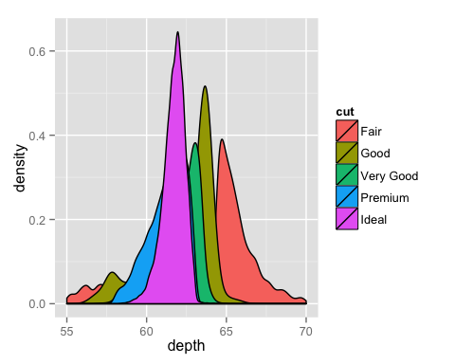

qplot(depth, data=diamonds, fill=cut, geom="density", alpha=1/4) + xlim(55, 70)

## Warning: Removed 43 rows containing non-finite values (stat_density).

## Warning: Removed 1 rows containing non-finite values (stat_density).

## Warning: Removed 1 rows containing non-finite values (stat_density).

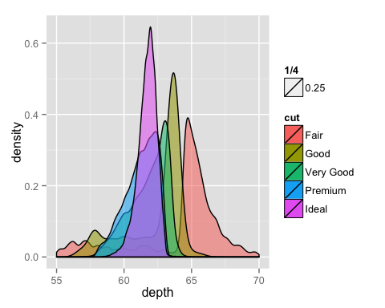

qplot(depth, data=diamonds, fill=cut, geom="density", alpha=carat) + xlim(55, 70)

## Warning: Removed 43 rows containing non-finite values (stat_density).

## Warning: Removed 1 rows containing non-finite values (stat_density).

## Warning: Removed 1 rows containing non-finite values (stat_density).



## ggplot2 help page

The [ggplot2 help page](http://docs.ggplot2.org/current/) is excellent. For more information on Geoms, Facets, Position adjustments, Themes, Aesthetics with many examples and much more go to the [ggplot2 help page](http://docs.ggplot2.org/current/)

## Using Histograms & Density plots on the Quasi-Twitter data

Load and look at the Quasi-Twitter data.

qplot(x=dob_day, data=twitter)

## stat_bin: binwidth defaulted to range/30. Use 'binwidth = x' to adjust this.

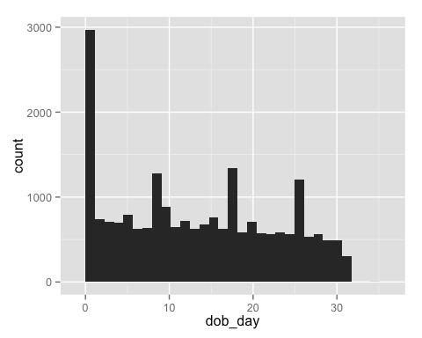 Notice January 1!

qplot(x=dob_day, data=twitter)+ facet_wrap(~dob_month) # a grid on one extra variable

## stat_bin: binwidth defaulted to range/30. Use 'binwidth = x' to adjust this.  
## stat_bin: binwidth defaulted to range/30. Use 'binwidth = x' to adjust this.  
## stat_bin: binwidth defaulted to range/30. Use 'binwidth = x' to adjust this.  
## stat_bin: binwidth defaulted to range/30. Use 'binwidth = x' to adjust this.  
## stat_bin: binwidth defaulted to range/30. Use 'binwidth = x' to adjust this.  
## stat_bin: binwidth defaulted to range/30. Use 'binwidth = x' to adjust this.  
## stat_bin: binwidth defaulted to range/30. Use 'binwidth = x' to adjust this.  
## stat_bin: binwidth defaulted to range/30. Use 'binwidth = x' to adjust this.  
## stat_bin: binwidth defaulted to range/30. Use 'binwidth = x' to adjust this.  
## stat_bin: binwidth defaulted to range/30. Use 'binwidth = x' to adjust this.  
## stat_bin: binwidth defaulted to range/30. Use 'binwidth = x' to adjust this.  
## stat_bin: binwidth defaulted to range/30. Use 'binwidth = x' to adjust this.  
## stat_bin: binwidth defaulted to range/30. Use 'binwidth = x' to adjust this.  
## stat_bin: binwidth defaulted to range/30. Use 'binwidth = x' to adjust this.

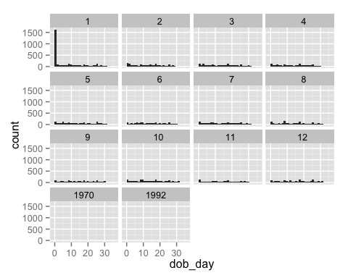 Bad data!!!

qplot(x=dob_year, data=twitter)

## stat_bin: binwidth defaulted to range/30. Use 'binwidth = x' to adjust this.

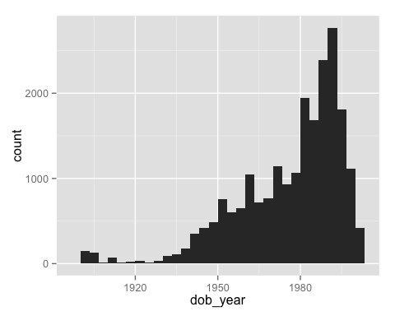

qplot(x=dob_day, data=twitter) + scale_x_discrete(breaks=1:31)

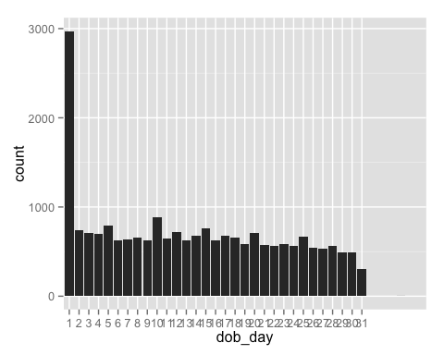

qplot(x=followers_count, data=twitter,color=I('#17331F'), fill=I('#CC0000'))

## stat_bin: binwidth defaulted to range/30. Use 'binwidth = x' to adjust this.

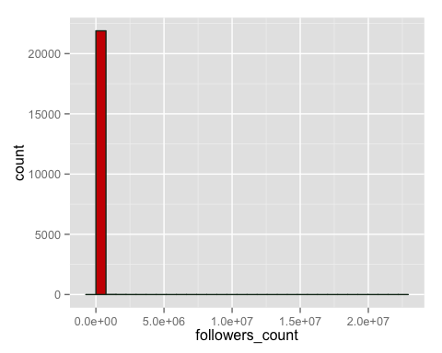

Fat-tailed! Log-transform.

qplot(x=log(followers_count+1,2), data=twitter,color=I('#17331F'), fill=I('#CC0000'))

## stat_bin: binwidth defaulted to range/30. Use 'binwidth = x' to adjust this.

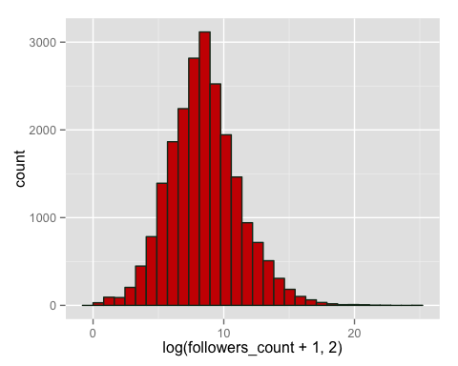 Zoom in?

qplot(x=followers_count, data=twitter,xlim=c(0,10000),color=I('#17331F'), fill=I('#CC0000'))

## stat_bin: binwidth defaulted to range/30. Use 'binwidth = x' to adjust this.

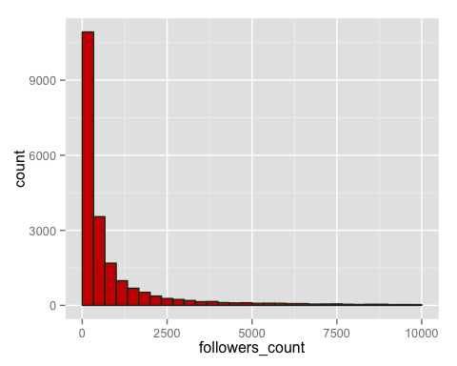

qplot(x=followers_count, data=twitter,color=I('#17331F'), fill=I('#CC0000'))+scale_x_continuous(limits=c(0,5000))

## stat_bin: binwidth defaulted to range/30. Use 'binwidth = x' to adjust this.

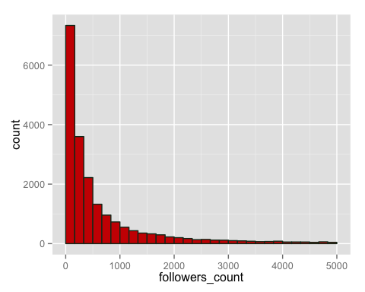

qplot(x=followers_count, data=twitter, binwidth=50,color=I('#17331F'), fill=I('#CC0000'))+scale_x_continuous(limits=c(0,5000), breaks=seq(0,5000,50))

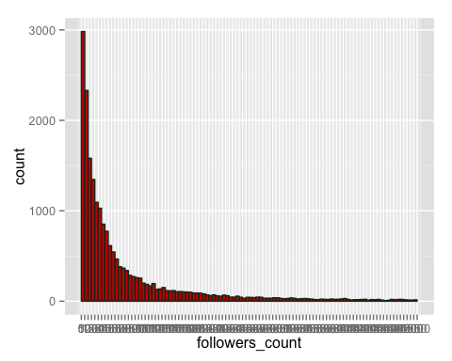

qplot(x=followers_count, data=twitter,xlim=c(0,10000),geom="density", color=I('#615445'), fill=I('#CC0000'))

## Warning: Removed 1055 rows containing non-finite values (stat_density).

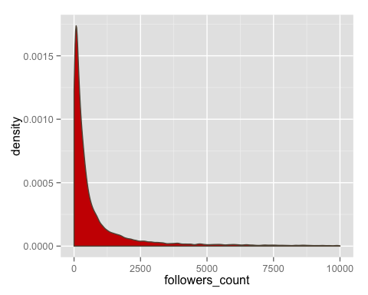

by(twitter$followers_count,twitter$gender,summary)

## twitter$gender: female  
## Min. 1st Qu. Median Mean 3rd Qu. Max.   
## 0 118 372 8580 1156 22190000   
## --------------------------------------------------------   
## twitter$gender: male  
## Min. 1st Qu. Median Mean 3rd Qu. Max.   
## 0 98 316 4503 1050 6257000

qplot(gender,followers_count, data =twitter, geom="boxplot",ylim=c(0,10000))+xlab("Gender")

## Warning: Removed 1055 rows containing non-finite values (stat_boxplot).

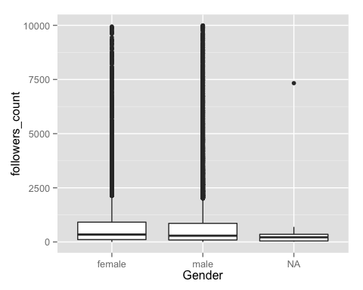

qplot(followers_count, data=twitter,xlim=c(0,10000))

## stat_bin: binwidth defaulted to range/30. Use 'binwidth = x' to adjust this.

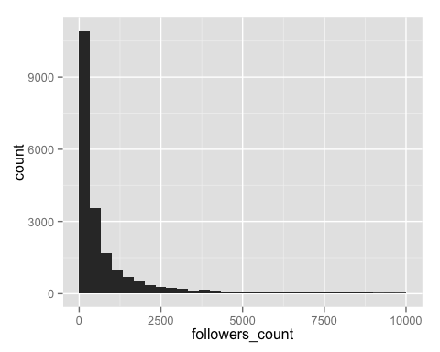

qplot(followers_count, data=twitter, fill=gender,xlim=c(0,10000))

## stat_bin: binwidth defaulted to range/30. Use 'binwidth = x' to adjust this.

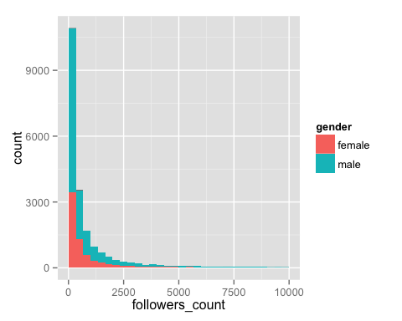

qplot(followers_count, data=twitter, fill=gender, position="stack",xlim=c(0,10000))

## stat_bin: binwidth defaulted to range/30. Use 'binwidth = x' to adjust this.



qplot(followers_count, data=twitter, fill=gender, position="dodge",xlim=c(0,10000))

## stat_bin: binwidth defaulted to range/30. Use 'binwidth = x' to adjust this.

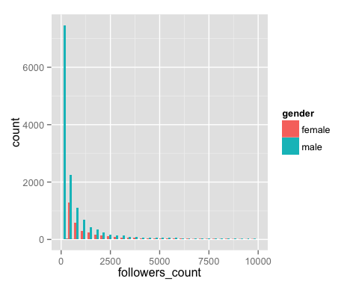

qplot(followers_count, data=twitter, fill=gender, position="identity",xlim=c(0,10000))

## stat_bin: binwidth defaulted to range/30. Use 'binwidth = x' to adjust this.

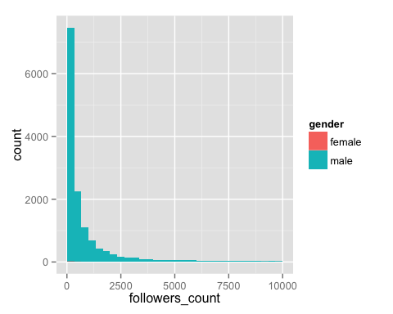

qplot(followers_count, data=twitter, fill=gender, position="fill",xlim=c(0,10000))

## stat_bin: binwidth defaulted to range/30. Use 'binwidth = x' to adjust this.

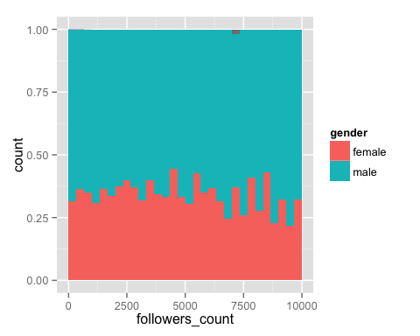

qplot(followers_count, data=twitter, binwidth=50, xlim=c(0,10000), geom="freqpoly", color=gender)

## Warning: Removed 2 rows containing missing values (geom_path).

## Warning: Removed 2 rows containing missing values (geom_path).

## Warning: Removed 2 rows containing missing values (geom_path).

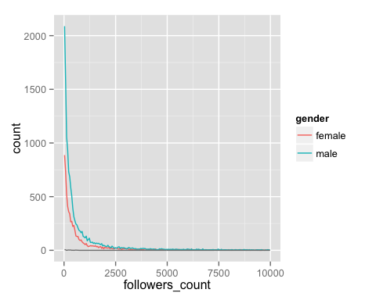

qplot(wage, data=twitter, binwidth=5, geom="freqpoly", color=gender)

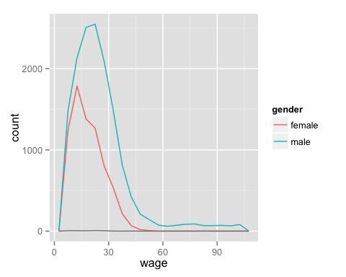

## Line plots

Line and path plots are typically used for time series data. Line plots join the points from left to right, while path plots join them in the order that they appear in the dataset (a line plot is just a path plot of the data sorted by x value).

To show this we'll use the ggplot2 economics dataset, which contains economic time-series data on the US measured over the last 40 years.

data(economics)  
str(economics)

## 'data.frame': 478 obs. of 6 variables:  
## $ date : Date, format: "1967-06-30" "1967-07-31" ...  
## $ pce : num 508 511 517 513 518 ...  
## $ pop : int 198712 198911 199113 199311 199498 199657 199808 199920 200056 200208 ...  
## $ psavert : num 9.8 9.8 9 9.8 9.7 9.4 9 9.5 8.9 9.6 ...  
## $ uempmed : num 4.5 4.7 4.6 4.9 4.7 4.8 5.1 4.5 4.1 4.6 ...  
## $ unemploy: int 2944 2945 2958 3143 3066 3018 2878 3001 2877 2709 ...

names(economics)

## [1] "date" "pce" "pop" "psavert" "uempmed" "unemploy"

qplot(date,pop, data=economics)+geom_line()

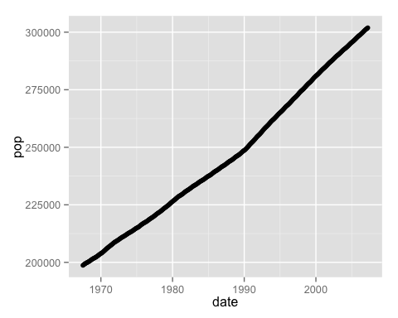

qplot(date, unemploy / pop, data = economics, geom = "line")

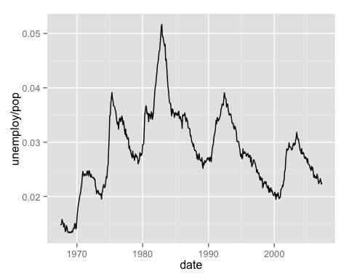

qplot(date, uempmed, data = economics, geom = "line")

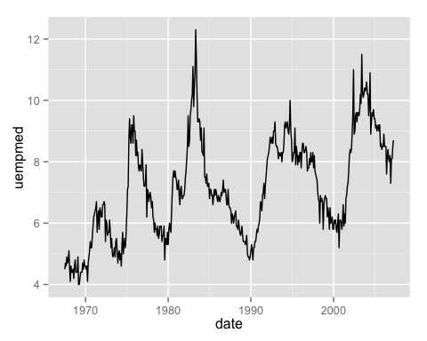

## Multivariate Exploritory Data Analysis

Multivariate analysis (MVA) is based on the statistical principle of multivariate statistics, which involves observation and analysis of more than one statistical outcome variable at a time.

* from [Multivariate analysis Wikipedia](https://en.wikipedia.org/wiki/Multivariate_analysis)

Bivariate analysis is one of the simplest forms of quantitative (statistical) analysis. It involves the analysis of two variables (often denoted as X, Y), for the purpose of determining the empirical relationship between them.

* from [Bivariate analysis Wikipedia](https://en.wikipedia.org/wiki/Bivariate_analysis)

## Scatter plot (Bivariate Visualization)

A scatter plot, scatterplot, or scattergraph is a type of mathematical diagram using Cartesian coordinates to display values for two variables for a set of data.

# Set a seed value for randomization  
set.seed(333)  
# create some random data  
trails<-333  
r_data <-data.frame(A=rnorm(n=trails,mean=33,sd=3),  
 B=rnorm(n=trails,mean=33,sd=9),  
 C=1:trails+rnorm(n=trails,sd=3),  
 D=1:trails+rnorm(n=trails,sd=3),   
 E=1:trails+rnorm(n=trails,sd=33),  
 F=1:trails+rnorm(n=trails,sd=33),   
 age=factor(sample(c(1,2,3,4),size=trails,replace=T),  
 levels=c(1,2,3,4),labels=c("Toddler","Child","Teen","Adult")),  
 gender=factor(sample(c(1,2),size=trails,replace=T),  
 levels=c(1,2),labels=c("Male","Female")),  
 wealth=factor(sample(c(1,2,3),size=trails,replace=T), levels=c(1,2,3),labels=c("Poor","Middle","Rich")))

*Scatter Plot with No apparent relationship*

qplot(A,B, data=r_data) # random

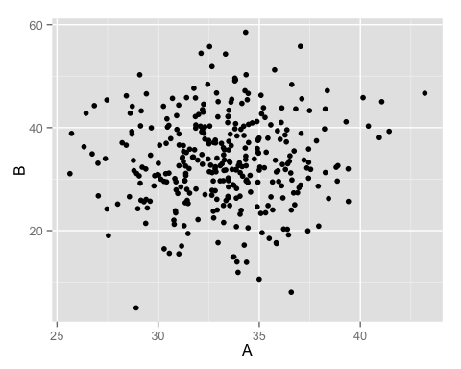

qplot(A,B, data=r_data) + geom_point(shape=r_data$gender)

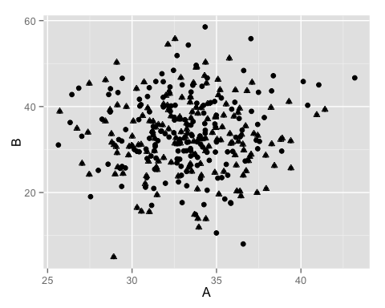

*Scatter Plot with Linear relationship*

A<-1:trails  
B<-A*5  
r_linear<-data.frame(A,B)  
qplot(A,B, data=r_linear) # linear

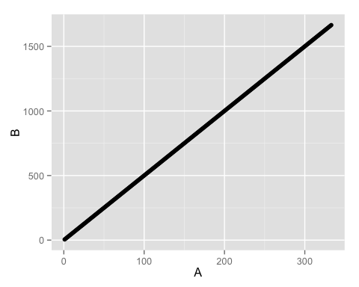

*Scatter Plot with Quadratic relationship*

B<-A^2  
r_llog<-data.frame(A,B)  
qplot(A,B, data=r_llog) # quadratic

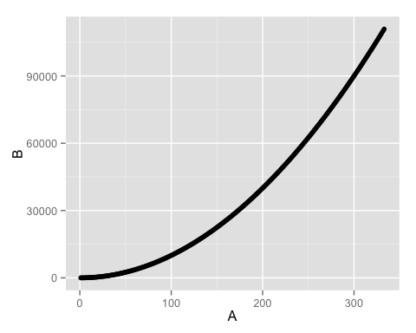

qplot(log(A,2),log(B,2), data=r_llog) # log-log

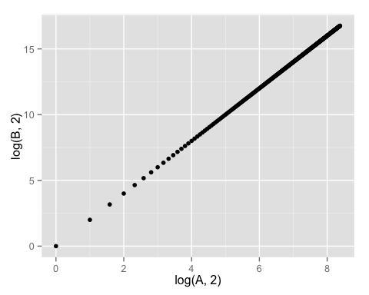

*Scatter plot with Homoscedastic relationship*

In statistics, a sequence or a vector of random variables is homoscedastic /??ho??mo??sk??'d?st??k/ if all random variables in the sequence or vector have the same finite variance. This is also known as homogeneity of variance. The complementary notion is called heteroscedasticity.

* from [Homoscedasticity](https://en.wikipedia.org/wiki/Homoscedasticity)

qplot(C,D, data=r_data) # homoscedastic

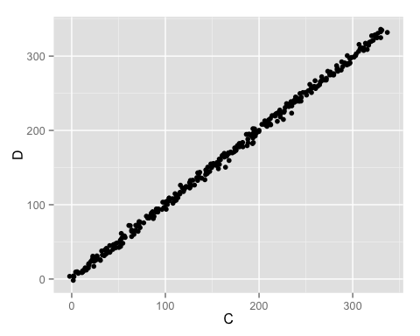

qplot(E,F, data=r_data) + geom_point(shape=1) # homoscedastic

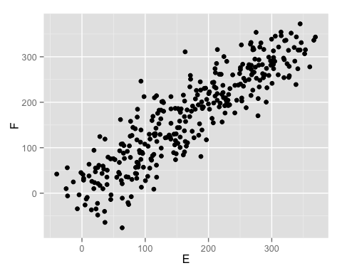

*Scatter Plot with Regression Lines*

Homoscedasticity means that the variance around the regression line is the same for all values of the predictor variable as in the graph below.

qplot(E,F, data=r_data) + geom_point(shape=2) + geom_smooth(method=lm)

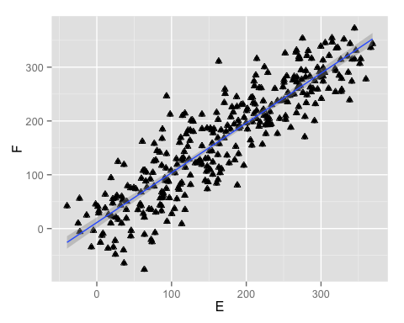

qplot(E,F, data=r_data) + geom_point(shape=3) + geom_smooth(method=lm, se=FALSE)

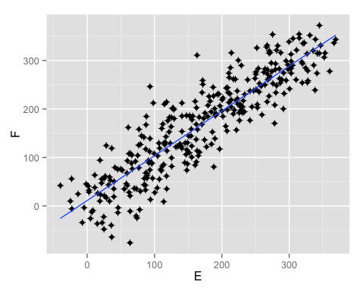

qplot(E,F, data=r_data) + geom_point(shape=4) + geom_smooth()

## geom_smooth: method="auto" and size of largest group is <1000, so using loess. Use 'method = x' to change the smoothing method.

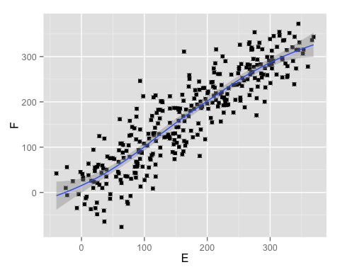

qplot(E,F, data=r_data,colour=gender)

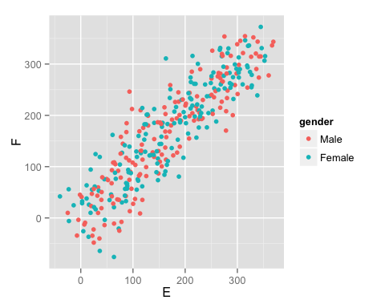

*Scatter plot with Jittering*

Integer data points can stack on top of one another hiding the distribution.

str(mpg)

## 'data.frame': 234 obs. of 11 variables:  
## $ manufacturer: Factor w/ 15 levels "audi","chevrolet",..: 1 1 1 1 1 1 1 1 1 1 ...  
## $ model : Factor w/ 38 levels "4runner 4wd",..: 2 2 2 2 2 2 2 3 3 3 ...  
## $ displ : num 1.8 1.8 2 2 2.8 2.8 3.1 1.8 1.8 2 ...  
## $ year : int 1999 1999 2008 2008 1999 1999 2008 1999 1999 2008 ...  
## $ cyl : int 4 4 4 4 6 6 6 4 4 4 ...  
## $ trans : Factor w/ 10 levels "auto(av)","auto(l3)",..: 4 9 10 1 4 9 1 9 4 10 ...  
## $ drv : Factor w/ 3 levels "4","f","r": 2 2 2 2 2 2 2 1 1 1 ...  
## $ cty : int 18 21 20 21 16 18 18 18 16 20 ...  
## $ hwy : int 29 29 31 30 26 26 27 26 25 28 ...  
## $ fl : Factor w/ 5 levels "c","d","e","p",..: 4 4 4 4 4 4 4 4 4 4 ...  
## $ class : Factor w/ 7 levels "2seater","compact",..: 2 2 2 2 2 2 2 2 2 2 ...

names(mpg)

## [1] "manufacturer" "model" "displ" "year"   
## [5] "cyl" "trans" "drv" "cty"   
## [9] "hwy" "fl" "class"

qplot(cty,hwy,data=mpg)

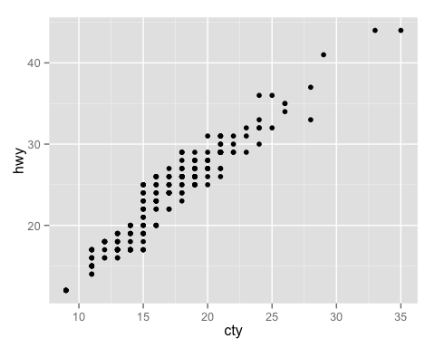

qplot(cty,hwy,data=mpg,position = "jitter")

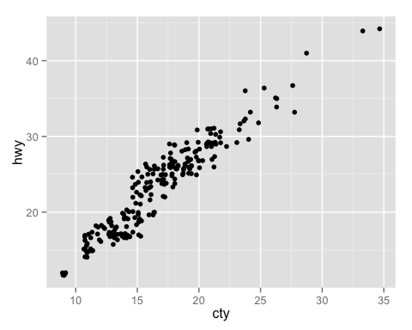

qplot(cty,hwy,data=mpg,position = "jitter") # jitter changes

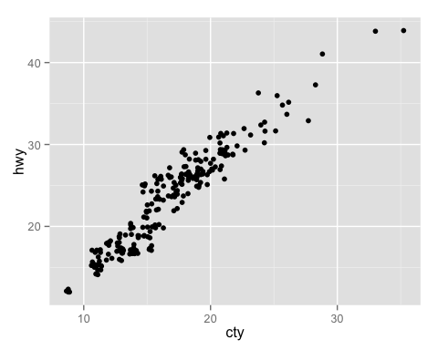

## Playing with scatter plots

The scatter diagram or scatter plot is the workhorse bivariate and multivariate plots. Let's play with scatter plots a bit.

qplot(carat, price, data = diamonds)

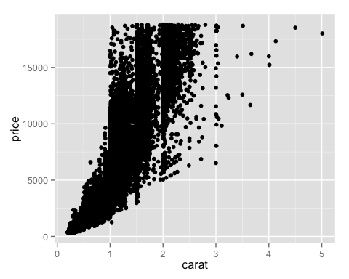

qplot(log(carat,2), log(price,2), data = diamonds)

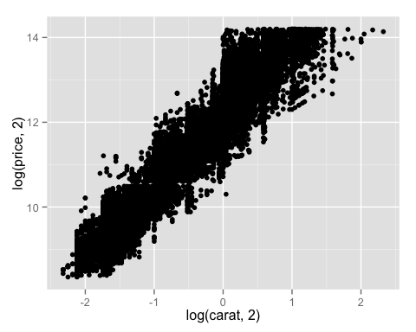

qplot(carat, x * y * z, data = diamonds)

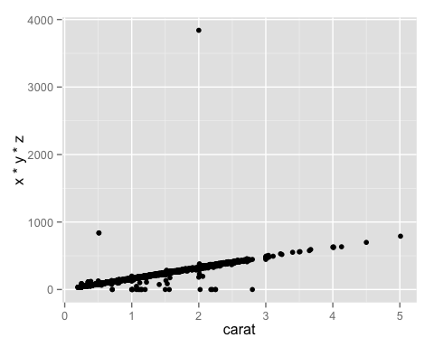

qplot(carat, price, data = diamonds, colour = color)

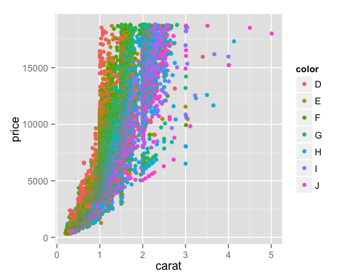

qplot(carat, price, data = diamonds, shape = cut)

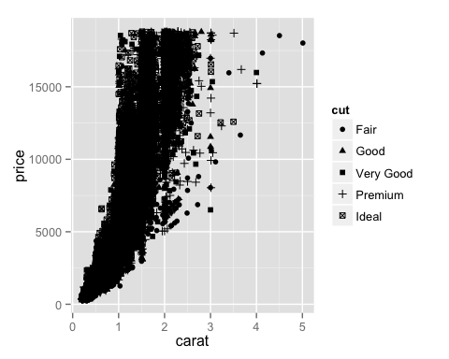

qplot(carat, price, data = diamonds, geom = c("point", "smooth"))

## geom_smooth: method="auto" and size of largest group is >=1000, so using gam with formula: y ~ s(x, bs = "cs"). Use 'method = x' to change the smoothing method.

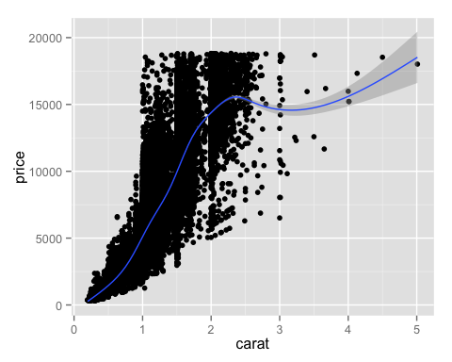

qplot(carat, price, data = diamonds, geom = "smooth")

## geom_smooth: method="auto" and size of largest group is >=1000, so using gam with formula: y ~ s(x, bs = "cs"). Use 'method = x' to change the smoothing method.

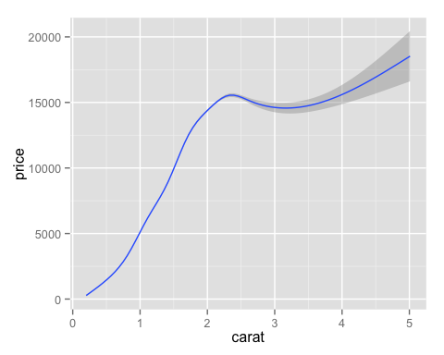

qplot(carat, price, data = diamonds)+geom_smooth()

## geom_smooth: method="auto" and size of largest group is >=1000, so using gam with formula: y ~ s(x, bs = "cs"). Use 'method = x' to change the smoothing method.



qplot(carat, price, data = diamonds, geom = c("point", "smooth"),  
 span = 0.2)

## geom_smooth: method="auto" and size of largest group is >=1000, so using gam with formula: y ~ s(x, bs = "cs"). Use 'method = x' to change the smoothing method.



qplot(color, price / carat, data = diamonds, geom = "jitter",  
 alpha = I(1 / 50))

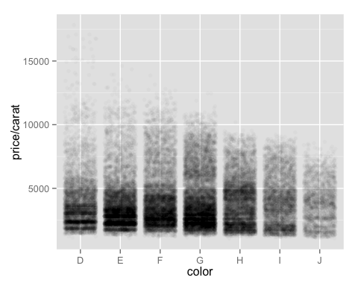

#### Faceting and scaling

One option we could use is to color-code the points by their clarity. Here, we pass another col= argument with the variable we'd like to use for color-coding:

qplot(carat, price, data = diamonds, col = clarity)

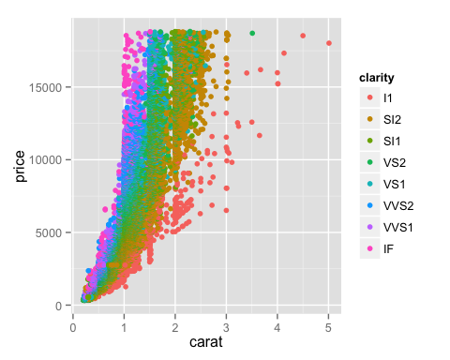

## Faceting

Facets display subsets of the dataset in different panels.

* facet_grid - Lay out panels in a grid.
* facet_null - Facet specification: a single panel.
* facet_wrap - Wrap a 1d ribbon of panels into 2d.
* label_both -Label facets with value and variable.
* label_bquote - Label facet with 'bquoted' expressions
* label_parsed - Label facets with parsed label.
* label_value - Label facets with their value

qplot(carat, price, data = diamonds, facets = ~ clarity)

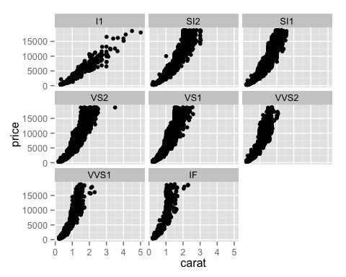

qplot(carat, price, data = diamonds, facets = ~ color)

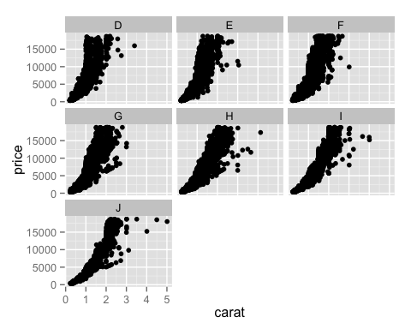

## QQplot

In statistics, a Q-Q plot ("Q" stands for quantile) is a probability plot, which is a graphical method for comparing two probability distributions by plotting their quantiles against each other.

from [Q-Q plot - Wikipedia](https://en.wikipedia.org/wiki/Q%E2%80%93Q_plot)

One of the first things we may ask about data is whether it deviates from an expectation to be normally distributed. The quantile-quantile (QQ) plot is a way to see whether the data deviate from normal (the plot can be set up to see if the data deviate from other distributions as well).

The process R goes through for creating a QQ plot involves determining what proportion of the 'observed' scores fall below any one score, then the -score that would fit that proportion if the data were normally distributed is calculated, and finally that -score that would cut off that proportion (the 'expected normal value') is translated back into the original metric to see what raw score that would be.

A scatter plot is then created that shows the relationship between the actual 'observed' values and what those values would be 'expected' to be if the data were normally distributed.

qqnorm(r_data$A)  
qqline(r_data$A)

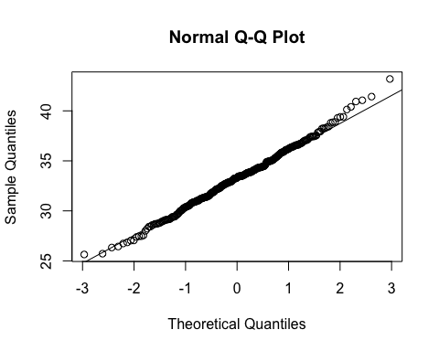

help(qqnorm)

qqnorm(r_linear$A)  
qqline(r_linear$A)

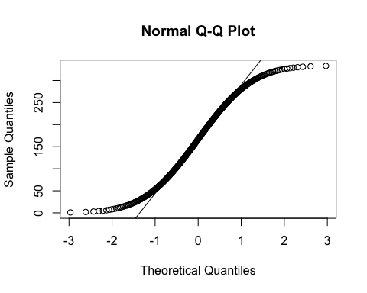

help(qqnorm)

qqnorm(r_llog$B)  
qqline(r_llog$B)

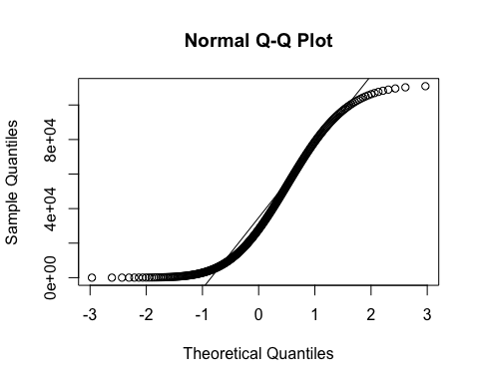

help(qqnorm)

qqnorm(twitter$followers_count)  
qqline(twitter$followers_count)

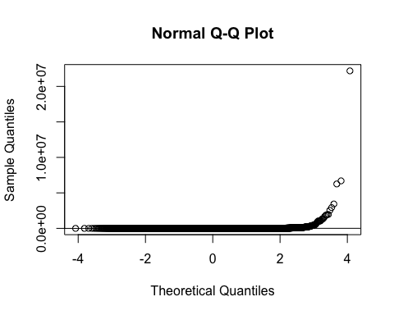

In statistics, a sequence or a vector of random variables is homoscedastic if all random variables in the sequence or vector

have the same finite variance.

## Homework Question 2

*Exploratory Data Analysis assignment*

* Load the file M01_quasi_twitter.csv
* Answer the following questions for the data in each column:
  + How is the data distributed?
  + Test distribution assumptions (e.g. normal distributions or skewed?)
  + What are the summary statistics?
  + Are there anomalies/outliers?
* identify useful raw data & transforms (e.g. log(x))
* identify data quality problems
* identify outliers
* identify subsets of interest
* suggest functional relationships

*Write your analysis up as an RMA file.*