M4_L4_RomilShah

Romil Shah

June 19, 2016

## Read Data and additional packages

require(arules)

## Loading required package: arules

## Warning: package 'arules' was built under R version 3.2.5

## Loading required package: Matrix

## Warning: package 'Matrix' was built under R version 3.2.5

##   
## Attaching package: 'arules'

## The following objects are masked from 'package:base':  
##   
## abbreviate, write

require(arulesViz)

## Loading required package: arulesViz

## Warning: package 'arulesViz' was built under R version 3.2.5

## Loading required package: grid

require(Matrix)  
  
urlData <- 'http://fimi.ua.ac.be/data/retail.dat'  
retail <- read.transactions(url(urlData))  
summary(retail)

## transactions as itemMatrix in sparse format with  
## 88162 rows (elements/itemsets/transactions) and  
## 16470 columns (items) and a density of 0.0006257289   
##   
## most frequent items:  
## 39 48 38 32 41 (Other)   
## 50675 42135 15596 15167 14945 770058   
##   
## element (itemset/transaction) length distribution:  
## sizes  
## 1 2 3 4 5 6 7 8 9 10 11 12 13 14 15   
## 3016 5516 6919 7210 6814 6163 5746 5143 4660 4086 3751 3285 2866 2620 2310   
## 16 17 18 19 20 21 22 23 24 25 26 27 28 29 30   
## 2115 1874 1645 1469 1290 1205 981 887 819 684 586 582 472 480 355   
## 31 32 33 34 35 36 37 38 39 40 41 42 43 44 45   
## 310 303 272 234 194 136 153 123 115 112 76 66 71 60 50   
## 46 47 48 49 50 51 52 53 54 55 56 57 58 59 60   
## 44 37 37 33 22 24 21 21 10 11 10 9 11 4 9   
## 61 62 63 64 65 66 67 68 71 73 74 76   
## 7 4 5 2 2 5 3 3 1 1 1 1   
##   
## Min. 1st Qu. Median Mean 3rd Qu. Max.   
## 1.00 4.00 8.00 10.31 14.00 76.00   
##   
## includes extended item information - examples:  
## labels  
## 1 0  
## 2 1  
## 3 10

# First few transactions  
inspect(retail[1:20])

## items  
## 1 {0,   
## 1,   
## 10,   
## 11,   
## 12,   
## 13,   
## 14,   
## 15,   
## 16,   
## 17,   
## 18,   
## 19,   
## 2,   
## 20,   
## 21,   
## 22,   
## 23,   
## 24,   
## 25,   
## 26,   
## 27,   
## 28,   
## 29,   
## 3,   
## 4,   
## 5,   
## 6,   
## 7,   
## 8,   
## 9}   
## 2 {30,   
## 31,   
## 32}   
## 3 {33,   
## 34,   
## 35}   
## 4 {36,   
## 37,   
## 38,   
## 39,   
## 40,   
## 41,   
## 42,   
## 43,   
## 44,   
## 45,   
## 46}   
## 5 {38,   
## 39,   
## 47,   
## 48}   
## 6 {38,   
## 39,   
## 48,   
## 49,   
## 50,   
## 51,   
## 52,   
## 53,   
## 54,   
## 55,   
## 56,   
## 57,   
## 58}   
## 7 {32,   
## 41,   
## 59,   
## 60,   
## 61,   
## 62}   
## 8 {3,   
## 39,   
## 48}   
## 9 {63,   
## 64,   
## 65,   
## 66,   
## 67,   
## 68}   
## 10 {32,   
## 69}   
## 11 {48,   
## 70,   
## 71,   
## 72}   
## 12 {39,   
## 73,   
## 74,   
## 75,   
## 76,   
## 77,   
## 78,   
## 79}   
## 13 {36,   
## 38,   
## 39,   
## 41,   
## 48,   
## 79,   
## 80,   
## 81}   
## 14 {82,   
## 83,   
## 84}   
## 15 {41,   
## 85,   
## 86,   
## 87,   
## 88}   
## 16 {100,  
## 101,  
## 39,   
## 48,   
## 89,   
## 90,   
## 91,   
## 92,   
## 93,   
## 94,   
## 95,   
## 96,   
## 97,   
## 98,   
## 99}   
## 17 {36,   
## 38,   
## 39,   
## 48,   
## 89}   
## 18 {102,  
## 103,  
## 104,  
## 105,  
## 106,  
## 107,  
## 108,  
## 39,   
## 41}   
## 19 {109,  
## 110,  
## 38,   
## 39,   
## 41}   
## 20 {111,  
## 112,  
## 113,  
## 114,  
## 115,  
## 116,  
## 117,  
## 118,  
## 39}

# Frequency of the data  
itemFrequency(retail[1:100,1:20])

## 0 1 10 100 1000 10000 10001 10002 10003 10004 10005 10006   
## 0.01 0.02 0.02 0.01 0.00 0.00 0.00 0.00 0.00 0.00 0.00 0.00   
## 10007 10008 10009 1001 10010 10011 10012 10013   
## 0.00 0.00 0.00 0.00 0.00 0.00 0.00 0.00

# Plotting the frequency  
itemFrequencyPlot(retail,support=0.01)

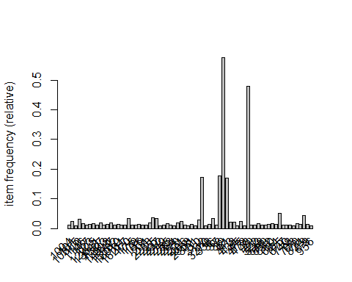

itemFrequencyPlot(retail,topN=25)

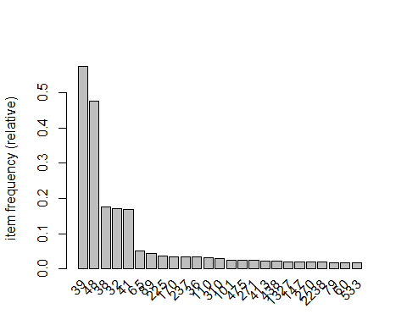

# First 1000 transaction visualization  
image(retail[1:1000])

## Warning: closing unused connection 5 (http://fimi.ua.ac.be/data/retail.dat)

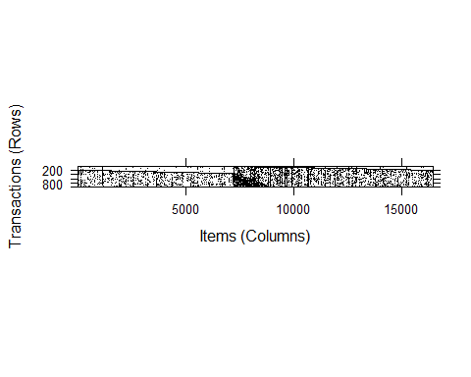

image(sample(retail,1000))

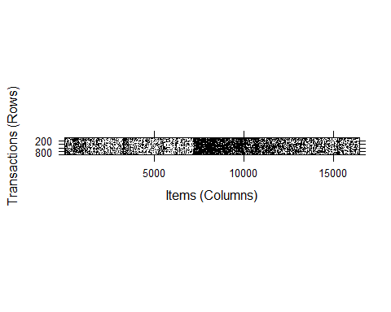

Generation of 50 or so non-redundant rules

rules1 <- apriori(retail)

## Apriori  
##   
## Parameter specification:  
## confidence minval smax arem aval originalSupport support minlen maxlen  
## 0.8 0.1 1 none FALSE TRUE 0.1 1 10  
## target ext  
## rules FALSE  
##   
## Algorithmic control:  
## filter tree heap memopt load sort verbose  
## 0.1 TRUE TRUE FALSE TRUE 2 TRUE  
##   
## Absolute minimum support count: 8816   
##   
## set item appearances ...[0 item(s)] done [0.00s].  
## set transactions ...[16470 item(s), 88162 transaction(s)] done [0.14s].  
## sorting and recoding items ... [5 item(s)] done [0.01s].  
## creating transaction tree ... done [0.03s].  
## checking subsets of size 1 2 3 done [0.00s].  
## writing ... [0 rule(s)] done [0.00s].  
## creating S4 object ... done [0.01s].

rules1

## set of 0 rules

This gives set of 0 rules

rules2 <- apriori(retail,parameter=list(support=0.01,confidence=0.52,minlen=2))

## Apriori  
##   
## Parameter specification:  
## confidence minval smax arem aval originalSupport support minlen maxlen  
## 0.52 0.1 1 none FALSE TRUE 0.01 2 10  
## target ext  
## rules FALSE  
##   
## Algorithmic control:  
## filter tree heap memopt load sort verbose  
## 0.1 TRUE TRUE FALSE TRUE 2 TRUE  
##   
## Absolute minimum support count: 881   
##   
## set item appearances ...[0 item(s)] done [0.00s].  
## set transactions ...[16470 item(s), 88162 transaction(s)] done [0.17s].  
## sorting and recoding items ... [70 item(s)] done [0.01s].  
## creating transaction tree ... done [0.04s].  
## checking subsets of size 1 2 3 4 done [0.00s].  
## writing ... [107 rule(s)] done [0.00s].  
## creating S4 object ... done [0.02s].

rules2

## set of 107 rules

summary(rules2)

## set of 107 rules  
##   
## rule length distribution (lhs + rhs):sizes  
## 2 3 4   
## 51 41 15   
##   
## Min. 1st Qu. Median Mean 3rd Qu. Max.   
## 2.000 2.000 3.000 2.664 3.000 4.000   
##   
## summary of quality measures:  
## support confidence lift   
## Min. :0.01013 Min. :0.5205 Min. :0.9698   
## 1st Qu.:0.01263 1st Qu.:0.6146 1st Qu.:1.1688   
## Median :0.01588 Median :0.6848 Median :1.2558   
## Mean :0.03038 Mean :0.7069 Mean :1.8113   
## 3rd Qu.:0.02338 3rd Qu.:0.7642 3rd Qu.:1.3833   
## Max. :0.33055 Max. :0.9942 Max. :5.6202   
##   
## mining info:  
## data ntransactions support confidence  
## retail 88162 0.01 0.52

This gives 107 rules

# Rules to dataframe conversion  
inspect(rules2)

## lhs rhs support confidence lift   
## 1 {37} => {38} 0.01186452 0.9739292 5.5054853  
## 2 {286} => {38} 0.01265852 0.9433643 5.3327062  
## 3 {12925} => {39} 0.01063950 0.6394001 1.1123985  
## 4 {1146} => {39} 0.01114993 0.6893408 1.1992830  
## 5 {79} => {48} 0.01012908 0.5581250 1.1678039  
## 6 {79} => {39} 0.01260180 0.6943750 1.2080412  
## 7 {1327} => {48} 0.01097979 0.5419933 1.1340504  
## 8 {1327} => {39} 0.01311223 0.6472564 1.1260665  
## 9 {438} => {48} 0.01162632 0.5501879 1.1511965  
## 10 {438} => {39} 0.01429187 0.6763285 1.1766448  
## 11 {60} => {39} 0.01114993 0.6601746 1.1485410  
## 12 {255} => {48} 0.01198929 0.7170963 1.5004307  
## 13 {255} => {39} 0.01198929 0.7170963 1.2475707  
## 14 {533} => {39} 0.01045802 0.6200403 1.0787173  
## 15 {270} => {48} 0.01085502 0.5519031 1.1547854  
## 16 {270} => {39} 0.01354325 0.6885813 1.1979616  
## 17 {2238} => {48} 0.01083233 0.5568513 1.1651388  
## 18 {2238} => {39} 0.01459813 0.7504373 1.3055758  
## 19 {110} => {38} 0.03090901 0.9753042 5.5132579  
## 20 {110} => {39} 0.01995191 0.6295634 1.0952849  
## 21 {147} => {48} 0.01175109 0.5823496 1.2184908  
## 22 {147} => {39} 0.01289671 0.6391231 1.1119165  
## 23 {271} => {48} 0.01236360 0.5205349 1.0891514  
## 24 {271} => {39} 0.01626551 0.6848138 1.1914070  
## 25 {413} => {48} 0.01287403 0.6037234 1.2632126  
## 26 {413} => {39} 0.01281731 0.6010638 1.0457028  
## 27 {36} => {38} 0.03164629 0.9502725 5.3717570  
## 28 {36} => {39} 0.02310519 0.6938011 1.2070428  
## 29 {475} => {48} 0.01619745 0.6589755 1.3788205  
## 30 {475} => {39} 0.01701413 0.6922012 1.2042593  
## 31 {170} => {38} 0.03437989 0.9780574 5.5288215  
## 32 {170} => {39} 0.02335473 0.6644079 1.1559058  
## 33 {101} => {48} 0.01487035 0.5860527 1.2262391  
## 34 {101} => {39} 0.01587986 0.6258382 1.0888041  
## 35 {310} => {48} 0.01919194 0.6522745 1.3647994  
## 36 {310} => {39} 0.02100678 0.7139553 1.2421061  
## 37 {237} => {48} 0.01907851 0.5547493 1.1607407  
## 38 {237} => {39} 0.02188018 0.6362137 1.1068549  
## 39 {225} => {48} 0.01969102 0.5330058 1.1152453  
## 40 {225} => {39} 0.02666682 0.7218299 1.2558060  
## 41 {89} => {48} 0.03173703 0.7292155 1.5257885  
## 42 {89} => {39} 0.03118123 0.7164451 1.2464378  
## 43 {65} => {48} 0.02868583 0.5655188 1.1832744  
## 44 {65} => {39} 0.03161226 0.6232111 1.0842336  
## 45 {38} => {39} 0.11734080 0.6633111 1.1539977  
## 46 {32} => {48} 0.09112770 0.5297026 1.1083338  
## 47 {32} => {39} 0.09590300 0.5574603 0.9698434  
## 48 {41} => {48} 0.10228897 0.6034125 1.2625621  
## 49 {41} => {39} 0.12946621 0.7637337 1.3287082  
## 50 {48} => {39} 0.33055058 0.6916340 1.2032726  
## 51 {39} => {48} 0.33055058 0.5750765 1.2032726  
## 52 {110,48} => {38} 0.01543749 0.9862319 5.5750305  
## 53 {110,38} => {39} 0.01973639 0.6385321 1.1108884  
## 54 {110,39} => {38} 0.01973639 0.9891984 5.5917998  
## 55 {110,48} => {39} 0.01176244 0.7514493 1.3073364  
## 56 {110,39} => {48} 0.01176244 0.5895395 1.2335346  
## 57 {36,48} => {38} 0.01542615 0.9604520 5.4293003  
## 58 {36,38} => {39} 0.02206166 0.6971326 1.2128388  
## 59 {36,39} => {38} 0.02206166 0.9548355 5.3975514  
## 60 {36,48} => {39} 0.01265852 0.7881356 1.3711615  
## 61 {36,39} => {48} 0.01265852 0.5478645 1.1463351  
## 62 {475,48} => {39} 0.01238629 0.7647059 1.3303996  
## 63 {39,475} => {48} 0.01238629 0.7280000 1.5232452  
## 64 {170,48} => {38} 0.01744516 0.9877970 5.5838781  
## 65 {170,38} => {39} 0.02290102 0.6661168 1.1588789  
## 66 {170,39} => {38} 0.02290102 0.9805731 5.5430421  
## 67 {170,48} => {39} 0.01367936 0.7745665 1.3475546  
## 68 {170,39} => {48} 0.01367936 0.5857212 1.2255454  
## 69 {101,48} => {39} 0.01073025 0.7215866 1.2553826  
## 70 {101,39} => {48} 0.01073025 0.6757143 1.4138441  
## 71 {310,48} => {39} 0.01527869 0.7960993 1.3850164  
## 72 {310,39} => {48} 0.01527869 0.7273218 1.5218262  
## 73 {237,48} => {39} 0.01411039 0.7395957 1.2867141  
## 74 {237,39} => {48} 0.01411039 0.6448937 1.3493561  
## 75 {225,48} => {39} 0.01587986 0.8064516 1.4030269  
## 76 {225,39} => {48} 0.01587986 0.5954913 1.2459879  
## 77 {48,89} => {39} 0.02410336 0.7594711 1.3212923  
## 78 {39,89} => {48} 0.02410336 0.7730084 1.6174193  
## 79 {48,65} => {39} 0.02038293 0.7105575 1.2361948  
## 80 {39,65} => {48} 0.02038293 0.6447793 1.3491168  
## 81 {32,38} => {48} 0.01867018 0.5810095 1.2156868  
## 82 {32,38} => {39} 0.02087067 0.6494882 1.1299492  
## 83 {38,41} => {48} 0.02692770 0.6091866 1.2746435  
## 84 {38,41} => {39} 0.03460675 0.7829099 1.3620702  
## 85 {38,48} => {39} 0.06921349 0.7681269 1.3363513  
## 86 {38,39} => {48} 0.06921349 0.5898502 1.2341847  
## 87 {32,41} => {48} 0.02340010 0.6454944 1.3506129  
## 88 {32,41} => {39} 0.02675756 0.7381101 1.2841296  
## 89 {32,48} => {39} 0.06127356 0.6723923 1.1697968  
## 90 {32,39} => {48} 0.06127356 0.6389119 1.3368399  
## 91 {41,48} => {39} 0.08355074 0.8168108 1.4210493  
## 92 {39,41} => {48} 0.08355074 0.6453478 1.3503063  
## 93 {110,38,48} => {39} 0.01169438 0.7575312 1.3179175  
## 94 {110,38,39} => {48} 0.01169438 0.5925287 1.2397892  
## 95 {110,39,48} => {38} 0.01169438 0.9942141 5.6201527  
## 96 {36,38,48} => {39} 0.01225018 0.7941176 1.3815688  
## 97 {36,38,39} => {48} 0.01225018 0.5552699 1.1618300  
## 98 {36,39,48} => {38} 0.01225018 0.9677419 5.4705094  
## 99 {170,38,48} => {39} 0.01353191 0.7756827 1.3494966  
## 100 {170,38,39} => {48} 0.01353191 0.5908866 1.2363532  
## 101 {170,39,48} => {38} 0.01353191 0.9892206 5.5919251  
## 102 {32,38,48} => {39} 0.01401965 0.7509113 1.3064004  
## 103 {32,38,39} => {48} 0.01401965 0.6717391 1.4055266  
## 104 {38,41,48} => {39} 0.02258343 0.8386689 1.4590770  
## 105 {38,39,41} => {48} 0.02258343 0.6525729 1.3654239  
## 106 {32,41,48} => {39} 0.01867018 0.7978672 1.3880921  
## 107 {32,39,41} => {48} 0.01867018 0.6977533 1.4599579

rulesDF <- as(rules2,"data.frame")  
str(rulesDF)

## 'data.frame': 107 obs. of 4 variables:  
## $ rules : Factor w/ 107 levels "{101,39} => {48}",..: 74 47 16 15 105 104 18 17 93 92 ...  
## $ support : num 0.0119 0.0127 0.0106 0.0111 0.0101 ...  
## $ confidence: num 0.974 0.943 0.639 0.689 0.558 ...  
## $ lift : num 5.51 5.33 1.11 1.2 1.17 ...

# Removing redundant rules  
subset.matrix <- is.subset(rules2,rules2)  
subset.matrix[lower.tri(subset.matrix,diag = T)] <- NA  
redundant <- colSums(subset.matrix,na.rm = T) >= 1  
which(redundant)

## {39,48} {110,38,48} {110,38,39} {110,38,39} {110,39,48}   
## 51 52 53 54 55   
## {110,39,48} {36,38,48} {36,38,39} {36,38,39} {36,39,48}   
## 56 57 58 59 60   
## {36,39,48} {39,475,48} {39,475,48} {170,38,48} {170,38,39}   
## 61 62 63 64 65   
## {170,38,39} {170,39,48} {170,39,48} {101,39,48} {101,39,48}   
## 66 67 68 69 70   
## {310,39,48} {310,39,48} {237,39,48} {237,39,48} {225,39,48}   
## 71 72 73 74 75   
## {225,39,48} {39,48,89} {39,48,89} {39,48,65} {39,48,65}   
## 76 77 78 79 80   
## {32,38,48} {32,38,39} {38,41,48} {38,39,41} {38,39,48}   
## 81 82 83 84 85   
## {38,39,48} {32,41,48} {32,39,41} {32,39,48} {32,39,48}   
## 86 87 88 89 90   
## {39,41,48} {39,41,48} {110,38,39,48} {110,38,39,48} {110,38,39,48}   
## 91 92 93 94 95   
## {36,38,39,48} {36,38,39,48} {36,38,39,48} {170,38,39,48} {170,38,39,48}   
## 96 97 98 99 100   
## {170,38,39,48} {32,38,39,48} {32,38,39,48} {38,39,41,48} {38,39,41,48}   
## 101 102 103 104 105   
## {32,39,41,48} {32,39,41,48}   
## 106 107

rulesPruned <- rules2[!redundant]  
rulesPruned

## set of 50 rules

inspect(rulesPruned)

## lhs rhs support confidence lift   
## 1 {37} => {38} 0.01186452 0.9739292 5.5054853  
## 2 {286} => {38} 0.01265852 0.9433643 5.3327062  
## 3 {12925} => {39} 0.01063950 0.6394001 1.1123985  
## 4 {1146} => {39} 0.01114993 0.6893408 1.1992830  
## 5 {79} => {48} 0.01012908 0.5581250 1.1678039  
## 6 {79} => {39} 0.01260180 0.6943750 1.2080412  
## 7 {1327} => {48} 0.01097979 0.5419933 1.1340504  
## 8 {1327} => {39} 0.01311223 0.6472564 1.1260665  
## 9 {438} => {48} 0.01162632 0.5501879 1.1511965  
## 10 {438} => {39} 0.01429187 0.6763285 1.1766448  
## 11 {60} => {39} 0.01114993 0.6601746 1.1485410  
## 12 {255} => {48} 0.01198929 0.7170963 1.5004307  
## 13 {255} => {39} 0.01198929 0.7170963 1.2475707  
## 14 {533} => {39} 0.01045802 0.6200403 1.0787173  
## 15 {270} => {48} 0.01085502 0.5519031 1.1547854  
## 16 {270} => {39} 0.01354325 0.6885813 1.1979616  
## 17 {2238} => {48} 0.01083233 0.5568513 1.1651388  
## 18 {2238} => {39} 0.01459813 0.7504373 1.3055758  
## 19 {110} => {38} 0.03090901 0.9753042 5.5132579  
## 20 {110} => {39} 0.01995191 0.6295634 1.0952849  
## 21 {147} => {48} 0.01175109 0.5823496 1.2184908  
## 22 {147} => {39} 0.01289671 0.6391231 1.1119165  
## 23 {271} => {48} 0.01236360 0.5205349 1.0891514  
## 24 {271} => {39} 0.01626551 0.6848138 1.1914070  
## 25 {413} => {48} 0.01287403 0.6037234 1.2632126  
## 26 {413} => {39} 0.01281731 0.6010638 1.0457028  
## 27 {36} => {38} 0.03164629 0.9502725 5.3717570  
## 28 {36} => {39} 0.02310519 0.6938011 1.2070428  
## 29 {475} => {48} 0.01619745 0.6589755 1.3788205  
## 30 {475} => {39} 0.01701413 0.6922012 1.2042593  
## 31 {170} => {38} 0.03437989 0.9780574 5.5288215  
## 32 {170} => {39} 0.02335473 0.6644079 1.1559058  
## 33 {101} => {48} 0.01487035 0.5860527 1.2262391  
## 34 {101} => {39} 0.01587986 0.6258382 1.0888041  
## 35 {310} => {48} 0.01919194 0.6522745 1.3647994  
## 36 {310} => {39} 0.02100678 0.7139553 1.2421061  
## 37 {237} => {48} 0.01907851 0.5547493 1.1607407  
## 38 {237} => {39} 0.02188018 0.6362137 1.1068549  
## 39 {225} => {48} 0.01969102 0.5330058 1.1152453  
## 40 {225} => {39} 0.02666682 0.7218299 1.2558060  
## 41 {89} => {48} 0.03173703 0.7292155 1.5257885  
## 42 {89} => {39} 0.03118123 0.7164451 1.2464378  
## 43 {65} => {48} 0.02868583 0.5655188 1.1832744  
## 44 {65} => {39} 0.03161226 0.6232111 1.0842336  
## 45 {38} => {39} 0.11734080 0.6633111 1.1539977  
## 46 {32} => {48} 0.09112770 0.5297026 1.1083338  
## 47 {32} => {39} 0.09590300 0.5574603 0.9698434  
## 48 {41} => {48} 0.10228897 0.6034125 1.2625621  
## 49 {41} => {39} 0.12946621 0.7637337 1.3287082  
## 50 {48} => {39} 0.33055058 0.6916340 1.2032726

Exactly 50 rules are obtained

# Visualize association rules  
plot(rules2)

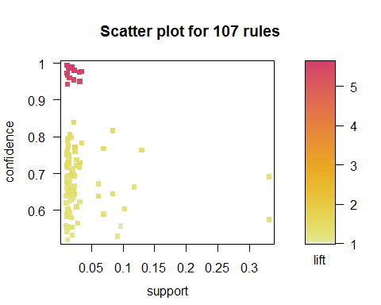

plot(rules2,method = "graph", control=list(type="items"))

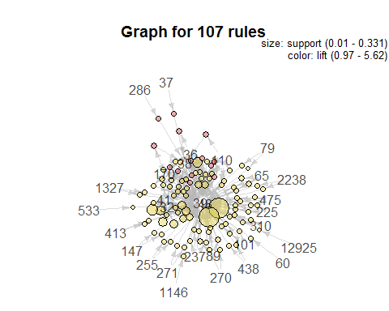

plot(rules2, method="paracoord", control=list(reorder=TRUE))

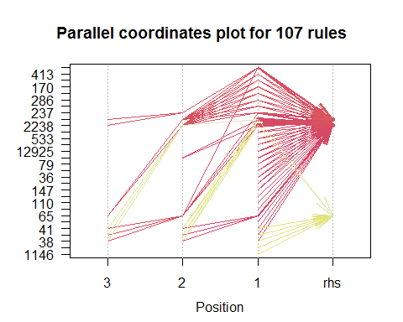

# Conviction  
conviction <- interestMeasure(rulesPruned, "conviction", transactions=retail)  
rulesConv<-as(rulesPruned, "data.frame")  
rulesConv<-data.frame(rulesConv, conviction)  
rulesConv

## rules support confidence lift conviction  
## 1 {37} => {38} 0.01186452 0.9739292 5.5054853 31.571702  
## 2 {286} => {38} 0.01265852 0.9433643 5.3327062 14.533215  
## 3 {12925} => {39} 0.01063950 0.6394001 1.1123985 1.179163  
## 4 {1146} => {39} 0.01114993 0.6893408 1.1992830 1.368721  
## 5 {79} => {48} 0.01012908 0.5581250 1.1678039 1.181495  
## 6 {79} => {39} 0.01260180 0.6943750 1.2080412 1.391267  
## 7 {1327} => {48} 0.01097979 0.5419933 1.1340504 1.139881  
## 8 {1327} => {39} 0.01311223 0.6472564 1.1260665 1.205425  
## 9 {438} => {48} 0.01162632 0.5501879 1.1511965 1.160647  
## 10 {438} => {39} 0.01429187 0.6763285 1.1766448 1.313696  
## 11 {60} => {39} 0.01114993 0.6601746 1.1485410 1.251248  
## 12 {255} => {48} 0.01198929 0.7170963 1.5004307 1.845409  
## 13 {255} => {39} 0.01198929 0.7170963 1.2475707 1.503006  
## 14 {533} => {39} 0.01045802 0.6200403 1.0787173 1.119082  
## 15 {270} => {48} 0.01085502 0.5519031 1.1547854 1.165090  
## 16 {270} => {39} 0.01354325 0.6885813 1.1979616 1.365383  
## 17 {2238} => {48} 0.01083233 0.5568513 1.1651388 1.178099  
## 18 {2238} => {39} 0.01459813 0.7504373 1.3055758 1.703804  
## 19 {110} => {38} 0.03090901 0.9753042 5.5132579 33.329520  
## 20 {110} => {39} 0.01995191 0.6295634 1.0952849 1.147850  
## 21 {147} => {48} 0.01175109 0.5823496 1.2184908 1.250024  
## 22 {147} => {39} 0.01289671 0.6391231 1.1119165 1.178257  
## 23 {271} => {48} 0.01236360 0.5205349 1.0891514 1.088865  
## 24 {271} => {39} 0.01626551 0.6848138 1.1914070 1.349062  
## 25 {413} => {48} 0.01287403 0.6037234 1.2632126 1.317446  
## 26 {413} => {39} 0.01281731 0.6010638 1.0457028 1.065849  
## 27 {36} => {38} 0.03164629 0.9502725 5.3717570 16.552170  
## 28 {36} => {39} 0.02310519 0.6938011 1.2070428 1.388659  
## 29 {475} => {48} 0.01619745 0.6589755 1.3788205 1.530896  
## 30 {475} => {39} 0.01701413 0.6922012 1.2042593 1.381441  
## 31 {170} => {38} 0.03437989 0.9780574 5.5288215 37.511499  
## 32 {170} => {39} 0.02335473 0.6644079 1.1559058 1.267032  
## 33 {101} => {48} 0.01487035 0.5860527 1.2262391 1.261207  
## 34 {101} => {39} 0.01587986 0.6258382 1.0888041 1.136422  
## 35 {310} => {48} 0.01919194 0.6522745 1.3647994 1.501394  
## 36 {310} => {39} 0.02100678 0.7139553 1.2421061 1.486501  
## 37 {237} => {48} 0.01907851 0.5547493 1.1607407 1.172537  
## 38 {237} => {39} 0.02188018 0.6362137 1.1068549 1.168834  
## 39 {225} => {48} 0.01969102 0.5330058 1.1152453 1.117943  
## 40 {225} => {39} 0.02666682 0.7218299 1.2558060 1.528582  
## 41 {89} => {48} 0.03173703 0.7292155 1.5257885 1.928002  
## 42 {89} => {39} 0.03118123 0.7164451 1.2464378 1.499554  
## 43 {65} => {48} 0.02868583 0.5655188 1.1832744 1.201601  
## 44 {65} => {39} 0.03161226 0.6232111 1.0842336 1.128499  
## 45 {38} => {39} 0.11734080 0.6633111 1.1539977 1.262904  
## 46 {32} => {48} 0.09112770 0.5297026 1.1083338 1.110091  
## 47 {32} => {39} 0.09590300 0.5574603 0.9698434 0.960831  
## 48 {41} => {48} 0.10228897 0.6034125 1.2625621 1.316413  
## 49 {41} => {39} 0.12946621 0.7637337 1.3287082 1.799689  
## 50 {48} => {39} 0.33055058 0.6916340 1.2032726 1.378900

## Answers:

#### A(1)

The rules that have high level of confidence and high support makes proper sense to me.  
The top 5 Best rules based on high confidence and high support are:  
1. {48} => {39}  
2. {41} => {39}  
3. {38} => {39}  
4. {41} => {48}  
5. {32} => {39}

The top 5 Worst rules based on low confidence and low support are:  
1. {533} => {39}  
2. {79} => {48}  
3. {12925} => {39}  
4. {2238} => {48}  
5. {270} => {48}

#### A(2)

Initially I used the default level of confidence and support but it yielded 0 results of rules. Thus I tried with a various permuation-conbination of 'support', 'confidence' and 'minlen'. Finally I was able to obtain about 107 rules with the following values:  
support = 0.01 confidence = 0.52 minlen = 2  
The reason I obtained 107 rules is that most of the rules will be pruned as they might be redundant and hence I would have 50 rules in the end.

#### A(3)

Lift and conviction for top 5 Best rules:  
No.....Rules............Lift..........Conviction

1. {48} => {39} | 1.2032726 | 1.378900
2. {41} => {39} | 1.3287082 | 1.799689
3. {38} => {39} | 1.1539977 | 1.262904
4. {41} => {48} | 1.2625621 | 1.316413
5. {32} => {39} | 0.9698434 | 0.960831

Lift and conviction for top 5 Worst rules:  
No.....Rules.............Lift.........Conviction

1. {533} => {39} | 1.0787173 | 1.119082
2. {79} => {48} | 1.1678039 | 1.181495
3. {12925} => {39}| 1.1123985 | 1.179163
4. {2238} => {48} | 1.1651388 | 1.178099
5. {270} => {48} | 1.1547854 | 1.165090

#### A(4)

The best rules end up being in the centre of the visualization graph. Thus this proves that they are the best ones. The worst rules are on the outer end of the graph. Hence they do not contribute to the dataframe. It is clearly seen that the rules '48', '39', '41', '32' etc are quite close by. The rules '270', '2238', '12925' are far away from the centre and hence are the worst rules.

#### A(5)

Yes absolutely. The model makes good sense as the rules guide which path is to be taken in order to maximize the outputs. In terms of supermarket, if customers buy X and Y together as well as Y and Z togehter, then the rules guide them in such a way that whomsoever buys X or Y would end up buying Y at the least. This is where the rules help in maximizing the transactions and understanding the relations between each data item with respect to the other.