M6_L3_RomilShah

Romil Shah

July 8, 2016

## Read Data and additional packages

require(ggplot2)

## Loading required package: ggplot2

## Warning: package 'ggplot2' was built under R version 3.2.5

require(e1071)

## Loading required package: e1071

## Warning: package 'e1071' was built under R version 3.2.5

require(kernlab)

## Loading required package: kernlab

## Warning: package 'kernlab' was built under R version 3.2.4

##   
## Attaching package: 'kernlab'

## The following object is masked from 'package:ggplot2':  
##   
## alpha

# Haberman's survival  
data_url <- 'https://archive.ics.uci.edu/ml/machine-learning-databases/haberman/haberman.data'  
dataframe <- read.csv(url(data_url), sep=",", header = TRUE)  
temp=dataframe  
temp$X1.1<-NULL  
temp$X30<-NULL  
x<-temp  
temp=dataframe  
y<-dataframe$X1.1  
dataframe<-data.frame(x=x,y=as.factor(y))  
plot(x,col=(3-y))

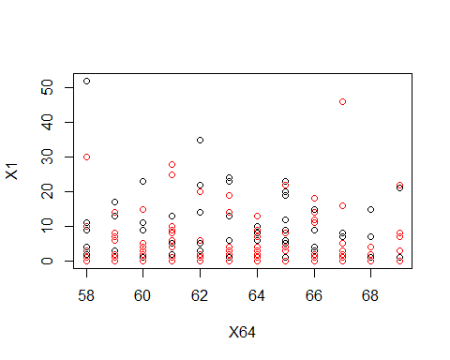

# Training of model  
svm.fit<- svm(y~.,data=dataframe, kernal="linear",cost=10,scale=FALSE)  
plot(svm.fit,dataframe)

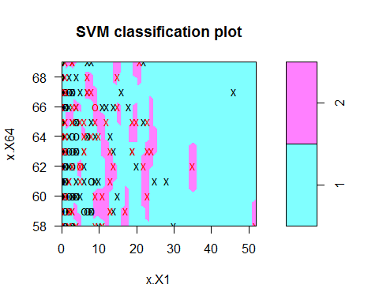

summary(svm.fit)

##   
## Call:  
## svm(formula = y ~ ., data = dataframe, kernal = "linear", cost = 10,   
## scale = FALSE)  
##   
##   
## Parameters:  
## SVM-Type: C-classification   
## SVM-Kernel: radial   
## cost: 10   
## gamma: 0.5   
##   
## Number of Support Vectors: 167  
##   
## ( 88 79 )  
##   
##   
## Number of Classes: 2   
##   
## Levels:   
## 1 2

# Changing cost  
svm.fit1<- svm(y~.,data=dataframe, kernal="linear",cost=0.1,scale=FALSE)  
plot(svm.fit1,dataframe)

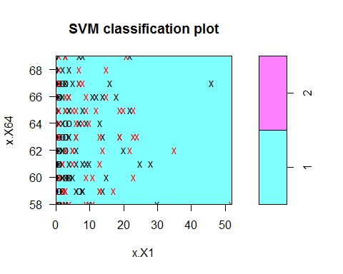

tune.out<- tune(svm,y~.,data=dataframe,kernal="linear",ranges=list(cost=c(0.001,0.01,0.1,1,5,10,100)))  
bestmodel<-tune.out$best.model  
summary(bestmodel)

##   
## Call:  
## best.tune(method = svm, train.x = y ~ ., data = dataframe, ranges = list(cost = c(0.001,   
## 0.01, 0.1, 1, 5, 10, 100)), kernal = "linear")  
##   
##   
## Parameters:  
## SVM-Type: C-classification   
## SVM-Kernel: radial   
## cost: 0.001   
## gamma: 0.5   
##   
## Number of Support Vectors: 162  
##   
## ( 81 81 )  
##   
##   
## Number of Classes: 2   
##   
## Levels:   
## 1 2

# Predict test dataframe  
testdf <- dataframe[1:25,]  
testdf

## x.X64 x.X1 y  
## 1 62 3 1  
## 2 65 0 1  
## 3 59 2 1  
## 4 65 4 1  
## 5 58 10 1  
## 6 60 0 1  
## 7 59 0 2  
## 8 66 9 2  
## 9 58 30 1  
## 10 60 1 1  
## 11 61 10 1  
## 12 67 7 1  
## 13 60 0 1  
## 14 64 13 1  
## 15 63 0 1  
## 16 60 1 1  
## 17 69 0 1  
## 18 60 0 1  
## 19 63 0 1  
## 20 58 0 1  
## 21 59 6 1  
## 22 60 15 1  
## 23 63 0 1  
## 24 69 21 2  
## 25 59 2 1

ypred=predict(bestmodel,testdf)  
ypred

## 1 2 3 4 5 6 7 8 9 10 11 12 13 14 15 16 17 18 19 20 21 22 23 24 25   
## 1 1 1 1 1 1 1 1 1 1 1 1 1 1 1 1 1 1 1 1 1 1 1 1 1   
## Levels: 1 2

table(pred=ypred,truth=testdf$y)

## truth  
## pred 1 2  
## 1 22 3  
## 2 0 0

agreement<-ypred==testdf$y  
table(agreement)

## agreement  
## FALSE TRUE   
## 3 22

prop.table(table(agreement))

## agreement  
## FALSE TRUE   
## 0.12 0.88

# Improve model performance   
classifier_rbf<-ksvm(y~.,data=testdf,kernel="rbfdot")  
predictions_rbf<-predict(classifier_rbf,testdf)  
predictions_rbf

## [1] 1 1 1 1 1 1 1 1 1 1 1 1 1 1 1 1 1 1 1 1 1 1 1 2 1  
## Levels: 1 2

agreement_rbf<-predictions_rbf==testdf$y  
table(agreement_rbf)

## agreement_rbf  
## FALSE TRUE   
## 2 23

prop.table(table(agreement_rbf))

## agreement_rbf  
## FALSE TRUE   
## 0.08 0.92

# Radial Kernal  
svmfit1<-svm(y~.,data=dataframe,kernal="radial",gamma=1,cost=10000)  
svmfit1

##   
## Call:  
## svm(formula = y ~ ., data = dataframe, kernal = "radial", gamma = 1,   
## cost = 10000)  
##   
##   
## Parameters:  
## SVM-Type: C-classification   
## SVM-Kernel: radial   
## cost: 10000   
## gamma: 1   
##   
## Number of Support Vectors: 171

plot(svmfit1,dataframe)

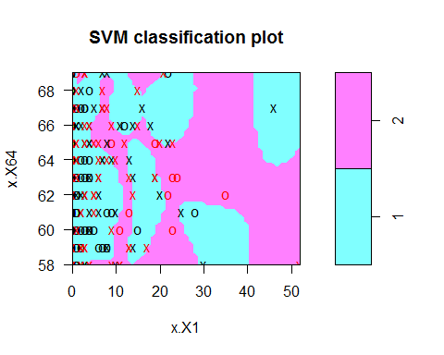

# Train model  
tune.out= tune(svm,y~.,data=dataframe,kernal="radial",ranges=list(cost=c(0.1,10,100,1000)),gamma=c(0.5,1,2,3,4))  
summary(tune.out)

##   
## Parameter tuning of 'svm':  
##   
## - sampling method: 10-fold cross validation   
##   
## - best parameters:  
## cost  
## 0.1  
##   
## - best performance: 0.2658065   
##   
## - Detailed performance results:  
## cost error dispersion  
## 1 1e-01 0.2658065 0.05541501  
## 2 1e+01 0.2821505 0.06622624  
## 3 1e+02 0.3017204 0.05958063  
## 4 1e+03 0.2854839 0.06619917

bestmodel1<-tune.out$best.model  
bestmodel1

##   
## Call:  
## best.tune(method = svm, train.x = y ~ ., data = dataframe, ranges = list(cost = c(0.1,   
## 10, 100, 1000)), kernal = "radial", gamma = c(0.5, 1, 2,   
## 3, 4))  
##   
##   
## Parameters:  
## SVM-Type: C-classification   
## SVM-Kernel: radial   
## cost: 0.1   
## gamma: 0.5 1 2 3 4   
##   
## Number of Support Vectors: 170

plot(bestmodel1,dataframe)

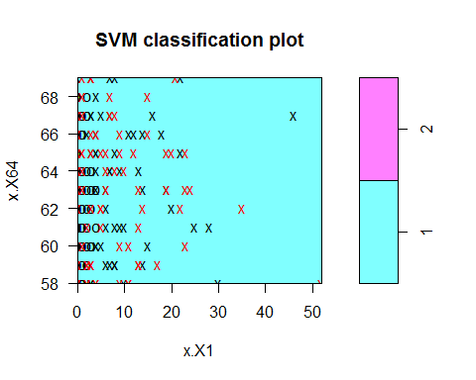

# Predict test dataframe  
testdf <- dataframe[1:25,]  
testdf

## x.X64 x.X1 y  
## 1 62 3 1  
## 2 65 0 1  
## 3 59 2 1  
## 4 65 4 1  
## 5 58 10 1  
## 6 60 0 1  
## 7 59 0 2  
## 8 66 9 2  
## 9 58 30 1  
## 10 60 1 1  
## 11 61 10 1  
## 12 67 7 1  
## 13 60 0 1  
## 14 64 13 1  
## 15 63 0 1  
## 16 60 1 1  
## 17 69 0 1  
## 18 60 0 1  
## 19 63 0 1  
## 20 58 0 1  
## 21 59 6 1  
## 22 60 15 1  
## 23 63 0 1  
## 24 69 21 2  
## 25 59 2 1

ypred=predict(bestmodel1,testdf)  
ypred

## 1 2 3 4 5 6 7 8 9 10 11 12 13 14 15 16 17 18 19 20 21 22 23 24 25   
## 1 1 1 1 1 1 1 1 1 1 1 1 1 1 1 1 1 1 1 1 1 1 1 1 1   
## Levels: 1 2

table(pred=ypred,truth=testdf$y)

## truth  
## pred 1 2  
## 1 22 3  
## 2 0 0

agreement_radial<-ypred==testdf$y  
table(agreement_radial)

## agreement_radial  
## FALSE TRUE   
## 3 22

prop.table(table(agreement_radial))

## agreement_radial  
## FALSE TRUE   
## 0.12 0.88

# Improve model performance   
classifier_radial_rbf<-ksvm(y~.,data=testdf,kernel="rbfdot")  
predictions_radial_rbf<-predict(classifier_radial_rbf,testdf)  
predictions_radial_rbf

## [1] 1 1 1 1 1 1 1 1 1 1 1 1 1 1 1 1 1 1 1 1 1 1 1 2 1  
## Levels: 1 2

agreement_radial_rbf<-predictions_radial_rbf==testdf$y  
table(agreement_radial_rbf)

## agreement_radial_rbf  
## FALSE TRUE   
## 2 23

prop.table(table(agreement_radial_rbf))

## agreement_radial_rbf  
## FALSE TRUE   
## 0.08 0.92

# Polynomial Kernal  
svmfit2<-svm(y~.,data=dataframe,kernal="polynomial",gamma=1,cost=10000)  
svmfit2

##   
## Call:  
## svm(formula = y ~ ., data = dataframe, kernal = "polynomial",   
## gamma = 1, cost = 10000)  
##   
##   
## Parameters:  
## SVM-Type: C-classification   
## SVM-Kernel: radial   
## cost: 10000   
## gamma: 1   
##   
## Number of Support Vectors: 171

plot(svmfit2,dataframe)



# Train model  
tune.out= tune(svm,y~.,data=dataframe,kernal="polynomial",ranges=list(cost=c(0.1,10,100,1000)),gamma=c(0.5,1,2,3,4))  
summary(tune.out)

##   
## Parameter tuning of 'svm':  
##   
## - sampling method: 10-fold cross validation   
##   
## - best parameters:  
## cost  
## 0.1  
##   
## - best performance: 0.2658065   
##   
## - Detailed performance results:  
## cost error dispersion  
## 1 1e-01 0.2658065 0.07025967  
## 2 1e+01 0.2852688 0.07623724  
## 3 1e+02 0.2951613 0.06029660  
## 4 1e+03 0.3051613 0.07976147

bestmodel2<-tune.out$best.model  
bestmodel2

##   
## Call:  
## best.tune(method = svm, train.x = y ~ ., data = dataframe, ranges = list(cost = c(0.1,   
## 10, 100, 1000)), kernal = "polynomial", gamma = c(0.5, 1,   
## 2, 3, 4))  
##   
##   
## Parameters:  
## SVM-Type: C-classification   
## SVM-Kernel: radial   
## cost: 0.1   
## gamma: 0.5 1 2 3 4   
##   
## Number of Support Vectors: 170

plot(bestmodel2,dataframe)



# Predict test dataframe  
testdf <- dataframe[1:25,]  
testdf

## x.X64 x.X1 y  
## 1 62 3 1  
## 2 65 0 1  
## 3 59 2 1  
## 4 65 4 1  
## 5 58 10 1  
## 6 60 0 1  
## 7 59 0 2  
## 8 66 9 2  
## 9 58 30 1  
## 10 60 1 1  
## 11 61 10 1  
## 12 67 7 1  
## 13 60 0 1  
## 14 64 13 1  
## 15 63 0 1  
## 16 60 1 1  
## 17 69 0 1  
## 18 60 0 1  
## 19 63 0 1  
## 20 58 0 1  
## 21 59 6 1  
## 22 60 15 1  
## 23 63 0 1  
## 24 69 21 2  
## 25 59 2 1

ypred=predict(bestmodel2,testdf)  
ypred

## 1 2 3 4 5 6 7 8 9 10 11 12 13 14 15 16 17 18 19 20 21 22 23 24 25   
## 1 1 1 1 1 1 1 1 1 1 1 1 1 1 1 1 1 1 1 1 1 1 1 1 1   
## Levels: 1 2

table(pred=ypred,truth=testdf$y)

## truth  
## pred 1 2  
## 1 22 3  
## 2 0 0

agreement_poly<-ypred==testdf$y  
table(agreement_poly)

## agreement_poly  
## FALSE TRUE   
## 3 22

prop.table(table(agreement_poly))

## agreement_poly  
## FALSE TRUE   
## 0.12 0.88

# Improve model performance   
classifier_poly_rbf<-ksvm(y~.,data=testdf,kernel="rbfdot")  
predictions_poly_rbf<-predict(classifier_poly_rbf,testdf)  
predictions_poly_rbf

## [1] 1 1 1 1 1 1 1 1 1 1 1 1 1 1 1 1 1 1 1 1 1 1 1 2 1  
## Levels: 1 2

agreement_poly_rbf<-predictions_poly_rbf==testdf$y  
table(agreement_poly_rbf)

## agreement_poly_rbf  
## FALSE TRUE   
## 2 23

prop.table(table(agreement_poly_rbf))

## agreement_poly_rbf  
## FALSE TRUE   
## 0.08 0.92

## Answers:

#### A(1)

The linear classifier has the efficiency of true and false is as follows:

prop.table(table(agreement))

## agreement  
## FALSE TRUE   
## 0.12 0.88

The radial classifier has the efficiency of true and false is as follows:

prop.table(table(agreement_radial))

## agreement_radial  
## FALSE TRUE   
## 0.12 0.88

It is seen that they are quite similar in the output. Thus for this database, the classifiers perform pretty well with over 0.88 TRUE and 0.12 FALSE for both linear and radial kernal. By changing cost and gamma, the best models give the efficiency of 0.92 TRUE and 0.08 FLASE asnd hence increases the TRUE values.

prop.table(table(agreement))

## agreement  
## FALSE TRUE   
## 0.12 0.88

prop.table(table(agreement_radial))

## agreement_radial  
## FALSE TRUE   
## 0.12 0.88

#### A(2)

Trying different kernals including linear, radial and polynomial and found that there is no change in the performance. All the kernals perform in the same way for this particular dataset. In terms of svm models, the linear model gives a clear and distinct graph in comaprison to that of polynomial and radial. Polynomial and radial have the same plot for the svm classifier and they are more spread out compared to linear.

#Linear Plot  
plot(svm.fit,dataframe)



#Radial Plot  
plot(svmfit1,dataframe)



#Polynomial Plot  
plot(svmfit2,dataframe)

#### A(3)

Increasing the sample size and bringing in more data would improve the performance of the svm classifier. Also using ksvm with kernal 'rbfdot' will improve the performance. It is clearly seen that it does improve the performace from 0.88 TRUE to 0.92 TRUE thus by 4%.

prop.table(table(agreement_rbf))

## agreement_rbf  
## FALSE TRUE   
## 0.08 0.92

prop.table(table(agreement_radial_rbf))

## agreement_radial_rbf  
## FALSE TRUE   
## 0.08 0.92