M11_L3_RomilShah

Romil Shah

August 1, 2016

library(RCurl)

## Loading required package: bitops

library(plyr)

## Warning: package 'plyr' was built under R version 3.2.5

library(forecast)

## Warning: package 'forecast' was built under R version 3.2.5

## Loading required package: zoo

## Warning: package 'zoo' was built under R version 3.2.5

##   
## Attaching package: 'zoo'

## The following objects are masked from 'package:base':  
##   
## as.Date, as.Date.numeric

## Loading required package: timeDate

## This is forecast 7.1

library(tseries)

## Warning: package 'tseries' was built under R version 3.2.5

data <- read.table("C:/Users/rams1/Desktop/DSCS6030/S01R01.txt")  
names(data) <- c("time","ankle1","ankle2","ankle3","ul1","ul2","ul3","ta1","ta2","ta3","labels")  
  
#This data consists of the ankle acceleration, upper leg acceleration and trunk acceleration with different subjects who are either healthy or have parkisons disease. This is a time series data which I am using in my project. Here I am using the information of a parkisons patient where the ankle data will be used to analyse using ARIMA models.  
  
ankles <- count(data, c("ankle1","ankle2","ankle3"))  
  
#Taking first 10000 values for consideration with frequency 2  
ankles_timeseries <- ts(ankles$freq,start = c(1, 1), end = c(10000, 1), frequency = 2)   
plot(ankles_timeseries, xlab='Time Stamp' ,ylab='Ankle Acceleration', main='Ankle Acceleration')

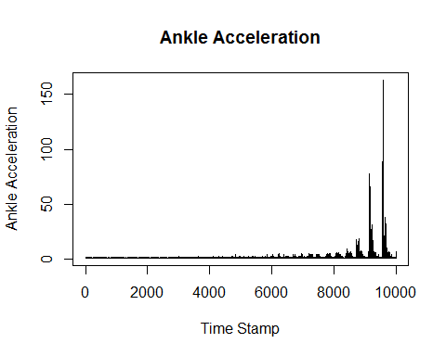

# plot a correlogram  
acf(ankles_timeseries)

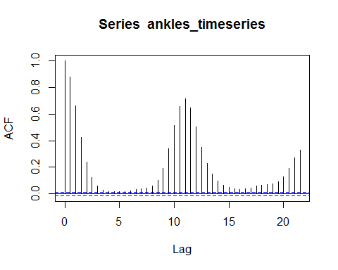

var(ankles_timeseries)

## [1] 11.52649

pacf(ankles_timeseries)

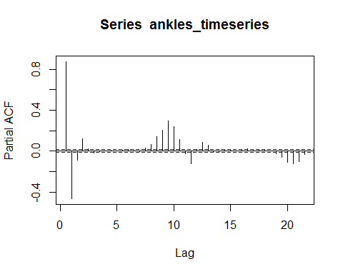

#Dickey-Fuller for stationarity  
adf.test(ankles_timeseries,alternative="stationary")

## Warning in adf.test(ankles_timeseries, alternative = "stationary"): p-value  
## smaller than printed p-value

##   
## Augmented Dickey-Fuller Test  
##   
## data: ankles_timeseries  
## Dickey-Fuller = -9.7569, Lag order = 27, p-value = 0.01  
## alternative hypothesis: stationary

#Philips Perron test  
PP.test(ankles_timeseries)

##   
## Phillips-Perron Unit Root Test  
##   
## data: ankles_timeseries  
## Dickey-Fuller = -32.968, Truncation lag parameter = 15, p-value =  
## 0.01

#Trend of the dataset  
anklests.stl = stl(ankles_timeseries, s.window="periodic")  
plot(anklests.stl)

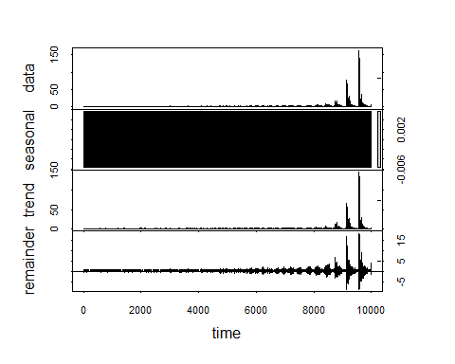

#The above plot shows the trend, seasonality and remainder of the timeseries. In this particular dataset, as there are acceleration values of the ankles and thighs, a trend is observed in the diseased and healthy patients. This helps in the further analysis and classification of the patients as healthy or parkinsons patients based on the trend observed in the data.  
#Using the trend of obtained here, we can classify a future data as far as this dataset is concerned.