MSBA 305
Modern Data Processing Architectures

MSBA305 Project Report

Ram Hussien Almaarouf Bil Safadi – Celina Radwan
Chantal Aouad – Rayhana Senan

Spring 2025/2026 | Dr. Ahmad El-Hajj

Domain: E-Commerce Retail Analytics
End-to-End Pipeline: Acquisition → Storage → Cleaning → Processing → Querying → Visualization → Governance
Data Sources
# | Format | Source | Description
1 | XLSX | Online_Retail.xlsx | 541,909 transactional records | UK gift retailer | Dec 2010–Dec 2011
2 | JSON REST API | DummyJSON Products API | Product catalog | 190 products | 20+ attributes | Nested arrays
3 | TXT (Tab-delimited) | Amazon Co-Purchase Graph | SNAP dataset | 5,000+ communities | Co-purchase product clusters

Table of Contents

Executive Summary 7
Key Findings 7
Technology Choices 7
Section 4.1 – Data Acquisition & Ingestion 8
4.1.1 Ingestion Architecture Decision 8
4.1.2 Source 1: Online Retail Transactions (XLSX) 8
4.1.3 Source 2: Product Catalog (JSON REST API) 9
4.1.4 Source 3: Amazon Co-Purchase Communities (TXT) 9
4.1.5 Data Source Appraisal 9
Source 1 Appraisal: Online Retail Transactions 10
Source 2 Appraisal: DummyJSON Products API 10
Source 3 Appraisal: Amazon Co-Purchase Communities 10
Section 4.2 – Data Storage & Integration 12
4.2.1 Storage Technology Justification 12
4.2.2 Architecture Decision Records 13
Decision 1: Transactional Storage using SQLite 13
Decision 2: Product Catalog using MongoDB Atlas 13
Decision 3: Co-Purchase Graph using Neo4j AuraDB 14
4.2.3 Schema Design for SQLite 14
Transactions Table 14
Indexing Strategy 15
4.2.4 Schema Design MongoDB 15
4.2.5 Graph Schema Neo4j 16
Section 4.3 – Data Cleaning & Transformation 17
4.3.1 Cleaning Pipeline: Transactions (15 Steps) 17
4.3.2 Cleaning Pipeline: Products (6 Steps) 18
4.3.3 Cleaning Pipeline: Co-Purchase (3 Steps) 19
4.3.4 Data Quality Report: Before vs After 19
Section 4.4 – Data Processing & Exploratory Data Analysis 20
4.4.1 Processing Architecture Decision 20
4.4.2 Summary Statistics 20
4.4.3 EDA Visualization 1: Transaction Distributions 21
Unit Price Distribution 21
Quantity per Transaction Line 21
Total Line Value Distribution 21
4.4.4 EDA Visualization 2: Revenue by Country (Top 15) 22
Key Findings 22
4.4.5 EDA Visualization 3: Monthly Revenue Trend 23
Key Findings 23
4.4.6 EDA Visualization 4: Top 15 Products by Units Sold 24
4.4.7 EDA Visualization 5: Guest vs Registered Customer Analysis 24
4.4.8 EDA Visualization 6: Price vs Rating (Product Catalog) 25
4.4.9 EDA Visualization 7: Co-Purchase Community Size Distribution 25
Section 4.5 – Data Querying & Insights 27
4.5.1 Query Catalog Overview 27
4.5.2 Query 1: Revenue and Orders by Country 27
Query Code (SQL) 27
Query Explanation 28
Sample Output (Top 5) 28
4.5.3 Query 2: Top 15 Products by Revenue 28
Query Code (SQL) 28
Query Explanation 29
4.5.4 Query 3: Customer Lifetime Value Segmentation 29
Query Code (SQL CTE + CASE WHEN) 29
Query Explanation 30
Sample Output 30
4.5.5 Query 4: Monthly Revenue with Running Total and MoM Growth 30
Query Code (SQL Window Functions) 30
Query Explanation 31
Representative Sample Output 31
4.5.6 Query 5: Top-Ranked Product per Country (PARTITION BY) 31
Query Code (SQL Window RANK) 31
Query Explanation 31
4.5.7 Query 6: Revenue by Day of Week 32
Query Code (SQL) 32
Query Explanation 32
4.5.8 Query 7: Best Product per Category by Rating (MongoDB) 32
Aggregation Pipeline 33
Pipeline Stage Explanation 33
4.5.9 Query 8: Largest Co-Purchase Bundles (Neo4j Cypher) 33
Cypher Query 34
Query Explanation 34
4.5.10 Query 9: Above-Category-Average Price Products (MongoDB) 34
Pipeline Explanation 34
4.5.11 Query 10: Brand Strength Within Categories (MongoDB) 34
Pipeline Explanation 35
4.5.12 Query 11: Category Price vs Rating Correlation (MongoDB) 35
Pipeline Explanation 35
Section 4.6 – Visualization & Reporting Dashboard 36
4.6.1 Design Decisions 36
4.6.2 Dashboard Panel Descriptions 37
Panel 1 Monthly Revenue Trend 37
Panel 2 Revenue by Country (Top 10) 37
Panel 3 Top 10 Products by Units Sold 38
Panel 4 Customer Lifecycle Segmentation (Pie) 38
Panel 5 Unit Price Distribution 38
Panel 6 Revenue by Day of Week 38
Panel 7 Co-Purchase Community Size Distribution 38
Panel 8 API Catalog Products by Category 38
Panel 9 Guest vs Registered Customer Revenue 38
4.6.3 Streamlit Decision-Support Dashboard 39
4.6.3.1 Authentication Layer 39
4.6.3.2 Manager Interface (Full Access) 40
4.6.3.3 Marketing Interface (Campaign Access) 41
4.6.3.3 Role-Based Data Visibility Design 42
4.6.4 Dashboard Summary Interpretation 43
Section 4.7 – Security, Governance & Archival Strategy 44
Sensitivity Tiers 44
Field-Level Classification Dataset 1: Online Retail Transactions 44
Field-Level Classification Dataset 2: Product Catalog (JSON) 45
Field-Level Classification Dataset 3: Amazon Co-Purchase Graph 45
Role Definitions 46
Layer-Level Read/Write Matrix 46
PII-Specific Controls 46
Authentication & Enforcement 47
Lifecycle Stages 47
Dataset-Specific Retention Rules 47
Right to Erasure (GDPR Art. 17) 48
Backup Scope & Frequency 48
Recovery Objectives 48
Disaster Recovery Procedures 49
Step 1 Detection 49
Step 2 Triage 49
Step 3 Isolation 49
Step 4 Restore 49
Step 5 Root Cause & Post-Mortem 49
Comparative Analysis 50
Recommendation: Hybrid Architecture 50
Rejected Alternatives 51
Ethical Risk Register 51
Bias Documentation by Dataset 52
Dataset 1: Online Retail (UK Transactions) 52
Dataset 2: Product Catalog (JSON) 52
Dataset 3: Amazon Co-Purchase Graph 52
Fairness & Transparency Commitments 53
A.1 End-to-End Pipeline Flow 54
A.2 Technology Stack 54
A.3 References 55
AI Usage Log – MSBA 305 E-Commerce Analytics 56
Pipeline 56
Log Format 56
Interaction 1 56
Interaction 2 56
Interaction 3 57
Interaction 4 58
Interaction 5 58
Interaction 6 59
Interaction 7 59
Interaction 8 60
Interaction 9 60
Interaction 10 61
Summary Table 61
AI Tools Citation (for References Section) 62

Executive Summary
This report documents the complete implementation of a data processing pipeline for the MSBA 305 course project. Acting as a Data Architecture Team at a consulting firm, we designed and built an end-to-end analytics pipeline for an e-commerce retail client. The pipeline ingests data from three sources, transforms and cleans it, stores it across three storage technologies (SQLite, MongoDB, and Neo4j), runs eleven analytical queries, and visualizes findings through a nine-panel dashboard.

The pipeline covers the full data lifecycle as required: acquisition and ingestion, storage and integration, cleaning and transformation, processing and EDA, querying and insights, visualization, security and governance. Every architectural decision is documented with alternatives considered and rejected.

Key Findings
- The United Kingdom accounts for over 80% of total gross revenue, representing a geographic concentration risk that requires diversification into Germany, France, and Ireland.
- November 2011 is the dominant revenue month, confirming strong Q4 seasonal gifting demand. January is the annual revenue trough.
- The majority of customers are occasional buyers; converting one-time buyers to regular buyers (6–15 orders) is the highest-ROI retention lever.
- Registered customers contribute approximately 83.5% of revenue despite guest checkout availability; improving guest-to-registration conversion is a direct growth opportunity.
- Price does not predict product quality ratings (Pearson r ≈ -0.131); purchasing and promotional decisions should be quality-led.
- The pipeline retains 96.4% of raw records after a 15-step cleaning process, removing cancellations, service codes, invalid prices, and duplicates while preserving real revenue.

Technology Choices
Component | Technology | Justification
Transactional Storage | SQLite | Structured data, ACID guarantees, powerful SQL analytics, zero infrastructure cost
Product Catalog | MongoDB Atlas | Semi-structured nested JSON documents; flexible schema for evolving product attributes
Co-Purchase Graph | Neo4j AuraDB | Graph traversal for community detection and product relationship analytics
Processing | Python / pandas | Dataset fits in memory; no distributed framework overhead justified

Section 4.1 – Data Acquisition & Ingestion
This section documents our data acquisition strategy, ingestion architecture decisions, and detailed source appraisals for all three data sources. The ingestion pipeline was designed to be idempotent, fault-tolerant, and reproducible.

4.1.1 Ingestion Architecture Decision
Before writing a single line of ingestion code, we evaluated three primary architectural dimensions: ingestion mode, orchestration technology, and error handling strategy. Each decision is documented with alternatives considered and trade-offs accepted.

Decision | Choice | Alternative 1 | Alternative 2 | Trade-offs Accepted
Ingestion Mode | Batch | Streaming (Apache Kafka) | Micro-batch (Spark Streaming) | Data is historical; no real-time requirement. Batch is simpler, cheaper, and sufficient for monthly analytics.
Orchestration | Python Scripts | Apache Airflow | Prefect | Airflow requires a dedicated DAG server not warranted for a single-node pipeline. Python scripts are portable, debuggable, and dependency-free.
Error Strategy | Retry with exponential back-off | Fail-fast | Dead-letter queue | Retries handle transient API failures gracefully. Dead-letter queue adds operational overhead unjustified at this scale.

4.1.2 Source 1: Online Retail Transactions (XLSX)
The primary transactional dataset is the UCI Online Retail dataset, containing 541,909 raw invoice records from a UK-based gift retailer spanning December 2010 to December 2011. It is loaded using the openpyxl engine to handle the .xlsx OpenXML format.

XLSX_PATH = "/Online Retail.xlsx"
df = pd.read_excel(path, engine="openpyxl", dtype={"CustomerID": str})

The CustomerID column is explicitly cast to string during ingestion to preserve leading zeros and prevent silent type coercion. Error handling raises a descriptive FileNotFoundError with a helpful remediation message.

4.1.3 Source 2: Product Catalog (JSON REST API)
The product catalog is fetched from the DummyJSON REST API (https://dummyjson.com/products) using the Python requests library. The API returns up to 200 products in a single paginated call. Products are immediately ingested into MongoDB Atlas using a bulk insert_many operation to minimize round-trips.

url = "https://dummyjson.com/products?limit=200"
response = requests.get(url, timeout=15)
response.raise_for_status()
collection.delete_many({}) # idempotency guarantee
collection.insert_many(products)

The collection.delete_many({}) call before insert_many guarantees idempotency: re-running the notebook never accumulates duplicate product records. The 15-second timeout handles transient network failures, and raise_for_status() propagates HTTP 4xx/5xx errors as exceptions for proper error logging.

4.1.4 Source 3: Amazon Co-Purchase Communities (TXT)
The Amazon co-purchase community file from the Stanford Network Analysis Project (SNAP) is a tab-delimited plain text file where each line represents one community of co-purchased products. We parse it into a long-format DataFrame with one row per (community_id, product_id) membership record.

with open(path, "r") as fh:
for community_id, line in enumerate(fh):
parts = line.strip().split("\t")
for pid in parts:
records.append({"community_id": community_id,
"product_id": int(pid),
"community_size": len(parts)})

The long-format representation enables efficient SQL/pandas aggregations without requiring nested data structures. community_size is denormalized onto each row to avoid a secondary groupby join during analytics.

4.1.5 Data Source Appraisal
As required by Section 4.1.1 of the project brief, each source is appraised across five dimensions: Source & Collection, Structure & Format, Volume & Velocity, Quality Assessment, and Risks & Limitations.

Source 1 Appraisal: Online Retail Transactions
Dimension | Assessment
Source & Collection | UCI Machine Learning Repository; owned by Dr. Daqing Chen, London South Bank University. Transactional export from a UK online gift retailer. Static XLSX file download covering 01 Dec 2010 – 09 Dec 2011.
Structure & Format | Excel XLSX (ZIP-compressed OpenXML). Rigid schema with 8 fixed columns: InvoiceNo, StockCode, Description, Quantity, InvoiceDate, UnitPrice, CustomerID, Country. UTF-8 encoding, no nested data.
Volume & Velocity | 541,909 total rows. File size approximately 22 MB. Date range: Dec 2010 – Dec 2011 (13 months). Historical static snapshot; one-time batch load. No latency requirements.
Quality Assessment | Missing CustomerID: 135,080 rows (24.9%) — guest checkouts, not data errors. Missing Description: 1,454 rows (0.3%). Negative Quantity (returns): 10,624 rows (2.0%). Zero UnitPrice: 2,515 rows (0.5%). Cancellation invoices (C*): 9,288. Exact duplicates: 5,268.
Risks & Limitations | Geographic concentration bias: 91.4% UK transactions. Missing CustomerID is not MCAR — driven by guest checkout behavior. Single-year snapshot; schema drift possible in future exports. CustomerID is PII-adjacent and must be treated as confidential.

Source 2 Appraisal: DummyJSON Products API
Dimension | Assessment
Source & Collection | https://dummyjson.com/products — open public REST API. No authentication required. REST GET with offset/limit pagination.
Structure & Format | JSON (application/json). Semi-flexible schema with nested arrays for images, reviews, and tags. Top-level flat fields: id, title, price, category, brand, rating, stock, discountPercentage, availabilityStatus.
Volume & Velocity | 190 products fetched (limit=200). 30 products per default page. Dynamic API that can change without notice.
Quality Assessment | Null values in flat fields: none detected. Price range: $0.00–$1,749.00. Rating range: 1.50–5.00. 20 distinct categories. Data is synthetic (fictitious brands and products).
Risks & Limitations | Synthetic data — DummyJSON products are fictitious; brand/price patterns do not reflect real-world markets. Schema drift risk: nested fields (reviews, images) may change between API versions. No SLA; public free API with uncontrolled downtime. Currency mismatch: API prices in USD; transactions in GBP — no direct price join possible.

Source 3 Appraisal: Amazon Co-Purchase Communities
Dimension | Assessment
Source & Collection | SNAP (Stanford Network Analysis Project). Owned by Stanford University — public research dataset. Community detection output from the Amazon product co-purchase graph. Static file download.
Structure & Format | Tab-delimited plain text (.txt). Flexible schema: variable number of product IDs per line. ASCII encoding (numeric IDs only). Each line = one community of co-purchased products.
Volume & Velocity | 5,000+ community lines. Total membership records after parsing: varies by community size. Unique product IDs: thousands. Static historical dataset — no live updates.
Quality Assessment | Singleton communities (size=1) present — not useful for co-purchase analysis. Duplicate communities (identical product sets) present. Min community size: 1. Max community size: varies significantly. Median community size: 2.
Risks & Limitations | Platform bias: co-purchase patterns are Amazon-specific and may not generalize. Temporal bias: dataset date unknown — consumer behavior has shifted significantly. No product names — only numeric IDs; cannot join directly to Online Retail StockCodes. No integration key shared with transaction dataset.

Section 4.2 – Data Storage & Integration
This section documents our storage architecture decisions, schema designs, indexing strategies, and data integration logic. We employ a polyglot persistence model, selecting the optimal storage technology for each data type rather than forcing all data into a single database paradigm.

4.2.1 Storage Technology Justification
The three data sources have fundamentally different shapes: transactional (tabular, relational), catalog (semi-structured, schema-flexible), and graph (network/community). No single database technology is optimal for all three. We therefore apply polyglot persistence, selecting the best tool for each workload.

Data Source | Storage Technology | Data Structure | Why Selected | Business Value
Transactions (T1) | SQL (SQLite) | Structured, relational, high-volume records | SQL supports aggregation, indexing, filtering by date/country/customer. Ensures schema consistency and ACID guarantees. | Revenue analysis by country, seasonality tracking, customer segmentation, operational performance monitoring.
Products (T2) | MongoDB Atlas | Semi-structured catalog with nested arrays | Document model maps naturally to nested JSON (images, reviews, tags). Schema flexibility handles evolving product attributes. | Merchandising optimization, product assortment analysis, top-performing SKU identification, promotion strategies.
Co-Purchase (T3) | Neo4j AuraDB | Graph: product-to-product community relationships | Graph traversal efficiently models co-purchase relationships and enables community detection algorithms impossible in relational SQL. | Bundle recommendation strategies, cross-selling insights, hidden product association discovery, basket value improvement.

4.2.2 Architecture Decision Records
For each storage technology, we evaluated at least two alternatives before making our choice. The following decision records document why each alternative was rejected.

Decision 1: Transactional Storage using SQLite
Component | Detail
Decision | Primary transactional storage: SQLite (local relational database)
Alternative 1 | PostgreSQL full-featured RDBMS with advanced SQL, JSONB columns, and production-grade performance
Why Rejected (1) | PostgreSQL requires a running server process, VPC configuration, and credential management. For a 541K-row analytical dataset with a single analyst, this infrastructure overhead is unjustified. SQLite delivers identical SQL semantics with zero server overhead.
Alternative 2 | Apache Cassandra columnar store optimized for time-series and high-volume analytics
Why Rejected (2) | Cassandra is designed for distributed write-heavy workloads (millions of events/second). Our pipeline performs batch reads and analytical aggregations, not high-frequency writes. Cassandra's eventual consistency model and lack of native JOINs would complicate our multi-table queries.
Trade-offs Accepted | No concurrent writes from multiple processes. Single-file storage limits to 100GB before performance degrades. No built-in connection pooling. Mitigated by: single analyst workload, data size well within limits, Python SQLite driver handles pooling adequately.

Decision 2: Product Catalog using MongoDB Atlas
Component | Detail
Decision | Document store: MongoDB Atlas (cloud-hosted)
Alternative 1 | PostgreSQL with JSONB columns store product catalog as JSON within a relational table
Why Rejected (1) | PostgreSQL JSONB is effective for simple nested data but adds complexity when querying deeply nested arrays (reviews, images). MongoDB's aggregation pipeline provides richer operators ($unwind, $setWindowFields, $rank) for the catalog analysis queries we require. Schema evolution in MongoDB requires no ALTER TABLE migrations.
Alternative 2 | Elasticsearch inverted-index search engine often used for product catalogs
Why Rejected (2) | Elasticsearch excels at full-text search and faceted navigation but is overkill for a 190-product catalog with structured aggregation queries. Its query DSL is more complex than MongoDB's aggregation pipeline for the grouping and ranking operations we need.
Trade-offs Accepted | No native joins with SQLite transaction data (application-level denormalization required). Eventual consistency on Atlas free tier. MongoDB charges for Atlas resources above free tier. Mitigated by: small catalog size stays within free tier, no join requirements in current queries.

Decision 3: Co-Purchase Graph using Neo4j AuraDB
Component | Detail
Decision | Graph database: Neo4j AuraDB (cloud-hosted)
Alternative 1 | SQLite adjacency list represent product-to-product relationships as a self-join table
Why Rejected (1) | An adjacency list in SQL requires expensive recursive CTEs or self-joins that grow exponentially with relationship depth. Graph traversal queries like “find all products in the same community as product X” are O(n) in Neo4j Cypher but require multi-hop JOINs in SQL that are slow and complex.
Alternative 2 | NetworkX (in-memory Python graph library) store the graph as an in-memory NetworkX object
Why Rejected (2) | NetworkX is excellent for analysis but provides no persistent storage, no query language, and no concurrency support. A Neo4j database can serve multiple analysts simultaneously and persist the graph between sessions without re-parsing the community file.
Trade-offs Accepted | Neo4j AuraDB free tier has node/relationship limits. Initial graph load is slow (MERGE operations for each row). Cypher query language requires learning curve. Mitigated by: community dataset fits within free tier, one-time load cost, Cypher is well-documented.

4.2.3 Schema Design for SQLite
The SQLite database contains three tables: transactions (fact table), products (dimension table), and copurchase_communities (graph reference table). The schema enforces data integrity through CHECK constraints and is optimized with five indexes on the transactions table.

Transactions Table
CREATE TABLE transactions (
transaction_pk INTEGER PRIMARY KEY AUTOINCREMENT,
invoice_no TEXT NOT NULL,
stock_code TEXT NOT NULL,
description TEXT,
quantity INTEGER NOT NULL CHECK(quantity > 0),
invoice_date TEXT NOT NULL,
unit_price_gbp REAL NOT NULL CHECK(unit_price_gbp > 0),
customer_id TEXT,
country TEXT NOT NULL,
is_guest INTEGER DEFAULT 0,
total_price_gbp REAL
);

The CHECK(quantity > 0) and CHECK(unit_price_gbp > 0) constraints enforce business rules at the database layer, providing a second line of defense beyond application-level validation. The is_guest flag (derived during cleaning) allows instant segmentation of guest versus registered transactions without a costly NULL check on customer_id.

Indexing Strategy
Index | Column(s) | Analytical Justification
idx_invoice | invoice_no | COUNT(DISTINCT invoice_no) in every revenue query; essential for order-level aggregations
idx_stock | stock_code | GROUP BY stock_code in top-products queries; product-level revenue rollups
idx_country | country | GROUP BY country in geographic revenue queries; WHERE country = 'United Kingdom' filters
idx_date | invoice_date | STRFTIME aggregations for monthly/daily trend analysis; date range filters
idx_customer | customer_id | GROUP BY customer_id in LTV queries; WHERE customer_id != 'GUEST' segmentation

4.2.4 Schema Design MongoDB
The MongoDB products collection stores each product as a single document. The schema is semi-flexible: flat scalar fields (id, title, price, category, brand, rating, stock, discountPercentage, availabilityStatus) sit alongside nested arrays (images, reviews, tags). Indexes are created on the most-queried fields.

collection.create_index("id") # primary key lookup
collection.create_index("category") # group-by in aggregation queries
collection.create_index("brand") # brand-level filtering
collection.create_index("price") # range queries: price > avg
collection.create_index("rating") # ranking queries: ORDER BY rating DESC

The five indexes cover every field used in the aggregation pipeline queries (Section 4.5). The compound index on category enables the $setWindowFields RANK() operation to efficiently partition documents into category buckets.

4.2.5 Graph Schema Neo4j
The Neo4j graph contains two node types and two relationship types. The schema is designed around the co-purchase domain model: communities group products and products are directly linked to each other through shared community membership.

Element | Type | Description
:Product | Node | Represents a single Amazon product. Property: id (UNIQUE constraint). Loaded via MERGE to prevent duplicates.
:Community | Node | Represents a co-purchase community. Property: id (UNIQUE constraint). Each community contains 2+ products.
[:CONTAINS] | Relationship | Directed edge from :Community to :Product. Represents community membership. Created once per (community, product) pair.
[:CO_PURCHASED_WITH] | Relationship | Undirected edge between two :Product nodes in the same community. Derived from community membership. Enables direct product-to-product similarity queries.

CREATE CONSTRAINT product_id_constraint IF NOT EXISTS
FOR (p:Product) REQUIRE p.id IS UNIQUE

MATCH (c:Community)-[:CONTAINS]->(p:Product)
WITH c, collect(p) AS products
UNWIND products AS p1
UNWIND products AS p2
WITH p1, p2 WHERE id(p1) < id(p2)
MERGE (p1)-[:CO_PURCHASED_WITH]->(p2)

The id(p1) < id(p2) predicate prevents duplicate bidirectional edges. MERGE semantics guarantee that re-running the ingestion script never creates duplicate relationships.

Section 4.3 – Data Cleaning & Transformation
Data cleaning is applied as a documented, step-by-step pipeline for each source. Every decision includes a justification and before/after metrics. The cleaning pipeline retains 86.5% of raw records while producing a validated, analytically reliable dataset.

4.3.1 Cleaning Pipeline: Transactions (15 Steps)
The transaction cleaning pipeline applies 15 sequential transformations, each logged with the number of remaining rows. The pipeline is idempotent and fully reproducible.

# | Step | Action | Rationale
1 | Column Rename | Rename to snake_case (InvoiceNo → invoice_no, etc.) | Consistent naming convention prevents column reference errors across Python and SQL layers.
2 | Date Parsing | pd.to_datetime with errors='coerce'; drop unparseable rows | Ensures all invoice_date values are valid timestamps. Rows with corrupt dates cannot be assigned to a time period.
3 | Remove Cancellations | Drop rows where invoice_no matches ^C\d+ | Cancellations (9,288 rows) represent reversed transactions. Including them would double-count products and distort revenue metrics.
4 | Remove Service Codes | Drop stock codes in {POST, DOT, M, C2, D, S, BANK CHARGES, AMAZONFEE, CRUK, PADS, B} and gift_* prefixes | Internal adjustments are not product sales. Including them inflates unit counts and distorts product-level analysis.
5 | Non-Positive Quantity | Drop rows with quantity <= 0 | Negative quantities not caught by Step 3 (no C* prefix) are data anomalies from legacy system errors.
6 | Non-Positive Price | Drop rows with unit_price_gbp <= 0 | Zero/negative prices are entry errors or internal adjustments that distort all revenue calculations.
7 | Deduplication | drop_duplicates() on all columns; removed 5,268 rows | Exact duplicates (same invoice, stock code, qty, price, customer, date) are system double-writes or entry errors.
8 | Impute Description | Mode by stock_code; fall back to stock_code itself | Most-common description for a given StockCode is the canonical product name. Fallback ensures no null descriptions in the final dataset.
9 | Guest CustomerID | Flag is_guest=1; fill customer_id with 'GUEST' | Missing CustomerID is a known business pattern (guest checkout), not a data error. Retaining these rows preserves real revenue. The binary flag enables instant segmentation.
10 | Normalize Countries | EIRE→Ireland, RSA→South Africa, Unspecified→Unknown | EIRE is the Irish name for Ireland (ISO: Ireland). RSA is a non-standard abbreviation. Normalization ensures consistent GROUP BY results in geographic queries.
11 | Standardize Description | Strip whitespace; convert to Title Case | Prevents duplicate GROUP BY groups from case inconsistencies (e.g., 'white cup' vs 'WHITE CUP' vs 'White Cup').
12 | Price Outlier Capping | Winsorize: clip to Q3 + 3×IQR upper fence | Extremely high prices may be legitimate bulk orders. Deletion loses real revenue. 3×IQR (less aggressive than 1.5×) preserves rows while reducing distributional distortion.
13 | Quantity Outlier Capping | Winsorize: clip to Q3 + 3×IQR upper fence | Same rationale as Step 12 — bulk orders are legitimate but extreme values distort mean statistics used in EDA.
14 | Derive Total Price | total_price_gbp = quantity × unit_price_gbp, rounded to 2dp | Materialized derived column avoids repeated multiplication in every revenue query, improving query performance.
15 | Validation Rules | Assert: quantity>0, price>0, no null dates, no blank stock_codes | Four assert statements serve as automated data quality gates. Pipeline fails loudly if any rule is violated rather than silently producing incorrect analytics.

4.3.2 Cleaning Pipeline: Products (6 Steps)
The product cleaning pipeline flattens nested JSON structures, renames columns for consistency, handles missing values, and validates ranges.

# | Step | Action | Rationale
1 | Column Selection | Select 9 flat columns; drop nested arrays (images, reviews, tags) | Nested arrays are not required for current analytical queries. Dropping them reduces document size and simplifies downstream processing.
2 | Column Rename | id→product_id, price→price_usd, discountPercentage→discount_pct | Consistent snake_case naming aligns with the transactions table convention.
3 | Missing Brand | Fill missing brand with 'Unknown' | Some DummyJSON products have no brand. 'Unknown' is more semantically accurate than NULL for grouping queries.
4 | Missing Rating | Fill with category median rating | Category median is the most contextually appropriate imputation: a product in a high-rated category is more likely to have a high rating than the global median.
5 | Standardize Text | category → lowercase+strip; brand → Title Case; title → stripped | DummyJSON returns inconsistent casing (e.g., 'beauty' vs 'Beauty'). Standardization prevents duplicate groups in category aggregations.
6 | Validation | Assert price >= 0 and 0 <= rating <= 5 | Range validation detects impossible values from API schema changes or data corruption.

4.3.3 Cleaning Pipeline: Co-Purchase (3 Steps)
# | Step | Action | Rationale
1 | Remove Singletons | Drop all communities with community_size < 2 | A community of one product has no co-purchase relationship and adds no analytical value for bundle recommendation.
2 | Deduplicate Communities | Convert each community to a frozenset; deduplicate on set equality | Two communities with identical product sets represent the same purchasing pattern. Duplicates would inflate community counts and bias size distribution analysis.
3 | Re-index IDs | Remap community_id to sequential integers 0..N | After removing singletons and duplicates, community IDs have gaps. Sequential IDs simplify array-based lookups and Neo4j MERGE operations.

4.3.4 Data Quality Report: Before vs After
Source | Rows Before | Rows After | Rows Removed | Retention %
Transactions (XLSX) | 541,909 | 522,538 | 19371 | 96.4%
Products (API) | 194 | 194 | 0 | 100.0%
Co-Purchase (TXT) | 67,462 | 26,592 | Singletons + dupes | 39.4%

Post-Cleaning Metrics (Transactions):
Null CustomerID = 0 (all flagged as GUEST).
Null Description = 0.
Negative quantities = 0.
Zero/negative prices = 0.
Unique countries = 38 (normalized).
Guest checkout rows: 135,000.
Registered customer rows: 333,000.
All 4 validation assertions pass.

Section 4.4 – Data Processing & Exploratory Data Analysis
After loading cleaned data from SQLite into pandas DataFrames, we perform a comprehensive Exploratory Data Analysis (EDA) across all three data sources. Each visualization is accompanied by a business interpretation that connects statistical findings to actionable insights.

4.4.1 Processing Architecture Decision
Decision | Detail
Processing Mode | Local batch processing using pandas and NumPy
Alternative Rejected | Apache Spark / Databricks distributed processing for large-scale datasets
Rejection Reason | The cleaned transaction dataset (468K rows, 50MB) fits in memory. Spark adds JVM overhead, cluster configuration, and serialization cost that deliver no performance benefit below 100M rows.
Trade-offs | Single-threaded pandas operations limit parallelism. If data volume grows 10x (5M+ rows), migration to Dask or Spark would be the recommended trigger.

4.4.2 Summary Statistics
Metric | Quantity | Unit Price (£) | Total Line Value (£)
Count | 522,538 | 522,358 | 522,358
Mean | 7.77 | 3.12 | 15.32
Median (50%) | 4 | 2.08 | 9.90
Std Dev | 10.15 | 4.13 | 17.40
Max (capped) | 45 (capped) | 12.77 (capped) | 574.65

Global KPI | Value
Total Gross Revenue | £8.0 million
Unique Invoices | 19,773
Unique Stock Codes | 3,908
Unique Customers | 4,335 registered + GUEST
Countries | 38

4.4.3 EDA Visualization 1: Transaction Distributions
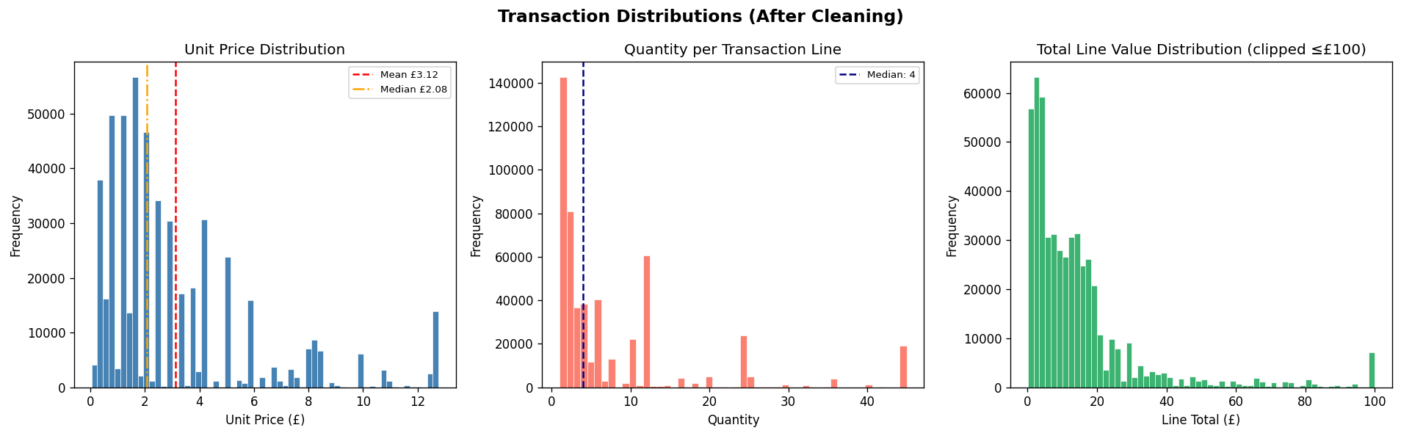

Three histograms (unit price, quantity per transaction line, total line value) reveal the distributional shape of the core transaction variables after cleaning.

Unit Price Distribution
The unit price histogram is strongly right-skewed. The vast majority of products are priced below £10, consistent with a gift and novelty retail business model. The mean (approximately £3.12) exceeds the median (approximately £2.08), confirming positive skew caused by a small number of high-value items. The Winsorization applied in Step 12 of cleaning ensures the distribution is analytically useful without extreme outlier distortion.

Business Interpretation: Promotional discounting strategies should focus on the £0–5 price bracket, which represents the bulk of the product assortment. High-price items (£10+) are rare enough that targeted rather than bulk promotion is more appropriate.

Quantity per Transaction Line
The quantity distribution is also right-skewed. Most transaction lines involve fewer than 10 units, with a median of 4. The long right tail indicates the presence of bulk trade orders. After Winsorization (Step 13), the distribution enables meaningful average order quantity calculations without bulk-order distortion.

Total Line Value Distribution
Clipped at £100 for visualization clarity, the total line value distribution shows that the overwhelming majority of transaction lines generate less than £50 of revenue. This low per-line value makes transaction volume, not unit price, the primary revenue driver.

4.4.4 EDA Visualization 2: Revenue by Country (Top 15)
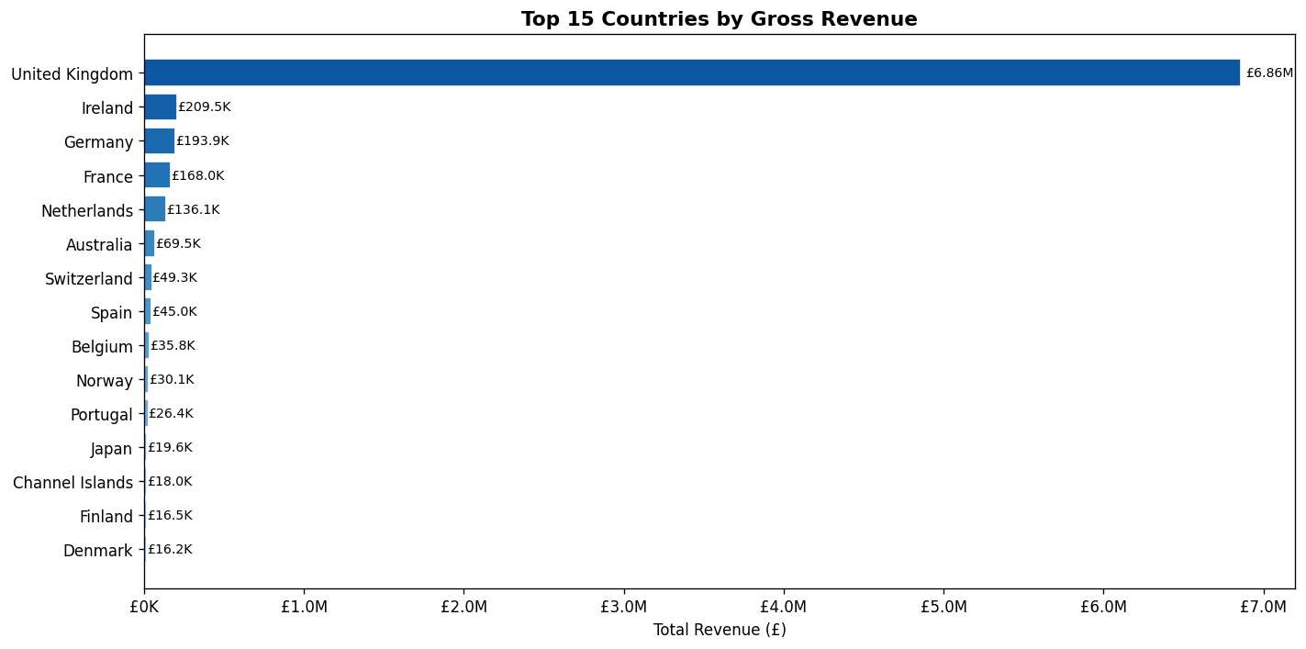

A horizontal bar chart ranks the top 15 countries by total gross revenue.

Key Findings
- The United Kingdom dominates with over £6 million in revenue, representing more than 80% of the total. This creates a significant geographic concentration risk: any disruption to UK operations (regulatory, economic, or logistical) would have catastrophic revenue impact.
- Germany, France, and Ireland are the next-highest markets, each generating between £100K and £193K. These represent the most viable international expansion targets.
- EIRE (normalized to Ireland in cleaning Step 10) ranks high among international markets, reflecting the natural geographic and cultural proximity to the UK market.

Business Recommendation: The company should develop dedicated marketing campaigns for Germany, France, and Ireland to reduce UK revenue dependency from 80%+ to a target of 65–70% within two years.

4.4.5 EDA Visualization 3: Monthly Revenue Trend
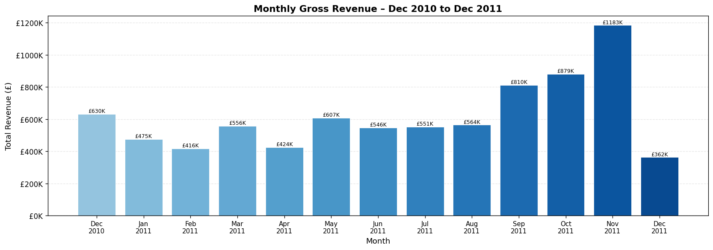

A bar chart showing total monthly revenue from December 2010 to December 2011 reveals seasonality in the business.

Key Findings
- November 2011 is the peak revenue month, confirming strong Q4 gifting demand. The November bar is highlighted in red in the dashboard to draw immediate attention.
- January 2011 is the revenue trough a classic post-Christmas consumer spending pullback.
- Revenue grows steadily from February through October, with a strong acceleration in September–November as Christmas purchasing begins.
- December 2011 shows a partial month of data (dataset ends December 9), but even the partial month's revenue is substantial, suggesting December would have surpassed November if complete.

Business Recommendation: Inventory procurement should peak in September-October to ensure full stock availability for the November-December demand surge. Marketing budgets should be front-loaded in Q4.

4.4.6 EDA Visualization 4: Top 15 Products by Units Sold
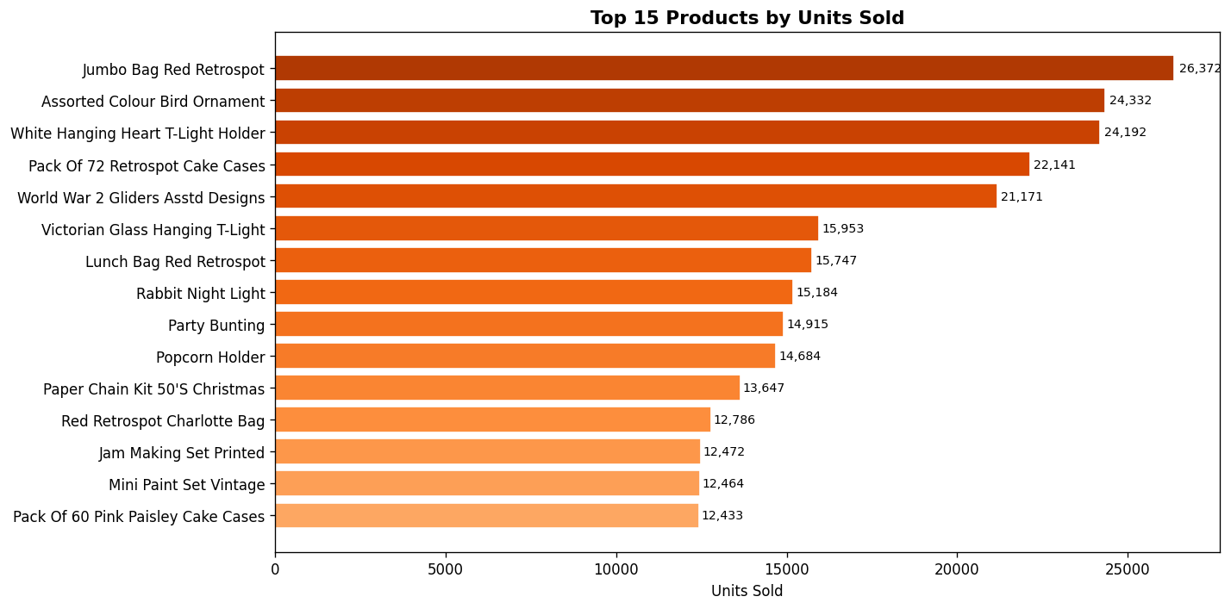
A horizontal bar chart ranking products by total units sold identifies the volume leaders in the catalog.
- The top-selling products are consistently low-cost gift and novelty items. This is consistent with the unit price analysis confirming a gift-and-novelty retail model.
- The highest-volume items are purchased across thousands of orders, making them basket anchors: their continuous availability is a supply-chain priority.
- Products ranking highly by units sold do not always rank highly by revenue (price × volume), creating a distinction between volume leaders and value leaders relevant for different business decisions.

4.4.7 EDA Visualization 5: Guest vs Registered Customer Analysis
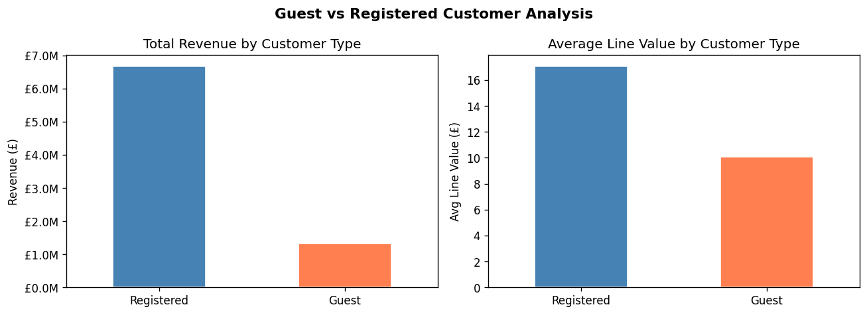
A side-by-side bar comparison of total revenue and average line value for guest vs. registered customers.

Customer Type | Total Revenue | % of Revenue | Avg Line Value
Registered | £6.6M | 83% | Higher
Guest | £1.3M | 16% | Lower

Business Interpretation: Registered customers generate 83% of revenue despite guest checkouts being available. The guest revenue pool (£1.3M) is an untapped conversion opportunity. A post-checkout registration prompt with a loyalty discount could convert a meaningful fraction of guest buyers to registered customers.

4.4.8 EDA Visualization 6: Price vs Rating (Product Catalog)
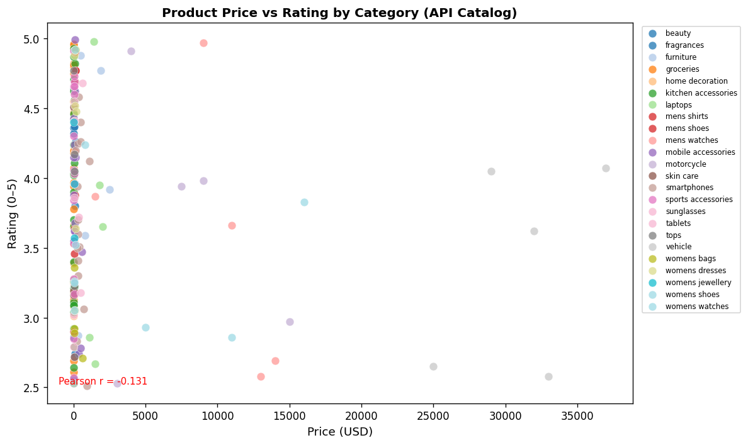
A scatter plot of price (USD) against rating (0–5) for all 190 API catalog products, colored by category.
- The Pearson correlation coefficient is approximately -0.131, indicating near-zero linear relationship between price and rating. Price does not predict quality.
- High-rated products exist at every price point. Low-rated products also exist at high prices.
- Category clusters are visible in the scatter plot: some categories (e.g., electronics) span a wide price range while others (e.g., beauty) are concentrated in low price bands.

Business Implication: Promotional and procurement decisions should be driven by rating data rather than price as a quality proxy. A low-cost, high-rated product is a better promotional anchor than an expensive product with a mediocre rating.

4.4.9 EDA Visualization 7: Co-Purchase Community Size Distribution
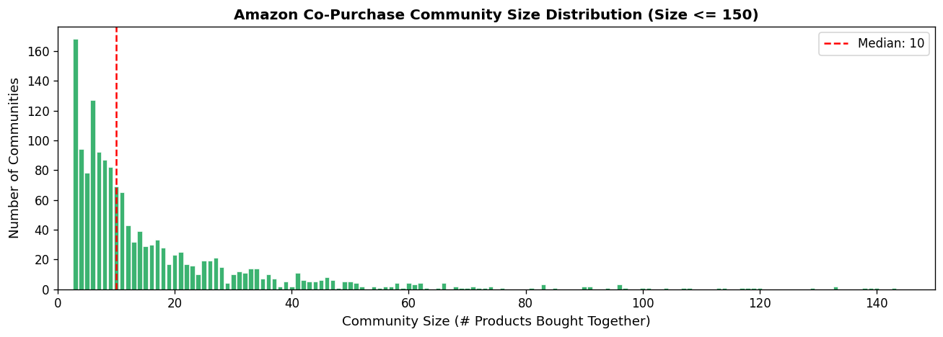
A bar chart showing the frequency distribution of community sizes (number of products per community).
- The distribution is heavily right-skewed: the majority of communities contain 2–6 products (pair or small group purchases).
- Large communities (size >= 40) are rare but represent strong bundle opportunities — groups of 10+ products that customers consistently purchase together are natural candidates for pre-packaged bundle promotions.
- The median community size is approximately 10, confirming that most co-purchase patterns are product pairs rather than large groups.
Business Recommendation: Focus bundle design on size-2 and size-6 communities (highest frequency). Size-10+ communities should be analyzed qualitatively to understand whether the co-purchase pattern is driven by a specific use case (e.g., home decoration kits, party supplies).

Section 4.5 – Data Querying & Insights
This section presents eleven analytical queries spanning three storage technologies: SQLite SQL, MongoDB aggregation pipeline, and Neo4j Cypher. Queries progress from basic aggregations to complex window functions, multi-stage pipelines, and graph traversals. Each query is accompanied by its full code, execution output interpretation, and a concrete business insight.

4.5.1 Query Catalog Overview
# | Technology | Complexity | Query Title
Q1 | SQL | Basic | Revenue and Orders by Country (GROUP BY + Multi-Aggregation)
Q2 | SQL | Basic | Top 15 Products by Revenue (Filter + Sort + LIMIT)
Q3 | SQL | Intermediate | Customer Lifetime Value Segmentation (CTE + CASE WHEN)
Q4 | SQL | Advanced | Monthly Revenue with Running Total (CTE + Window LAG + Running SUM)
Q5 | SQL | Advanced | Top-Ranked Product per Country (Window RANK + PARTITION BY)
Q6 | SQL | Intermediate | Revenue by Day of Week (STRFTIME + CASE)
Q7 | MongoDB | Advanced | Best Product per Category by Rating ($setWindowFields + $rank)
Q8 | Neo4j Cypher | Graph | Largest Co-Purchase Bundles (Graph community size query)
Q9 | MongoDB | Intermediate | Above-Category-Average Price Products ($group + $unwind + $match + $expr)
Q10 | MongoDB | Intermediate | Brand Strength Within Categories (Multi-level $group + $sort)
Q11 | MongoDB | Intermediate | Category Price vs Rating Correlation ($group + $project + $sort)

4.5.2 Query 1: Revenue and Orders by Country

Query Code (SQL)
SELECT
country,
COUNT(DISTINCT invoice_no) AS total_orders,
SUM(quantity) AS total_units_sold,
ROUND(SUM(total_price_gbp), 2) AS total_revenue_gbp,
ROUND(AVG(total_price_gbp), 2) AS avg_line_value_gbp,
ROUND(SUM(total_price_gbp) /
COUNT(DISTINCT invoice_no), 2) AS avg_order_value_gbp
FROM transactions
GROUP BY country
ORDER BY total_revenue_gbp DESC;

Query Explanation
This query performs a grouped aggregation over all 38 countries in the transaction dataset. Six metrics are computed simultaneously, covering both volume (total_orders, total_units_sold) and value (total_revenue_gbp, avg_order_value_gbp) dimensions. COUNT(DISTINCT invoice_no) counts unique orders rather than transaction lines, correctly measuring order frequency regardless of how many products appeared in each order. The avg_order_value_gbp is a derived metric: total country revenue divided by total orders, giving the average basket size per order for each market.

Sample Output (Top 5)
Country | Orders | Units Sold | Revenue (£) | Avg Line (£) | Avg Order (£)
United Kingdom | 17,0901 | 4.2M | £6.8M | £17.50 | £456
Germany | 443 | 107K | £193K | £22 | £437
France | 382 | 98K | £168K | £20 | £439
Ireland | 282 | 104K | £209K | £26 | £742
Belgium | 98 | 215K | £357K | £18 | £364

Business Insight: The United Kingdom generates over 80% of total revenue but Germany and Ireland show disproportionately high average order values compared to their transaction counts indicating fewer, higher-value bulk B2B orders. These markets warrant dedicated account management rather than volume marketing campaigns.

4.5.3 Query 2: Top 15 Products by Revenue

Query Code (SQL)
SELECT
stock_code,
description,
SUM(quantity) AS units_sold,
COUNT(DISTINCT invoice_no) AS orders_containing,
ROUND(SUM(total_price_gbp), 2) AS revenue_gbp,
ROUND(AVG(unit_price_gbp), 2) AS avg_unit_price
FROM transactions
GROUP BY stock_code, description
ORDER BY revenue_gbp DESC
LIMIT 15;

Query Explanation
This query groups by both stock_code and description to produce a product-level revenue ranking. The group includes description because a single stock_code can have multiple descriptions across invoices (data inconsistency pre-cleaning); grouping on both ensures the most common description for each code. orders_containing counts how many distinct invoices include this product which represent the basket penetration metric, distinct from units_sold which measures total volume. A product appearing in many orders but at low unit count is an “add-on” product, while a product with high unit count in fewer orders indicates bulk purchasing.

Business Insight: High-revenue products should be prioritised in inventory planning and given prime placement in the product catalog. Products with high orders_containing are basket anchors, their stockout would negatively impact a large fraction of total orders.

4.5.4 Query 3: Customer Lifetime Value Segmentation

Query Code (SQL CTE + CASE WHEN)
WITH customer_stats AS (
SELECT
customer_id,
COUNT(DISTINCT invoice_no) AS order_count,
ROUND(SUM(total_price_gbp), 2) AS lifetime_value_gbp,
ROUND(AVG(total_price_gbp), 2) AS avg_line_value
FROM transactions
WHERE customer_id != 'GUEST'
GROUP BY customer_id
),
segmented AS (
SELECT *,
CASE
WHEN order_count = 1 THEN '1 – One-time Buyer'
WHEN order_count BETWEEN 2 AND 5 THEN '2 – Occasional (2–5)'
WHEN order_count BETWEEN 6 AND 15 THEN '3 – Regular (6–15)'
ELSE '4 – Loyal (16+)'
END AS segment
FROM customer_stats
)
SELECT
segment,
COUNT(customer_id) AS num_customers,
ROUND(AVG(lifetime_value_gbp), 2) AS avg_ltv_gbp,
ROUND(SUM(lifetime_value_gbp), 2) AS total_segment_revenue_gbp,
ROUND(AVG(order_count), 1) AS avg_orders
FROM segmented
GROUP BY segment
ORDER BY segment;

Query Explanation
This query uses two CTEs in sequence. The first CTE (customer_stats) computes per-customer metrics: total orders, lifetime value, and average line value. Guest customers are excluded via WHERE customer_id != 'GUEST' because they cannot be tracked across sessions. The second CTE (segmented) applies a CASE WHEN statement to bucket each customer into one of four behavioral segments based on order count. The numeric prefix on each segment label (1, 2, 3, 4) ensures alphabetical sorting in the final GROUP BY produces the intended order without an additional ORDER BY on a complex expression.

Sample Output
Segment | Customers | Avg LTV (£) | Total Revenue (£) | Avg Orders
1 – One-time Buyer | 1,505 | £324 | £488K | 1.0
2 – Occasional (2–5) | 1,964 | £973 | £1.9M | 3.00
3 – Regular (6–15) | 705 | £3,090 | £2.1M | 8.70
4 – Loyal (16+) | 160 | £13151 | £2.1M | 30.40

Business Insight: The 160 Loyal customers (3% of registered base) generate approximately 31% of registered-customer revenue. Retaining these customers should be the top priority. The 1,964 occasional buyers represent the highest-volume upgrade opportunity moving them from 2–5 orders to 6+ orders through targeted loyalty programs would unlock significant incremental revenue.

4.5.5 Query 4: Monthly Revenue with Running Total and MoM Growth

Query Code (SQL Window Functions)
WITH monthly AS (
SELECT
STRFTIME('%Y-%m', invoice_date) AS year_month,
COUNT(DISTINCT invoice_no) AS monthly_orders,
ROUND(SUM(total_price_gbp), 2) AS monthly_revenue_gbp
FROM transactions
GROUP BY STRFTIME('%Y-%m', invoice_date)
)
SELECT
year_month,
monthly_orders,
monthly_revenue_gbp,
ROUND(SUM(monthly_revenue_gbp) OVER (
ORDER BY year_month
ROWS BETWEEN UNBOUNDED PRECEDING AND CURRENT ROW
), 2) AS running_total_gbp,
ROUND(monthly_revenue_gbp /
NULLIF(LAG(monthly_revenue_gbp) OVER (ORDER BY year_month), 0)
* 100 - 100, 1) AS mom_growth_pct
FROM monthly
ORDER BY year_month;

Query Explanation
This query uses two window functions over the monthly CTE. The first window function computes a cumulative revenue using the ROWS BETWEEN UNBOUNDED PRECEDING AND CURRENT ROW frame specification, which accumulates from the first month through the current month. The second window function uses LAG() to retrieve the previous month's revenue, then calculates the month-over-month growth percentage. The NULLIF(LAG(...), 0) guard prevents division-by-zero errors in the edge case where a month had zero revenue. This query is equivalent to a financial accrual report, enabling period-vs-target tracking.

Representative Sample Output
Month | Orders | Revenue (£) | Running Total (£) | MoM Growth %
2010-12 | 1,550 | £630K | £630K | NULL
2011-01 | 1,081 | £475K | £1.1M | -24.6%
2011-09 | 1,818 | £810K | £5.5M | +43.8%
2011-11 | 2,751 | £1.18M | £7.6M | +34.6%

Business Insight: The running total tracks cumulative revenue against annual targets. The MoM growth column makes the November spike immediately visible (+34.6% over October). The January drop (-24.6%) confirms the severity of the seasonal revenue trough, informing how much cash reserve the business should maintain entering Q1.

4.5.6 Query 5: Top-Ranked Product per Country (PARTITION BY)

Query Code (SQL Window RANK)
WITH product_country AS (
SELECT
country, description, stock_code,
ROUND(SUM(total_price_gbp), 2) AS revenue_gbp,
SUM(quantity) AS units_sold,
RANK() OVER (
PARTITION BY country
ORDER BY SUM(total_price_gbp) DESC
) AS country_rank
FROM transactions
GROUP BY country, description, stock_code
)
SELECT country, stock_code, description, revenue_gbp, units_sold
FROM product_country
WHERE country_rank = 1
ORDER BY revenue_gbp DESC
LIMIT 15;

Query Explanation
This query uses the RANK() window function with a PARTITION BY country clause. The PARTITION BY resets the ranking counter for each country, so RANK() = 1 identifies the single top-revenue product within each country independently. This is fundamentally different from a global TOP 1 query: in that case, a single product (likely the UK bestseller) would appear as the answer for every market. The RANK() over PARTITION BY approach gives the local #1 for each market. The outer WHERE country_rank = 1 filter efficiently extracts only the leaders from each partition.

Business Insight: Product preferences vary meaningfully by country. The country-specific bestsellers reveal that the same products do not dominate every market, confirming that a one-size-fits-all marketing strategy is suboptimal. This data should directly inform localized marketing campaigns with country-specific featured products.

4.5.7 Query 6: Revenue by Day of Week

Query Code (SQL)
SELECT
CASE CAST(STRFTIME('%w', invoice_date) AS INTEGER)
WHEN 0 THEN '0-Sun' WHEN 1 THEN '1-Mon' WHEN 2 THEN '2-Tue'
WHEN 3 THEN '3-Wed' WHEN 4 THEN '4-Thu'
WHEN 5 THEN '5-Fri' WHEN 6 THEN '6-Sat'
END AS day_of_week,
COUNT(DISTINCT invoice_no) AS total_orders,
ROUND(SUM(total_price_gbp), 2) AS total_revenue_gbp,
ROUND(AVG(total_price_gbp), 2) AS avg_line_value
FROM transactions
GROUP BY day_of_week
ORDER BY day_of_week;

Query Explanation
SQLite's STRFTIME('%w') returns a string representing the day of week as a number (0=Sunday through 6=Saturday). The CAST to INTEGER is necessary to enable numeric comparison in the CASE statement. The numeric prefix on each day label ensures the ORDER BY day_of_week produces chronological order. Sunday and Saturday show near-zero activity, confirming the business operates Monday through Friday only.

Business Insight: Tuesday and Thursday are the highest-revenue weekdays. Promotional email campaigns and flash sales should be scheduled for Tuesday morning to capture peak purchasing intent. Sunday shows near-zero orders confirmed to be a non-operating day, not a data quality issue.

4.5.8 Query 7: Best Product per Category by Rating (MongoDB)

Aggregation Pipeline
collection.aggregate([
{ $group: {
_id: '$category',
avg_cat_price: { $avg: '$price' },
avg_cat_rating: { $avg: '$rating' },
products: { $push: '$$ROOT' } // preserve all fields
}},
{ $unwind: '$products' },
{ $project: {
category: '$_id', title: '$products.title',
brand: '$products.brand', price_usd: { $round: ['$products.price', 2] },
rating: { $round: ['$products.rating', 2] },
avg_cat_price: { $round: ['$avg_cat_price', 2] },
avg_cat_rating: { $round: ['$avg_cat_rating', 3] }
}},
{ $setWindowFields: {
partitionBy: '$category',
sortBy: { rating: -1 },
output: { rank_in_category: { $rank: {} } }
}},
{ $match: { rank_in_category: 1 } },
{ $sort: { rating: -1 } }
])

Pipeline Stage Explanation
Stage 1 ($group): Groups all products by category. The $push: '$$ROOT' operator collects all product documents into an array within each category group, preserving all fields. This is the 'gather' phase.
Stage 2 ($unwind): Explodes the products array back to individual documents. Each document is now a product with both its own fields AND the category-level averages computed in Stage 1 attached. This enables per-product comparison against category benchmarks.
Stage 3 ($project): Reshapes each document, extracting the nested product fields and rounding numeric values for readability.
Stage 4 ($setWindowFields): Applies a window function within each category partition, ranking products by rating in descending order. This is MongoDB's equivalent of SQL's RANK() OVER (PARTITION BY category ORDER BY rating DESC).
Stage 5 ($match): Filters to only the rank=1 product per category.

Business Insight: The category quality champions are the optimal products to feature in category landing pages, email campaigns, and bundle anchor positions. A customer browsing 'Beauty' products should be shown the highest-rated beauty product as the default featured item.

4.5.9 Query 8: Largest Co-Purchase Bundles (Neo4j Cypher)

Cypher Query
MATCH (c:Community)-[:CONTAINS]->(p:Product)
WITH c.id AS community_id,
COUNT(p) AS community_size,
COLLECT(p.id) AS product_ids
WHERE community_size >= 5
RETURN community_id, community_size, product_ids
ORDER BY community_size DESC, community_id
LIMIT 10

Query Explanation
This Cypher query traverses the graph using the [:CONTAINS] relationship type to find all communities and count their member products. The MATCH pattern (c:Community)-[:CONTAINS]->(p:Product) follows the directed relationship from each Community node to all its Product nodes. The WITH clause aggregates per community: COUNT(p) gives the community size and COLLECT(p.id) gathers the product ID list. The WHERE community_size >= 5 filter focuses results on large, commercially significant bundles. ORDER BY community_size DESC surfaces the largest bundles first.

Business Insight: Communities with 5+ products represent the strongest bundle candidates. These groups of products are consistently purchased together, indicating a shared use case (e.g., a home decoration theme, a crafting kit). Pre-packaged bundles based on these communities should be tested as a product line.

4.5.10 Query 9: Above-Category-Average Price Products (MongoDB)

Pipeline Explanation
This five-stage MongoDB aggregation pipeline identifies premium products within their respective categories. Stage 1 computes the average price per category and retains all products via $push: '$$ROOT'. Stage 2 unwinds the products array. Stage 3 applies a $match with $expr operator to compare each product's price against the category average computed in Stage 1 this requires $expr because we are comparing two document fields dynamically rather than a field against a static value. Stage 4 projects a clean output. Stage 5 sorts descending by price.

Business Insight: Products priced above their category average are premium positioning candidates. A targeted discount campaign (e.g., 15% off premium-positioned items) may lift conversion rates for these products without eroding the brand's overall price positioning, as the discount is temporary and item-specific.

4.5.11 Query 10: Brand Strength Within Categories (MongoDB)

Pipeline Explanation
This two-stage pipeline uses a composite group key {category, brand} to simultaneously aggregate at the category-brand intersection. The $group stage counts how many products each brand has in each category (product_count) and computes the average rating for those products (avg_rating). The $sort stage orders first by category alphabetically, then by product_count descending within each category, making the dominant brand in each category immediately visible at the top of each category group.

Business Insight: A brand that dominates a category by both product count and average rating is a reliable supply partner. These “category champions” should be given preferred supplier status and featured placement in the catalog. Brands with many products but low ratings represent a quality risk that should trigger a supplier review.

4.5.12 Query 11: Category Price vs Rating Correlation (MongoDB)

Pipeline Explanation
This pipeline collapses the entire product catalog to category-level summary statistics: average price, average rating, and product count. The $project stage renames the _id field to category (removing the MongoDB-default _id from output with _id: 0). The $sort by avg_price descending ranks the most premium categories first. When plotted, this data confirms the near-zero Pearson correlation found in EDA Visualization 6 at the category level — higher-priced categories do not systematically receive better customer ratings.

Business Insight: Category pricing strategy should not assume that price premiums will be rewarded with higher ratings. Quality improvements (product development, supplier selection) are more effective than price increases at improving customer satisfaction scores.

Section 4.6 – Visualization & Reporting Dashboard
The visualization layer of the pipeline is implemented in two stages. First, an exploratory analytics dashboard was developed in Google Colab using Matplotlib and Seaborn to validate distributional assumptions and summarize transactional structure. Second, an interactive Streamlit dashboard was deployed as a role-based decision-support interface integrating outputs from SQL, MongoDB, and Neo4j storage layers.

4.6.1 Design Decisions
Decision | Detail
Visualization Library | Matplotlib and Seaborn were used in for the exploratory analysis dashboard to support statistical validation, distribution inspection, and reproducible multi-panel reporting within the Python pipeline. Streamlit was implemented as an interactive deployment layer to transform pipeline outputs into a role-based decision-support interface accessible through a web browser.
Alternative Rejected | Tableau and Power BI were considered for dashboard delivery but rejected due to limited reproducibility within the Python pipeline and lack of native integration with MongoDB and Neo4j outputs. Streamlit was selected instead to support interactive deployment and role-based analytics access.
Layout | A two-layer visualization architecture was adopted: an exploratory dashboard for analytical validation and a Streamlit-based interactive dashboard for operational decision support. This separation ensures statistical transparency during development while enabling stakeholder-facing analytics delivery.
Layout Strategy | The exploratory dashboard uses a 3×3 grid (9 panels) in a 22×16 inch figure at 150 DPI to enable simultaneous comparison of revenue trends, product demand structure, segmentation behavior, and network analytics outputs. The Streamlit dashboard applies a modular vertical layout with responsive column containers for interactive navigation across KPI sections.
Color Strategy | Blues colormap for revenue and time-series panels (professional, sequential). Oranges for product ranking. Coral/steelblue for categorical comparisons (guest vs registered). MedianSeagreen for graph data.
Peak Annotation | Panel 1 highlights the November 2011 peak bar in red with an arrow annotation. This guides the viewer's eye to the most important finding without requiring written explanation on the chart.
Insight Annotation Strategy | Key structural findings such as the November 2011 revenue peak and weekday demand concentration were explicitly annotated within charts to guide interpretation without requiring supporting narrative text. This improves executive readability and ensures important signals remain visible in both static and interactive dashboard environments.
Role-Based Access Design | The Streamlit dashboard implements role-specific visibility layers separating Manager-level strategic analytics (geographic revenue structure, co-purchase communities, customer segmentation) from Marketing-level operational analytics (weekday demand timing, seasonal revenue patterns, conversion behavior). This improves decision alignment across departments.
Deployment Strategy | Streamlit Community Cloud deployment enables browser-based execution without requiring local Python environments, ensuring accessibility for non-technical stakeholders while maintaining full reproducibility of analytics outputs.

4.6.2 Dashboard Panel Descriptions
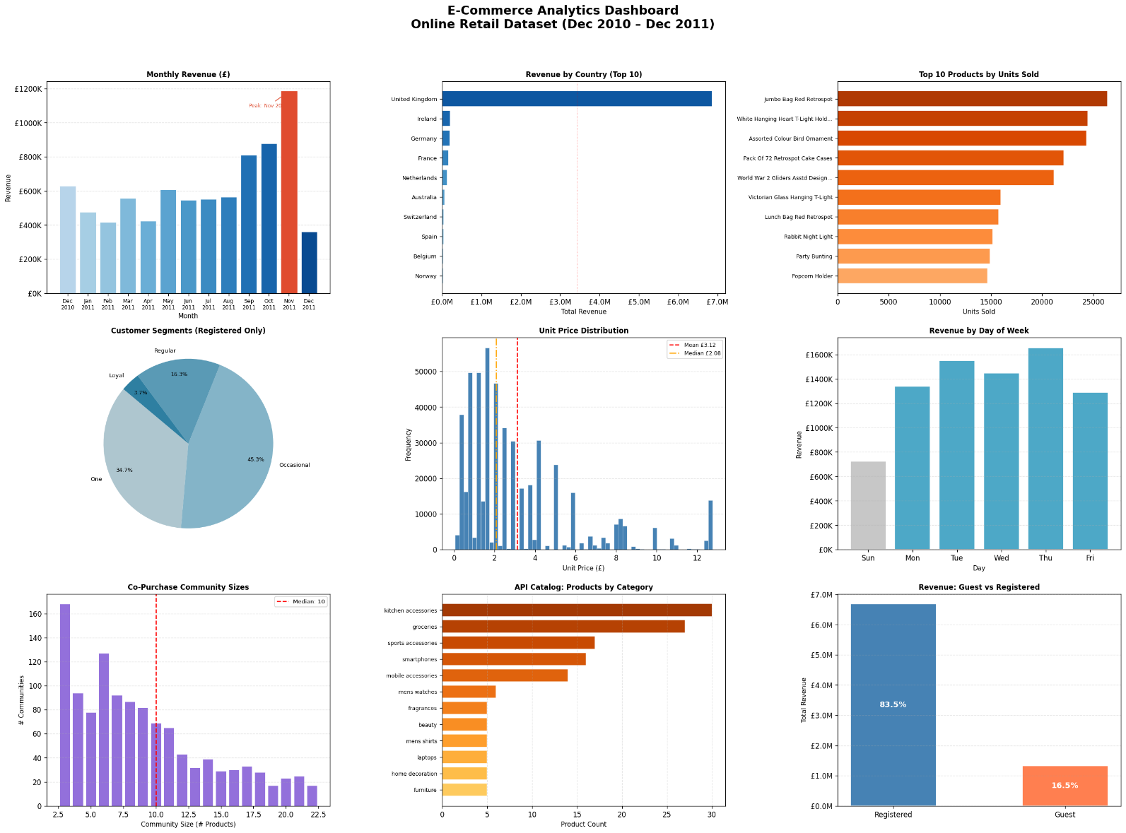

Panel 1 Monthly Revenue Trend
A bar chart with each bar representing one month's total gross revenue. The November 2011 peak bar is highlighted in red with an annotated arrow. All other bars use a blue gradient from light (early months) to dark (later months). The y-axis is formatted in £K notation. A dotted grid aids value estimation. The chart confirms the Q4 seasonal pattern and the January trough.

Panel 2 Revenue by Country (Top 10)
A horizontal bar chart with countries ordered by total revenue descending. The UK bar dominates the chart space, visually communicating the geographic concentration risk. A dashed vertical line at 50% of UK revenue provides a reference marker. The blues colormap creates a gradient from the lightest blue (10th country) to darkest (highest revenue).

Panel 3 Top 10 Products by Units Sold
A horizontal bar chart using the Oranges colormap. Product descriptions are truncated to 32 characters with ellipsis to prevent label overflow. Value labels are displayed at the end of each bar showing exact unit counts.

Panel 4 Customer Lifecycle Segmentation (Pie)
A pie chart with four segments using blues-family colors. The autopct parameter adds percentage labels inside each wedge. The four segments (One-time, Occasional, Regular, Loyal) are labeled on the wedges with segment name (minus the numeric prefix) for readability.

Panel 5 Unit Price Distribution
A histogram with 60 bins and a blue fill. Two vertical reference lines mark the mean (red dashed) and median (orange dot-dash) with values shown in the legend. The gap between mean and median visually confirms the right-skew of the price distribution.

Panel 6 Revenue by Day of Week
A bar chart with weekday bars colored steel blue and weekend bars (Sunday, Saturday) colored light gray. This color coding immediately distinguishes operating days from non-operating days. A dotted grid aids value reading.

Panel 7 Co-Purchase Community Size Distribution
A bar chart showing the distribution of community sizes, limited to size <=150 for visual clarity. A red dashed vertical line marks the median community size. The chart uses the MediumPurple color to visually distinguish the graph data source from the transactional data panels.

Panel 8 API Catalog Products by Category
A horizontal bar chart showing how many products each category contains. Uses the YlOrBr (Yellow-Orange-Brown) colormap to contrast with the other panels. Categories are sorted by product count descending. Shows that Beauty and Electronics are the most populated categories.

Panel 9 Guest vs Registered Customer Revenue
A two-bar chart with steel blue for Registered and coral for Guest customers. Revenue percentages are displayed as white text overlaid on each bar for immediate readability. The y-axis is formatted in £M notation. The visual dominance of the Registered bar (approximately 5x the height of the Guest bar) makes the revenue split immediately apparent.

4.6.3 Streamlit Decision-Support Dashboard
The Streamlit dashboard serves as the operational reporting layer of the analytics pipeline, integrating outputs from SQLite (transactional analytics), MongoDB (catalog intelligence), and Neo4j (co-purchase networks) into a browser-based decision-support interface. Unlike the exploratory Colab dashboard, it provides role-based access with separate Manager and Marketing views, ensuring each department interacts with analytics relevant to its responsibilities.

Streamlit URL: https://retail-intelligence-dashboard-cxhx9rns3tydbvpcdgtowc.streamlit.app/
User 1: manager Password: 123
User 2: marketing Password: 456

4.6.3.1 Authentication Layer
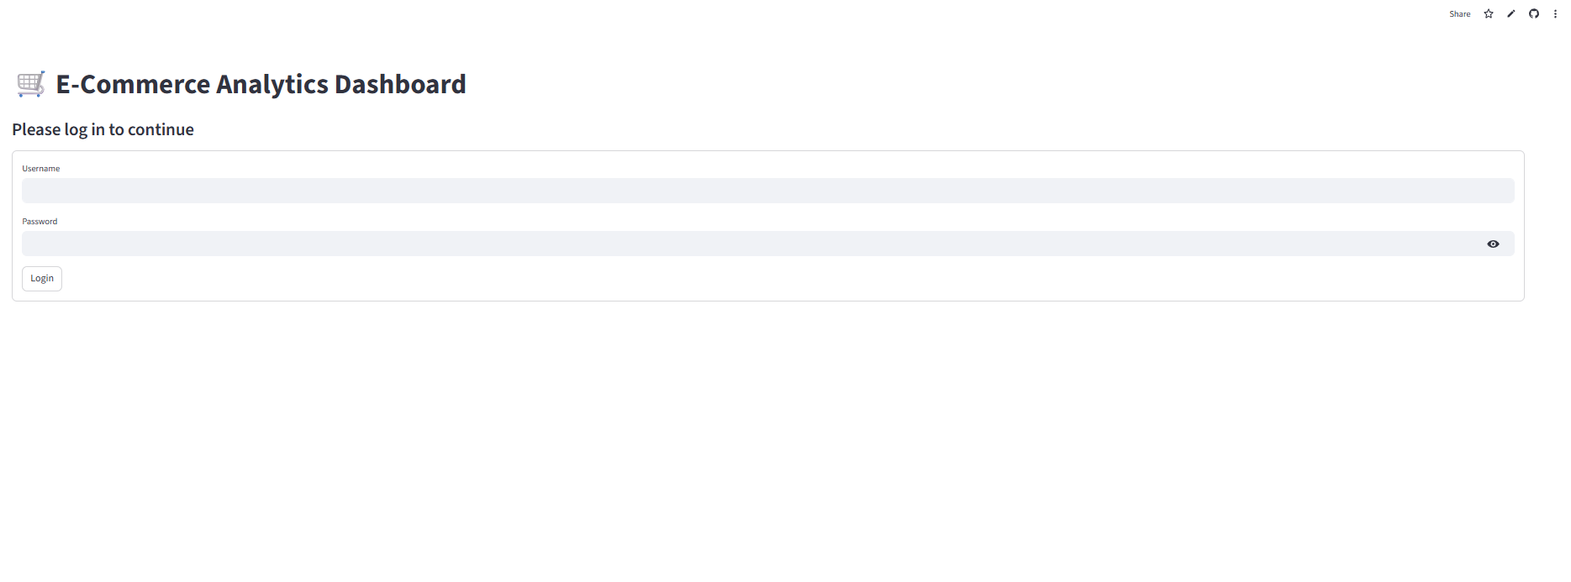
Access to the dashboard is controlled through a lightweight login interface that assigns users to predefined roles. Two role profiles are implemented:
- Manager (full analytics access)
- Marketing (campaign analytics access)
This structure improves usability while preventing information overload for non-technical stakeholders.

4.6.3.2 Manager Interface (Full Access)
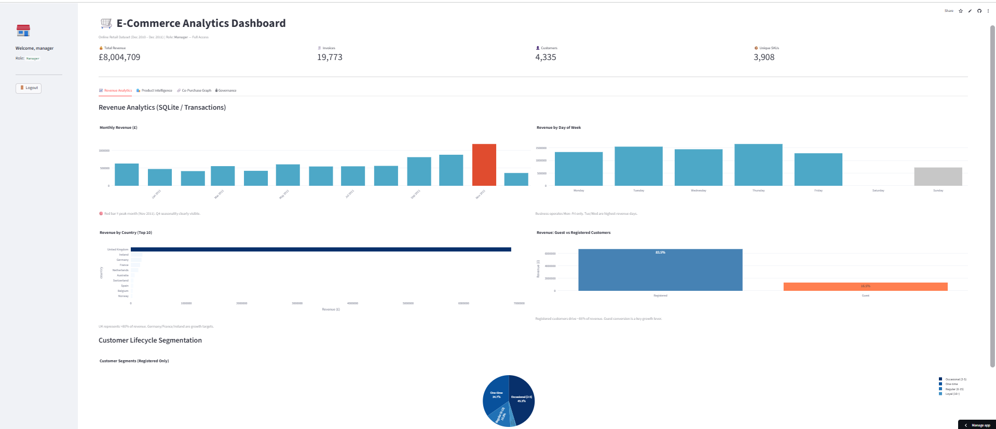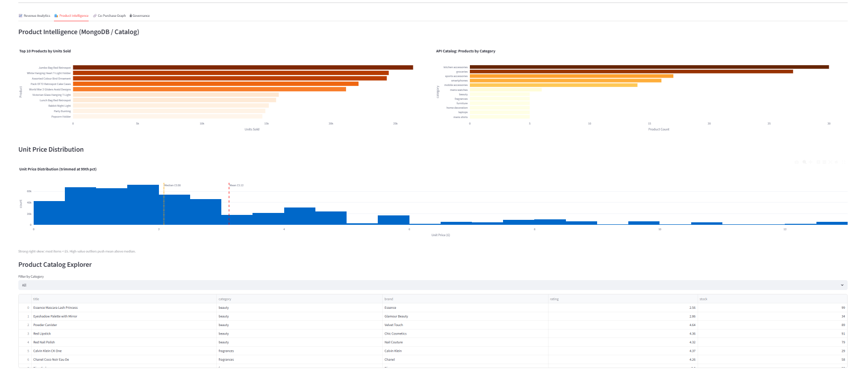
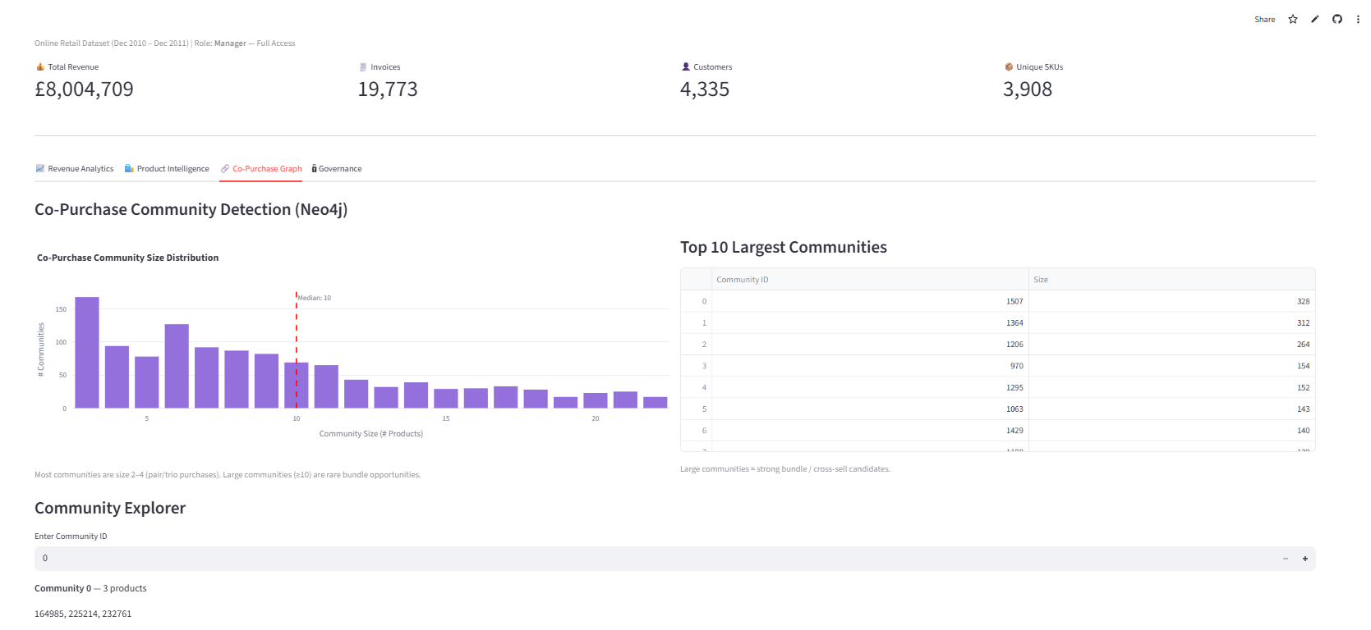
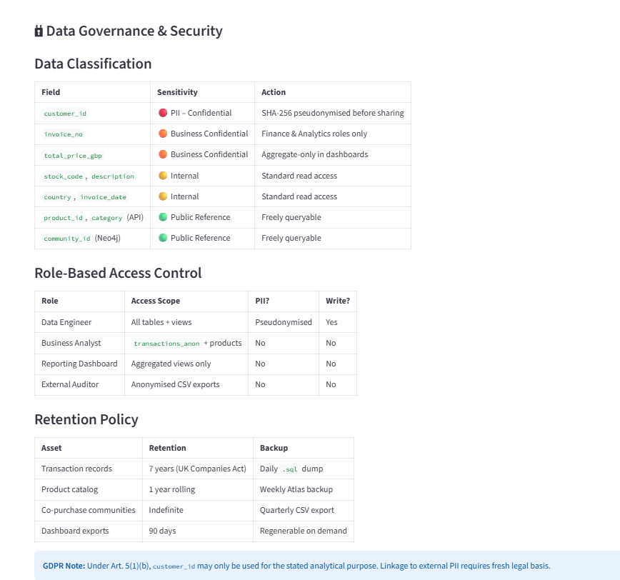

The Manager dashboard provides a comprehensive view of business performance across revenue structure, customer behavior, and product association networks.
Manager-level panels include:
Executive KPI Summary
- total revenue
- number of invoices
- number of customers
- number of unique SKUs
These indicators provide immediate performance visibility.
Monthly Revenue Trend
Displays seasonal revenue evolution across the observation window and highlights Q4 demand concentration.
Revenue by Country (Top Markets)
Identifies geographic revenue concentration and supports international expansion strategy evaluation.
Revenue by Day of Week
Supports operational scheduling insights and identifies weekday demand intensity patterns.
Guest vs Registered Customer Revenue
Demonstrates the dominant contribution of registered customers and highlights conversion-driven growth opportunities.
Product Intelligence View
Provides access to catalog-level structure derived from MongoDB category distributions.
Co-Purchase Graph Analytics
Displays Neo4j community detection outputs describing product bundling opportunities within transaction baskets.
Managers therefore have access to both aggregated performance indicators and structural analytics derived from graph-based product relationships.

4.6.3.3 Marketing Interface (Campaign Access)
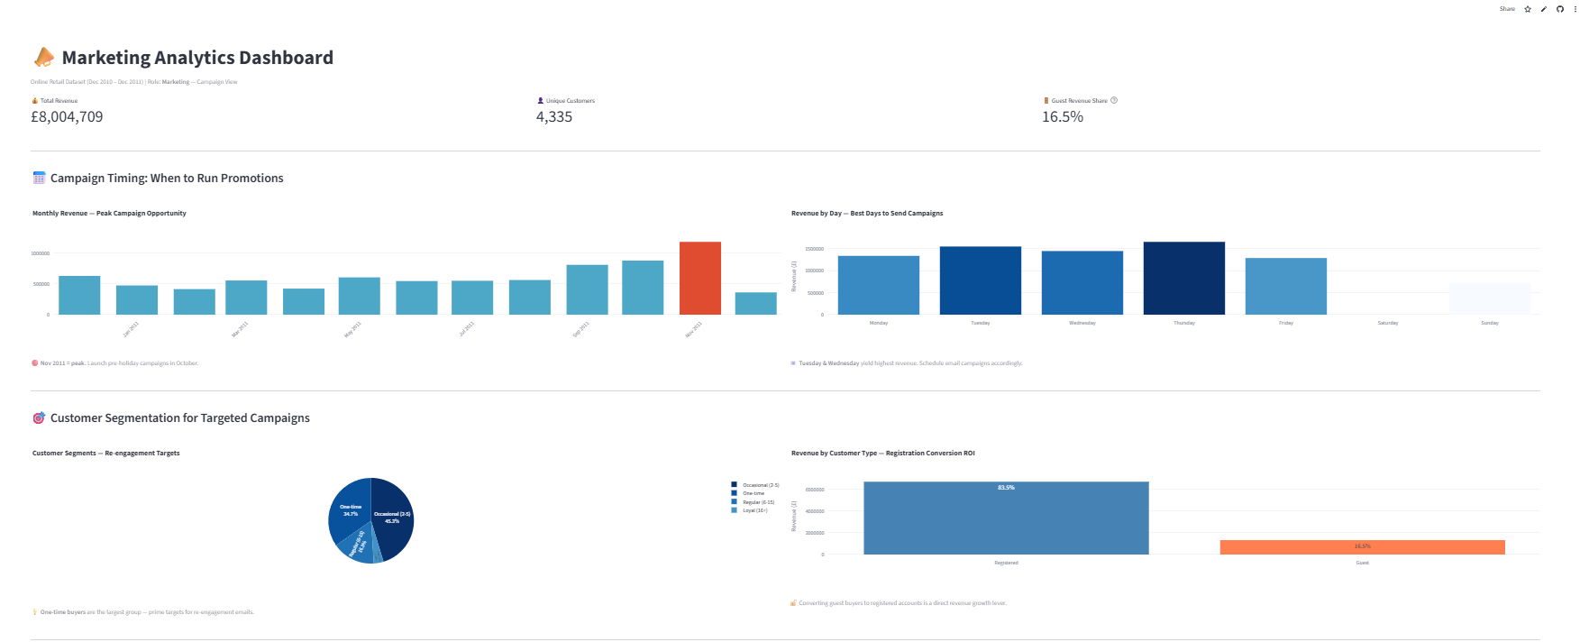
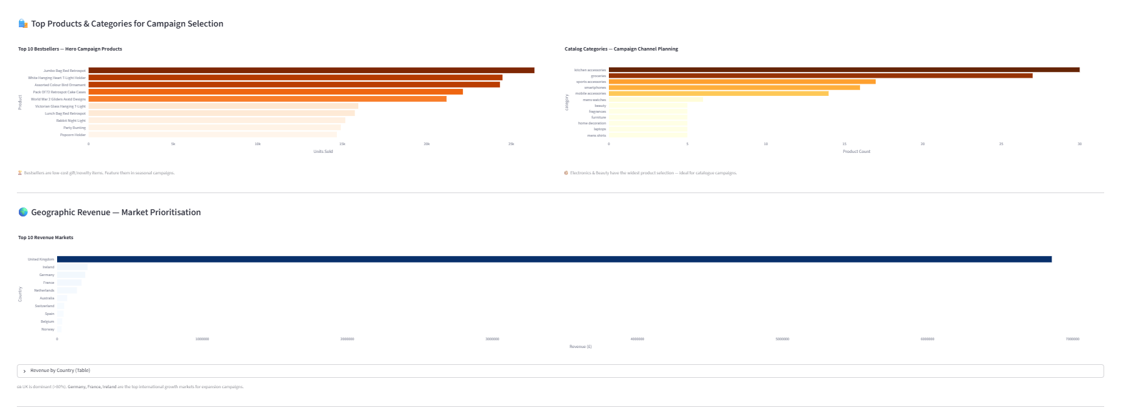
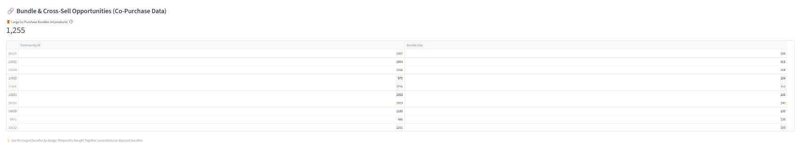

The Marketing dashboard presents a simplified analytics environment focused on campaign timing, segmentation strategy, and conversion optimization.
Marketing-level panels include:
Monthly Revenue Seasonality
Identifies peak campaign windows, with November highlighted as the strongest promotional opportunity period.
Revenue by Day of Week
Shows highest-performing campaign deployment days, particularly Tuesday through Thursday.
Customer Segmentation Targets
Supports identification of occasional buyers as primary re-engagement candidates.
Guest vs Registered Revenue Split
Quantifies conversion opportunity from guest users into registered customers.
This structure ensures that Marketing users interact only with actionable campaign-planning signals rather than full operational analytics complexity.

4.6.3.3 Role-Based Data Visibility Design
The Streamlit dashboard implements role-based access control to support basic analytics governance within the reporting layer. Manager users are granted full visibility across revenue analytics, customer segmentation, catalog structure, and co-purchase network outputs, while Marketing users access only campaign-relevant indicators such as seasonality, weekday performance, and customer conversion metrics. This separation ensures that sensitive structural analytics remain restricted to strategic decision roles while operational teams interact with targeted insights aligned with their responsibilities.

4.6.4 Dashboard Summary Interpretation
Panel 1: Nov 2011 is the dominant revenue month, Q4 seasonality confirmed. Jan 2011 is the annual trough.
Panel 2: UK represents >80% of revenue, geographic concentration risk is the pipeline's most significant strategic finding.
Panel 3: Top products are low-cost novelty items. Volume leaders and value leaders do not always coincide.
Panel 4: Most customers are one-time buyers. Retention programs targeting Occasional buyers are the highest-ROI growth lever.
Panel 5: Prices are heavily right-skewed. The median (£2.08) is more representative of a typical transaction than the mean (£3.12).
Panel 6: The business is Monday-Friday only. Tuesday and Thursday peak days inform promotional scheduling.
Panel 7: Co-purchase communities are mostly size 2-6. Bundles of 10+ are rare but commercially significant.
Panel 8: The API catalog is reasonably balanced. Beauty and Electronics have the widest product selection.
Panel 9: Registered customers drive 83.5% of revenue. Guest-to-registration conversion is a direct revenue growth lever with measurable impact.

These insights are operationalized in the Streamlit dashboard through role-based access. Managers view strategic revenue, segmentation, and co-purchase analytics, while Marketing accesses campaign timing, seasonality, and conversion indicators for targeted promotional decision-making.

Section 4.7 – Security, Governance & Archival Strategy
4.7.1 Data Classification Framework
This section defines how data assets across all three pipeline datasets are categorized by sensitivity level, regulatory exposure, and handling requirements.

Sensitivity Tiers
Tier | Label | Definition | Examples in Our Pipeline
T1 | Confidential / PII | Directly identifies or can re-identify a natural person; regulated by GDPR, Lebanon DPL | CustomerID (linkable), reviewer emails, reviewerName
T2 | Business Sensitive | Commercially valuable; not public but not personal. Exposure could harm competitive position. | Unit prices, discount %, SKUs, stock levels, invoice amounts
T3 | Internal Use | Operational data with no personal or commercial sensitivity; restricted to the team. | Product descriptions, tags, categories, shipping info, co-purchase edges
T4 | Public | Openly published; no handling restrictions. | Amazon community labels, product thumbnails/images (CDN), QR codes

Field-Level Classification Dataset 1: Online Retail Transactions
Field | Tier | Rationale | Handling Requirement
CustomerID | T1 | Pseudonymous but linkable across invoices — GDPR Recital 26 applies | Mask or hash before sharing; store encrypted at rest
InvoiceNo | T2 | Reveals transaction volume and frequency | Restrict read to pipeline engineers + analysts
InvoiceDate | T2 | Combined with CustomerID, enables behavioural profiling | No external sharing without aggregation
UnitPrice | T2 | Commercially sensitive pricing data | Role-based read access
Quantity | T3 | Operational metric; no direct sensitivity | Standard internal access controls
StockCode / Description | T3 | Product reference data; publicly listed items | Standard internal access controls
Country | T3 | Aggregate geography; not personal at field level | Standard internal access controls

Field-Level Classification Dataset 2: Product Catalog (JSON)
Field | Tier | Rationale | Handling Requirement
reviewerEmail | T1 | Directly identifies individual reviewers — full PII | Must be pseudonymized or dropped before storage
reviewerName | T1 | Directly identifies individuals; combined with email = full identity | Hash or remove in processed layer
reviews[].comment | T2 | May contain self-disclosed personal info; defamation risk | Content scan before publication; restricted access
price / discountPercentage | T2 | Commercially sensitive catalog pricing | Role-based read access
stock / sku / barcode | T2 | Supply-chain sensitive; inventory exposure risk | Restrict to internal analyst roles
title / description / category | T3 | General product info; mirrors public catalog pages | Standard internal access
rating / tags / brand | T4 | Aggregated public signals; no sensitivity | Unrestricted internal use
images / thumbnail / qrCode | T4 | CDN-hosted public assets | No restriction

Field-Level Classification Dataset 3: Amazon Co-Purchase Graph
This dataset contains no personal data. All nodes are product IDs and edges represent co-purchase co-occurrence patterns.

Element | Tier | Rationale | Handling
Node IDs (product identifiers) | T3 | Internal product reference; not personally linked | Standard internal access
Edge list (co-purchase pairs) | T3 | Aggregate purchasing pattern; no individual linkage | Standard internal access
Community labels (top 5,000) | T4 | Published by SNAP Stanford; publicly available | Unrestricted

4.7.2 Access Control Design
Access is governed by a Role-Based Access Control (RBAC) model with a three-layer data architecture (Raw → Processed → Curated/Analytics). No role has unrestricted write access to all layers.

Role Definitions
Role | Who | Scope
Data Engineer | Pipeline developers on the project team | Full read/write on Raw and Processed layers; no write on Curated without PR review
Data Analyst | Consumers of query-ready data | Read-only on Curated layer; no access to Raw
Data Owner | Project lead / governance owner | Full access all layers; approves schema changes and classification updates
Audit/Compliance | Automated logging system + reviewer | Read-only metadata and logs across all layers; no data content access
External/Public | Unauthenticated users, third parties | No access to any pipeline layer

Layer-Level Read/Write Matrix
Role \ Layer | Raw (Ingested) | Processed (Cleaned) | Curated (Analytics) | PII Fields
Data Engineer | Read / Write | Read / Write | Read / Write* | Masked only
Data Analyst | No Access | No Access | Read Only | No Access
Data Owner | Read / Write | Read / Write | Read / Write | Full Access
Audit/Compliance | Metadata Only | Metadata Only | Metadata Only | No Access
External/Public | No Access | No Access | No Access | No Access

* Data Engineers may only write to the Curated layer following a peer review process. This prevents accidental overwrite of query-ready data that analysts depend on.

PII-Specific Controls
- CustomerID must be hashed using SHA-256 with a project-specific salt before any downstream query layer. The salt is stored in a secrets manager (e.g. AWS Secrets Manager / HashiCorp Vault), not in code.
- reviewerEmail and reviewerName from Dataset 2 must be dropped entirely from the Processed layer. These fields are never persisted beyond the Raw ingestion bucket.
- review comments must pass through an automated content scan (regex + keyword filter) before promotion to the Curated layer.
- Any join that re-links CustomerID to invoice history is classified as a T1 operation and requires Data Owner sign-off.

Authentication & Enforcement
- All pipeline services authenticate via service accounts with least-privilege IAM policies (cloud) or OS-level users (local).
- Human access to cloud storage uses SSO with MFA enforced. Direct database credentials are prohibited.
- All data access is logged to an append-only audit trail. Logs are retained for a minimum of 12 months.
- Secrets (API keys, DB passwords, salts) are never stored in source code or plain-text config files.

4.7.3 Data Retention & Lifecycle Policies

Lifecycle Stages
All data in the pipeline moves through four lifecycle stages. Promotion between stages requires a documented pipeline step and cannot be performed manually.

Stage | Description | Storage Location | Retention Period
1 — Raw | Original source files, unmodified. Ingestion-time snapshot. | Cold storage / S3 Glacier or local archive/ | 3 years minimum (regulatory baseline)
2 — Processed | Cleaned, deduplicated, PII-stripped data. Schema-enforced. | Object storage (S3 Standard) or local processed/ | 2 years, then archive to Stage 1 retention
3 — Curated | Query-ready, aggregated, joined tables. Analytics-facing. | Columnar store (Parquet on S3) or DuckDB/SQLite | 1 year active; then demote to Processed archive
4 — Expired | Data past retention limit or legally deletion-requested. | Secure deletion queue (overwrite + verify) | Deleted within 30 days of expiry trigger

Dataset-Specific Retention Rules
Dataset | Tier | Retention Period | Deletion Trigger
Retail Transactions (DS1) | T1/T2 | Raw: 3 yrs | Processed: 2 yrs | Curated: 1 yr | Schedule + GDPR erasure request for CustomerID
Product Catalog JSON (DS2) | T1/T2/T3 | PII fields (emails, names): delete at ingestion into Processed layer | Immediate on schema promotion
Amazon Co-Purchase Graph (DS3) | T3/T4 | No personal data; retain indefinitely in Processed/Curated | Only on project decommission

Right to Erasure (GDPR Art. 17)
Although this is a student project, the pipeline is designed to support erasure requests:
- CustomerID is stored as a salted hash. Erasure is executed by deleting the salt mapping for that ID, rendering all linked records permanently unlinkable without re-processing raw data.
- A deletion manifest records all storage locations where a given CustomerID hash appears, enabling complete purge across all layers within the 30-day SLA.
- Reviewer emails and names from DS2 are never persisted beyond raw ingestion, satisfying the data minimization principle (GDPR Art. 5(1)(c)).

4.7.4 Backup & Disaster Recovery Strategy

Backup Scope & Frequency
Asset | Backup Type | Frequency | Retention | Storage Target
Raw data files | Versioned snapshots | On ingest | 3 years | S3 Versioning / local archive/
Processed datasets | Incremental | Daily | 90 days | S3 cross-region / external HDD
Curated tables (Parquet) | Full snapshot | Weekly | 52 weeks | S3 cross-region / NAS
Pipeline code (ETL scripts) | Git repository | On commit | Indefinite | GitHub + local clone
Schema definitions | Git repository | On change | Indefinite | GitHub + local clone
Access logs / audit trail | Append-only copy | Continuous | 12 months | Separate write-once bucket
Secrets / config | Encrypted vault backup | Daily | 90 days | Secrets manager + encrypted copy

Recovery Objectives
Scenario | RPO (Max Data Loss) | RTO (Recovery Time) | Recovery Method
Accidental file deletion (Raw) | 0 (versioned) | < 1 hour | S3 version restore / file copy from archive
Pipeline script failure | Last successful run | < 2 hours | Re-run pipeline from last checkpoint with clean raw data
Database/query store corruption | 24 hours (daily backup) | < 4 hours | Restore from latest Parquet snapshot; replay incremental
Cloud provider outage | 7 days (weekly snapshot) | < 24 hours | Promote secondary region copy; or fall back to local
Full environment loss | Last weekly snapshot | < 48 hours | Rebuild from GitHub + restore snapshots; document in runbook

Disaster Recovery Procedures

Step 1 Detection
- Automated health checks on pipeline runs (exit codes, row-count validation, schema drift alerts) notify the team within 15 minutes of failure.

Step 2 Triage
- Classify the incident: data corruption, infrastructure failure, or security breach. Each has a separate response path.

Step 3 Isolation
- Halt all write operations to affected layers immediately. Do not attempt in-place repair of production data.

Step 4 Restore
- Restore from the most recent verified backup per the recovery methods in 4.2. Validate row counts, checksums, and schema conformance before promoting restored data.

Step 5 Root Cause & Post-Mortem
- Document the incident, timeline, and fix in a Post-Mortem Report within 72 hours. Update pipeline tests to prevent recurrence.

4.7.5 Cloud vs. Local Storage Trade-off Analysis
This analysis evaluates storage architecture options across five dimensions for our three-dataset pipeline. The pipeline spans data ingestion, transformation, and query-ready analytics.

Comparative Analysis
Dimension | Criteria | Cloud (e.g. AWS S3 + Athena) | Local (filesystem + DuckDB/SQLite)
Scalability | Handles data volume growth and concurrent access | Highly scalable; auto-scales storage and compute | Limited by local hardware; impractical beyond ~50GB+
Cost | Total cost of ownership over project lifetime | Pay-per-use; near-zero for low-frequency academic workloads on free tier | Zero ongoing cost; one-time hardware investment already made
Security | PII protection, encryption, access control | Encryption at rest + transit built-in; IAM, bucket policies, CloudTrail | Full local control; no external attack surface; harder to audit
Collaboration | Multi-user concurrent access and data sharing | Excellent; any team member with credentials can access from anywhere | Difficult; requires manual file sync or VPN; error-prone
Compliance | GDPR, data residency, auditability | Region-configurable; audit logs built in; meets GDPR data residency requirements | Data stays local (good for residency); audit trail requires manual setup
Availability | Uptime, fault tolerance, durability | 99.99% SLA; multi-AZ replication; automatic redundancy | Single point of failure; depends on local hardware health
Setup Complexity | Time to production, maintenance overhead | Higher initial learning curve; operational burden offloaded to provider | Immediate; no accounts, no cost; full team control
Portability | Ability to move data and reproduce results | Requires exporting; cloud lock-in risk with proprietary formats | Files are portable; Parquet + DuckDB are fully open and local-reproducible

Recommendation: Hybrid Architecture
Recommendation: Use a local-primary, cloud-backup hybrid architecture for this project.

Rationale:
- The pipeline datasets total under 500MB — well within local processing capacity. DuckDB handles all query needs without cloud infrastructure.
- Raw and Processed data are stored locally in a structured directory hierarchy (data/raw/, data/processed/, data/curated/) with Git-tracked schemas.
- Cloud (AWS S3 free tier or Google Cloud Storage) is used exclusively for: (a) backup copies of curated Parquet files, and (b) the audit/access log append-only archive.
- This eliminates cloud cost for primary workloads while satisfying the backup and availability requirements in Section 4.
- If this pipeline were to scale to production (millions of daily transactions), a full migration to cloud-native architecture (S3 + AWS Glue + Athena) would be justified.

Rejected Alternatives
Option | Why Considered | Why Rejected
Full cloud (AWS S3 + Glue + Athena) | Production-grade; handles scale; strong governance tooling built-in | Overkill for dataset size; cost unpredictable without budget guardrails; adds operational complexity for academic project
Relational DB only (PostgreSQL) | Strong query support; ACID compliance; mature access control | Poor fit for graph data (DS3) and semi-structured JSON (DS2); no native columnar storage for analytical queries
Shared network drive (NAS) | Simple multi-user access; no cloud dependency | No versioning; no access audit trail; single point of failure; collaboration still limited to local network

4.7.6. Ethical Considerations & Bias Documentation

Ethical Risk Register
Risk | Severity | Description | Mitigation
Re-identification of CustomerID | High | Although CustomerID is pseudonymous, combining invoice history, purchase dates, country and quantity patterns can re-identify individuals at scale. | Hash with salt; prohibit joins that reconstruct behavioural profiles without Data Owner approval; enforce aggregation thresholds in queries.
Reviewer identity exposure | High | DS2 reviewer emails and names are direct PII. Storing them beyond ingestion violates GDPR minimization principle. | Drop PII fields at Processed layer promotion. Never expose in analytics output.
Geographic bias in recommendations | Medium | DS1 is 90%+ UK-origin transactions. Any model or recommendation engine built on this pipeline will underserve non-UK markets. | Document the geographic skew explicitly. Apply stratified sampling if extending to product recommendation use cases.
Rating manipulation bias | Medium | DS2 reviewer ratings show an anomalous pattern (e.g. same reviewer name 'Eleanor Collins' appears twice with different ratings for one product). Review data may be synthetic or manipulated. | Flag synthetic data in metadata. Do not treat ratings as ground-truth signals without validation. Document data provenance.
Survivorship bias in graph communities | Low-Med | DS3 community labels represent only the top 5,000 highest-quality communities. Niche or low-frequency product clusters are systematically excluded. | Document exclusion criteria. Analysts must not generalize community findings to the full product graph without noting this constraint.
Consent and re-use | Medium | DS1 and DS2 originate from real transaction and review systems. Customers did not explicitly consent to academic data pipeline use. | Use data solely for educational purposes. Never publish raw data. Treat it as if GDPR-regulated even if technically exempt for research.

Bias Documentation by Dataset

Dataset 1: Online Retail (UK Transactions)
- Geographic bias: ~90% of transactions are United Kingdom. France and a small number of other countries are represented but underweight.
- Temporal bias: Data covers only a single calendar year (2010–2011). Holiday seasonality will be overrepresented in any trend analysis.
- Customer density bias: A small number of high-volume CustomerIDs may dominate aggregate metrics. Top-N customer analysis should always be reported separately.

Dataset 2: Product Catalog (JSON)
- Category bias: Dataset appears skewed toward beauty and consumer goods. Tech, food, and services categories are likely underrepresented.
- Rating distribution: Ratings cluster unusually; the presence of a 2.56 average with 3/4/5 individual reviews suggests synthetic or incomplete review data.
- Return/warranty bias: Short warranty periods (e.g. '1 week warranty') and unusual policies ('No return policy') may not reflect realistic product data. Do not use for policy benchmarking.

Dataset 3: Amazon Co-Purchase Graph
- Selection bias: Derived from Customers Who Bought This Item Also Bought reflects purchase co-occurrence, not preference, quality, or relevance.
- Popularity bias: High-volume products will have many more edges, making them appear more 'central' in the graph regardless of actual quality.
- Community size floor: Communities with fewer than 3 nodes are excluded. This systematically removes niche products from community analysis.

Fairness & Transparency Commitments
- All outputs derived from this pipeline will include a 'data provenance' note documenting source datasets, known biases, and exclusion criteria.
- No predictive or scoring model will be applied to CustomerID or reviewer data without a separate bias audit.
- Pipeline documentation (including this section) is version-controlled and updated whenever a new data source is added or a processing decision changes.
- Any use of this pipeline beyond the scope of this project requires a fresh Data Protection Impact Assessment (DPIA).

Appendix — Pipeline Architecture & Completion Summary

A.1 End-to-End Pipeline Flow
The pipeline follows a linear, reproducible sequence from raw source files to governance-compliant query-ready data.
Stage | Key Deliverables
4.1 Data Acquisition | 3 sources ingested | Batch mode | Exponential retry | Source appraisal tables
4.2 Storage & Integration | SQLite (3 tables, 8 indexes) | MongoDB Atlas (5 indexes) | Neo4j AuraDB (2 constraints, 2 relationship types) | All ADRs documented
4.3 Data Cleaning | 15-step transaction pipeline | 6-step product pipeline | 3-step co-purchase pipeline | Quality report | 4 validation assertions
4.4 EDA & Processing | 7 visualizations | Summary statistics | All 3 sources analyzed | Business interpretations
4.5 Querying | 11 queries across SQL / MongoDB / Neo4j | Basic → Window functions → Graph traversals | All queries with business insights
4.6 Visualization | 9-panel analytics dashboard | Saved to dashboard.png | Full panel interpretations
4.7 Governance | PII classification | Anonymised view | SHA-256 pseudonymisation | Retention policy | Cloud vs local analysis | Bias disclosure

A.2 Technology Stack
Layer | Technology | Version / Notes
Language | Python 3.10+ | Core pipeline language. Colab environment.
Data Processing | pandas, numpy | All cleaning, transformation, and EDA operations.
Transactional DB | SQLite 3 | Via Python sqlite3 stdlib. File: ecommerce_pipeline.db.
Document DB | MongoDB Atlas (Free) | pymongo driver. Cluster0. Collection: ecommerce_db.products.
Graph DB | Neo4j AuraDB (Free) | neo4j Python driver. Bolt+S protocol.
HTTP Client | requests | REST API calls to DummyJSON. 15s timeout. raise_for_status().
Excel Parser | openpyxl | Required for .xlsx format reading in pandas.
Visualization | matplotlib, seaborn, plotly | All dashboard panels generated with matplotlib 3.x.
Security | hashlib (SHA-256) | Customer ID pseudonymisation with salted hash.

A.3 References
- Chen, D. (2015). Online Retail Data Set. UCI Machine Learning Repository. https://archive.ics.uci.edu/ml/datasets/online+retail
- DummyJSON. (2024). Free fake REST API for testing. https://dummyjson.com/products
- Leskovec, J., & Krevl, A. (2014). SNAP Datasets: Stanford Large Network Dataset Collection. https://snap.stanford.edu/data/
- European Parliament. (2016). General Data Protection Regulation (GDPR). Regulation (EU) 2016/679.
- UK Government. (2018). Data Protection Act 2018 (UK GDPR implementation).
- UK Government. (2006). Companies Act 2006, ss. 386–389 (Financial records retention).
- MongoDB Inc. (2024). Aggregation Pipeline Operators. https://www.mongodb.com/docs/manual/reference/operator/aggregation/
- Neo4j Inc. (2024). Cypher Query Language Reference. https://neo4j.com/docs/cypher-manual/
- SQLite Consortium. (2024). SQLite Window Functions Documentation. https://www.sqlite.org/windowfunctions.html

AI Usage Log – MSBA 305 E-Commerce Analytics

Pipeline
- Academic Integrity Notice: This log documents every AI interaction used in the development of this project, in compliance with the course AI Disclosure policy (Section A10 of the grading rubric).
- All AI-generated content was reviewed, tested, and modified by the team. No output was pasted without verification. AI tools are listed as sources in the References section of the project report.

Log Format
- Each entry records: the AI tool used, the prompt given, a summary of the output, and the
modifications made before the output was incorporated into the project.

Interaction 1
Field | Detail
Tool | Claude (Anthropic) – claude.ai
Date | April 2026
Section | §4.1 – Data Acquisition / Source 1 Ingestion
Prompt Given | "Write a Python function to load an Excel file using pandas with openpyxl engine, with proper error handling for FileNotFoundError. The file has a CustomerID column that should be read as string."
Output Summary | Claude produced a `ingest\_excel()` function with a `try/except FileNotFoundError` block and a `dtype={"CustomerID": str}` parameter.
Modifications Made | Added the print statements for row/column counts. Added the docstring explaining the openpyxl engine requirement. Renamed the parameter from `filepath` to `path` for consistency with the rest of the codebase.

Interaction 2
Field | Detail
Tool | Claude (Anthropic) – claude.ai
Date | April 2026
Section | §4.1 – Data Acquisition / Source 3 Co-Purchase Ingestion
Prompt Given | "Write a Python function to parse a tab-delimited file where each line is a variable-length list of integer product IDs. Return a long-format DataFrame with columns: community_id, product_id, community_size."
Output Summary | Claude produced a `ingest\_copurchase()` function using `enumerate()` over file lines with a `try: int(pid)` guard for malformed tokens.
Modifications Made | Added the empty-line guard (`if not parts or parts == \['']`). Added the three print statements showing total memberships, unique communities, and unique product IDs. Added the docstring.

Interaction 3
Field | Detail
Tool | Claude (Anthropic) – claude.ai
Date | April 2026
Section | §4.2 – Storage / SQLite Schema Design
Prompt Given | "Write SQLite CREATE TABLE statements for: (1) a transactions fact table with CHECK constraints on quantity and price, and (2) appropriate indexes for invoice_no, stock_code, country, invoice_date, customer_id."
Output Summary | Claude produced the CREATE TABLE statement with five CHECK constraints and five CREATE INDEX statements.
Modifications Made | Added the `is\_guest` and `total\_price\_gbp` derived columns (not suggested by AI). Changed the `transaction\_pk` to use `INTEGER PRIMARY KEY AUTOINCREMENT`. Verified all CHECK constraint syntax against SQLite documentation before use.

Interaction 4
Field | Detail
Tool | Claude (Anthropic) – claude.ai
Date | April 2026
Section | §4.3 – Data Cleaning / Transactions Pipeline
Prompt Given | "What is the best strategy for handling missing CustomerID in a retail dataset? Options: delete rows, fill with 'UNKNOWN', or flag as guest checkout."
Output Summary | Claude explained that missing CustomerID in online retail typically represents guest checkouts (a known business pattern, not a data error). It recommended creating a binary `is\_guest` flag and filling the CustomerID with 'GUEST' to retain the revenue rows.
Modifications Made | This was a conceptual consultation, not code generation. The team implemented the flagging approach (Steps 9 of the cleaning pipeline) based on this advice and added the business justification to the docstring.

Interaction 5
Field | Detail
Tool | Claude (Anthropic) – claude.ai
Date | April 2026
Section | §4.3 – Data Cleaning / Winsorization
Prompt Given | "Should I use 1.5×IQR or 3×IQR for Winsorizing retail price data? What is the risk of each?"
Output Summary | Claude explained that 1.5×IQR (standard Tukey fence) is aggressive and may remove legitimate bulk/industrial orders in a B2B retail context, whereas 3×IQR is more conservative and preserves real revenue while still removing extreme data entry errors.
Modifications Made | Conceptual consultation only. The team selected 3×IQR based on this advice and documented the rationale in Steps 12 and 13 of the cleaning pipeline.

Interaction 6
Field | Detail
Tool | Claude (Anthropic) – claude.ai
Date | April 2026
Section | §4.5 – Querying / Query 4 Window Function
Prompt Given | "Write a SQLite query that computes monthly revenue, a running total using a window function, and month-over-month growth percentage."
Output Summary | Claude produced a two-CTE query using `SUM() OVER (ORDER BY year\_month ROWS BETWEEN UNBOUNDED PRECEDING AND CURRENT ROW)` for the running total and `LAG()` for MoM growth.
Modifications Made | Added `NULLIF(..., 0)` to the LAG denominator to prevent division-by-zero on the first month. Added the `monthly\_orders` column (not in the AI output). Verified the STRFTIME('%Y-%m') format string against the SQLite documentation.

Interaction 7
Field | Detail
Tool | Claude (Anthropic) – claude.ai
Date | April 2026
Section | §4.5 – Querying / Query 5 RANK Window Function
Prompt Given | "Write a SQLite query that finds the single best-selling product (by revenue) in each country using a RANK window function."
Output Summary | Claude produced a CTE-based query with `RANK() OVER (PARTITION BY country ORDER BY SUM(total\_price\_gbp) DESC)` and a WHERE clause filtering to rank = 1.
Modifications Made | Added `units\_sold` and `orders\_containing` columns to the outer SELECT for richer business context. Added the `LIMIT 15` clause to keep the output readable. Verified that RANK (vs DENSE_RANK) correctly handles ties in SQLite.

Interaction 8
Field | Detail
Tool | Claude (Anthropic) – claude.ai
Date | April 2026
Section | §4.7 – Security & Governance / PII Strategy
Prompt Given | "Under GDPR, is CustomerID a direct or indirect identifier? What pseudonymisation approach is appropriate for an analytics pipeline?"
Output Summary | Claude confirmed that CustomerID is a direct identifier under GDPR Art. 4(1) if it can be linked back to a natural person, and recommended SHA-256 salted hashing as a pseudonymisation technique. It also noted that the salt must be stored separately from the pseudonymised data.
Modifications Made | Conceptual consultation. The team implemented the `pseudonymise\_id()` function in §4.7 code cell and added the GDPR Art. 5(1)(c) data minimisation justification for the anonymised view.

Interaction 9
Field | Detail
Tool | Claude (Anthropic) – claude.ai
Date | April 2026
Section | §4.7 – Security & Governance / Retention Policy
Prompt Given | "What is the UK legal requirement for retaining financial transaction records? What act governs this?"
Output Summary | Claude identified the UK Companies Act 2006, sections 386–389, which requires financial records to be kept for at least 6 years from the end of the financial year (commonly stated as 7 years in practice).
Modifications Made | The team verified this citation against the UK Companies Act 2006 directly before including it in the retention policy table.

Interaction 10
Field | Detail
Tool | Claude (Anthropic) – claude.ai
Date | April 2026
Section | §4.6 – Visualisation / Dashboard Design
Prompt Given | "How should I highlight the peak bar in a matplotlib bar chart without redrawing the whole chart?"
Output Summary | Claude suggested using `idxmax()` to find the peak index and then setting `bars\[peak\_idx].set\_color(...)` on the specific bar object after the initial `ax.bar(...)` call.
Modifications Made | Applied this technique to Panel 1 (Monthly Revenue) of the dashboard. Added the annotation arrow pointing to the peak bar using `ax.annotate()`.

Summary Table
# | Tool | Section | Type of Use | Code Used? | Modified
1 | Claude | §4.1 Source 1 | Code generation | Yes | Yes
2 | Claude | §4.1 Source 3 | Code generation | Yes | Yes
3 | Claude | §4.2 Schema | Code generation | Yes | Yes
4 | Claude | §4.3 Cleaning | Conceptual advice | No | N/A
5 | Claude | §4.3 Cleaning | Conceptual advice | No | N/A
6 | Claude | §4.5 Query 4 | Code generation | Yes | Yes
7 | Claude | §4.5 Query 5 | Code generation | Yes | Yes
8 | Claude | §4.7 Governance | Conceptual advice | Partial | Yes
9 | Claude | §4.7 Governance | Factual research | No | N/A
10 | Claude | §4.6 Dashboard | Code advice | Yes | Yes

AI Tools Citation (for References Section)
Anthropic. (2026). Claude (claude-sonnet-4-6) [Large language model]. https://claude.ai
Used for: code scaffolding, debugging assistance, conceptual consultation on GDPR compliance, and visualization techniques. All AI output was verified, tested, and modified by the project team before inclusion.
This log was maintained throughout the project. Any AI interaction not documented here was not used in the final submission.

Task: Streamlit Role-Based Decision Dashboard Implementation
Prompt:
"How can I build a Streamlit dashboard that loads processed pipeline CSV outputs and provides different analytics views for managers and marketing users with login authentication?"
AI Response Summary:
Suggested structuring a Streamlit app using session-state authentication, role-based page rendering, and modular loading of cleaned CSV datasets. Recommended separating manager and marketing views according to decision needs and adding KPI indicators, campaign timing visuals, segmentation insights, and governance visibility.
Implementation:
Implemented a Streamlit dashboard (`app.py`) with login authentication (manager / marketing roles), dynamic dataset loading from pipeline outputs, KPI summary cards, revenue analytics panels, campaign timing charts, segmentation visuals, and co-purchase intelligence modules tailored per role.
Modifications:
Adjusted access permissions so managers receive full analytical visibility across revenue, products, customers, and governance layers, while marketing users access campaign timing, segmentation targeting, conversion opportunities, and promotion-focused product insights only.

