**Name:** Ram Sai Kiran Chintala

ID : 12594885

**RESULTS**

**Configuration - 1:**

**Configuration -2:**

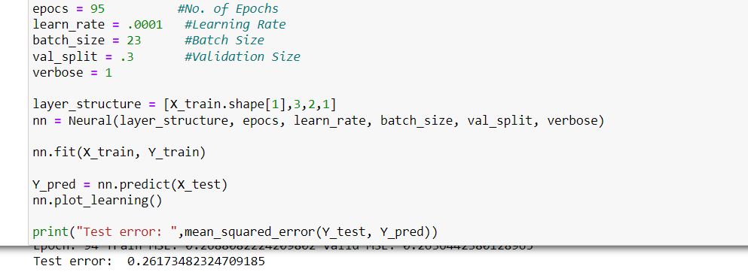

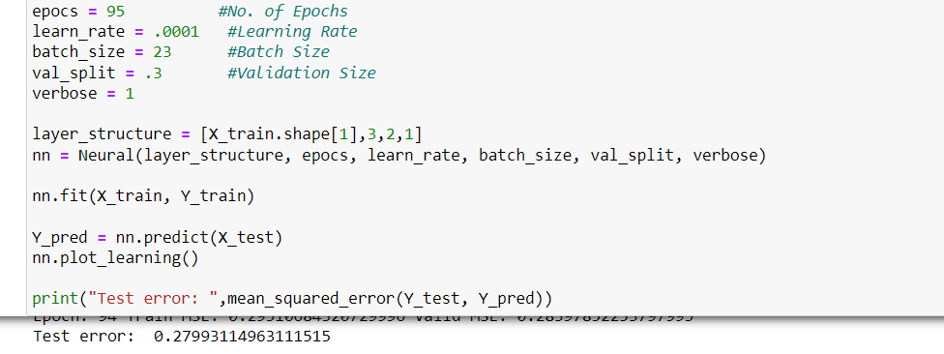

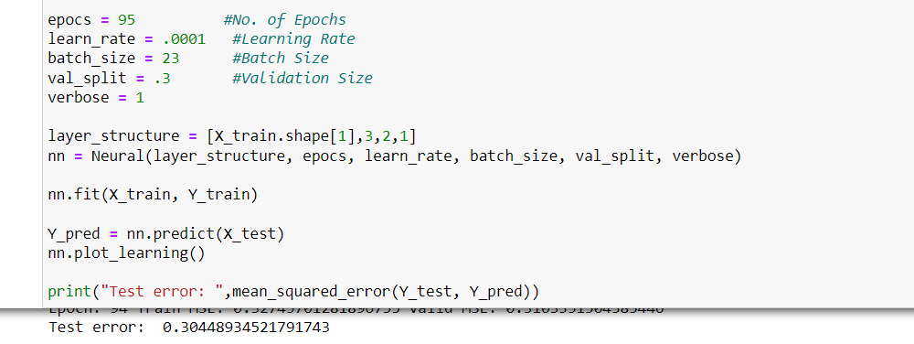

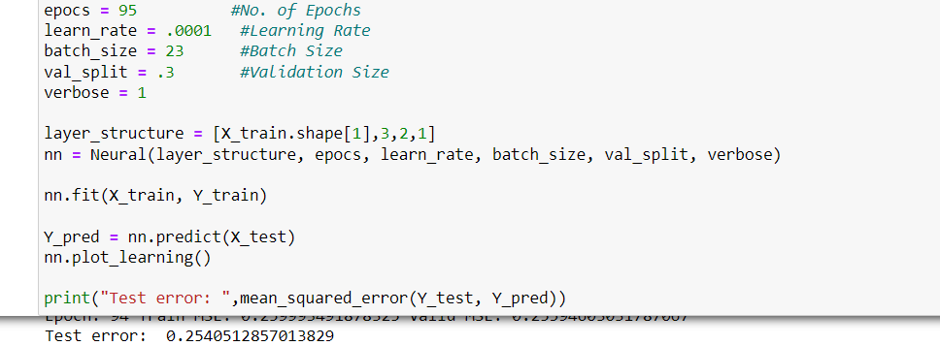

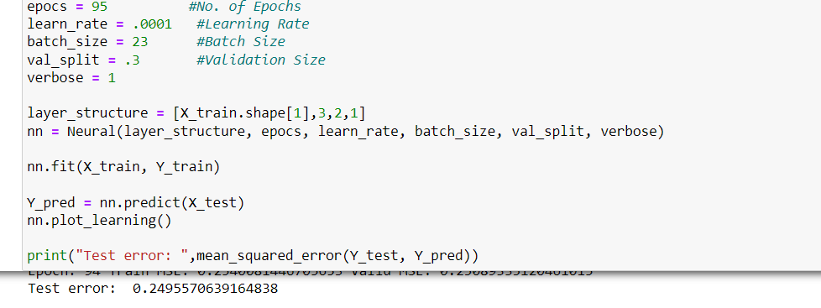

**Configuration – 3:**

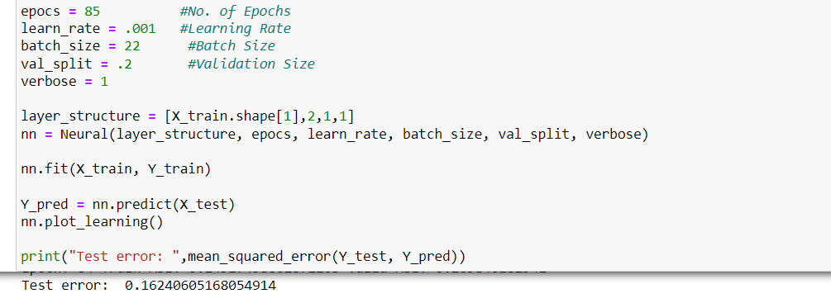

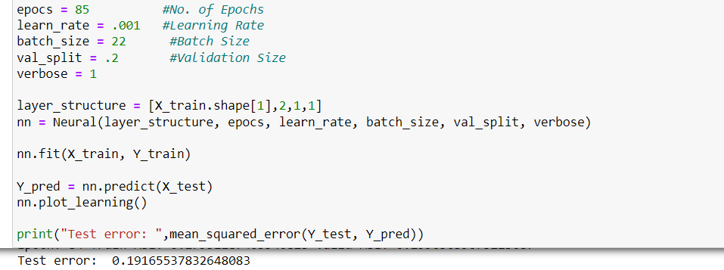

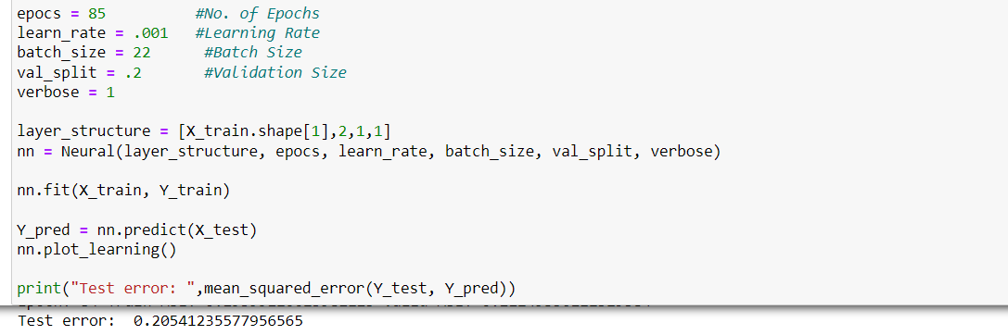

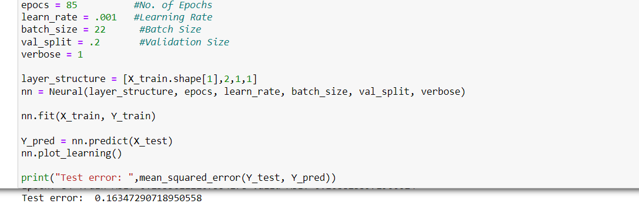

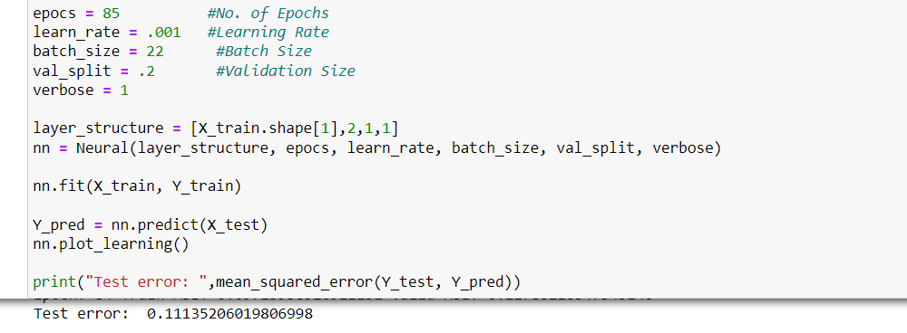

**Configuration – 4:**

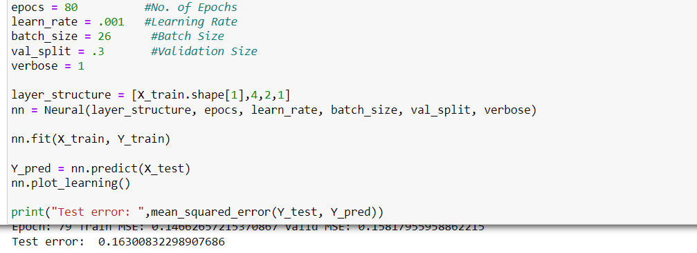

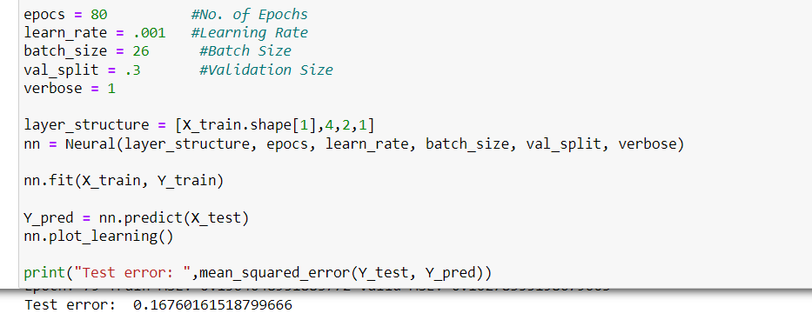

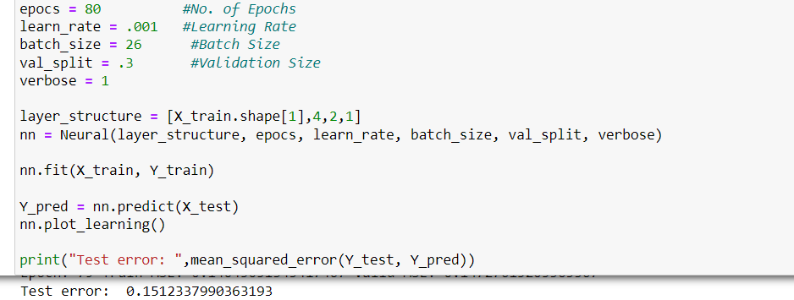

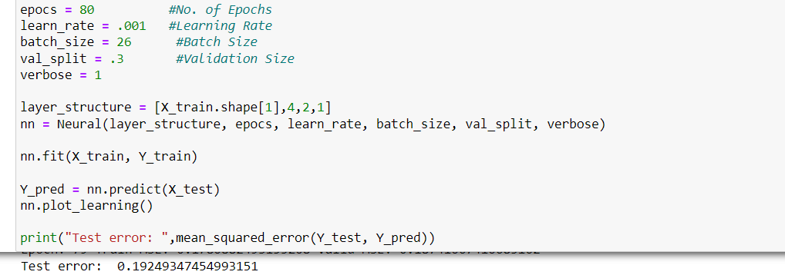

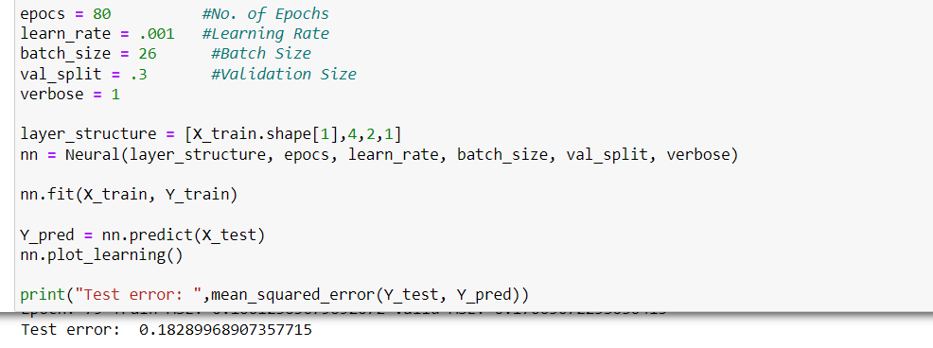

**Configuration – 5:**

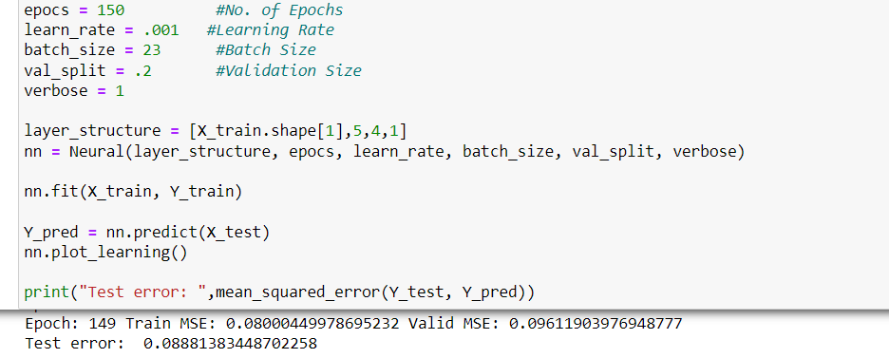

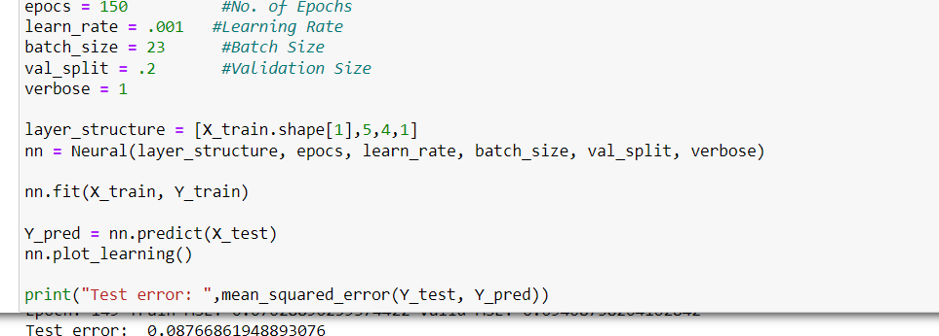

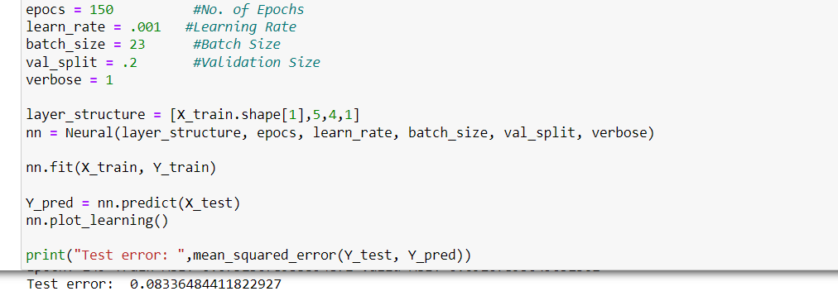

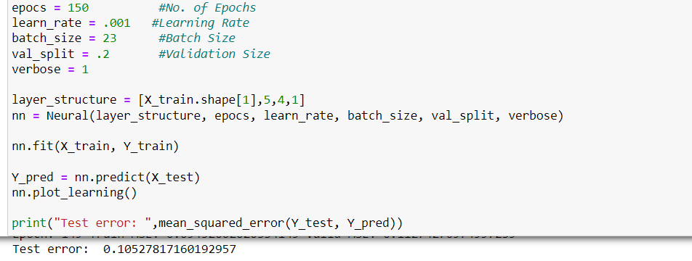

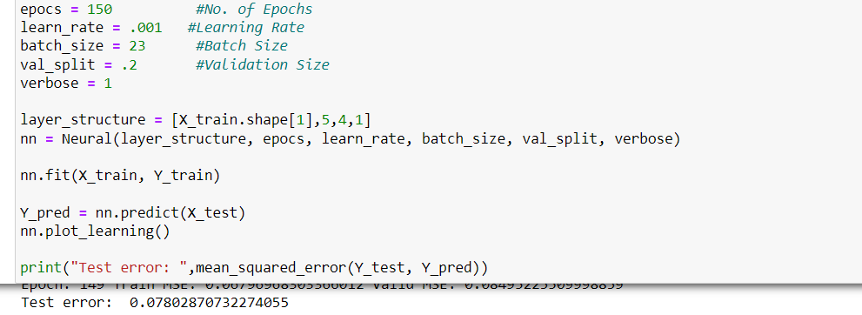

**Configuration – 6:**

**Configuration – 7:**

**Configuration – 8:**

**Configuration – 9:**

**Configuration – 10:**

