For HP ALM -<http://qafriend.com/alm-quality-center/exporting-tests-to-alm-quality-center>

sample user story

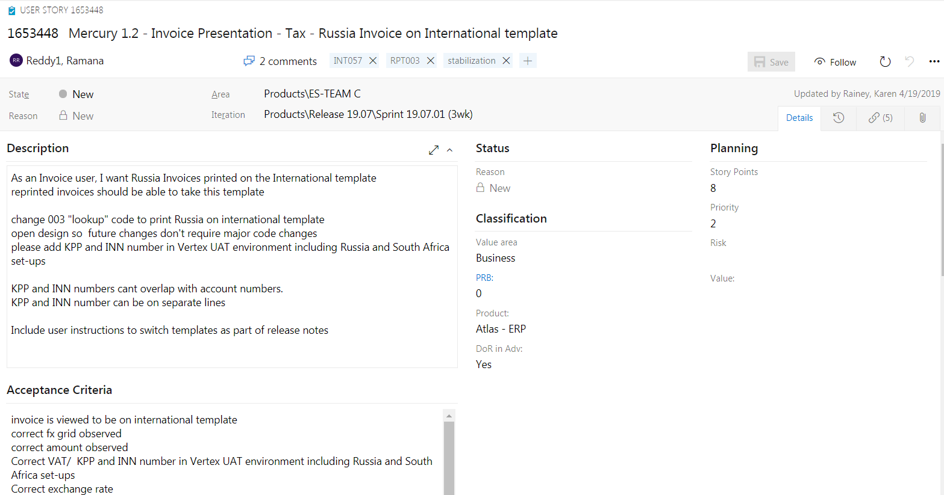

Tasks for this user story

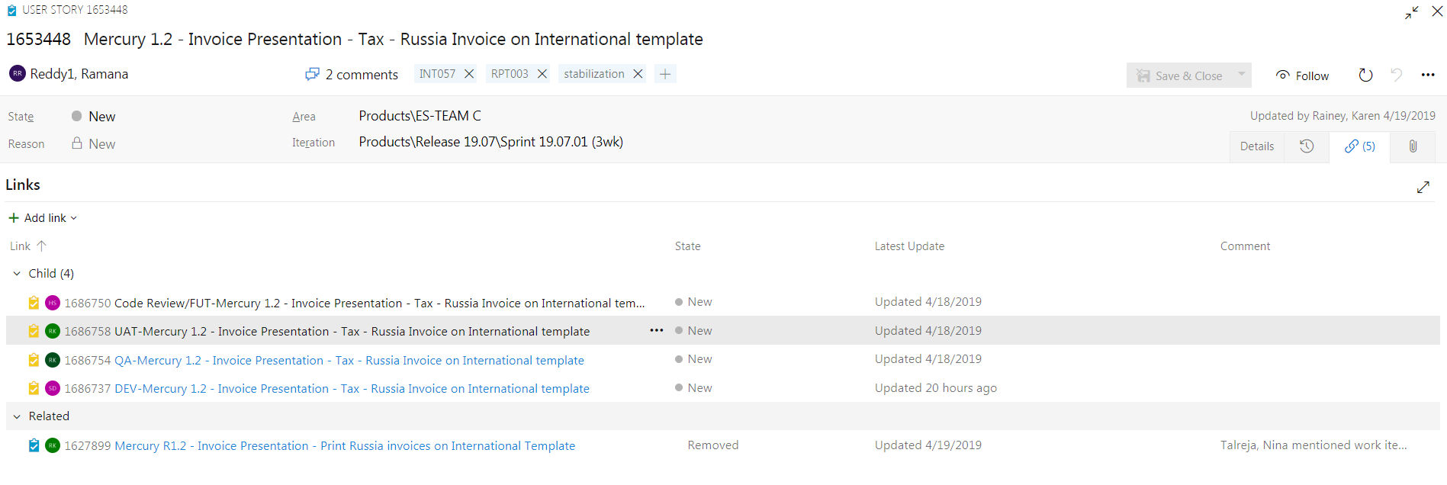

Bugs

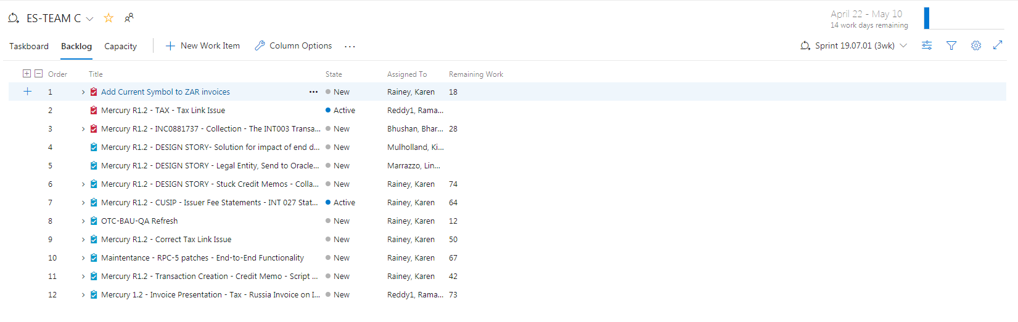

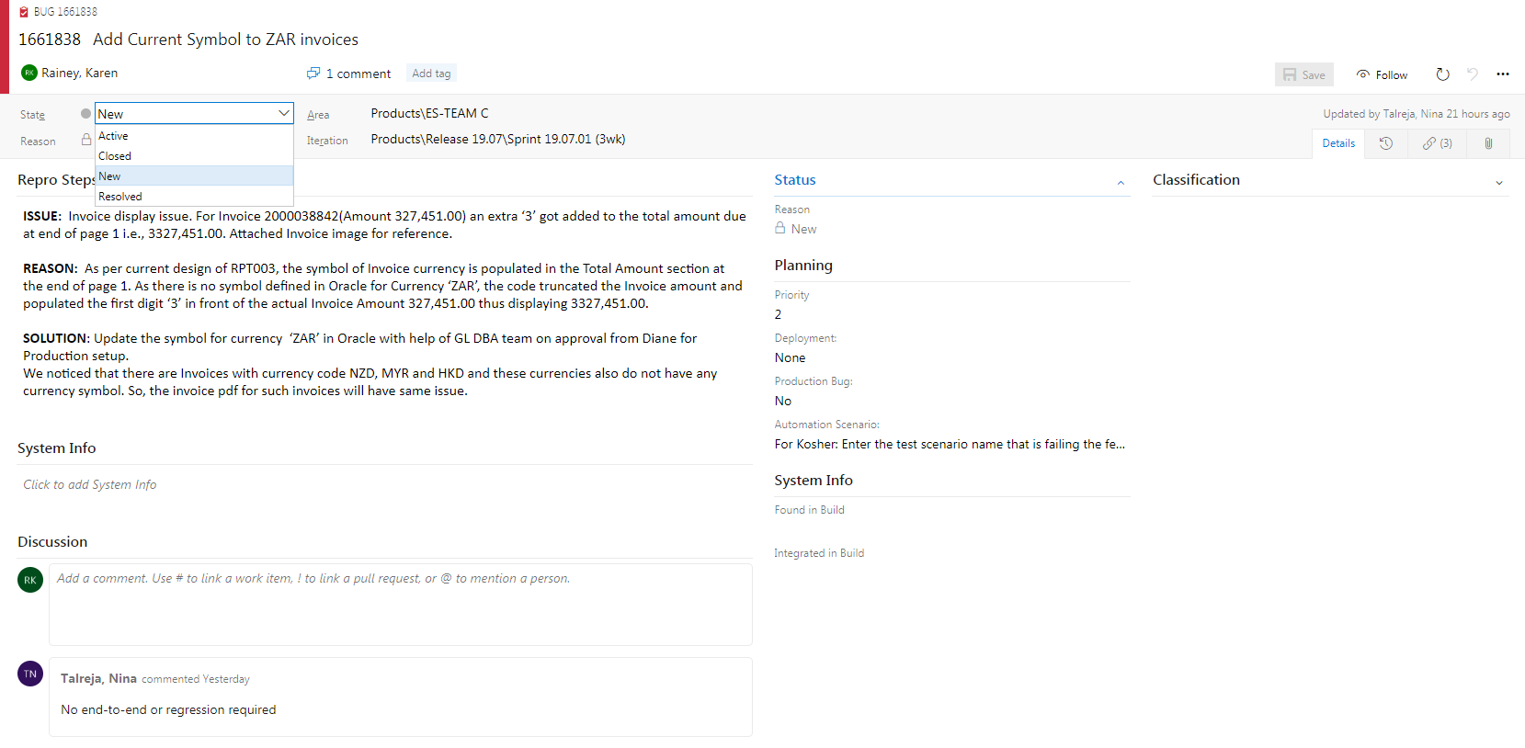

JIRATOOL

[**Jira**](http://WWW.PAVANONLINETRAININGS.COM/) **Tutorial**

**Login into JIRA tool on Cloud**

Link: <https://www.atlassian.com/software/jira/try>

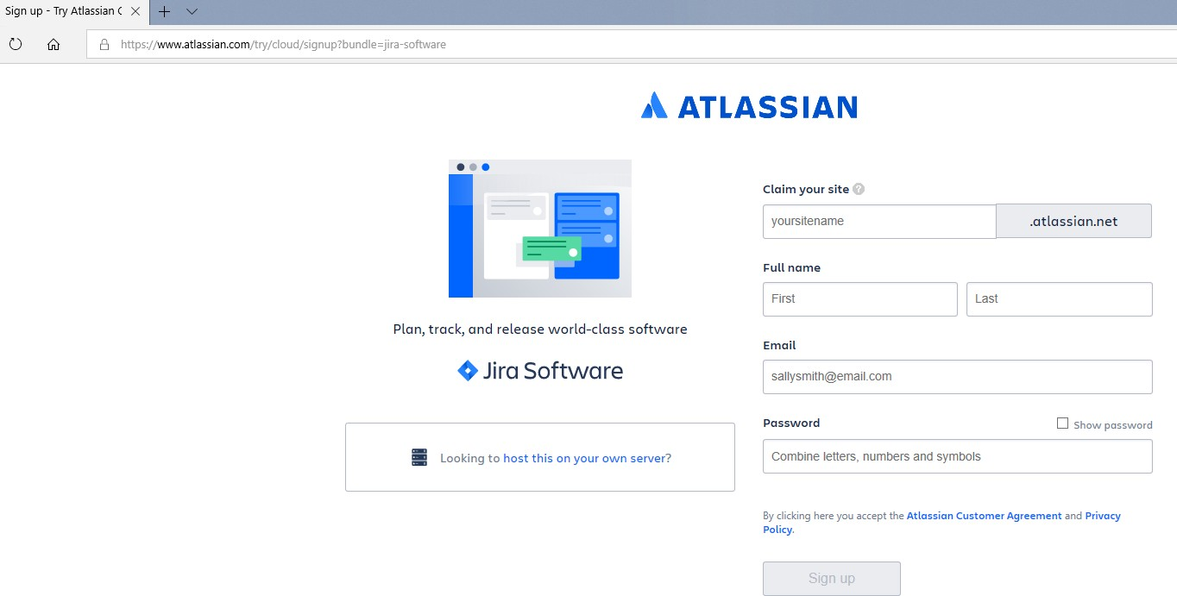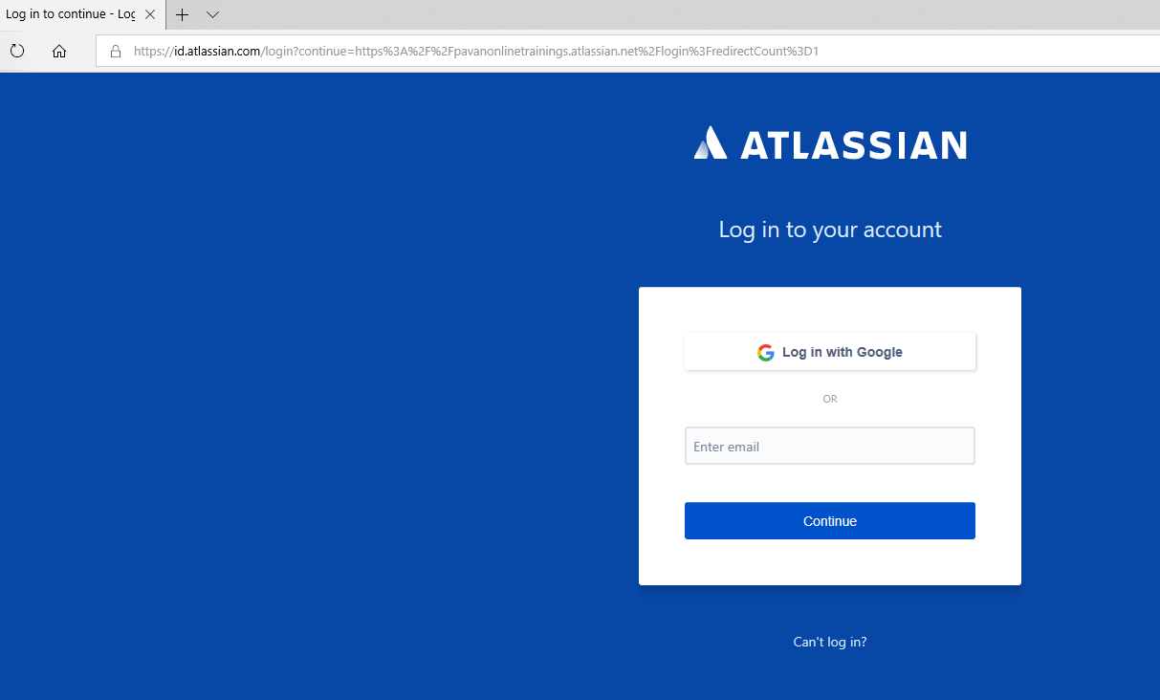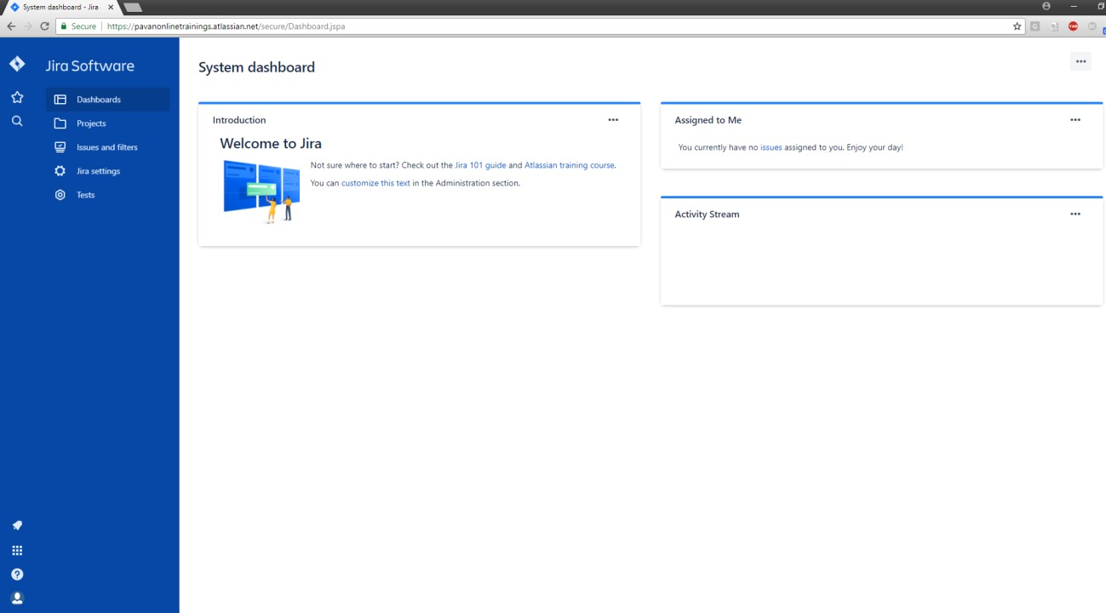

Dash Board Page

**Create a New Project in Jira**

Projects→CreateProject→ProvideProjectName→Create

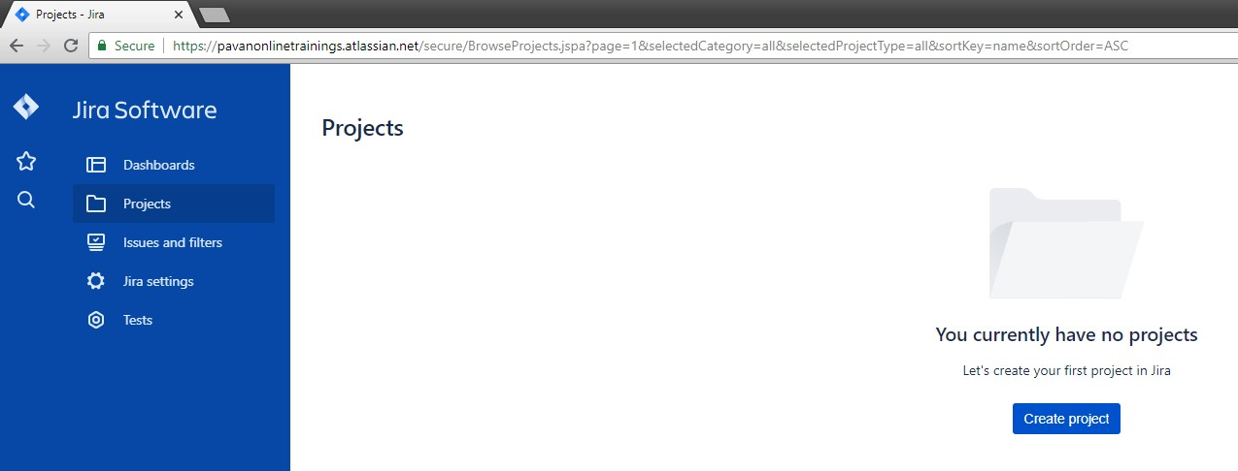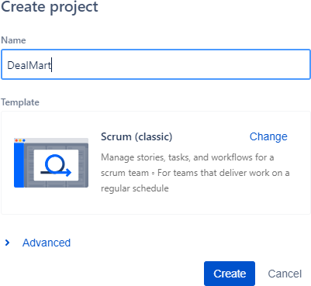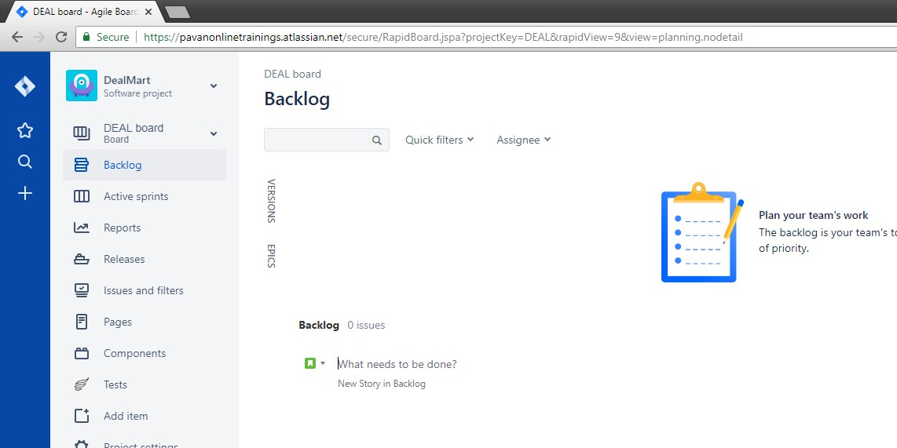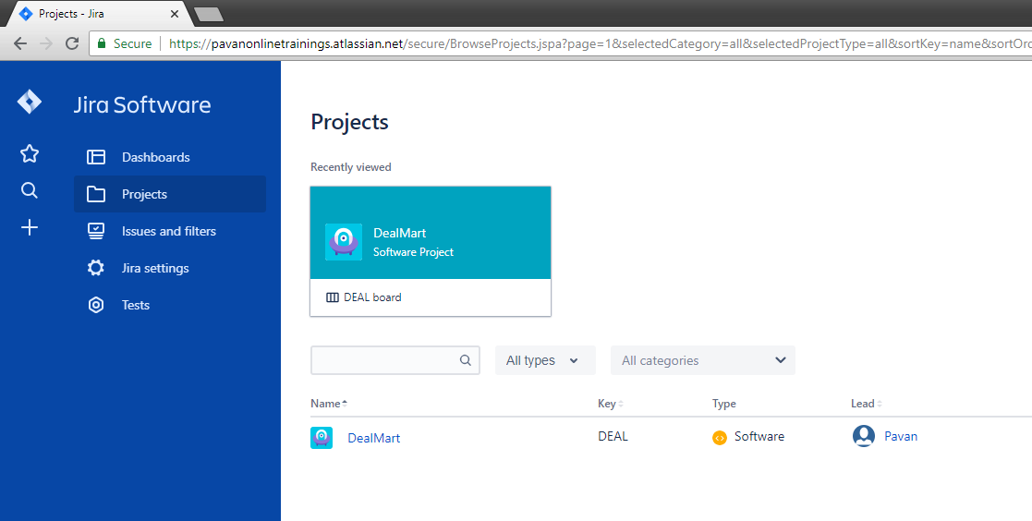

**Add New users/people in Jira**

JiraSettings→Usermanagement→Invitenewusers

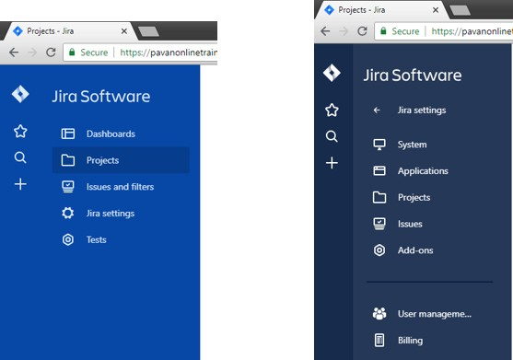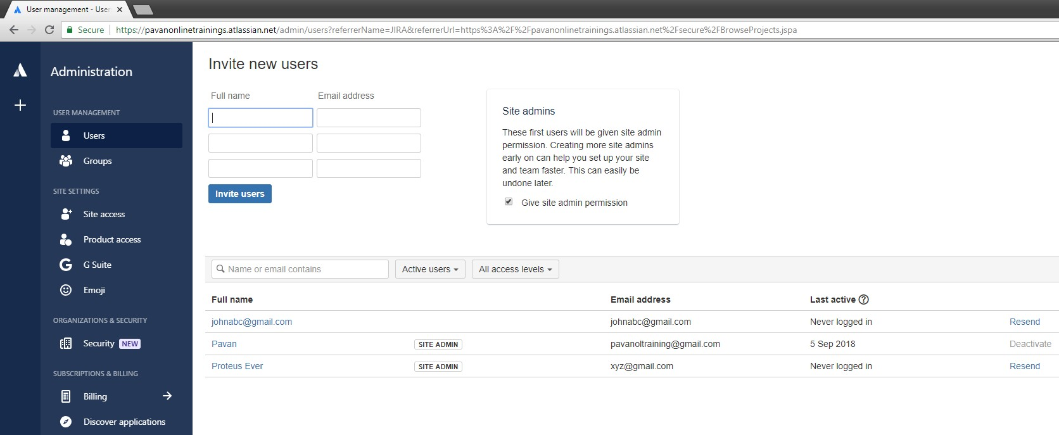

List Users will beaddedinthe BelowTable

**Create an Epic in the Backlog**

Projects→ClickonProjectLink→Createepiclink→ProvideName and summary of epic →Create

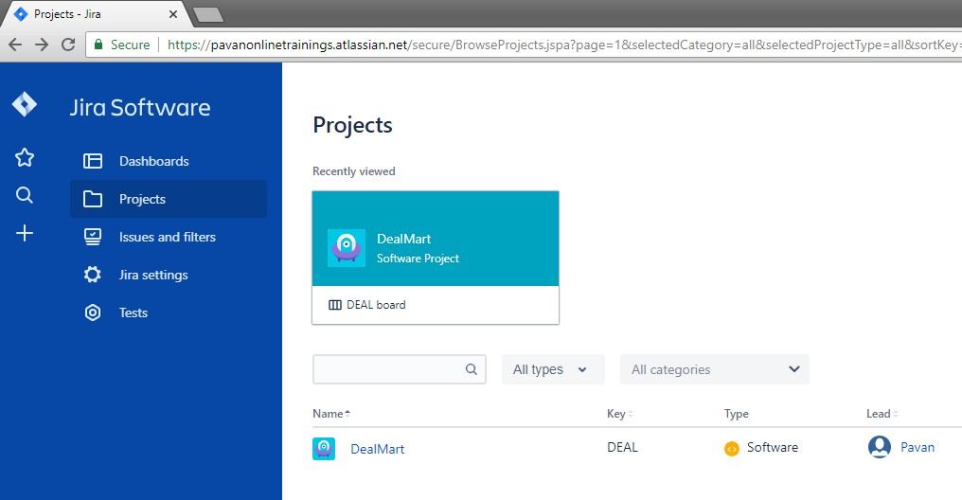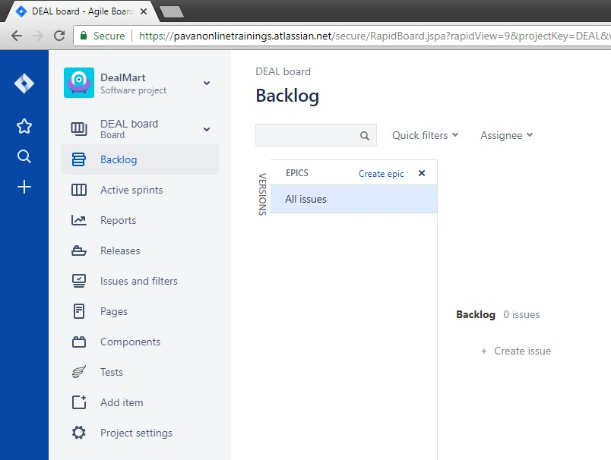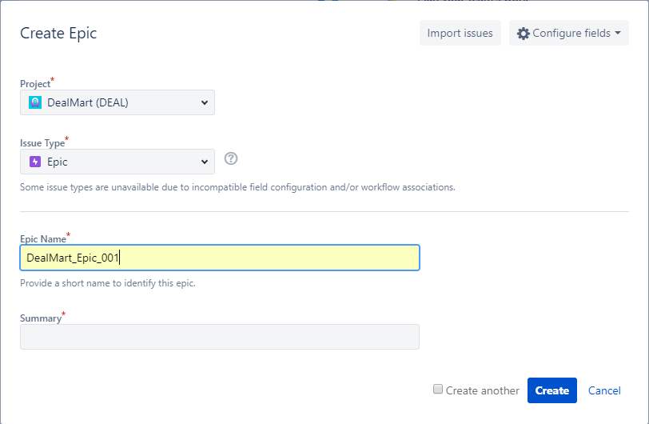

**Create User Stories in Jira**

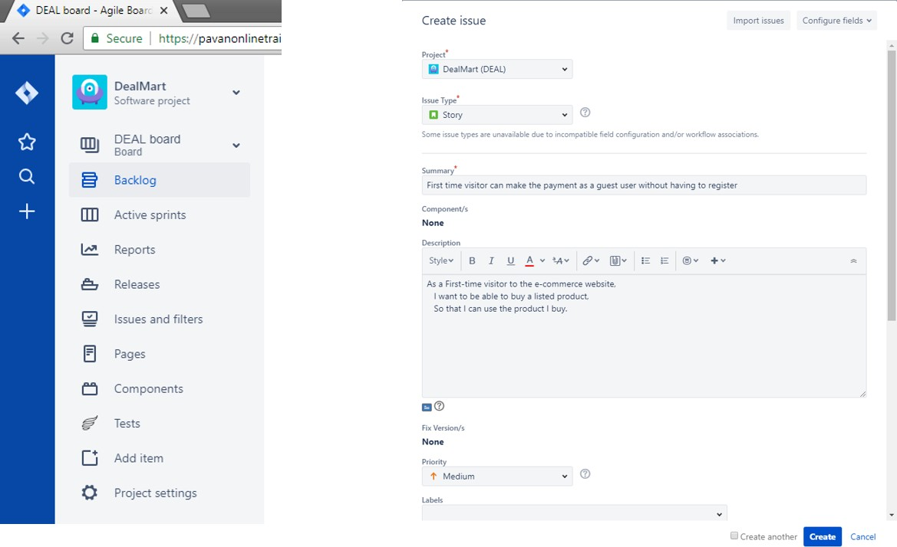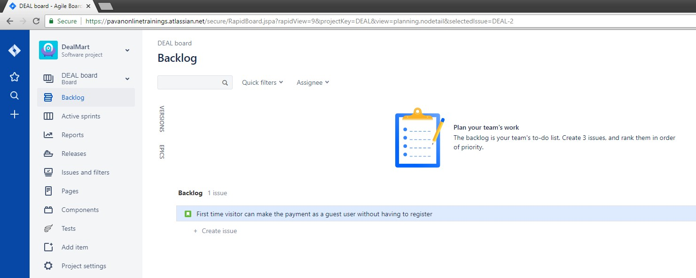

**Create New Sprint in Jira**

Backlog→Createsprint

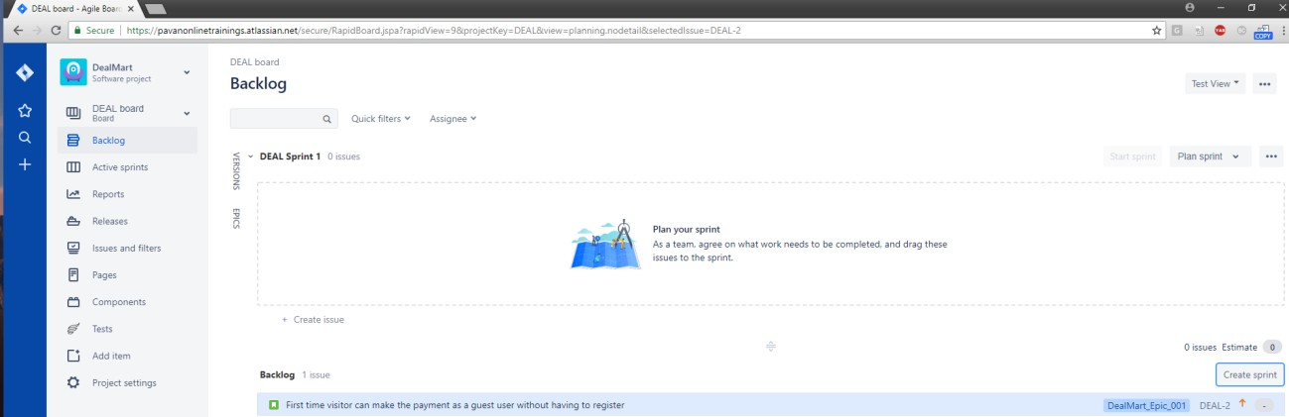

**Add user stories to sprint**

Drag and drop story from Backlog Section to Sprint box



**Drag & Drop**

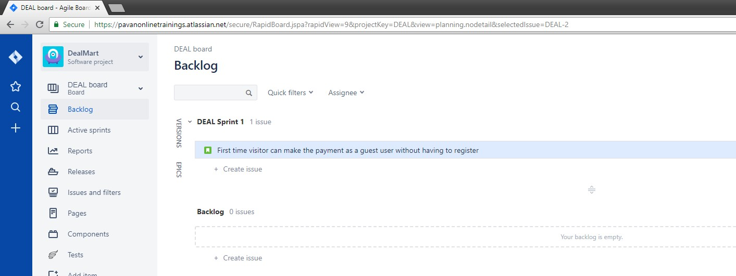

**Start sprint**

Clickonstartsprint→Provide sprintname→start→Goto Active sprints

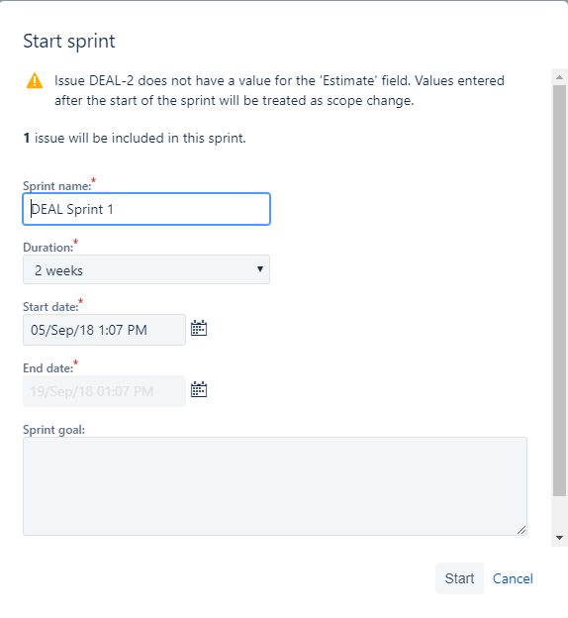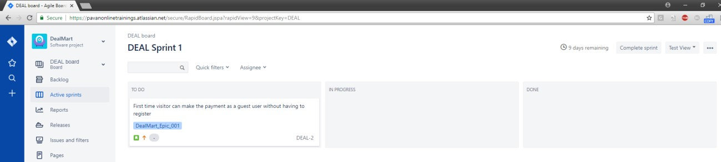

**Add sub Tasks to Story**

Clickonstory→ClickonTickmark->Providesub-taskname→

Create



**Click Here**

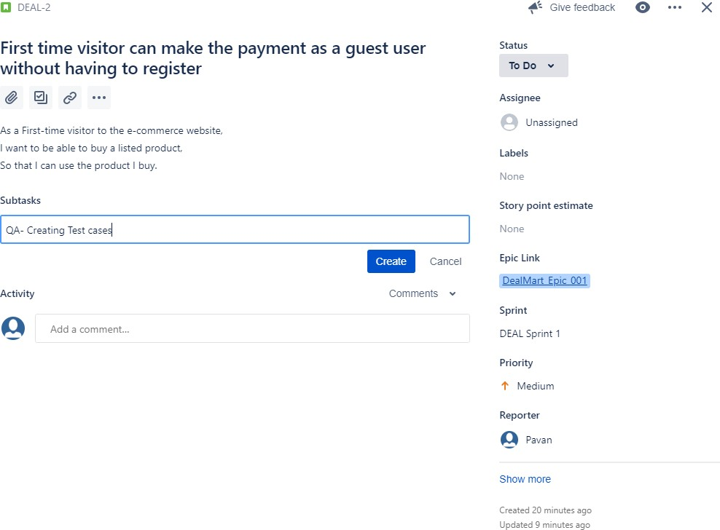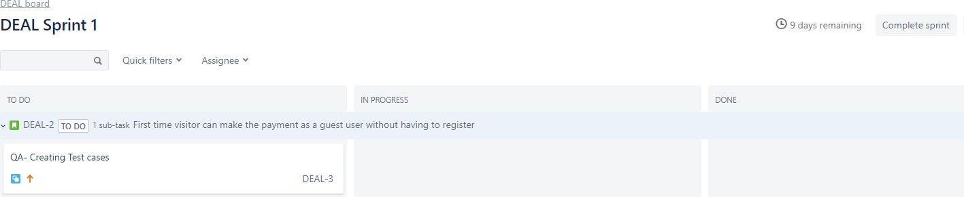

**Sub-Task is added to the story**

**Create Bugs inJira**

