Grade Analyzer
Test 1 (normal): Run with your original scores.txt and verify the report looks correct. 1
Test 1 (hardcoded data): Screenshot of the java code execution of GradAnalyzer java program that fetch hardcoded data 3
Test 2 (empty file): Create an empty scores.txt and confirm the program handles it gracefully, printing a message rather than crashing. 4
Test 3 (all invalid): Fill scores.txt with only non-number lines and confirm every line is warned and skipped. 4
Test 4 (single score): Put just one number in the file and confirm that all statistics are correct. 5

Test 1 (normal): Run with your original scores.txt and verify the report looks correct.

- Screenshot of the java code execution of GradAnalyzer java program that fetches data from scores.txt file.

Arguments:
Input file name: scores.txt
Output file name: reports.txt
Flag: true/false, fetch hardcoded data(true) or data from file(false)
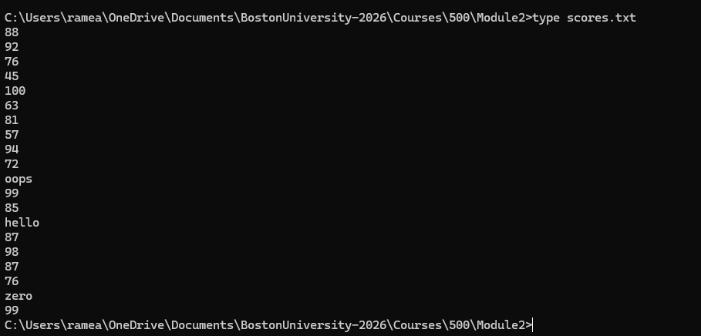
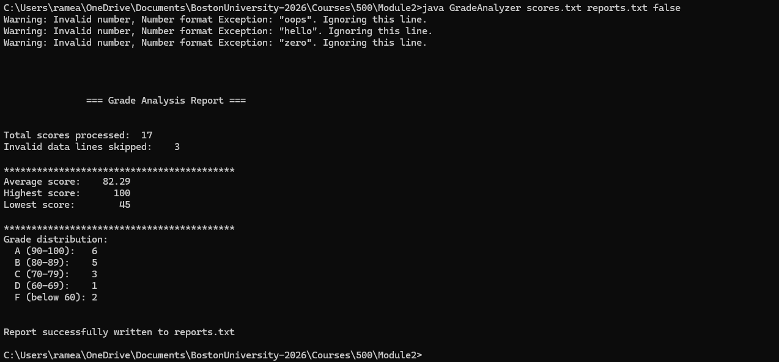
- Screenshot of reports.txt file
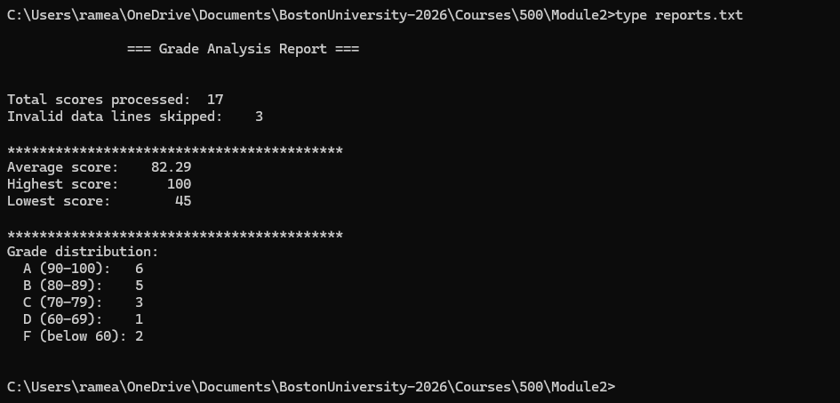

Test 1 (hardcoded data): Screenshot of the java code execution of GradAnalyzer java program that fetch hardcoded data
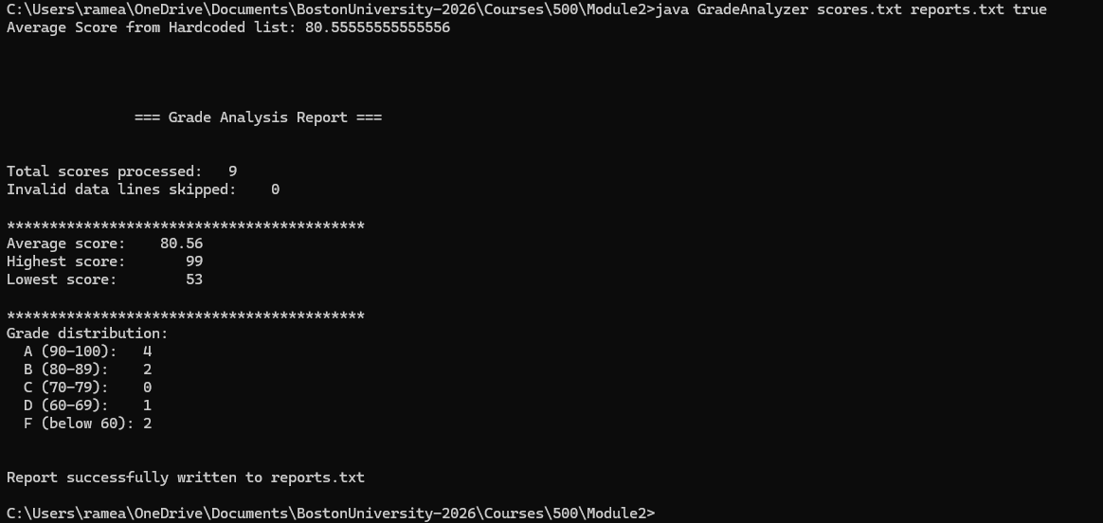
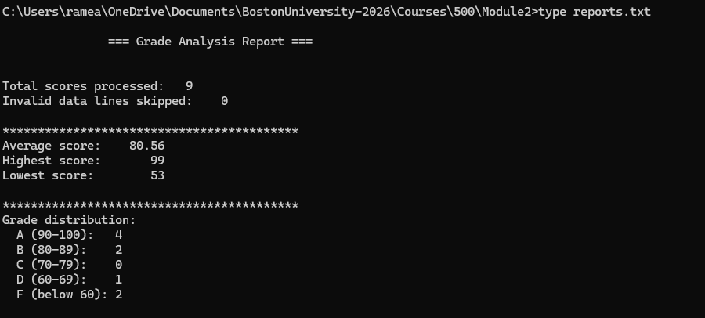

Test 2 (empty file): Create an empty scores.txt and confirm the program handles it gracefully, printing a message rather than crashing.

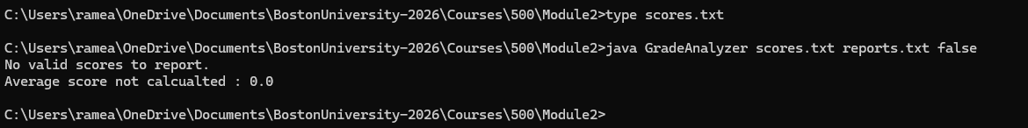

Test 3 (all invalid): Fill scores.txt with only non-number lines and confirm every line is warned and skipped.

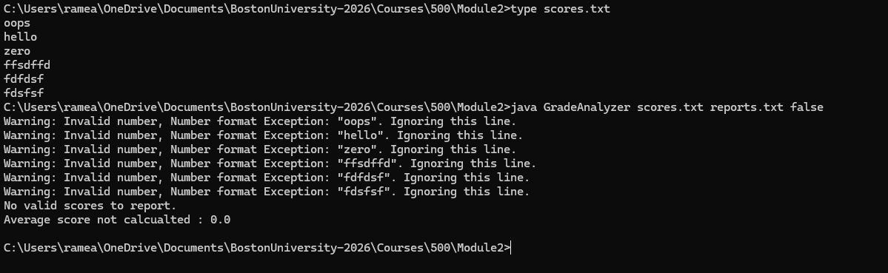

Test 4 (single score): Put just one number in the file and confirm that all statistics are correct.

