Comparison of prompt architectures for large language model agents in intraoperative anaesthetic decision-making: a retrospective in silico study
Running title: Prompt architectures for anaesthesia LLM agents
Authors: Ramses Marrero García (1, 2)*, Rosalía Cayuela (1, 2), Petter Peñafiel (1), Carlos Ferrando (1), Xavier Borrat (1, 2, 3), Hyung-Chul Lee (4)
- Hospital Clínic de Barcelona, Barcelona, Spain
- University of Barcelona, Barcelona, Spain
- Massachusetts Institute of Technology, Cambridge, MA, USA
- Seoul National University Hospital, Seoul, Republic of Korea
*Corresponding author: Ramses Marrero García. E-mail: rmarrero@clinic.cat
Word counts: abstract …; main text [… limit 3000]. Tables and figures: 3 tables and 3 figures (limit 6). References: 35 (limit 40).
Keywords: clinical decision support systems; in-context learning; intraoperative monitoring; large language models; propofol infusion; remifentanil infusion; total intravenous anaesthesia

Abstract
Background. Large language models (LLMs) are proposed as intraoperative decision support, wrapped in prompt architectures. It is unknown which architectural components change the anaesthetic decision, and whether the LLM adds anything beyond the cases it is shown.
Methods. In this retrospective in silico study of 3457 decision windows from 149 test cases (AnesLLM benchmark, VitalDB), three LLMs predicted the anaesthetist's next action (increase or decrease propofol or remifentanil, or no change) under nine architectures, with and without reasoning effort. All methods saw the same audited data, except the effect-site sample at the decision point, withheld from XGBoost. Controls were an unweighted vote of the same neighbours retrieved for few-shot prompting, XGBoost and trivial rules. The primary outcome was agreement with the anaesthetist; the primary contrast was equivalence (margin ±0.05) between the best LLM and the neighbour vote.
Results. Only few-shot prompting with retrieved cases improved agreement over zero-shot (+0.05 to +0.17; all P<0.001). Chain-of-thought, self-consistency, critic and structured-output architectures did not; guideline retrieval and simulation-based critique reduced agreement (−0.019 to −0.026). The best configuration of each model (0.390, 0.422, 0.430) was equivalent to the neighbour vote (0.413; P≤0.033) and below XGBoost (0.635). LLM concordance with the vote rose from 41–45% with divided neighbours to 75–90% with agreeing neighbours, and the LLM outperformed the vote mainly when neighbours disagreed. Architectures without benefit multiplied input tokens two- to five-fold.
Conclusions. In propofol–remifentanil titration, LLM agreement with anaesthetists depended on retrieved cases rather than reasoning architectures. LLM decision support should be benchmarked against a vote of similar cases before adding architecture.

Introduction
Evidence on large language models (LLMs) in anaesthesia comes almost entirely from text tasks: specialty examinations, ASA physical status classification, preoperative planning and report extraction.[1–6] Outside anaesthesia, LLMs do not outperform conventional machine learning in clinical prediction from structured data,[7–9] and they reason poorly over physiological time series.[10] The response has been to add architecture around the model: chain-of-thought reasoning, self-consistency, critics, and retrieval of guidelines or of similar cases.[11–14] Each layer adds cost, and it is not known which of them changes the decision.
Retrieval of similar cases raises a specific question. In in-context learning, LLMs tend to copy the labels of the most similar examples and behave like a nearest-neighbour classifier.[15–17] If the same happens in clinical decisions, the gain from few-shot prompting would come from the cases, not from the model's reasoning. In medicine this has not been tested against a matched control: a vote, without an LLM, of exactly the same retrieved neighbours.[18]
We aimed to decompose what drives the anaesthetic decision of an LLM during propofol–remifentanil total intravenous anaesthesia (TIVA). The primary aim was to determine whether the best LLM configuration adds agreement with the anaesthetist beyond a vote of the same retrieved cases. Secondary aims were to compare nine prompt architectures against zero-shot prompting, to test whether their effects generalise across three LLMs, to assess the effect of reasoning effort, to quantify input-token cost, and to describe safety, error severity, clinical context, sex and age, temporal coherence and the circumstances in which the LLM departs from its retrieved examples.

Methods

Ethics
The Research Ethics Committee (CEIm) of Hospital Clínic de Barcelona issued a favourable opinion on 17 August 2026 (registry HCB/2026/0831; protocol AnesLLM-2026 v2.0) for an in silico development and evaluation study. Informed consent was waived because VitalDB is a public, de-identified database. The study complied with the Declaration of Helsinki. It is reported following TRIPOD-LLM;[19] the checklist is provided as supplementary material.

Data and task
We used AnesLLM, a benchmark of intraoperative decision windows built from VitalDB, an open database of non-cardiac surgery at Seoul National University Hospital.[20] The benchmark contains 84 813 windows from 3168 cases. Each window holds patient and surgical data, vital signs for the 10 min before the decision (bispectral index [BIS], arterial pressure, heart rate, SpO2 and others) and the history of propofol and remifentanil target-controlled infusion adjustments for the preceding 20 min. The label is the direction of the infusion change at the decision point, in five classes: increase or decrease hypnotic (propofol), increase or decrease opioid (remifentanil), or no action. Vasopressor, ventilation and volatile-agent changes were excluded as actions. The split is by case: training 2994 cases (80933 windows), development 25 (423) and test 149 (3457). The test set is stratified by difficulty and contains no physiologically impossible values. All results refer to the test set. The primary outcome was agreement with the action actually taken by the anaesthetist.

Shared data view and leakage audit
The LLMs and the neighbour vote received exactly the same 228 of 280 fields, and XGBoost the same fields with one exception. We hid identifiers and processing metadata, information after the decision or about the outcome, the volatile agent, and plasma concentrations and pump targets. The latter were hidden because they already encoded the action at the decision point: remifentanil plasma concentration moved with the label in 74–86% of windows with an opioid action, against <8% of no-action windows. All samples after the decision point were removed. The exception was the effect-site concentration sample at the decision point: the decision point falls at or just after the remifentanil target change, so that sample also moves with the action. XGBoost received effect-site features computed from samples up to 30 s before the decision, plus the target set by the previous adjustment of each drug, which the prose already states; whether the LLMs used the sample was tested in a sensitivity analysis. Each case was presented to the LLM as clinical prose followed by the full record of visible fields.

Models
We evaluated gpt-5.4-mini (snapshot gpt-5.4-mini-2026-03-17; OpenAI), deepseek-flash (DeepSeek) and gemini-pro-latest (Google), queried in October 2026 (SHAP ranking and sensitivity analysis in November 2026). The two aliases are returned unchanged by their APIs; from provider documentation they served DeepSeek-V4.1-Flash[31] and Gemini 3.1 Pro Preview.[32] Each model was run with reasoning effort 'none' and 'high'. 'None' was implemented by omitting the parameter, so each model used its default: no reasoning for gpt-5.4-mini,[33] reasoning at high effort for DeepSeek-V4.1-Flash,[34] and reasoning that cannot be disabled for Gemini 3.1.[35] Temperature was 0 where the API accepts it.
Gemini was added post hoc to validate the direction of effects, with three architectures (zero-shot, chain-of-thought and few-shot with k=8). Windows without an answer within the 60 s time limit (three retries) were excluded: none for gpt or deepseek, and one or two per run (≈0.1%) for gemini.

Prompt architectures
All architectures share the zero-shot base prompt and the same case representation, so each differs from the base in one element. The model answers with a single letter (a–e).
- Zero-shot: the case and the five options.
- Few-shot with retrieved cases (k=5, 8, 10): the k most similar training windows, each with the anaesthetist's actual action, precede the case. Neighbours are found by Euclidean distance on standardised numerical variables of the shared view; labels never enter the search and the patient's own windows are excluded.
- Chain-of-thought: structured analysis of haemodynamics, hypnotic depth and analgesia, followed by up to four thought–query–observation steps over the case text.
- Self-consistency: the zero-shot prompt sent five times (temperature 1.0 where accepted) with majority voting.
- Structured output: the same instructions and case packed into a single JSON object.
- Critic–verifier: a zero-shot proposal reviewed in a second call that confirms or replaces it.
- Simulation-based critic: the LLM first proposes the two most appropriate, distinct actions among the five options, covering the competing readings of the case when it is ambiguous; this step also tests the model's ability to rank the options. Both candidate actions are then applied to a pharmacological simulator (Python Anesthesia Simulator 1.0.0) calibrated to the window and projected 5 min ahead; a second call chooses, blinded, between the two simulated states.
- Guideline retrieval (RAG): the zero-shot prompt plus 28.6 kB of verbatim excerpts from TIVA guidelines, propofol and remifentanil labels, BIS guidance and perioperative arterial pressure consensus. The excerpts were selected by an anaesthetist on the team for their relevance to the decision, and their total size was limited to reduce loss of information in the middle of long contexts.[36]
- SHAP ranking: the zero-shot prompt plus the ranking of visible variables by mean absolute SHAP value in the XGBoost model.

Controls
The matched control was the unweighted majority vote of the same k retrieved neighbours, without an LLM (ties broken by a fixed action order); at k=10 it reproduced an independently run nearest-neighbour control in all windows. XGBoost, trained on the same visible variables (effect-site features as above), served as the performance ceiling for the information in the window. Trivial controls were persistence (repeat the last action), never acting and random choice.

Safety
An anaesthetist on the team defined safety rules during the analysis; they were then adjusted for context after auditing the windows in which the anaesthetist's own action triggered them. The primary safety metric combined moving the anaesthetist's drug in the opposite direction, and increasing the hypnotic with BIS between 10 and 35 (BIS <10 was treated as artefact). Increasing remifentanil with heart rate <50 beats min^−1^, and no action with BIS >70 outside emergence (surgery ended or anaesthesia ending within 15 min, identified from audit fields never shown to any model), were reported descriptively.

Neighbour analysis and cost
For each few-shot run we reconstructed the vote of the same neighbours the model saw and measured LLM–vote concordance, and the accuracy of the LLM when it overrode the vote, by neighbour agreement (proportion of neighbours behind the vote). A hybrid rule, fixed before evaluation and not tuned, used the vote when it was a strict majority and the LLM otherwise. Input tokens were computed deterministically by rebuilding every message without calling the models, with three tokenisers (o200k, DeepSeek-V3 and Gemma 3 as a proxy for Gemini). Latency was not analysed because network effects could not be isolated.

Statistical analysis
All comparisons were paired on the same windows. Two-sided 95% confidence intervals (CI) came from a bootstrap resampling whole cases (2000 replicates, fixed seed), because windows of the same patient are not independent. Differences in agreement were tested with the exact McNemar test; interactions and safety differences with a two-sided bootstrap P value. Holm correction was applied within each family of comparisons, and a difference was considered present only when the adjusted P was <0.05. The primary contrast was equivalence between the best configuration of each model and the neighbour vote by two one-sided tests (TOST) with a margin of ±0.05 agreement, judged on the 90% CI. The margin and contrast were fixed before computation but after descriptive results were known; the study was not preregistered. Analyses were performed in Python 3 (code available; see Data availability).

Results
The test set comprised 3457 windows from 149 cases (age 57.4 [SD 14.4] yr; 49.7% female; ASA physical status ≥3, 16.1%; invasive arterial pressure in 54.4% of windows). Actions taken were no action 27.3%, decrease opioid 27.2%, increase opioid 23.8%, decrease hypnotic 13.3% and increase hypnotic 8.4%. Agreement of the controls was 0.635 for XGBoost, 0.413 for the neighbour vote (k=10), 0.325 for persistence and 0.273 for never acting; zero-shot agreement was 0.25–0.28 across models.

Effect of prompt architecture
Few-shot prompting with retrieved cases was the only architecture with large and consistent gains over zero-shot, in all three models (Table 1, Fig. 1): +0.052 to +0.075 for gpt without reasoning, +0.133 to +0.140 for gpt with reasoning, +0.124 to +0.147 for deepseek and +0.167 for gemini (all P<0.001). Chain-of-thought (+0.017; P=0.015) and the SHAP ranking (+0.015, P=0.036; +0.016, P=0.041) gave small, isolated gains. Self-consistency, structured output and the critic–verifier never differed from zero-shot. Guideline retrieval reduced agreement in deepseek (−0.019, P=0.013; −0.023, P<0.001), as did the simulation-based critic (gpt −0.025, P=0.028; deepseek −0.026, P=0.010).
The sign of the effect agreed between models in 20 of 28 comparisons. Seven interactions survived correction, all of magnitude and almost all in few-shot prompting: without reasoning, gpt gained 0.073–0.098 less than deepseek and gemini, which reason by default (all P<0.001).

LLM vs the vote of its own neighbours
The best configuration of each model was equivalent to the neighbour vote within ±0.05 (Table 2): gpt −0.023 (90% CI −0.040 to −0.005; P=0.033), deepseek +0.009 (−0.009 to +0.026; P<0.001) and gemini +0.017 (+0.001 to +0.034; P<0.001). Nine of 14 few-shot configurations were equivalent; gpt without reasoning fell below the vote by more than the margin (−0.062 to −0.085). All LLMs were well below XGBoost (−0.205 to −0.245; P<0.001) and above the trivial controls.
LLM concordance with the vote rose with neighbour agreement, from 41–45% when ≤40% of neighbours supported the vote to 75–90% when ≥80% did (Fig. 2). With divided neighbours the LLM outperformed the vote in 11 of 14 runs; with consensus it fell below the vote in 12 of 14. When it overrode the vote, gpt without reasoning lost agreement (−0.099 to −0.108; P<0.001), whereas gemini gained (+0.062; P=0.045). The untuned hybrid rule improved on the vote by 0.019–0.022 in three of 14 runs (P=0.003 to 0.049), within the equivalence margin.
Withholding the effect-site sample at the decision point reduced XGBoost agreement by 0.111 (0.740 to 0.629, without the previous targets), whereas each further 30 s removed 0.015–0.047. The same cut changed the neighbour vote by +0.005 (95% CI −0.005 to +0.016) and zero-shot agreement by −0.013 to +0.007 across the six model–reasoning conditions (one interval excluded zero). In the 142 windows in which the remifentanil effect-site concentration rose at the decision point, 63% were opioid increases; the LLMs chose that action in 6–13% of these windows with the sample and in 6–15% without it.

Reasoning effort
In gpt, reasoning improved few-shot agreement (+0.036 to +0.054; P≤0.001) and reduced it for zero-shot (−0.026; P=0.024), structured output (−0.035; P<0.001) and guideline retrieval (−0.029; P=0.002). It reduced opposite-direction errors in all 11 architectures (−0.022 to −0.053; P≤0.001) and changed the answer in 44–58% of windows. In deepseek and gemini both conditions used reasoning (see Methods), so its effect could not be isolated.

Input-token cost
Architectures without benefit multiplied input tokens 2.0- to 5.0-fold (critic–verifier, SHAP ranking, guideline retrieval, self-consistency), and few-shot prompting 5.4- to 9.8-fold (Table 3). Multipliers differed by ≤0.2 between tokenisers, except for guideline retrieval (3.3–3.7).

Safety and error severity
Opposite-direction errors made up 98% of primary safety flags. The most accurate architectures also had the most flags (Table 2, Fig. 3). The best few-shot configurations did not differ in primary safety flags from the neighbour vote (−0.014 to +0.008; P≥0.057) or from XGBoost (−0.012 to +0.010; P≥0.23). Zero-shot had fewer flags because it acted less. Auditing the anaesthetist's own flagged windows explained most of them: 31 of 47 'no action with BIS >70' windows were emergence, 9 of 20 'hypnotic increase with BIS <35' windows had BIS <10, and the lowest heart rate during remifentanil increases was 42 beats min^−1^. After adjustment the anaesthetist triggered state rules in 1.7% of windows.
Among moves of the anaesthetist's drug, the proportion in the opposite direction was 0.28 for the neighbour vote, 0.19 for XGBoost and 0.23–0.27 for the best LLMs. Zero-shot prompting over-called hypnotic decreases (+0.19 above the observed frequency, against +0.04 with few-shot).

Clinical context, sex, age and temporal coherence
The difference between the best LLM and the neighbour vote ranged from −0.14 to +0.09 across clinical strata, and the hardest strata (difficult windows and transplantation) were the same for both. No interaction by sex or age survived correction for agreement or safety flags. The anaesthetist changed action in 67% of consecutive windows and reversed direction on the same drug in 12.4%; models changed in 61% and reversed in 4%. The best LLMs of the three models shared 69–73% of their errors. Excluding the 60 windows in which the anaesthetist triggered an adjusted state rule changed agreement by 0 to +0.004 and preserved equivalence with the vote.

Discussion
In intraoperative propofol–remifentanil titration, the only architecture that improved an LLM's decision was showing it similar cases, and with them the LLM was equivalent to a vote of those same cases. Reasoning and external-knowledge layers added nothing or reduced agreement while multiplying cost. The LLM added value only as a tie-breaker when the retrieved cases disagreed.
Several of these observations confirm previous work. LLMs underperform conventional machine learning on structured clinical data,[7–9] as our XGBoost ceiling shows. Chain-of-thought, self-correction and added reasoning do not consistently improve clinical tasks,[11,21–23] and guideline retrieval can degrade performance.[24] Outside medicine, in-context learning with retrieved examples has been shown to resemble a nearest-neighbour classifier.[15–17] To our knowledge, this is the first clinical study to quantify how much of the few-shot gain is explained by the vote of the retrieved cases, using a matched control on the same neighbours and an equivalence test. The closest clinical study compared an LLM given similar cases with a nearest-neighbour model, but with different neighbours and without an equivalence test.[18] It is also, as far as we know, the first systematic comparison of prompt architectures for anaesthetic decisions on real intraoperative data, with cost and harm measured for each architecture. Preprints using VitalDB evaluate signal prediction[10] or model titration with sparse machine learning,[25] without LLMs or architecture comparisons.
The pattern by neighbour agreement matches that described in text classification.[17] When neighbours agree the model copies their vote, and departing from it is almost always an error; when they are divided the model uses more than the labels and outperforms the vote. The resulting hybrid rule is a cascade with deferral, a known pattern in machine learning and clinical systems.[26–28] Our contribution is clinical evidence on where to route, using a signal that comes free with retrieval. The gain was small (1–2 points) and should not be overstated.
For those designing or procuring decision-support systems, five implications follow. First, invest in the case base and its retrieval rather than in prompt engineering. Second, in this task, do not add guideline retrieval, critics or self-consistency: they did not improve agreement and cost two to five times more input tokens. Third, use the LLM as a tie-breaker when similar cases disagree, and do not let it contradict a clear consensus. Fourth, re-validate architecture and reasoning effort with every change of base model, because effect sizes did not transfer. Fifth, always report a retrieval-only control and the rate of opposite-direction errors, not only agreement.
Agreement with the anaesthetist measures imitation, not quality of care. Instantaneous threshold rules flagged correct practice, namely emergence, BIS artefact and mild bradycardia in a lightening patient, as reported in sepsis.[29,30] This argues for context-aware safety definitions; for this reason the primary safety metric was the direction of the error, which does not depend on thresholds. Few-shot prompting inherited the error profile of the neighbour vote, with a larger share of opposite-direction moves than XGBoost: imitating better does not guarantee erring more safely.

Strengths and limitations
Strengths include a single leakage-audited data view shared by the LLMs and the neighbour vote, with XGBoost as a positive control for its one residual leak, a matched retrieval-only control, paired case-level statistics with multiplicity correction, three LLM providers and deterministic cost accounting.
The study has limitations. It is single-centre and retrospective, without external or prospective validation. The primary outcome rewards imitation of one anaesthetist and penalises correct alternatives where several actions are acceptable. We did not permute neighbour labels, so we can state that LLM answers behave like the vote of their examples and track neighbour agreement, but not that the model copies labels causally. Proprietary model versions change over time; we mitigated this with three providers and the consistency of effect direction. No configuration was repeated, so intervals reflect between-case rather than between-run variability. The 'none' reasoning condition omitted the parameter and did not disable reasoning in deepseek or gemini, so the effect of reasoning was evaluated only in gpt-5.4-mini. Safety rules use current BIS and heart rate without trends or haemodynamic context. Only input tokens were counted: output and reasoning tokens require the API usage record and varied widely between windows; latency was excluded because network effects could not be isolated. The LLMs and the neighbour vote saw the effect-site sample at the decision point, which moves with the remifentanil adjustment; withholding it changed their agreement by at most 0.013, against 0.111 for XGBoost. The study was not preregistered; the primary contrast and its margin were fixed before computation but after descriptive results were known, and all other comparisons are secondary.

Conclusions
In intraoperative propofol and remifentanil titration, what drives an LLM's decision is the similar cases it is shown, not its reasoning. With them, the LLM is equivalent to a vote of the same cases and remains far below a conventional model trained on the same variables. Reasoning, critique and guideline architectures add cost without benefit, and the LLM helps only as a tie-breaker when cases disagree. Before adding architecture to an anaesthetic decision-support system, it should be compared with a vote of similar cases and the direction of its errors should be measured.

Authors' contributions
Study conception and design: RMG. Benchmark construction and data curation: RMG, HCL. Software and statistical analysis: RMG. Clinical definition of safety rules: RMG. Interpretation of results: all authors. Writing of the first draft: RMG. Critical revision of the manuscript: RC, PP, CF, XB, HCL. All authors approved the final version.

Declaration of interests
The authors declare that they have no conflicts of interest.

Funding
This work was carried out as a collaboration between SIMTRI (Seoul National University Hospital) and Hospital Clínic de Barcelona without specific funding. Data availability
VitalDB is publicly available.[20] The AnesLLM benchmark is deposited in Zenodo (doi:10.5281/zenodo.23330475).
Analysis code, prompts and stored predictions are available at github.com/ramsestein/harness_gpt54mini.

Declaration of Generative AI and AI-assisted technologies in the writing process
During the preparation of this work the authors used Claude (Anthropic) to draft and translate the manuscript text and to assist in writing analysis code. After using this tool, the authors reviewed and edited the content as needed and take full responsibility for the content of the publication.

References
- Aldridge MJ, Penders R. Artificial intelligence and anaesthesia examinations: exploring ChatGPT as a prelude to the future. Br J Anaesth 2023; 131: e36–7
- Shay D, Kumar B, Redaelli S, et al. Could ChatGPT-4 pass an anaesthesiology board examination? Br J Anaesth 2024; 132: 172–4
- Lim DYZ, Ke YH, Sng GGR, et al. Large language models in anaesthesiology: use of ChatGPT for American Society of Anesthesiologists physical status classification. Br J Anaesth 2023; 131: e73–5
- Abdel Malek M, van Velzen M, Dahan A, et al. Generation of preoperative anaesthetic plans by ChatGPT-4.0: a mixed-method study. Br J Anaesth 2025; 134: 1333–40
- MacKay EJ, Goldfinger S, Chan TJ, et al. Automated structured data extraction from intraoperative echocardiography reports using large language models. Br J Anaesth 2025; 134: 1308–17
- Chen R, Warburton AJ, Do R, et al. Large-scale evaluation of five large language models in anesthesia decision-making for hip fracture surgery. Anesth Analg 2026. Advance online publication. doi:10.1213/ANE.0000000000008148 (volume and pages pending)
- Hager P, Jungmann F, Holland R, et al. Evaluation and mitigation of the limitations of large language models in clinical decision-making. Nat Med 2024; 30: 2613–22
- Chen C, Yu J, Chen S, et al. ClinicalBench: can LLMs beat traditional ML models in clinical prediction? arXiv 2024; 2411.06469 †
- Brown KE, Yan C, Li Z, et al. Large language models are less effective at clinical prediction tasks than locally trained machine learning models. J Am Med Inform Assoc 2025; 32: 811–22
- Li S, Xiao S, Joshi M, et al. HEARTS: benchmarking LLM reasoning on health time series. arXiv 2026; 2603.06638 †
- Nori H, Lee YT, Zhang S, et al. Can generalist foundation models outcompete special-purpose tuning? Case study in medicine. arXiv 2023; 2311.16452 †
- Wang X, Wei J, Schuurmans D, et al. Self-consistency improves chain of thought reasoning in language models. International Conference on Learning Representations 2023
- Kim Y, Park C, Jeong H, et al. MDAgents: an adaptive collaboration of LLMs for medical decision-making. Advances in Neural Information Processing Systems 2024
- Nori H, Usuyama N, King N, et al. From Medprompt to o1: exploration of run-time strategies for medical challenge problems and beyond. arXiv 2024; 2411.03590 †
- Lyu X, Min S, Beltagy I, Zettlemoyer L, Hajishirzi H. Z-ICL: zero-shot in-context learning with pseudo-demonstrations. arXiv 2022; 2212.09865 †
- Liu J, Shen D, Zhang Y, Dolan B, Carin L, Chen W. What makes good in-context examples for GPT-3? Proceedings of Deep Learning Inside Out (DeeLIO) 2022 †
- Narnoli H, Surdeanu M. The alchemy of thought. arXiv 2026; 2601.01290 †
- Chen E, Luo L, Gunturkun F, et al. Evaluation of large language models as emergency department revisit predictors. Pac Symp Biocomput 2026; 31: 130–43
- Gallifant J, Afshar M, Ameen S, et al. The TRIPOD-LLM reporting guideline for studies using large language models. Nat Med 2025; 31: 60–9
- Lee HC, Park Y, Yoon SB, Yang SM, Park D, Jung CW. VitalDB, a high-fidelity multi-parameter vital signs database in surgical patients. Sci Data 2022; 9: 279
- Wu J, Xie K, Gu B, Krüger N, Lin KJ, Yang J. Why chain of thought fails in clinical text understanding. arXiv 2025; 2509.21933 †
- Huang J, Chen X, Mishra S, et al. Large language models cannot self-correct reasoning yet. International Conference on Learning Representations 2024
- Oh G, Kim S, Park S, Kim BH. Rethinking test-time scaling for medical AI: model and task-aware strategies for LLMs and VLMs. arXiv 2025; 2506.13102 †
- [Authors to verify]. Rethinking retrieval-augmented generation for medicine: an expert evaluation. arXiv 2025; 2511.06738 †
- Aubouin-Pairault B, Alamir M, Meyer B, Wolf R, Moussa K. How is remifentanil dosed without dedicated indicator? arXiv 2025; 2512.19220 †
- Mozannar H, Sontag D. Consistent estimators for learning to defer to an expert. International Conference on Machine Learning 2020 †
- Dvijotham K, Winkens J, Barsbey M, et al. Enhancing the reliability and accuracy of AI-enabled diagnosis via complementarity-driven deferral to clinicians. Nat Med 2023; 29: 1814–20
- Kondadadi R, Ortega JE. L2D-Clinical: learning to defer for adaptive model selection in clinical text classification. arXiv 2026; 2604.13285 †
- Festor P, Jia Y, Gordon AC, Faisal AA, Habli I, Komorowski M. Assuring the safety of AI-based clinical decision support systems: a case study of the AI Clinician for sepsis treatment. BMJ Health Care Inform 2022 †
- Jeter R, Josef C, Shashikumar S, Nemati S. Does the ‘Artificial Intelligence Clinician’ learn optimal treatment strategies for sepsis in intensive care? arXiv 2019; 1902.03271 †
- DeepSeek. API change log: DeepSeek-V4.1-Flash release (10 September 2026). Available from https://api-docs.deepseek.com/updates (accessed 12 October 2026)
- Google. Gemini API changelog. Available from https://ai.google.dev/gemini-api/docs/changelog (accessed 12 October 2026)
- OpenAI. GPT-5.4 mini model documentation. Available from https://developers.openai.com/docs/models/gpt-5.4-mini (accessed 12 October 2026)
- DeepSeek. Thinking mode guide. Available from https://api-docs.deepseek.com/guides/thinking_mode (accessed 12 October 2026)
- Google. Gemini API: OpenAI compatibility. Available from https://ai.google.dev/gemini-api/docs/openai (accessed 12 October 2026)
- Liu NF, Lin K, Hewitt J, et al. Lost in the middle: how language models use long contexts. Trans Assoc Comput Linguist 2024; 12: 157–73

Tables
Table 1. Difference in agreement with the anaesthetist's action vs zero-shot prompting of the same model and reasoning condition (n=3457 windows; gemini n=3454–3456). Bold: Holm-adjusted P<0.05 (exact McNemar test). —, not run.
Architecture | gpt, none | gpt, high | deepseek, none | deepseek, high | gemini, none | gemini, high
Few-shot k=5 | +0.052 | +0.133 | +0.139 | +0.124 | — | —
Few-shot k=8 | +0.069 | +0.140 | +0.142 | +0.137 | +0.167 | +0.167
Few-shot k=10 | +0.075 | +0.138 | +0.147 | +0.141 | — | —
Chain-of-thought | +0.005 | +0.017 | +0.004 | +0.001 | −0.005 | −0.004
SHAP ranking | +0.002 | +0.015 | +0.016 | +0.005 | — | —
Self-consistency | −0.004 | +0.005 | +0.005 | −0.004 | — | —
Structured output | +0.005 | −0.003 | −0.012 | −0.012 | — | —
Critic–verifier | +0.003 | +0.009 | +0.009 | −0.009 | — | —
Simulation-based critic | −0.025 | −0.001 | −0.020 | −0.026 | — | —
Guideline retrieval | −0.011 | −0.013 | −0.019 | −0.023 | — | —
Table 2. Best configuration of each LLM vs controls: agreement, equivalence with the vote of the same retrieved neighbours (two one-sided tests, margin ±0.05, Holm-adjusted) and primary safety flags (opposite direction, or hypnotic increase with 10≤BIS<35). CI, confidence interval.
Method | Agreement | Δ vs neighbour vote (90% CI) | P (TOST) | Primary safety flags (95% CI)
gpt-5.4-mini, few-shot k=8, high | 0.390 | −0.023 (−0.040 to −0.005) | 0.033 | 0.102 (0.090–0.114)
deepseek-flash, few-shot k=10, none | 0.422 | +0.009 (−0.009 to +0.026) | <0.001 | 0.104 (0.093–0.115)
gemini-pro-latest, few-shot k=8, high | 0.430 | +0.017 (+0.001 to +0.034) | <0.001 | 0.083 (0.070–0.095)
Neighbour vote (k=10) | 0.413 | — | — | 0.096 (0.084–0.110)
XGBoost | 0.635 | — | — | 0.095 (0.082–0.107)
Zero-shot (range of three models) | 0.25–0.28 | — | — | 0.036–0.086
Table 3. Input tokens per decision window, computed deterministically before any model call (o200k tokeniser; n=3457 windows).
Architecture | Calls per window | Tokens per window | Multiple of zero-shot
Zero-shot | 1 | 2361 | 1.0
Structured output | 1 | 2509 | 1.06
Chain-of-thought | 1 | 2826 | 1.2
Simulation-based critic | 2 | 2838 | 1.2
Critic–verifier | 2 | 4786 | 2.0
SHAP ranking | 1 | 4921 | 2.1
Guideline retrieval | 1 | 8831 | 3.7
Self-consistency | 5 | 11 804 | 5.0
Few-shot k=5 / 8 / 10 | 1 | 12 782 / 18 937 / 23 039 | 5.4 / 8.0 / 9.8

Figure legends
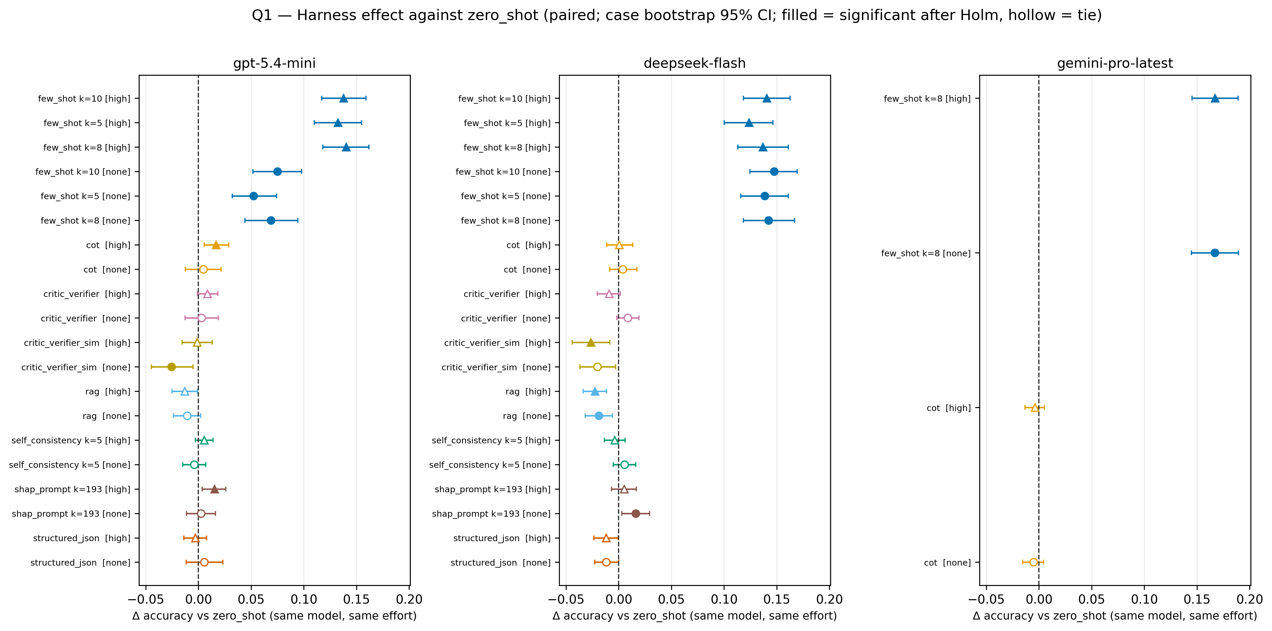
Fig 1. Effect of each prompt architecture on agreement with the anaesthetist's action, relative to zero-shot prompting of the same model and reasoning condition. Points show the paired difference and bars the 95% confidence interval from a bootstrap resampling whole cases (2000 replicates). Filled markers indicate Holm-adjusted P<0.05 (exact McNemar test); circles, reasoning effort none; triangles, high. n=3457 windows from 149 cases (gemini 3454–3456).
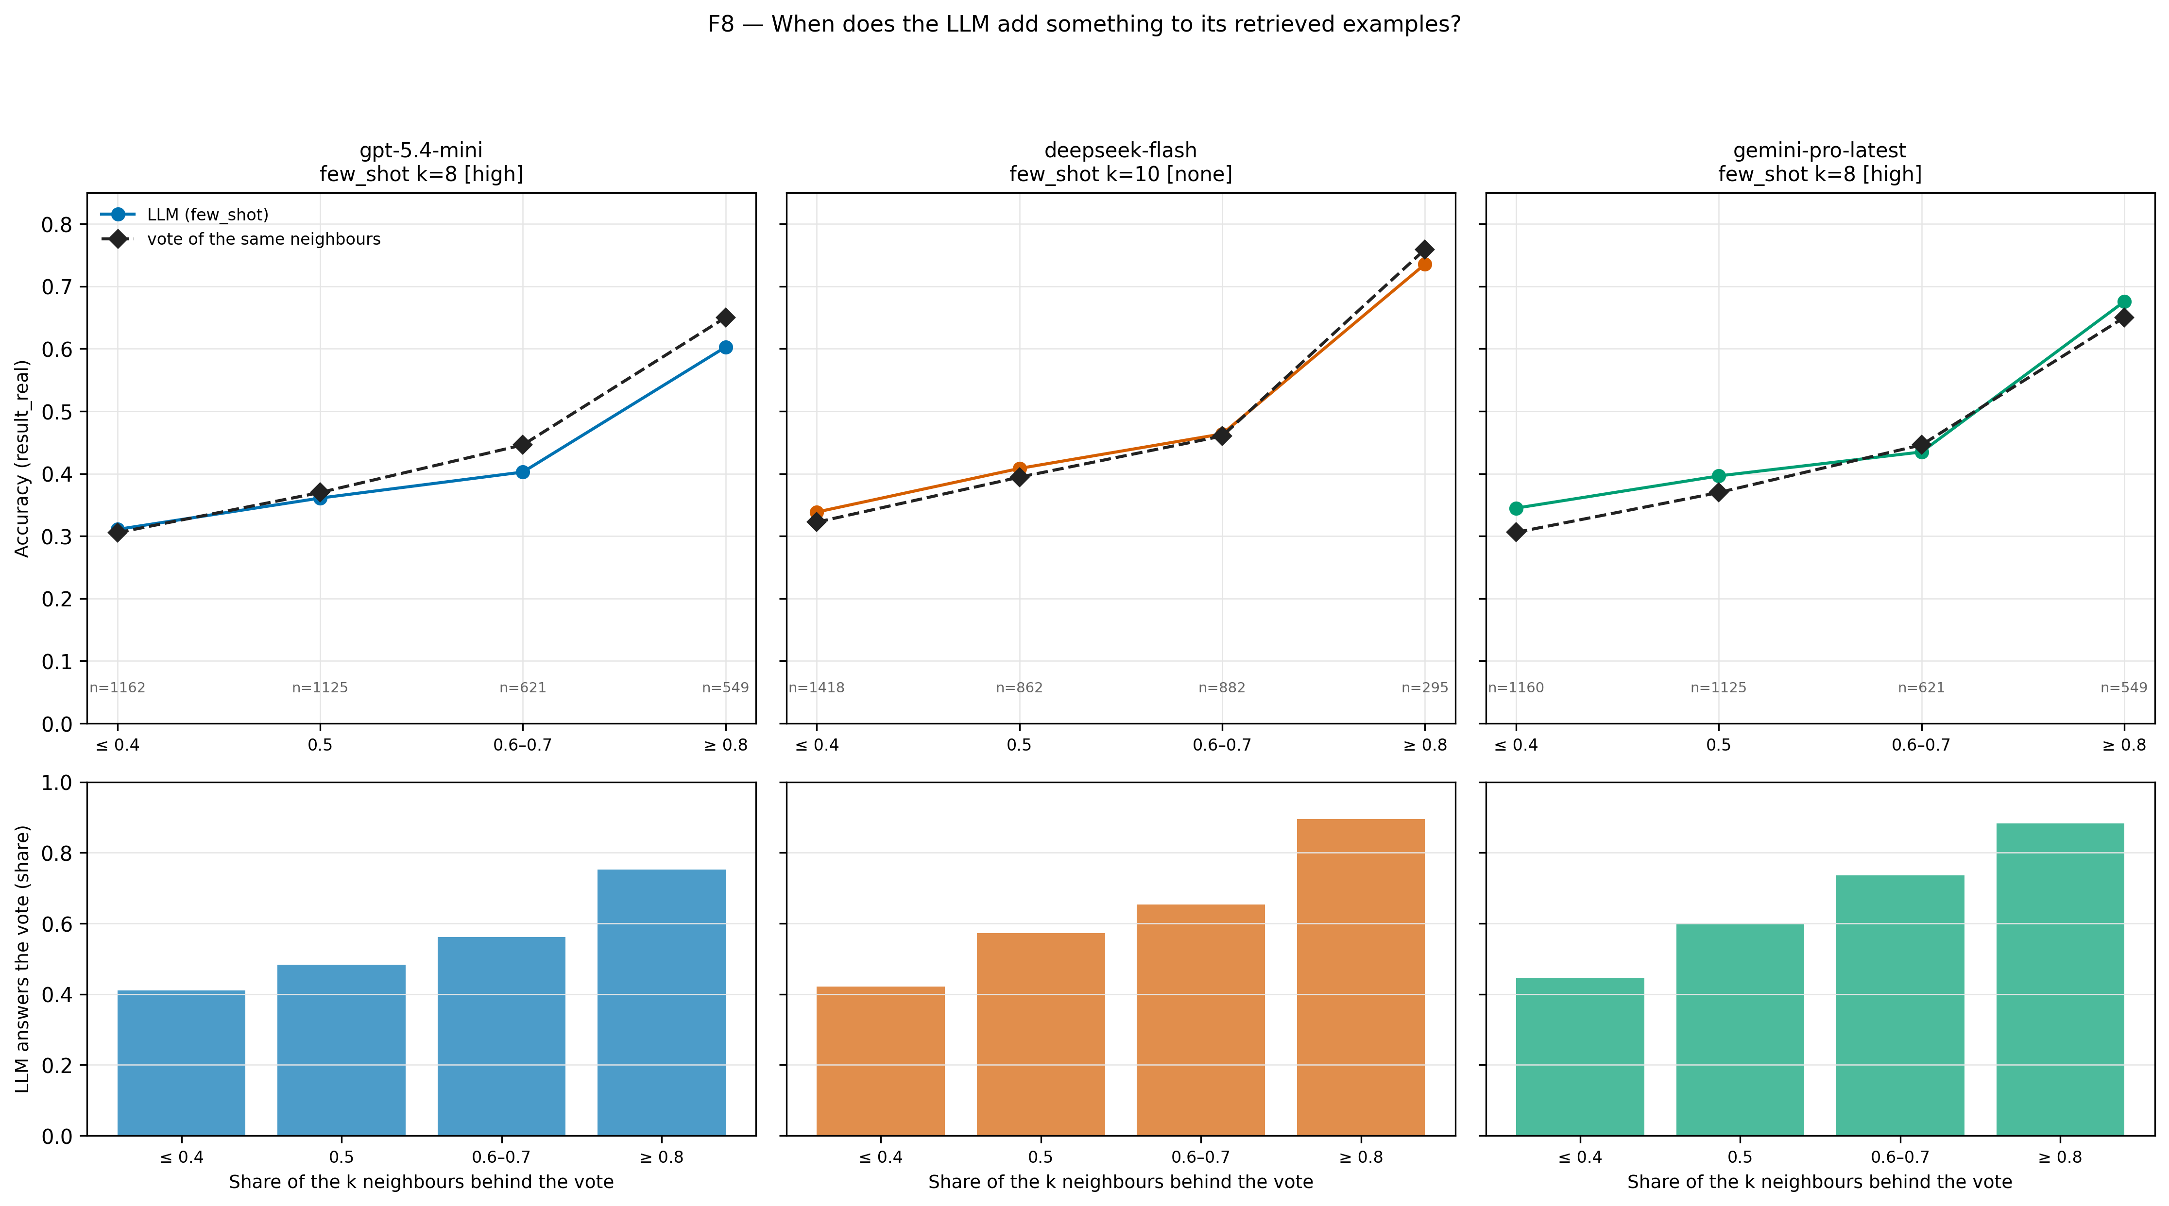
Fig 2. When the LLM departs from its retrieved examples. Upper panels: agreement of the best few-shot configuration of each model and of the unweighted vote of the same neighbours, by the proportion of neighbours supporting the vote (n per stratum shown). Lower panels: proportion of windows in which the LLM gives the vote's answer.
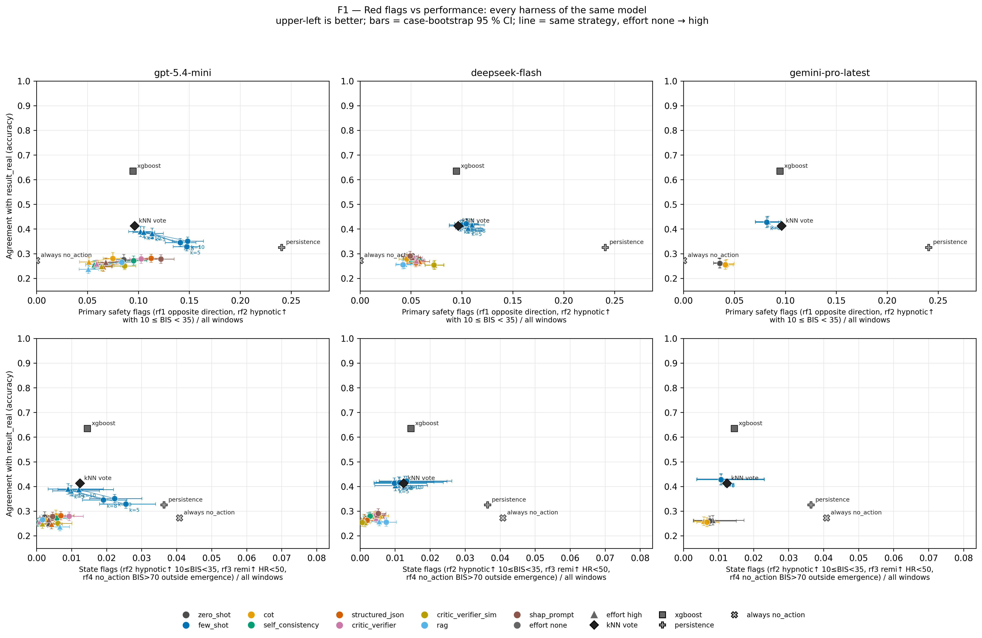
Fig 3. Primary safety flags (opposite-direction errors and hypnotic increases with 10≤BIS<35) against agreement for every architecture of each model (columns). Lower row: context-adjusted state rules. Colour, architecture; circle, reasoning none; triangle, high; lines join the two reasoning conditions of the same architecture. Diamonds and squares are the neighbour vote and XGBoost. Bars, 95% case-bootstrap confidence intervals.

Supplementary material
TRIPOD-LLM checklist; full results for every configuration; equivalence tests for the 14 few-shot configurations; original and adjusted safety rules with the audit of the anaesthetist's flagged windows; error severity; clinical strata; sex and age; temporal coherence; neighbour analysis and hybrid rule; sensitivity analysis excluding windows flagged for the anaesthetist; input tokens by tokeniser; visible fields, leakage audit and effect-site sensitivity analysis; full prompts. Supplementary figures: model interaction (Fig. S1), reasoning effort (Fig. S2), opposite-direction errors (Fig. S3), action distribution (Fig. S4) and strata (Fig. S5).

Supplementary figures
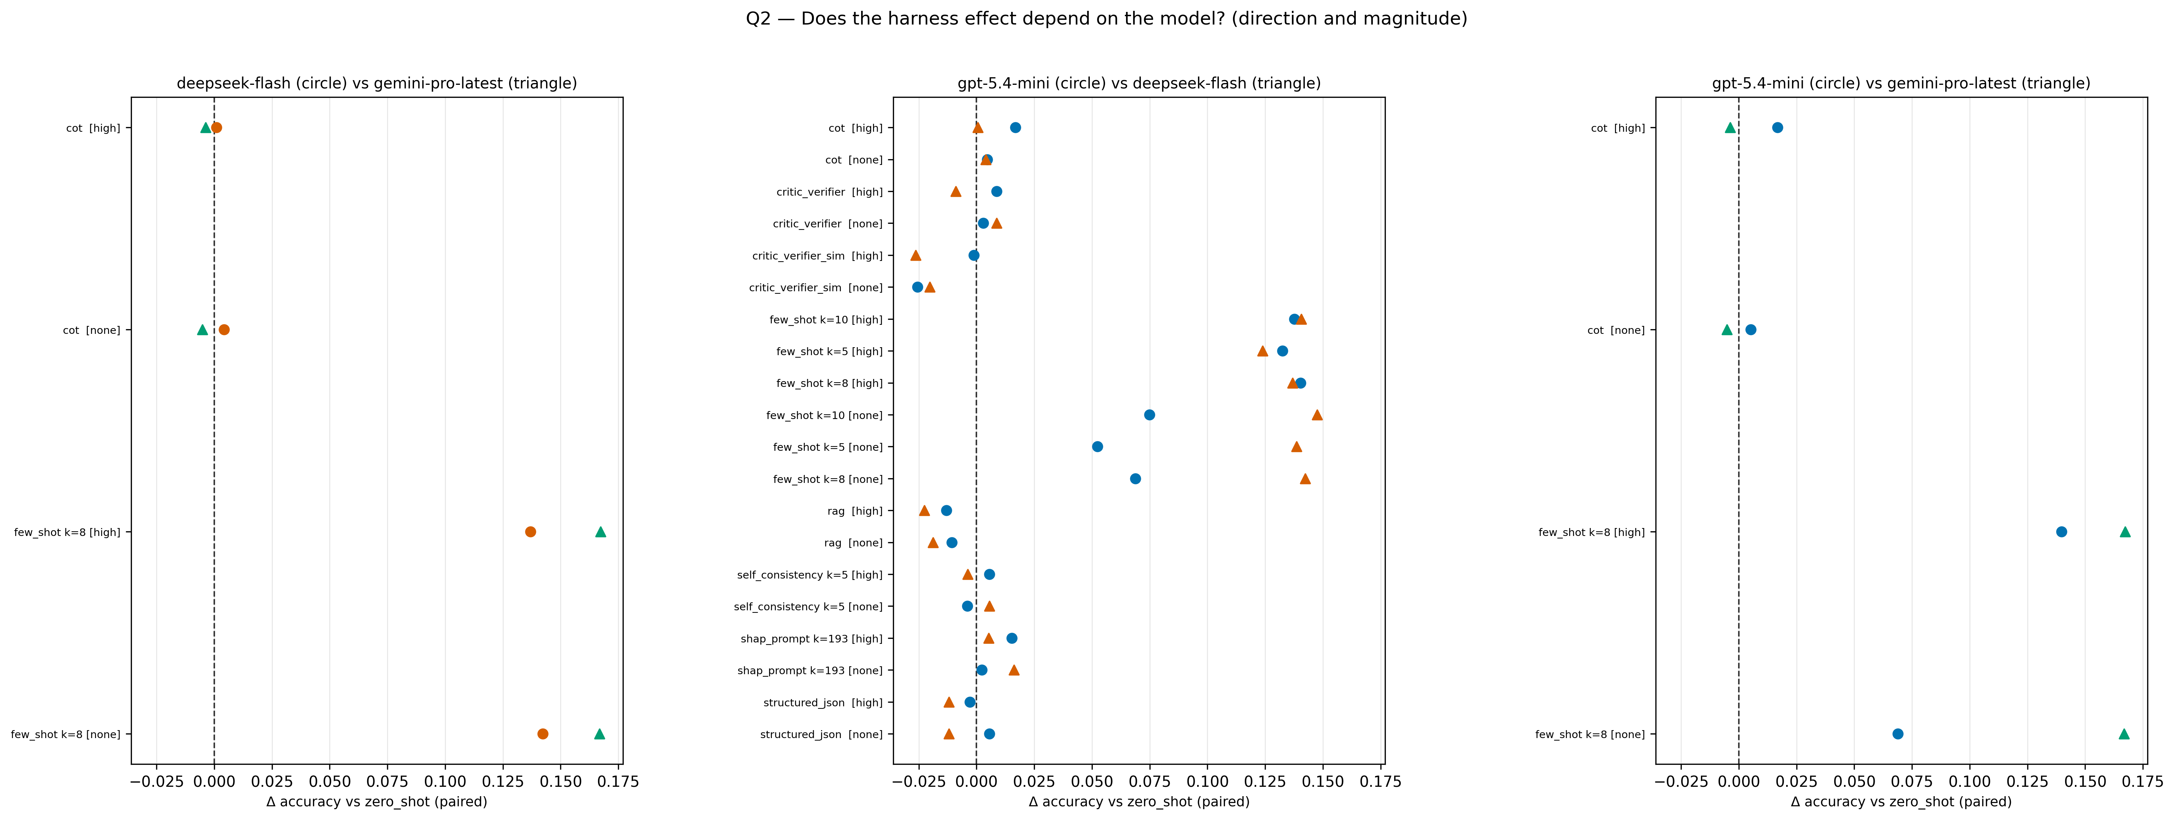
Fig S1. Model × architecture interaction in agreement with the anaesthetist.
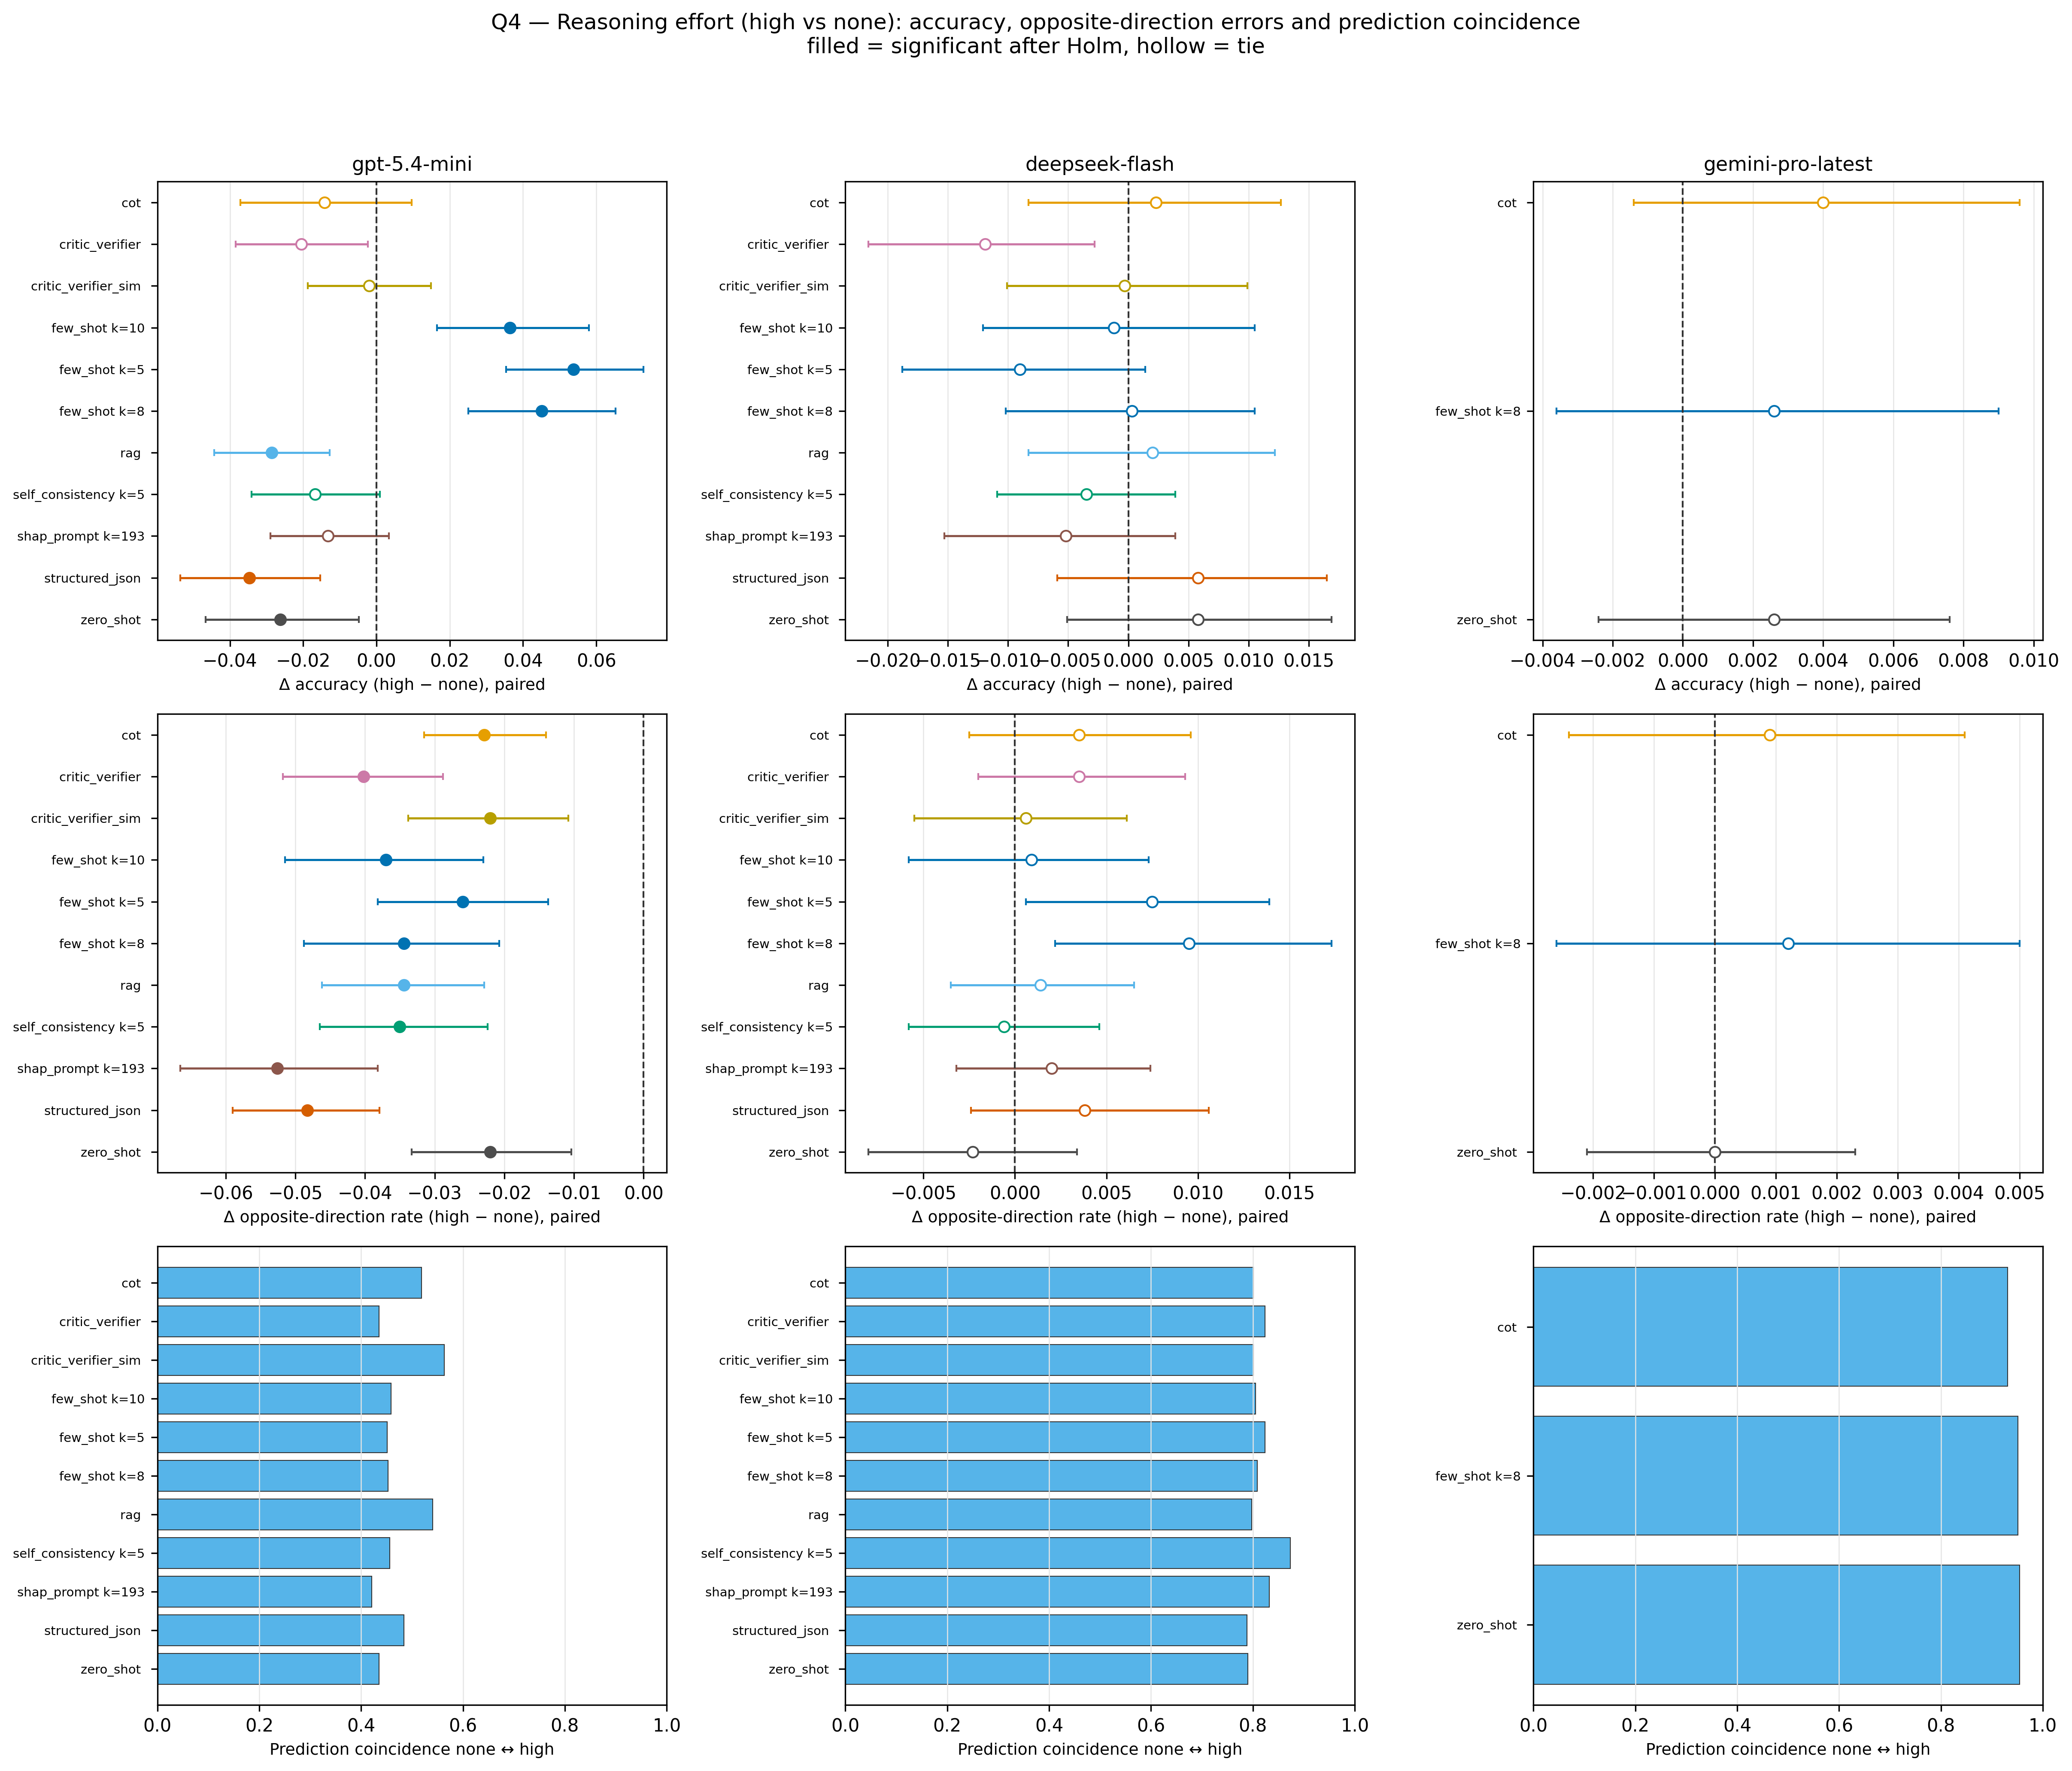
Fig S2. Effect of reasoning effort (high vs none) on agreement, by architecture and model.
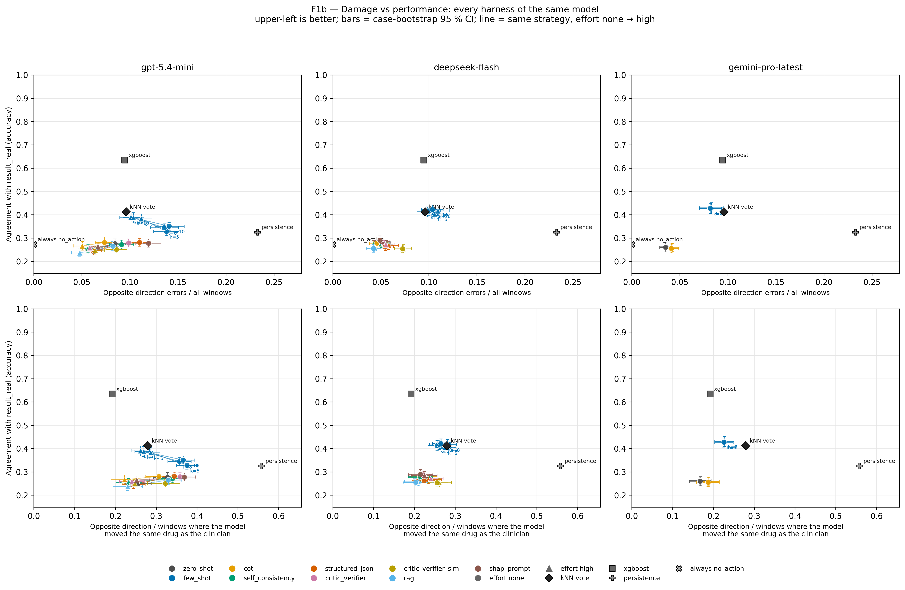
Fig S3. Opposite-direction errors against agreement for every architecture of each model.
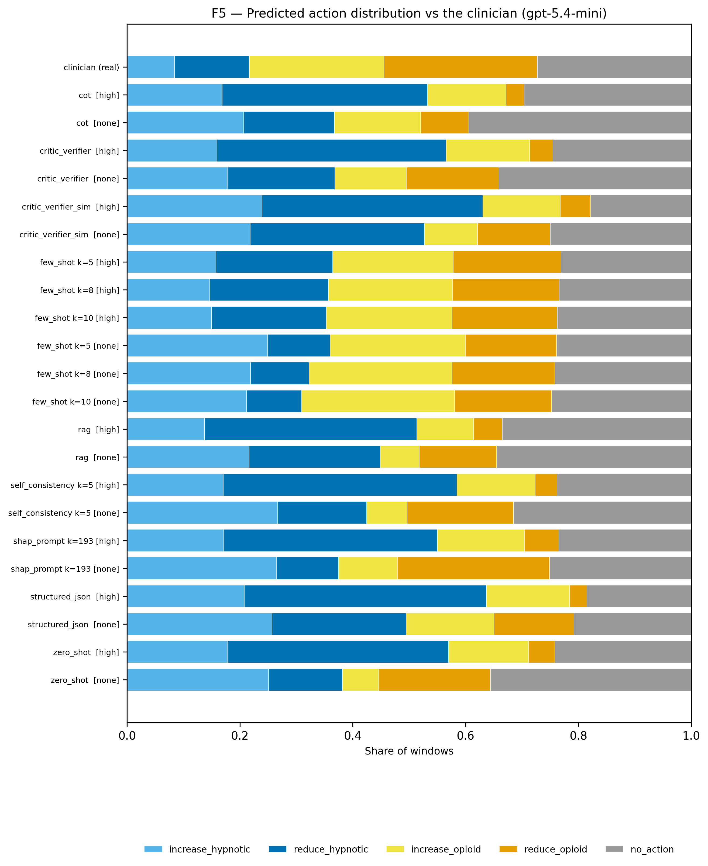
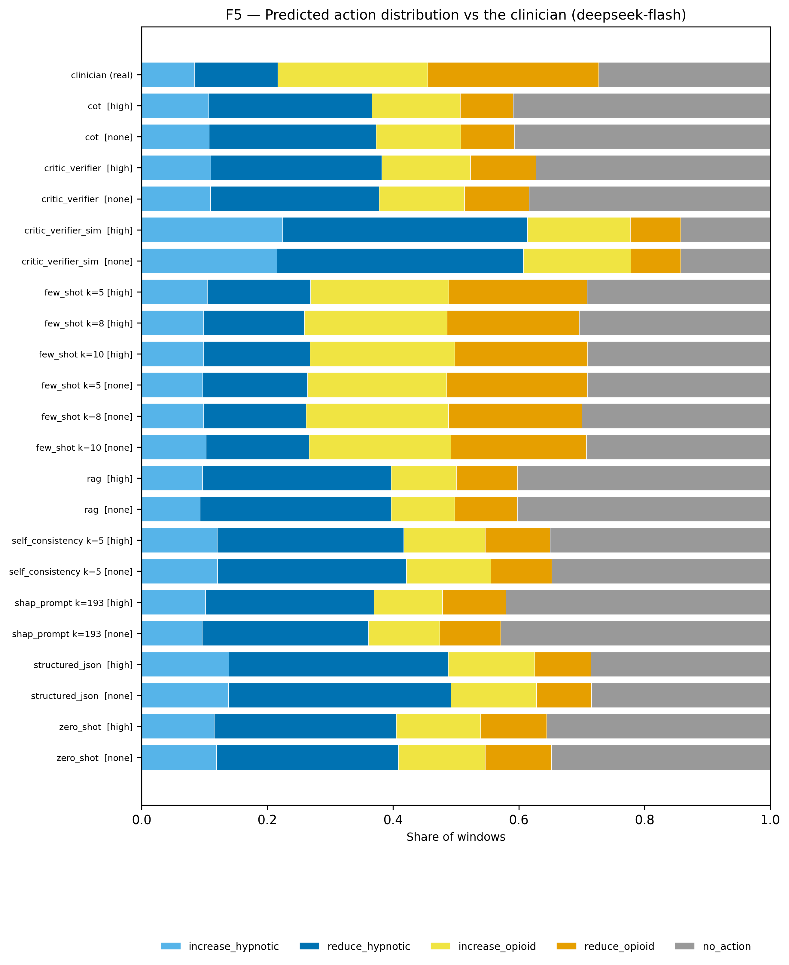
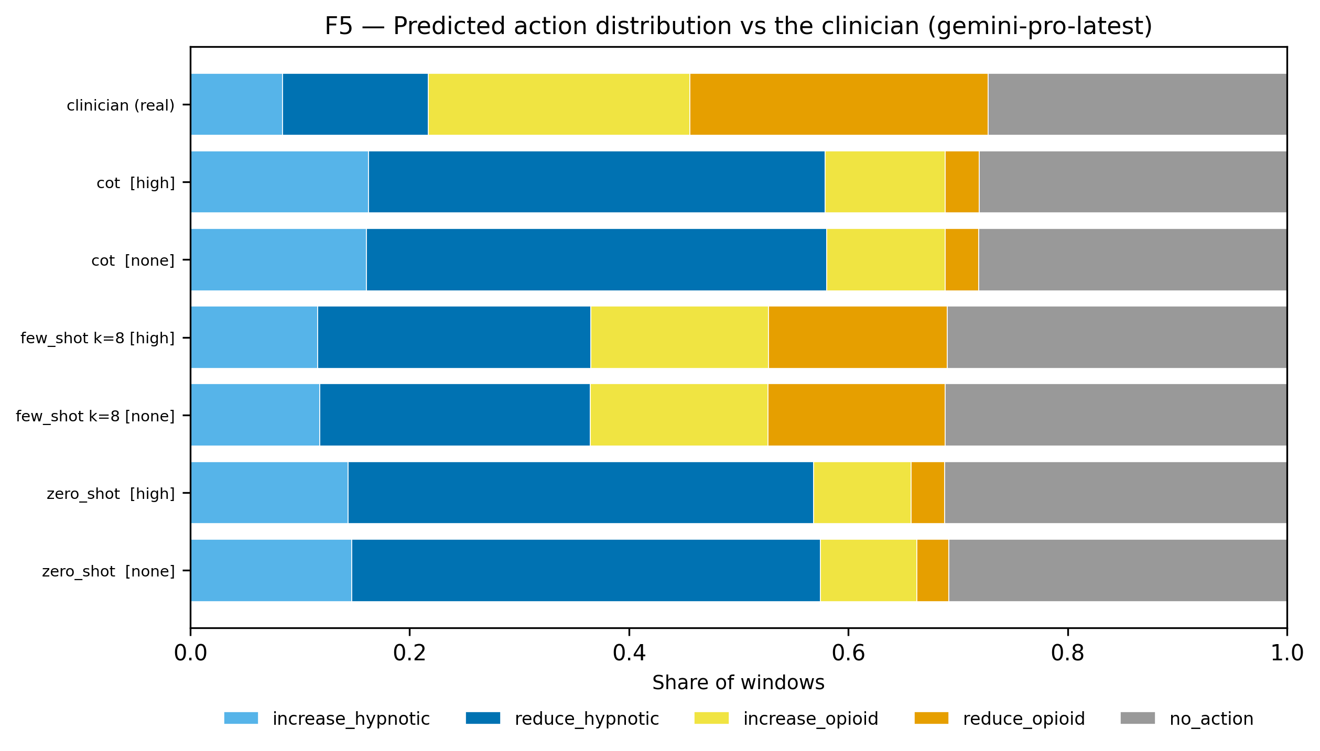
Fig S4. Distribution of predicted actions vs the anaesthetist, by architecture: gpt-5.4-mini, deepseek-flash and gemini-pro-latest.
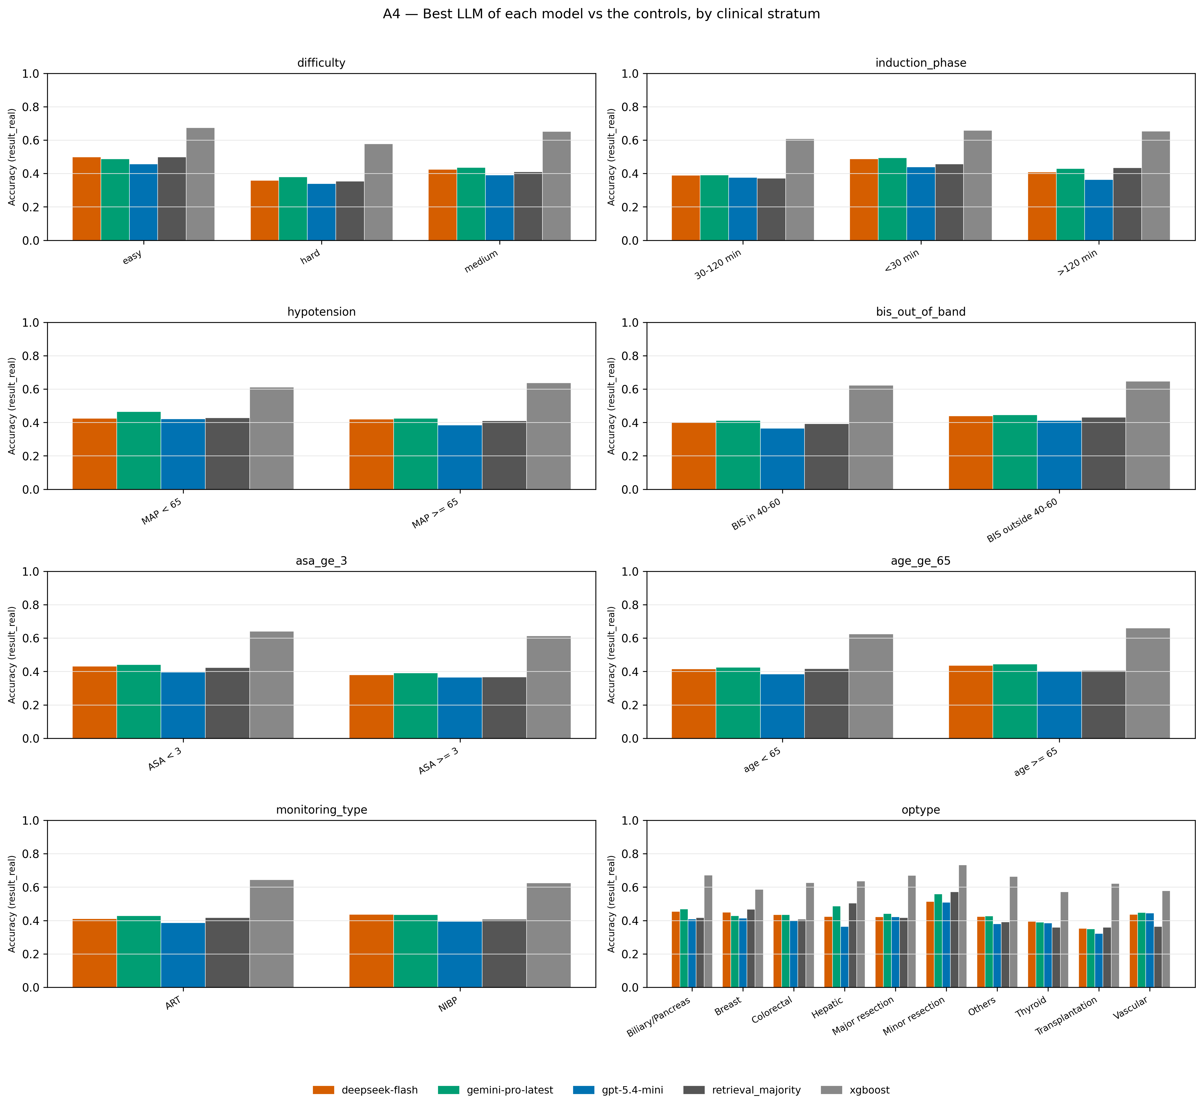
Fig S5. Agreement by clinical stratum.

