# Correlation between Web Design and User-Participation Experiments

By Sethuraman Srinivasan

# Abstract

The report illustrates about the two user-participation experiments conducted in Psychology department at Australian National University and discusses about the relevance of those experiments to web design and development. The first experiment investigates about the early stages of attention, especially on how they are affected by emotions. The second experiment focuses on the information sampling behaviours and their relationships with individual difference variables. Inspirations have been drawn from the two experiments and are discussed.

# Introduction

In the process of developing an interactive web development system, it is essential to conduct user evaluations of those systems. This report illustrates the following experiments regarding the user evaluation of those systems:

* Experiment 1 - Investigating the effects of depression on the early stages of attention
* Experiment 2 - Information sampling and individual differences

Each experiment has been elucidated on the grounds of the purpose and the steps involved in the experiment, the experience of participating in the experiment, and the user feedback about the experiment. A comparison between both the experiments has been discussed. Then the relevance of user-participation experiments to web design and development is studied.

# Investigating the effects of depression on the early stages of attention

# Summary:

The purpose of the experiment was to investigate the early stages of attention, which includes the following:

* How humans process short time intervals
* How early stages of attention are affected by emotions
* Any symptoms of depression and anxiety

I was asked to view a sequence of images, one of which would be rotated 90 degrees either clockwise or counter-clockwise, another of which consists of either nudity, erotica, unpleasant injuries, blood, violence or weapons, and my task was to identify whether the rotated image was in clockwise or counter-clockwise direction. The sequence of images was displayed very rapidly, and the task was repeated numerous times (Research School of Computer Science 2017).

# Experience:

I was asked to do a mechanical task. Like mentioned above, I had to view a sequence of images and had to identify whether the rotated image is in clockwise or counter-clockwise direction. I did enjoy taking part in the experiment because it helped me to judge my attention level, whether I could identify the exact direction of the image in the rapidly displaying scenario. The steps to follow in the experiment were in the range of in between easy and medium. The reasons are the following:

* Rapidly displaying images i.e. each image was displayed for less than half a second.
* When an image of nudity or of blood appears, it distracts the attention of identifying the direction of the rotated image.

I understood what I was asked to do in the experiment, which was to identify the direction of the rotated image for every sequence of images. During and at the end of the experiment, I was debriefed by the researcher via a set of questionnaires to ensure that I was not distressed.

# Feedback:

The main strength of the experiment is that it took place in a well-organised manner as it was not conducted in a group fashion. At one point in time, only one person participated in the experiment supervised by the PhD student. Since this was a depression based experiment, conducting the experiment on an individual basis was the right approach because the participant is given full attention by the supervisor throughout the experiment.

The ultimate aim of the experiment that was described in the information sheet was to understand more about how the human attentional mechanism can vary in different situations, and how the attentional mechanisms are affected by symptoms of depression, anxiety and stress. I believe that the weakness of the experiment is to rely on a single experiment to work on multiple goals.

As mentioned above, the experiment displays a distressing image to the participant in the sequence of images, and despite viewing the image, the participant must be able to concentrate on the direction of the rotated image. As a result, the experiment allows the researcher to identify the type of distressing image, on which the participant is getting distracted i.e. the participant couldn't identify the correct orientation. Based on the distressing image, the situation and the symptoms could be deduced. Hence, I believe the experiment met the aims that were stated in the Information Sheet.

If the experiment was conducted with only few participants, the data gathered might not be reliable. As this experiment involve 100 participants, the group results, which would be used for analysis and conclusion, are reliable.

# Information sampling and individual differences

# Summary:

The purpose of the experiment is to understand the information sampling behaviours and their relationships with individual difference variables (Research School of Computer Science 2017).

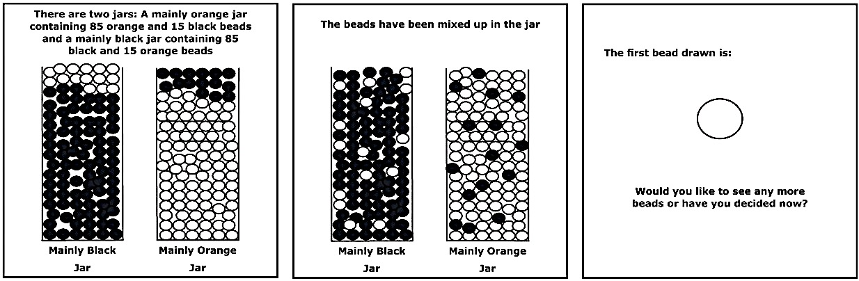

**Figure 1:** The Beads Task as seen on-screen (Philippa Garety, 2011)

The task carried out was based on the beads task paradigm – a task designed to test how information relating to how probable something relates decision-making under conditions of uncertainty. It is a typical probabilistic reasoning task in which the participants are asked to request as many pieces of evidence (coloured beads) as they would like before deciding from which of two hidden jars the beads are drawn. In the experiment, the participant is shown two jars having beads of two different colours in which one jar has more proportion of one colour and another jar has more proportion of another colour (Philippa Garety, 2011). After a bead is drawn, I had to estimate the probability of the bead belonging to Jar 1 and Jar 2.

# Experience:

In this experiment, I was asked to be an intelligent participant. My task was to make a rational judgement based on the probability of withdrawn beads from the jar. I did enjoy taking part in the experiment because it helped me to judge my decision-making quality, whether I could identify the correct jar from which the beads are drawn. The difficulty level of the experiment was in the range of medium because the experiment involved the cognitive task of decision-making. I understood what I was asked to do; I had to estimate the probability of the drawn beads belonging to Jar 1 and 2. I had to estimate the probabilities until 20 beads were drawn, and after that I had to make the decision on which jar the beads were drawn.

# Feedback:

I believe that the strength of the experiment is that a demo task was provided, ahead of the original task, for the participants to get comfortable with the experiment process. My opinion on the weakness of the experiment is that the participants could have been given feedback on their decision-making quality after the completion of required task.

I consider that the experiment met the aims that were stated in the Information Sheet. In a nutshell, the experiment's goal is to investigate how certainty may relate to being comfortable to decide under less certain circumstances. In the experiment, we were asked to find the probability of the jar from which the beads were being drawn. The circumstances provided were very less, because, the only advantage the participant had is that he had the history of the colour of the beads drawn.

The experiment was conducted in a well-organised manner. Each participant was provided a separate computer, so that he doesn’t have to wait for other participants to start the experiment. I consider that the data collected from the experiment might not be reliable as it is a cognitive based task and the decision-making capacity varies from person to person.

# Comparison of two experiments

|  |  |
| --- | --- |
| First Experiment | Second Experiment |
| It was more of a mechanical task where I must follow the given instructions. | It was a cognitive based one where I had to make decisions based on probabilities. |
| At a time, the experiment was conducted for only one participant. As it was based on emotions, constant supervision must be provided to the participant. | The experiment was conducted for multiple participants at a time. As it was not based on either emotions or stress, an overall supervision is sufficient. Each participant was provided a computer. |
| As the experiment involved questionnaires about my mind set and daily habits to test the distress level, they made me think about a lot of events in my past. The experiment helped me to reflect on few events. | As the experiment is only about probabilities and decision-making, I felt neither happy nor sad about taking part in the experiment. |
| Both the experiments were run in a well-organised manner with adequate supervision. | |

# Web-Design and Development

Human Computer Interaction is the study, planning, and design of what happens when users and the computer collaborate (Danino, 2001). The interaction occurs at the user interface. My first experiment was about emotions and stress. The goals of HCI are to produce usable and safe systems, as well as functional systems. I learnt that the images, videos, and animations used in the website should not disturb the users mentally. Initially, I used dark red colour for the banner of the website. After taking part in the experiment, I changed the colour to mild brown. The first experiment did not have any UI elements except images. The second experiment involved a lot of user interactions when compared to the first experiment. In the first experiment, I just had to press the left or right arrow key to indicate the orientation of the rotated image. In the second experiment, which was a probability based experiment, I had to use the sliders to indicate the probability of the beads being drawn from the first jar. If text boxes were used instead of sliders to indicate the probability, it would have been less convenient for the user the interact. I learnt that the user convenience is more important when input data is required from the users.

Usability measures the quality of a user’s experience when interacting with a product or a system (Huang, n.d.) . On developing user-evaluation experiments, appropriate evaluation approach and methods should be determined with respect to the identified goals. Then, the practical issues in the identified approach should be analysed and appropriate steps should be taken. While dealing with all the factors, users rights should always be favoured.

# Conclusion

A more detailed analysis had been done on the above-mentioned experiments and had been compared. From the first experiment, a lesson had been learnt about the usage of images, colour, and other media on the website which should not affect the users psychologically. The second experiment inspired to use appropriate elements on the website that should be comfortable to the users. Human-Computer Interaction can be improved by identifying the apt user-evaluation experiment and improving the website design by correlating with the feedback from the experiment.

# References:

Danino, N., 2001. *Human-Computer Interaction and Your Site.* [Online]   
Available at: https://www.sitepoint.com/computer-interaction-site/  
[Accessed 27 May 2017].

Huang, T., n.d. *INFO5993 IT RESEARCH METHODS.* [Online]   
Available at: http://www.cs.usyd.edu.au/~info4990/2009s2/rm06b.pdf  
[Accessed 26 May 2017].

Philippa Garety, D. F. S. J. K. R. H. W. G. D., 2011. Jumping to conclusions: the psychology of delusional reasoning. *Advances in Psychiatric Treatment,* 1 August, Volume 17, pp. 332 - 339.

Research School of Computer Science 2017, *Information Sampling and Individual Differences*, practical & tutorial manual, The Australian National University, Canberra.

Research School of Computer Science 2017, *Investigating the effects of depression on the early stages of attention*, practical & tutorial manual, The Australian National University, Canberra.