ASSIGNMENT 4

Ramsey King

2021-04-24

# Markdown Basics

## Favorite Foods

1. French Fries
2. Cheesecake
3. Dark Chocolate

## Images

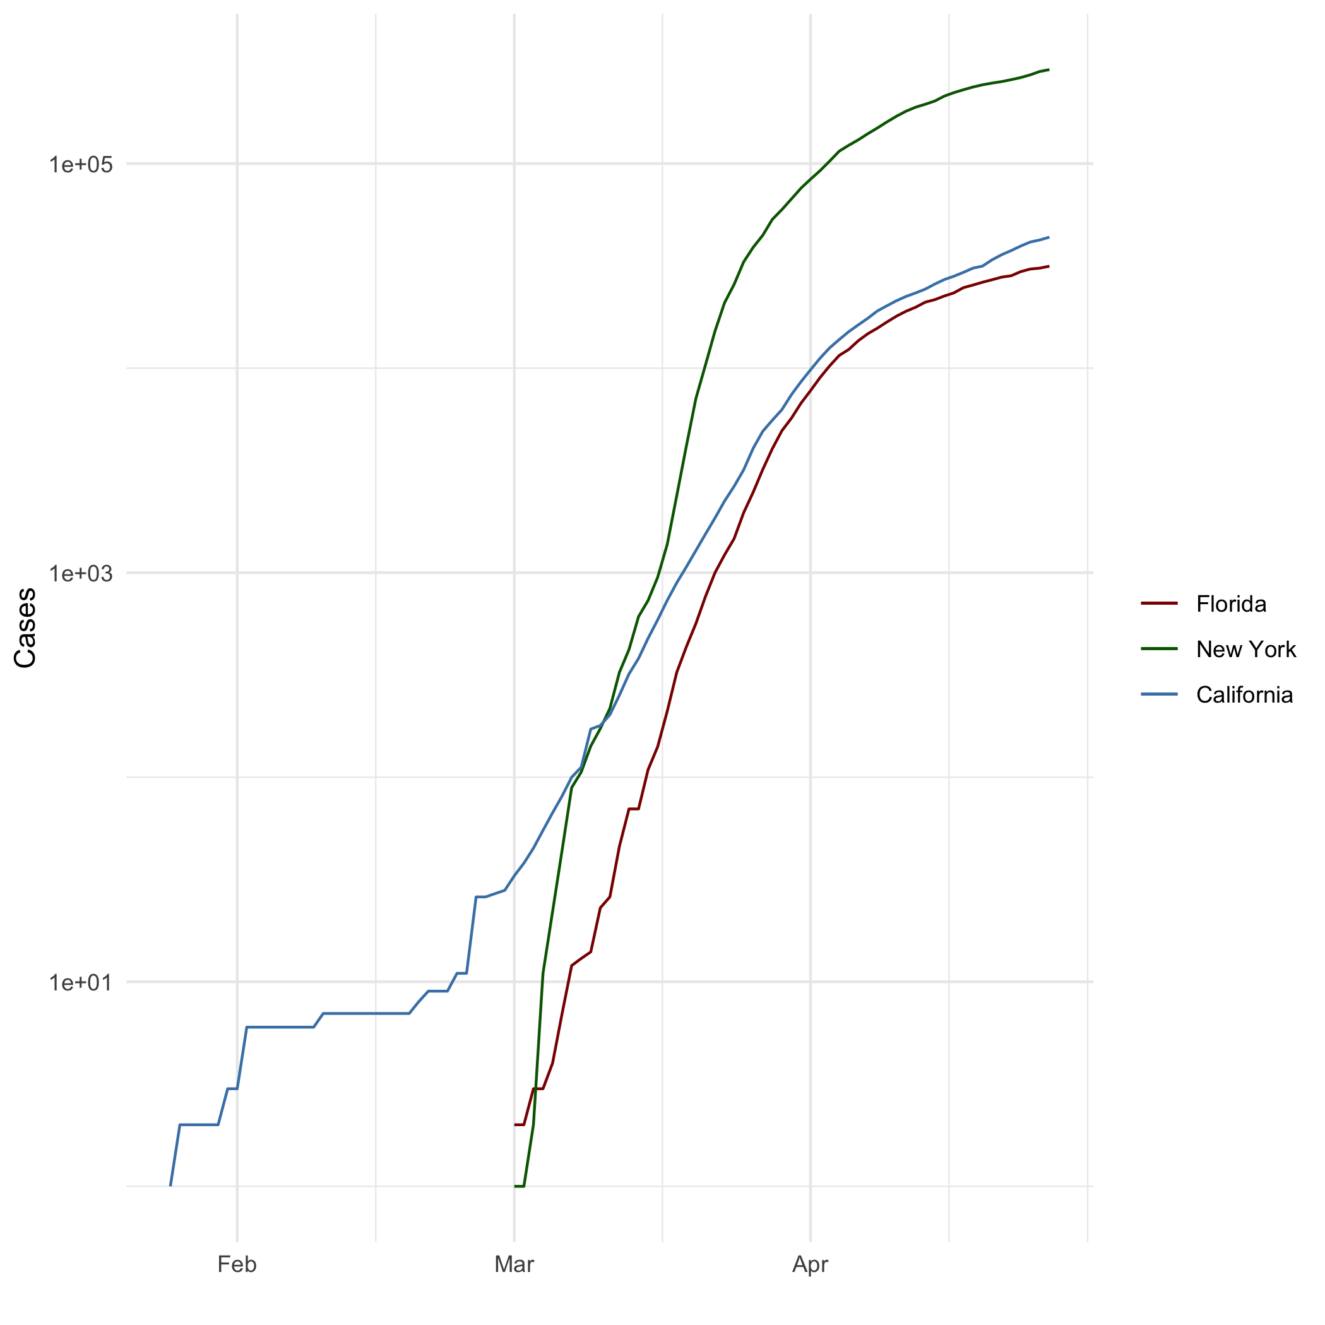

All Cases (Log Plot)

## Add a Quote

Our deepest fear is not that we are inadequate. Our deepest fear is that we are powerful beyond measure. It is our light, not our darkness that most frightens us. We ask ourselves, ‘Who am I to be brilliant, gorgeous, talented, fabulous?’ Actually, who are you not to be? You are a child of God. Your playing small does not serve the world. There is nothing enlightened about shrinking so that other people won’t feel insecure around you. We are all meant to shine, as children do. We were born to make manifest the glory of God that is within us. It’s not just in some of us; it’s in everyone. And as we let our own light shine, we unconsciously give other people permission to do the same. As we are liberated from our own fear, our presence automatically liberates others.

## Add an Equation

$$c^{2}=a^{2}+b^{2}$$

## Add a Footnote

This is a footnote[1]

## Add Citations

* R for Everyone cited (Lander 2014)
* Discovering Statistics Using R cited (Field, Miles, and Field 2012)

# Inline Code

## NY Times COVID-19 Data

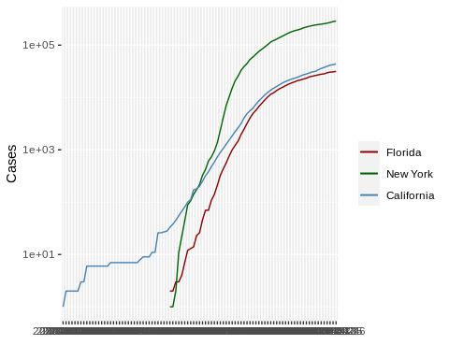

## R4DS Height vs Earnings

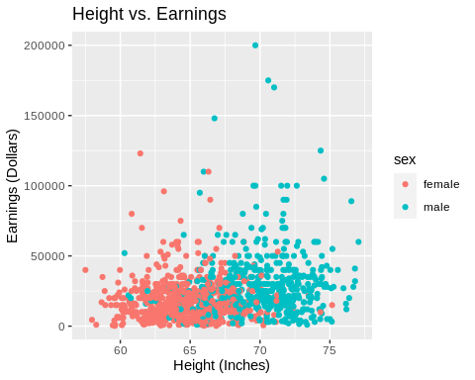

# Tables

## Knitr Table with Kable

One Ring to Rule Them All

|  |  |  |  |  |
| --- | --- | --- | --- | --- |
| name | race | in_fellowship | ring_bearer | age |
| Aragon | Men | TRUE | FALSE | 88 |
| Bilbo | Hobbit | FALSE | TRUE | 129 |
| Frodo | Hobbit | TRUE | TRUE | 51 |
| Galadriel | Elf | FALSE | FALSE | 7000 |
| Sam | Hobbit | TRUE | TRUE | 36 |
| Gandalf | Maia | TRUE | TRUE | 2019 |
| Legolas | Elf | TRUE | FALSE | 2931 |
| Sauron | Maia | FALSE | TRUE | 7052 |
| Gollum | Hobbit | FALSE | TRUE | 589 |

## Pandoc Table

Pandoc Grid Table

|  |  |  |  |  |
| --- | --- | --- | --- | --- |
| Name | Race | In Fellowship? | Is Ring Bearer? | Age |
| Aragon | Men | Yes | No | 88 |
| Bilbo | Hobbit | No | Yes | 129 |
| Frodo | Hobbit | Yes | Yes | 51 |
| Sam | Hobbit | Yes | Yes | 36 |
| Sauron | Maia | No | Yes | 7052 |

# References

Field, A., J. Miles, and Z. Field. 2012. *Discovering Statistics Using r*. SAGE Publications. <https://books.google.com/books?id=wd2K2zC3swIC>.

Lander, J. P. 2014. *R for Everyone: Advanced Analytics and Graphics*. Addison-Wesley Data and Analytics Series. Addison-Wesley. <https://books.google.com/books?id=3eBVAgAAQBAJ>.

1. Refers to the footnote