**MINOR PROJECT II**

**SYNOPSIS**

**ON**

**Cost Estimation Tool for Resource Allocation Service using java**

**in Linux**

**Submitted By**

|  |  |  |  |
| --- | --- | --- | --- |
|  | Ayush Vyas | Nikhil Gupta |  |
|  | 500029928 | 500030106 |  |
|  |  |  |  |

***Under the guidance of***

**Mr. Gagandeep Singh**

**Assistant Professor CIT Department, UPES**

Department of Computer Science & Engineering,



**Department of Computer Science and Engineering,**

**Centre for Information Technology,**

**UNIVERSITY OF PETROLEUM AND ENERGY STUDIES**

**Dehradun-248007**

**2016**



**Centre for Information Technology**

**University of Petroleum & Energy Studies, Dehradun**

**Project Proposal Approval Form (2015-16)**

 II

**Minor**

**Project Title:** Cost Estimation Tool for Resource Allocation Service using java in Linux.

**Abstract:**

In this concept, the users pay only for the resources that they use. But the problem here is that different services cost users differently and a wrong choice of technology or combination of services can monumentally increase their costs. The code should divide this monthly budget of the customer by number of minutes in a month and store it in the database against the entry of each customer. During the system usage, the resource utilization of the customer must be recorded in a database every minute. So in any given minute, if the utilization by the customer exceeds the maximum per minute cost the customer has specified, then a notification should notifying him of this issue.

**Introduction:**

The cloud computing model is changing how the technology solutions are accessed and consumed by the users. The most important component of Cloud Based services is the PAYG model. This means customers do not pay a fixed price per month for using these services but instead pay as per the amount of computation capacity they have used. This means, the total memory they have used in the hard disk, the amount of RAM their applications have utilized, the amount of processing power they wanted etc. are all taken into consideration for computing the billable.

**Problem Statement:**

When a Customerhosted an application in cloud which uses heavy processing power then they must check their algorithms before uploading the code on to the servers, for every 1MB of RAM used is change some fixed amount per minute, similarly there is a charge for every 1MB of Hard Disk that has been used per minute, number of minutes each processor was running the applications else the bill will be coming too high. but the customer may not be aware of this issue. which sometimes motivates them to leave these PAYG models and go to fixed monthly costings instead. Hence there is a need to create an application which will take from the customer the maximum monthly budget they have as input. if the utilization by the customer exceeds the maximum per minute cost the customer has specified, then an SMS/Email should go to the customer notifying him of this issue. By doing this, the company can ensure satisfied customers and lesser dropouts due to bills every year.

**Literature Review:**

Magnito Servers Farms Pvt Ltdis a latest company established in Siberia with a vision to provide low cost Cloud Based services to consumers across the world. This company has decided to setup server farms in the size of 20 Acres with complete central air conditioning and relying on a power grid that draws power from both renewable and non-renewable energy resources. In order to create an edge over their competition, Magnito appointed a team to study the various problems of existing Cloud Service providers so that they can address these issues in a creative manner and attract more customers from across the globe. The team came back with various issues, of which one is explained below.

Most Cloud based offerings like Amazon Cloud Services, BigRock etc. provide cloud resources on a pay-as-you-go model. This means customers do not pay a fixed price per month for using these servers but instead pay as per the amount of computation capacity they have used. This means, the total memory they have used in the hard disk, the amount of RAM their applications have utilized

**Objectives:**

The concept of Cloud computing relies on sharing of resources in a model similar to a utility (like the electricity grid) over a network. The most important component of Cloud Based services is the pay-as-you-go model. In this model, the users pay only for the resources that they use. But the problem here is that different services cost users differently and a wrong choice of technology or combination of services cam monumentally increase their costs. This system takes from the users their monthly budget and computes at any point of time their monthly cost on the basis of their average usage till date. If the costing is going beyond their monthly budget, it notifies the user via an email by giving exact breakup of services and the projected cost based on existing usage.

**Methodology:**

1. Flow chart Diagrams is used to explain the feature of our project.

The Flow chart diagram would help us understand the flow and the technique that is to be used.

1. First we create the connection between Host and client.
2. Then we do scripting for backend process using linux shell commands.
3. Then we will create User interface with the help of Java Programming.
4. Database of the persons with their details would be created.

* In the database all the user details would be saved and then it could be retrieved as per user requirement.
* Total Costing will be check each time at each user’s session and compare it with User budget. And if, it is beyond the limit then it will pop a warming and send the notification to the user via email.

1. Java Object Oriented Technique would be used to implement the algorithm.

**System Requirements:**

Software Requirements:

Operating System: Red Hat Enterprise Linux 7

Software: Open JDK

Programming Language: Java

Hardware Requirements:

RAM: 4.00 GB

Hard Disk: 500GB

Processor: Intel Core i3 2.40GHz

**Schedule: (PERT Chart)**

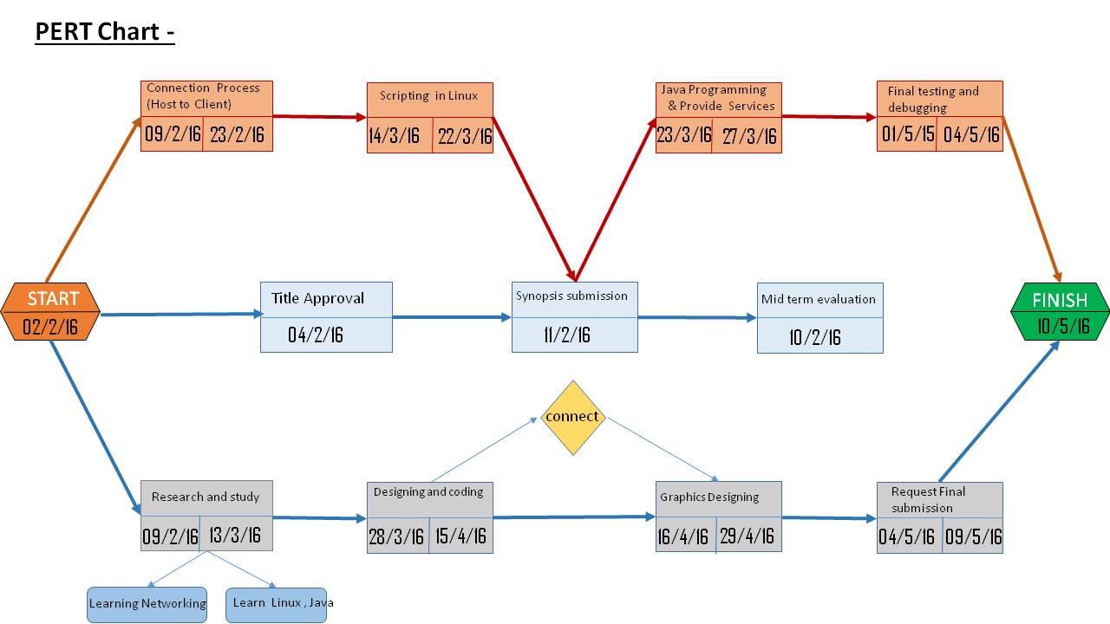

**References:**

1. <http://searchcloudprovider.techtarget.com/definition/cloud-services>.
2. <http://www.freeos.com/guides/lsst/>
3. <https://docs.oracle.com/javase/tutorial/networking/sockets/>
4. <http://www.landofcode.com/java-tutorials/java-graphics.php>
5. <http://www.tutorialspoint.com/java/>

**Approved By**

**Mr. Gagandeep Singh Mr. Hanumat G Sastry**

**Project Guide Program Head**