PiKVM v2 Build Guide
Raspberry Pi Zero 2 W, Geekworm X630 HDMI capture, OLED status display, and W5500 wired Ethernet
Author: Robert T. Ramsey II. Written October 14, 2026 and revised October 17, 2026, from two working builds.
Tested in October 2026 on two units running PiKVM OS with kvmd 4.226. The OLED behavior in section 11 comes from kvmd's current code, so check it again after a major update.

0. Before you start
This guide builds one complete unit. Build and wire all of the hardware first (sections 1 to 4), then install the software and configure it (sections 5 to 11), and finish with the checklist (section 12).

Example addresses used in this guide
Item | Example value | Notes
Wi-Fi (wlan0) | 192.168.1.11/24 | Always reachable, even with the Ethernet cable out. The Pi uses it for the traffic it starts itself, and the OLED shows this address. The Zero 2 W supports 2.4 GHz only.
Ethernet (eth0, W5500) | 192.168.1.12/24 | Optional wired path. Browse to this address when you want the wired link for video and uploads.
Gateway | 192.168.1.1 | Your router.
DNS | 192.168.1.7 | Your DNS server, or your router.

These are examples. Replace every 192.168.1.x value in this guide with addresses from your own network, in the same file positions. Keep both unit addresses outside your DHCP pool, or create reservations for them.

Conventions
- PiKVM keeps its root filesystem read-only. Run rw before you edit any file. The filesystem is read-only again after every reboot, so you only need ro if you finish without rebooting.
- Files are edited with vi. Press i to start typing, press Esc when you are done, then type :wq and press Enter to save. To leave without saving, press Esc and type :q!. To replace the whole contents of a file, open it, type :%d and press Enter to empty it, press i, paste the new contents, then save. To delete one line, put the cursor on it in command mode (after Esc) and press dd.
- Commands shown with a # prompt style are run as root. Over SSH, log in with ssh root@<ip>. The default SSH password is root, and the default web login is admin and admin.
- Power the unit off and unplug it before you connect or move any wire. Never hot plug jumpers on the GPIO header.
- Pin numbers are physical header pin numbers. Pin 1 has the square pad, and pin 2 is directly beside it across the header.

1. Parts list
Part names below match what was used in this build. Check the listing on your own order, because vendors revise board versions.
Item | Part / model | Qty | Notes
Single board computer | Raspberry Pi Zero 2 W (product code SC0510) | 1 | Needs a 2x20 male header soldered on. Buy it pre-soldered or solder it yourself.
HDMI capture | Geekworm X630 HDMI to CSI-2 bridge (TC358743) | 1 | Board is 30 x 42.4 mm. The board includes the CSI cable for the Zero, so you do not need to buy one.
OLED status display | HiLetgo 0.96 inch I2C OLED, 128 x 64, SSD1306, 4 pin | 1 | Check the silkscreen order of the four pins.
Ethernet | HiLetgo W5500 Ethernet module, HW-243 (SPI) | 1 | Power it from 5VDC. Leave its 3V3 and RST pins open.
Heatsink | Geekworm 8PCS heatsink set (Amazon ASIN B0B2CP1G23); use the 15 x 15 x 5 mm copper heatsink from the set | 1 | Lowered the CPU temperature by 13°C in this build. The Pi throttles at 80°C, and the heatsink plus the lid vents keep the unit well below that. The other pieces in the set are not used.
microSD card | 16 GB or larger, A1 rating or better, name brand | 1 | Quality matters; cheap cards fail early.
Jumper wires and housings | Single row Dupont housings, crimp pins, 24 AWG wire | as needed | Pi end: 1x4 and 1x2 and 1x1. Details in sections 2 and 3.
Screws | M1.7 x 4 mm machine screws | 14 | Pi 4, X630 4, OLED 4, W5500 2.
Washers | 1 mm thick washers to suit M1.7 | 14 | One between each screw head and PCB.
Power and host connection | See Power options below | 1 set | Choose option A, B, or C. Never connect a wall supply and a host cable without a blocker or splitter.
HDMI cable | Standard HDMI cable, short | 1 | Target HDMI output to the X630.
Ethernet cable | Cat5e or better patch cable | 1 | Into the W5500 RJ45.
Enclosure | Printed body, lid, and lettering (pikvm_body.stl, pikvm_lid_slots_green_black.3mf) | 1 | Green PLA lid with black PLA lettering. The lid has vent slots. The case in the photos was printed on a Bambu Lab P1S.

Power options
The Zero 2 W has two micro-USB ports. PWR IN carries power only. The USB port is the OTG data port; it connects to the target computer and carries the keyboard, mouse, and virtual media connection. Either port can power the unit. Any 5VDC USB source works, whatever its connector type, provided the cable matches.
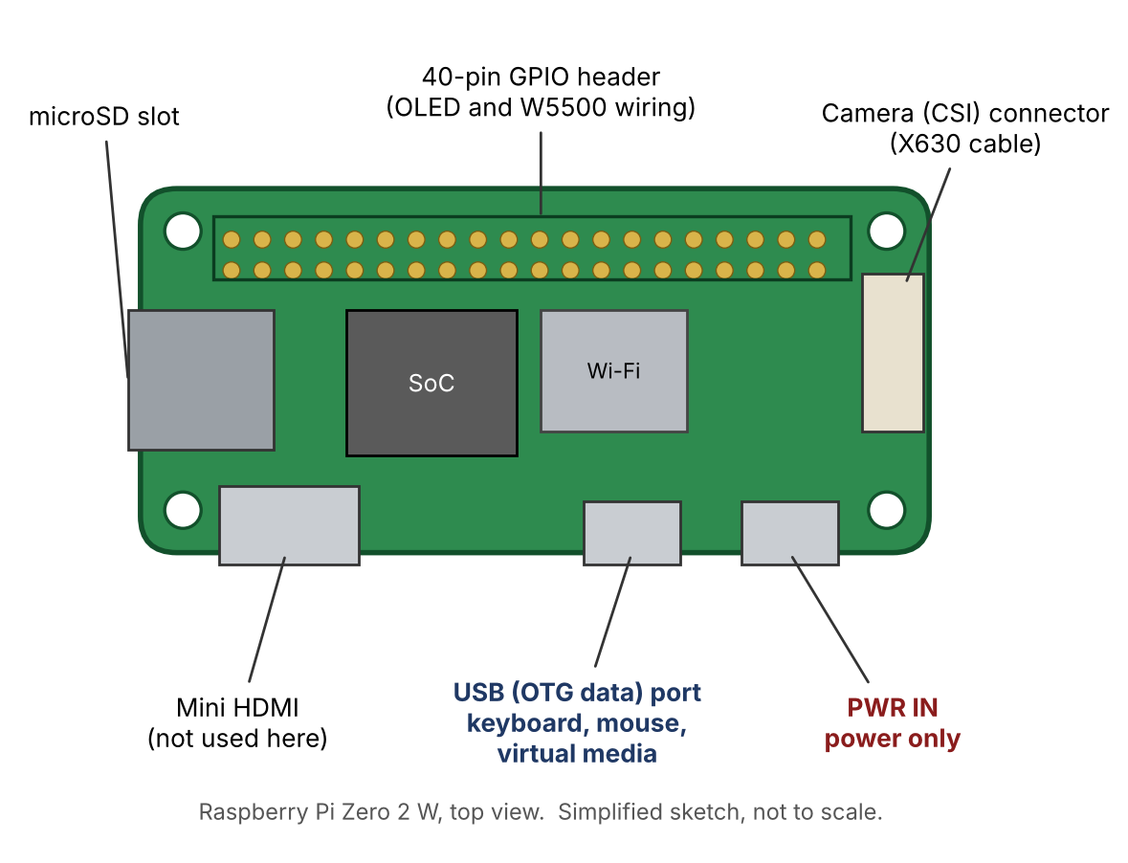
Figure 1. Ports on the Zero 2 W.
Choose one of options A, B, or C.
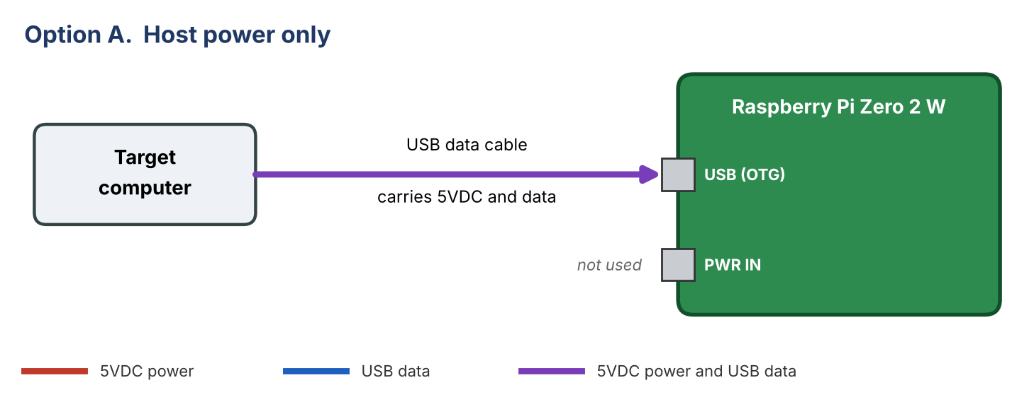
Figure 2. Option A. Simplest. A USB 2.0 port supplies 500mA and this build peaked near 0.52A, so a weak host port can brown out under load.
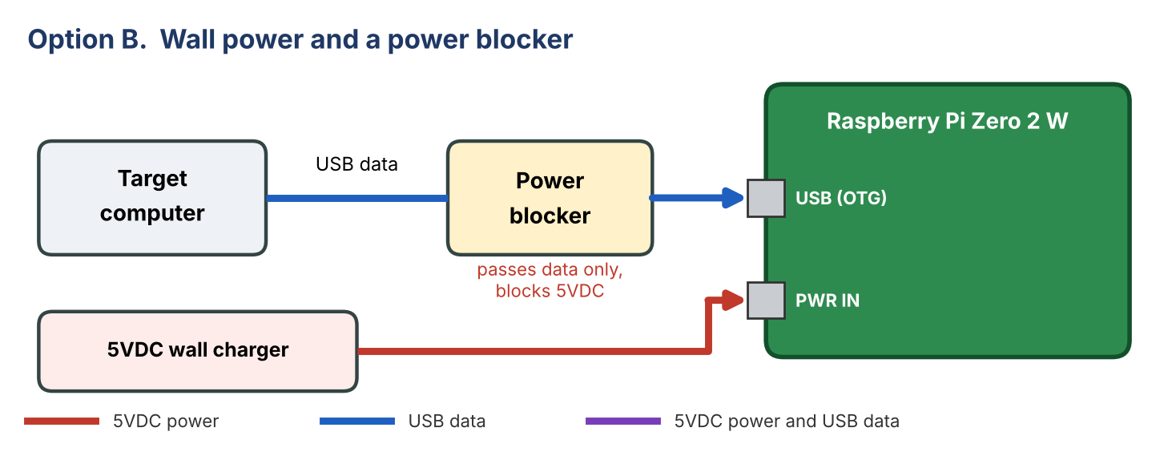
Figure 3. Option B. Parts: PortaPow USB Power Blocker (USB-A male to female) and a 5VDC USB charger. Use a USB-A to USB-C adapter if the host has only USB-C ports.
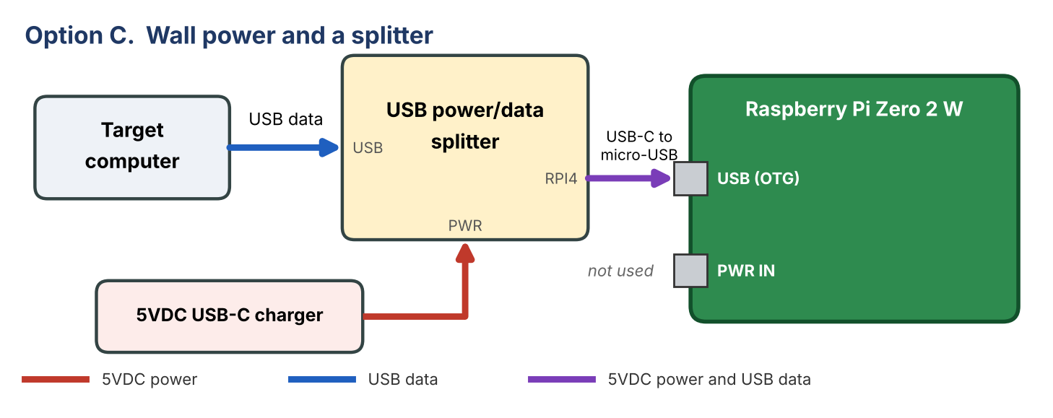
Figure 4. Option C. Parts: a USB power/data splitter with ports marked PWR, USB, and RPI4, and a USB-C to micro-USB cable. The host cable can be USB-C to USB-A or USB-C to USB-C. If the output cable goes into PWR IN instead, the unit gets power and video only, and the target sees no keyboard, mouse, or virtual media.
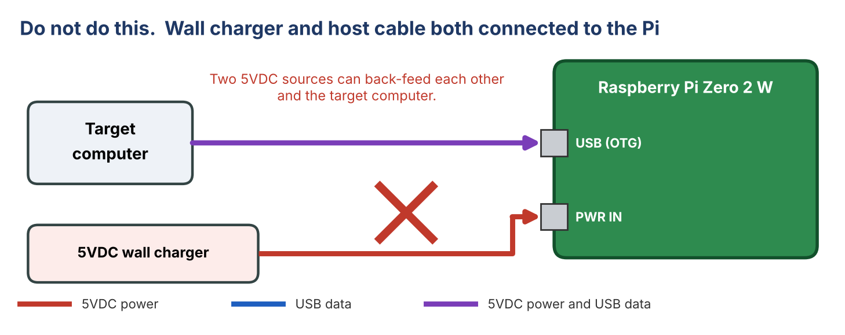
Figure 5. Never connect a wall charger and a host cable directly, with no blocker or splitter between them.
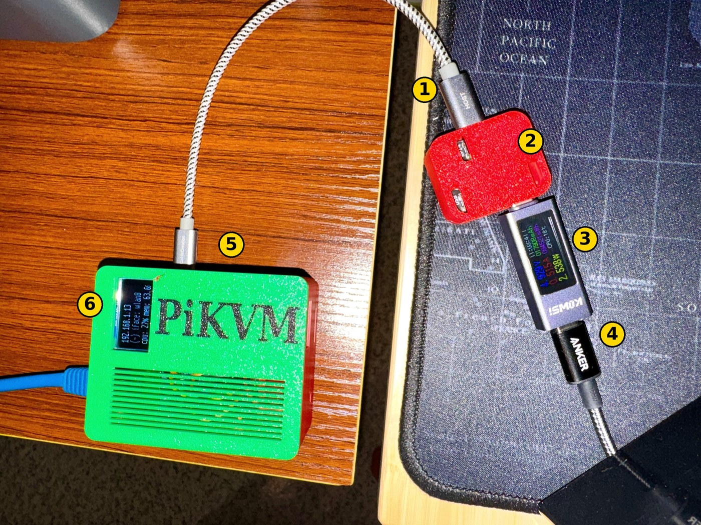
Figure 6. Option C as built. 1: host cable into the splitter USB port. 2: splitter in a printed case. 3: USB power meter. 4: USB-C charger. 5: splitter output to the Pi OTG port. 6: OLED showing the Wi-Fi address.
Measured on this build with option C and a USB power meter in line, with the X630, OLED, and W5500 fitted and Wi-Fi and Ethernet connected: 4.95VDC at 0.30A (1.5W) idle, and 4.93VDC at 0.52A (2.5W) with the CPU at 27%. A 5VDC supply rated 1A or more is enough, and 2.5A gives plenty of margin. After boot, run vcgencmd get_throttled. It should print throttled=0x0. Use a short, good quality cable, because a thin or long cable drops voltage.
Parts: PortaPow USB Power Blocker (https://portablepowersupplies.co.uk/product/usb-power-blocker). PiKVM USB power/data splitter (https://www.pishop.us/product/pikvm-usb-power-data-splitter/); similar splitters are sold on eBay and AliExpress. Printable splitter case (https://www.printables.com/model/1797404-case-for-blicube-usb-c-powerdata-splitter).

Tools
- Crimper for Dupont pins, wire stripper, small Phillips screwdriver, and a USB card reader.
- A computer with Raspberry Pi Imager, plus an SSH client.

2. Cable the OLED display

Pi header pinout
Sections 2 and 3 both use the 40-pin header. Figure 7 shows every pin, with the ones this build uses highlighted. Pin numbers are physical pin numbers. Hold the board with the microSD slot end up; pin 1 is the square pad at the top left, with odd pins down the left column and even pins down the right.
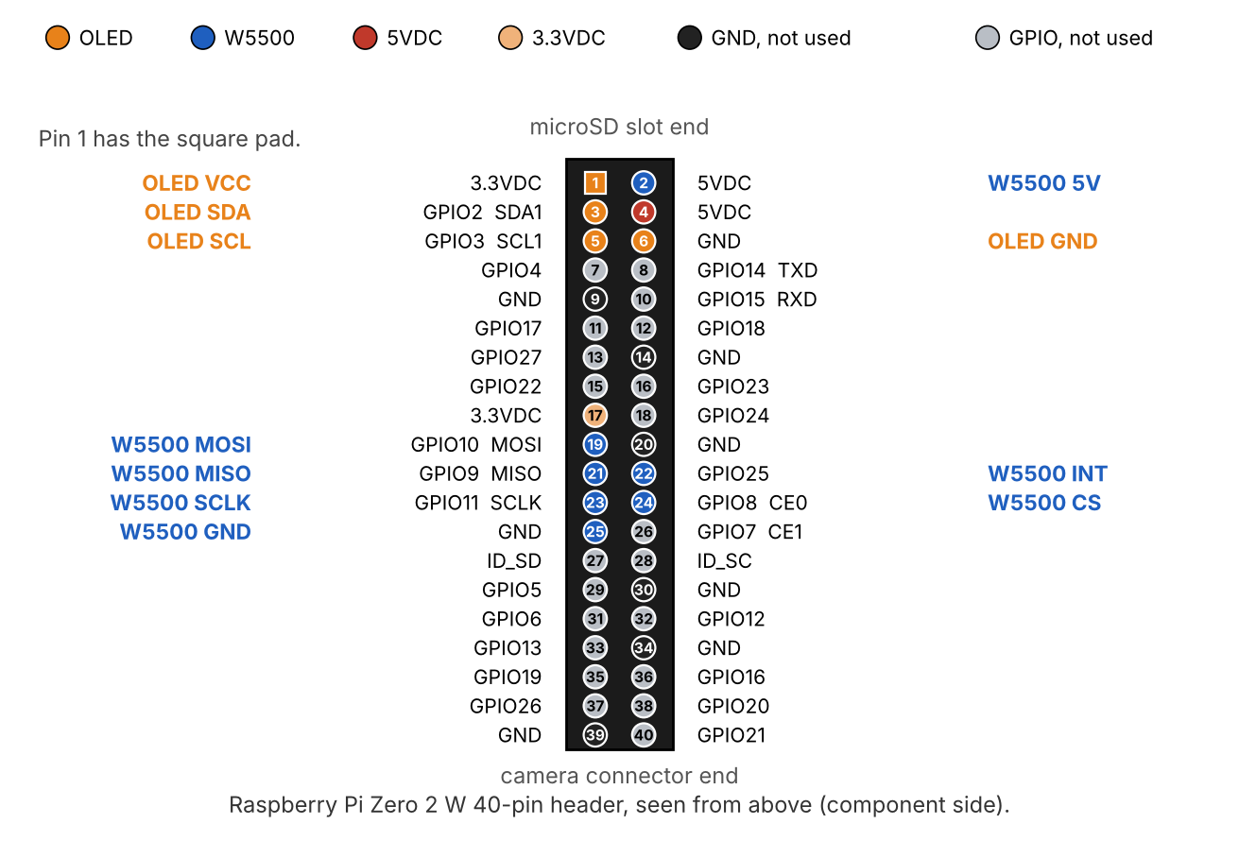
Figure 7. Header pinout. OLED: pins 1, 3, 5, 6. W5500: pins 2, 19, 21, 22, 23, 24, 25.
The OLED uses I2C and needs four wires. It runs from the Pi's 3.3VDC pin.
OLED pin | Pi header pin | Note
VCC | 1 (3V3) | Pin 1 is the square pad.
SDA | 3 (GPIO2, SDA1)
SCL | 5 (GPIO3, SCL1)
GND | 6 (GND) | Pin 9 is also ground and works equally well.

- Power off and unplug the Pi.
- Read the four silkscreen labels on the OLED board. Do not assume the order; boards of this type are often GND, VCC, SCL, SDA, but yours must be checked.
- Crimp a single row 1x4 housing on the OLED end in the board's own order. On the Pi end, use separate housings (1x1 on pin 1, 1x1 on pin 3, 1x1 on pin 5, 1x1 on pin 6), or one 1x2 on pins 5 and 6 plus two singles on pins 1 and 3.
- Mark pin 1 on each housing with a paint dot. Dupont housings have no key, so a swapped connector will fit.
- Check the wiring against the table twice before applying power. VCC on the wrong pin can destroy the display.
Pins 1, 3, 5, and 6 are not used by the W5500 harness in section 3, so there is no conflict.

3. Cable the W5500 Ethernet module
The W5500 is an SPI device on SPI0. Wire it with the Pi powered off. Go by the silkscreen labels on the module, because the top and underside views are mirrored.
Module pin | Pi header pin | Note
SCLK | 23 (GPIO11) | SPI0 clock.
MISO | 21 (GPIO9) | SPI0 data from the module.
MOSI | 19 (GPIO10) | SPI0 data to the module.
CS (SCS) | 24 (GPIO8, CE0) | Chip select.
INT | 22 (GPIO25) | Required by the Linux driver.
5V | 2 (or 4) | Power the module from 5VDC only.
GND (beside 5V) | 25 | One ground connection is enough.
Leave open | 3V3, RST, top left pin | Never connect the module 3V3 to the Pi. RST has an internal pull-up. The top left pin is NC or GND, depending on the board revision.

Module pin map (top view)
Left column from the top: NC, INT, RST, GND, 5V. Right column from the top: SCLK, SCS, MOSI, MISO, 3.3V.

Suggested harness with single row housings
End | Housings
Pi end | 1x4 on pins 19, 21, 23, 25. 1x2 on pins 22 and 24. Separate 1x1 for 5VDC on pin 2.
Module end | 1x4 on SCLK, SCS, MOSI, MISO (right column). 1x4 starting at INT (INT, an empty RST cavity, GND, 5V) on the left column.

Mark pin 1 on every housing. In the finished case the harness runs about 40 to 50 mm, so cut the wires to length after you route them.
No Pi pin is shared with the OLED wiring in section 2.

4. Assemble the enclosure
Print the body (pikvm_body.stl) and the two part lid (pikvm_lid_slots_green_black.3mf: lid on filament 1, lettering on filament 2). The case in the photos was printed in PLA on a Bambu Lab P1S, with the black lettering as a second filament. The lid prints outer face down. The vent slots print without supports.

Orientation
- The X630 HDMI input is on the end wall at the SD card side. The RJ45 jack is on the opposite end wall.
- The Pi ports face the long wall on one side, and the GPIO header faces the other.
- The OLED faces up through the lid window. The vent slots sit over the W5500 and the Pi and X630 area.
- The heatsink goes on the Pi's CPU, the large square chip beside the microSD slot. Heat from it escapes through the vent slots in the lid and the slots in the body walls.

What it should look like
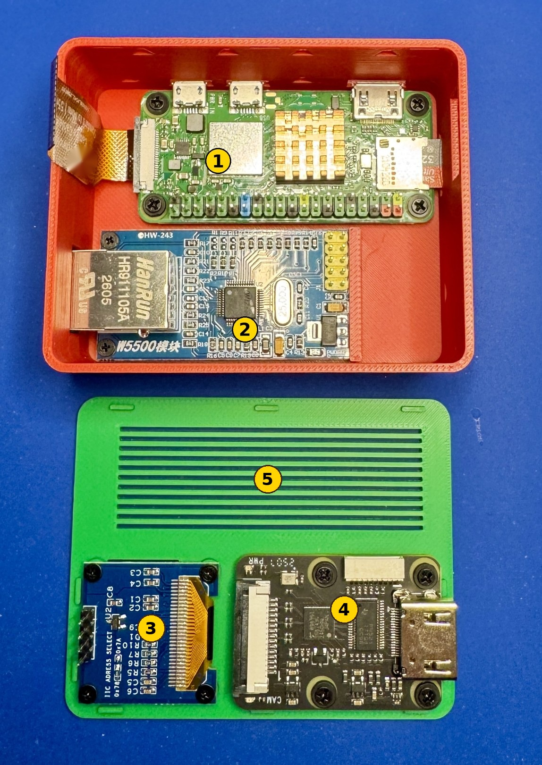
Figure 8. Use this photo to check your layout. Parts in place, before the wire harnesses are connected. 1: Pi Zero 2 W, with the copper heatsink on the CPU. 2: W5500 module, with the RJ45 jack at the end wall. 3: OLED on the lid bosses. 4: X630 on the lid bosses. 5: vent slots.

Steps
- Peel the backing off the 15 x 15 x 5 mm copper heatsink and press it onto the Pi's CPU, the large square chip. Hold it for a few seconds.
- Seat the Pi Zero 2 W on its four standoffs with M1.7 x 4 mm screws and 1 mm washers.
- Slide the W5500 board edge into the slotted ledge at the header end. Fasten the jack end with two M1.7 screws and washers. The jack face sits flush with the outer wall.
- Connect the W5500 harness (section 3) and the OLED harness (section 2) to the Pi header. Route them before closing the lid.
- Fit the X630 to the two lid bosses at the HDMI end, and the OLED to the four trimmed bosses, each with a screw and a 1 mm washer. Connect the 75 mm CSI cable from the X630 to the Pi, and mind the ribbon fold.
- Connect the USB power and host cables last, using one of the Power options in section 1.
- Leave the lid resting on the body, unsnapped, until the final checklist in section 12 passes. That keeps the harnesses and cables reachable if you need to fix a wire. Then continue with the software in section 5.

5. Install the operating system
Use the PiKVM image for the Zero 2 W with the HDMI to CSI bridge. Do not use the image for the HDMI USB dongle.
- Download the image: https://files.pikvm.org/images/v2-hdmi-zero2w/arm/v2-hdmi-zero2w-arm-latest.img.xz. The checksum file is the same URL with .sha1 added.
- Open Raspberry Pi Imager. Choose NO FILTERING, then CHOOSE OS, then Use custom at the bottom of the list. Select the .img.xz file without unpacking it.
- Press Ctrl+Shift+X and confirm the advanced settings are blank.
- Choose the microSD card carefully, then click WRITE. Decline every customization option, because they do not work on PiKVM OS.
- Wait for the write and verify to finish. It may sit at 99% for a while.
Linux alternative: run xz --decompress on the file, find the card with lsblk -dpno NAME,SIZE,MODEL, write it with dd bs=4M conv=fsync oflag=direct, then sync.
Leave the card in the computer for the next section. The Wi-Fi settings go on the card before the first boot.

6. Create the initial Wi-Fi configuration
The first FAT32 partition of the card mounts on your computer as the boot drive. PiKVM reads a file named pikvm.txt from its root on the first boot, applies it, and then deletes it.
- Open pikvm.txt on the boot drive. On a fresh image it normally contains FIRST_BOOT=1; keep that line. If the file is missing, create it with that line.
- Add your network and a static address, one setting per line. Use single quotes, and write a backslash in a password as two backslashes. Replace every value below with your own:
FIRST_BOOT=1
WIFI_ESSID='YourNetworkName'
WIFI_PASSWD='YourPassword'
WIFI_REGDOM=US
WIFI_ADDR=192.168.1.11/24
WIFI_GW=192.168.1.1
WIFI_DNS=192.168.1.7

WIFI_ADDR, WIFI_GW, and WIFI_DNS give the unit a fixed address from its very first boot, so you never have to look it up on your router's DHCP list. Set all three together with the network name and password. Choose an address outside your DHCP pool. Section 8 later adds the routing rules for the Ethernet port, and it keeps this same address.
Save the file, eject the card safely, and put it in the Pi Zero 2 W.
Zero 2 W units support 2.4 GHz networks only, and they do not support WPA3. If your router mixes WPA2 and WPA3, add WIFI_WPA23=1. For a hidden network add WIFI_HIDDEN=1.

First power up
- Make sure the unit is fully built and wired (sections 2 to 4), with the X630, OLED, and W5500 connected. Leave the lid unsnapped for now. The OLED and W5500 stay idle until you configure them in sections 9 and 10.
- Power the unit with one source from the Power options in section 1. For the first boot, the simplest is a wall charger in PWR IN with no host cable connected. The fully wired unit draws up to about 0.52A, which is more than some USB 2.0 host ports supply. Wait several minutes. The first boot generates SSH keys and certificates; do not remove power until it finishes.
- Browse to the address you set in pikvm.txt, for example https://192.168.1.11/. Accept the self-signed certificate warning.
- Log in to the web interface with admin and admin.

7. Perform the initial OS update
Do this with the unit within reach, because the update restarts services and may reboot the device.
rw
pikvm-update

When it finishes, reboot and confirm the platform package and the capture device:
reboot

# after it comes back:
pacman -Q | grep kvmd-platform
dmesg | egrep 'tc35|uvc'
systemctl status kvmd-tc358743

With the X630 connected and a source powered on, the web interface should show the target screen.

8. Add the Wi-Fi routing rules
The pikvm.txt settings already gave the unit its static Wi-Fi address. Replace the generated network file with the one below. It keeps the same address and adds the routes and rules that keep Wi-Fi reachable when the Ethernet cable is unplugged.
rw
vi /etc/systemd/network/wlan0.network

Replace the contents with this, using your own addresses:
[Match]
Name=wlan0

[Network]
DHCP=no
DNSSEC=no
DNS=192.168.1.7

[Address]
Address=192.168.1.11/24
AddPrefixRoute=no

[Route]
Gateway=192.168.1.1
Metric=10

[Route]
Destination=192.168.1.0/24
Scope=link
Metric=10

[Route]
Destination=192.168.1.0/24
Scope=link
Table=101

[RoutingPolicyRule]
From=192.168.1.11/32
Table=101
Priority=101

Reboot to apply it. Your SSH session will drop, and the unit comes back at the same address.
reboot

Verify with ip -br a and ip route after it returns.
The Wi-Fi default and subnet route metrics are 10 on purpose. The Ethernet route in section 11 uses 50, so traffic the Pi starts itself (time sync, updates, syslog, and lookups to hosts on the same subnet such as your DNS server) goes over Wi-Fi whenever both are up. The Table=101 subnet route and the rule make every reply to a client on the local subnet that arrived on 192.168.1.11 leave through Wi-Fi. Both are needed. Do not add a default route to the extra tables; it makes the OLED daemon lose track of the default interface and show the Ethernet address. The W5500 driver never reports a pulled cable, so without the rule the Pi keeps answering through a dead Ethernet port.
Capital letters matter in systemd files. Write Address=, not address=, or the setting may be ignored.
If you did not set the static address in pikvm.txt, this same file also sets it on a running system. Use your own address in Address= and reconnect to it after the reboot.

9. Configure the OS for the OLED
PiKVM already ships the kvmd-oled service. It only needs I2C enabled.
rw
vi /etc/modules-load.d/kvmd-extra.conf

Add this line. The file may not exist yet, and vi creates it. If the line is already there, leave it.
i2c-dev

vi /boot/config.txt

Add this line at the end of the file, unless it is already there:
dtparam=i2c_arm=on

Then enable the services and reboot:
systemctl enable --now kvmd-oled kvmd-oled-reboot kvmd-oled-shutdown
reboot

The enable --now step may print an error about the display before the first reboot, because the I2C bus does not exist yet. That is expected; the reboot fixes it.

Verify
ls /dev/i2c-1
systemctl status kvmd-oled

The display should show the PiKVM status after a few seconds, including the address of the unit.
If the display shows only the top half of the image or looks stretched, the module is a 128 x 64 panel that the service is driving as 128 x 32. Run rw, then vi /usr/lib/systemd/system/kvmd-oled.service and add the right display flags (for example --height 64, and --display sh1106 if the chip is an SH1106) to both the ExecStartPre and ExecStart lines. Then run systemctl daemon-reload and systemctl restart kvmd-oled.

10. Configure the OS for the W5500
First add the overlay. The defaults match this wiring: INT on GPIO25, 30 MHz, chip select 0.
rw
vi /boot/config.txt

Add this line at the end of the file, unless it is already there:
dtoverlay=w5500

Next create a fixed MAC address for the module. Use a different MAC on every unit you build.
vi /etc/systemd/network/10-w5500.link

The file does not exist yet. Give it these contents:
[Match]
OriginalName=eth0

[Link]
MACAddress=02:50:49:4B:56:4D

Plug in the Ethernet cable and reboot:
reboot

Verify the link
dmesg | grep -i -E 'w5500|w5100'
cat /sys/class/net/eth0/carrier
ip -4 addr show eth0

Carrier prints 1 and the RJ45 LEDs show link and activity when the cable is in. This driver reports the link as up even with no cable, and it does not report speed or duplex, so judge the link by the LEDs and by throughput. The bench result for this design was 0% loss, 0.775 ms latency, and about 16.7 Mbit/s receive and 14.4 Mbit/s transmit with the stream running, which is far above the roughly 1.75 Mbit/s the stream needs.

Roll back if needed
rw
vi /boot/config.txt

Delete the dtoverlay=w5500 line. Press Esc, put the cursor on that line, press dd, and save with :wq. Then remove the link file and reboot:
rm /etc/systemd/network/10-w5500.link
reboot

11. Set a static IP address on the Ethernet port
rw
vi /etc/systemd/network/eth0.network

Give the file these contents, using your own addresses. The file may not exist yet, and vi creates it. If it does exist, replace everything in it:
[Match]
Name=eth0

[Network]
DHCP=no
DNSSEC=no
DNS=192.168.1.7

[Address]
Address=192.168.1.12/24
AddPrefixRoute=no

[Route]
Gateway=192.168.1.1
Metric=50

[Route]
Destination=192.168.1.0/24
Scope=link
Metric=50

[Route]
Destination=192.168.1.0/24
Scope=link
Table=100

[RoutingPolicyRule]
From=192.168.1.12/32
Table=100
Priority=100

Reboot to apply it:
reboot

The unit stays reachable at its Wi-Fi address, and the Ethernet port answers at 192.168.1.12 (your own address from the file). Then verify:
ip -br a
ip route
ip rule
ip route show table 100
ip route show table 101
python -c "import netifaces; print(netifaces.gateways()['default'])"
ping -c 5 192.168.1.1

The main table should show the default route and the 192.168.1.0/24 route via wlan0 with metric 10, and the same two via eth0 with metric 50. ip route get 192.168.1.7 (your DNS server) should say dev wlan0. ip rule should list one rule for each address (priorities 100 and 101). Tables 100 and 101 should each hold only the 192.168.1.0/24 route on their own interface. The netifaces line should name wlan0. The OLED shows the address of the default-route interface, found with that library, so it then shows the Wi-Fi address. If Wi-Fi goes down, the Ethernet default route takes over and the OLED shows the Ethernet address.
Why the extra rules: both interfaces share one subnet, and the W5500 driver always reports the link as up, even with the cable pulled. Without the rules, the Pi answers a PC through Ethernet even when nothing is plugged in, and the unit looks dead on Wi-Fi. Unplug the cable, wait a minute, and ping the Wi-Fi address from your PC to confirm it still replies.
A DHCP reservation on your router is an alternative to a static address. It only works well because the fixed MAC from section 10 survives reboots.

12. Final checklist
Run these checks with the lid unsnapped. When everything passes, press the lid down. Its barbed tabs snap into the V grooves in the body walls. Do not force it; if it resists, check for a trapped wire.
Check | Expected result
pacman -Q | grep kvmd-platform | Shows a v2-hdmi-zero2w platform package.
Web interface video | Target screen shows with correct resolution.
OLED | Status text appears after boot, showing the Wi-Fi address.
ip -br a | eth0 at 192.168.1.12/24 and wlan0 at 192.168.1.11/24.
ip route | Default and subnet routes via wlan0 at metric 10 and via eth0 at metric 50.
ip rule | Rules for 192.168.1.11 (table 101) and 192.168.1.12 (table 100).
Cable out test | Unplug Ethernet, wait a minute, and ping 192.168.1.11 from your PC. It replies.
vcgencmd get_throttled | Prints throttled=0x0.
Reboot test | Both addresses return, and the OLED comes back by itself.

If something does not work
Symptom | First thing to check
No Wi-Fi on first boot | The network is 2.4 GHz and WPA2. The quotes and backslashes in pikvm.txt are correct. Confirm the file was on the boot partition, because PiKVM deletes it after use.
No video | CSI cable orientation and full seating at both ends. dmesg | egrep 'tc35|uvc' and systemctl status kvmd-tc358743.
OLED blank | Wire order and pins. ls /dev/i2c-1 must exist. systemctl status kvmd-oled.
No eth0 | Wiring of INT (pin 22) and CS (pin 24). dmesg | grep -i w5500. Overlay line in /boot/config.txt.
eth0 has no link | Cable and switch port. Whether the module is receiving 5VDC. The driver does not drop the interface when a cable is pulled, so judge by the jack LEDs and the switch port.
Wi-Fi address unreachable with the cable out | The Table= routes and [RoutingPolicyRule] in both network files. ip rule must list both rules.
Random reboots or throttled is not 0x0 | Power. Try a shorter cable or a different supply, or move to option B or C in section 1 if you are on host power.
Static IP ignored | File name and capitalization (Address=). networkctl status eth0 and journalctl -u systemd-networkd.

Sources
- PiKVM documentation, V2 quick start: https://docs.pikvm.org/v2/
- PiKVM documentation, flashing the OS: https://docs.pikvm.org/flashing_os
- PiKVM documentation, on boot configuration: https://docs.pikvm.org/on_boot_config/
- PiKVM documentation, Wi-Fi: https://docs.pikvm.org/wifi/
- PiKVM OLED for DIY V2 (GitHub issue 797): https://github.com/pikvm/pikvm/issues/797
- PortaPow USB Power Blocker: https://portablepowersupplies.co.uk/product/usb-power-blocker
- PiKVM USB power/data splitter: https://www.pishop.us/product/pikvm-usb-power-data-splitter/
- Case for the Blicube USB-C power/data splitter, by Gareth79 on Printables: https://www.printables.com/model/1797404-case-for-blicube-usb-c-powerdata-splitter

