
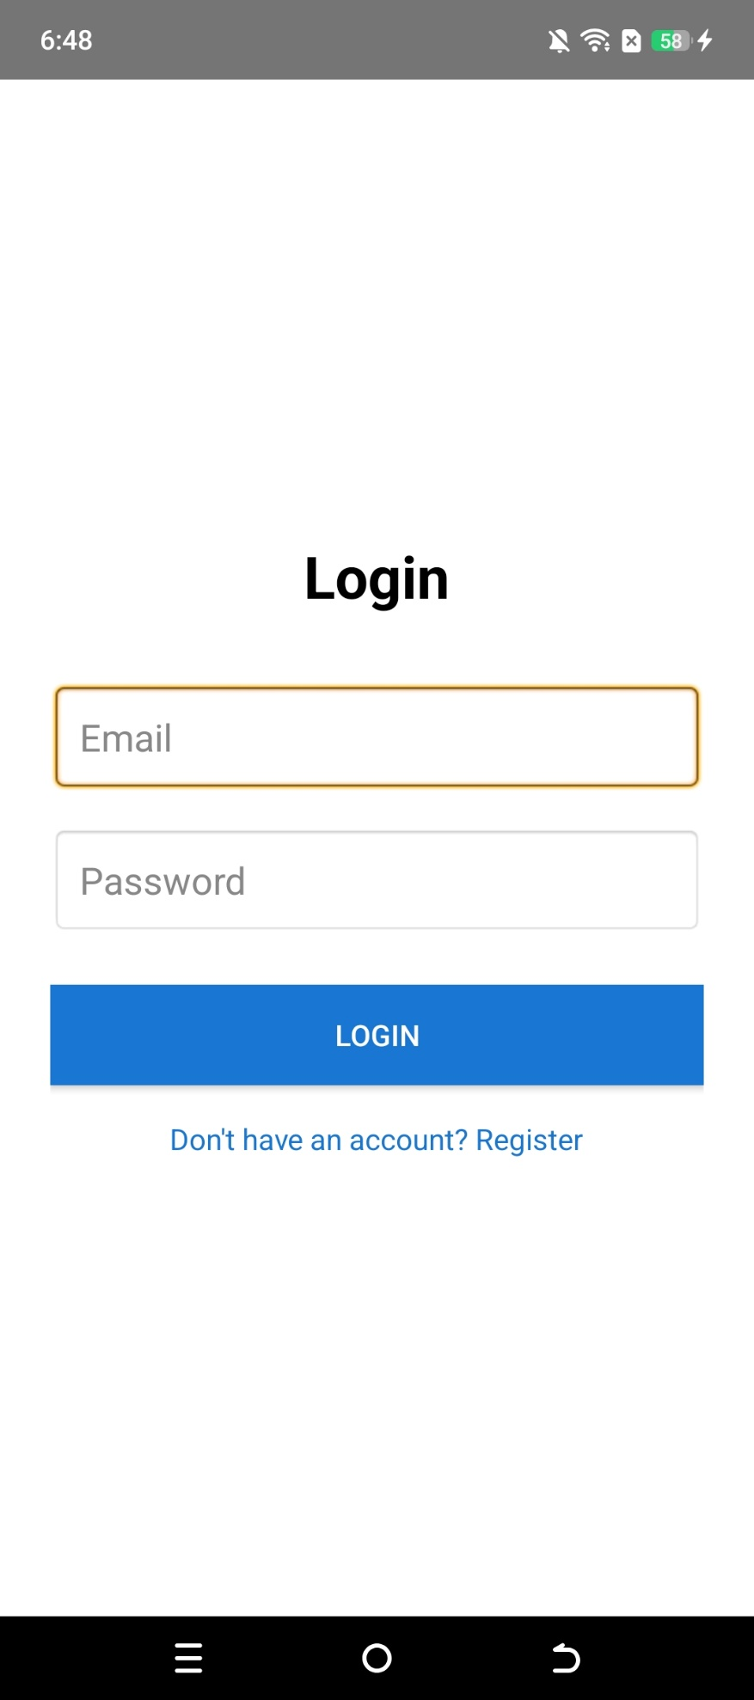
Project Title: Lost&Found Application
Submitted by:
Ramsha Arooj
Department:
Information Technology
Semester:
6th
Institute Name:
Govt Graduate College Boys
Sheikhupura
SEMESTER PROJECT
README

Project Objectives
The main objectives of this project are to develop an Android application that allows users to report lost or found items, provide an easy platform for searching items, enable communication between the finder and the owner, and ensure a secure and user friendly system.

Screenshots of the App


LOST&FOUND APPLICATION LOGO

How to Run the Project
- Open the project in Android Studio.
- Connect an Android device via USB or start an emulator (Android 5.0 or above).
- Click on the Run button (green triangle) or press Shift + F10.
- The app will install on your device or emulator.
- Open the app. First time users must register with full name, email and password.
- After registration, login with the same email and password.
- Now you can add new items, view all items, search items, and delete items.
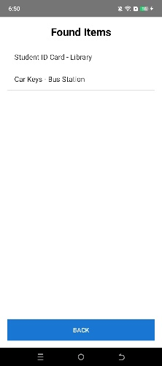
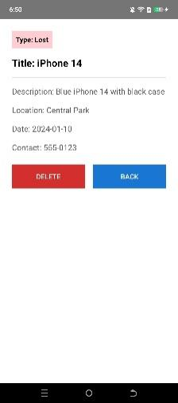
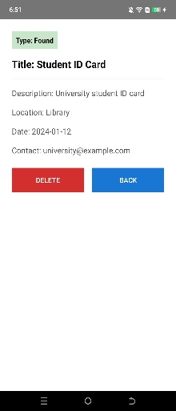
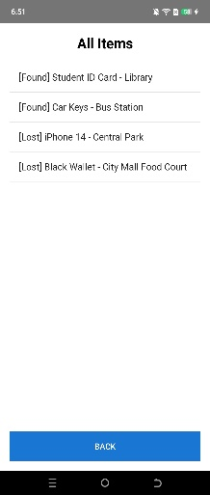
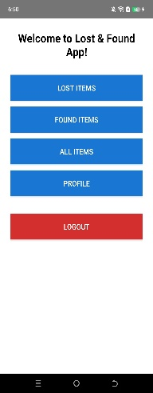
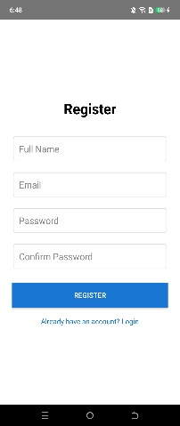
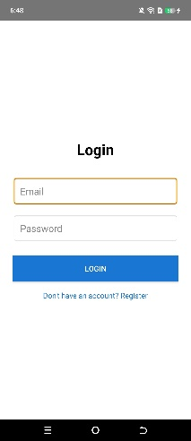
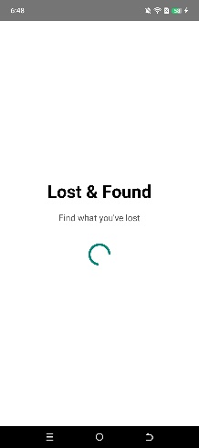

Features of the App
- User registration and login system
- Add lost or found items with title, description, location and contact number
- View all items in a list
- Search items by typing a keyword (searches title, description or location)
- Click on any item to see full details including date and contact
- Delete any item from the detail screen
- All data is stored locally using SQLite (works offline)

Technologies Used

1. Java Programming Language
Java is the primary programming language used for developing this Android application. Java is an object oriented language which makes the code organized reusable and easy to manage. We chose Java because it is widely used for Android development and has strong community support. Java provides features like classes, objects, inheritance and exception handling which helped us write clean and reliable code. All the logic for user registration, login, adding items, searching and deleting items is written in Java. The DatabaseHelper class which handles all SQLite operations is also written in Java. Java is platform independent and runs on Android devices smoothly.

2. SQLite Database
SQLite is a lightweight relational database management system used in this project for local data storage. Unlike cloud databases, SQLite stores all data directly on the user's device which means the app works completely offline. No internet connection is required to register, login, add items or search items. SQLite is embedded within the Android operating system so there is no need to install any additional software or drivers. We created two tables in SQLite. The first table is called users which stores user id, name, email and password. The second table is called items which stores item id, title, description, location, date, contact number and the user id of the person who added the item. All CRUD operations (Create, Read, Update, Delete) are performed using SQL queries inside the DatabaseHelper class. SQLite is fast, reliable and perfect for small scale semester projects like ours.

3. XML for User Interface Design
XML (Extensible Markup Language) is used to design the user interface of all screens in this application. Each activity has its own XML layout file. For example activity_login.xml defines the login screen, activity_register.xml defines the register screen, activity_all_items.xml defines the main list screen, activity_add_item.xml defines the add item form, and activity_item_detail.xml defines the item details screen. XML allows us to arrange text fields, buttons, list views and other UI components easily. We also used a colors.xml file to define custom colors like purple for buttons and white for backgrounds. The styles.xml and themes.xml files define the overall look and feel of the app including the action bar and status bar colors. XML is simple to learn and works perfectly with Android Studio's drag and drop designer.

4. Android Studio IDE
Android Studio is the official integrated development environment for Android app development. We used Android Studio to write all the Java code, design the XML layouts, test the app on emulators and physical devices, and debug any errors. Android Studio provides features like code completion, real time error checking, built in SQLite database inspector, and a visual layout editor. It also makes it easy to manage project files, dependencies, and Gradle build scripts. The app was tested on both an Android emulator running Android 12 and a physical device running Android 13. Android Studio also helped us generate the APK file for final submission.

5. Gradle Build System
Gradle is used to manage dependencies and build the project. In the build.gradle file (module app), we specified the minimum SDK version (API 21) and target SDK version (API 33). No external libraries were required because SQLite is built into Android. Gradle compiles all Java files, processes XML resources, and packages everything into a single APK file that can be installed on any Android device.

6. Android SDK (Software Development Kit)
The Android SDK provides all the necessary tools and APIs for building Android apps. We used the standard Android SDK components including the Android framework libraries for activities, intents, list views, edit texts, buttons, toasts, shared preferences, and SQLite database support. The app targets Android 5.0 (Lollipop) and above which covers most devices currently in use.

Why These Technologies Were Chosen
We chose Java and SQLite because they are simple, well documented, and do not require any paid licenses or cloud services. Since this is a semester project, we wanted a solution that works offline and can be demonstrated easily without internet dependency. XML and Android Studio are the standard tools taught in our course so using them made the development process smoother. All these technologies together allowed us to build a complete functional app within the given time frame.

Conclusion
This Lost and Found Android Application is a semester level project developed by students of the Information Technology department. The app uses SQLite database so that all data stays on the mobile device and no internet connection is required. This project offers basic functionality like user registration, adding items, searching and deleting items. We hope this project can help people in real life.

