
Project Title: Lost&Found Application
Submitted by:
Ramsha Arooj
Department:
Information Technology
Semester:
6th
Institute Name:
Govt Graduate College Boys
Sheikhupura

SEMESTER PROJECT
LOST AND FOUND ANDROID APPLICATION

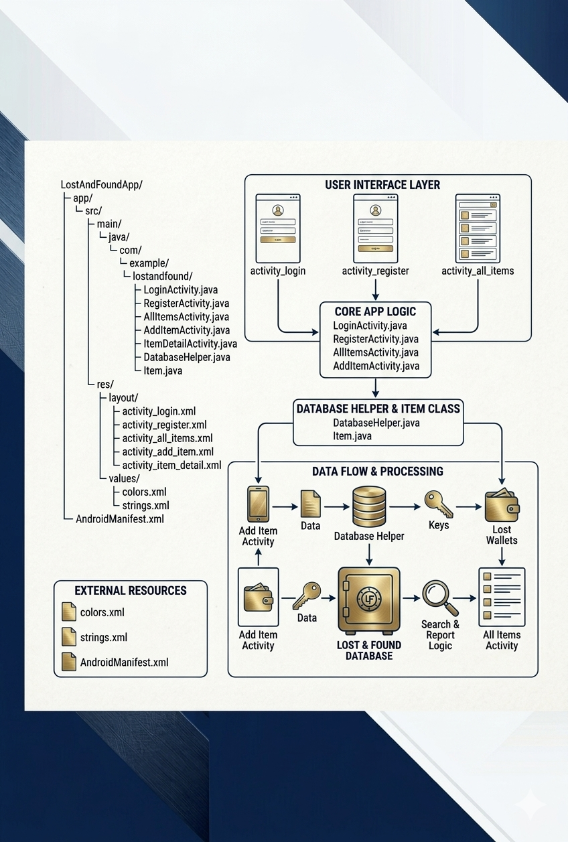
Source Code of Lost&Found Android Application

AndriodManifest.xml
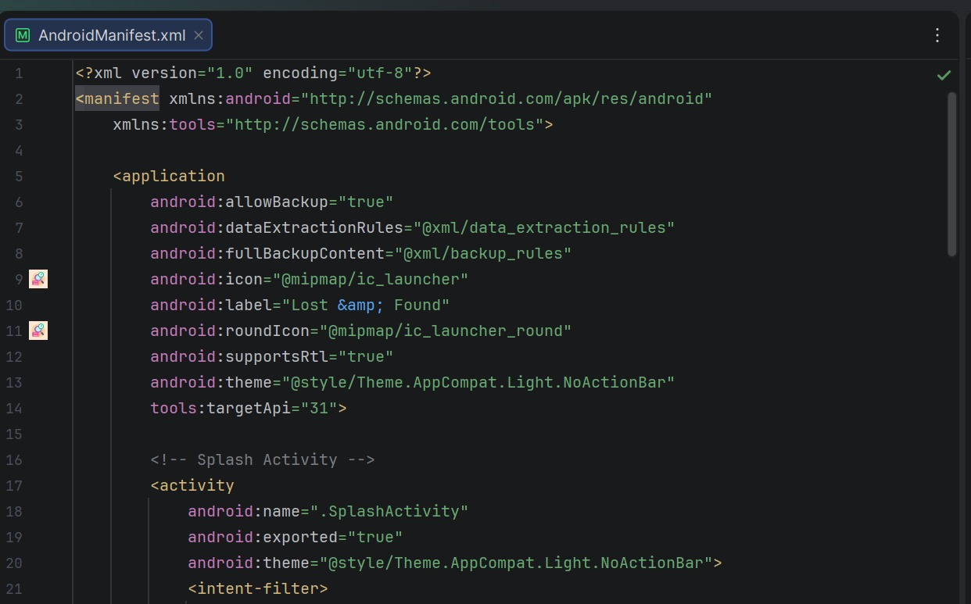
This file tells the Android system about your app. It defines the app name, icon, and all activities. It also specifies which activity opens first when the user taps the app icon. If you forget to add an activity here, that screen will not work. In your Lost and Found project, this file makes sure LoginActivity is the first screen to appear.
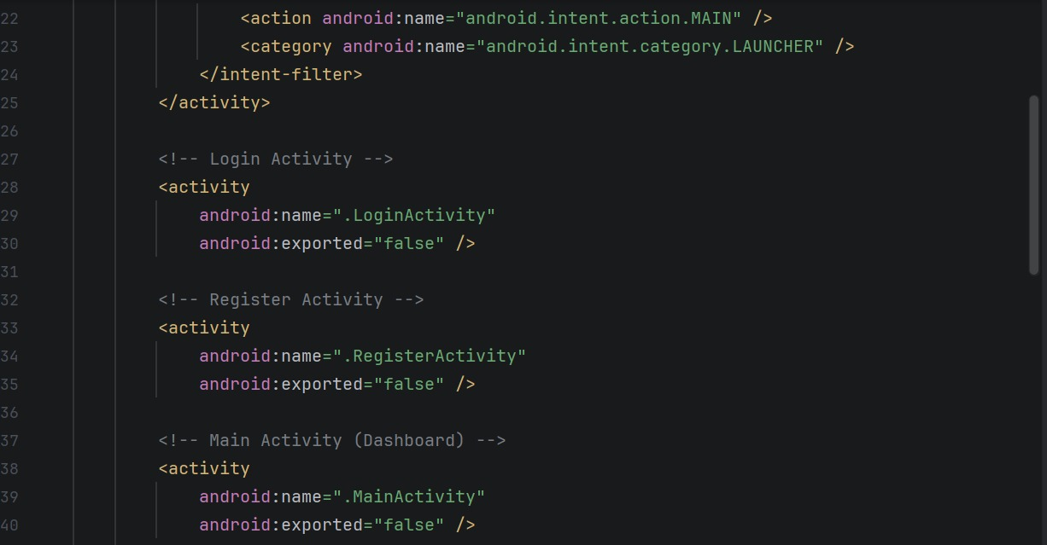
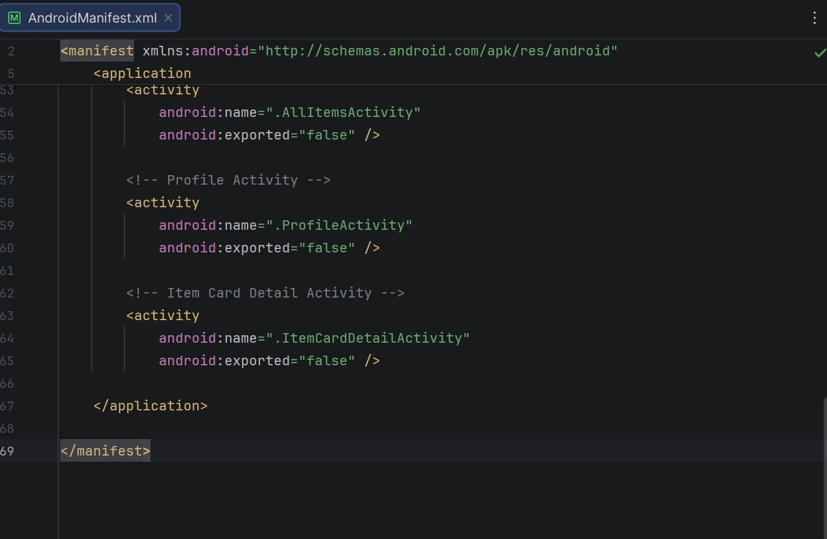
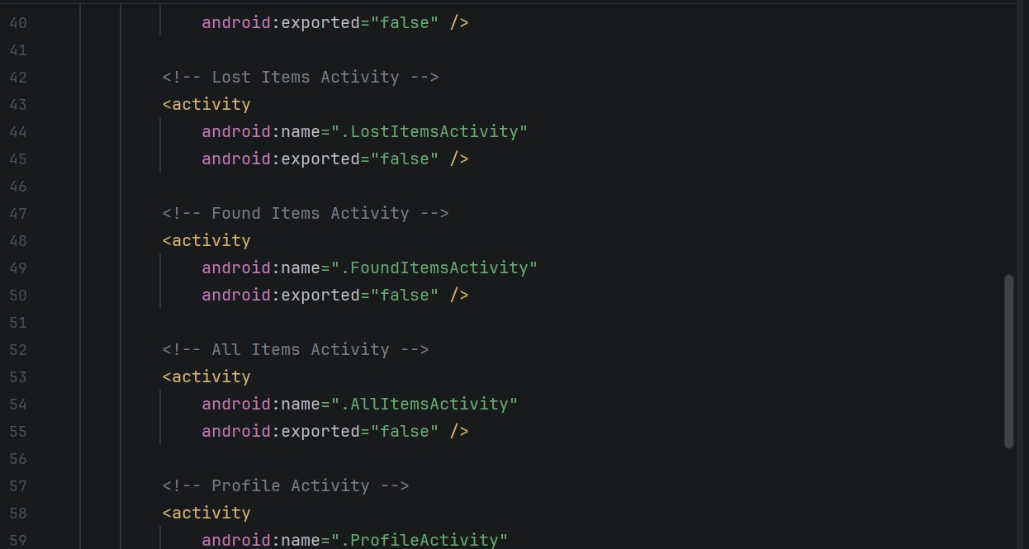
AllItemsActivity.java
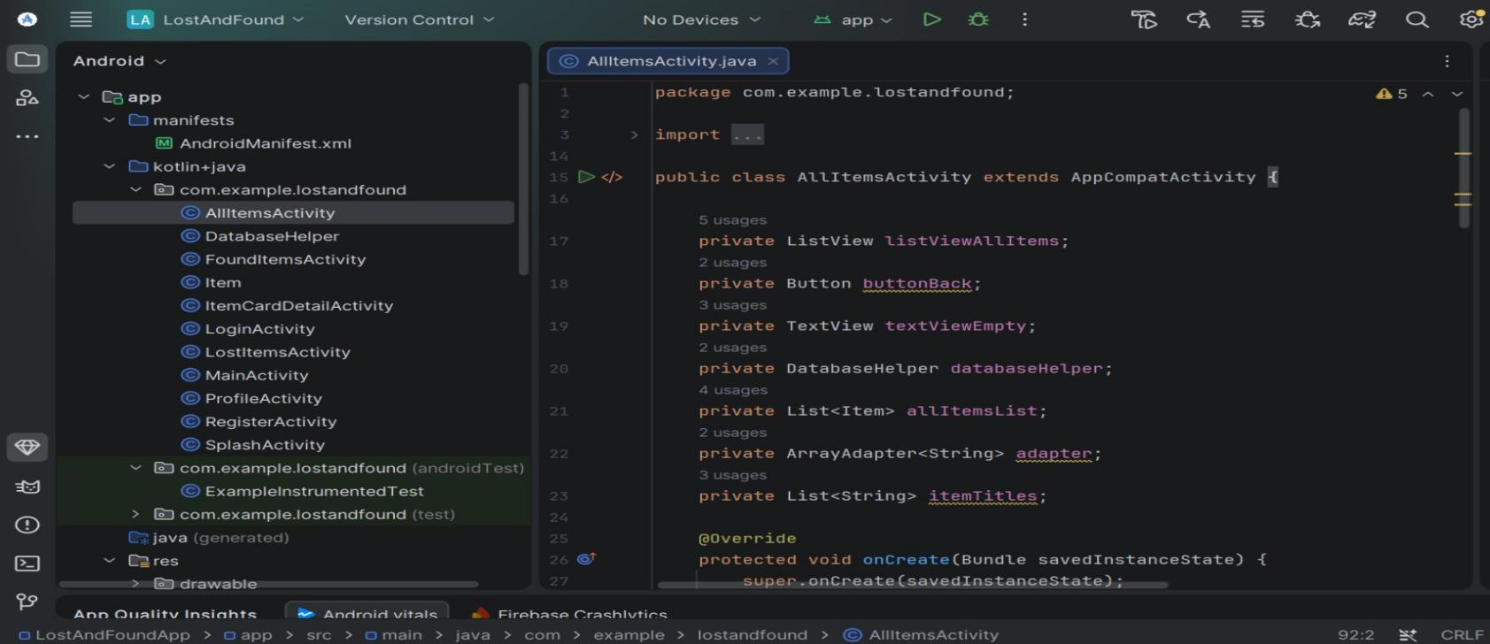
This file is the main screen of your app. It shows a list of all lost and found items that users have already added. There is a search bar at the top where you can type any word to find items by title description or location. An Add New Item button lets you go to the screen where you can add a new item. When you click on any item from the list, the app opens the detail screen for that item.
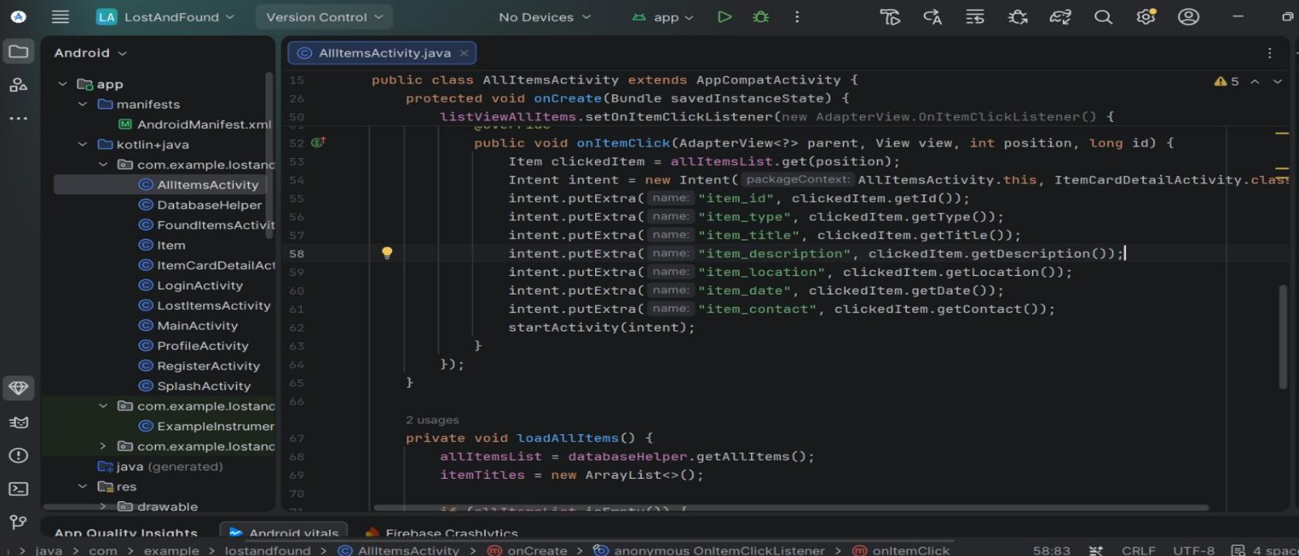
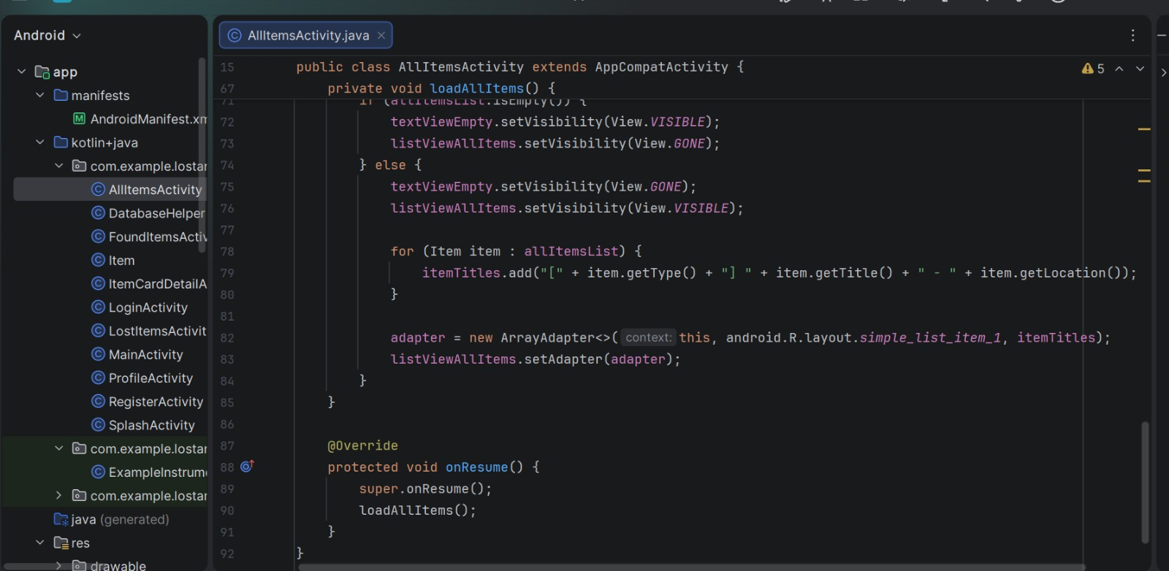
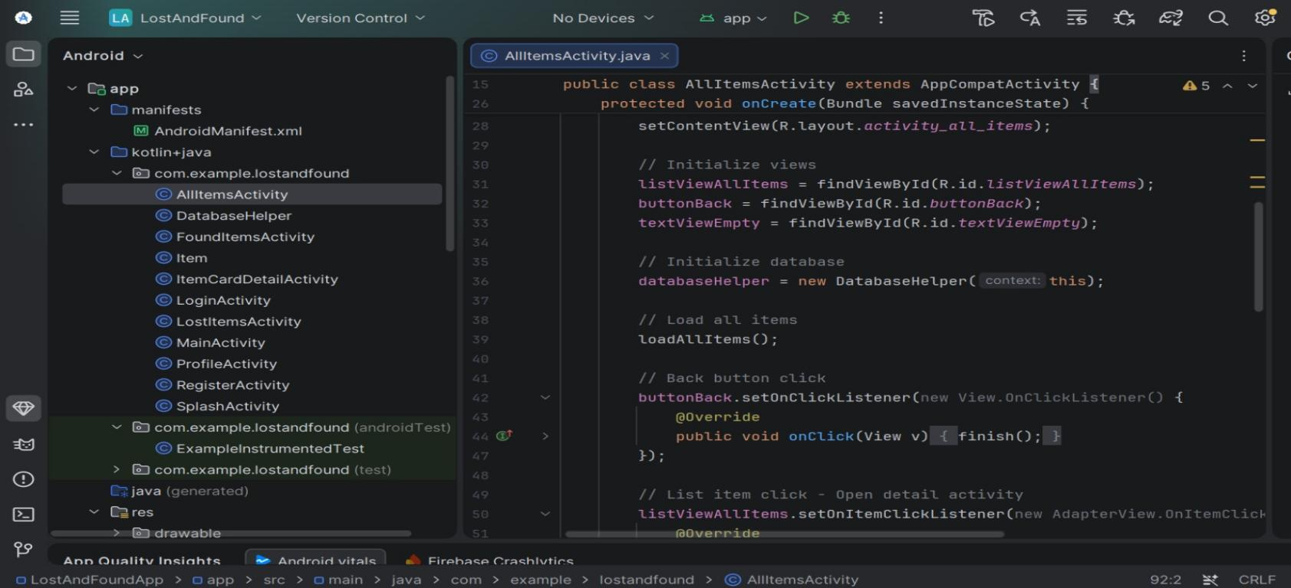

DatabaseHelper.java
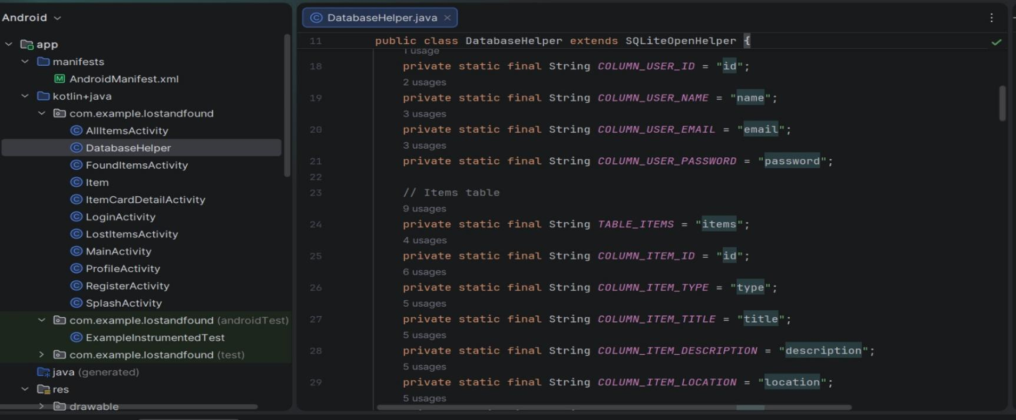
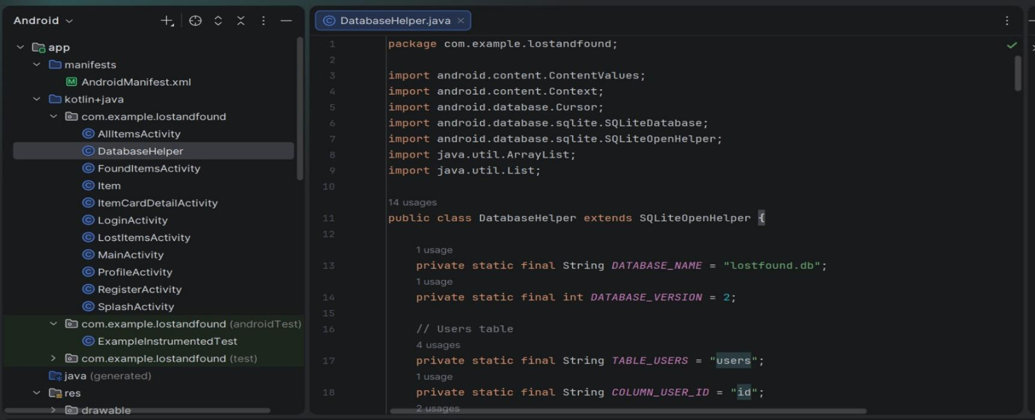
This file manages all database work for the app. It creates the SQLite database and builds two tables one for storing user accounts and one for storing lost and found items. It includes functions to register a new user, check login credentials, add a new item, fetch all items, search for items using a keyword, and delete an item. This file runs behind the scenes so the app can save and retrieve data without needing an internet connection.

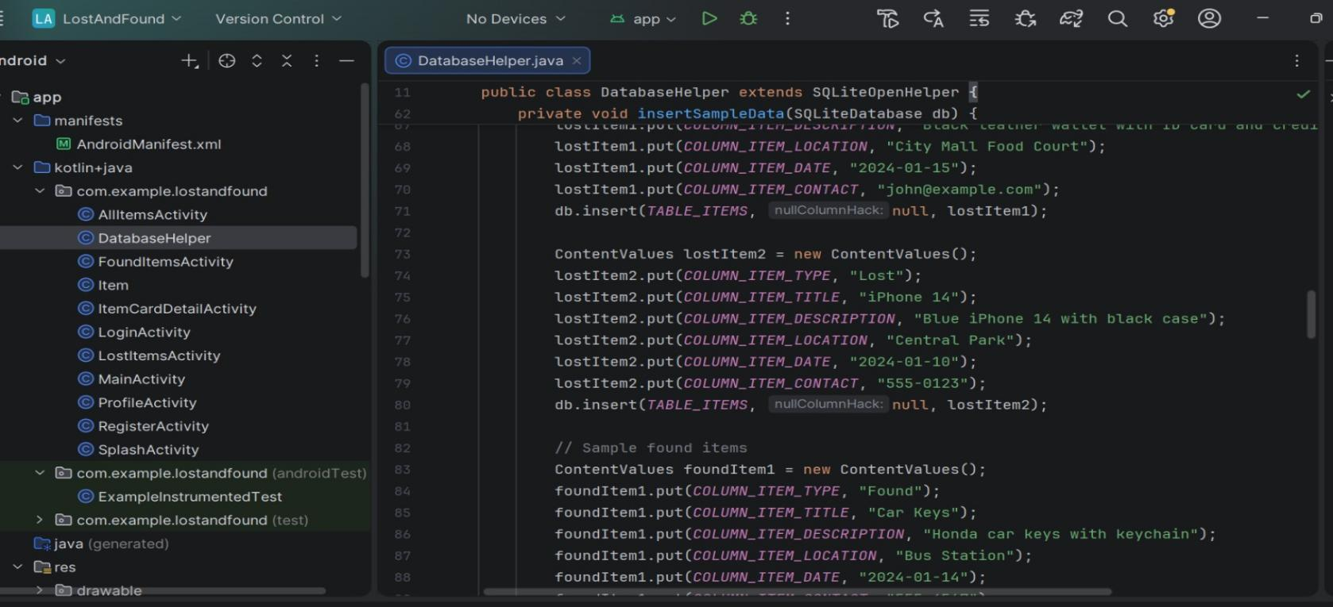
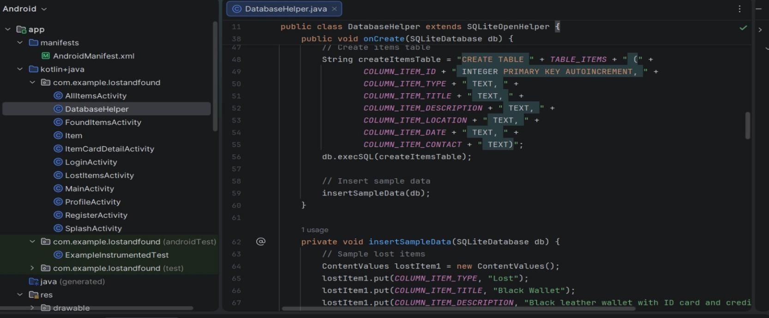
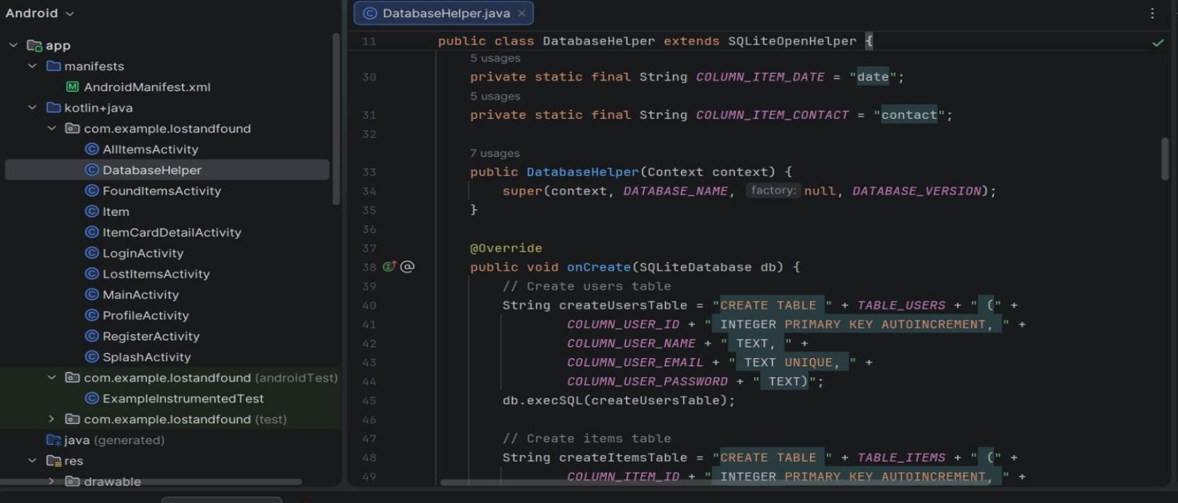
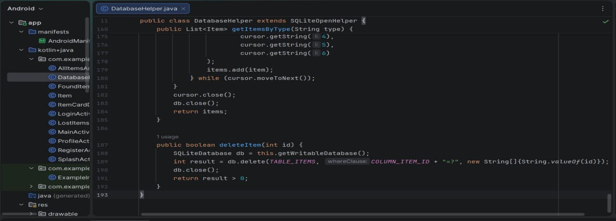
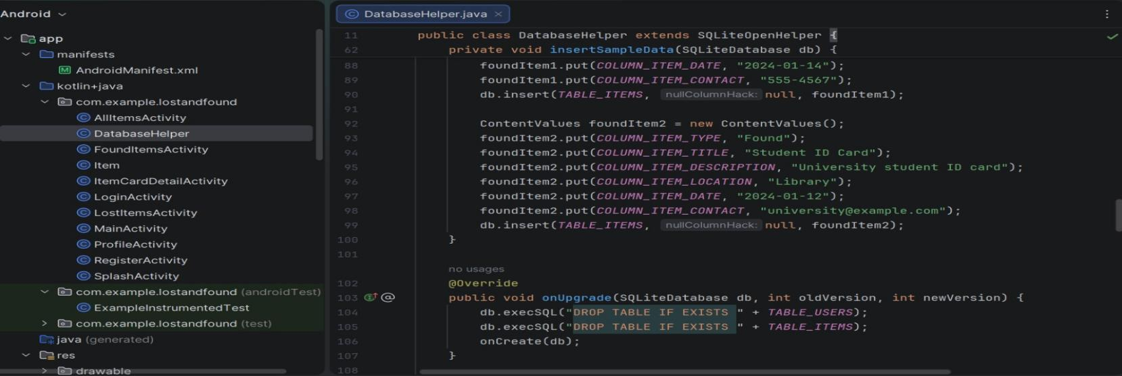

FoundItemsActivity.java
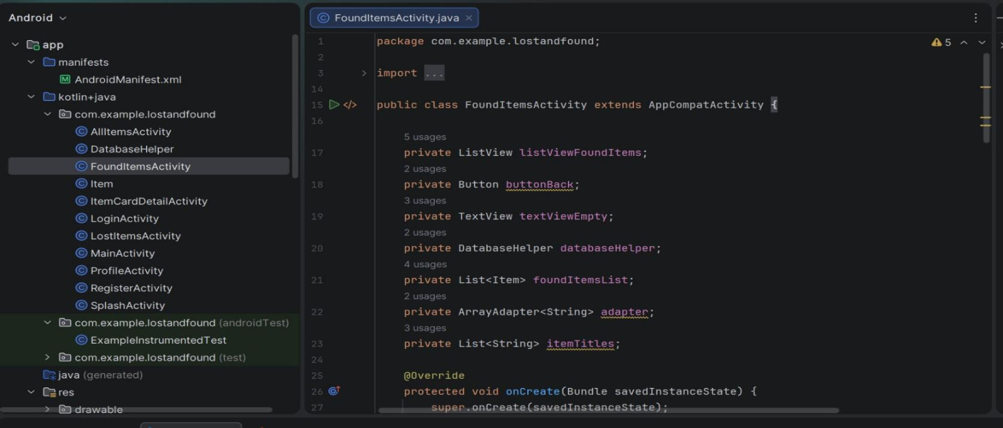
This file shows only the items that have been reported as found. It displays a list of found items with their titles and locations. Users can click on any found item to view its full details including description, date, and contact information. This screen helps users quickly see what items have been found by others.
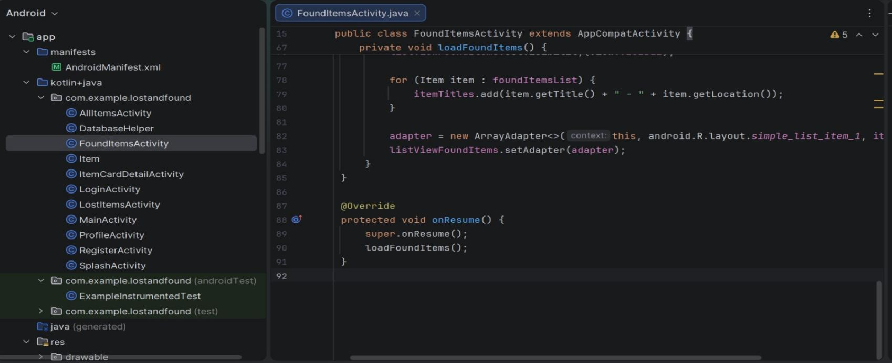
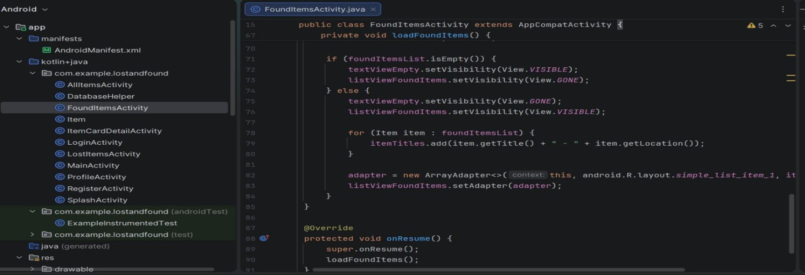
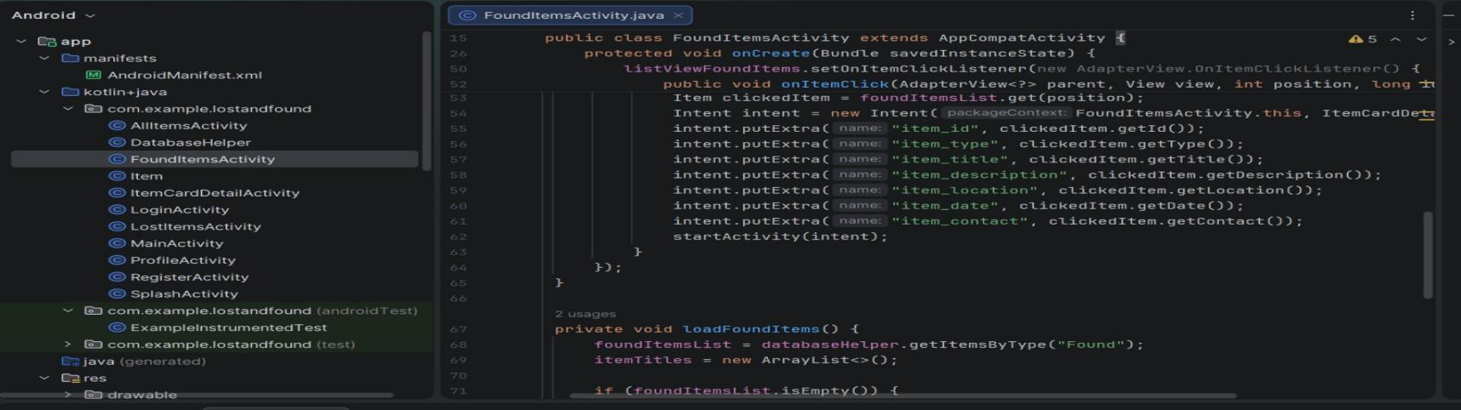
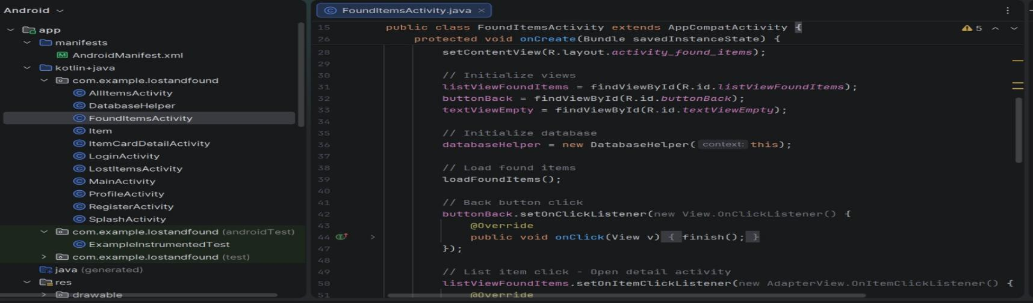

LostItemsActivity.java
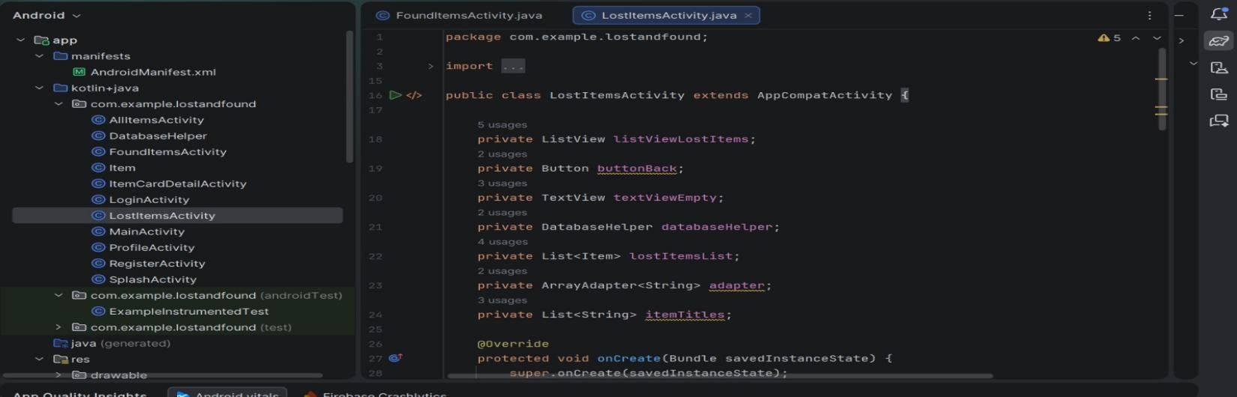
This file shows only the items that have been reported as lost. It displays a list of lost items with their titles and locations. Users can click on any lost item to view its full details including description, date, and contact information. This screen helps users quickly see what items other people have lost.
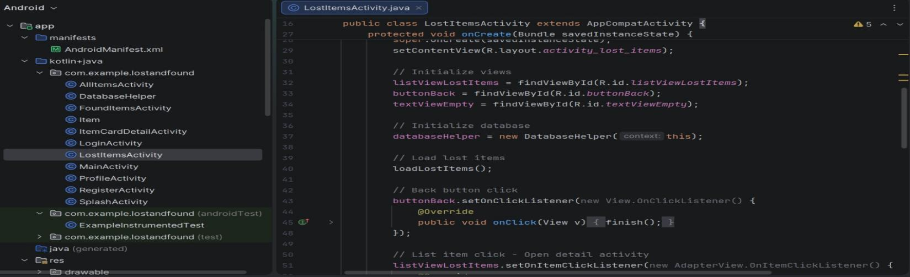
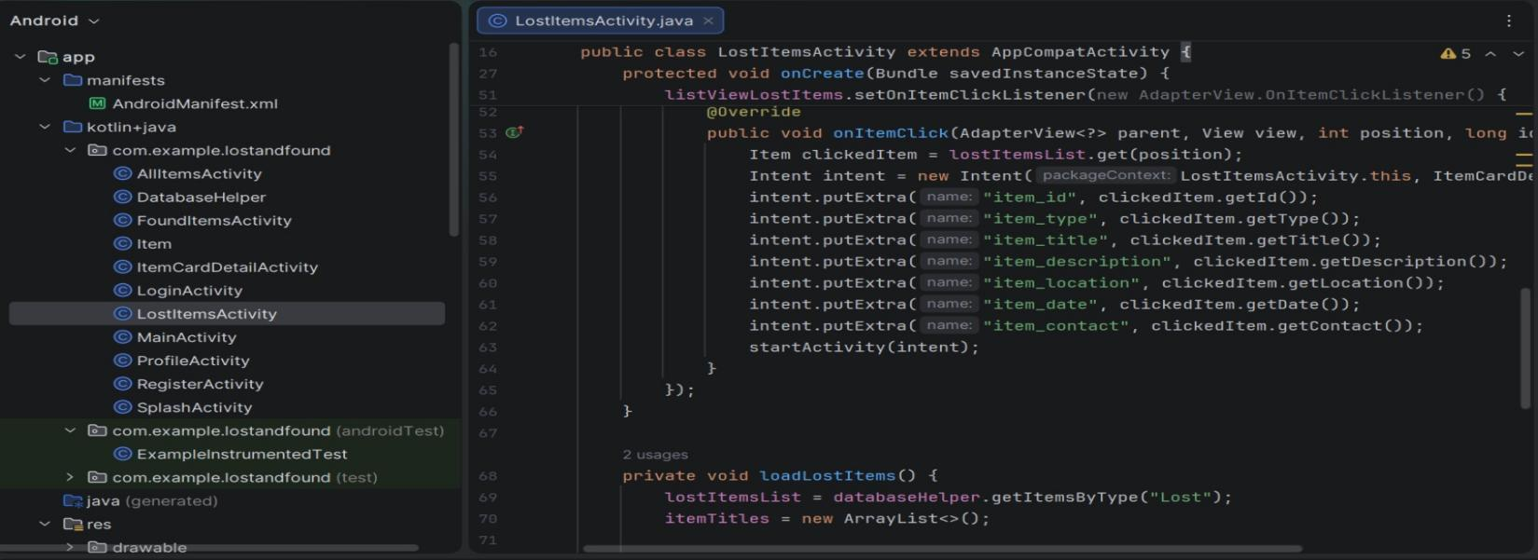
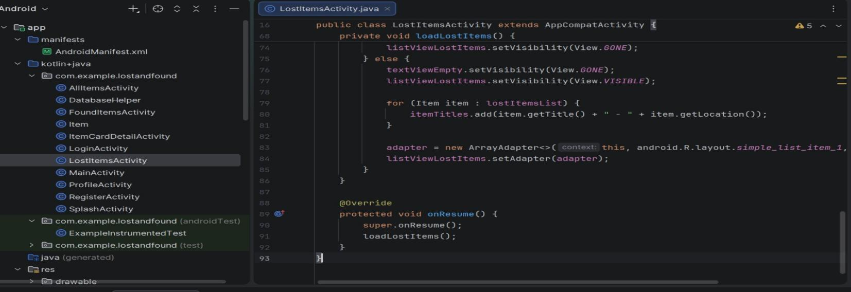

LoginActivity.java
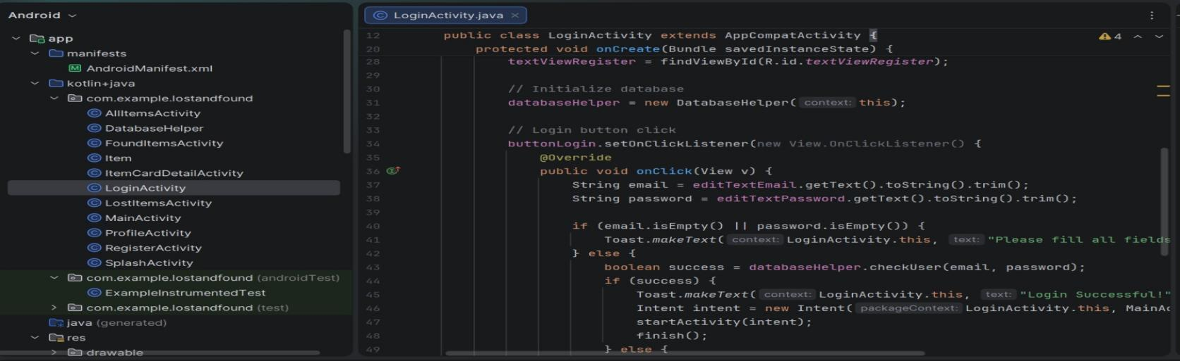
This file is the first screen that users see when they open the app. It has two text fields for entering email and password and a login button. When users tap the login button the app checks if the email and password match a registered account. If the details are correct the user is taken to the main screen. There is also a register link for new users to create an account.
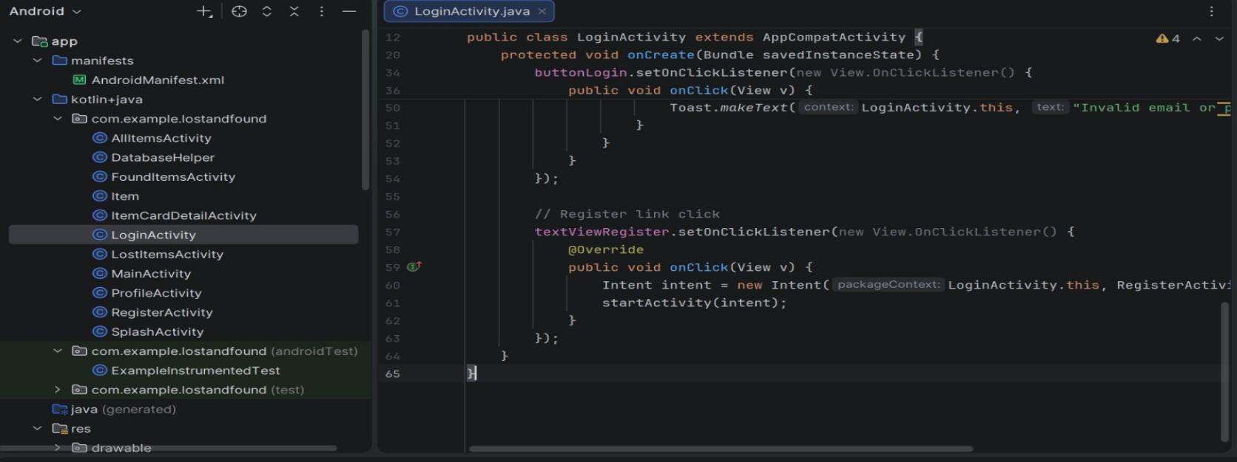

MainActivity.java
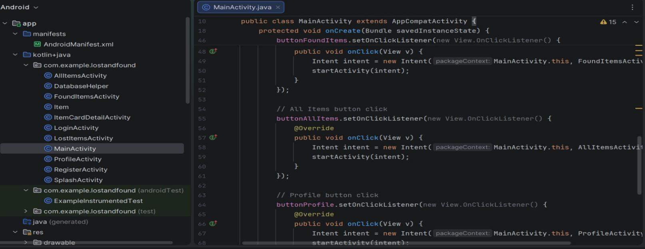
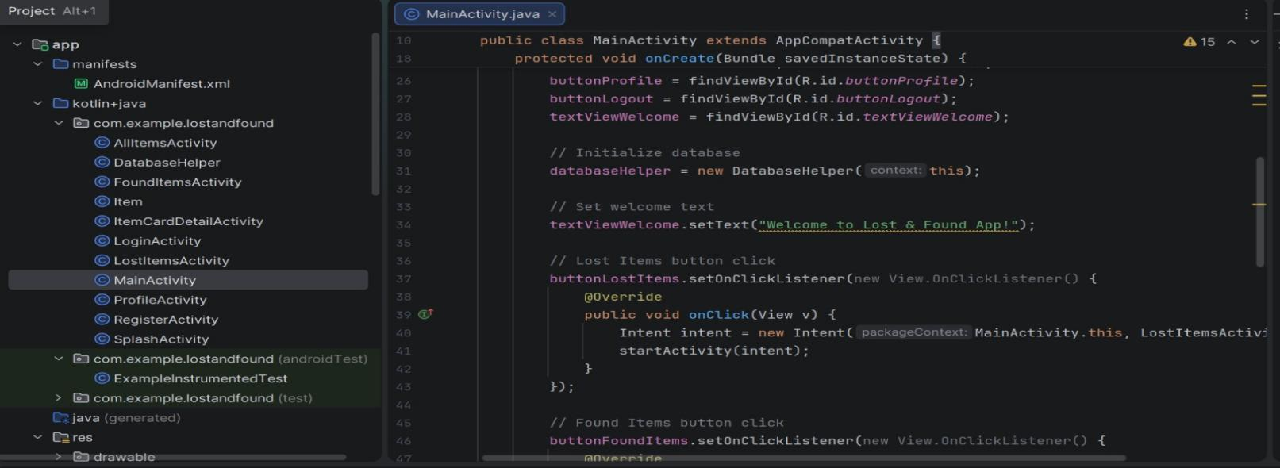
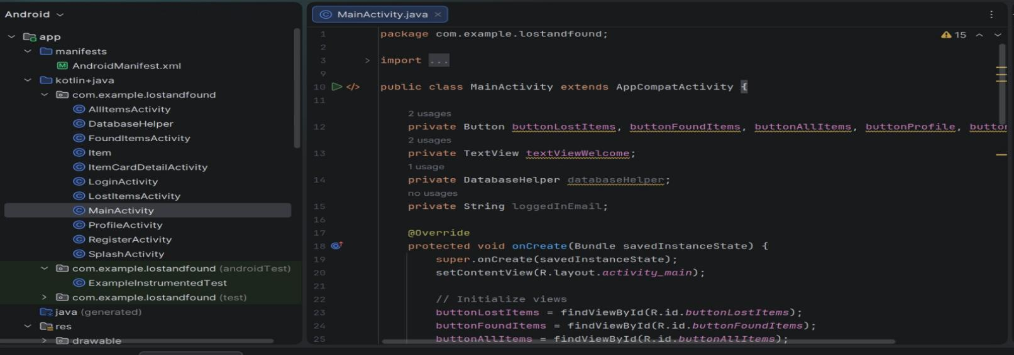
This file serves as the main dashboard after the user logs in. It contains buttons that let users navigate to different parts of the app such as adding a new item viewing all items viewing only lost items or viewing only found items. It acts as a central hub to access the main features of the Lost and Found app.
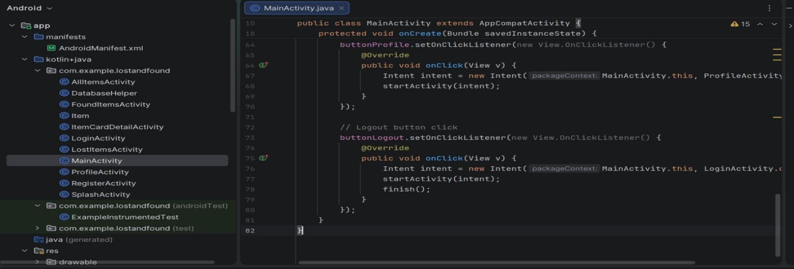

RegisterActivity.java
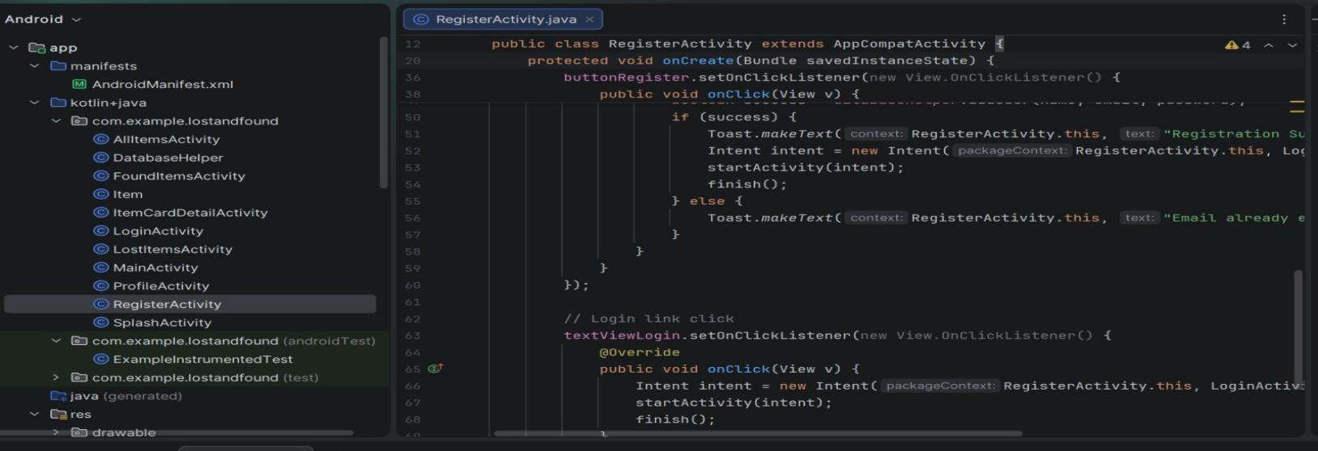
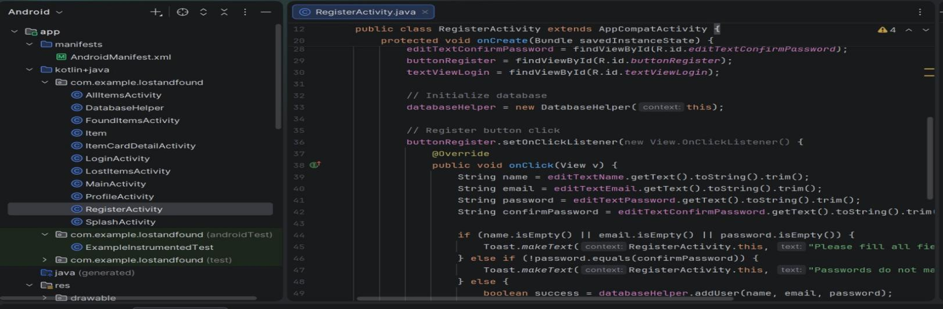
This file allows new users to create an account. It has fields for full name, email, password, and confirm password. When the user taps the register button, the app checks that all fields are filled and the passwords match. If everything is correct, the user's information is saved in the database and they can go back to the login screen to sign in.
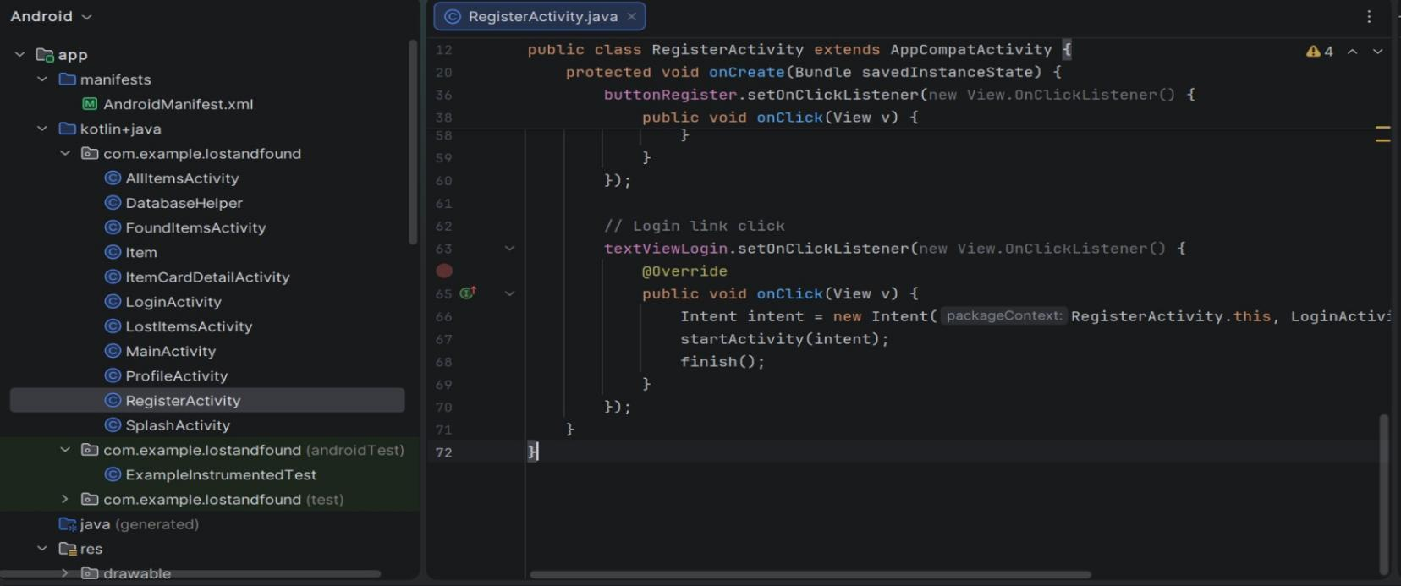

ProfileActivity.java
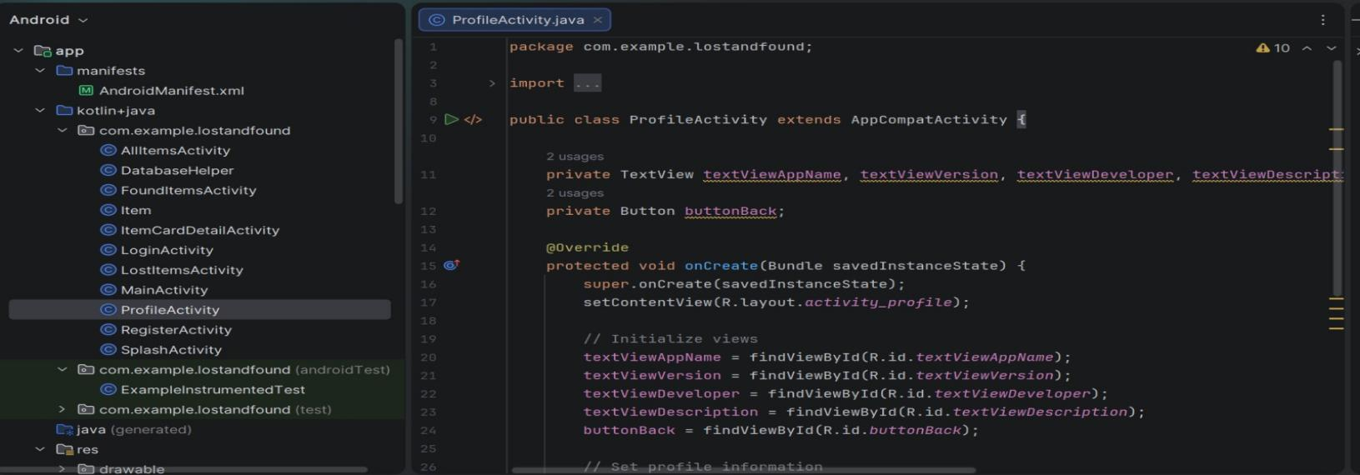
This file shows the logged in user’s personal information such as their name, email, and phone number. It may also display a list of items that the user has added. The user can log out from this screen. This helps users manage their account and see their own lost or found posts
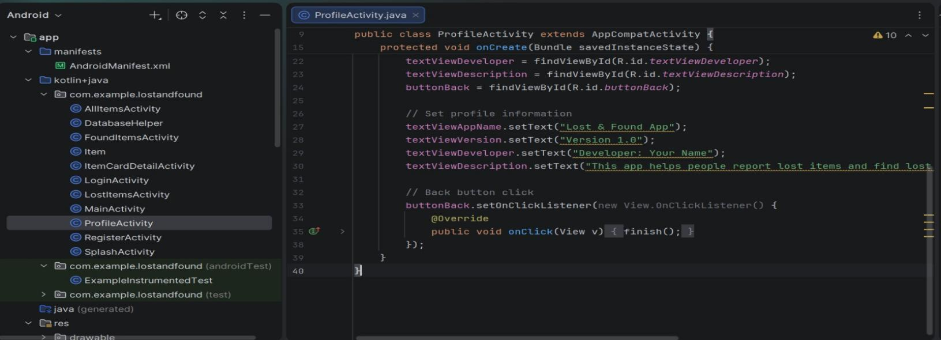

SplashActivity.java
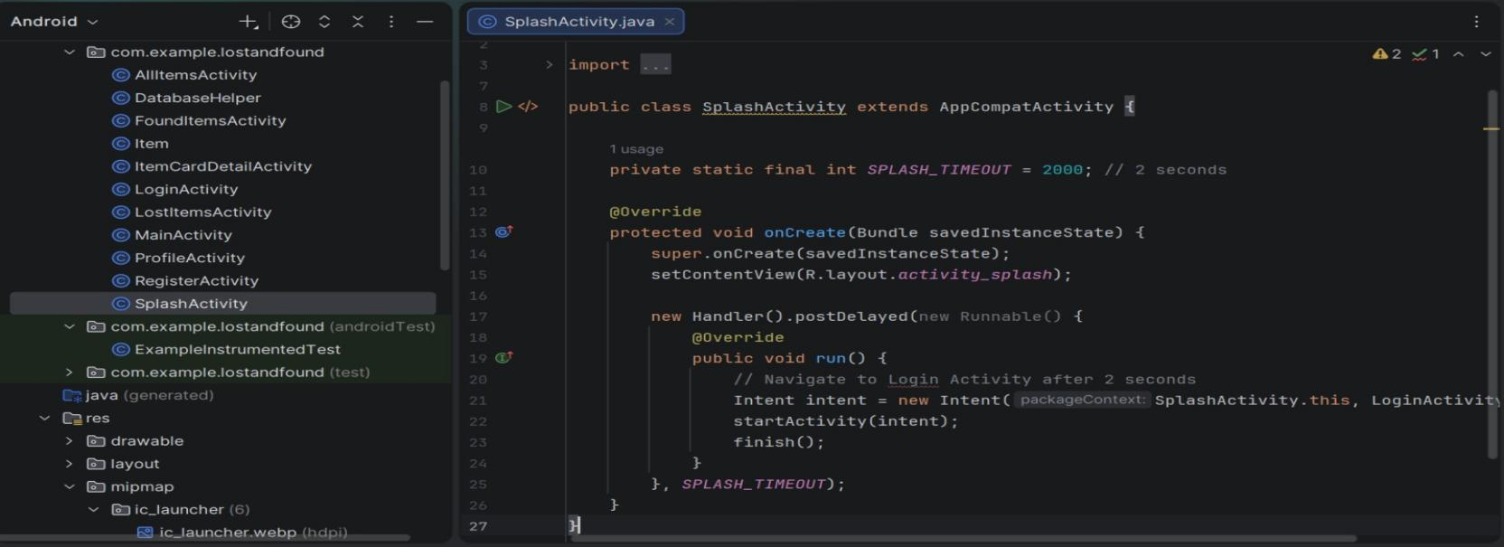
This file shows a welcome screen when the app first opens. It displays the app name and logo for a few seconds. After that short delay it automatically takes the user to the login screen. This gives the app a smooth and professional start.

ItemCardDetailActivity.java
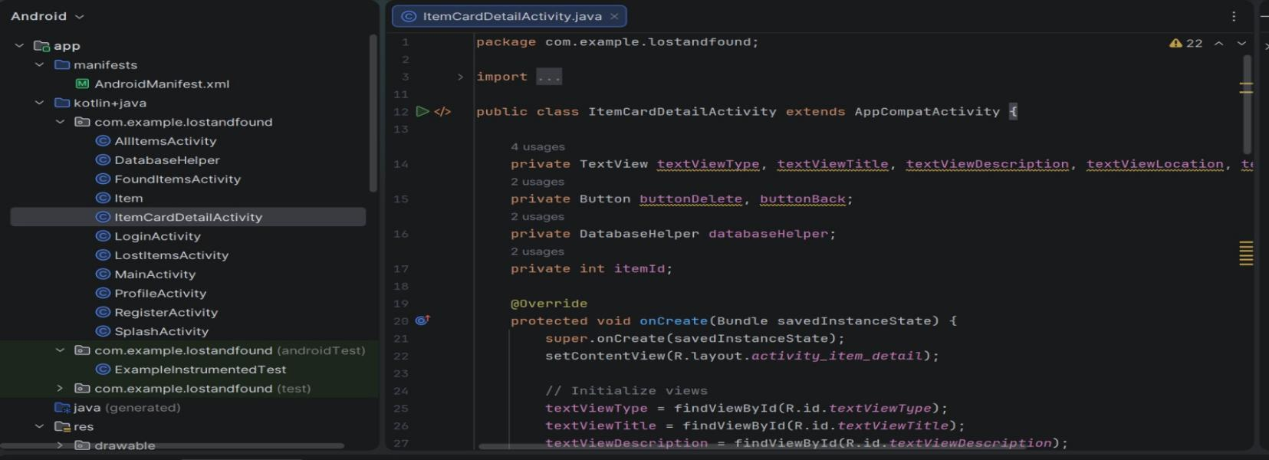
This file shows the complete details of a single lost or found item. It displays information such as the item title, description, location, date when it was reported, and the contact number of the person who posted it. The screen also includes a delete button so the user can remove the item if needed and a back button to return to the list. This is the screen users see after tapping an item from the list.
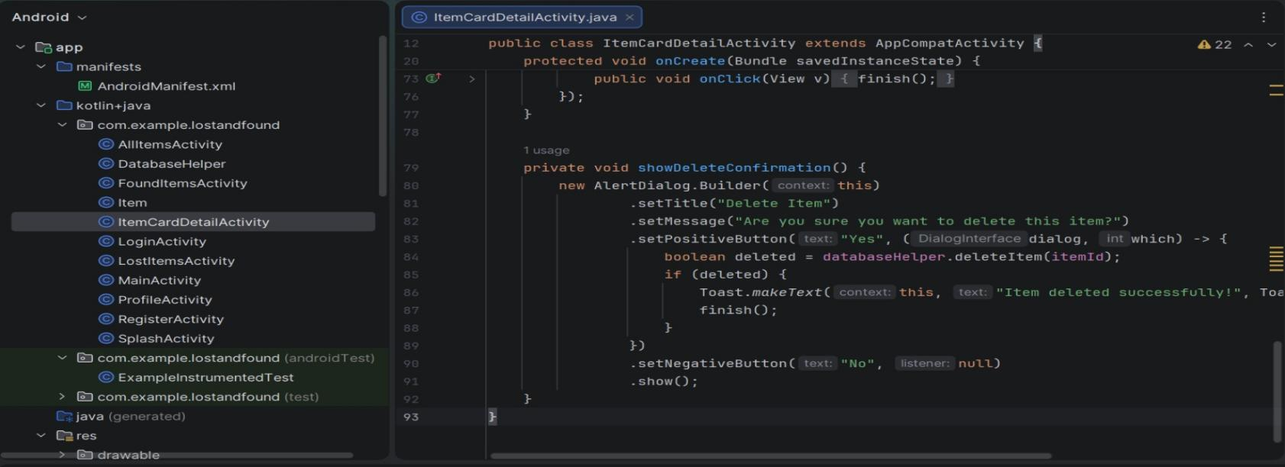
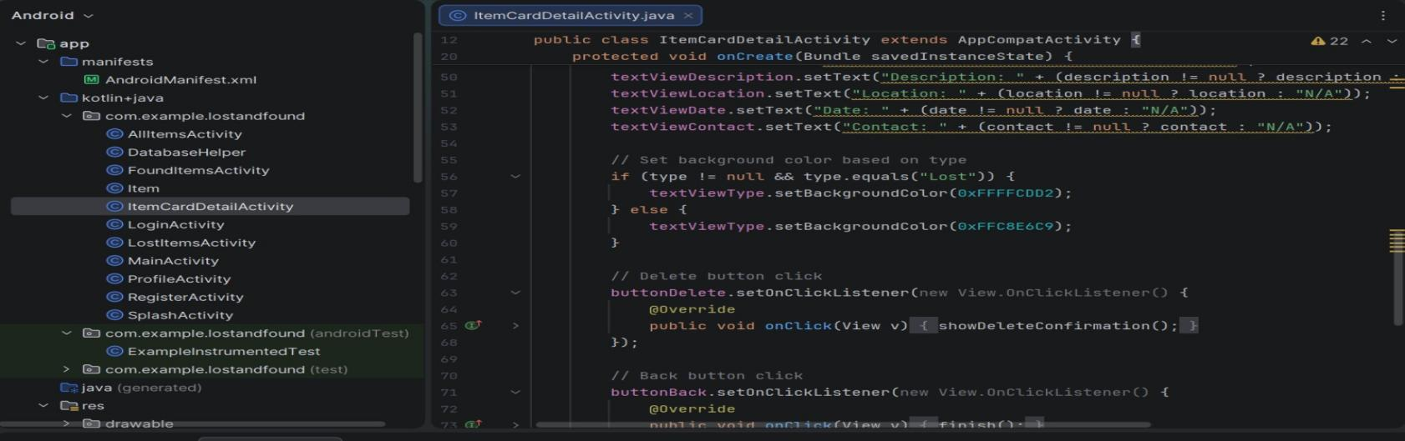
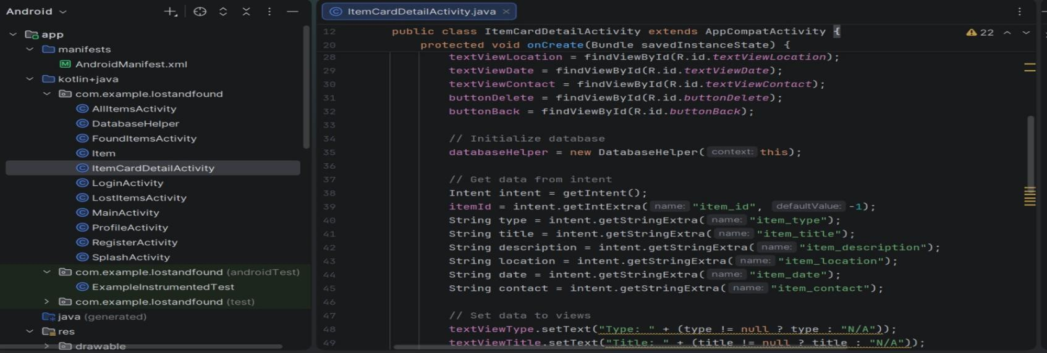
Item.java
This file defines the structure of an item object in the app. It holds all the information for a single lost or found item such as its unique id, title, description, location, date, contact number, and the user id of the person who added it. This class is used to store and pass item data between different parts of the app.
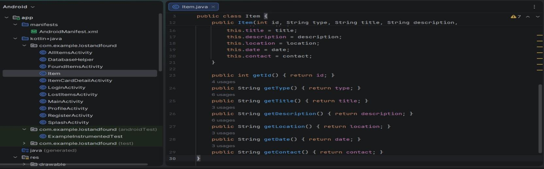
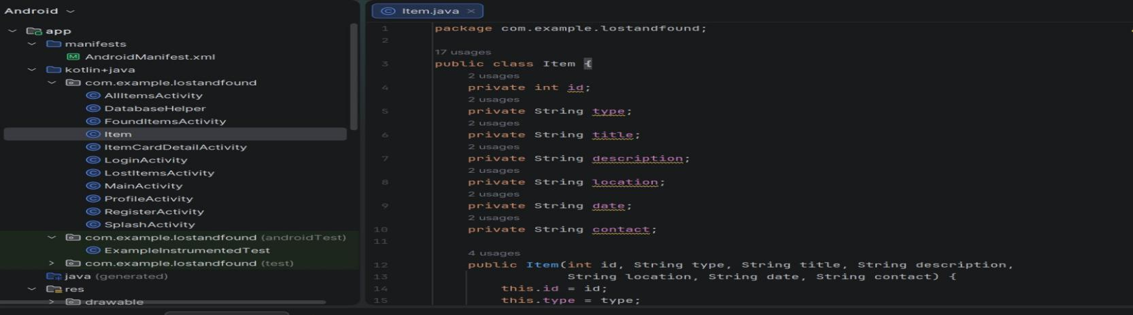

activity_add_item.xml
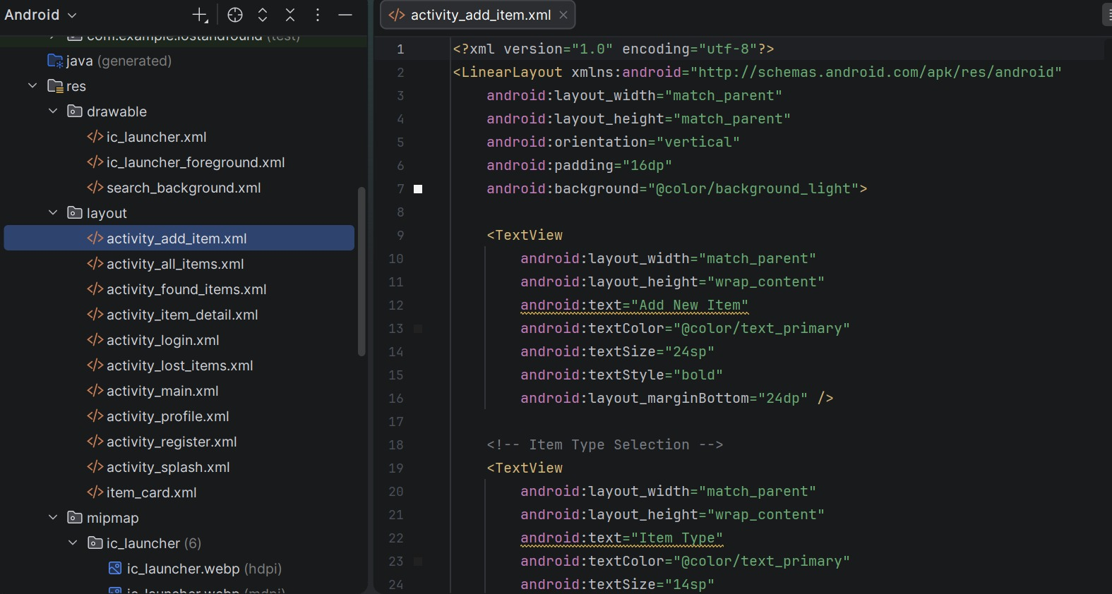
This layout file creates the screen where users can add a new lost or found item. It contains input fields for the item title, description, location, and contact number. There is also a submit button to save the item to the database. The design uses a clean white background with simple edit texts and a button.
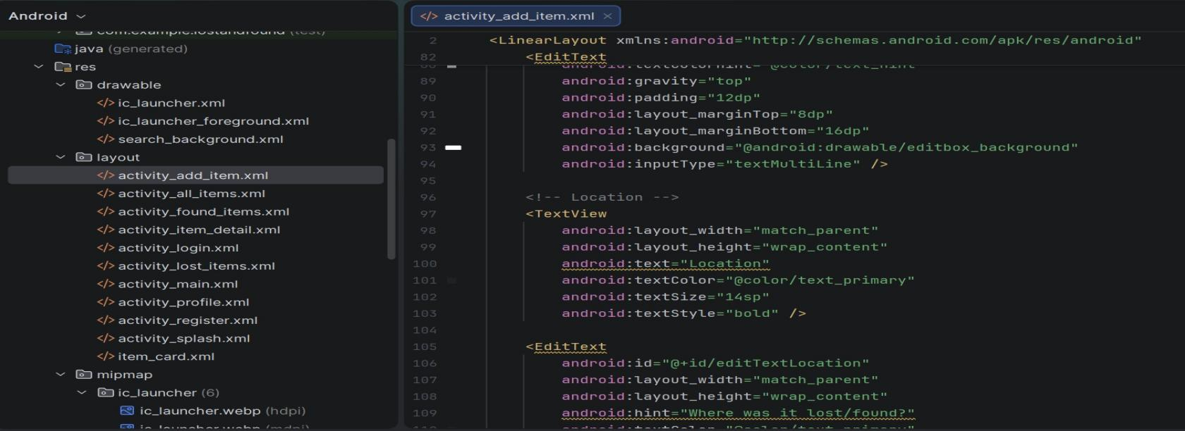
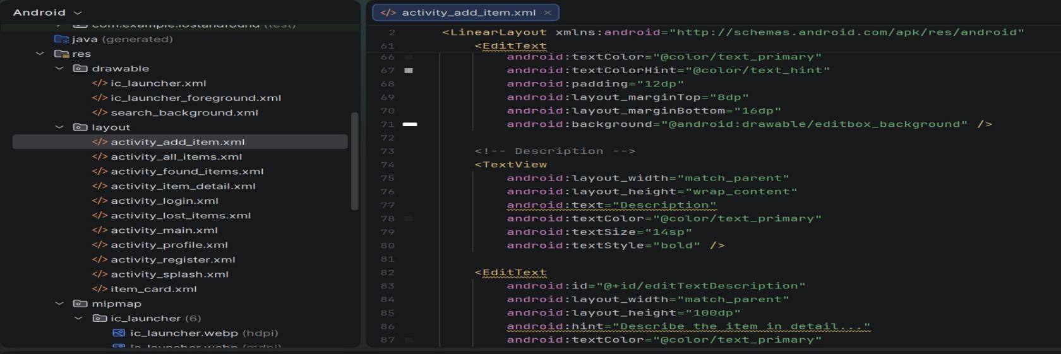
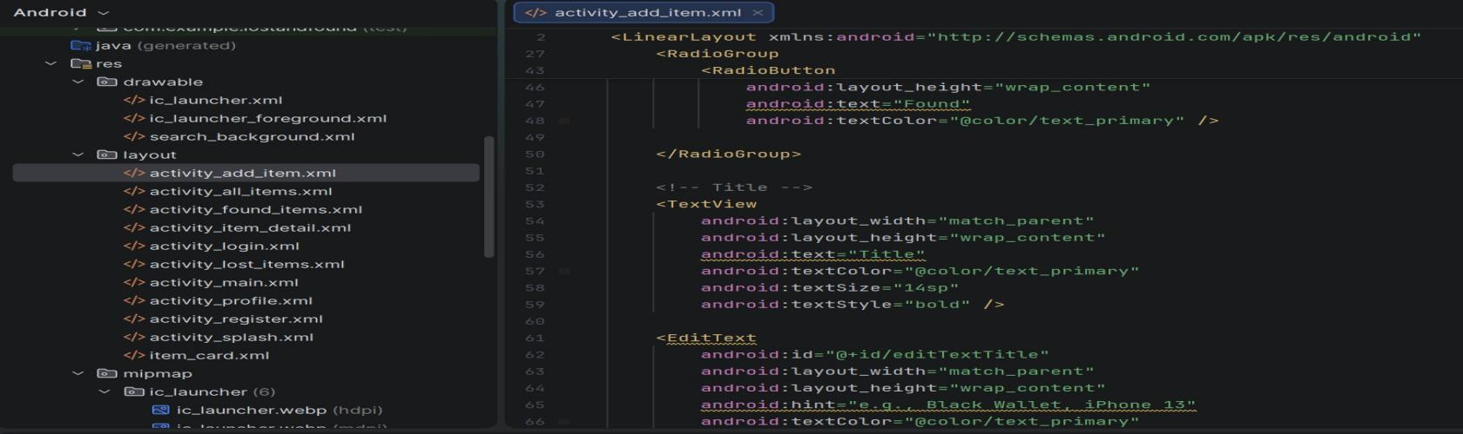
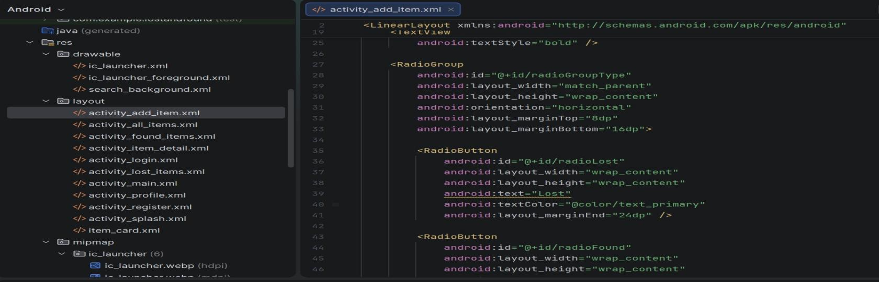
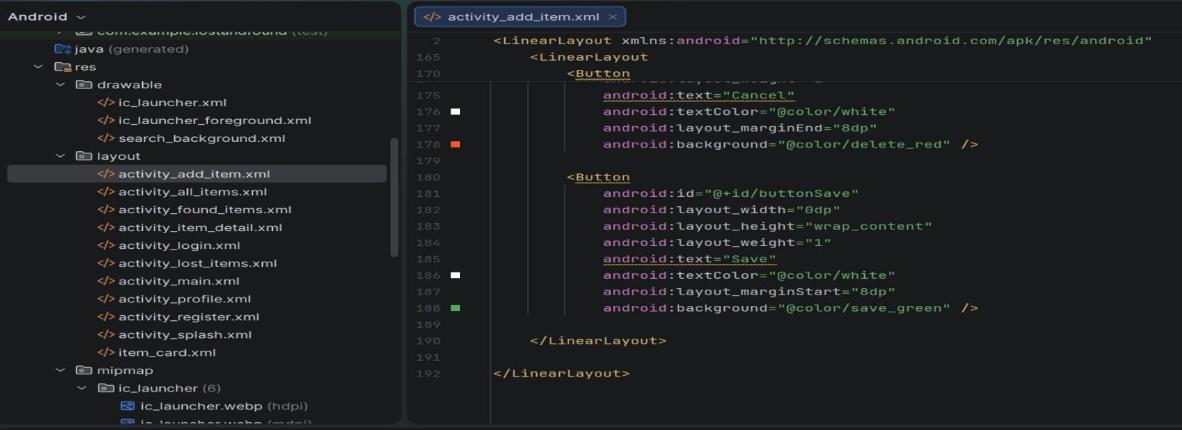
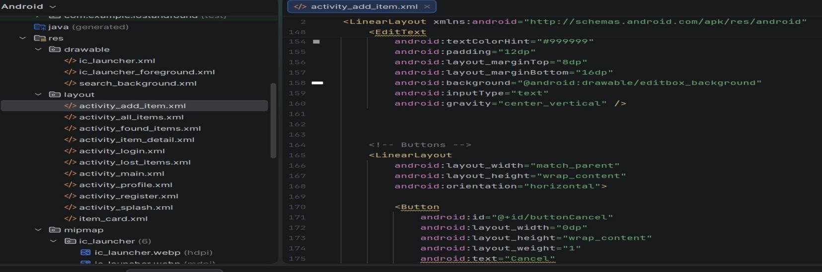
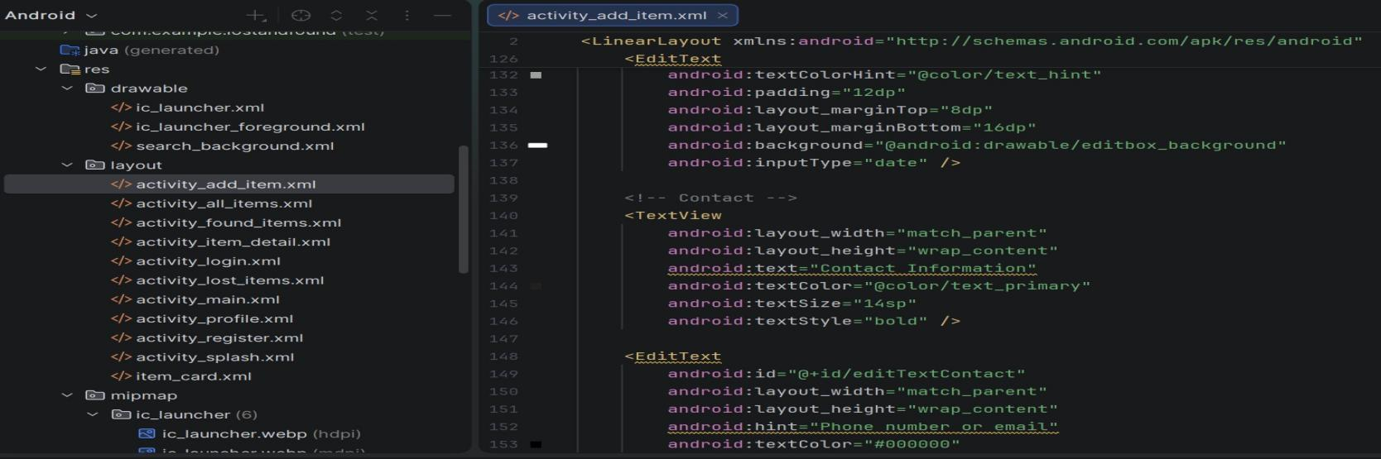
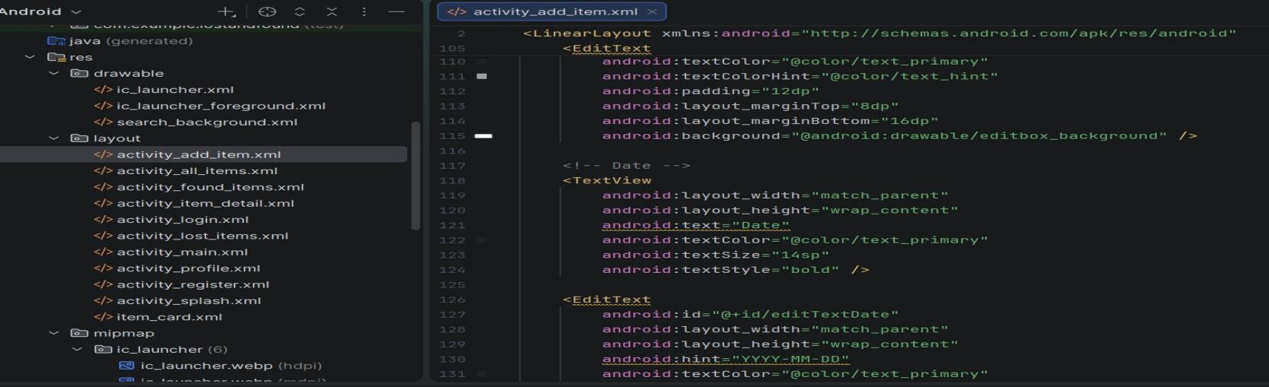
activity_all_items.xml
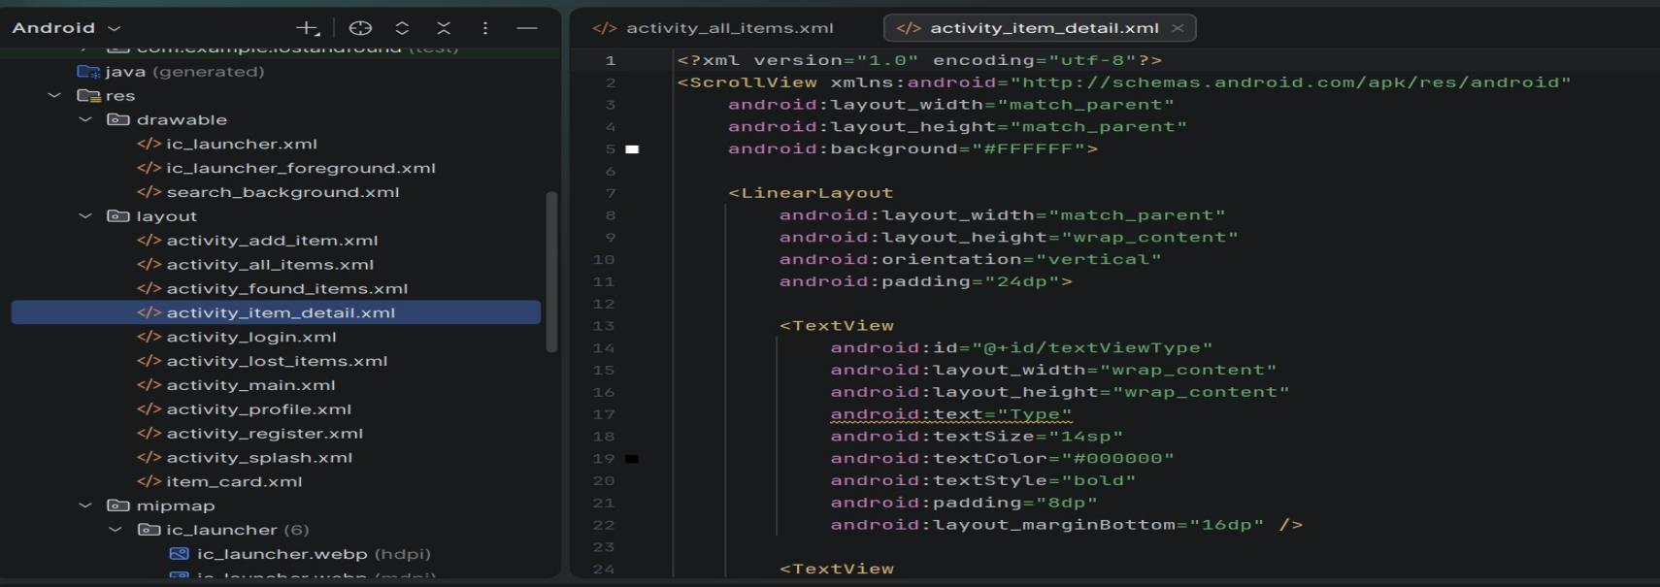
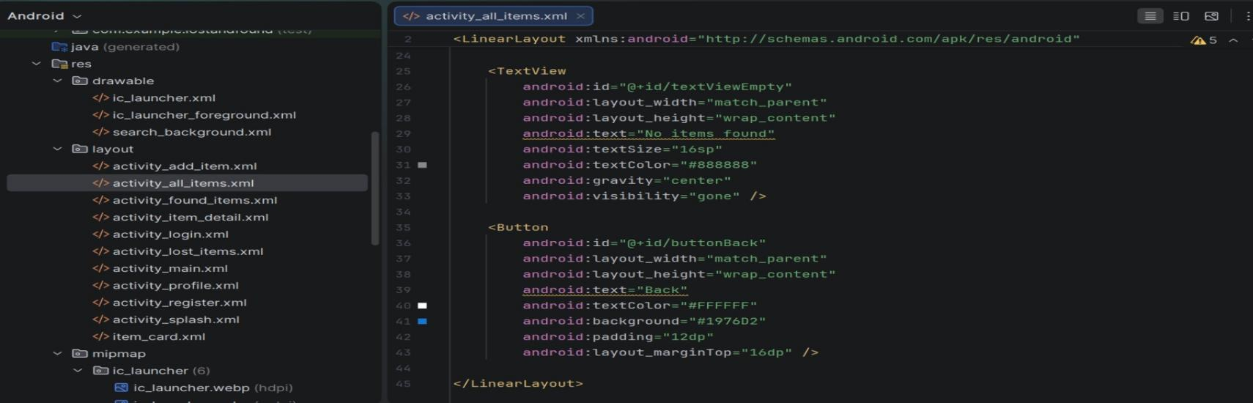
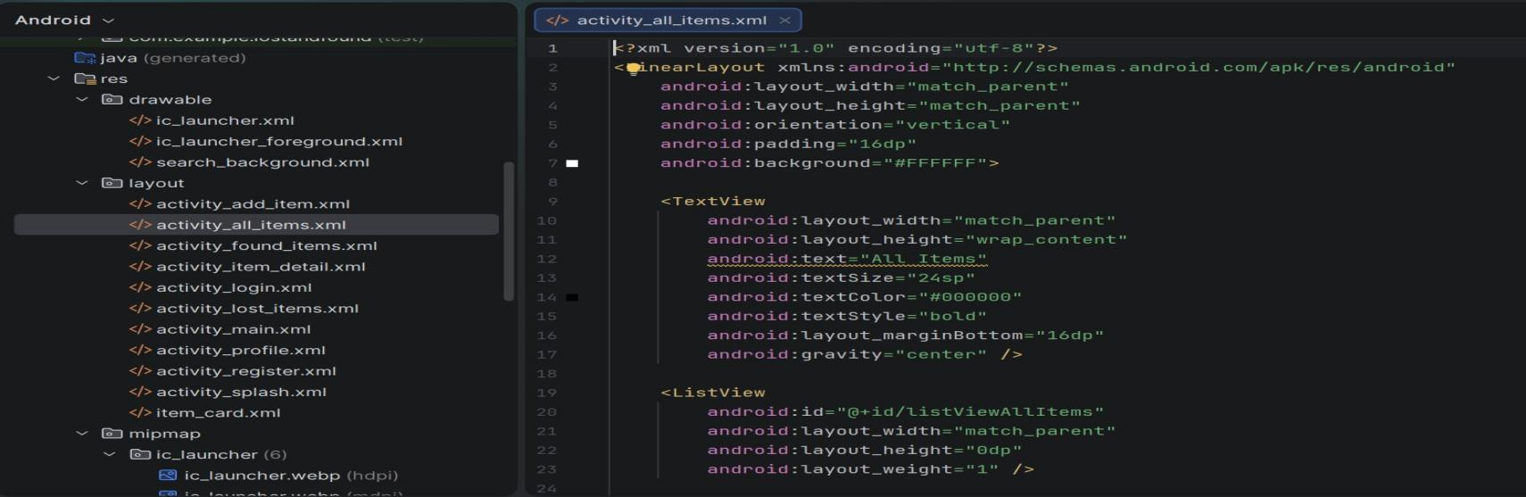
This layout file creates the main screen where all lost and found items are displayed. It contains a search bar with a search button, an Add New Item button, and a list view that shows the items. Users can type keywords to search and tap on any item to see its full details.
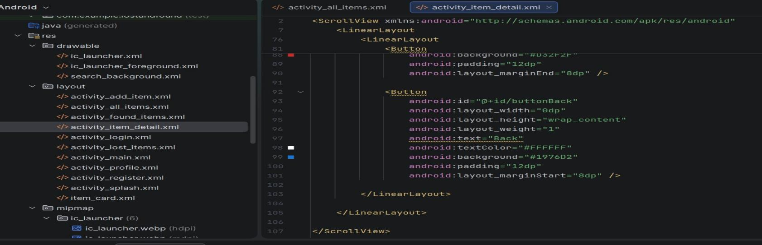
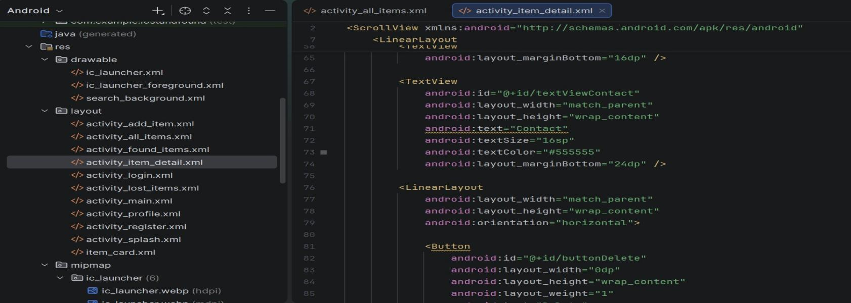
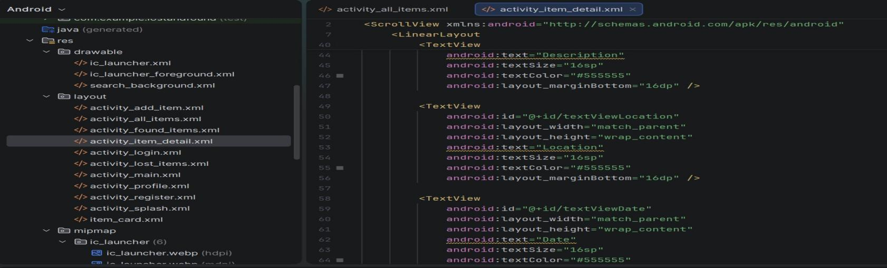
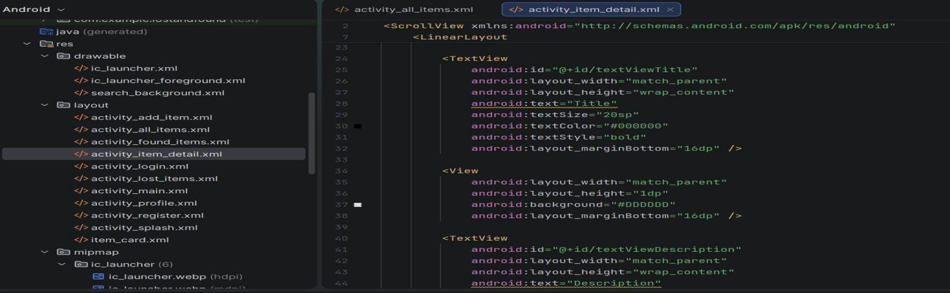

activity_login.xml
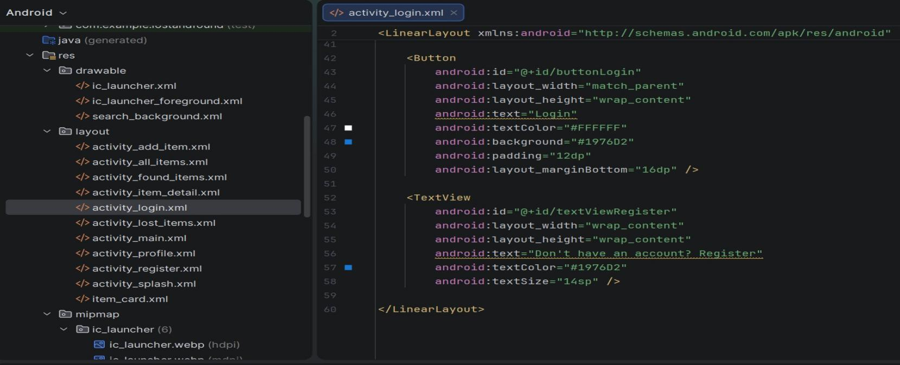
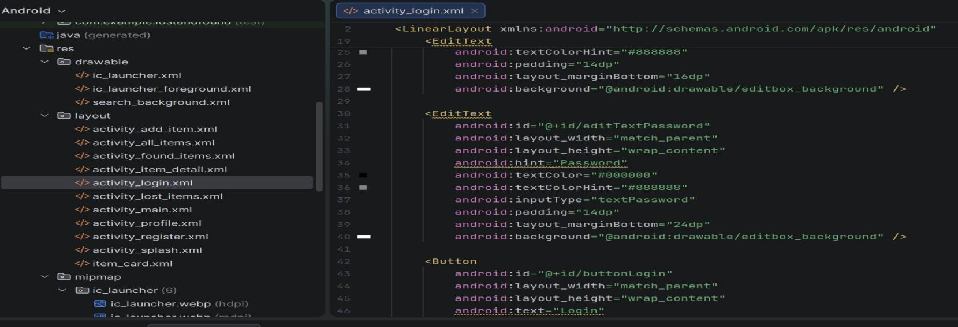
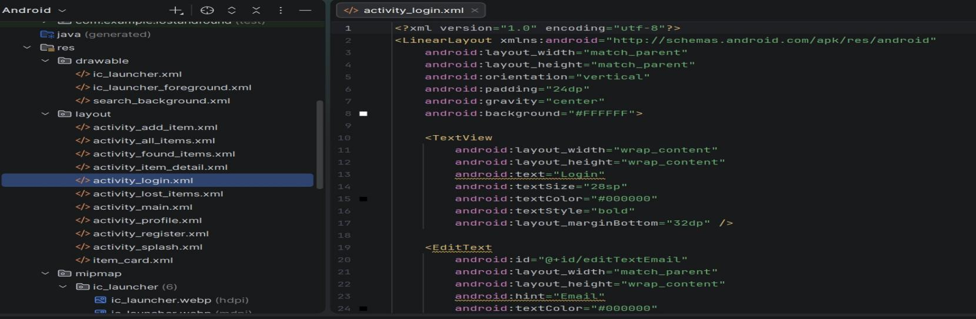
This layout file creates the login screen of the app. It contains two text fields for entering email and password, a login button, and a register link for new users. The design is simple with a white background and a purple button to match the app theme.

colors.xml
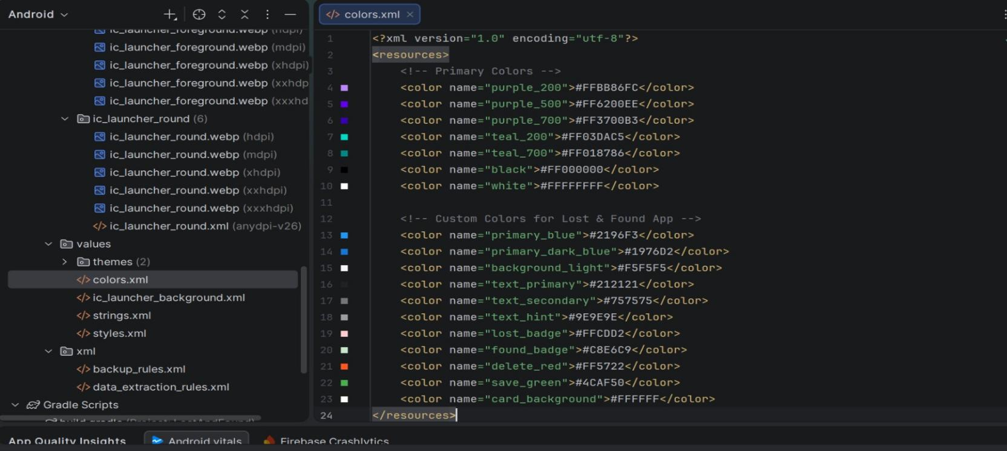
This file defines the color values used throughout the app. It stores colors like purple for buttons and text, white for backgrounds, and other shades. By keeping all colors in one place, it is easy to change the app theme consistently without editing each layout file individually.

styles.xml
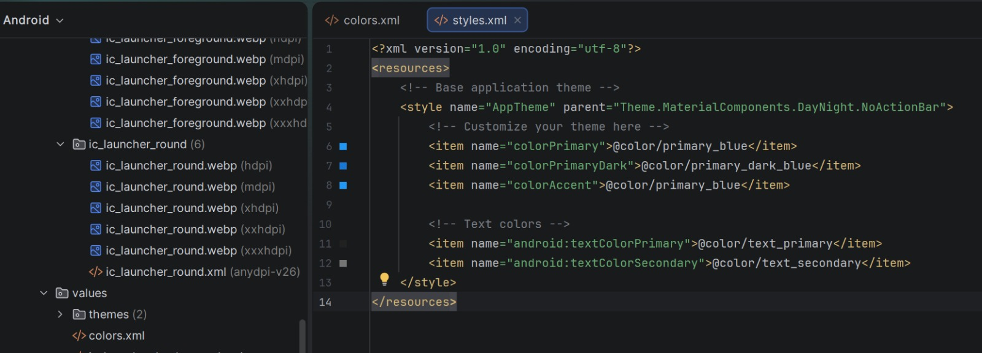
This file defines the visual themes and styles for the app. It controls things like the default color of the action bar, the background of the window, and the overall look of the interface. By using a theme, the app maintains a consistent appearance across all screens.

themes.xml
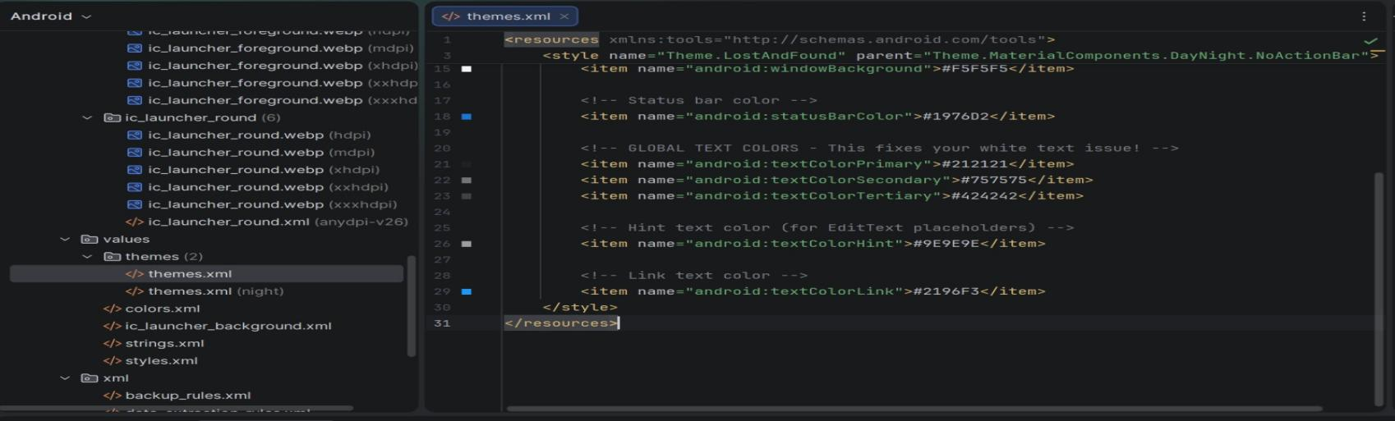
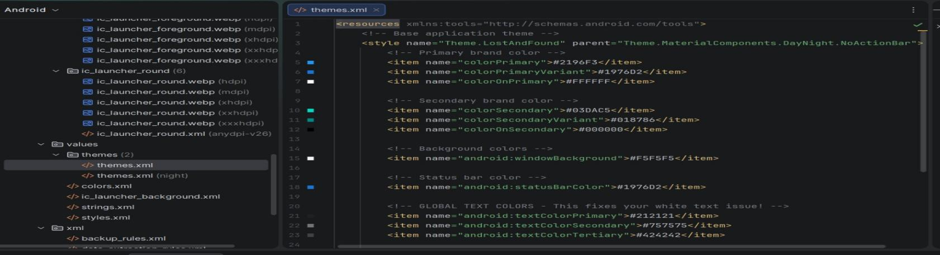
This file defines the custom themes for the app. It controls the overall appearance including the color of the action bar, status bar, window background, and button styles. By using themes, the app keeps a consistent and professional look across all screens. This file is often used together with colors.xml to apply a unified design.

build.gradle (Project Level)
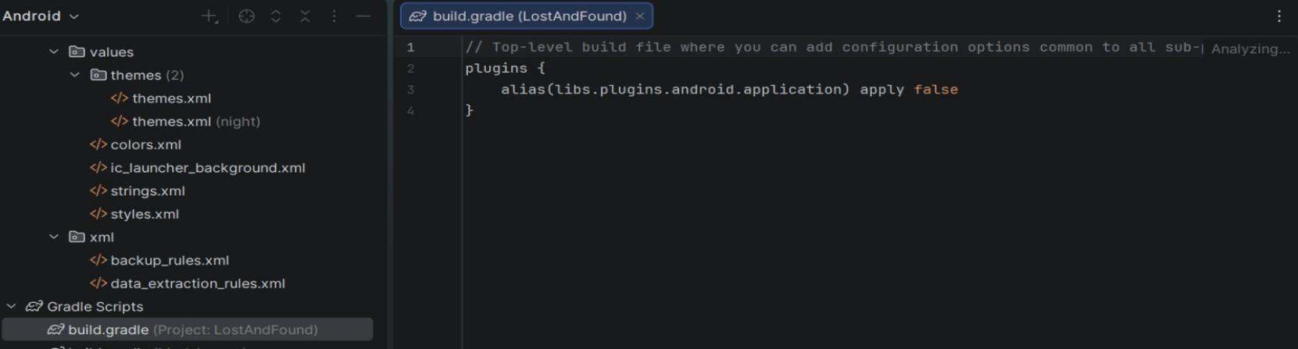
This file configures the build settings for the entire project. It defines the repositories where dependencies are downloaded from and sets the Gradle version that the project uses. It also applies common plugins to all modules. This file is usually not changed frequently and controls the overall build environment.

build.gradle (Module :app)
This file configures the build settings for the app module only. It specifies the Android SDK versions like minimum and target API levels, dependencies that the app needs such as AndroidX libraries, and other build options. Any library or plugin used by the app is declared here. This file is important for compiling and packaging the app correctly.
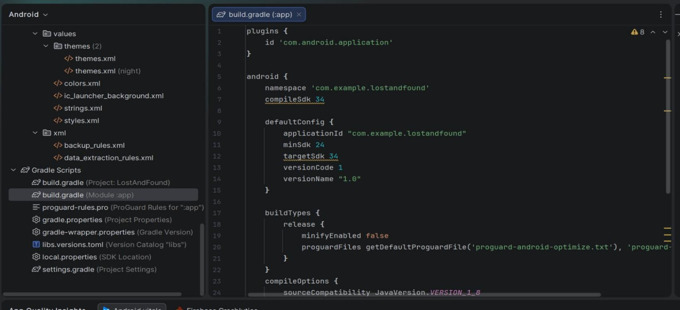
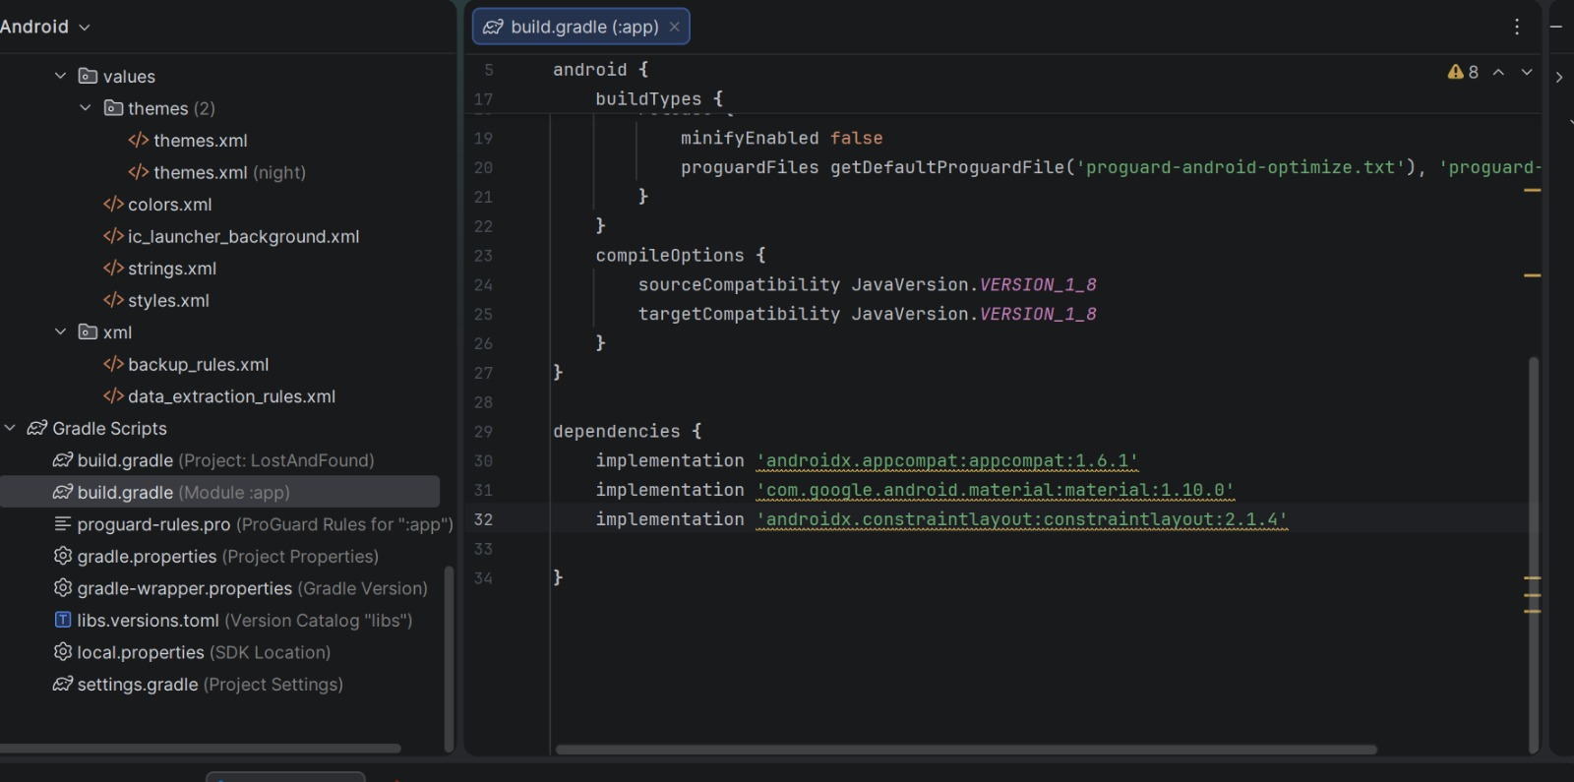

settings.gradle
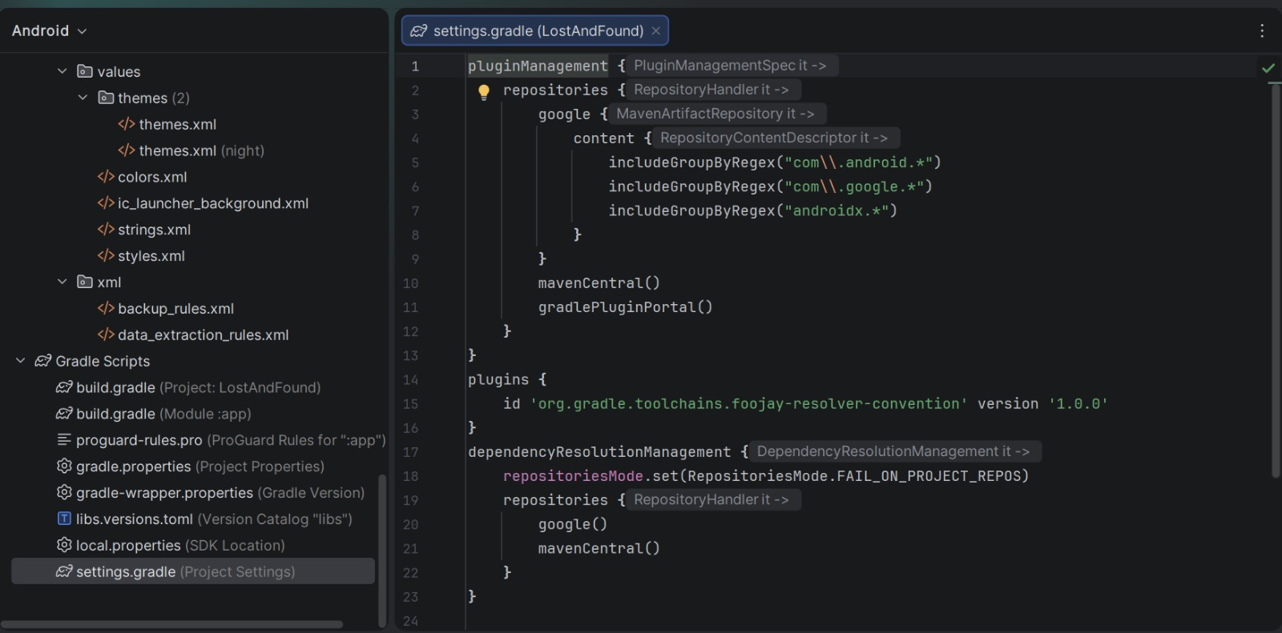
This file tells Android Studio which modules are included in the project. For a simple project like Lost and Found, it usually includes only the app module. It helps the build system understand the structure of the project.

Conclusion
This Lost and Found Android Application is a semester level project developed by 6th semester students of the Information Technology department. The purpose of this project is to provide users with an easy platform where they can report lost or found items. The app uses SQLite database so that all data stays on the mobile device and no internet connection is required. This project offers basic functionality like user registration, adding items, searching, and deleting items. We hope this project can help people in real life.

