**Testing code** – using debug mode where answer is displayed after each turn so I can decide what to test accordingly.

**Case 1:** user guesses the word without the score reaching 5 before. It tests that in case that the score reaches 5 when user guesses the word correctly, the code should not enter loop to give two guesses. Instead it should announce that the user won. Here, I tested this:

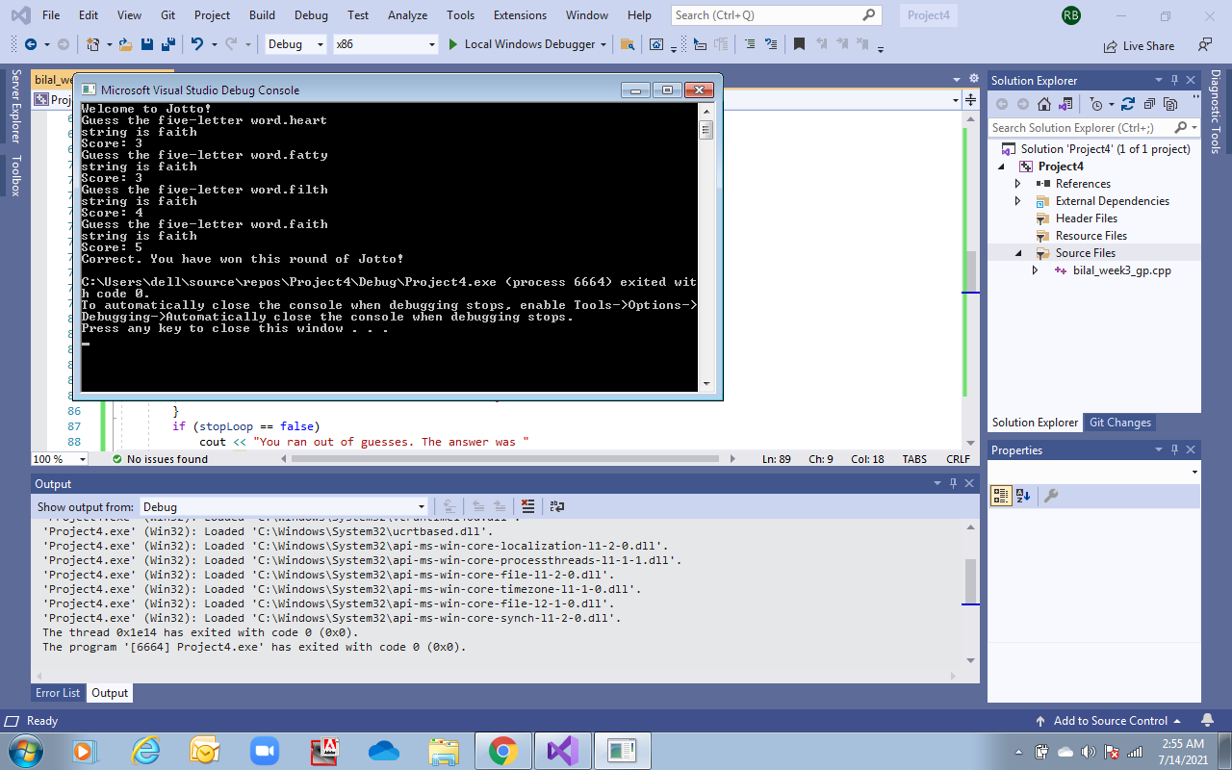

**Case 2:** Testing that the validateString() checks the length of string both during the first loop and later during the two guesses as well. It also tested that in case of invalid string, user can re-enter a new string until string is valid:

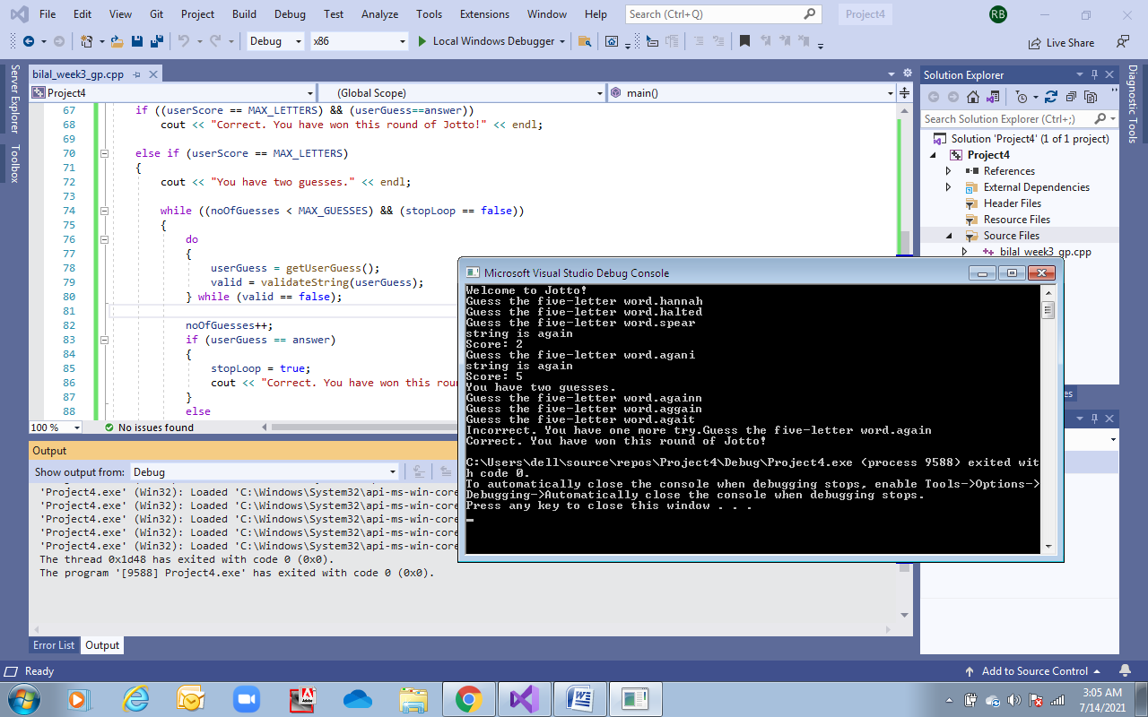

**Case 3:** To test that in case user enters a string with repeated letters and that letter only occurs once in the answer, then it is only counted once in the score.

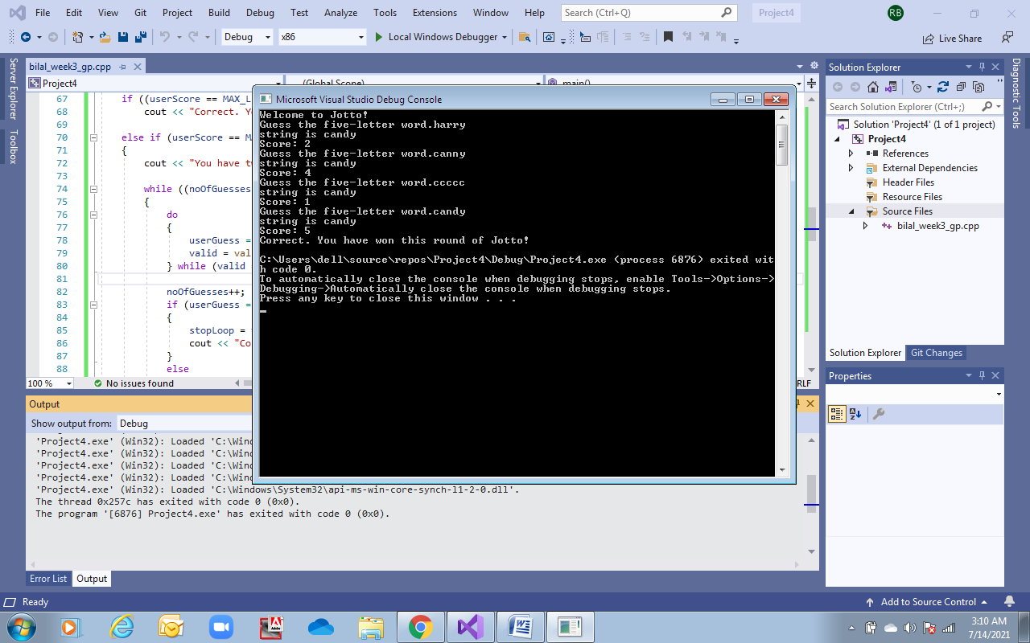

**Case 4:** testing that winning statement outputs correctly both if user wins on first try or on first/second guess:

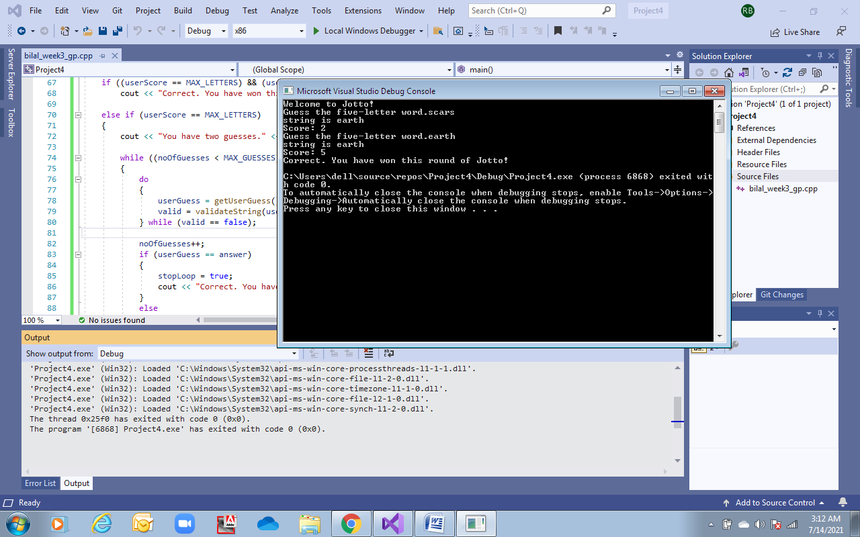

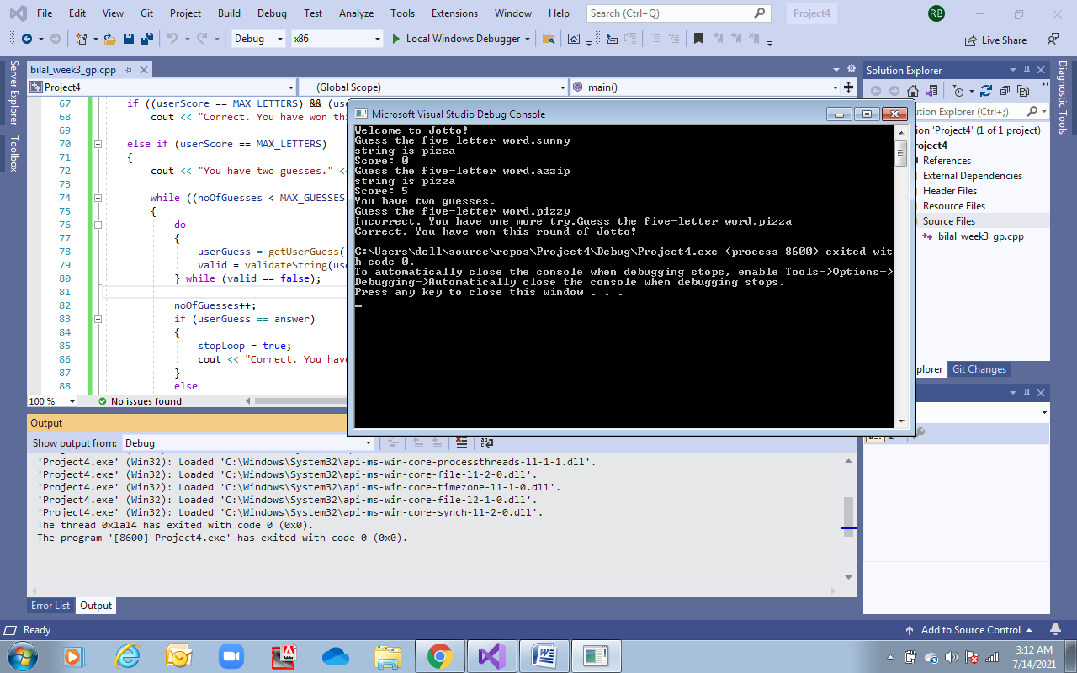

**Case 5:** testing that losing statement outputs correctly and actual answer is displayed in the end:

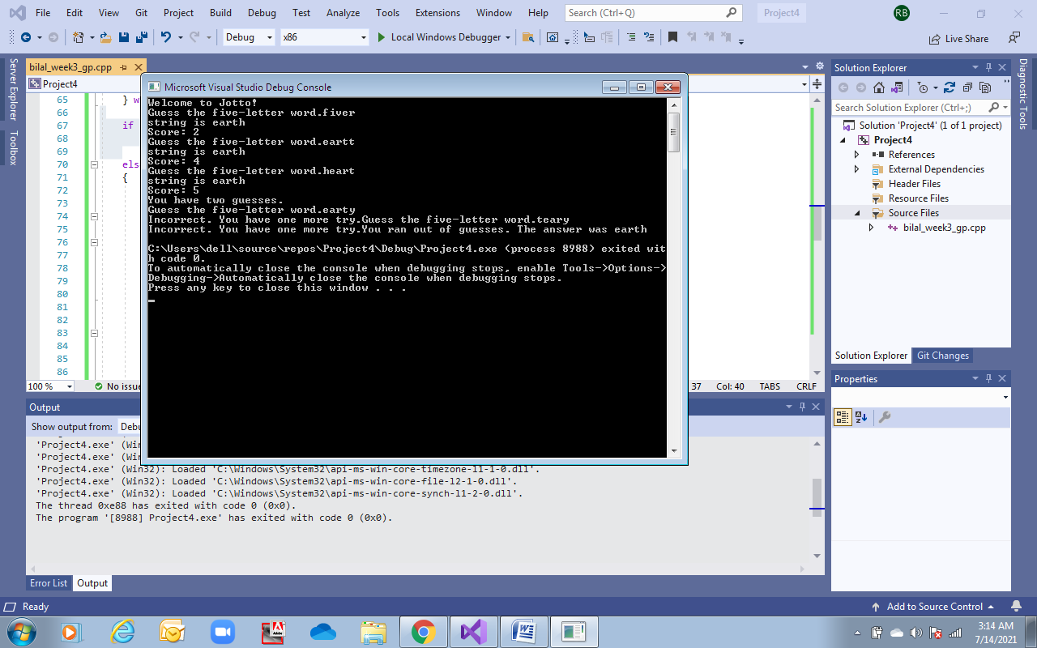

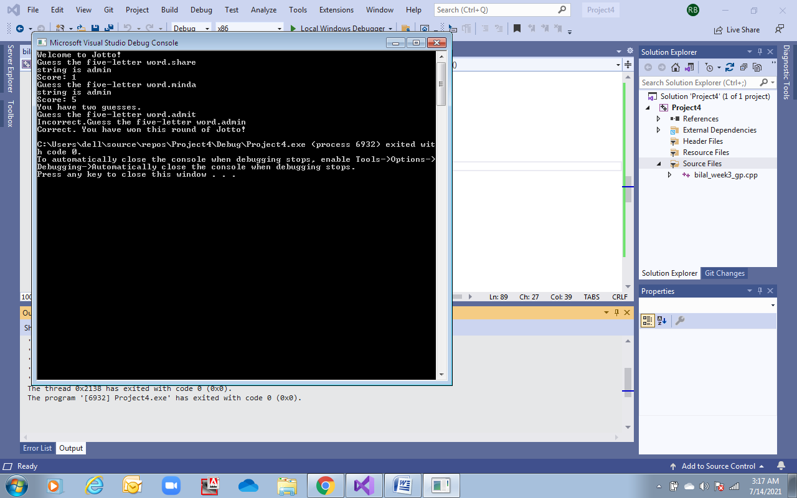

**Case 6:** Checking that guesses and scores display correctly after each turn:

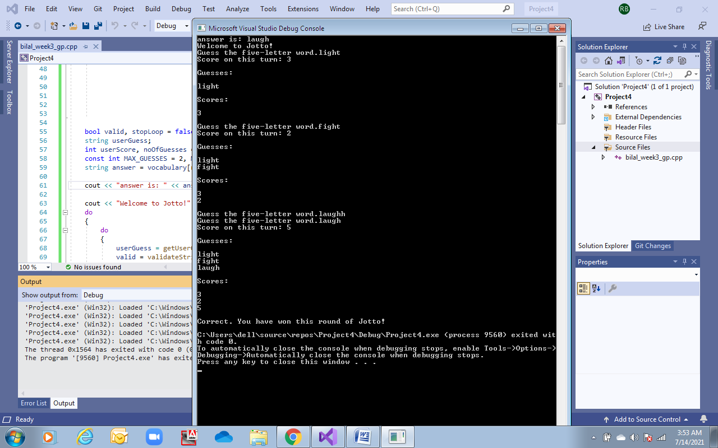

**Case 7:** Testing that letter list displays correctly:

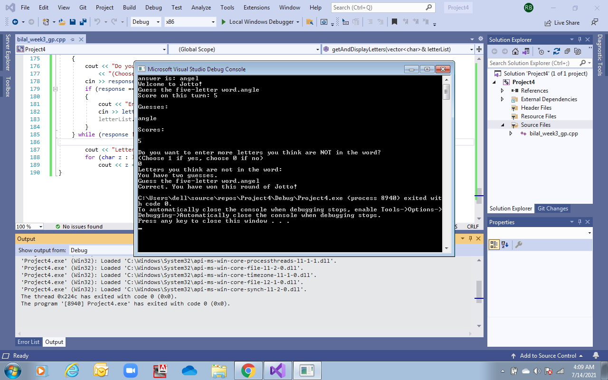

**Case 8:** To ensure that letter list does not ask for more letters when score is 5 since all letters are correctly guessed:

