**Testing problem set 3:**

**Problem 3 – Palindrome**

**Case 1: Testing that function cleanText() properly takes char array as input and cleans the word by removing all spaces, punctutation, etc and converts the chars to lower case.**

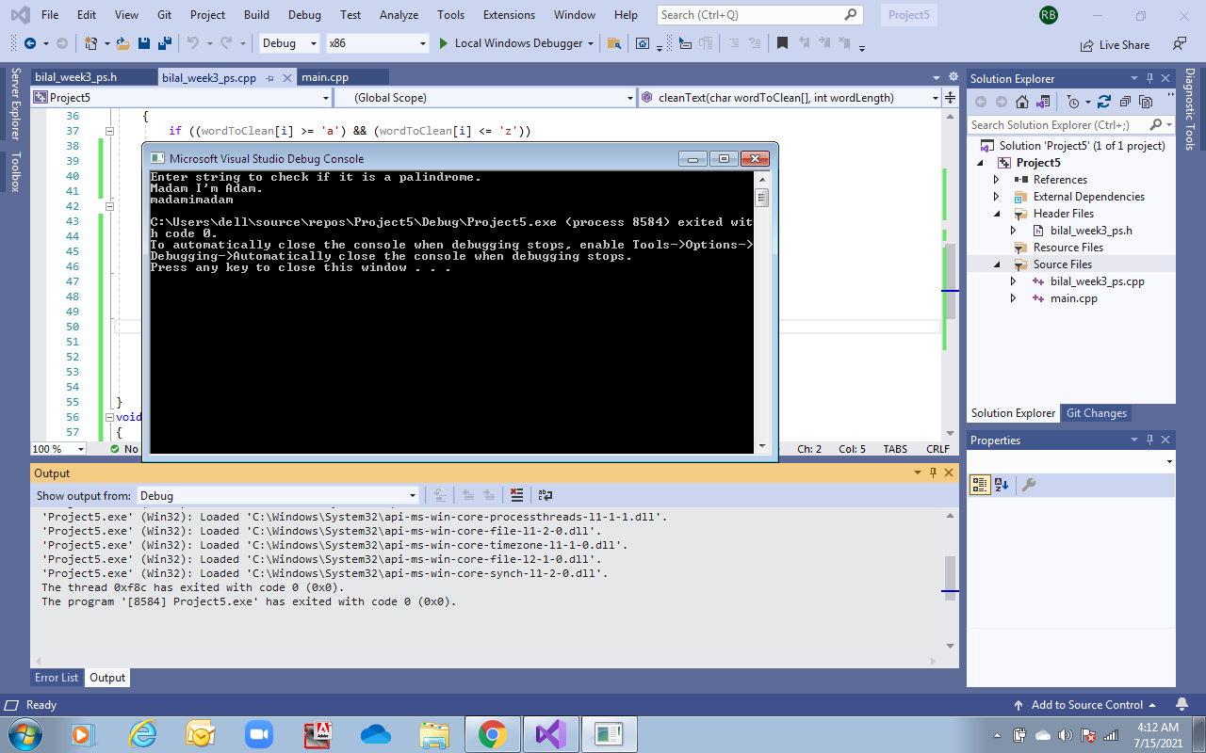



**Case 2: Testing all functions using debug mode (supporting outputs and statements to show that each function works properly.)**

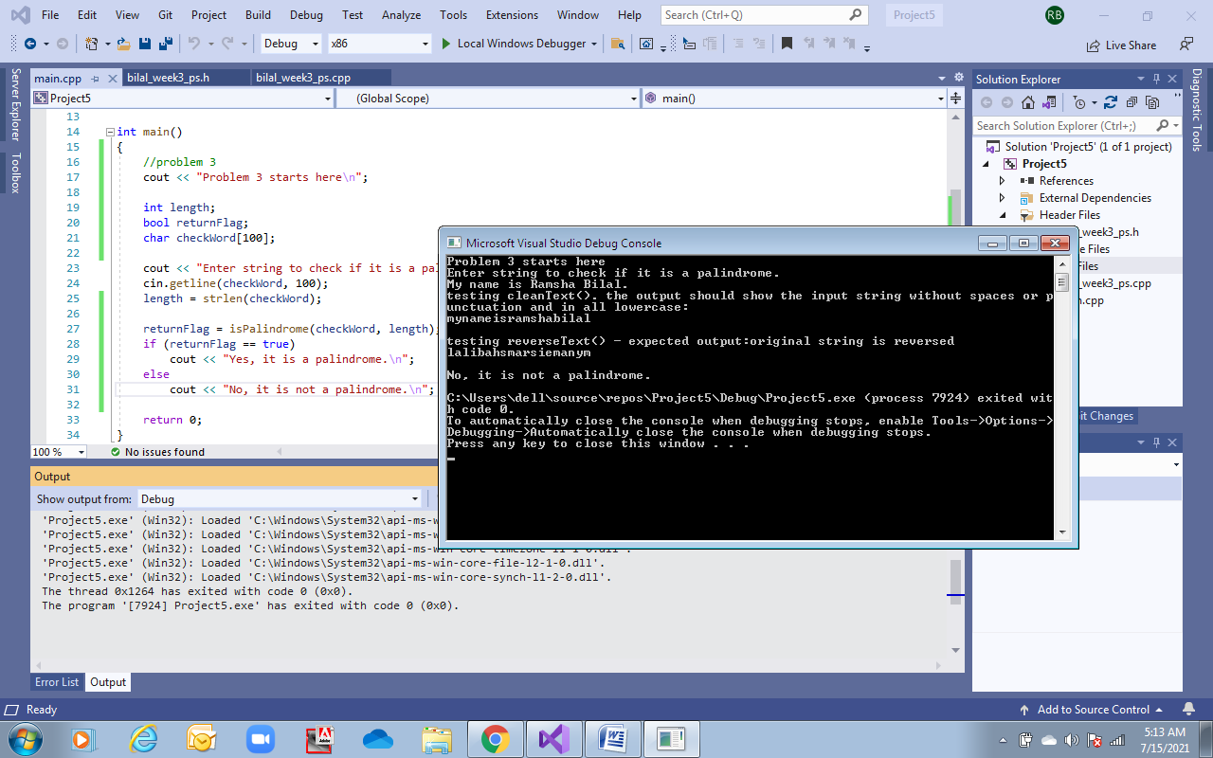



**Case 3:** **Testing the statements given in problem set 3 using debug mode:**

**Number 1:** Are we not drawn onward, we few, drawn onward to new era?

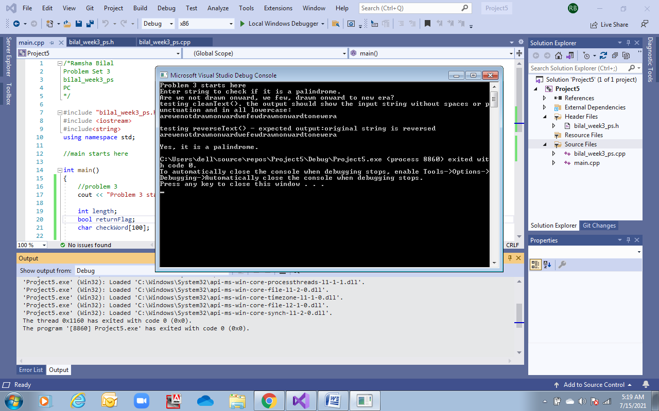



**Number 2:** Doc, note, I Dissent. A fast never prevents a fatness. I diet on cod.

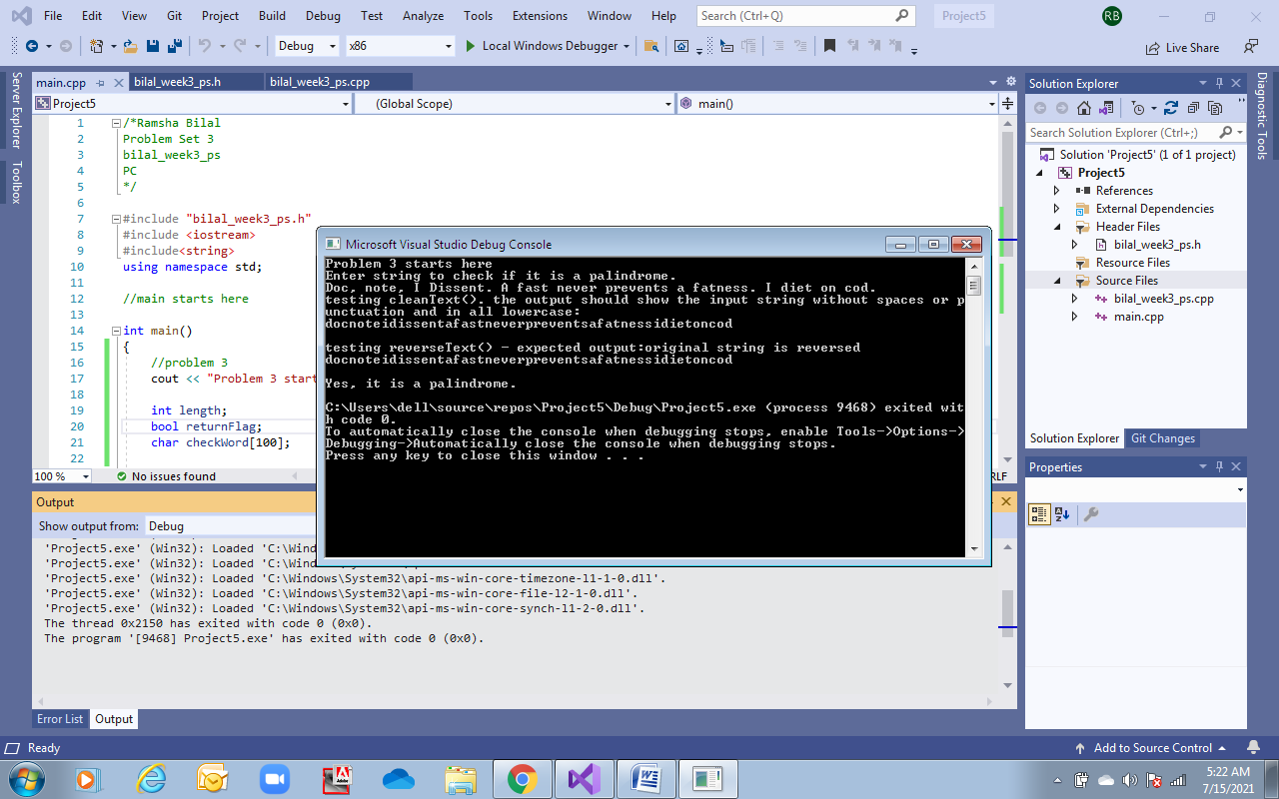



**Number 3:** God, Art! Name no pup “One Mantra Dog.”

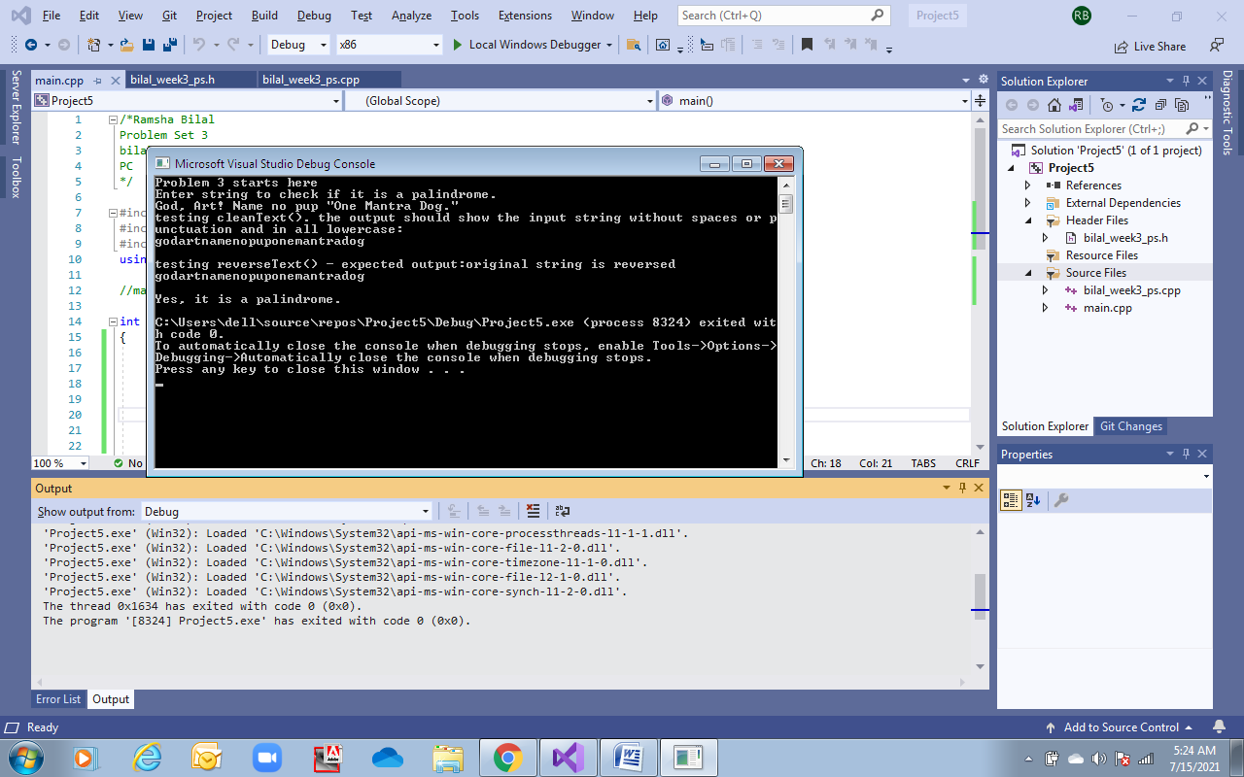



**Number 4:** Madam, I am Adam.

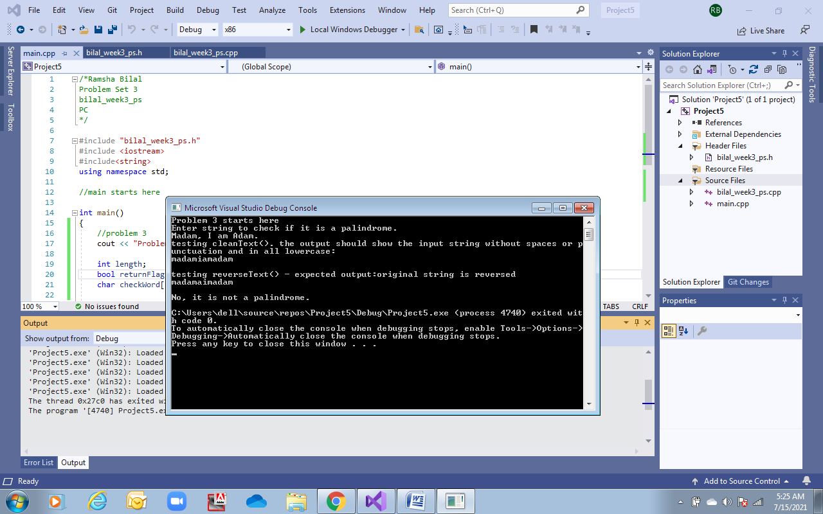



**Other examples:**

**Case: not a palindrome**

* **“How you doin’?”**

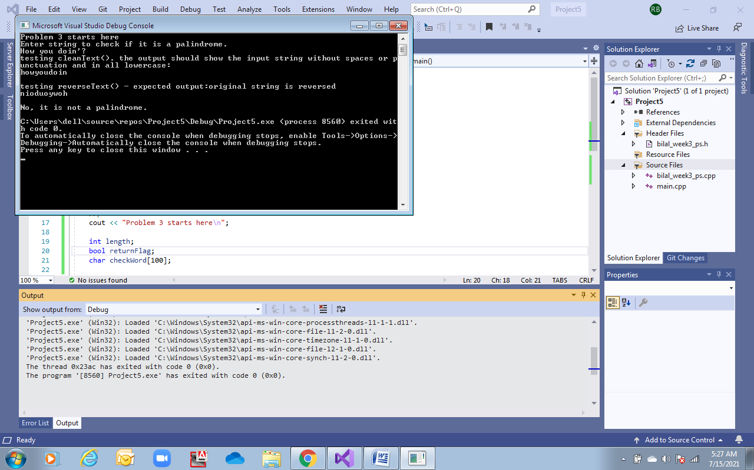

**Case: a palindrome – On a clover, if alive, erupts a vast, pure evil; a fire volcano**

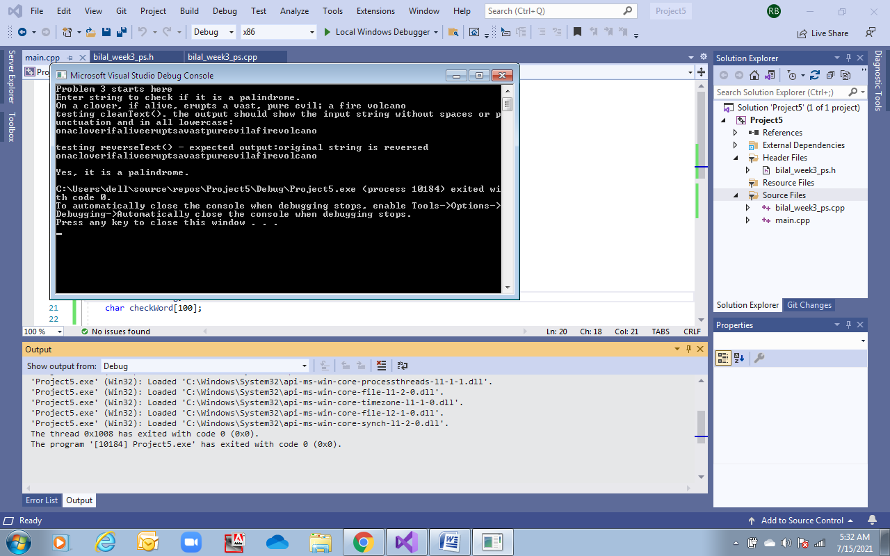

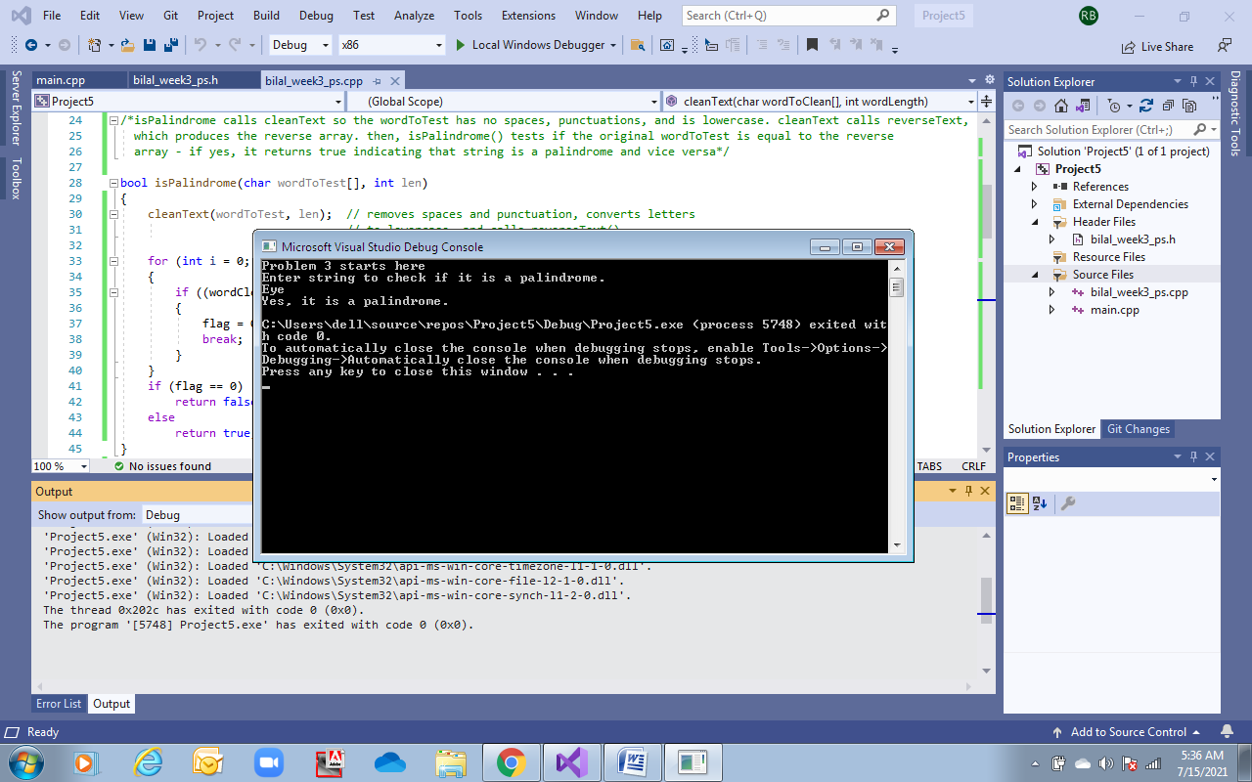

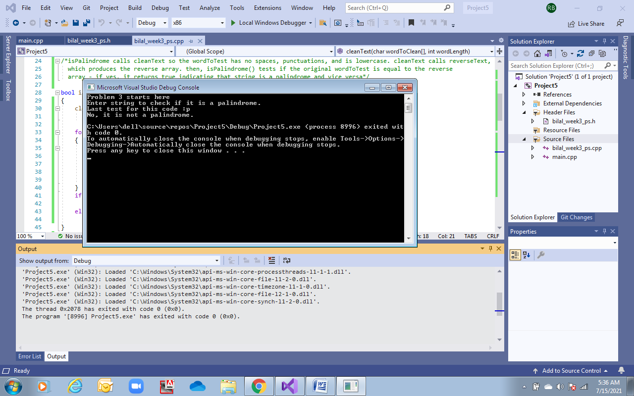

To test that reverseText() and cleanText() work properly.

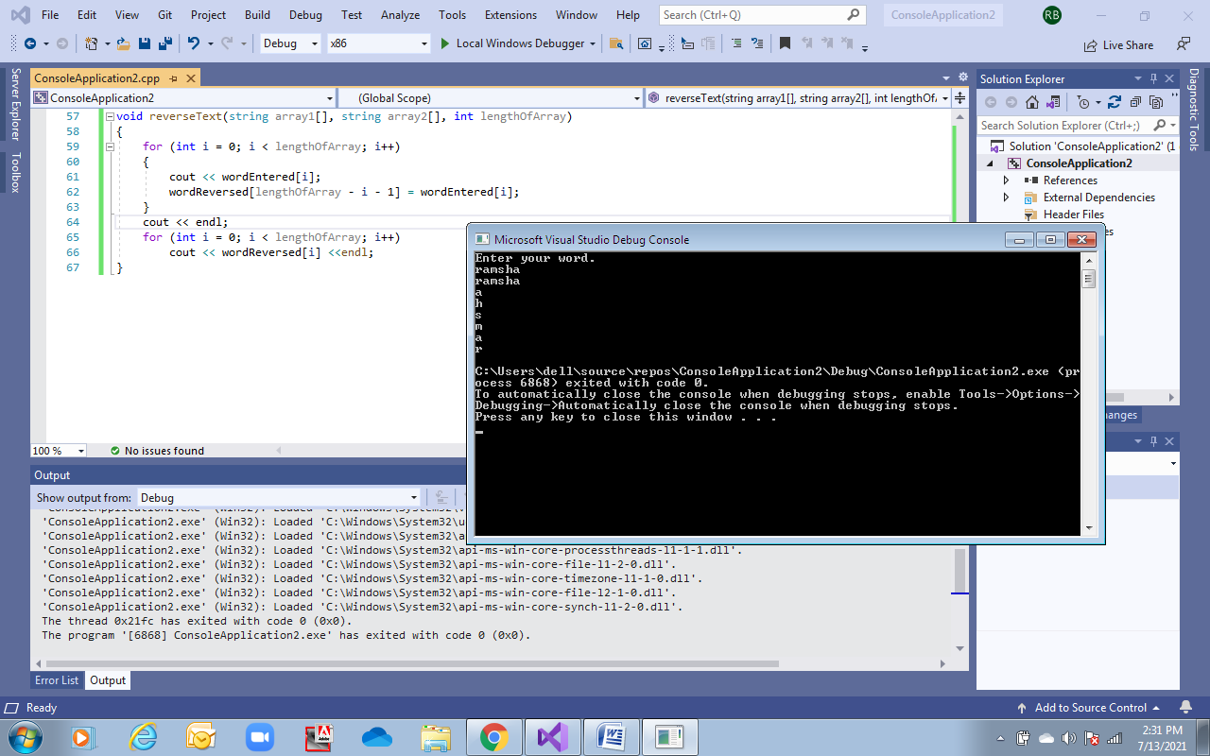

Trial runs:

