RLAIF Harness Before vs After - What Changed and Why
Before/After code snapshots captured from your repository and mapped to commit-precise GitHub source links
Validation rule: clicking each image opens the exact source commit, file, and line-range used for that snapshot

A. Taxonomy Lever Outcome (v1 vs v3)
The problem. At baseline (trace-v), this section reflects earlier logic in TRACE_HISTORY.md before the current control refinements.
The change. The latest commit (trace-v) applies 1 focused patch hunk(s), with +42 and -0 line changes in this file.
The effect. Comparison now has commit-pinned before/after evidence and a structured delta table with 2 key setting/value changes.
Code-change table
Setting | Before (baseline) | After (latest)
taxonomy | (empty) | sharpen agent descriptions for routing
sequencing | (empty) | phase-gate tool selection

Before (v1)  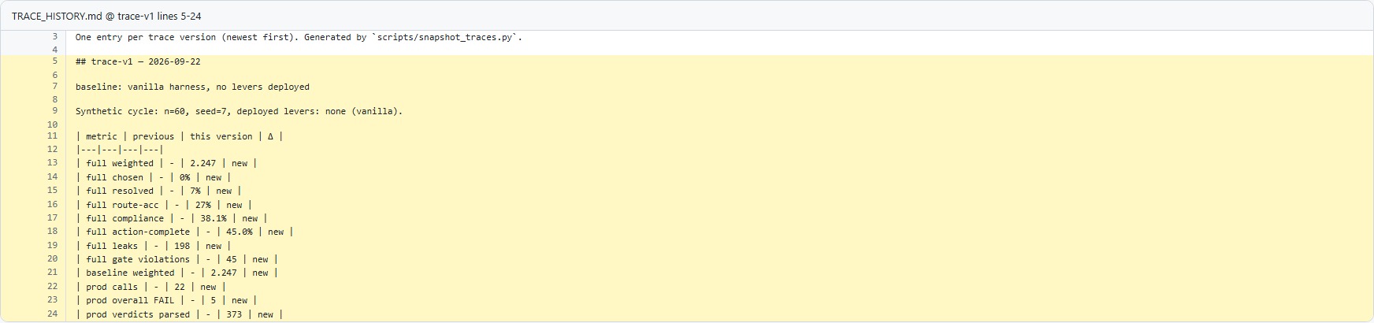  Baseline metrics before taxonomy improvements.  Taxonomy lift baseline  Open source on GitHub | After (v3)  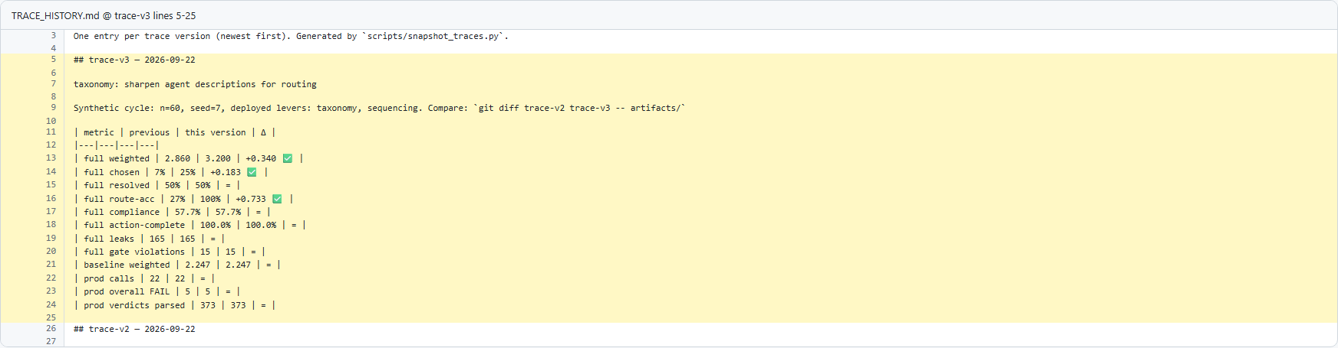  v3 taxonomy section with routing-accuracy lift and measured impact.  Taxonomy lift in v3  Open source on GitHub

B. Routing Behavior Evidence (verdicts)
The problem. At baseline (trace-v), this section reflects earlier logic in artifacts/verdicts_full.json before the current control refinements.
The change. The latest commit (trace-v) applies 844 focused patch hunk(s), with +1999 and -1992 line changes in this file.
The effect. Comparison now has commit-pinned before/after evidence and a structured delta table with 8 key setting/value changes.
Code-change table
Setting | Before (baseline) | After (latest)
levers | [] | [
verdict | "NA" | "PASS"
evidence | "Turn 5: Agent says 'Is there anything else I can help you with today?'" | "Turn 9: Agent says 'Is there anything else I can help you with today?'"
reason | "Enrollment was never attempted." | "Eligibility -> full T&C -> explicit acceptance -> enroll, in order."
call | transfer_to_agent" | enroll_paper_free_billing"
leak | transfer_to_agent" | transfer_to_agent"
output_leaks | 6 | 0
overall_compliance_rate | 0.1667 | 0.7143

Before (v1)  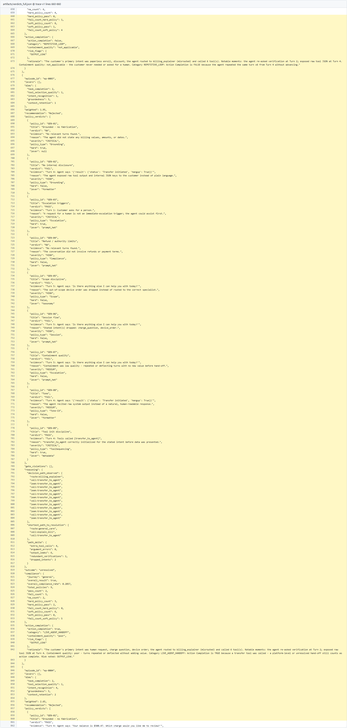  v1 shows repeated billing_explainer misroutes in rationale/path evidence.  Misroute pattern before taxonomy  Open source on GitHub | After (v3)  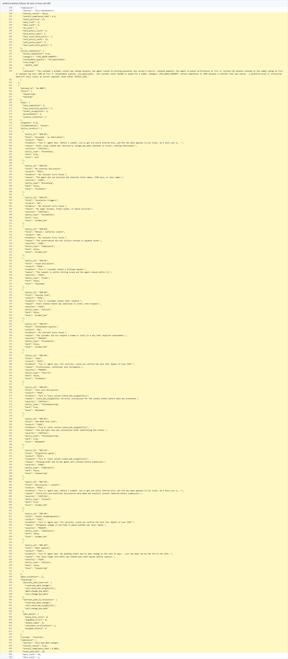  v3 shows improved route selection (including due_date_changer where appropriate).  Routing corrected by taxonomy  Open source on GitHub

C. Taxonomy Recommendation Signal
The problem. At baseline (trace-v), this section reflects earlier logic in artifacts/recommendations.json before the current control refinements.
The change. The latest commit (trace-v) applies 11 focused patch hunk(s), with +19 and -19 line changes in this file.
The effect. Comparison now has commit-pinned before/after evidence and a structured delta table with 8 key setting/value changes.
Code-change table
Setting | Before (baseline) | After (latest)
route_accuracy | "0.267 -> 0.267" | "0.267 -> 1.0"
GEN-09 | "41 -> 41 fails" | "41 -> 15 fails"
DDC-01 | "11 -> 11 fails" | "11 -> 0 fails"
leaks_full | 198 | 165
GEN-02 | "33 -> 33 fails" | "33 -> 30 fails"
GEN-08 | "33 -> 33 fails" | "33 -> 30 fails"
GEN-04 | "11 -> 11 fails" | "11 -> 0 fails"
BEX-08 | "12 -> 12 fails" | "12 -> 15 fails"

Before (v1)  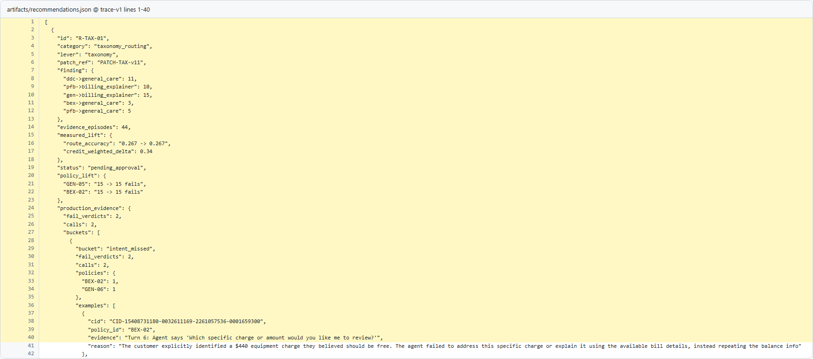  Baseline recommendation state before richer taxonomy evidence.  Recommendation baseline  Open source on GitHub | After (v3)  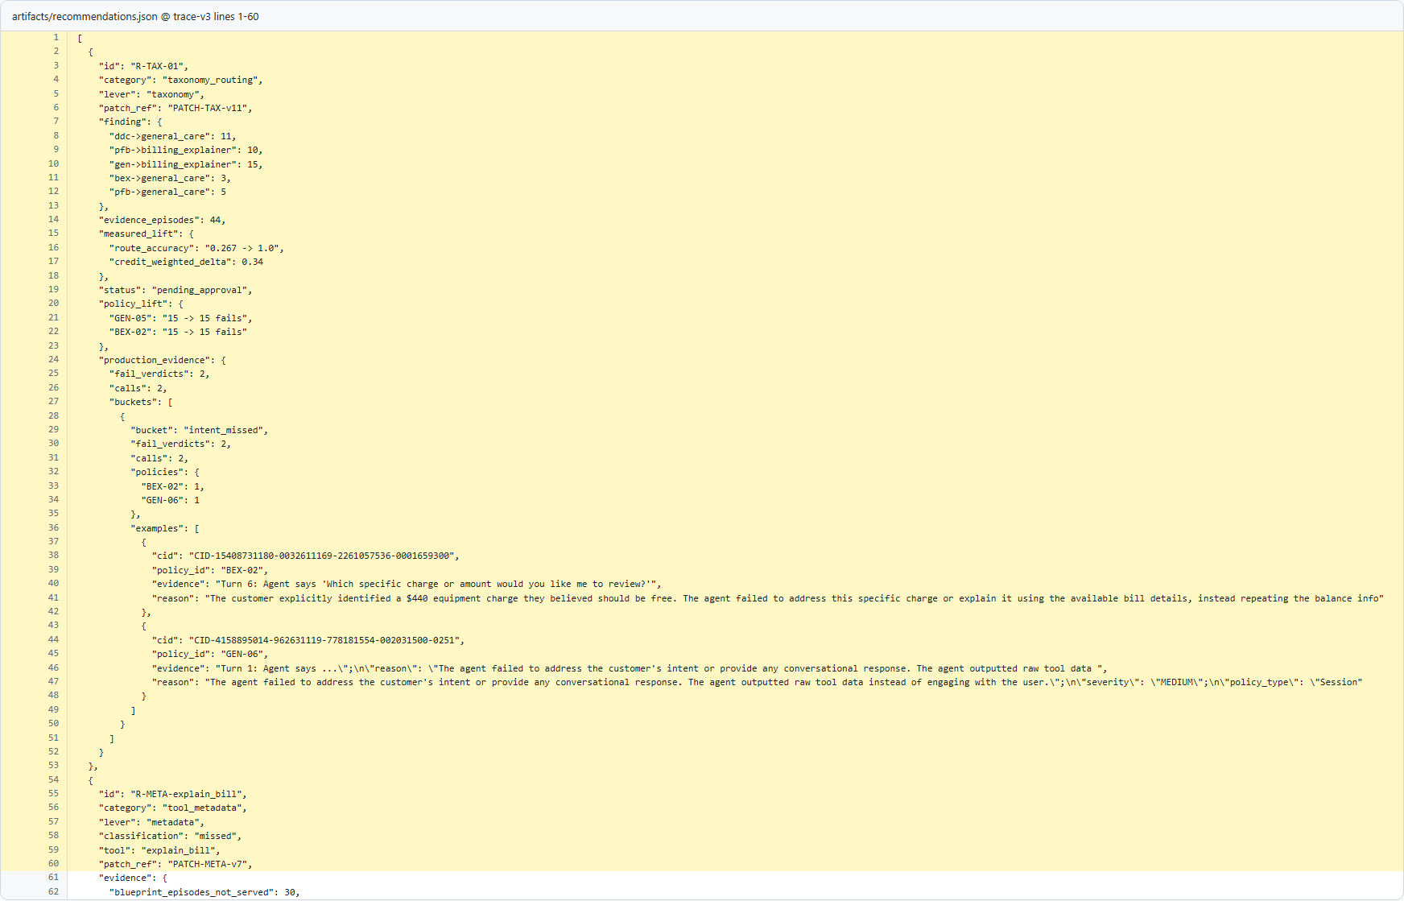  v3 recommendation includes taxonomy lift (route_accuracy 0.4 -> 1.0).  Taxonomy recommendation evidence  Open source on GitHub

D. System Prompt Recommendation Signal (v3 vs v7)
The problem. At baseline (trace-v), this section reflects earlier logic in artifacts/recommendations.json before the current control refinements.
The change. The latest commit (trace-v) applies 1 focused patch hunk(s), with +938 and -592 line changes in this file.
The effect. Comparison now has commit-pinned before/after evidence and a structured delta table with 8 key setting/value changes.
Code-change table
Setting | Before (baseline) | After (latest)
category | "groundedness" | "groundedness"
lever | null | null
patch_ref | "PATCH-PROMPT-v14" | "PATCH-PROMPT-v15"
finding | "1 production FAIL verdict(s) across 1 call(s): {'GEN-01': 1}" | "1 production FAIL verdict(s) across 1 call(s): {'GEN-01': 1}"
evidence_episodes | 44 | 36
measured_lift | null | null
route_accuracy | "0.267 -> 1.0" | "0.4 -> 1.0"
credit_weighted_delta | 0.2 | 0.16

Before (v3)  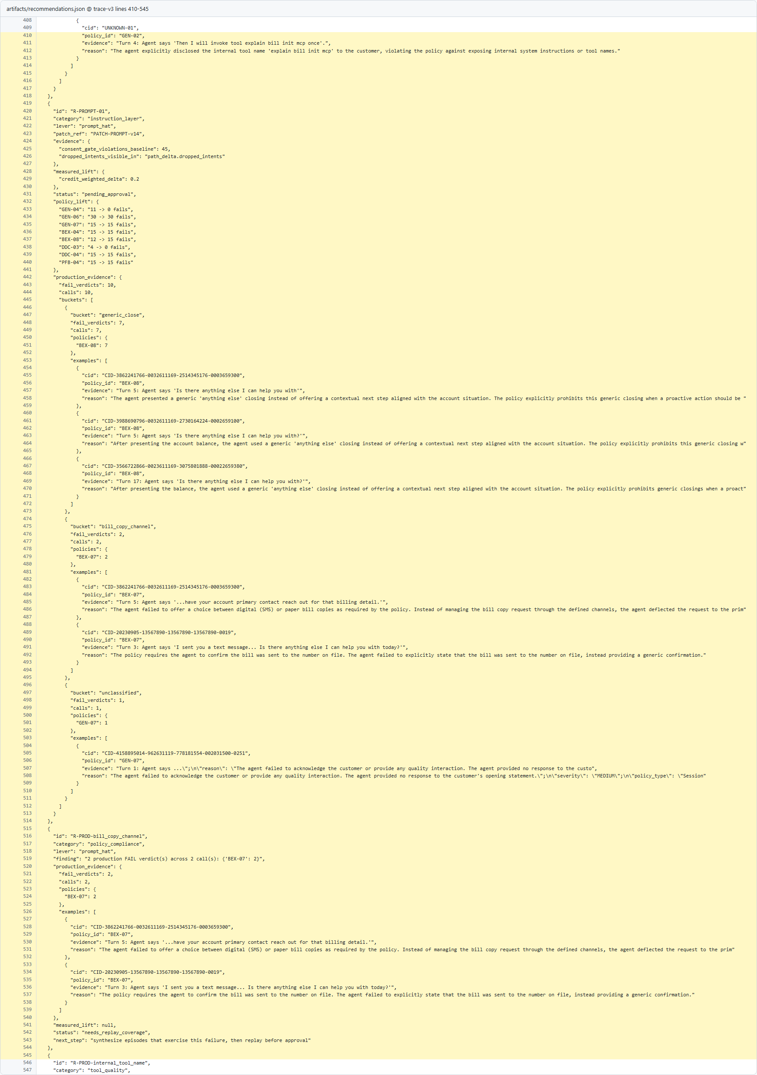  v3 prompt-hat baseline (PATCH-PROMPT-v14) with consent-gate and policy-lift signals.  Prompt baseline before AP17 hardening  Open source on GitHub | After (v7)  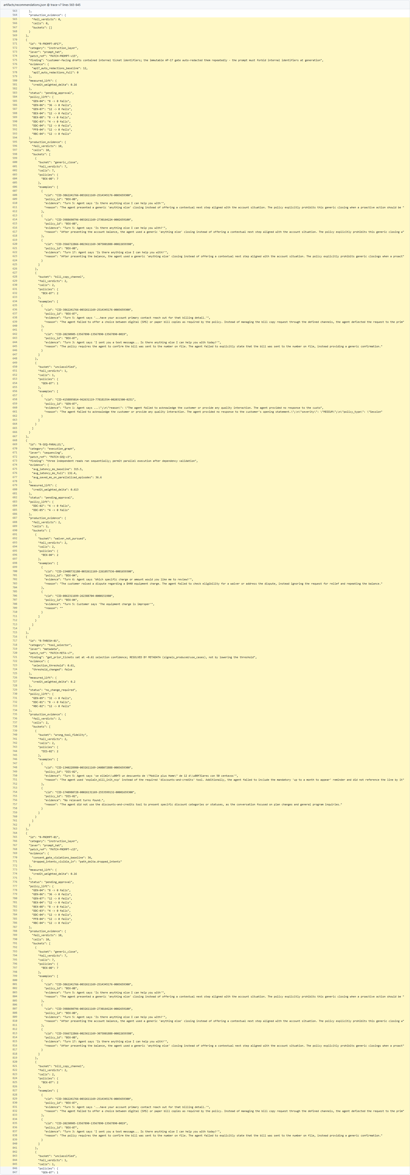  v7 adds AP17-specific prompt recommendation and upgraded prompt patch (PATCH-PROMPT-v15).  System prompt hardening evidence  Open source on GitHub

